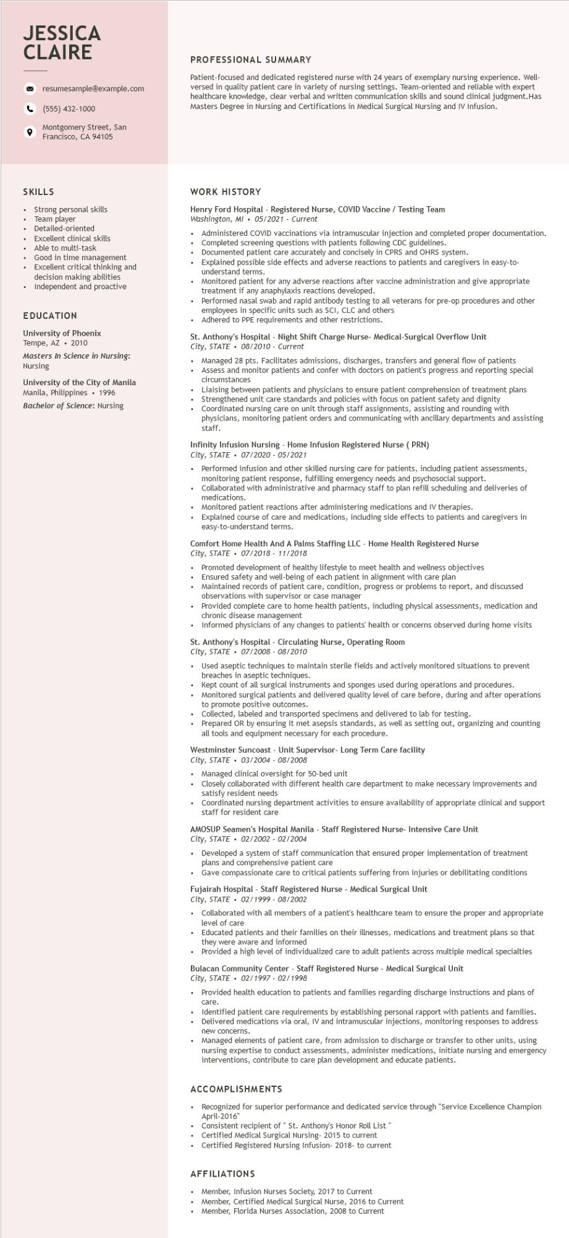

**JESSICA CLAIRE**

°

resumesample@example.com

(555) 432-1000

Montgomery Street, San Francisco, CA 94105

**PROFESSIONAL SUMMARY**

Patient-focused and dedicated registered nurse with 24 years of exemplary nursing experience. Well- versed in quality patient care in variety of nursing settings. Team-oriented and reliable with expert healthcare knowledge, clear verbal and written communication skills and sound clinical judgment.Has Masters Degree in Nursing and Certifications in Medical Surgical Nursing and IV Infusion.

SKILLS

Strong personal skills

Team player

Detailed-oriented

Excellent clinical skills

Able to multi-task

Good in time management

Excellent critical thinking and decision making abilities

• Independent and proactive

EDUCATION

University of Phoenix

Tempe, AZ

2010

Masters In Science in Nursing: Nursing

University of the City of Manila Manila, Philippines • 1996 Bachelor of Science: Nursing

WORK HISTORY

Henry Ford Hospital - Registered Nurse, COVID Vaccine / Testing Team Washington, MI 05/2021 Current

Administered COVID vaccinations via intramuscular injection and completed proper documentation. Completed screening questions with patients following CDC guidelines.

Documented patient care accurately and concisely in CPRS and OHRS system.

Explained possible side effects and adverse reactions to patients and caregivers in easy-to- understand terms.

• Monitored patient for any adverse reactions after vaccine administration and give appropriate treatment if any anaphylaxis reactions developed.

• Performed nasal swab and rapid antibody testing to all veterans for pre-op procedures and other employees in specific units such as SCI, CLC and others

•

Adhered to PPE requirements and other restrictions.

St. Anthony's Hospital - Night Shift Charge Nurse- Medical-Surgical Overflow Unit City, STATE 08/2010 - Current

Managed 28 pts. Facilitates admissions, discharges, transfers and general flow of patients Assess and monitor patients and confer with doctors on patient's progress and reporting special circumstances

Liaising between patients and physicians to ensure patient comprehension of treatment plans Strengthened unit care standards and policies with focus on patient safety and dignity Coordinated nursing care on unit through staff assignments, assisting and rounding with physicians, monitoring patient orders and communicating with ancillary departments and assisting staff.

**Infinity Infusion Nursing - Home Infusion Registered Nurse (PRN) City, STATE**

.

*07/2020-05/2021*

Performed infusion and other skilled nursing care for patients, including patient assessments, monitoring patient response, fulfilling emergency needs and psychosocial support.

Collaborated with administrative and pharmacy staff to plan refill scheduling and deliveries of medications.

Monitored patient reactions after administering medications and IV therapies.

Explained course of care and medications, including side effects to patients and caregivers in easy-to-understand terms.

Comfort Home Health And A Palms Staffing LLC - Home Health Registered Nurse City, STATE

07/2018 - 11/2018

Promoted development of healthy lifestyle to meet health and wellness objectives Ensured safety and well-being of each patient in alignment with care plan

Maintained records of patient care, condition, progress or problems to report, and discussed observations with supervisor or case manager

Provided complete care to home health patients, including physical assessments, medication and chronic disease management

Informed physicians of any changes to patients' health or concerns observed during home visits

St. Anthony's Hospital - Circulating Nurse, Operating Room

*City, STATE⚫ 07/2008 - 08/2010*

.

Used aseptic techniques to maintain sterile fields and actively monitored situations to prevent breaches in aseptic techniques.

• Kept count of all surgical instruments and sponges used during operations and procedures. Monitored surgical patients and delivered quality level of care before, during and after operations to promote positive outcomes.

Collected, labeled and transported specimens and delivered to lab for testing.

• Prepared OR by ensuring it met asepsis standards, as well as setting out, organizing and counting all tools and equipment necessary for each procedure.

Westminster Suncoast Unit Supervisor- Long Term Care facility

*City, STATE⚫ 03/2004 - 08/2008*

• Managed clinical oversight for 50-bed unit

• Closely collaborated with different health care department to make necessary improvements and satisfy resident needs

.

Coordinated nursing department activities to ensure availability of appropriate clinical and support staff for resident care

**AMOSUP Seamen's Hospital Manila - Staff Registered Nurse- Intensive Care Unit City, STATE**

02/2002-02/2004

• Developed a system of staff communication that ensured proper implementation of treatment plans and comprehensive patient care

•

Gave compassionate care to critical patients suffering from injuries or debilitating conditions

Fujairah Hospital - Staff Registered Nurse - Medical Surgical Unit

*City, STATE 02/1999 - 08/2002*

.

Collaborated with all members of a patient's healthcare team to ensure the proper and appropriate level of care

• Educated patients and their families on their illnesses, medications and treatment plans so that they were aware and informed

• Provided a high level of individualized care to adult patients across multiple medical specialties

Bulacan Community Center - Staff Registered Nurse - Medical Surgical Unit City, STATE 02/1997 - 02/1998

.

Provided health education to patients and families regarding discharge instructions and plans of care.

Identified patient care requirements by establishing personal rapport with patients and families. Delivered medications via oral, IV and intramuscular injections, monitoring responses to address

new concerns.

Managed elements of patient care, from admission to discharge or transfer to other units, using nursing expertise to conduct assessments, administer medications, initiate nursing and emergency interventions, contribute to care plan development and educate patients.

ACCOMPLISHMENTS

.

Recognized for superior performance and dedicated service through "Service Excellence Champion April-2016"

Consistent recipient of " St. Anthony's Honor Roll List"

Certified Medical Surgical Nursing- 2015 to current Certified Registered Nursing Infusion- 2018- to current

**AFFILIATIONS**

• Member, Infusion Nurses Society, 2017 to Current

• Member, Certified Medical Surgical Nurse, 2016 to Current

• Member, Florida Nurses Association, 2008 to Current