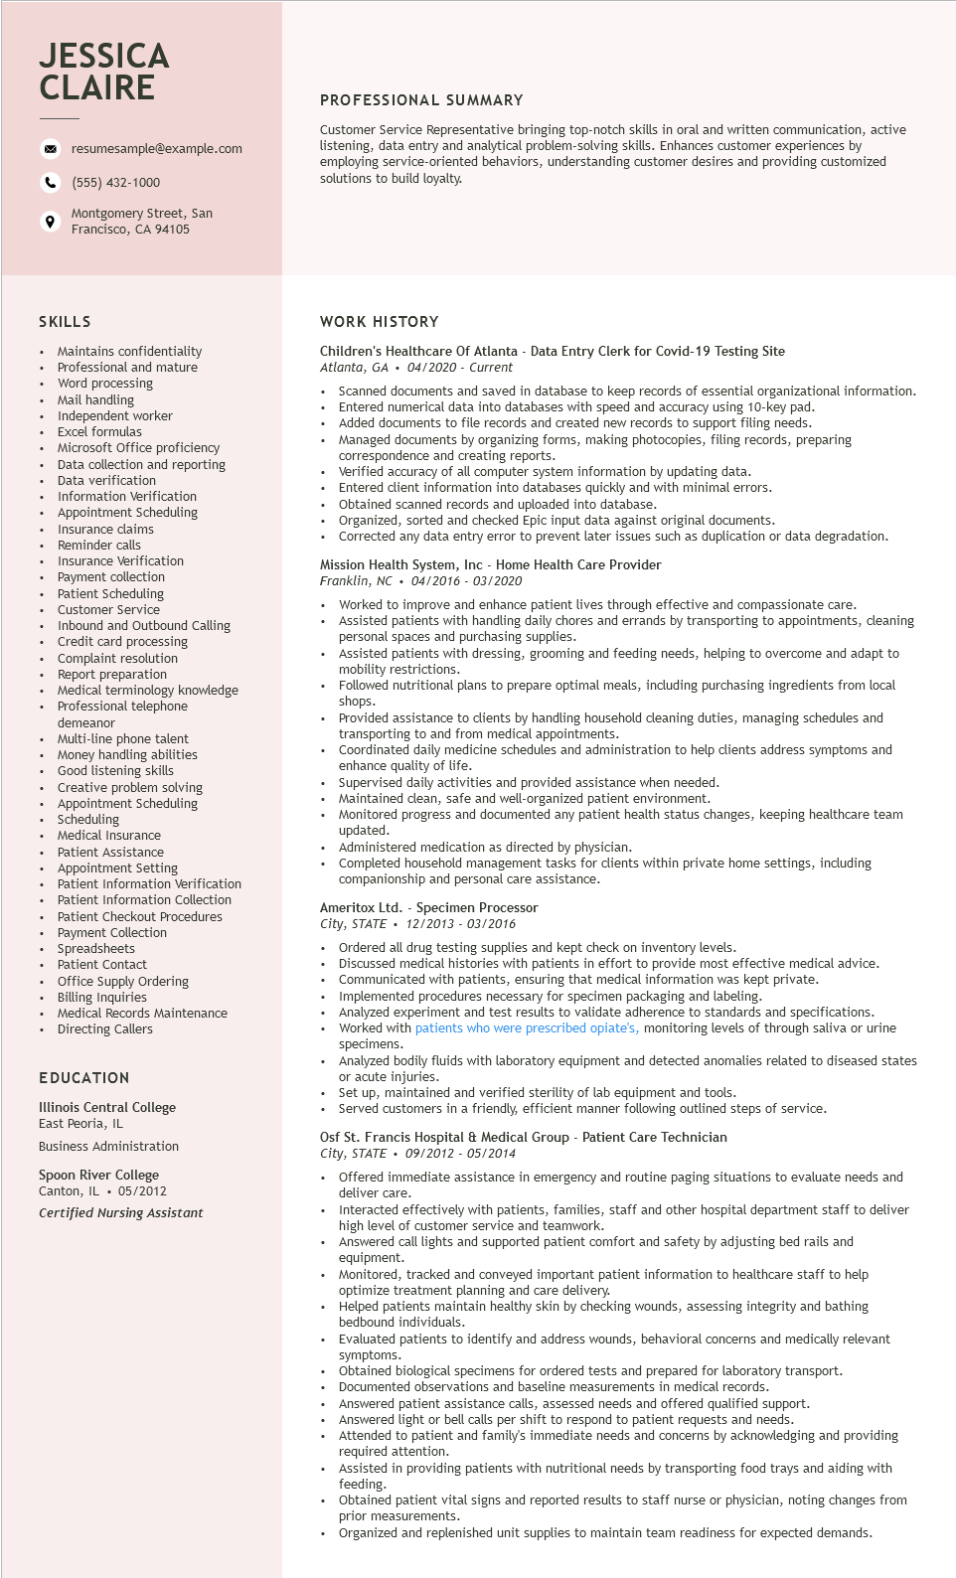

**JESSICA CLAIRE**

°

resumesample@example.com

(555) 432-1000

Montgomery Street, San Francisco, CA 94105

PROFESSIONAL SUMMARY

Customer Service Representative bringing top-notch skills in oral and written communication, active listening, data entry and analytical problem-solving skills. Enhances customer experiences by employing service-oriented behaviors, understanding customer desires and providing customized solutions to build loyalty.

SKILLS

Maintains confidentiality Professional and mature

Word processing

Mail handling

Independent worker

Excel formulas

Microsoft Office proficiency

Data collection and reporting Data verification Information Information Verification

Appointment Scheduling

Insurance claims misurance Clam Reminder calls

Insurance Verification

Payment collection

Patient Scheduling

Customer Service

Inbound and Outbound Calling Credit card processing

Complaint resolution

Report preparation

Medical terminology knowledge

Professional telephone

demeanor

Multi-line phone talent

Money handling abilities

. Good

Good listening skills

Creative problem solving Appointment Scheduling Scheduling Medical Insurance Patient Assistance Appointment Setting

Patient Information Verification Patient Information Collection Patient Che

Checkout Procedures

Payment Collection

Spreadsheets

Patient Contact

• Office Supply Ordering

• Billing Inquiries

• Medical Records Maintenance

• Directing Callers

**EDUCATION**

Illinois Central College East Peoria, IL

Business Administration

Spoon River College Canton, IL. 05/2012

*Certified Nursing Assistant*

WORK HISTORY

Children's Healthcare Of Atlanta - Data Entry Clerk for Covid-19 Testing Site Atlanta, GA. 04/2020 Current

.

Scanned documents and saved in database to keep records of essential organizational information. Entered numerical data into databases with speed and accuracy using 10-key pad.

Added documents to file records and created new records to support filing needs.

• Managed documents by organizing forms, making photocopies, filing records, preparing correspondence and creating reports.

Verified accuracy of all computer system information by updating data.

Entered client information into databases quickly and with minimal errors.

Obtained scanned records and uploaded into database.

Organized, sorted and checked Epic input data against original documents.

Corrected any data entry error to prevent later issues such as duplication or data degradation.

Mission Health System, Inc - Home Health Care Provider

*Franklin, NC 04/2016 - 03/2020*

Worked to improve and enhance patient lives through effective and compassionate care. Assisted patients with handling daily chores and errands by transporting to appointments, cleaning personal spaces and purchasing supplies.

Assisted patients with dressing, grooming and feeding needs, helping to overcome and adapt to mobility restrictions.

Followed nutritional plans to prepare optimal meals, including purchasing ingredients from local shops. shops.

Provided assistance to clients by handling household cleaning duties, managing schedules and transporting to and from medical appointments. Coordinated

I daily medicine schedules and administration to help clients address symptoms and enhance quality of life.

Supervised daily activities and provided assistance when needed.

Maintained clean, safe and well-organized patient environment.

Monitored progress and documented any patient health status changes, keeping healthcare team updated.

Administered medication as directed by physician.

Completed household management tasks for clients within private home settings, including companionship and personal care assistance.

Ameritox Ltd. - Specimen Processor

*City, STATE. 12/2013 - 03/2016*

Ordered all drug testing supplies and kept check on inventory levels.

Discussed medical histories with patients in effort to provide most effective medical advice. Communicated with patients, ensuring that medical information was kept private. Implemented procedures necessary for specimen packaging and labeling.

• Analyzed experiment and test results to validate adherence to standards and specifications. Worked with patients who were prescribed opiate's, monitoring levels of through saliva or urine specimens.

Analyzed bodily fluids with laboratory equipment and detected anomalies related to diseased states or acute injuries.

Set up, maintained and verified sterility of lab equipment and tools.

• Served customers in a friendly, efficient manner following outlined steps of service.

Osf St. Francis Hospital & Medical Group - Patient Care Technician City, STATE 09/2012 - 05/2014

Offered immediate assistance in emergency and routine paging situations to evaluate needs and deliver care.

Interacted effectively with patients, families, staff and other hospital department staff to deliver high level of customer service and teamwork.

Answered call lights and supported patient comfort and safety by adjusting bed rails and equipment.

Monitored, tracked and conveyed important patient information to healthcare staff to help optimize treatment planning and care delivery.

Helped I patients maintain healthy skin by checking wounds, assessing integrity and bathing bedbound individuals.

• Evaluated patients to identify and address wounds, behavioral concerns and medically relevant symptoms.

Obtained biological specimens for ordered tests and prepared for laboratory transport.

Documented observations and baseline measurements in medical records.

Answered patient assistance calls, assessed needs and offered qualified support. Answered

Answered light or bell calls per shift to respond to patient requests and needs.

Attended to patient and family's immediate needs and concerns by acknowledging and providing required attention.

Assisted in providing patients with nutritional needs by transporting food trays and aiding with

feeding.

Obtained patient vital signs and reported results to staff nurse or physician, noting changes from prior measurements.

Organized and replenished unit supplies to maintain team readiness for expected demands.