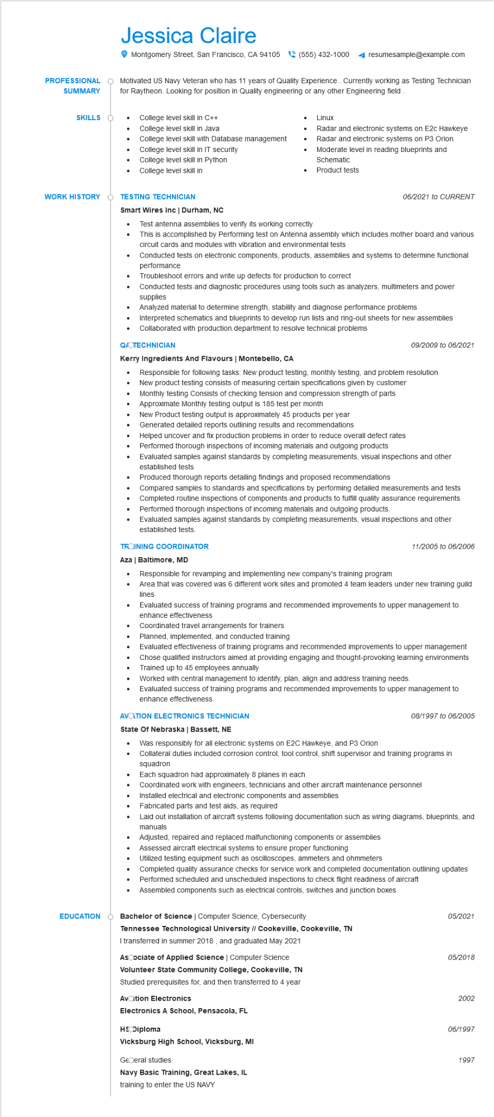

**PROFESSIONAL**

**SUMMARY**

Jessica Claire

Montgomery Street, San Francisco, CA 94105 (555) 432-1000

resumesample@example.com

Motivated US Navy Veteran who has 11 years of Quality Experience. Currently working as Testing Technician for Raytheon. Looking for position in Quality engineering or any other Engineering field

**SKILLS O**

•

College level skill in C++

•

College level skill in Java

•

College level skill with Database management

•

College level skill in IT security

College level skill in Python

•

College level skill in

**WORK HISTORY**

**EDUCATION**

Linux

Radar and electronic systems on E2c Hawkeye

Radar and electronic systems on P3 Orion Moderate level in reading blueprints and Schematic

•

Product tests

**TESTING TECHNICIAN**

**Smart Wires Inc | Durham, NC**

•

Test antenna assemblies to verify its working correctly

*06/2021 to CURRENT*

This is accomplished by Performing test on Antenna assembly which includes mother board and various circuit cards and modules with vibration and environmental tests

Conducted tests on electronic components, products, assemblies and systems to determine functional performance

Troubleshoot errors and write up defects for production to correct

Conducted tests and diagnostic procedures using tools such as analyzers, multimeters and power supplies

Analyzed material to determine strength, stability and diagnose performance problems

Interpreted schematics and blueprints to develop run lists and ring-out sheets for new assemblies Collaborated with production department to resolve technical problems

**QUOTECHNICIAN**

**Kerry Ingredients And Flavours | Montebello, CA**

·

•

•

•

*09/2009 to 06/2021*

Responsible for following tasks: New product testing, monthly testing, and problem resolution New product testing consists of measuring certain specifications given by customer Monthly testing Consists of checking tension and compression strength of parts Approximate Monthly testing output is 185 test per month

New Product testing output is approximately 45 products per year

Generated detailed reports outlining results and recommendations

Helped uncover and fix production problems in order to reduce overall defect rates

Performed thorough inspections of incoming materials and outgoing products

Evaluated samples against standards by completing measurements, visual inspections and other established tests

Produced thorough reports detailing findings and proposed recommendations

Compared samples to standards and specifications by performing detailed measurements and tests

Completed routine inspections of components and products to fulfill quality assurance requirements Performed thorough inspections of incoming materials and outgoing products.

Evaluated samples against standards by completing measurements, visual inspections and other established tests.

**TROINING COORDINATOR**

Aza | Baltimore, MD

*11/2005 to 06/2006*

•

•

Responsible for revamping and implementing new company's training program

Area that was covered was 6 different work sites and promoted 4 team leaders under new training guild lines

Evaluated success of training programs and recommended improvements to upper management to enhance effectiveness

•

Coordinated travel arrangements for trainers

Planned, implemented, and conducted training

•

Evaluated effectiveness of training programs and recommended improvements to upper management

Chose qualified instructors aimed at providing engaging and thought-provoking learning environments Trained up to 45 employees annually

Worked with central management to identify, plan, align and address training needs.

Evaluated success of training programs and recommended improvements to upper management to enhance effectiveness.

**AVATION ELECTRONICS TECHNICIAN**

**State Of Nebraska | Bassett, NE**

08/1997 to 06/2005

Was responsibly for all electronic systems on E2C Hawkeye, and P3 Orion

•

Collateral duties included corrosion control, tool control, shift supervisor and training programs in squadron

Each squadron had approximately 8 planes in each

Coordinated work with engineers, technicians and other aircraft maintenance personnel

•

Installed electrical and electronic components and assemblies

•

Fabricated parts and test aids, as required

•

Laid out installation of aircraft systems following documentation such as wiring diagrams, blueprints, and manuals

•

Adjusted, repaired and replaced malfunctioning components or assemblies Assessed aircraft electrical systems to ensure proper functioning

Utilized testing equipment such as oscilloscopes, ammeters and ohmmeters

Completed quality assurance checks for service work and completed documentation outlining updates Performed scheduled and unscheduled inspections to check flight readiness of aircraft

•

Assembled components such as electrical controls, switches and junction boxes

Bachelor of Science | Computer Science, Cybersecurity

**Tennessee Technological University // Cookeville, Cookeville, TN**

I transferred in summer 2018, and graduated May 2021

**Ascociate of Applied Science | Computer Science Volunteer State Community College, Cookeville, TN Studied prerequisites for, and then transferred to 4 year**

**Avation Electronics**

**Electronics A School, Pensacola, FL**

HS Diploma

**Vicksburg High School, Vicksburg, MI**

GEOeral studies

**Navy Basic Training, Great Lakes, IL**

training to enter the US NAVY

05/2021

*05/2018*

2002

06/1997

1997