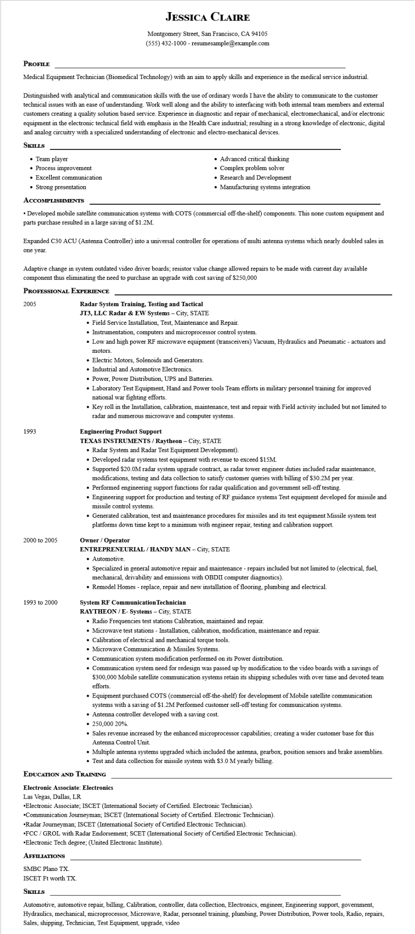

**JESSICA CLAIRE**

Montgomery Street, San Francisco, CA 94105 (555) 432-1000 - resumesample@example.com

**PROFILE**

Medical Equipment Technician (Biomedical Technology) with an aim to apply skills and experience in the medical service industrial.

Distinguished with analytical and communication skills with the use of ordinary words I have the ability to communicate to the customer technical issues with an ease of understanding. Work well along and the ability to interfacing with both internal team members and external customers creating a quality solution based service. Experience in diagnostic and repair of mechanical, electromechanical, and/or electronic equipment in the electronic technical field with emphasis in the Health Care industrial; resulting in a strong knowledge of electronic, digital and analog circuitry with a specialized understanding of electronic and electro-mechanical devices.

**SKILLS**

Team player

• Process improvement

• Excellent communication

• Strong presentation

**ACCOMPLISHMENTS**

• Advanced critical thinking

• Complex problem solver

• Research and Development • Manufacturing systems integration

•Developed mobile satellite communication systems with COTS (commercial off-the-shelf) components. This none custom equipment and parts purchase resulted in a large saving of $1.2M.

Expanded C30 ACU (Antenna Controller) into a universal controller for operations of multi antenna systems which nearly doubled sales in

one year.

Adaptive change in system outdated video driver boards; resistor value change allowed repairs to be made with current day available component thus eliminating the need to purchase an upgrade with cost saving of $250,000

**PROFESSIONAL EXPERIENCE**

2005

1993

2000 to 2005

1993 to 2000

**Radar System Training, Testing and Tactical**

**JT3, LLC Radar & EW Systems - City, STATE**

• Field Service Installation, Test, Maintenance and Repair.

• Instrumentation, computers and microprocessor control system.

• Low and high power RF microwave equipment (transceivers) Vacuum, Hydraulics and Pneumatic - actuators and

motors.

• Electric Motors, Solenoids and Generators.

• Industrial and Automotive Electronics.

• Power, Power Distribution, UPS and Batteries.

• Laboratory Test Equipment, Hand and Power tools Team efforts in military personnel training for improved national war fighting efforts.

• Key roll in the Installation, calibration, maintenance, test and repair with Field activity included but not limited to radar and numerous microwave and computer systems.

**Engineering Product Support**

**TEXAS INSTRUMENTS/Raytheon - City, STATE**

• Radar System and Radar Test Equipment Development).

• Developed radar systems test equipment with revenue to exceed $15M.

• Supported $20.0M radar system upgrade contract, as radar tower engineer duties included radar maintenance, modifications, testing and data collection to satisfy customer queries with billing of $30.2M per year.

• Performed engineering support functions for radar qualification and government sell-off testing.

• Engineering support for production and testing of RF guidance systems Test equipment developed for missile and missile control systems.

• Generated calibration, test and maintenance procedures for missiles and its test equipment Missile system test platforms down time kept to a minimum with engineer repair, testing and calibration support.

**Owner/Operator**

**ENTREPRENEURIAL / HANDY MAN - City, STATE**

• Automotive.

• Specialized in general automotive repair and maintenance - repairs included but not limited to (electrical, fuel, mechanical, drivability and emissions with OBDII computer diagnostics).

• Remodel Homes - replace, repair and new installation of flooring, plumbing and electrical.

**System RF Communication Technician**

**RAYTHEON/E- Systems - City, STATE**

• Radio Frequencies test stations Calibration, maintained and repair.

• Microwave test stations - Installation, calibration, modification, maintenance and repair.

• Calibration of electrical and mechanical torque tools.

• Microwave Communication & Missiles Systems.

• Communication system modification performed on its Power distribution.

• Communication system need for redesign was passed up by modification to the video boards with a savings of $300,000 Mobile satellite communication systems retain its shipping schedules with over time and devoted team efforts.

• Equipment purchased COTS (commercial off-the-shelf) for development of Mobile satellite communication systems with a saving of $1.2M Performed customer sell-off testing for communication systems.

• Antenna controller developed with a saving cost.

• 250,000 20%.

• Sales revenue increased by the enhanced microprocessor capabilities; creating a wider customer base for this Antenna Control Unit.

• Multiple antenna systems upgraded which included the antenna, gearbox, position sensors and brake assemblies. • Test and data collection for missile system with $3.0 M yearly billing.

**EDUCATION AND TRAINING**

**Electronic Associate: Electronics**

Las Vegas, Dallas, LR

•Electronic Associate; ISCET (International Society of Certified. Electronic Technician). •Communication Journeyman; ISCET (International Society of Certified. Electronic Technician).

•Radar Journeyman; ISCET (International Society of Certified Electronic Technician).

•FCC/GROL with Radar Endorsement; SCET (International Society of Certified Electronic Technician). •Electronic Tech degree; (United Electronic Institute).

**AFFILIATIONS**

SMBC Plano TX.

ISCET Ft Worth TX.

**SKILLS**

Automotive, automotive repair, billing, Calibration, controller, data collection, Electronics, engineer, Engineering support, government, Hydraulics, mechanical, microprocessor, Microwave, Radar, personnel training, plumbing, Power Distribution, Power tools, Radio, repairs, Sales, shipping, Technician, Test Equipment, upgrade, video