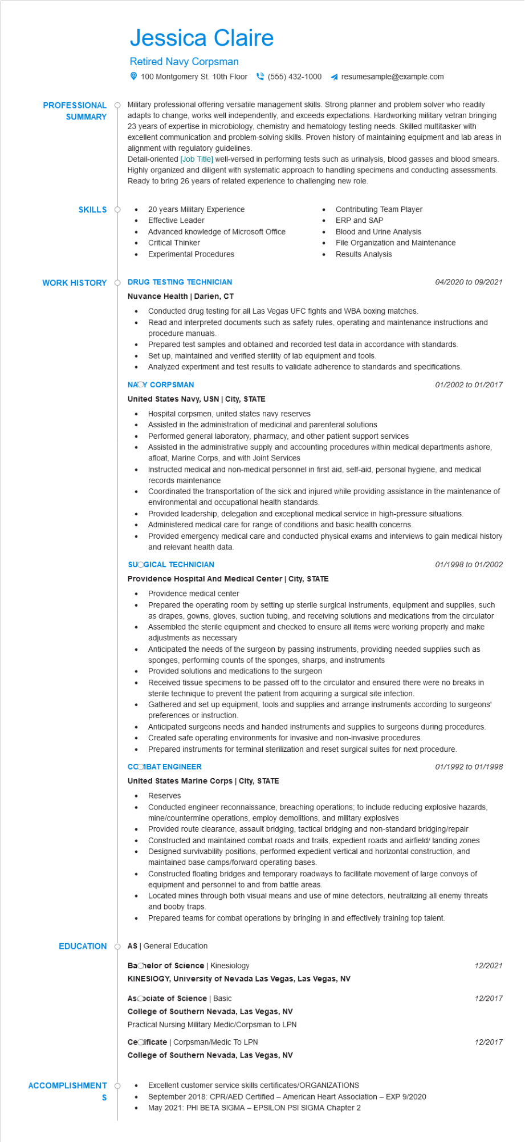

**PROFESSIONAL**

**SUMMARY**

Jessica Claire

Retired Navy Corpsman

100 Montgomery St. 10th Floor (555) 432-1000 4 resumesample@example.com

Military professional offering versatile management skills. Strong planner and problem solver who readily adapts to change, works well independently, and exceeds expectations. Hardworking military vetran bringing 23 years of expertise in microbiology, chemistry and hematology testing needs. Skilled multitasker with excellent communication and problem-solving skills. Proven history of maintaining equipment and lab areas in alignment with regulatory guidelines.

Detail-oriented [Job Title] well-versed in performing tests such as urinalysis, blood gasses and blood smears. Highly organized and diligent with systematic approach to handling specimens and conducting assessments. Ready to bring 26 years of related experience to challenging new role.

**SKILLS**

•

20 years Military Experience Effective Leader

•

Advanced knowledge of Microsoft Office

Critical Thinker

Experimental Procedures

**WORK HISTORY DRUG TESTING TECHNICIAN**

Nuvance Health | Darien, CT

•

•

Contributing Team Player ERP and SAP

Blood and Urine Analysis

File Organization and Maintenance Results Analysis

Conducted drug testing for all Las Vegas UFC fights and WBA boxing matches.

04/2020 to 09/2021

Read and interpreted documents such as safety rules, operating and maintenance instructions and procedure manuals.

Prepared test samples and obtained and recorded test data in accordance with standards.

Set up, maintained and verified sterility of lab equipment and tools.

Analyzed experiment and test results to validate adherence to standards and specifications.

**NAOY CORPSMAN**

**United States Navy, USN | City, STATE**

· Hospital corpsmen, united states navy reserves

• Assisted in the administration of medicinal and parenteral solutions

•

Performed general laboratory, pharmacy, and other patient support services

•

•

•

•

*01/2002 to 01/2017*

Assisted in the administrative supply and accounting procedures within medical departments ashore, afloat, Marine Corps, and with Joint Services

Instructed medical and non-medical personnel in first aid, self-aid, personal hygiene, and medical records maintenance

Coordinated the transportation of the sick and injured while providing assistance in the maintenance of environmental and occupational health standards.

Provided leadership, delegation and exceptional medical service in high-pressure situations. Administered medical care for range of conditions and basic health concerns.

Provided emergency medical care and conducted physical exams and interviews to gain medical history and relevant health data.

**SUOGICAL TECHNICIAN**

**Providence Hospital And Medical Center | City, STATE**

•

•

Providence medical center

01/1998 to 01/2002

Prepared the operating room by setting up sterile surgical instruments, equipment and supplies, such as drapes, gowns, gloves, suction tubing, and receiving solutions and medications from the circulator Assembled the sterile equipment and checked to ensure all items were working properly and make adjustments as necessary

Anticipated the needs of the surgeon by passing instruments, providing needed supplies such as sponges, performing counts of the sponges, sharps, and instruments

Provided solutions and medications to the surgeon

Received tissue specimens to be passed off to the circulator and ensured there were no breaks in sterile technique to prevent the patient from acquiring a surgical site infection.

Gathered and set up equipment, tools and supplies and arrange instruments according to surgeons' preferences or instruction.

Anticipated surgeons needs and handed instruments and supplies to surgeons during procedures. Created safe operating environments for invasive and non-invasive procedures.

· Prepared instruments for terminal sterilization and reset surgical suites for next procedure.

**CCOIBAT ENGINEER**

**United States Marine Corps | City, STATE**

Reserves

01/1992 to 01/1998

• Conducted engineer reconnaissance, breaching operations; to include reducing explosive hazards, mine/countermine operations, employ demolitions, and military explosives

•

•

Provided route clearance, assault bridging, tactical bridging and non-standard bridging/repair Constructed and maintained combat roads and trails, expedient roads and airfield/ landing zones Designed survivability positions, performed expedient vertical and horizontal construction, and maintained base camps/forward operating bases.

Constructed floating bridges and temporary roadways to facilitate movement of large convoys of equipment and personnel to and from battle areas.

•

Located mines through both visual means and use of mine detectors, neutralizing all enemy threats and booby traps.

Prepared teams for combat operations by bringing in and effectively training top talent.

**EDUCATION**

Ó AS General Education

**Bachelor of Science | Kinesiology**

**KINESIOGY, University of Nevada Las Vegas, Las Vegas, NV**

**Asociate of Science | Basic**

**College of Southern Nevada, Las Vegas, NV**

Practical Nursing Military Medic/Corpsman to LPN

Cecificate | Corpsman/Medic To LPN

**College of Southern Nevada, Las Vegas, NV**

**ACCOMPLISHMENT O**

• Excellent customer service skills certificates/ORGANIZATIONS

**S**

September 2018: CPR/AED Certified - American Heart Association - EXP 9/2020

• May 2021: PHI BETA SIGMA - EPSILON PSI SIGMA Chapter 2

12/2021

12/2017

12/2017