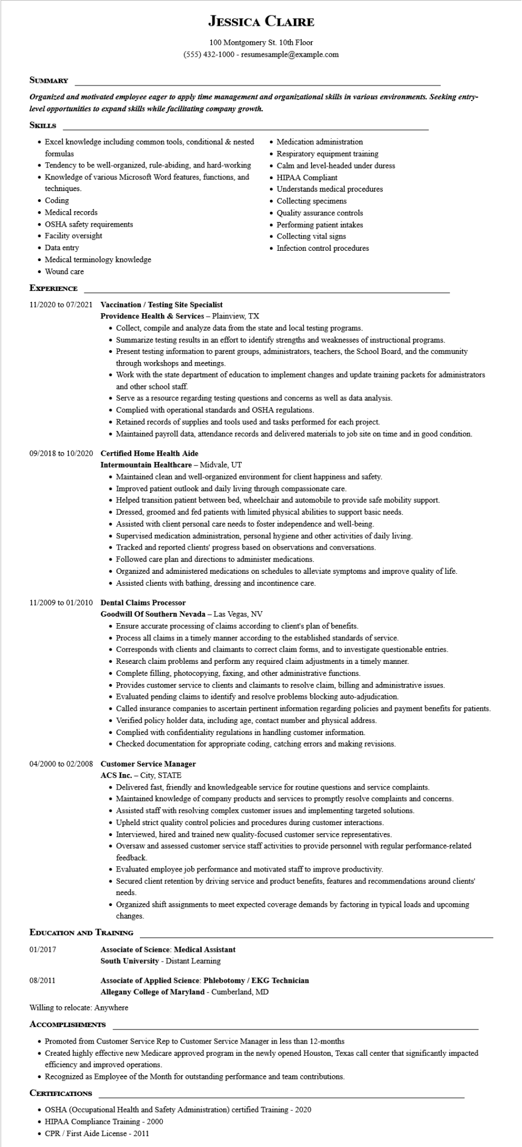

**JESSICA CLAIRE**

100 Montgomery St. 10th Floor (555) 432-1000 - resumesample@example.com

**SUMMARY**

***Organized and motivated employee eager to apply time management and organizational skills in various environments. Seeking entry- level opportunities to expand skills while facilitating company growth.***

**SKILLS**

• Excel knowledge including common tools, conditional & nested formulas

• Tendency to be well-organized, rule-abiding, and hard-working

• Knowledge of various Microsoft Word features, functions, and techniques.

• Coding

• Medical records

• OSHA safety requirements

• Facility oversight

Data entry

• Medical terminology knowledge

• Wound care

**EXPERIENCE**

**11/2020 to 07/2021 Vaccination/Testing Site Specialist**

**Providence Health & Services - Plainview, TX**

• Medication administration

• Respiratory equipment training

• Calm and level-headed under duress

• HIPAA Compliant

• Understands medical procedures

• Collecting specimens

• Quality assurance controls

• Performing patient intakes

• Collecting vital signs

• Infection control procedures

• Collect, compile and analyze data from the state and local testing programs.

• Summarize testing results in an effort to identify strengths and weaknesses of instructional programs.

• Present testing information to parent groups, administrators, teachers, the School Board, and the community through workshops and meetings.

• Work with the state department of education to implement changes and update training packets for administrators and other school staff.

• Serve as a resource regarding testing questions and concerns as well as data analysis.

• Complied with operational standards and OSHA regulations.

• Retained records of supplies and tools used and tasks performed for each project.

• Maintained payroll data, attendance records and delivered materials to job site on time and in good condition.

**09/2018 to 10/2020 Certified Home Health Aide**

**Intermountain Healthcare - Midvale, UT**

• Maintained clean and well-organized environment for client happiness and safety.

• Improved patient outlook and daily living through compassionate care.

• Helped transition patient between bed, wheelchair and automobile to provide safe mobility support.

• Dressed, groomed and fed patients with limited physical abilities to support basic needs.

• Assisted with client personal care needs to foster independence and well-being.

• Supervised medication administration, personal hygiene and other activities of daily living.

• Tracked and reported clients' progress based on observations and conversations.

• Followed care plan and directions to administer medications.

• Organized and administered medications on schedules to alleviate symptoms and improve quality of life.

• Assisted clients with bathing, dressing and incontinence care.

**11/2009 to 01/2010 Dental Claims Processor**

**Goodwill of Southern Nevada - Las Vegas, NV**

• Ensure accurate processing of claims according to client's plan of benefits.

• Process all claims in a timely manner according to the established standards of service.

• Corresponds with clients and claimants to correct claim forms, and to investigate questionable entries.

• Research claim problems and perform any required claim adjustments in a timely manner.

• Complete filling, photocopying, faxing, and other administrative functions.

• Provides customer service to clients and claimants to resolve claim, billing and administrative issues.

• Evaluated pending claims to identify and resolve problems blocking auto-adjudication.

• Called insurance companies to ascertain pertinent information regarding policies and payment benefits for patients.

• Verified policy holder data, including age, contact number and physical address.

• Complied with confidentiality regulations in handling customer information.

• Checked documentation for appropriate coding, catching errors and making revisions.

**04/2000 to 02/2008 Customer Service Manager**

ACS Inc. City, STATE

• Delivered fast, friendly and knowledgeable service for routine questions and service complaints.

• Maintained knowledge of company products and services to promptly resolve complaints and concerns.

• Assisted staff with resolving complex customer issues and implementing targeted solutions.

• Upheld strict quality control policies and procedures during customer interactions.

• Interviewed, hired and trained new quality-focused customer service representatives.

• Oversaw and assessed customer service staff activities to provide personnel with regular performance-related feedback.

• Evaluated employee job performance and motivated staff to improve productivity.

• Secured client retention by driving service and product benefits, features and recommendations around clients' needs.

• Organized shift assignments to meet expected coverage demands by factoring in typical loads and upcoming changes.

**EDUCATION AND TRAINING**

01/2017

08/2011

**Associate of Science: Medical Assistant**

**South University - Distant Learning**

**Associate of Applied Science: Phlebotomy/EKG Technician**

Allegany College of Maryland - Cumberland, MD

Willing to relocate: Anywhere

**ACCOMPLISHMENTS**

• Promoted from Customer Service Rep to Customer Service Manager in less than 12-months

• Created highly effective new Medicare approved program in the newly opened Houston, Texas call center that significantly impacted efficiency and improved operations.

• Recognized as Employee of the Month for outstanding performance and team contributions.

**CERTIFICATIONS**

• OSHA (Occupational Health and Safety Administration) certified Training - 2020

• HIPAA Compliance Training - 2000

• CPR/First Aide License - 2011