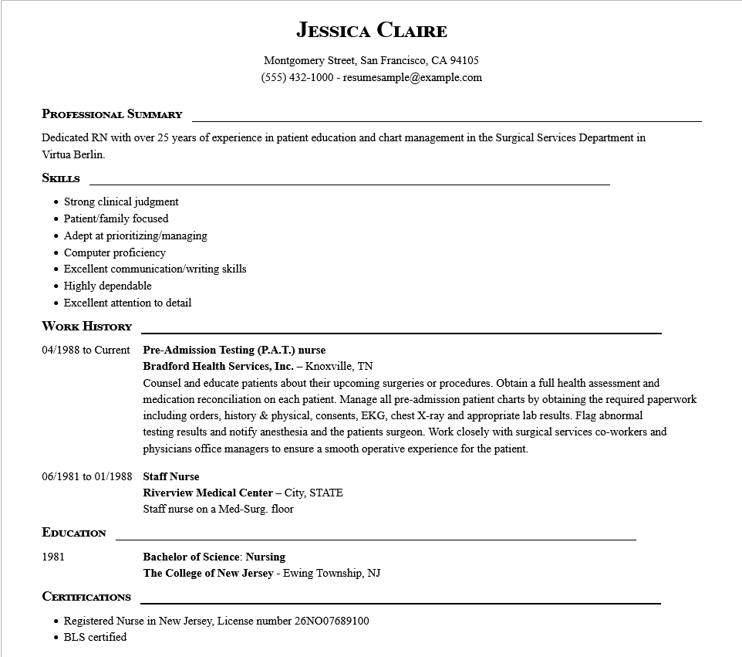

**JESSICA CLAIRE**

Montgomery Street, San Francisco, CA 94105

(555) 432-1000-resumesample@example.com

**PROFESSIONAL SUMMARY**

Dedicated RN with over 25 years of experience in patient education and chart management in the Surgical Services Department in Virtua Berlin.

**SKILLS**

• Strong clinical judgment

• Patient/family focused

• Adept at prioritizing/managing

• Computer proficiency

• Excellent communication/writing skills

• Highly dependable

• Excellent attention to detail

**WORK HISTORY**

**04/1988 to Current Pre-Admission Testing (P.A.T.) nurse**

**Bradford Health Services, Inc. - Knoxville, TN**

Counsel and educate patients about their upcoming surgeries or procedures. Obtain a full health assessment and medication reconciliation on each patient. Manage all pre-admission patient charts by obtaining the required paperwork including orders, history & physical, consents, EKG, chest X-ray and appropriate lab results. Flag abnormal testing results and notify anesthesia and the patients surgeon. Work closely with surgical services co-workers and physicians office managers to ensure a smooth operative experience for the patient.

06/1981 to 01/1988 Staff Nurse

**Riverview Medical Center - City, STATE**

Staff nurse on a Med-Surg. floor

**EDUCATION**

1981

**CERTIFICATIONS**

Bachelor of Science: Nursing

The College of New Jersey - Ewing Township, NJ

Registered Nurse in New Jersey, License number 26NO07689100 • BLS certified