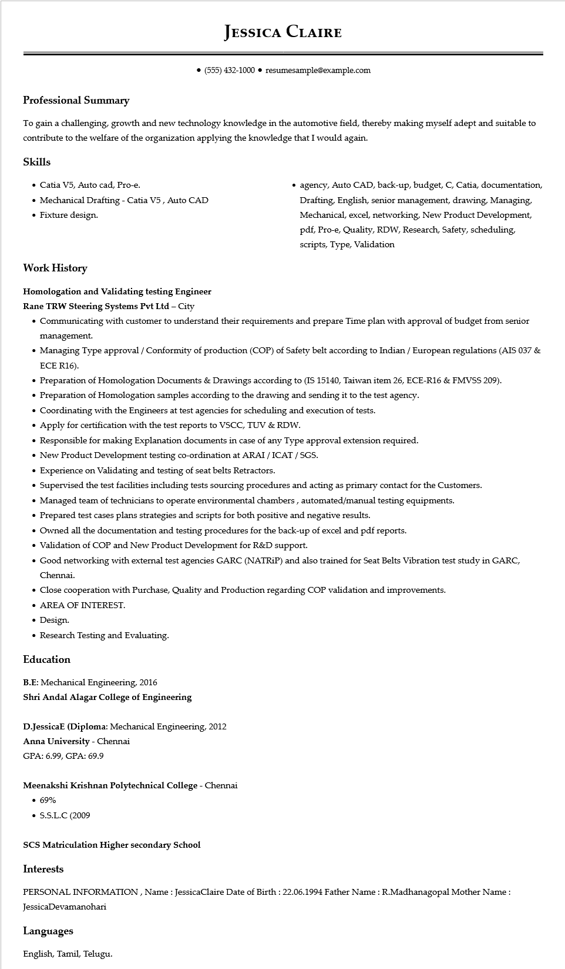

**JESSICA CLAIRE**

⚫ (555) 432-1000 resumesample@example.com

**Professional Summary**

To gain a challenging, growth and new technology knowledge in the automotive field, thereby making myself adept and suitable to contribute to the welfare of the organization applying the knowledge that I would again.

**Skills**

• Catia V5, Auto cad, Pro-e.

• Mechanical Drafting - Catia V5, Auto CAD

• Fixture design.

⚫ agency, Auto CAD, back-up, budget, C, Catia, documentation, Drafting, English, senior management, drawing, Managing, Mechanical, excel, networking, New Product Development, pdf, Pro-e, Quality, RDW, Research, Safety, scheduling, scripts, Type, Validation

**Work History**

**Homologation and Validating testing Engineer**

Rane TRW Steering Systems Pvt Ltd - City

• Communicating with customer to understand their requirements and prepare Time plan with approval of budget from senior management.

• Managing Type approval / Conformity of production (COP) of Safety belt according to Indian / European regulations (AIS 037 & ECE R16).

• Preparation of Homologation Documents & Drawings according to (IS 15140, Taiwan item 26, ECE-R16 & FMVSS 209).

• Preparation of Homologation samples according to the drawing and sending it to the test agency.

• Coordinating with the Engineers at test agencies for scheduling and execution of tests.

• Apply for certification with the test reports to VSCC, TUV & RDW.

• Responsible for making Explanation documents in case of any Type approval extension required.

• New Product Development testing co-ordination at ARAI/ICAT/SGS.

• Experience on Validating and testing of seat belts Retractors.

• Supervised the test facilities including tests sourcing procedures and acting as primary contact for the Customers.

• Managed team of technicians to operate environmental chambers, automated/manual testing equipments.

• Prepared test cases plans strategies and scripts for both positive and negative results.

• Owned all the documentation and testing procedures for the back-up of excel and pdf reports.

• Validation of COP and New Product Development for R&D support.

• Good networking with external test agencies GARC (NATRIP) and also trained for Seat Belts Vibration test study in GARC, Chennai.

• Close cooperation with Purchase, Quality and Production regarding COP validation and improvements.

• AREA OF INTEREST.

• Design.

• Research Testing and Evaluating.

**Education**

B.E: Mechanical Engineering, 2016

**Shri Andal Alagar College of Engineering**

D.JessicaE (Diploma: Mechanical Engineering, 2012

Anna University - Chennai

GPA: 6.99, GPA: 69.9

**Meenakshi Krishnan Polytechnical College - Chennai**

• 69%

• S.S.L.C (2009

**SCS Matriculation Higher secondary School**

**Interests**

PERSONAL INFORMATION, Name: JessicaClaire Date of Birth: 22.06.1994 Father Name: R.Madhanagopal Mother Name: JessicaDevamanohari

**Languages**

English, Tamil, Telugu.