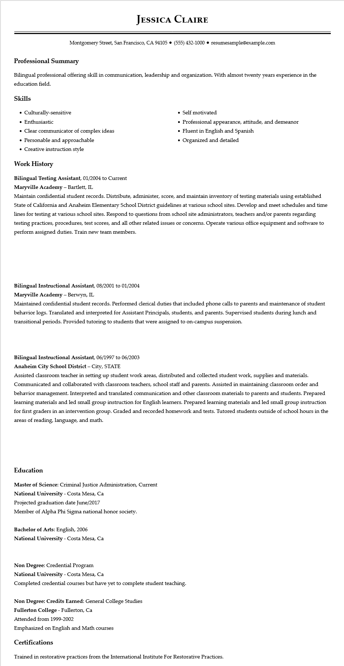

**JESSICA CLAIRE**

Montgomery Street, San Francisco, CA 94105⚫ (555) 432-1000⚫ resumesample@example.com

**Professional Summary**

Bilingual professional offering skill in communication, leadership and organization. With almost twenty years experience in the education field.

**Skills**

• Culturally-sensitive

• Enthusiastic

• Self motivated

• Professional appearance, attitude, and demeanor

• Clear communicator of complex ideas

• Personable and approachable

• Creative instruction style

**Work History**

Bilingual Testing Assistant, 01/2004 to Current Maryville Academy - Bartlett, IL

• Fluent in English and Spanish

• Organized and detailed

Maintain confidential student records. Distribute, administer, score, and maintain inventory of testing materials using established State of California and Anaheim Elementary School District guidelines at various school sites. Develop and meet schedules and time lines for testing at various school sites. Respond to questions from school site administrators, teachers and/or parents regarding testing practices, procedures, test scores, and all other related issues or concerns. Operate various office equipment and software to perform assigned duties. Train new team members.

**Bilingual Instructional Assistant, 08/2001 to 01/2004**

**Maryville Academy - Berwyn, IL**

Maintained confidential student records. Performed clerical duties that included phone calls to parents and maintenance of student behavior logs. Translated and interpreted for Assistant Principals, students, and parents. Supervised students during lunch and transitional periods. Provided tutoring to students that were assigned to on-campus suspension.

**Bilingual Instructional Assistant, 06/1997 to 06/2003**

Anaheim City School District - City, STATE

Assisted classroom teacher in setting up student work areas, distributed and collected student work, supplies and materials. Communicated and collaborated with classroom teachers, school staff and parents. Assisted in maintaining classroom order and behavior management. Interpreted and translated communication and other classroom materials to parents and students. Prepared learning materials and led small group instruction for English learners. Prepared learning materials and led small group instruction for first graders in an intervention group. Graded and recorded homework and tests. Tutored students outside of school hours in the areas of reading, language, and math.

**Education**

Master of Science: Criminal Justice Administration, Current

National University - Costa Mesa, Ca

Projected graduation date June/2017

Member of Alpha Phi Sigma national honor society.

**Bachelor of Arts: English, 2006**

**National University - Costa Mesa, Ca**

Non Degree: Credential Program

National University - Costa Mesa, Ca

Completed credential courses but have yet to complete student teaching.

Non Degree: Credits Earned: General College Studies

**Fullerton College - Fullerton, Ca**

Attended from 1999-2002

Emphasized on English and Math courses

Certifications

Trained in restorative practices from the International Institute For Restorative Practices.