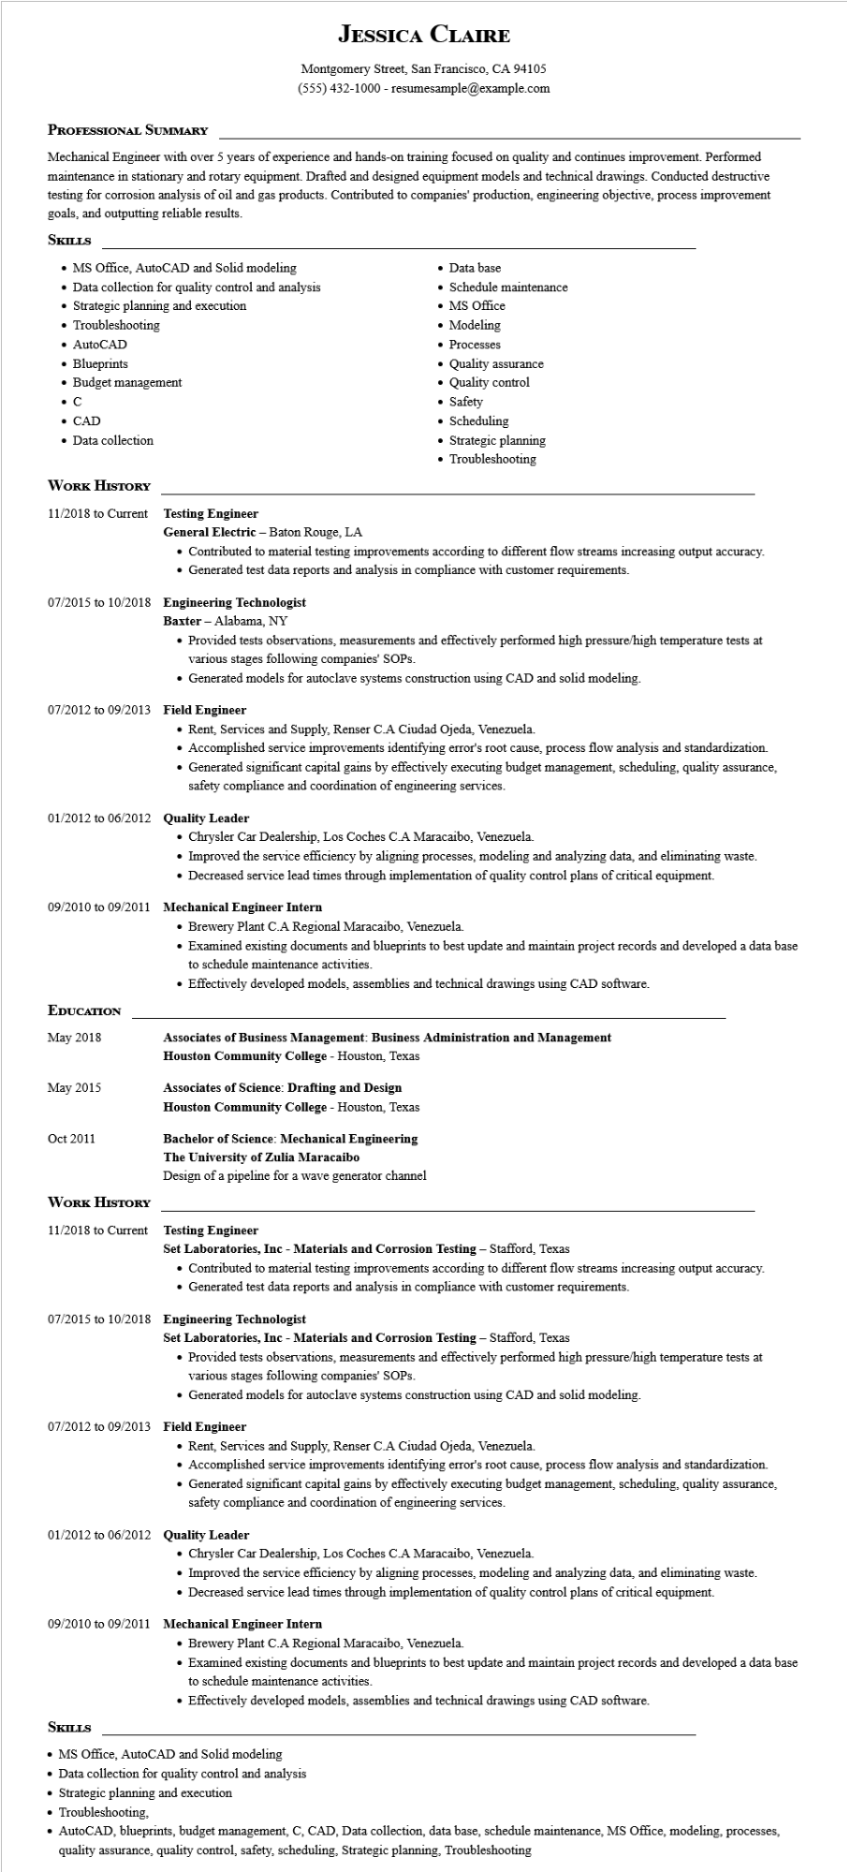

**JESSICA CLAIRE**

Montgomery Street, San Francisco, CA 94105

(555) 432-1000 - resumesample@example.com

**PROFESSIONAL SUMMARY**

Mechanical Engineer with over 5 years of experience and hands-on training focused on quality and continues improvement. Performed maintenance in stationary and rotary equipment. Drafted and designed equipment models and technical drawings. Conducted destructive testing for corrosion analysis of oil and gas products. Contributed to companies' production, engineering objective, process improvement goals, and outputting reliable results.

**SKILLS**

• MS Office, AutoCAD and Solid modeling

• Data collection for quality control and analysis

• Strategic planning and execution

• Troubleshooting

• AutoCAD

• Blueprints

• Budget management

**C**

• CAD

• Data collection

• Data base

• Schedule maintenance

• MS Office

• Modeling

• Processes

Quality assurance

• Quality control

• Safety

• Scheduling

• Strategic planning

• Troubleshooting

**WORK HISTORY**

11/2018 to Current Testing Engineer

**General Electric - Baton Rouge, LA**

• Contributed to material testing improvements according to different flow streams increasing output accuracy. • Generated test data reports and analysis in compliance with customer requirements.

**07/2015 to 10/2018 Engineering Technologist**

Baxter - Alabama, NY

• Provided tests observations, measurements and effectively performed high pressure/high temperature tests at various stages following companies' SOPs.

• Generated models for autoclave systems construction using CAD and solid modeling.

**07/2012 to 09/2013 Field Engineer**

• Rent, Services and Supply, Renser C.A Ciudad Ojeda, Venezuela.

• Accomplished service improvements identifying error's root cause, process flow analysis and standardization.

• Generated significant capital gains by effectively executing budget management, scheduling, quality assurance, safety compliance and coordination of engineering services.

01/2012 to 06/2012 Quality Leader

• Chrysler Car Dealership, Los Coches C.A Maracaibo, Venezuela.

• Improved the service efficiency by aligning processes, modeling and analyzing data, and eliminating waste.

• Decreased service lead times through implementation of quality control plans of critical equipment.

**09/2010 to 09/2011 Mechanical Engineer Intern**

• Brewery Plant C.A Regional Maracaibo, Venezuela.

• Examined existing documents and blueprints to best update and maintain project records and developed a data base to schedule maintenance activities.

• Effectively developed models, assemblies and technical drawings using CAD software.

**EDUCATION**

May 2018

**Associates of Business Management: Business Administration and Management Houston Community College - Houston, Texas**

May 2015

**Associates of Science: Drafting and Design Houston Community College - Houston, Texas**

Oct 2011

**WORK HISTORY**

**Bachelor of Science: Mechanical Engineering The University of Zulia Maracaibo**

Design of a pipeline for a wave generator channel

11/2018 to Current Testing Engineer

**Set Laboratories, Inc - Materials and Corrosion Testing - Stafford, Texas**

• Contributed to material testing improvements according to different flow streams increasing output accuracy.

• Generated test data reports and analysis in compliance with customer requirements.

07/2015 to 10/2018 Engineering Technologist

**Set Laboratories, Inc - Materials and Corrosion Testing - Stafford, Texas**

• Provided tests observations, measurements and effectively performed high pressure/high temperature tests at various stages following companies' SOPs.

• Generated models for autoclave systems construction using CAD and solid modeling.

07/2012 to 09/2013 Field Engineer

• Rent, Services and Supply, Renser C.A Ciudad Ojeda, Venezuela.

• Accomplished service improvements identifying error's root cause, process flow analysis and standardization.

• Generated significant capital gains by effectively executing budget management, scheduling, quality assurance, safety compliance and coordination of engineering services.

01/2012 to 06/2012 Quality Leader

• Chrysler Car Dealership, Los Coches C.A Maracaibo, Venezuela.

• Improved the service efficiency by aligning processes, modeling and analyzing data, and eliminating waste.

• Decreased service lead times through implementation of quality control plans of critical equipment.

**09/2010 to 09/2011 Mechanical Engineer Intern**

• Brewery Plant C.A Regional Maracaibo, Venezuela.

• Examined existing documents and blueprints to best update and maintain project records and developed a data base to schedule maintenance activities.

• Effectively developed models, assemblies and technical drawings using CAD software.

**SKILLS**

• MS Office, AutoCAD and Solid modeling

• Data collection for quality control and analysis

• Strategic planning and execution

• Troubleshooting,

• AutoCAD, blueprints, budget management, C, CAD, Data collection, data base, schedule maintenance, MS Office, modeling, processes, quality assurance, quality control, safety, scheduling, Strategic planning, Troubleshooting