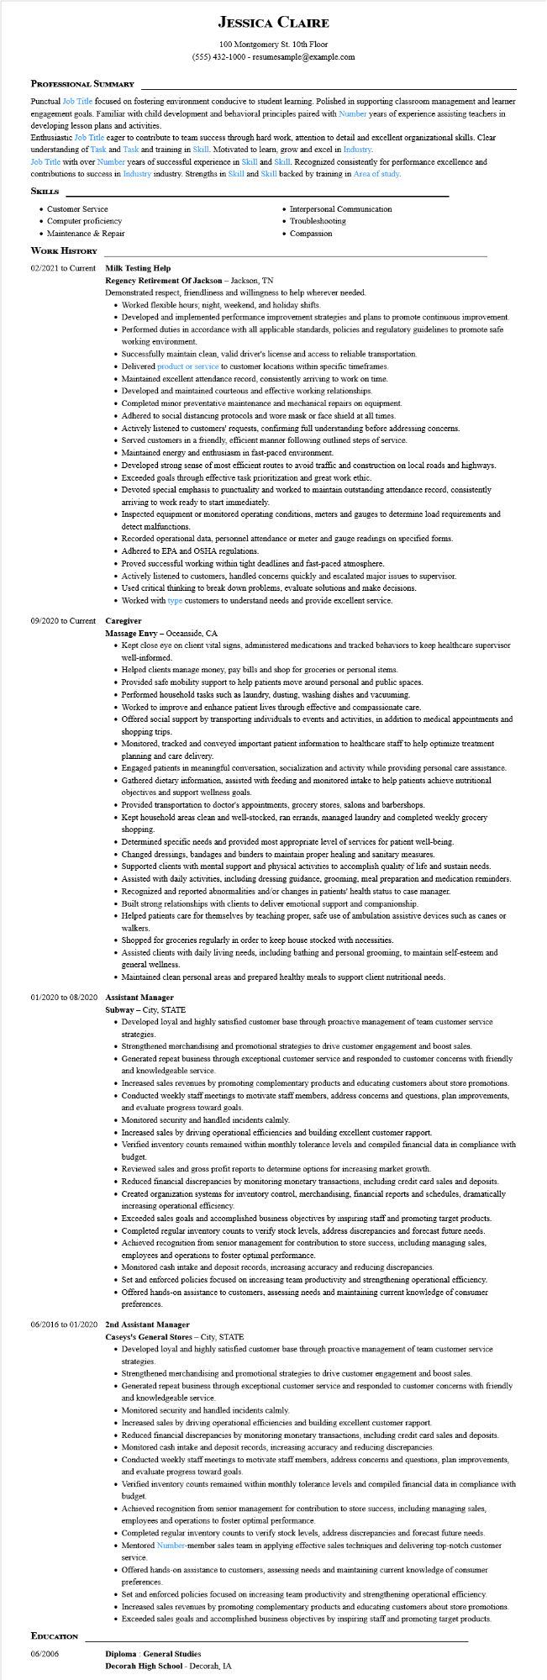

**JESSICA CLAIRE**

100 Montgomery St. 10th Floor (555) 432-1000 - resumesample@example.com

**PROFESSIONAL SUMMARY**

Punctual Job Title focused on fostering environment conducive to student learning. Polished in supporting classroom management and learner engagement goals. Familiar with child development and behavioral principles paired with Number years of experience assisting teachers in developing lesson plans and activities.

Enthusiastic Job Title eager to contribute to team success through hard work, attention to detail and excellent organizational skills. Clear understanding of Task and Task and training in Skill. Motivated to learn, grow and excel in Industry.

Job Title with over Number years of successful experience in Skill and Skill. Recognized consistently for performance excellence and contributions to success in Industry industry. Strengths in Skill and Skill backed by training in Area of study.

**SKILLS**

• Customer Service

• Computer proficiency

• Maintenance & Repair

**WORK HISTORY**

02/2021 to Current Milk Testing Help

**Regency Retirement Of Jackson - Jackson, TN**

• Interpersonal Communication

• Troubleshooting

• Compassion

Demonstrated respect, friendliness and willingness to help wherever needed.

• Worked flexible hours; night, weekend, and holiday shifts.

• Developed and implemented performance improvement strategies and plans to promote continuous improvement.

• Performed duties in accordance with all applicable standards, policies and regulatory guidelines to promote safe working environment.

• Successfully maintain clean, valid driver's license and access to reliable transportation.

• Delivered product or service to customer locations within specific timeframes.

• Maintained excellent attendance record, consistently arriving to work on time.

• Developed and maintained courteous and effective working relationships.

• Completed minor preventative maintenance and mechanical repairs on equipment.

• Adhered to social distancing protocols and wore mask or face shield at all times.

• Actively listened to customers' requests, confirming full understanding before addressing concerns.

• Served customers in a friendly, efficient manner following outlined steps of service.

• Maintained energy and enthusiasm in fast-paced environment.

• Developed strong sense of most efficient routes to avoid traffic and construction on local roads and highways.

• Exceeded goals through effective task prioritization and great work ethic.

• Devoted special emphasis to punctuality and worked to maintain outstanding attendance record, consistently arriving to work ready to start immediately.

• Inspected equipment or monitored operating conditions, meters and gauges to determine load requirements and detect malfunctions.

• Recorded operational data, personnel attendance or meter and gauge readings on specified forms.

• Adhered to EPA and OSHA regulations.

• Proved successful working within tight deadlines and fast-paced atmosphere.

• Actively listened to customers, handled concerns quickly and escalated major issues to supervisor.

• Used critical thinking to break down problems, evaluate solutions and make decisions.

• Worked with type customers to understand needs and provide excellent service.

**09/2020 to Current Caregiver**

**Massage Envy - Oceanside, CA**

• Kept close eye on client vital signs, administered medications and tracked behaviors to keep healthcare supervisor well-informed.

• Helped clients manage money, pay bills and shop for groceries or personal items.

• Provided safe mobility support to help patients move around personal and public spaces.

• Performed household tasks such as laundry, dusting, washing dishes and vacuuming.

• Worked to improve and enhance patient lives through effective and compassionate care.

• Offered social support by transporting individuals to events and activities, in addition to medical appointments and shopping trips.

• Monitored, tracked and conveyed important patient information to healthcare staff to help optimize treatment planning and care delivery.

• Engaged patients in meaningful conversation, socialization and activity while providing personal care assistance.

• Gathered dietary information, assisted with feeding and monitored intake to help patients achieve nutritional objectives and support wellness goals.

• Provided transportation to doctor's appointments, grocery stores, salons and barbershops.

• Kept household areas clean and well-stocked, ran errands, managed laundry and completed weekly grocery shopping.

• Determined specific needs and provided most appropriate level of services for patient well-being.

• Changed dressings, bandages and binders to maintain proper healing and sanitary measures.

• Supported clients with mental support and physical activities to accomplish quality of life and sustain needs.

• Assisted with daily activities, including dressing guidance, grooming, meal preparation and medication reminders.

• Recognized and reported abnormalities and/or changes in patients' health status to case manager.

• Built strong relationships with clients to deliver emotional support and companionship.

• Helped patients care for themselves by teaching proper, safe use of ambulation assistive devices such as canes or walkers.

• Shopped for groceries regularly in order to keep house stocked with necessities.

• Assisted clients with daily living needs, including bathing and personal grooming, to maintain self-esteem and general wellness.

• Maintained clean personal areas and prepared healthy meals to support client nutritional needs.

01/2020 to 08/2020 Assistant Manager

**Subway City, STATE**

• Developed loyal and highly satisfied customer base through proactive management of team customer service strategies.

• Strengthened merchandising and promotional strategies to drive customer engagement and boost sales.

• Generated repeat business through exceptional customer service and responded to customer concerns with friendly and knowledgeable service.

• Increased sales revenues by promoting complementary products and educating customers about store promotions.

• Conducted weekly staff meetings to motivate staff members, address concerns and questions, plan improvements, and evaluate progress toward goals.

• Monitored security and handled incidents calmly.

• Increased sales by driving operational efficiencies and building excellent customer rapport.

• Verified inventory counts remained within monthly tolerance levels and compiled financial data in compliance with budget.

• Reviewed sales and gross profit reports to determine options for increasing market growth.

• Reduced financial discrepancies by monitoring monetary transactions, including credit card sales and deposits.

• Created organization systems for inventory control, merchandising, financial reports and schedules, dramatically increasing operational efficiency.

• Exceeded sales goals and accomplished business objectives by inspiring staff and promoting target products.

• Completed regular inventory counts to verify stock levels, address discrepancies and forecast future needs.

• Achieved recognition from senior management for contribution to store success, including managing sales, employees and operations to foster optimal performance.

• Monitored cash intake and deposit records, increasing accuracy and reducing discrepancies.

• Set and enforced policies focused on increasing team productivity and strengthening operational efficiency.

• Offered hands-on assistance to customers, assessing needs and maintaining current knowledge of consumer preferences.

06/2016 to 01/2020 2nd Assistant Manager

**EDUCATION**

06/2006

**Caseys's General Stores - City, STATE**

• Developed loyal and highly satisfied customer base through proactive management of team customer service strategies.

• Strengthened merchandising and promotional strategies to drive customer engagement and boost sales.

• Generated repeat business through exceptional customer service and responded to customer concerns with friendly and knowledgeable service.

• Monitored security and handled incidents calmly.

• Increased sales by driving operational efficiencies and building excellent customer rapport.

• Reduced financial discrepancies by monitoring monetary transactions, including credit card sales and deposits.

• Monitored cash intake and deposit records, increasing accuracy and reducing discrepancies.

• Conducted weekly staff meetings to motivate staff members, address concerns and questions, plan improvements, and evaluate progress toward goals.

• Verified inventory counts remained within monthly tolerance levels and compiled financial data in compliance with budget.

• Achieved recognition from senior management for contribution to store success, including managing sales, employees and operations to foster optimal performance.

• Completed regular inventory counts to verify stock levels, address discrepancies and forecast future needs.

• Mentored Number-member sales team in applying effective sales techniques and delivering top-notch customer

service.

• Offered hands-on assistance to customers, assessing needs and maintaining current knowledge of consumer

preferences.

• Set and enforced policies focused on increasing team productivity and strengthening operational efficiency.

• Increased sales revenues by promoting complementary products and educating customers about store promotions.

• Exceeded sales goals and accomplished business objectives by inspiring staff and promoting target products.

**Diploma: General Studies**

**Decorah High School - Decorah, IA**