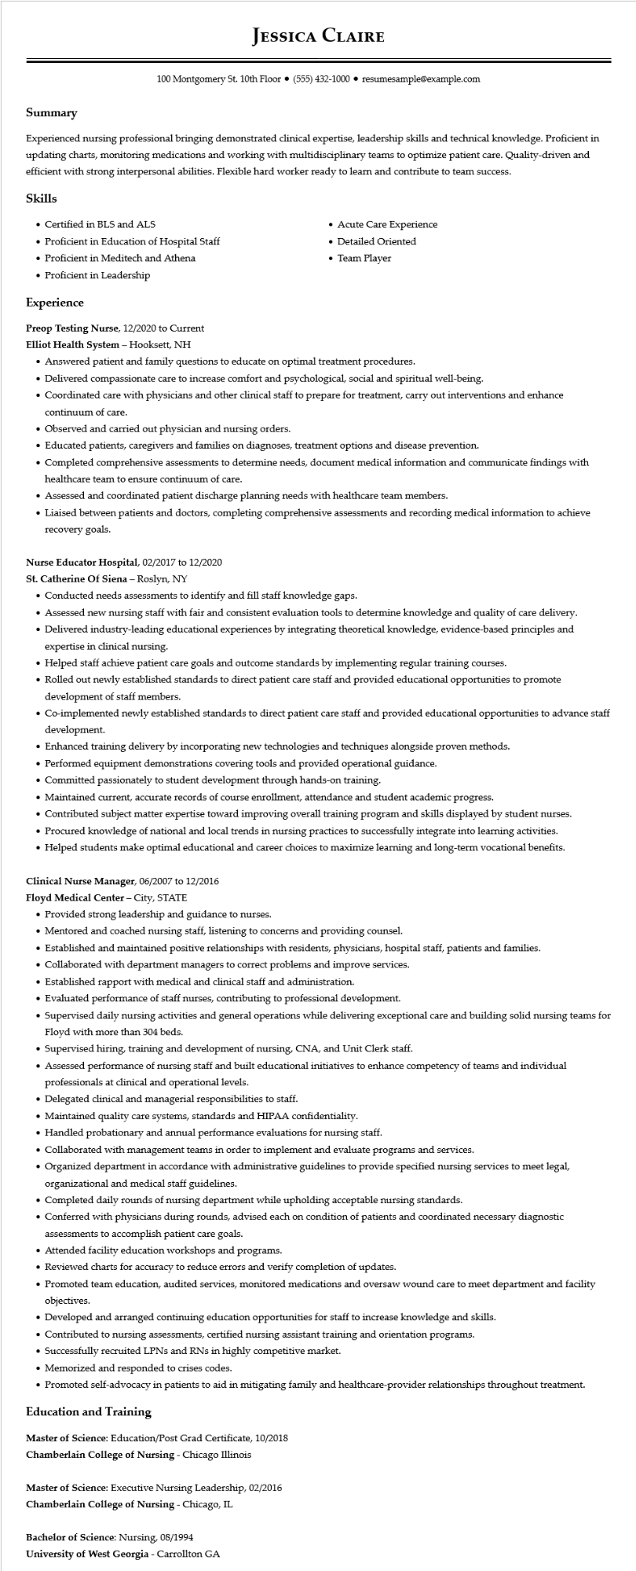

**JESSICA CLAIRE**

100 Montgomery St. 10th Floor (555) 432-1000⚫ resumesample@example.com

**Summary**

Experienced nursing professional bringing demonstrated clinical expertise, leadership skills and technical knowledge. Proficient in updating charts, monitoring medications and working with multidisciplinary teams to optimize patient care. Quality-driven and efficient with strong interpersonal abilities. Flexible hard worker ready to learn and contribute to team success.

**Skills**

• Certified in BLS and ALS

• Proficient in Education of Hospital Staff

• Proficient in Meditech and Athena

• Proficient in Leadership

**Experience**

Preop Testing Nurse, 12/2020 to Current

**Elliot Health System - Hooksett, NH**

• Acute Care Experience

• Team Player

• Detailed Oriented

• Answered patient and family questions to educate on optimal treatment procedures.

• Delivered compassionate care to increase comfort and psychological, social and spiritual well-being.

• Coordinated care with physicians and other clinical staff to prepare for treatment, carry out interventions and enhance continuum of care.

• Observed and carried out physician and nursing orders.

• Educated patients, caregivers and families on diagnoses, treatment options and disease prevention.

• Completed comprehensive assessments to determine needs, document medical information and communicate findings with healthcare team to ensure continuum of care.

• Assessed and coordinated patient discharge planning needs with healthcare team members.

• Liaised between patients and doctors, completing comprehensive assessments and recording medical information to achieve recovery goals.

**Nurse Educator Hospital, 02/2017 to 12/2020**

St. Catherine Of Siena - Roslyn, NY

• Conducted needs assessments to identify and fill staff knowledge gaps.

• Assessed new nursing staff with fair and consistent evaluation tools to determine knowledge and quality of care delivery.

• Delivered industry-leading educational experiences by integrating theoretical knowledge, evidence-based principles and expertise in clinical nursing.

• Helped staff achieve patient care goals and outcome standards by implementing regular training courses.

• Rolled out newly established standards to direct patient care staff and provided educational opportunities to promote development of staff members.

• Co-implemented newly established standards to direct patient care staff and provided educational opportunities to advance staff development.

• Enhanced training delivery by incorporating new technologies and techniques alongside proven methods.

• Performed equipment demonstrations covering tools and provided operational guidance.

• Committed passionately to student development through hands-on training.

• Maintained current, accurate records of course enrollment, attendance and student academic progress.

• Contributed subject matter expertise toward improving overall training program and skills displayed by student nurses.

• Procured knowledge of national and local trends in nursing practices to successfully integrate into learning activities.

• Helped students make optimal educational and career choices to maximize learning and long-term vocational benefits.

Clinical Nurse Manager, 06/2007 to 12/2016

**Floyd Medical Center - City, STATE**

• Provided strong leadership and guidance to nurses.

• Mentored and coached nursing staff, listening to concerns and providing counsel.

• Established and maintained positive relationships with residents, physicians, hospital staff, patients and families.

• Collaborated with department managers to correct problems and improve services.

• Established rapport with medical and clinical staff and administration.

• Evaluated performance of staff nurses, contributing to professional development.

•

Supervised daily nursing activities and general operations while delivering exceptional care and building solid nursing teams for Floyd with more than 304 beds.

• Supervised hiring, training and development of nursing, CNA, and Unit Clerk staff.

• Assessed performance of nursing staff and built educational initiatives to enhance competency of teams and individual professionals at clinical and operational levels.

• Delegated clinical and managerial responsibilities to staff.

• Maintained quality care systems, standards and HIPAA confidentiality.

• Handled probationary and annual performance evaluations for nursing staff.

• Collaborated with management teams in order to implement and evaluate programs and services.

• Organized department in accordance with administrative guidelines to provide specified nursing services to meet legal, organizational and medical staff guidelines.

• Completed daily rounds of nursing department while upholding acceptable nursing standards.

• Conferred with physicians during rounds, advised each on condition of patients and coordinated necessary diagnostic assessments to accomplish patient care goals.

• Attended facility education workshops and programs.

• Reviewed charts for accuracy to reduce errors and verify completion of updates.

• Promoted team education, audited services, monitored medications and oversaw wound care to meet department and facility objectives.

• Developed and arranged continuing education opportunities for staff to increase knowledge and skills.

• Contributed to nursing assessments, certified nursing assistant training and orientation programs.

• Successfully recruited LPNs and RNs in highly competitive market.

• Memorized and responded to crises codes.

• Promoted self-advocacy in patients to aid in mitigating family and healthcare-provider relationships throughout treatment.

**Education and Training**

Master of Science: Education/Post Grad Certificate, 10/2018

**Chamberlain College of Nursing - Chicago Illinois**

Master of Science: Executive Nursing Leadership, 02/2016

**Chamberlain College of Nursing - Chicago, IL**

Bachelor of Science: Nursing, 08/1994

University of West Georgia - Carrollton GA