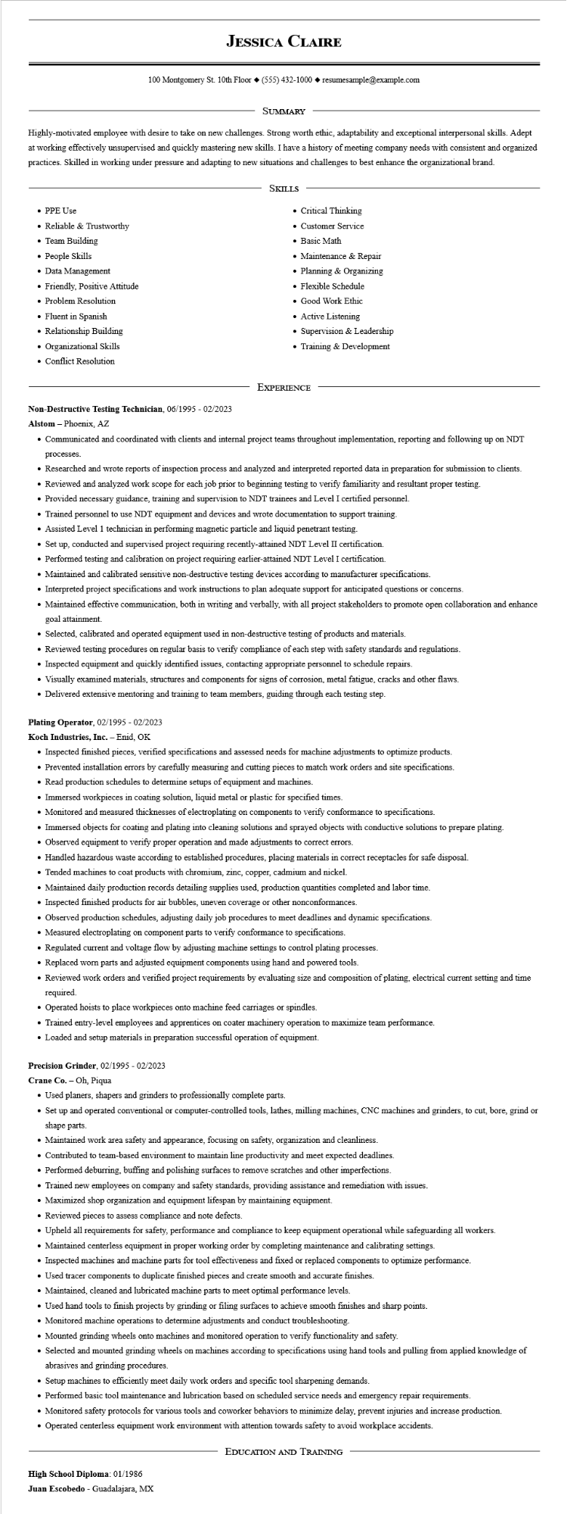

**JESSICA CLAIRE**

100 Montgomery St. 10th Floor (555) 432-1000◆ resumesample@example.com

SUMMARY

Highly-motivated employee with desire to take on new challenges. Strong worth ethic, adaptability and exceptional interpersonal skills. Adept at working effectively unsupervised and quickly mastering new skills. I have a history of meeting company needs with consistent and organized practices. Skilled in working under pressure and adapting to new situations and challenges to best enhance the organizational brand.

SKILLS

• Critical Thinking

• PPE Use

• Reliable & Trustworthy

• Team Building

• People Skills

• Data Management

• Friendly, Positive Attitude

• Problem Resolution

• Fluent in Spanish

• Relationship Building

• Organizational Skills

• Conflict Resolution

• Customer Service

• Basic Math

• Maintenance & Repair

• Planning & Organizing

• Flexible Schedule

• Good Work Ethic

• Active Listening

• Supervision & Leadership

•

Training & Development

EXPERIENCE

**Non-Destructive Testing Technician, 06/1995 - 02/2023**

Alstom - Phoenix, AZ

• Communicated and coordinated with clients and internal project teams throughout implementation, reporting and following up on NDT processes.

• Researched and wrote reports of inspection process and analyzed and interpreted reported data in preparation for submission to clients.

• Reviewed and analyzed work scope for each job prior to beginning testing to verify familiarity and resultant proper testing.

• Provided necessary guidance, training and supervision to NDT trainees and Level I certified personnel.

• Trained personnel to use NDT equipment and devices and wrote documentation to support training.

• Assisted Level 1 technician in performing magnetic particle and liquid penetrant testing.

• Set up, conducted and supervised project requiring recently-attained NDT Level II certification.

• Performed testing and calibration on project requiring earlier-attained NDT Level I certification.

• Maintained and calibrated sensitive non-destructive testing devices according to manufacturer specifications.

• Interpreted project specifications and work instructions to plan adequate support for anticipated questions or concerns.

• Maintained effective communication, both in writing and verbally, with all project stakeholders to promote open collaboration and enhance goal attainment.

• Selected, calibrated and operated equipment used in non-destructive testing of products and materials.

• Reviewed testing procedures on regular basis to verify compliance of each step with safety standards and regulations.

• Inspected equipment and quickly identified issues, contacting appropriate personnel to schedule repairs.

• Visually examined materials, structures and components for signs of corrosion, metal fatigue, cracks and other flaws.

• Delivered extensive mentoring and training to team members, guiding through each testing step.

**Plating Operator, 02/1995 - 02/2023**

**Koch Industries, Inc. - Enid, OK**

• Inspected finished pieces, verified specifications and assessed needs for machine adjustments to optimize products.

• Prevented installation errors by carefully measuring and cutting pieces to match work orders and site specifications.

• Read production schedules to determine setups of equipment and machines.

• Immersed workpieces in coating solution, liquid metal or plastic for specified times.

• Monitored and measured thicknesses of electroplating on components to verify conformance to specifications.

• Immersed objects for coating and plating into cleaning solutions and sprayed objects with conductive solutions to prepare plating.

• Observed equipment to verify proper operation and made adjustments to correct errors.

• Handled hazardous waste according to established procedures, placing materials in correct receptacles for safe disposal.

• Tended machines to coat products with chromium, zinc, copper, cadmium and nickel.

• Maintained daily production records detailing supplies used, production quantities completed and labor time.

• Inspected finished products for air bubbles, uneven coverage or other nonconformances.

• Observed production schedules, adjusting daily job procedures to meet deadlines and dynamic specifications.

• Measured electroplating on component parts to verify conformance to specifications.

• Regulated current and voltage flow by adjusting machine settings to control plating processes.

• Replaced worn parts and adjusted equipment components using hand and powered tools.

• Reviewed work orders and verified project requirements by evaluating size and composition of plating, electrical current setting and time required.

• Operated hoists to place workpieces onto machine feed carriages or spindles.

• Trained entry-level employees and apprentices on coater machinery operation to maximize team performance.

• Loaded and setup materials in preparation successful operation of equipment.

**Precision Grinder, 02/1995 - 02/2023**

**Crane Co. - Oh, Piqua**

• Used planers, shapers and grinders to professionally complete parts.

• Set up and operated conventional or computer-controlled tools, lathes, milling machines, CNC machines and grinders, to cut, bore, grind or shape parts.

• Maintained work area safety and appearance, focusing on safety, organization and cleanliness.

• Contributed to team-based environment to maintain line productivity and meet expected deadlines.

• Performed deburring, buffing and polishing surfaces to remove scratches and other imperfections.

• Trained new employees on company and safety standards, providing assistance and remediation with issues.

• Maximized shop organization and equipment lifespan by maintaining equipment.

• Reviewed pieces to assess compliance and note defects.

• Upheld all requirements for safety, performance and compliance to keep equipment operational while safeguarding all workers.

• Maintained centerless equipment in proper working order by completing maintenance and calibrating settings.

• Inspected machines and machine parts for tool effectiveness and fixed or replaced components to optimize performance.

• Used tracer components to duplicate finished pieces and create smooth and accurate finishes.

• Maintained, cleaned and lubricated machine parts to meet optimal performance levels.

• Used hand tools to finish projects by grinding or filing surfaces to achieve smooth finishes and sharp points.

• Monitored machine operations to determine adjustments and conduct troubleshooting.

• Mounted grinding wheels onto machines and monitored operation to verify functionality and safety.

• Selected and mounted grinding wheels on machines according to specifications using hand tools and pulling from applied knowledge of abrasives and grinding procedures.

• Setup machines to efficiently meet daily work orders and specific tool sharpening demands.

• Performed basic tool maintenance and lubrication based on scheduled service needs and emergency repair requirements.

• Monitored safety protocols for various tools and coworker behaviors to minimize delay, prevent injuries and increase production.

• Operated centerless equipment work environment with attention towards safety to avoid workplace accidents.

EDUCATION AND TRAINING

**High School Diploma: 01/1986 Juan Escobedo - Guadalajara, MX**