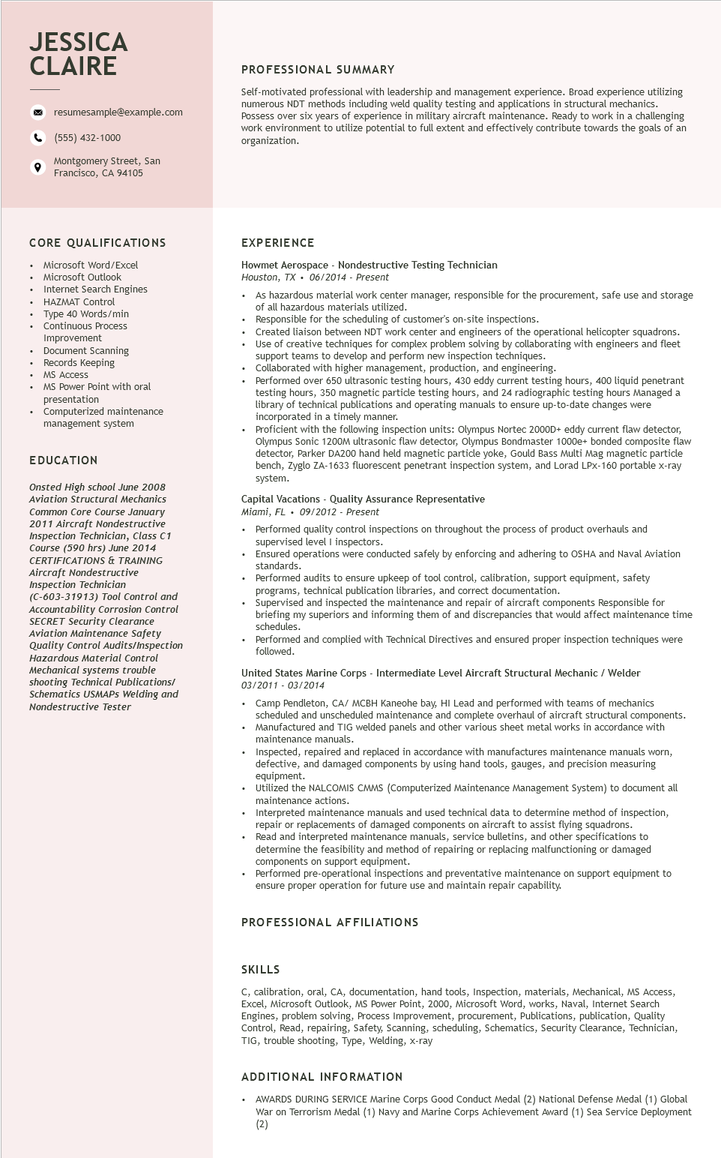

**JESSICA CLAIRE**

9

resumesample@example.com

(555) 432-1000

Montgomery Street, San

Francisco, CA 94105

**PROFESSIONAL SUMMARY**

Self-motivated professional with leadership and management experience. Broad experience utilizing numerous NDT methods including weld quality testing and applications in structural mechanics. Possess over six years of experience in military aircraft maintenance. Ready to work in a challenging work environment to utilize potential to full extent and effectively contribute towards the goals of an organization.

**CORE QUALIFICATIONS**

.

Microsoft Word/Excel Microsoft Outlook

Internet Search Engines HAZMAT Control

Type 40 Words/min Continuous Process Improvement Document Scanning Records Keeping

MS Access

MS Power Point with oral

presentation

Computerized maintenance

management system

**EDUCATION**

*Onsted High school June 2008 Aviation Structural Mechanics Common Core Course January 2011 Aircraft Nondestructive Inspection Technician, Class C1 Course (590 hrs) June 2014 CERTIFICATIONS & TRAINING Aircraft Nondestructive Inspection Technician*

(C-603-31913) Tool Control and

Accountability Corrosion Control Accountability Corros.

SECRET Security Clearanc SECRET Security Clearance Aviation Maintenance Safety

*Quality Control Audits/Inspection*

*Hazardous Material Control*

*Mechanical systems trouble*

*shooting Technical Publications/*

*Schematics USMAPS Welding and Nondestructive Tester*

EXPERIENCE

Howmet Aerospace - Nondestructive Testing Technician

Houston, TX. 06/2014 - Present

.

As hazardous material work center manager, responsible for the procurement, safe use and storage of all hazardous materials utilized.

• Responsible for the scheduling of customer's on-site inspections.

Created liaison between NDT work center and engineers of the operational helicopter squadrons. Use of creative techniques for complex problem solving by collaborating with engineers and fleet support teams to develop and perform new inspection techniques. Collaborated with higher management, production, and engineering.

Dorfor

Performed over 650 ultrasonic testing hours, 430 eddy current testing hours, 400 liquid penetrant testing hours, 350 magnetic particle testing hours, and 24 radiographic testing hours Managed a Horary

library of technical publications and operating manuals to ensure up-to-date changes were

incorporated in a timely manner.

Proficient with the following inspection units: Olympus Nortec 2000D+ eddy current flaw detector, Olympus Sonic 1200M ultrasonic flaw detector, Olympus Bondmaster 1000e+ bonded composite flaw detector, Parker DA200 hand held magnetic particle yoke, Gould Bass Multi Mag magnetic particle bench, Zyglo ZA-1633 fluorescent penetrant inspection system, and Lorad LPX-160 portable x-ray system.

Capital Vacations - Quality Assurance Representative

*Miami, FL. 09/2012 - Present*

•

Performed quality control inspections on throughout the process of product overhauls and supervised level I inspectors.

Ensured operations were conducted safely by enforcing and adhering to OSHA and Naval Aviation standards.

Performed audits to ensure upkeep of tool control, calibration, support equipment, safety programs, technical publication libraries, and correct documentation.

• Supervised and inspected the maintenance and repair of aircraft components Responsible for briefing my superiors and informing them of and discrepancies that would affect maintenance time schedules.

• Performed and complied with Technical Directives and ensured proper inspection techniques were followed.

United States Marine Corps - Intermediate Level Aircraft Structural Mechanic / Welder 03/2011-03/2014

•

Camp Pendleton, CA/ MCBH Kaneohe bay, HI Lead and performed with teams of mechanics scheduled and unscheduled maintenance and complete overhaul of aircraft structural components. Manufactured and TIG welded panels and other various sheet metal works in accordance with maintenance manuals.

Inspected, repaired and replaced in accordance with manufactures maintenance manuals worn, defective, and damaged components by using hand tools, gauges, and precision measuring equipment.

. Utilized the NALCOMIS CMMS (Computerized Maintenance Management System) to document all maintenance actions.

Interpreted maintenance manuals and used technical data to determine method of inspection, repair or replacements of damaged components on aircraft to assist flying squadrons. Read and interpreted maintenance manuals, service bulletins, and other specifications to determine the feasibility and method of repairing or replacing malfunctioning or damaged components on support equipment.

Performed pre-operational inspections and preventative maintenance on support equipment to ensure proper operation for future use and maintain repair capability.

**PROFESSIONAL AFFILIATIONS**

SKILLS

C, calibration, oral, CA, documentation, hand tools, Inspection, materials, Mechanical, MS Access, Excel, Microsoft Outlook, MS Power Point, 2000, Microsoft Word, works, Naval, Internet Search Engines, problem solving, Process Improvement, procurement, Publications, publication, Quality Control, Read, repairing, Safety, Scanning, scheduling, Schematics, Security Clearance, Technician, TIG, trouble shooting, Type, Welding, x-ray

ADDITIONAL INFORMATION

•

AWARDS DURING SERVICE Marine Corps Good Conduct Medal (2) National Defense Medal (1) Global War on Terrorism Medal (1) Navy and Marine Corps Achievement Award (1) Sea Service Deployment

(2)