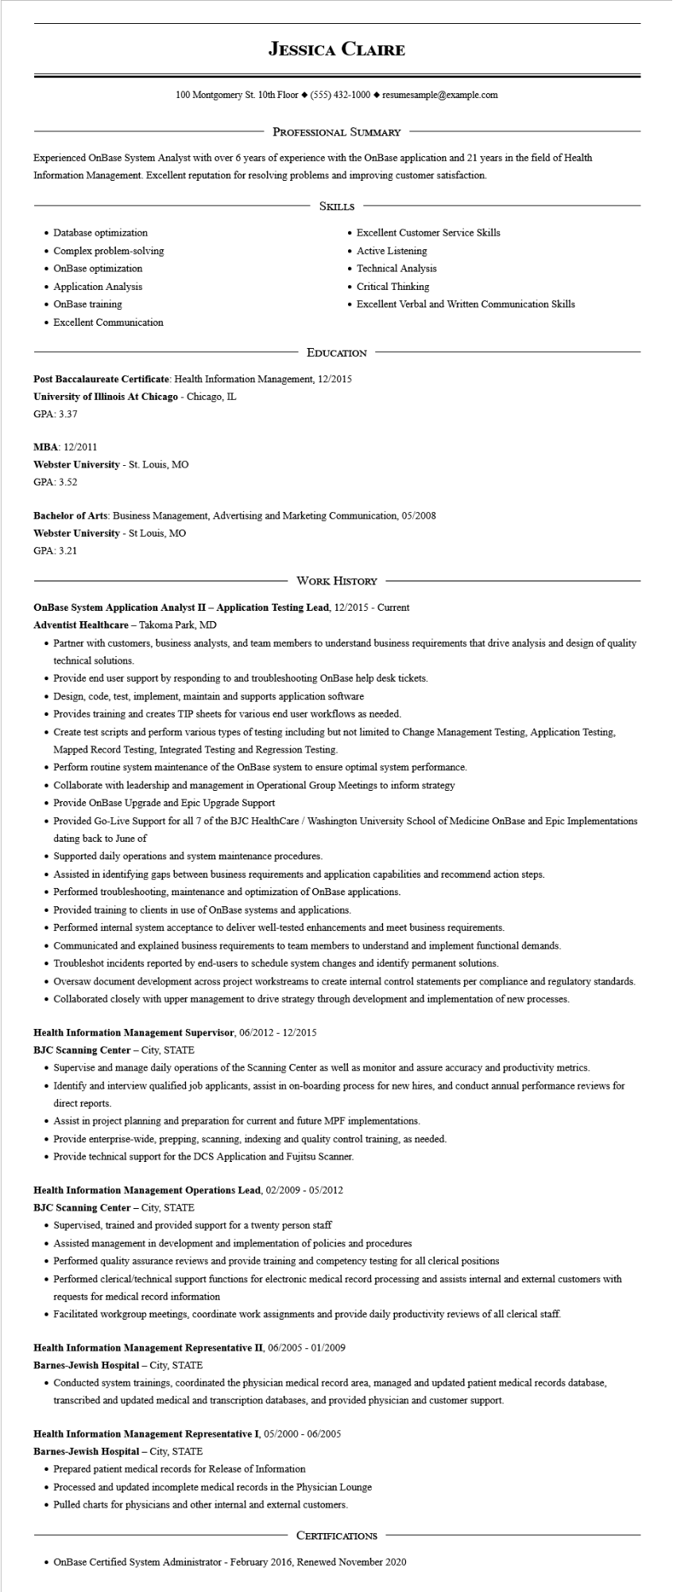

**JESSICA CLAIRE**

100 Montgomery St. 10th Floor (555) 432-1000◆ resumesample@example.com

PROFESSIONAL SUMMARY

Experienced OnBase System Analyst with over 6 years of experience with the OnBase application and 21 years in the field of Health Information Management. Excellent reputation for resolving problems and improving customer satisfaction.

• Database optimization

• Complex problem-solving

• OnBase optimization

• Application Analysis

• OnBase training

• Excellent Communication

SKILLS

• Excellent Customer Service Skills

• Active Listening

• Technical Analysis

• Critical Thinking

• Excellent Verbal and Written Communication Skills

EDUCATION

Post Baccalaureate Certificate: Health Information Management, 12/2015

**University of Illinois At Chicago - Chicago, IL**

GPA: 3.37

MBA: 12/2011

**Webster University - St. Louis, MO**

GPA: 3.52

Bachelor of Arts: Business Management, Advertising and Marketing Communication, 05/2008 Webster University - St Louis, MO

GPA: 3.21

WORK HISTORY

**OnBase System Application Analyst II - Application Testing Lead, 12/2015 - Current**

**Adventist Healthcare - Takoma Park, MD**

• Partner with customers, business analysts, and team members to understand business requirements that drive analysis and design of quality technical solutions.

• Provide end user support by responding to and troubleshooting OnBase help desk tickets.

• Design, code, test, implement, maintain and supports application software

• Provides training and creates TIP sheets for various end user workflows as needed.

• Create test scripts and perform various types of testing including but not limited to Change Management Testing, Application Testing, Mapped Record Testing, Integrated Testing and Regression Testing.

• Perform routine system maintenance of the OnBase system to ensure optimal system performance.

• Collaborate with leadership and management in Operational Group Meetings to inform strategy

• Provide OnBase Upgrade and Epic Upgrade Support

• Provided Go-Live Support for all 7 of the BJC HealthCare / Washington University School of Medicine OnBase and Epic Implementations dating back to June of

• Supported daily operations and system maintenance procedures.

• Assisted in identifying gaps between business requirements and application capabilities and recommend action steps.

• Performed troubleshooting, maintenance and optimization of OnBase applications.

• Provided training to clients in use of OnBase systems and applications.

• Performed internal system acceptance to deliver well-tested enhancements and meet business requirements.

• Communicated and explained business requirements to team members to understand and implement functional demands.

• Troubleshot incidents reported by end-users to schedule system changes and identify permanent solutions.

• Oversaw document development across project workstreams to create internal control statements per compliance and regulatory standards.

• Collaborated closely with upper management to drive strategy through development and implementation of new processes.

**Health Information Management Supervisor, 06/2012 - 12/2015**

**BJC Scanning Center - City, STATE**

• Supervise and manage daily operations of the Scanning Center as well as monitor and assure accuracy and productivity metrics.

• Identify and interview qualified job applicants, assist in on-boarding process for new hires, and conduct annual performance reviews for direct reports.

• Assist in project planning and preparation for current and future MPF implementations.

• Provide enterprise-wide, prepping, scanning, indexing and quality control training, as needed.

• Provide technical support for the DCS Application and Fujitsu Scanner.

**Health Information Management Operations Lead, 02/2009 - 05/2012**

**BJC Scanning Center - City, STATE**

Supervised, trained and provided support for a twenty person staff

• Assisted management in development and implementation of policies and procedures

• Performed quality assurance reviews and provide training and competency testing for all clerical positions

• Performed clerical/technical support functions for electronic medical record processing and assists internal and external customers with requests for medical record information

• Facilitated workgroup meetings, coordinate work assignments and provide daily productivity reviews of all clerical staff.

**Health Information Management Representative II, 06/2005 - 01/2009**

Barnes-Jewish Hospital - City, STATE

• Conducted system trainings, coordinated the physician medical record area, managed and updated patient medical records database, transcribed and updated medical and transcription databases, and provided physician and customer support.

**Health Information Management Representative I, 05/2000 - 06/2005**

**Barnes-Jewish Hospital - City, STATE**

• Prepared patient medical records for Release of Information

• Processed and updated incomplete medical records in the Physician Lounge

• Pulled charts for physicians and other internal and external customers.

CERTIFICATIONS

• OnBase Certified System Administrator - February 2016, Renewed November 2020