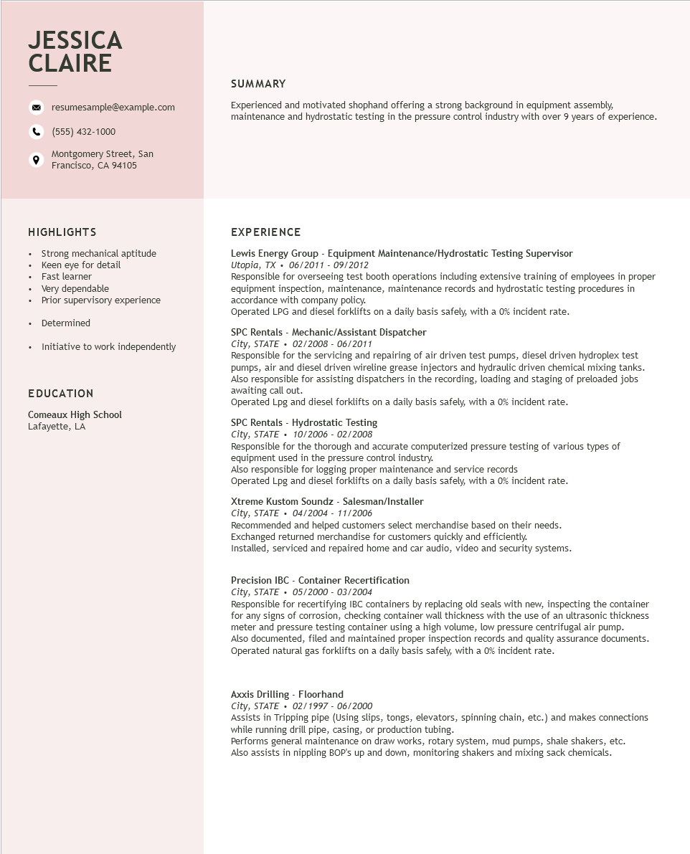

**JESSICA CLAIRE**

resumesample@example.com

(555) 432-1000

Montgomery Street, San Francisco, CA 94105

**SUMMARY**

Experienced and motivated shophand offering a strong background in equipment assembly, maintenance and hydrostatic testing in the pressure control industry with over 9 years of experience.

**HIGHLIGHTS**

Strong mechanical aptitude

·

•

Keen eye for detail

·

Fast learner

·

Very dependable

•

Prior supervisory experience

• Determined

• Initiative to work independently

**EDUCATION**

Comeaux High School Lafayette, LA

EXPERIENCE

Lewis Energy Group - Equipment Maintenance/Hydrostatic Testing Supervisor Utopia, TX. 06/2011- 09/2012

Responsible for overseeing test booth operations including extensive training of employees in proper equipment inspection, maintenance, maintenance records and hydrostatic testing procedures in accordance with company policy.

Operated LPG and diesel forklifts on a daily basis safely, with a 0% incident rate.

SPC Rentals - Mechanic/Assistant Dispatcher

*City, STATE⚫ 02/2008 - 06/2011*

Responsible for the servicing and repairing of air driven test pumps, diesel driven hydroplex test pumps, air and diesel driven wireline grease injectors and hydraulic driven chemical mixing tanks. Also responsible for assisting dispatchers in the recording, loading and staging of preloaded jobs awaiting call out.

Operated Lpg and diesel forklifts on a daily basis safely, with a 0% incident rate.

SPC Rentals - Hydrostatic Testing

City, STATE 10/2006 - 02/2008

·

Responsible for the thorough and accurate computerized pressure testing of various types of equipment used in the pressure control industry.

Also responsible for logging proper maintenance and service records

Operated Lpg and diesel forklifts on a daily basis safely, with a 0% incident rate.

Xtreme Kustom Soundz - Salesman/Installer

*City, STATE⚫ 04/2004 - 11/2006*

Recommended and helped customers select merchandise based on their needs.

Exchanged returned merchandise for customers quickly and efficiently.

Installed, serviced and repaired home and car audio, video and security systems.

Precision IBC - Container Recertification

*City, STATE 05/2000 - 03/2004*

Responsible for recertifying IBC containers by replacing old seals with new, inspecting the container for any signs of corrosion, checking container wall thickness with the use of an ultrasonic thickness meter and pressure testing container using a high volume, low pressure centrifugal air pump. Also documented, filed and maintained proper inspection records and quality assurance documents. Operated natural gas forklifts on a daily basis safely, with a 0% incident rate.

Axxis Drilling - Floorhand

*City, STATE*

02/1997 - 06/2000

Assists in Tripping pipe (Using slips, tongs, elevators, spinning chain, etc.) and makes connections while running drill pipe, casing, or production tubing.

Performs general maintenance on draw works, rotary system, mud pumps, shale shakers, etc. Also assists in nippling BOP's up and down, monitoring shakers and mixing sack chemicals.