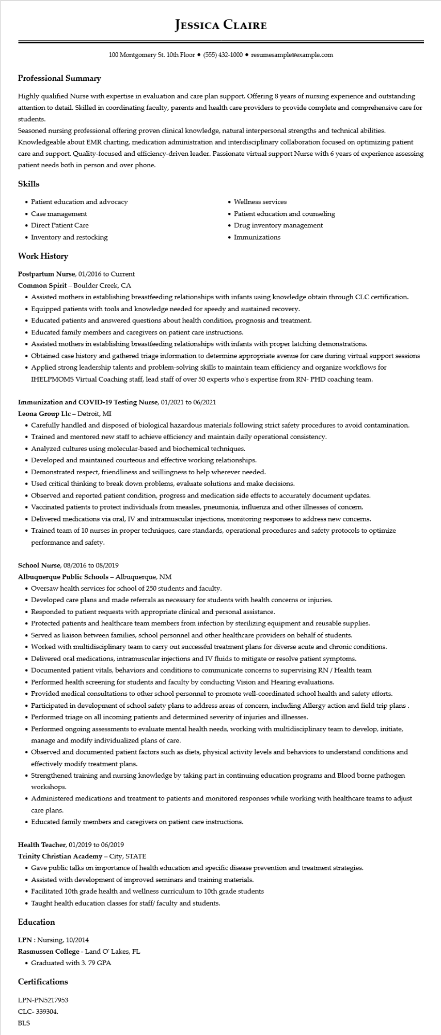

**Professional Summary**

**JESSICA CLAIRE**

100 Montgomery St. 10th Floor⚫ (555) 432-1000⚫ resumesample@example.com

Highly qualified Nurse with expertise in evaluation and care plan support. Offering 8 years of nursing experience and outstanding attention to detail. Skilled in coordinating faculty, parents and health care providers to provide complete and comprehensive care for students.

Seasoned nursing professional offering proven clinical knowledge, natural interpersonal strengths and technical abilities. Knowledgeable about EMR charting, medication administration and interdisciplinary collaboration focused on optimizing patient care and support. Quality-focused and efficiency-driven leader. Passionate virtual support Nurse with 6 years of experience assessing patient needs both in person and over phone.

Skills

• Patient education and advocacy

• Case management

• Direct Patient Care

• Inventory and restocking

**Work History**

Postpartum Nurse, 01/2016 to Current

Common Spirit - Boulder Creek, CA

• Wellness services

• Patient education and counseling

• Drug inventory management • Immunizations

• Assisted mothers in establishing breastfeeding relationships with infants using knowledge obtain through CLC certification.

• Equipped patients with tools and knowledge needed for speedy and sustained recovery.

• Educated patients and answered questions about health condition, prognosis and treatment.

• Educated family members and caregivers on patient care instructions.

• Assisted mothers in establishing breastfeeding relationships with infants with proper latching demonstrations.

• Obtained case history and gathered triage information to determine appropriate avenue for care during virtual support sessions Applied strong leadership talents and problem-solving skills to maintain team efficiency and organize workflows for

·

IHELPMOMS Virtual Coaching staff, lead staff of over 50 experts who's expertise from RN- PHD coaching team.

**Immunization and COVID-19 Testing Nurse, 01/2021 to 06/2021**

**Leona Group Llc - Detroit, MI**

• Carefully handled and disposed of biological hazardous materials following strict safety procedures to avoid contamination.

• Trained and mentored new staff to achieve efficiency and maintain daily operational consistency.

• Analyzed cultures using molecular-based and biochemical techniques.

• Developed and maintained courteous and effective working relationships.

• Demonstrated respect, friendliness and willingness to help wherever needed.

• Used critical thinking to break down problems, evaluate solutions and make decisions.

• Observed and reported patient condition, progress and medication side effects to accurately document updates.

• Vaccinated patients to protect individuals from measles, pneumonia, influenza and other illnesses of concern.

• Delivered medications via oral, IV and intramuscular injections, monitoring responses to address new concerns.

• Trained team of 10 nurses in proper techniques, care standards, operational procedures and safety protocols to optimize performance and safety.

School Nurse, 08/2016 to 08/2019

Albuquerque Public Schools - Albuquerque, NM

• Oversaw health services for school of 250 students and faculty.

• Developed care plans and made referrals as necessary for students with health concerns or injuries.

• Responded to patient requests with appropriate clinical and personal assistance.

• Protected patients and healthcare team members from infection by sterilizing equipment and reusable supplies.

• Served as liaison between families, school personnel and other healthcare providers on behalf of students.

• Worked with multidisciplinary team to carry out successful treatment plans for diverse acute and chronic conditions.

• Delivered oral medications, intramuscular injections and IV fluids to mitigate or resolve patient symptoms.

• Documented patient vitals, behaviors and conditions to communicate concerns to supervising RN/Health team

• Performed health screening for students and faculty by conducting Vision and Hearing evaluations.

• Provided medical consultations to other school personnel to promote well-coordinated school health and safety efforts.

• Participated in development of school safety plans to address areas of concern, including Allergy action and field trip plans.

• Performed triage on all incoming patients and determined severity of injuries and illnesses.

• Performed ongoing assessments to evaluate mental health needs, working with multidisciplinary team to develop, initiate, manage and modify individualized plans of care.

• Observed and documented patient factors such as diets, physical activity levels and behaviors to understand conditions and effectively modify treatment plans.

• Strengthened training and nursing knowledge by taking part in continuing education programs and Blood borne pathogen workshops.

• Administered medications and treatment to patients and monitored responses while working with healthcare teams to adjust care plans.

• Educated family members and caregivers on patient care instructions.

Health Teacher, 01/2019 to 06/2019

**Trinity Christian Academy - City, STATE**

• Gave public talks on importance of health education and specific disease prevention and treatment strategies.

• Assisted with development of improved seminars and training materials.

• Facilitated 10th grade health and wellness curriculum to 10th grade students

• Taught health education classes for staff/ faculty and students.

**Education**

LPN: Nursing, 10/2014

**Rasmussen College - Land O' Lakes, FL**

• Graduated with 3. 79 GPA

Certifications

LPN-PN5217953

CLC-339304.

BLS