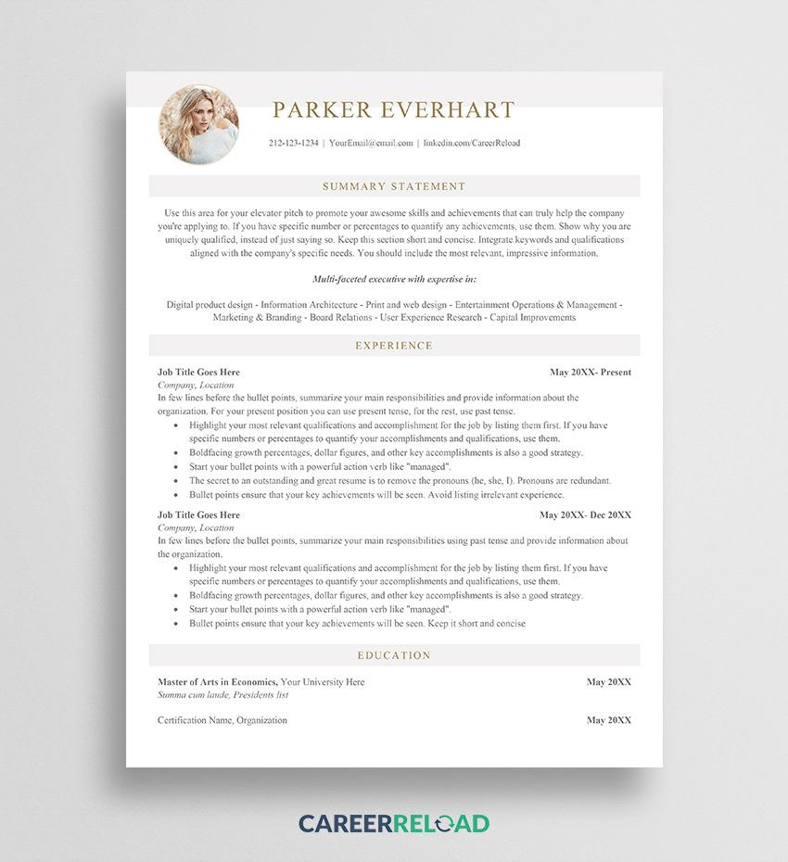

PARKER EVERHART

212-123-1234 | YourEmail@email.com | linkedin.com/CareerReload

SUMMARY STATEMENT

Use this area for your elevator pitch to promote your awesome skills and achievements that can truly help the company you're applying to. If you have specific number or percentages to quantify any achievements, use them. Show why you are uniquely qualified, instead of just saying so. Keep this section short and concise. Integrate keywords and qualifications aligned with the company's specific needs. You should include the most relevant, impressive information.

*Multi-faceted executive with expertise in:*

Digital product design - Information Architecture - Print and web design - Entertainment Operations & Management - Marketing & Branding - Board Relations - User Experience Research - Capital Improvements

EXPERIENCE

Job Title Goes Here

*Company, Location*

May 20XX- Present

In few lines before the bullet points, summarize your main responsibilities and provide information about the organization. For your present position you can use present tense, for the rest, use past tense.

• Highlight your most relevant qualifications and accomplishment for the job by listing them first. If you have specific numbers or percentages to quantify your accomplishments and qualifications, use them.

⚫ Boldfacing growth percentages, dollar figures, and other key accomplishments is also a good strategy.

⚫ Start your bullet points with a powerful action verb like "managed".

The secret to an outstanding and great resume is to remove the pronouns (he, she, I). Pronouns are redundant. Bullet points ensure that your key achievements will be seen. Avoid listing irrelevant experience.

Job Title Goes Here

*Company, Location*

May 20XX- Dec 20XX

In few lines before the bullet points, summarize your main responsibilities using past tense and provide information about the organization.

⚫ Highlight your most relevant qualifications and accomplishment for the job by listing them first. If you have specific numbers or percentages to quantify your accomplishments and qualifications, use them.

⚫ Boldfacing growth percentages, dollar figures, and other key accomplishments is also a good strategy.

⚫ Start your bullet points with a powerful action verb like "managed".

Bullet points ensure that your key achievements will be seen. Keep it short and concise

EDUCATION

Master of Arts in Economics, Your University Here

Summa cum laude, Presidents list

Certification Name, Organization

**CAREERRELOAD**

May 20XX

May 20XX