CM­_PROPERTIES.COM

**End Term Report**

*By*

Ayush Tiwari, Rohan Chainani , Vinayak Shukla

Section:K20KH

### Registration Numbers: 12014175, 12015057 , 12014991



**School of Computer Science Engineering**

**Lovely Professional University, Jalandhar**

**April-2021**

Student Declaration

This is to declare that this report has been written by me/us. No part of the report is copied from other sources. All information included from other sources has been duly acknowledged. I/We aver that if any part of the report is found to be copied, I/we are shall take full responsibility for it.

Ayush Tiwari

Registration Number: 12014175

Rohan Chainani

Registration Number: 12015057

Vinayak Shukla

Registration Number: 12014991

LPU, Jalandhar

30-April-2021

TABLE OF CONTENTS

TITLE PAGE NO.

1. Background and objectives of the project assigned. 5-7
2. Description of Project 8
3. Flow chart 9
4. Description of Work Division in terms of Roles among Students. 10
5. Implementation of scheduled work of Project 11-13
6. Technologies and Framework to be used. 14
7. SWOT Analysis achieved in project. 15

BONAFIDE CERTIFICATE

Certified that this project report “CM_PROPERTIES.COM” is the bonafide work of “Ayush Tiwari, Rohan Chainani and Vinayak Shukla ” who carried out the project work under my supervision.

Ashish Srivastava

Professor

25703

Division of Information Technology

BACKGROUND AND OBJECTIVE

CM_PROPERTIES.COM is a property based website which helps the user to sell, buy or rent property from a wide range of available options. Properties are ideally placed having a friendly neighborhood and are close to hospital, supermarket, airport, etc. Sellers can also sell their property hassle-free and can find the perfect buyer without any need of the middleman. In this era of online marketing,

CM_PROPERTIES.COM provides the perfect opportunity for buyers to buy their dream home, office, etc. and for sellers to get the best price of their property. Website is easily accessible and has a friendly user interface. Properties are available in major cities of India at a very reasonable rate. You can easily get properties to rent, buy and sell which can be very crucial for the people in dire need of properties to live or start a business.

It can also help you to get consultancy about the properties and you can easily get information about your desired property from assured people. You can also contact the website for more information about the same. This allows people to progress together as they can get a property of their choice that fits their budget, needs, location, property type, etc. As its tagline suggests it is “HOME IS WHERE STORY BEGINS.”

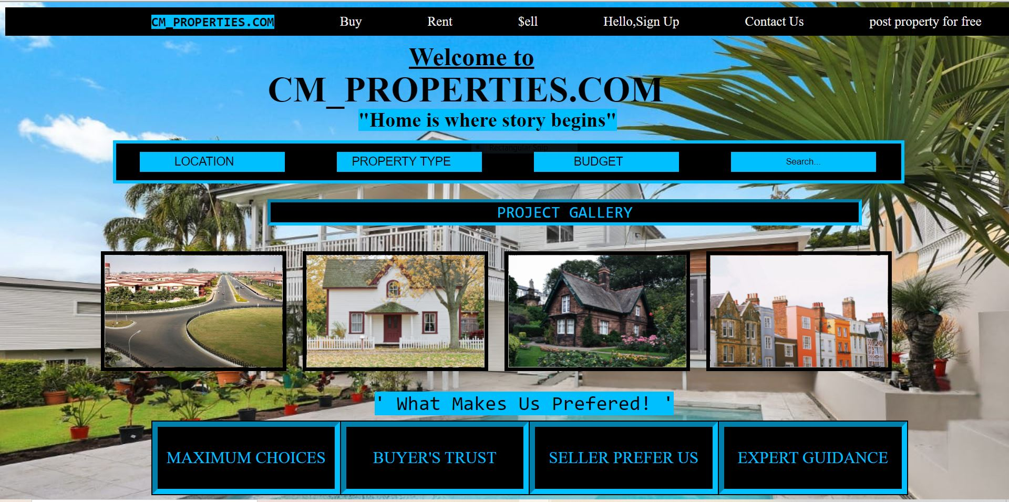

This website shows the images, proper details of the property available which will attract the user to buy property from the website. These things provide more demand of the property as it will get seen by people at a global level. Its interface is the simplest in the market and anybody can use it easily. It is also there for the assistance for the company and also provides the platform to empower the seller in their daily transactions. It also makes their daily transactions details safe and structured which will help them to have a clean and structured business. it is a customizable and provide highly beneficial for their financial wealth. It provides full and comprehensive information what the company’s selling, renting allowing prospective customers to easily choose from this site. It also provides additional security issues (i.e. SSL encrypted connections-https) and addressed them in an adequate manner for safe and pleasant user experience.

CM_PROPERTIES.COM provides the best customer service available in the market. It’s 24x7 customer helpline helps the user to communicate with the friendly customer care executives guiding them to buy or sell their property with complete satisfaction. Customers can contact using the helpline number or can send their messages using the contact us option.

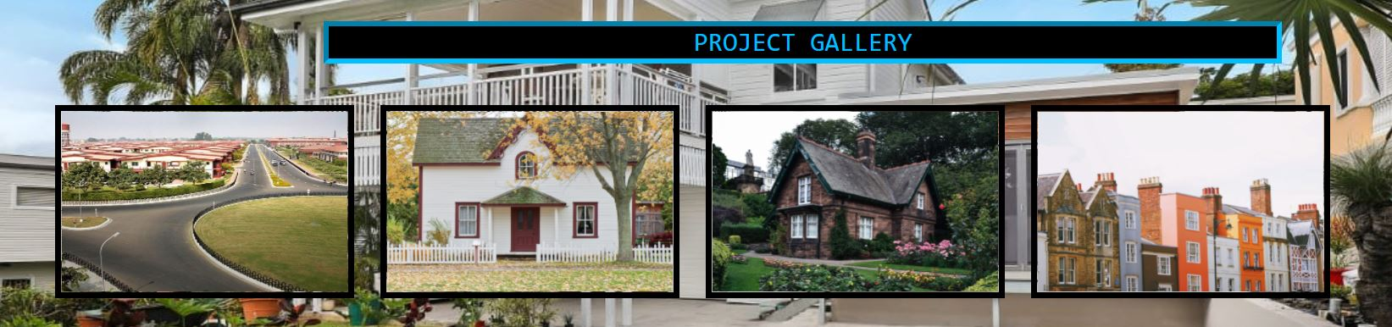

Its objective is to provide seller, buyer an online platform in which they can sell or buy their properties online. As in today’s world the competition level is very high and it is really difficult to find properties at reasonable rate. So by the help of the online platform of this website user can list their properties all over the world and it increases their chance find a potential buyer. By the help of CM_PROPERTIES.COM they can sell their properties and lands easily without any hidden fees or upfront cost and it empowers the customer to buy properties effortlessly without contacting any real estate agent. It gives you an amazing opportunity to get access of a variety of selections of land pieces based on your requirement. The website has a very easy interface and everyone can easily access all its features to make optimum utilization of the various benefits that the website has to provide.

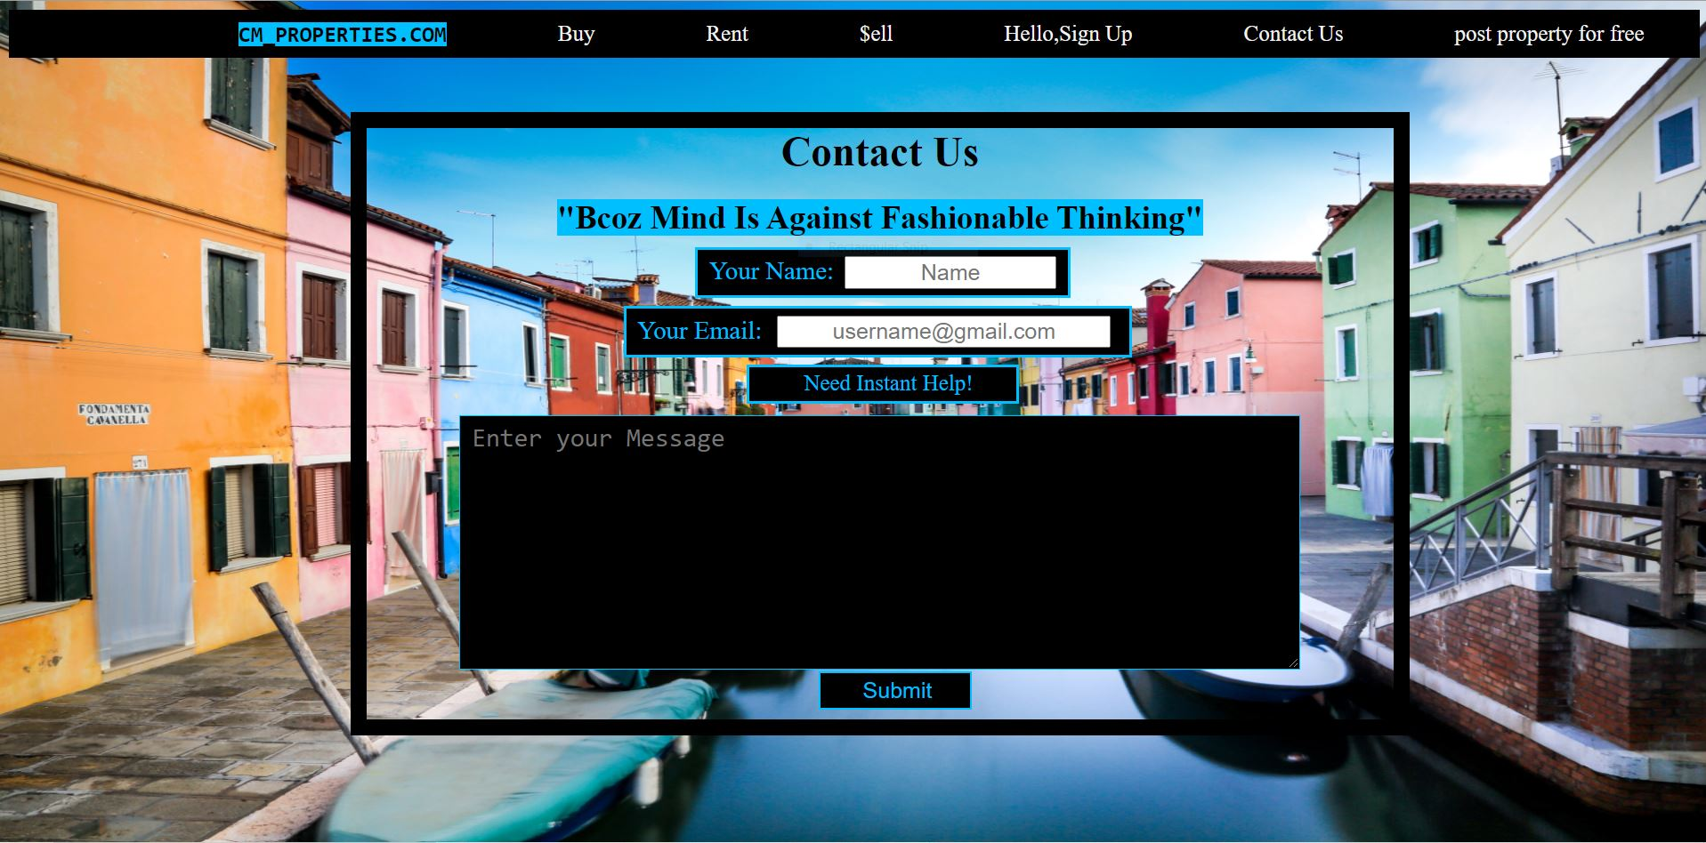

CM_PROPERTIES.COM really help the society in many ways because it helps the customers to broaden their market and help them to go global, we all know that in today's world the competition level is very high in and it's really difficult for customers to choose the ideal property, by the help this website they can choose thousands of properties from certified sellers from all over the world and it increases their level of opportunity to buy, sell or rent their properties.



Description of Project

# Modules

## BUY

In this part of the website, you have the option to buy new property based on your preferences. You can filter your choices and get appropriate results.

## RENT

This feature gives you the option to rent new properties. You can also post up a property for the same and get tenants.

## SELL

Using this feature on the website, you can sell your property and find suitable buyers for your land.

## SIGN UP

You can also become a member of the group and can sign up by entering your basic details. Using this, you will be informed about the latest available properties and you can get them without any hassle.

## CONTACT US

You can get contact details from the website and can use them to get further information about the land and property and you can easily get your work done.

Flow chart

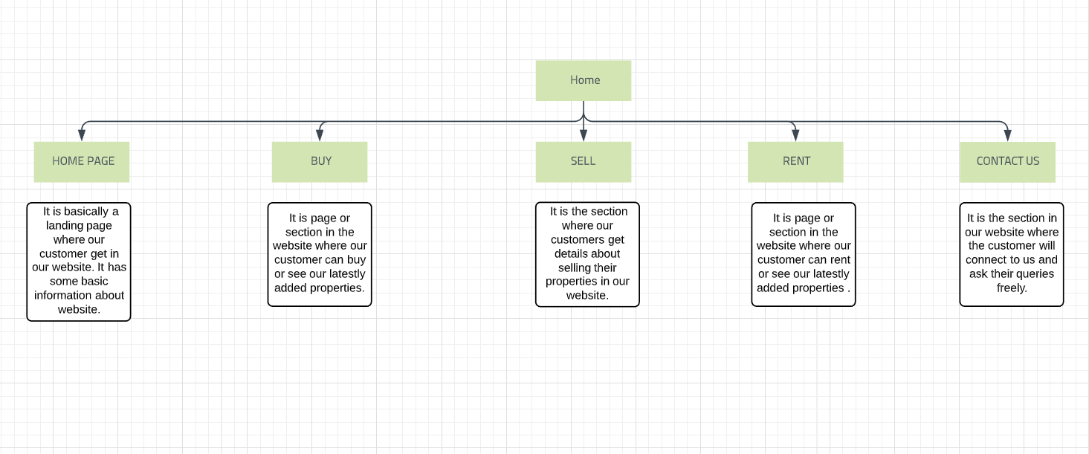

ROLE OF EACH MEMBER

# Rohan Chainani

1. Create modules like Home page, about, feature , contact us.
2. Do the whole navigation bar and header section.
3. Make the up button at footer part.
4. Help designing the whole website.
5. Set the layouts.
6. Do the whole responsive coding.
7. Help group mates in their part of work.

# Ayush Tiwari

1. Create modules like buy, sell.
2. Help in designing the whole website.
3. Help in setting the layouts.
4. Help group mates in their part of work.

## Vinayak Shukla

1. Create modules like sign up, rent.
2. Help in designing the whole website.
3. Help group mates in their work.
4. Help in making forms.

Implementation of scheduled work of Project

* First page is our home page in this page we use many interesting techniques like we use a beautiful background image than we quadrilateral gradient effect and we create an amazing navigation bar also with gradient effect than we use two buttons with beautiful hover effect.



* Second page is our about us page and it basically about we are and what we do it tells our customers about us in this page we use special clipart’s so it look awesome we also use the box shadow effect which give page a next level feel.

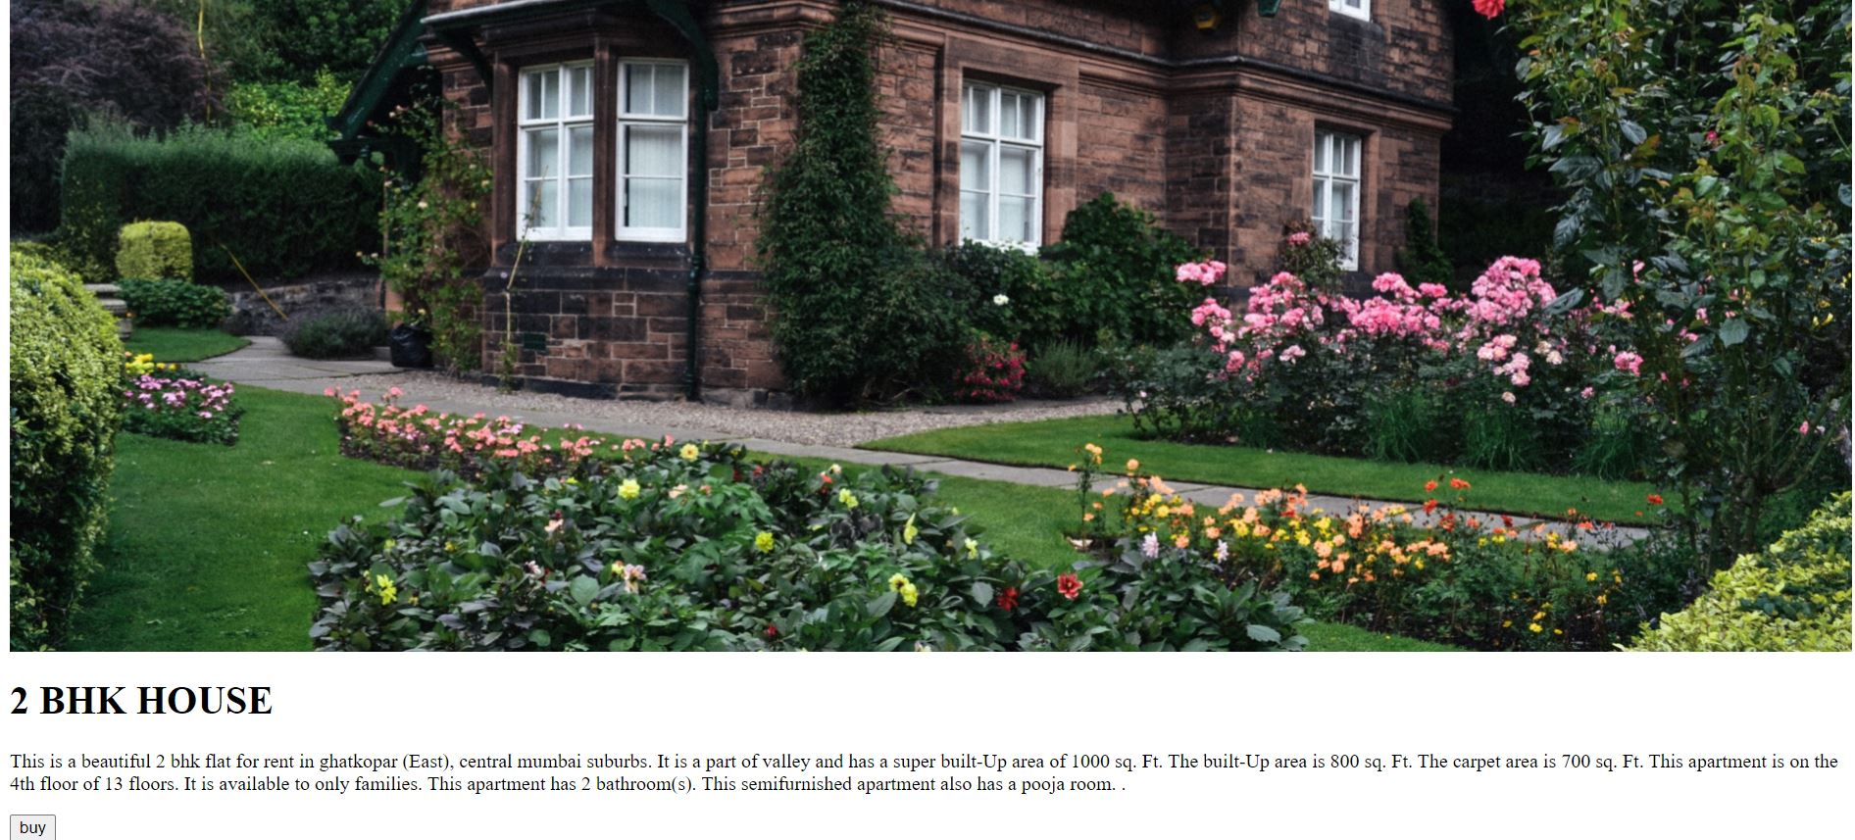

* Third page is our feature page it’s tells our customers about our special features which make us different from our competitors. We are constantly adding new properties so that we can always find something to meet your demands.



* Contact section: by this section our customers get connected to our website and ask any queries about any issue they are facing or they need any help, in this section again we used a beautiful gradient effect.



Technologies and Framework

**Technologies & languages:-**

* HTML
* C

**Framework & platforms:-**

* W3schools.com
* Google Fonts
* Shutters Stock.com(For images)
* Font Awesome.com(for clipart’s)



**STRENGTHS (+)**

•World-Class responsive websites.

•Easy to Access.

•Best property options.

•24/7 customer support.

**WEAKNESSES (–)**

•Server capacity issues.

•Lack of options for all locations.

•Work-force management.

**OPPORTUNITIES (+)**

•Less competitors.

•Large Online Market.

•The urge to be more inclined towards an online platform.

**THREATS (–)**

•Market changing so fast.

•Competitors growing day by day.

•Technology evolving day by day.

•Changing customer’s attitude.