# Abyssinica SIL Features

The Ethiopic script does not require much rendering except for some combining marks for gemination and vowel length. Abyssinica SIL provides both OpenType and Graphite rendering solutions for rendering the combining marks and for kerning as well as for the special glyph variations that can occur for the Ethiopic script. The tables below give lists of the OpenType Stylistic Sets and OpenType Character Variants available in Abyssinica SIL.

## Abyssinica SIL OpenType Features

**New** (version 1.500): Character Variants were added to Abyssinica SIL. If an application supports Character Variants, those are preferred. The Stylistic Sets do not offer as many options as are available in the Character Variants. However, the OpenType Stylistic Sets are still in the font in order to provide support for applications (such as InDesign CS4+ and Microsoft Office 2007+) that only support Stylistic Sets and not Character Variants.

### Stylistic Sets

In InDesign, from the “Character” palette select “**OpenType / Stylistic Sets**” and then choose the Set you want to apply to the text you have selected. The default character should change to the variant character. You can also set your Stylistic Set preference in paragraph and character styles. It is recommended to have “**[No language]**” selected if there is no Ethiopic-based language available.

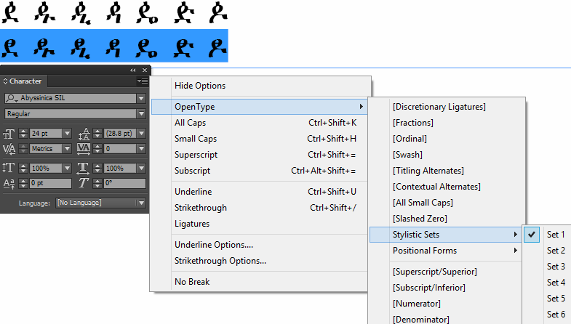

In Microsoft Word, select the text, then select “**Font / Advanced**” and then choose the Stylistic Set you want to apply to the text you have selected.

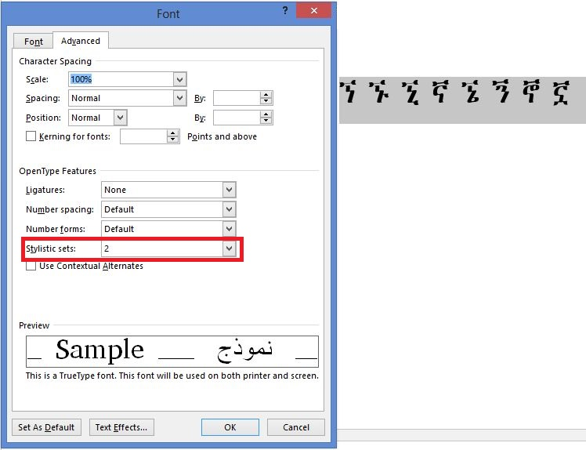

### Stylistic Sets Table

| **OpenType Feature Name** | **Feature setting** | **Feature IDs** | **Character shapes** |
| --- | --- | --- | --- |
| Archaic Oromo dda forms (U+12F8..U+12FE) | Standard |  | ዸ ዹ ዺ ዻ ዼ ዽ ዾ |
|  | Alternate | ss01 | ዸ ዹ ዺ ዻ ዼ ዽ ዾ[1] |
| Gumuz nya forms (U+1298..U+129F) | Standard |  | ኘ ኙ ኚ ኛ ኜ ኝ ኞ ኟ |
|  | Disconnected | ss02 | ኘ ኙ ኚ ኛ ኜ ኝ ኞ ኟ[2] |
| Old Style forms (U+1297 U+12C3 U+12E5 U+1313 U+133F U+134F) | Standard |  | ኗ ዃ ዥ ጓ ጿ ፏ |
|  | Disconnected | ss03 | ኗ[3] ዃ[4] ዥ[5] ጓ[6] ጿ ፏ3 |
| Disconnected gga forms (U+1318..U+131E) | Standard |  | ጘ ጙ ጚ ጛ ጜ ጝ ጞ |
|  | Disconnected | ss04 | ጘ ጙ ጚ ጛ ጜ ጝ ጞ[7] |
| Sebat Bet gwaa form (U+1313) | Standard |  | ጓ |
|  | Sebat Bet | ss05 | ጓ[8] |
| Leslau's Sebat Bet alternates (U+1381 U+1383 U+1387 U+138B U+138F) | Standard |  | ᎁ ᎃ ᎇ ᎋ ᎏ |
|  |  | ss06 | ᎁ ᎃ ᎇ ᎋ ᎏ[9] |
| Sebat Bet xwa forms (U+1288..U+128D) | Standard |  | ኈ ኊ ኋ ኌ ኍ |
|  | Handwriting | ss07 | ኈ ኊ ኋ ኌ ኍ |
| Sebat Bet 3rd form alternates | Standard |  | ቊ ኲ ዂ ጒ ᎁ ᎅ ᎍ |
| (U+124A U+12B2 U+12C2 U+1312 U+1381 U+1385 U+138D) | Alternate | ss08 | ቊ ኲ ዂ ጒ ᎁ ᎅ ᎍ8 |
| Sebat Bet 6th form alternates | Standard |  | ቍ ኵ ዅ ጕ |
| (U+124D U+12B5 U+12C5 U+1315) | Alternate | ss09 | ቍ ኵ ዅ ጕ8 |
| Sebat Bet mwe alternate (U+1383) | Standard |  | ᎃ |
|  | Sebat Bet | ss10 | ᎃ8 |
| Traditional fwee alternate (U+138A) | Standard |  | ᎊ |
|  | Alternate | ss11 | ᎊ9 |
| Typewriter ggwaa alternate (U+131F) | Standard |  | ጟ |
|  | Disconnected | ss12 | ጟ7 |
| xoa alternate (U+1287) | Standard |  | ኇ |
|  | Alternate | ss13 | ኇ |
| Latin punctuation | Ethiopic-style |  | ! $ % * + / 0 1 2 3 4 5 6 7 8 9 = ? ¡ © « ² ³ ¹ » × ‘ ’ “ ” ‹ › ⁰ ⁴ ⁵ ⁶ ⁷ ⁸ ⁹ € |
|  | Latin-style | ss14 | ! $ % * + / 0 1 2 3 4 5 6 7 8 9 = ? ¡ © « ² ³ ¹ » × ‘ ’ “ ” ‹ › ⁰ ⁴ ⁵ ⁶ ⁷ ⁸ ⁹ € |

### Character Variants

For applications which support OpenType Character Variants, such as in CSS, the Character Variant ID and setting is chosen. For example, in CSS, if cv32, is desired, you might have this code in your .css:

...

@font-face {

font-family: AbyssinicaSIL;

src: url(AbyssinicaSIL-R.woff);

}

.cv320 {

font-family: AbyssinicaSIL;

-moz-font-feature-settings: "cv32" 0; font-size: 200%;

}

.cv321 {

font-family: AbyssinicaSIL;

-moz-font-feature-settings: "cv32" 1; font-size: 200%;

}

...

and this in your .html:

<p class=cv320> ዸ ዹ ዺ ዻ ዼ ዽ ዾ</cv320> [cv32=0]</p>

<p class=cv321> ዸ ዹ ዺ ዻ ዼ ዽ ዾ</cv321> [cv32=1]</p>

Which would produce this:

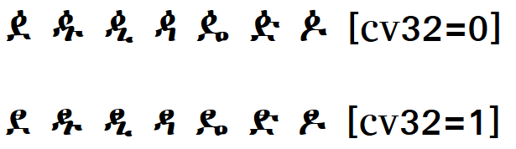

### Character Variants Table

| **OpenType Feature Name** | **Feature setting** | **Feature IDs** | **Character shapes** |
| --- | --- | --- | --- |
| Punctuation | Ethiopic-style |  | ! $ % * + / 0 1 2 3 4 5 6 7 8 9 = ? ¡ © « ² ³ ¹ » × ‘ ’ “ ” ‹ › ⁰ ⁴ ⁵ ⁶ ⁷ ⁸ ⁹ € |
|  | Latin-style | cv01=1 | ! $ % * + / 0 1 2 3 4 5 6 7 8 9 = ? ¡ © « ² ³ ¹ » × ‘ ’ “ ” ‹ › ⁰ ⁴ ⁵ ⁶ ⁷ ⁸ ⁹ € |
| mwa alternates (U+121F) | Standard |  | ሟ |
|  | Alternate-1 | cv04=1 | ሟ[10] |
|  | Alternate-2 | cv04=2 | ሟ4 |
| rwa alternate (U+122F) | Standard |  | ሯ |
|  | Alternate | cv05=1 | ሯ4 |
| xoa alternate (U+1287) | Standard |  | ኇ |
|  | Alternate | cv17=1 | ኇ |
| xwa alternates (U+1288..U+128D) | Standard |  | ኈ ኊ ኋ ኌ ኍ |
|  | Handwriting | cv18=1 | ኈ ኊ ኋ ኌ ኍ |
| nwa alternate (U+1297) | Standard |  | ኗ |
|  | Alternate | cv19=1 | ኗ10 |
| nya alternates (U+1298..U+129E) | Standard |  | ኘ ኙ ኚ ኛ ኜ ኝ ኞ |
|  | Disconnected | cv20=1 | ኘ ኙ ኚ ኛ ኜ ኝ ኞ2 |
| nywa alternates (U+129F) | Standard |  | ኟ |
|  | Disconnected | cv21=1 | ኟ2 |
|  | Cohen | cv21=2 | ኟ4 |
| kxwaa alternate (U+12C3) | Standard |  | ዃ |
|  | Alternate | cv26=1 | ዃ4 |
| zha alternates (U+12E0..U+12E6) | Standard |  | ዠ ዡ ዢ ዣ ዤ ዥ ዦ |
|  | Cohen | cv31=1 | ዠ ዡ ዢ ዣ ዤ ዥ ዦ5 |
|  | Chaine | cv31=2 | ዠ ዡ ዢ ዣ ዤ ዥ ዦ[11] |
| dda alternates (U+12F8..U+12FE) | Standard |  | ዸ ዹ ዺ ዻ ዼ ዽ ዾ |
|  | Alternate | cv32=1 | ዸ ዹ ዺ ዻ ዼ ዽ ዾ1 |
| gwaa alternates (U+1313) | Standard |  | ጓ |
|  | Sebat Bet | cv40=1 | ጓ8 |
|  | Alone Stokes | cv40=2 | ጓ4 |
| gga alternates (U+1318..U+131E) | Standard |  | ጘ ጙ ጚ ጛ ጜ ጝ ጞ |
|  | Disconnected | cv41=1 | ጘ ጙ ጚ ጛ ጜ ጝ ጞ7 |
| ggwaa alternate (U+131F) | Standard |  | ጟ |
|  | Disconnected | cv42=1 | ጟ7 |
| phe alternate (U+1335) | Standard |  | ጵ |
|  | Alternate | cv45=1 | ጵ[12] |
| tswa alternate (U+133F) | Standard |  | ጿ |
|  | Alternate | cv46=1 | ጿ |
| fwa alternates (U+134F) | Standard |  | ፏ |
|  | Cohen-1 | cv48=1 | ፏ10 |
|  | Cohen-2 | cv48=2 | ፏ10 |
| rya alternate (U+1358) | Standard |  | ፘ |
|  | Alternate | cv49=1 | ፘ4 |
| mya alternate (U+1359) | Standard |  | ፙ |
|  | Alternate | cv50=1 | ፙ4 |
| mwi alternates (U+1381) | Standard |  | ᎁ |
|  | Sebat Bet | cv60=1 | ᎁ8 |
|  | Leslau | cv60=2 | ᎁ9 |
| mwe alternates (U+1383) | Standard |  | ᎃ |
|  | Sebat Bet | cv61=1 | ᎃ8 |
|  | Leslau | cv61=2 | ᎃ9 |
| bwe alternate (U+1387) | Standard |  | ᎇ |
|  | Alternate | cv62=1 | ᎇ9 |
| fwee alternate (U+138A) | Standard |  | ᎊ |
|  | Alternate | cv63=1 | ᎊ9 |
| fwe alternate (U+138B) | Standard |  | ᎋ |
|  | Alternate | cv64=1 | ᎋ9 |
| pwe alternate (U+138F) | Standard |  | ᎏ |
|  | Alternate | cv65=1 | ᎏ9 |
| ggwa alternates (U+2D93..U+2D96) | Standard |  | ⶓ ⶔ ⶕ ⶖ |
|  | Disconnected | cv70=1 | ⶓ ⶔ ⶕ ⶖ7 |
| 3rd form alternates | Standard |  | ቊ ኲ ዂ ጒ ᎅ ᎍ |
| (U+124A U+12B2 U+12C2 U+1312 U+1385 U+138D) | Alternate | cv80=1 | ቊ ኲ ዂ ጒ ᎅ ᎍ8 |
| 6th form alternates | Standard |  | ቍ ኵ ዅ ጕ |
| (U+124D U+12B5 U+12C5 U+1315) | Alternate | cv85=1 | ቍ ኵ ዅ ጕ8 |

## References

Alone, John Philip Herbert Mackenzie. 1946 (Fourth edition). *The Alone-Stokes Short Manual of the Amharic Language (with vocabularies).* Macmillan and Co. Limited: London.

Chaîne, Marius. 1907. *Grammaire éthiopienne. Imprimerie catholique*. Beyrouth.

Cohen, Marcel. 1970 Seconde edition. *Traité de langue amharique (Abyssinie)*. Institut d'ethnologie: Paris.

Leslau, Wolf. 1966. *Ethiopians Speak: Studies in Cultural Background. Part 2: Chaha.* University of California Publication. Near Eastern Studies, Volume 9. University of California Press: Berkeley

Praetorius, Franz. 1955. *Aethiopische Grammatik mit Paradigmen, Litteratur, Chrestomathie und Glossar*. Frederick Ungar Publishing Co. New York.

1. Archaic Oromo language preference
2. Gumuz language preference
3. Chaîne (p 3), Cohen (table 2)
4. Cohen (table 2)
5. Alone-Stokes, Chaîne (p 3), Cohen (table 1)
6. Alone-Stokes (inside back cover)
7. Bilen language preference
8. Sebat Bet language preference
9. Leslau
10. Chaîne (p 3), Cohen (table 2)
11. Chaîne (p 3)
12. Praetorius (p 6)