Steps to Run Jupyter Notebook:

1. Open the command prompt
2. Open the folder location of Jupyter notebooks

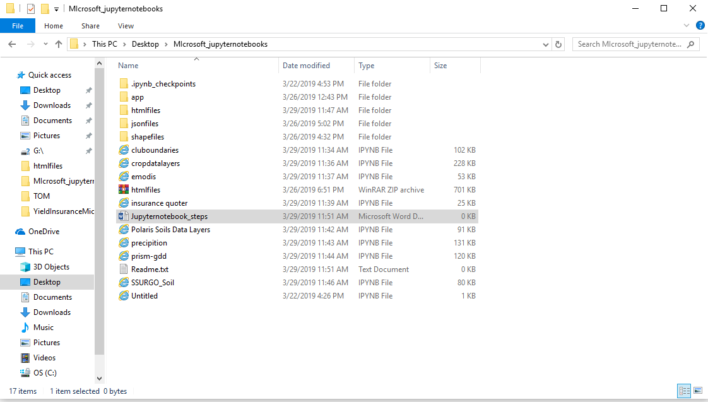

1. Go to the location in command prompt

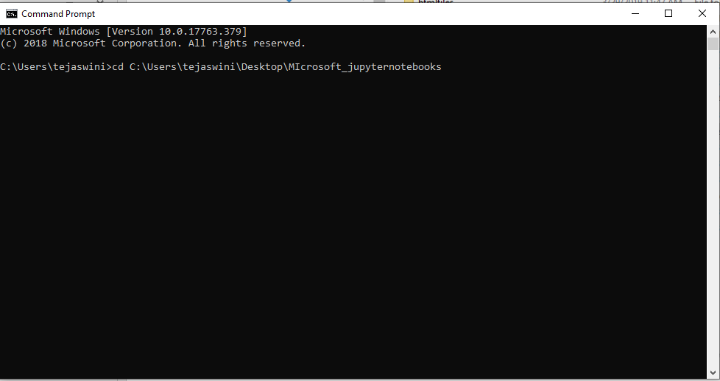

1. Open the Jupyter notebook using your notebook executable file

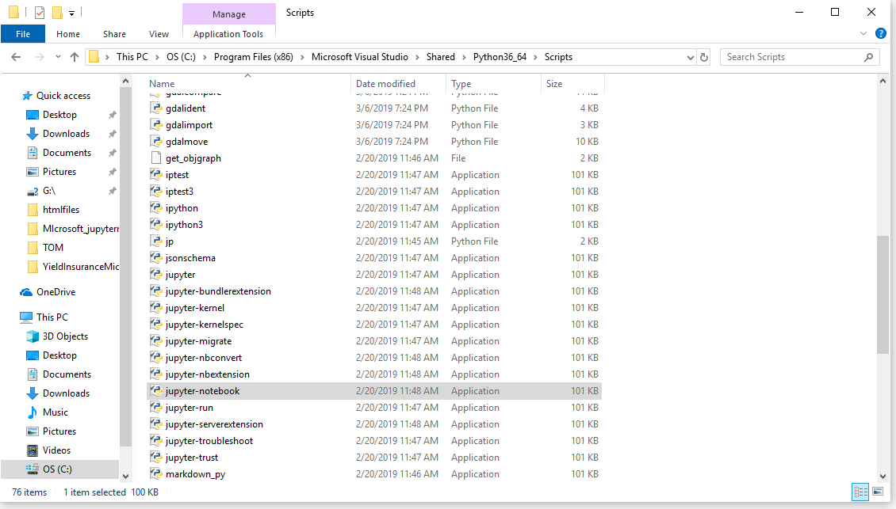

1. Copy the location in command prompt as shown below and click enter

"C:\Program Files (x86)\Microsoft Visual Studio\Shared\Python36_64\Scripts\jupyter-notebook.exe" ./

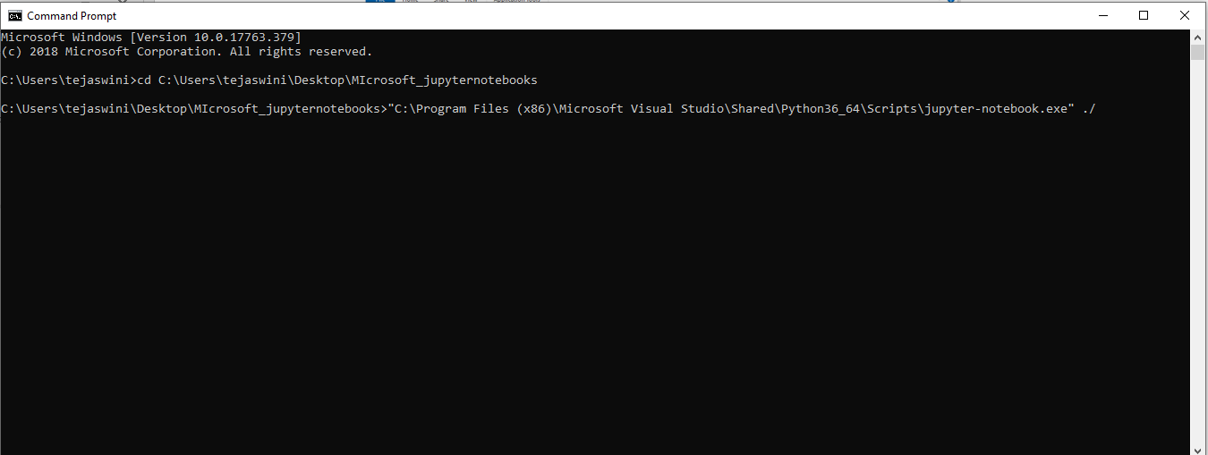

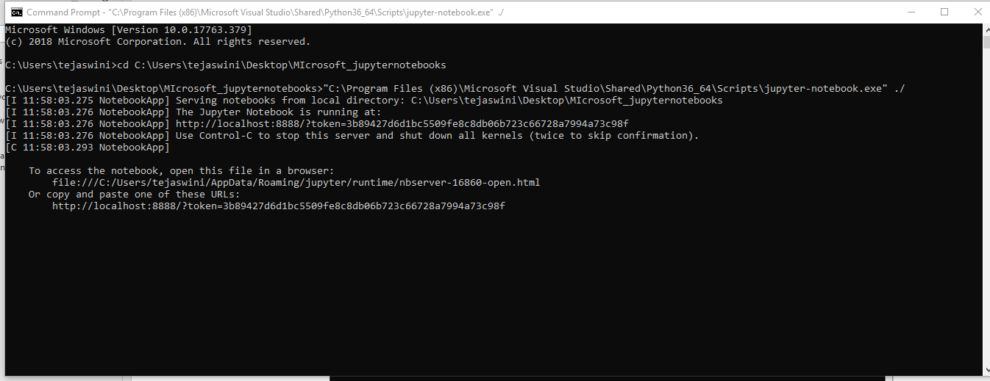

1. Now a window will be opened in your chrome or default browser as below automatically once had clicked enter in previous step

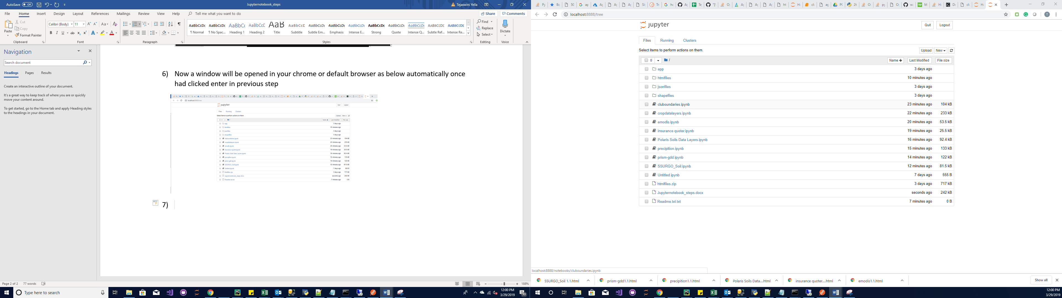

1. Click on the .ipynb format files and then your Jupyter notebook will be open and select each cell and click on run one after other or go to cell in screenshot as show below and click run all.

