Forecasting Twelve Month Metabolic Response in MTBLS242 Using Monotonic Logistic Regression L2 Elastic Net and SVM

Abstract This study compared four learning approaches for predicting a predefined metabolic response at 12 months after bariatric surgery from preoperative serum nuclear magnetic resonance measurements. The MTBLS242 analysis included 71 participants with paired baseline and 12-month samples and 21 baseline metabolite features. A strong responder was defined as a participant with at least 9 of 11 specified markers changing in the designated direction; 31 participants met this experimental criterion. Monotonic logistic regression with an L2 penalty, unconstrained L2 logistic regression, Elastic Net logistic regression, and a radial basis function support vector machine were evaluated using identical subject partitions in nested stratified five-fold cross-validation, with five inner folds. Scaling, hyperparameter tuning, and embedded feature selection were restricted to training data within the nested procedure. Mean outer-fold average precision, reported as PR-AUC, was 0.633 ± 0.198 for Monotonic, 0.641 ± 0.173 for L2, 0.548 ± 0.126 for Elastic Net, and 0.530 ± 0.118 for SVM. The dispersion represents population standard deviation across folds, not a confidence interval. L2 exceeded Monotonic by only 0.008 on average and outperformed it in one fold. Selecting the algorithm and its parameters within the inner folds yielded a mean outer-fold PR-AUC of 0.564. These exploratory findings do not establish a consistently superior model or clinical utility. Independent validation is required.
Keywords metabolic response; MTBLS242; monotonic constraints; regularization; nested cross-validation; average precision

I INTRODUCTION

A Background and research question
Serum metabolomics provides measurements of biochemical patterns before and after bariatric surgery. The original MTBLS242 study reported that these patterns changed over time and differed by surgical procedure [1], [2]. This motivates a prediction question: can a preoperative metabolite profile rank patients by their likelihood of meeting a specified metabolic response criterion one year later?
The present work addresses fixed-horizon binary outcome prediction. It uses one baseline feature vector per participant and a paired 12-month outcome. It does not model a regularly sampled time series. The endpoint is an operational metabolite-change criterion rather than incident diabetes, weight loss, or a clinically validated measure of treatment success.

B Study objective and contribution
The objective was to compare monotonic constraints, L2 regularization, Elastic Net regularization, and a nonlinear SVM under the same target and patient partitions. The contribution is a reproducible comparison in which model tuning is separated from held-out evaluation. Particular attention is given to whether a small improvement in mean PR-AUC is consistent across folds and whether algorithm selection itself changes the estimated performance.

II RELATED WORK AND MODEL RATIONALE

A Regularization and monotonic constraints
An L2 penalty shrinks regression coefficients and discourages large fitted effects. Elastic Net combines L1 and L2 penalties, allowing some coefficients to become zero while retaining shrinkage [3]. These approaches are relevant when a limited cohort must support several correlated predictors. Monotonic constraints instead restrict coefficient signs. In a logistic model, a nonnegative coefficient ensures that increasing that feature cannot decrease the predicted response probability while other inputs are fixed.
Here, Monotonic also includes an L2 penalty. Thus, Monotonic versus L2 is a comparison of sign-constrained and unconstrained logistic regression with the same loss function and penalty grid. The constraints express an opportunity-to-improve assumption inherited from the existing experiment; an association with obesity does not, by itself, establish the direction of a future treatment response.

B Support vector machines
Support vector machines construct a decision boundary using a margin-based criterion [4]. An RBF kernel permits nonlinear relationships between the baseline profile and the binary endpoint. SVM was included to test whether this additional flexibility improved held-out ranking within the specified search space. Its raw decision score was used for PR-AUC; that score is not a calibrated probability.

C Nested validation and precision recall evaluation
Using the same validation outcomes for tuning and final reporting can produce optimistic estimates. Nested cross-validation reserves an outer test partition while the inner loop chooses the learning configuration [5]. PR evaluation focuses on retrieval of the positive class [6]. In this cohort, the positive fraction is 43.7%, so the choice of PR-AUC reflects the responder-focused question and continuity with the prior experiment, rather than an assertion of severe class imbalance.

III METHODOLOGY

A Data source and cohort construction
This secondary analysis used the local MTBLS242 sample metadata and metabolite annotation matrix associated with the MetaboLights accession [1]. The metadata contained 465 sample records: 106 preoperative, 98 at 3 months, 98 at 6 months, 92 at 9 months, and 71 at 12 months. These records represent repeated measurements, not 465 independent participants. The present analysis retained only preoperative and 12-month pairs.
Four-digit identifiers extracted from sample names linked the two time points. One unique pair was obtained for each of 71 participants. Of the 106 baseline participants, 35 had no matched 12-month record in the supplied metadata and were excluded from this endpoint analysis. The reason for missing follow-up was not established. All 21 baseline features and paired follow-up values were finite and nonnegative; no imputation was required. Intermediate visits were not used as predictors.
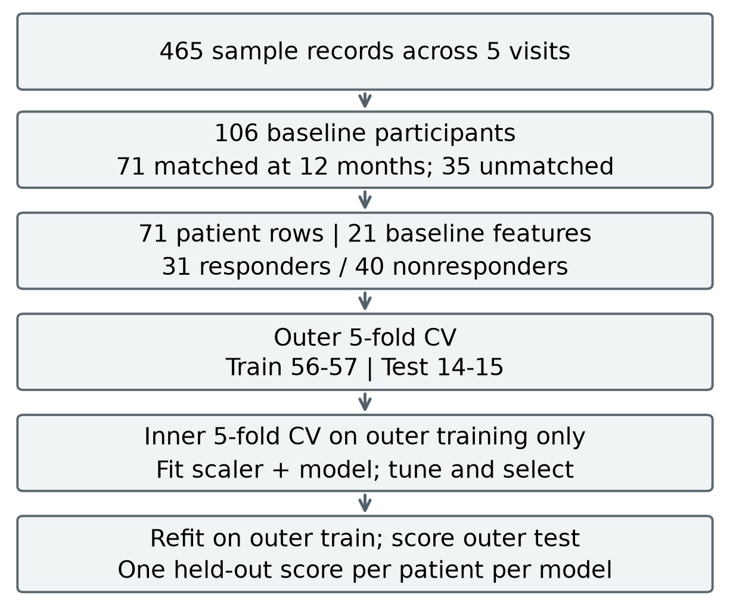
Fig. 1. Cohort construction and nested evaluation. All four models share the same patient partitions. The outer test partition is excluded from inner tuning.

B Fixed response definition and directions
The response criterion was retained from the existing forecast experiment. Eight markers were designated to decrease: L-valine, L-leucine, L-allo-Isoleucine, L-tyrosine, D-phenylalanine, L-alanine, lipoproteins, and L-Lactic acid. Three were designated to increase: glycine, L-glutamine, and histidine. Names follow the supplied matrix. Each marker received one point if its 12-month value changed strictly in the designated direction relative to baseline; an unchanged value received no point.
A participant was labeled a strong responder when at least 9 of the 11 markers met this condition. This produced 31 positives and 40 negatives. The rule counts direction only, without a minimum effect magnitude or marker-specific weight. It is an experimental endpoint, not an established definition of clinical recovery. The same 11 baseline markers received monotonic signs of +1 for the eight decrease-designated markers and -1 for the three increase-designated markers; the other 10 features remained unconstrained. These signs constrain response probability, not the future concentration itself.

C Preprocessing and patient partitions
A fixed log1p transformation was applied to nonnegative abundances. Because it is monotonic, it preserves the sign of each paired change and does not learn a parameter from the cohort. StandardScaler was fitted on each training partition and then applied to its validation or test partition. No full-cohort feature ranking, oversampling, undersampling, or class weighting was performed. Elastic Net provided embedded feature selection during fitting; all models started with the same 21 predefined features.
The outer loop used five stratified folds with seed 42 and exactly reproduced the previous subject allocation. Fold 1 contained 56 training and 15 test participants; folds 2-5 contained 57 training and 14 test participants. The corresponding numbers of test positives were 7, 6, 6, 6, and 6. Each participant contributed one outer held-out score per model. With one row per participant, no participant appeared in both training and test data within a fold.
Within each outer training set, five stratified inner folds were generated with seed 42 plus the outer-fold number. These inner partitions were identical across models. Every candidate was fitted separately in each inner training partition and evaluated by mean inner average precision. The first grid entry was selected in an exact tie. The chosen configuration was then refitted on the complete outer training set and evaluated once on the outer test set.

D Model specifications and tuning
Monotonic and L2 minimized mean logistic loss plus one half of lambda times the squared coefficient norm, with an unpenalized intercept. Both used L-BFGS-B; only Monotonic imposed coefficient sign bounds. Elastic Net used logistic regression with the SAGA solver, an L1 mixing ratio, and C equal to the reciprocal of training sample size times lambda. SVM used an RBF kernel and its decision function. Table I gives the full grid; scale for gamma denotes the scikit-learn training-data rule.
TABLE I HYPERPARAMETER SEARCH SPACE
Model | Search values
Monotonic | lambda: 0.001, 0.01, 0.1, 1, 10
L2 | lambda: 0.001, 0.01, 0.1, 1, 10
Elastic Net | Same lambda grid;  L1 ratio: 0.1, 0.5, 0.9
SVM RBF | C: 0.01, 0.1, 1, 10, 100;  gamma: scale, 0.01, 0.1

There were 40 candidate configurations per outer fold and 1,000 inner training fits in total, followed by 20 outer refits. Convergence and sign checks were recorded. In a separate evaluation of model selection, the algorithm with the highest best-inner mean AP was selected within each outer fold, and its outer test score was retained. This evaluates the selection procedure rather than retrospectively taking the best outer mean.

E Evaluation metric and reproducibility
PR-AUC was computed as average precision using scikit-learn, with tied scores grouped and precision weighted by increments in recall [7]. This step-based calculation differs from trapezoidal integration. The primary summary was the unweighted mean of the five outer-fold AP values. Dispersion was the population standard deviation, using divisor five, consistent with the stored experiment. It was not treated as a confidence interval or divided by the square root of five to imply independent fold estimates.
Overall responder prevalence, 31/71 = 0.437, was shown as a descriptive reference; fold-specific values were 0.467 and 0.429. Prevalence is not an exact finite-sample expected AP under random ranking. Pooled out-of-fold AP was retained as a secondary descriptive quantity because scores from separately fitted models may have different scales, especially SVM margins. No threshold-dependent performance or probability calibration was evaluated. Saved predictions, fold memberships, parameter grids, source hashes, and verification results support reproduction [9].

IV EXPERIMENTAL RESULTS

A Overall comparison
Table II summarizes held-out performance. L2 had the highest mean outer-fold AP at 0.641, followed closely by Monotonic at 0.633. Elastic Net and SVM obtained 0.548 and 0.530. All four means exceeded the overall prevalence reference numerically, but this observation is not a statistical test against random ranking. The uncertainty and fold dependence prevent a claim that any model has established generalizable discrimination.
TABLE II OUTER FOLD AVERAGE PRECISION
Model | Mean AP | SD
L2 | 0.641 | 0.173
Monotonic | 0.633 | 0.198
Elastic Net | 0.548 | 0.126
SVM | 0.530 | 0.118

SD is population SD across five outer folds, not a confidence interval.
The mean paired difference between L2 and Monotonic was +0.008. L2 was higher in fold 1, lower in folds 3 and 4, and equal in folds 2 and 5. Accordingly, the highest mean did not indicate a consistent advantage across patient partitions. Elastic Net was higher than Monotonic in one fold, and SVM in two folds. These counts describe this split and are not significance tests.

B Variation across folds
TABLE III PAIRED OUTER TEST RESULTS
Fold | Mono | L2 | EN | SVM
1 | 0.485 | 0.582 | 0.484 | 0.671
2 | 0.472 | 0.472 | 0.489 | 0.351
3 | 0.852 | 0.837 | 0.691 | 0.650
4 | 0.897 | 0.856 | 0.697 | 0.497
5 | 0.457 | 0.457 | 0.379 | 0.479

Mono = Monotonic; EN = Elastic Net. All entries are held-out AP.
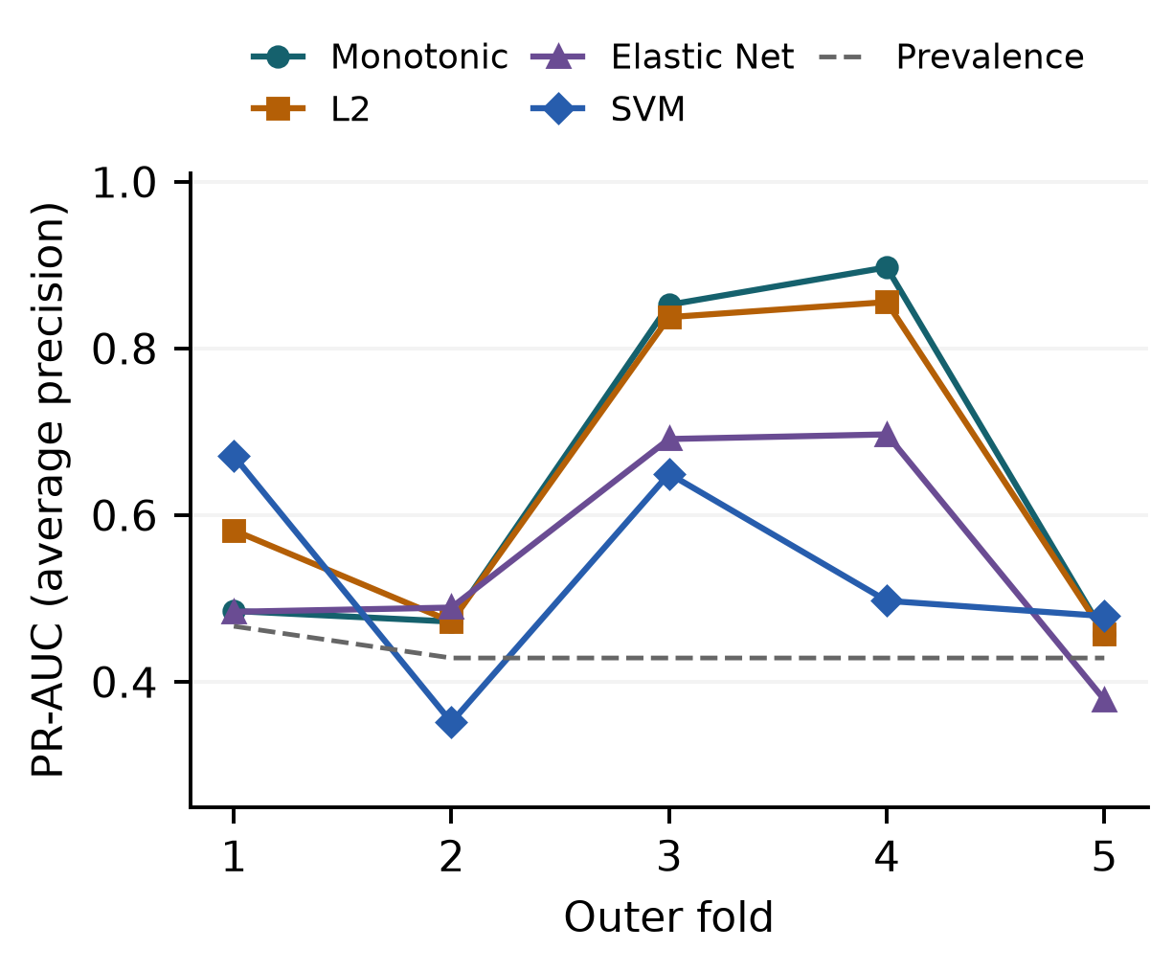
Fig. 2. PR-AUC on identical outer test participants. Lines link fold results for readability; fold numbers do not represent time. The dashed line indicates fold prevalence.
Monotonic ranged from 0.457 to 0.897, and L2 from 0.457 to 0.856. SVM achieved the highest AP in fold 1, whereas Monotonic led folds 3 and 4. A test fold contained only 14-15 participants and 6-7 positives, so changes in the ordering of a few participants can materially change AP. The reported standard deviations therefore communicate substantial variation rather than precise model rankings.

C Tuning and algorithm selection
The selected lambda values for Monotonic were 0.1, 10, 10, 1, and 10 across folds; those for L2 were 1, 10, 10, 1, and 10. The preference for larger penalties in several folds is consistent with substantial shrinkage in this small dataset, although it does not prove overfitting was eliminated. Elastic Net retained 9, 8, 6, 3, and 17 nonzero coefficients in its outer fits, indicating variable selection that depended on the training partition.
When both the algorithm and its parameters were selected through inner validation, Elastic Net was selected in outer folds 1-4 and L2 in fold 5. Their retained outer AP values were 0.484, 0.489, 0.691, 0.697, and 0.457, giving a mean of 0.564. This result addresses a different question from the separate model means: how well does the specified selection procedure perform on held-out patients? It should accompany, rather than be replaced by, the post hoc best mean of 0.641.
Pooled out-of-fold AP was 0.565 for Monotonic, 0.590 for L2, 0.476 for Elastic Net, and 0.439 for SVM. These are descriptive values, not the primary ranking criterion. Recorded verification confirmed target and outer-partition agreement with the previous experiment, one held-out prediction per participant, inner/test separation, recomputed AP values, solver convergence, and compliance with monotonic signs [9]. No new model fitting was performed for this manuscript.

V DISCUSSION AND LIMITATIONS

A Interpretation of the model comparison
The results provide no consistent empirical advantage for removing monotonic constraints: L2 had a slightly higher mean, but won only one fold and tied two. Conversely, the results do not show that the sign assumptions are biologically correct. Monotonicity is a property of the fitted prediction function, and a verified coefficient sign cannot establish a causal effect or the direction of an individual treatment response.
Elastic Net and SVM had lower mean AP within the grids tested. This does not establish that sparse or nonlinear models are generally inferior. The candidate counts also differed between model families. The evaluation supports conclusions about these concrete pipelines, features, outcome definition, and partitions, rather than an unrestricted comparison of all possible versions of the algorithms.

B Sample size and follow up availability
Only 71 participants supported 21 predictors, and outer training sets contained 56-57 participants. Small samples can yield uncertain cross-validation estimates even with appropriate nesting [8]. Repeating folds reuses the same people and cannot increase the number of independent participants. Moreover, requiring paired 12-month data retained 67.0% of the 106 baseline participants. If follow-up availability is related to response, complete-pair selection may bias the analyzed population.

C Endpoint construction and biological interpretation
The 9-of-11 endpoint is a directional composite without a validated clinical threshold. Baseline metabolites contribute both to the predictors and to the calculation of change. Mathematical coupling and regression to the mean can therefore contribute to apparent predictability. The direction assumptions and endpoint were inherited from an earlier analysis; nested tuning in this comparison does not remove any bias introduced by prior outcome or hypothesis development on the same cohort.
The source study included distinct surgical procedures [2], but the comparison used baseline metabolites only and did not estimate procedure-specific performance. It also did not evaluate the incremental value over clinical predictors, calibration, clinical decision thresholds, or patient benefit. Since all analyzed participants underwent surgery, the scores cannot estimate a treatment effect relative to no surgery.

VI CONCLUSION AND FUTURE WORK
Under identical nested five-by-five patient partitions, L2 and Monotonic logistic regression produced similar mean outer-fold PR-AUC, while Elastic Net and RBF SVM produced lower means. The small L2 advantage of 0.008 was not consistent across folds. Inner selection of both algorithm and parameters yielded a mean outer PR-AUC of 0.564. The study establishes a reproducible exploratory comparison, not a validated clinical forecasting tool.
Future work should first lock the endpoint, feature definitions, and direction assumptions. Repeated nested validation can then assess sensitivity to patient partitions, while acknowledging reuse of the same participants. An additional diagnostic experiment could repeat the complete training and selection pipeline under permuted labels. Validation in an independent longitudinal cohort should examine procedure differences, follow-up missingness, calibration, and clinically meaningful outcomes before practical application.

DATA AND CODE AVAILABILITY
The source dataset is available through MetaboLights accession MTBLS242 [1]. The comparison code, fixed patient partitions, predictions, and results are available in the Forecast repository at commit e6820b7 [9]. This manuscript uses the saved nested comparison, not the earlier pooled-only responder result. The two input-file SHA-256 values matched those recorded in the experiment protocol when the manuscript was prepared.

REFERENCES
[1] EMBL-EBI, MetaboLights study MTBLS242, Metabolomic fingerprint of severe obesity is dynamically affected by bariatric surgery in a procedure-dependent manner. Dataset. Accessed Sep. 6, 2026. https://www.ebi.ac.uk/metabolights/MTBLS242
[2] E. Gralka, C. Luchinat, L. Tenori, B. Ernst, M. Thurnheer, and B. Schultes, "Metabolomic fingerprint of severe obesity is dynamically affected by bariatric surgery in a procedure-dependent manner," American Journal of Clinical Nutrition, vol. 102, no. 6, pp. 1313-1322, 2015. doi: 10.3945/ajcn.115.110536.
[3] H. Zou and T. Hastie, "Regularization and variable selection via the elastic net," Journal of the Royal Statistical Society Series B, vol. 67, no. 2, pp. 301-320, 2005. doi: 10.1111/j.1467-9868.2005.00503.x.
[4] C. Cortes and V. Vapnik, "Support-vector networks," Machine Learning, vol. 20, pp. 273-297, 1995. doi: 10.1007/BF00994018.
[5] S. Varma and R. Simon, "Bias in error estimation when using cross-validation for model selection," BMC Bioinformatics, vol. 7, article 91, 2006. doi: 10.1186/1471-2105-7-91.
[6] T. Saito and M. Rehmsmeier, "The precision-recall plot is more informative than the ROC plot when evaluating binary classifiers on imbalanced datasets," PLOS ONE, vol. 10, no. 3, e0118432, 2015. doi: 10.1371/journal.pone.0118432.
[7] Scikit-learn developers, average_precision_score, scikit-learn documentation. Accessed Sep. 6, 2026. https://scikit-learn.org/stable/modules/generated/sklearn.metrics.average_precision_score.html
[8] G. Varoquaux, "Cross-validation failure: Small sample sizes lead to large error bars," NeuroImage, vol. 180, part A, pp. 68-77, 2018. doi: 10.1016/j.neuroimage.2017.06.061.
[9] Chaiporn2005, Forecast, MTBLS242 model comparison code and results, commit e6820b7, 2026. https://github.com/Chaiporn2005/Forecast/tree/e6820b7/MTBLS242_forecast

