Bauhaus-Universität Weimar

Max Mustermann, born on the 22.02.2022 in Weimar

Matriculation Number 01234

For the degree Master of Science in Digital Engineering

Chair of Intelligent Technical Design

Submission date

17.01.2022

[Related company if available]

First Referee: Prof. Dr.-Ing. Christian Koch

Second Referee: Someone else

**Using a flux compensator for time travel with a maximum speed of WARP 7**

Master’s Thesis

Faculty of Civil Engineering / Faculty of Media

Study Programme Digital Engineering

**Declaration**

I declare that this thesis was composed by myself, that the work contained herein is my own except where explicitly stated otherwise in the text, and that this work has not been submitted for any other degree or processional qualification except as specified.

I agree that my work may be published, i.e. that the work may be stored electronically, converted into other formats, made publicly available on the servers of the Bauhaus-Universität Weimar and distributed via the Internet.

Weimar, 17.01.2022

Max Mustermann

List of Content

List of Table iv

List of Figures v

List of Abbreviations vi

1 Introduction 1

1.1 First Section 1

1.1.1 Text highlighting 1

1.1.2 Quotes 1

1.2 Second Section 1

1.2.1 Abbreviations 1

Literaturarbeit 2

2 Second Chapter 2

2.1 Figures 2

2.2 Tables 3

2.3 Formulas 4

2.4 Source Code 4

Literature iv

List of Table

Table 1 Example table with content types 3

List of Figures

Figure 1 Photo of the Mars Rover of the NASA 3

List of Abbreviations

**ABR** Abbreviation

**ACM** Association of Computing Machinery

**PDF** Portable Document Format

**IEEE** Institute of Electrical and Electronics Engineers

**ISO** International Organization for Standardization

# Introduction

## First Section

Introduction to the thesis.

You can have further subsections here.

### Text highlighting

You can highlight words by using *italic* or **bold** letters.

Man kann Text auch *kursiv* oder **fett** setzen. There are hyphens -, dashes – and long dashes —. Bold markings should be avoided (except in headings).

### Quotes

You are allowed to take “double quotes” or ‘single quotes’. Please decide for one of the options and us it consequently.

## Second Section

### Abbreviations

An Abbreviation [1] (ABR) is fully written at the first use. Thereafter, the short version, the ABR, is used only.

Please refer to section 0 at page 2. References to sections, pages, figures, and tables should be done by using Cross-references from the insert tab.

#### Sub Headings

This here is a dummy text for testing text editions. Whoever reads this text has only himself to blame. The text only indicates the gray value of the font. Is this really so? Does it make no difference whether I write, "This is a dummy text" or "Huardest gefburn"? Kjift - not at all! A dummy text provides me with important information. I use it to measure the legibility of a typeface, its impression, how harmoniously the figures are set to each other, and to check how wide or narrow it runs. A dummy text should contain as many different letters as possible and be set in the original language. It does not have to make sense, but it should be readable. Foreign-language texts such as "Lorem ip-sum" do not serve the actual purpose, since they convey a false impression.

### Literaturarbeit

It is important to cite sources correctly, as shown by Smarsly [1]. In this context, the article by Vixie is also interesting [2]. Literature References should be inserted via Links/Insert citation. Please use the Harvard or IEEE referencing style. This can be chosen in Links/Citation and Literature References. The formatting of the list of references is predefined and may be adjusted by changing the style *Literaturverzeichnis*. Furthermore, we recommend to use a literature management system. The university offers a free access to Citavi [3]. Other possible software is Mendeley [4] or EndNote [5]

Longer citations are type set with indentions. Use the style ZitatEingerückt for this format:

Daß die Elektrodynamik Maxwells – wie dieselbe gegenwärtig aufgefasst zu werden pflegt – in ihrer Anwendung auf bewegte Körper zu Asymmetrien führt, welche den Phänomenen nicht anzuhaften scheinen, ist bekannt. Man denke z. B. an die elektrodynamische Wechselwirkung zwischen einem Magneten und einem Leiter. [6]

# Second Chapter

## Figures

Of course, graphics and images can also be included as shown by Figure 1. Add a caption to figures and tables by opening the context menu with a right click and selecting “Add caption”.

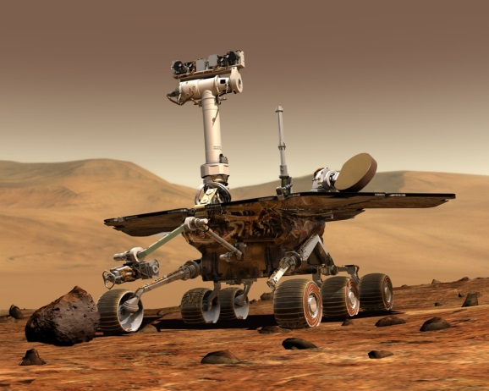

Figure Photo of the Mars Rover of the NASA

This here is a dummy text for testing text editions. Whoever reads this text has only himself to blame. The text only indicates the gray value of the font. Is this really so? Does it make no difference whether I write, "This is a dummy text" or "Huardest gefburn"? Kjift - not at all! A dummy text provides me with important information. I use it to measure the legibility of a typeface, its impression, how harmoniously the figures are set against each other, and to check how wide or narrow it runs. A dummy text should contain as many different letters as possible and be set in the original language. It does not have to make sense, but it should be readable. Foreign-language texts such as "Lorem ip-sum" do not serve the actual purpose, since they convey a false impression.

## Tables

Omit vertical lines in table. Table 1 shows an example to illustrate the format of a table. If you prefer to use captions with an uppercase letter at the start, you can add further categories in the dialog of adding captions. If you use another label as table or figure, you have to adjust the fields in the lists as well.

Table Example table with content types

|  |  |
| --- | --- |
| **Content type** | **Description and use** |
| Table | Show 2-dimensional data or relationships |
| Figure | Show photos, sketches or diagrams to illustrate explanations |
| Listings | Include source code for detailed documentation |
| Lists | Show a short overview of several elements |

.

## Formulas

You can even set formulas with Word, although it is not much fun. For many formulas, LaTeX is better suited.

$$a_{2}=\sqrt{x^{3}}$$

## Source Code

Source code needs a special format, which uses an equal width for all characters. The font “Consolas” has this characteristic. Furthermore, you can highlight keywords or types with bold letters or appropriate colors.

**public** **interface** Crypter {

/**

* Encrypts the text with the given key.

*

* **@param** key to be used

* **@param** message to be encrypted

*

* **@return** encrypted text.

*/

**public** String encrypt (Key key, String message);

Literature

|  |  |
| --- | --- |
| [1] | K. Smarsly and K. Dragos, Scientific Writing in Engineering, Hamburg: tredition, 2019. |
| [2] | P. Vixie, "DNS complexity," *Queue,* p. 24, April 2007. |
| [3] | B.-U. Weimar, "Citavi Campuslizenz," 2019. [Online]. Available: https://www.uni-weimar.de/de/universitaet/struktur/zentrale-einrichtungen/scc-rechenzentrum/software/citavi-campuslizenz/. [Accessed 19 04 2021]. |
| [4] | Mendeley Ltd., "Download Mendeley Desktop," 01 01 2020. [Online]. Available: https://www.mendeley.com/download-desktop-new/. [Accessed 19 04 2021]. |
| [5] | Clarivate Analytics, "EndNote," 01 01 2019. [Online]. Available: https://endnote.com/. [Accessed 19 04 2021]. |
| [6] | A. Einstein, " Zur Elektrodynamik bewegter Körper," *Annalen der Physik,* pp. 891-912, September 1905. |
| [7] | M. Kornmeier, Wissenschaftlich schreiben leicht, 4. Hrsg., UTB, 2011. |

1. Fully written means that the full term is used and not the abbreviation.