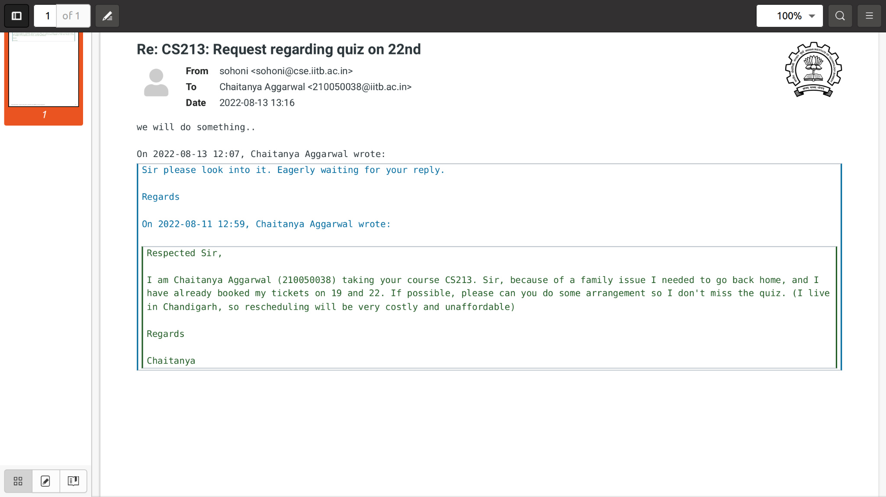

Mail regarding a request about the quiz that was announced on 11th August.

In the endsem break I travel by train, but because the journey takes 24 hours, it was not possible to travel by train between a semester.

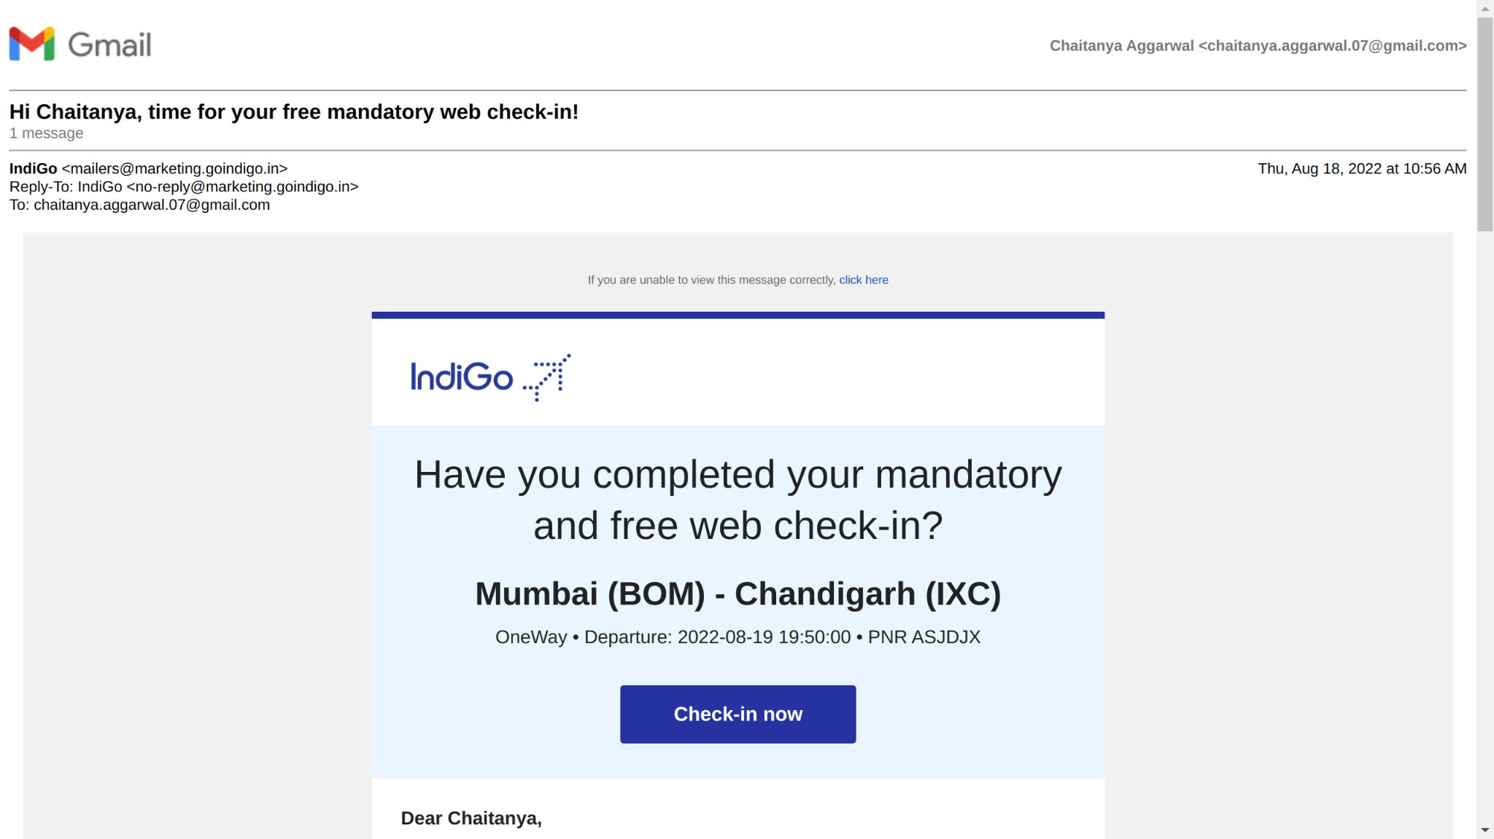

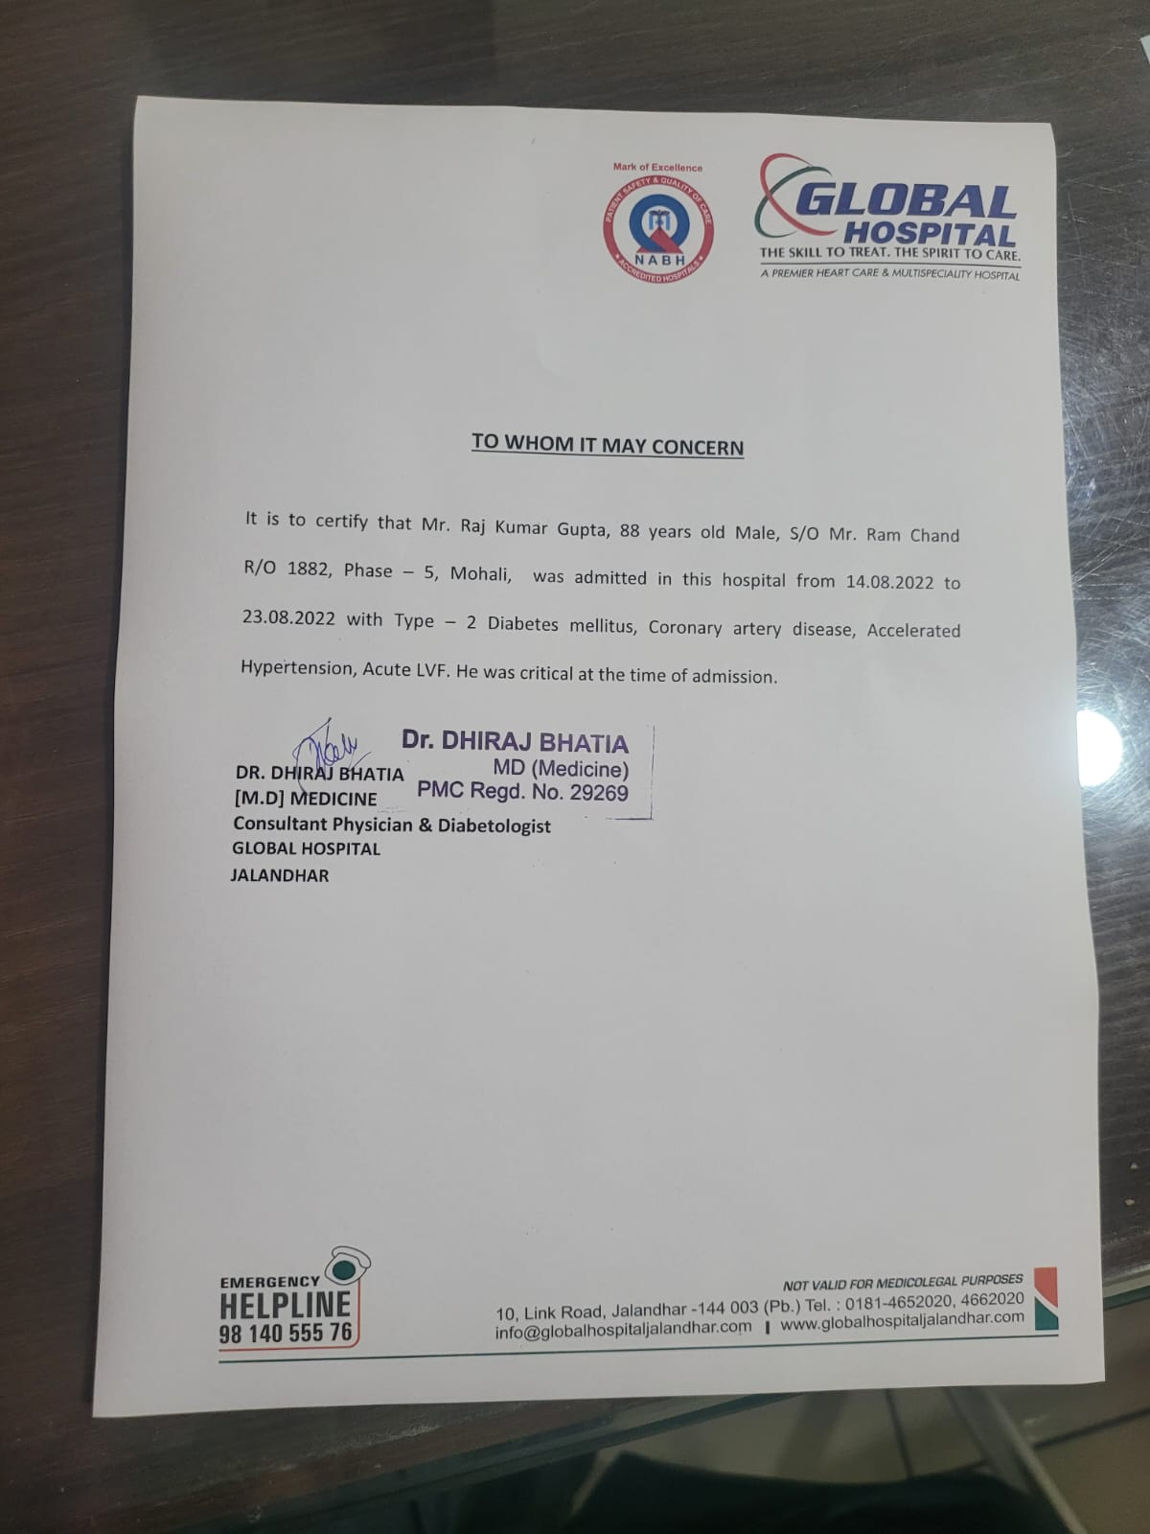

Certificate from the hospital in which my grandfather was admitted. (He couldn't get admission into PGI, and as he needed urgent treatment, he was taken to Jalandhar (2 hours from Chandigarh)).

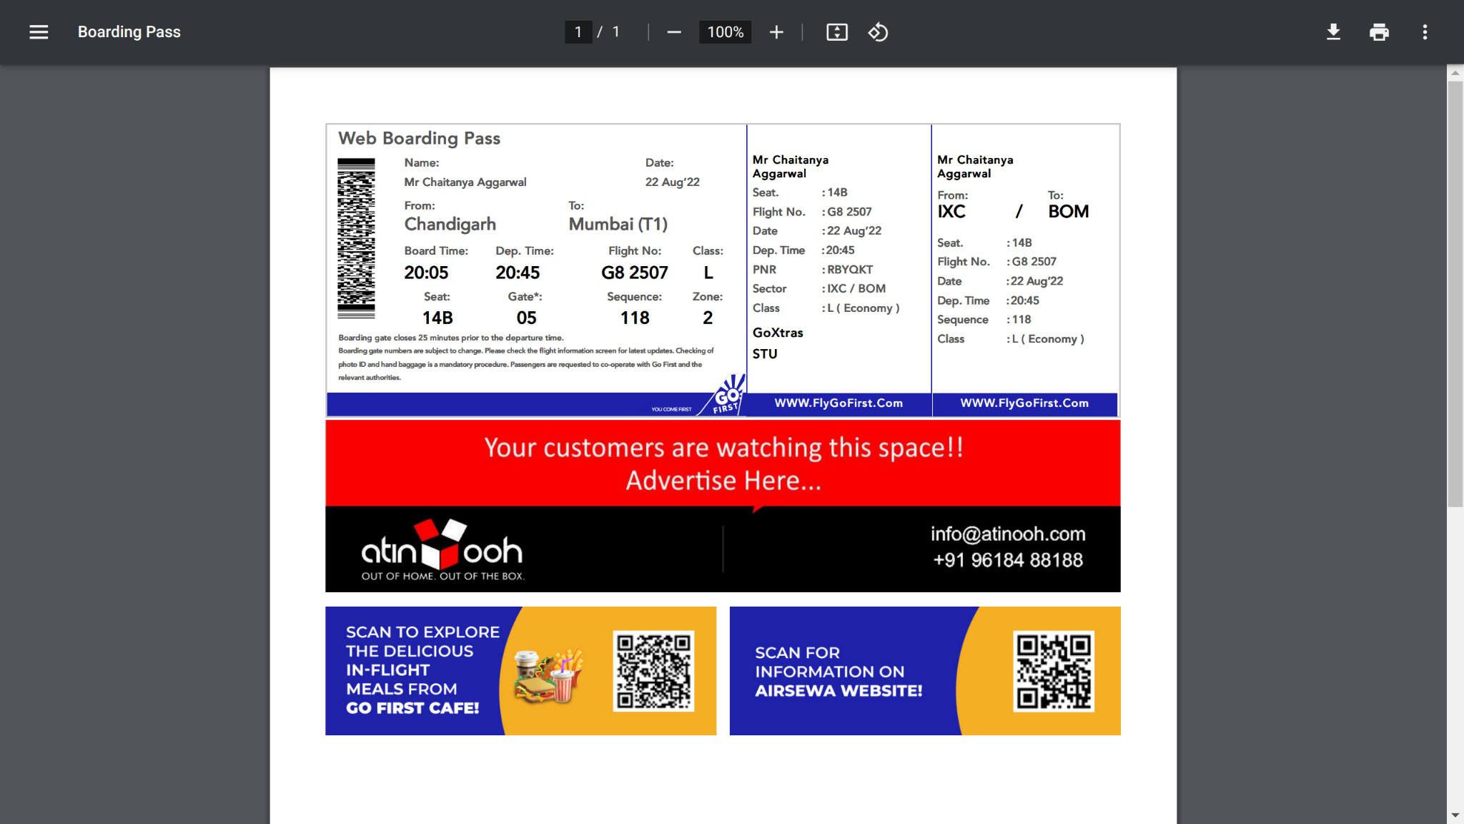

Boarding pass of the return journey.