**Smart Waste Management Database System (SWMDS)**

# Objectives and Scope

Objectives: The key objectives of the Smart Waste Management Database System (SWMDS) include:

1. Boosting efficiency in waste collection and disposal: SWMDS aims to improve waste management operations by offering real-time data on waste quantities, enhancing collection route planning, and supervising vehicle performance.
2. Minimizing environmental impact: Through the optimization of waste collection and disposal processes, SWMDS helps decrease greenhouse gas emissions, reduce fuel usage, and mitigate the overall environmental consequences linked to waste management practices.
3. Promoting data-driven decision-making: The database system empowers waste management stakeholders to access pertinent data and insights, fostering informed decision-making and ongoing improvement.
4. Enhancing waste reduction and recycling efforts: By providing detailed waste data and insights, SWMDS encourages waste generators to minimize waste production and improve recycling practices, contributing to a more circular economy.
5. Streamlining communication and collaboration: The database system fosters better communication between waste management stakeholders, including municipalities, private waste management companies, and residents, enabling efficient coordination and collaboration.
6. Facilitating public awareness and engagement: SWMDS promotes increased public understanding of waste management issues and engages citizens in responsible waste disposal habits by providing accessible information on waste generation and disposal practices.

Scope: The SWMDS covers the following aspects:

1. Domain: The database system focuses on urban waste management, addressing residential, commercial, and industrial waste collection and disposal.
2. Size: SWMDS is tailored to meet the demands of various city scales, from small towns to sprawling urban centers. The system is adaptable, permitting the incorporation of new waste collection points, vehicles, and routes as cities expand or waste management needs evolve.
3. Constraints: The database system faces multiple constraints, such as:

a. Adherence to legal and regulatory requirements: SWMDS must comply with applicable waste management regulations and data protection laws.

b. Ensuring data quality and accuracy: Maintaining precise and up-to-date real-time data, like waste volumes and vehicle locations, is vital for the system's effectiveness.

c. Compatibility with existing infrastructure: SWMDS must be designed to work with current waste management infrastructure, including waste collection vehicles and facilities, to guarantee a smooth implementation and operation.

d. Safeguarding security and privacy: The system is required to shield sensitive data from unauthorized access and preserve the privacy of individual users and businesses.

e. Scalability and adaptability: SWMDS must be designed to accommodate future technological advancements, such as autonomous waste collection vehicles, and incorporate new waste management methods as they emerge.

f. Financial viability: The system should offer a cost-effective solution that takes into account initial setup costs, ongoing maintenance, and the potential for a return on investment through enhanced waste management efficiency.

g. Training and support: SWMDS must provide adequate training materials and support services to ensure smooth adoption and operation by various user groups.

1. Functionality: The database system comprises various modules, such as waste generation tracking, route optimization, vehicle performance monitoring, and waste disposal data analysis, to provide a comprehensive waste management solution.
2. Integration: SWMDS is designed to integrate with other relevant systems, including Geographic Information Systems (GIS), Internet of Things (IoT) devices, and data analytics tools, to enhance the overall effectiveness and efficiency of waste management practices.
3. User Groups: The system caters to a wide range of users, including waste management authorities, private waste management companies, environmental organizations, and individual citizens, by offering customizable access levels and interfaces tailored to their needs.

# User Requirements

1. Real-time data on waste collection points: The system should provide up-to-date information about waste collection points, including the current volume of waste at each location and projections of future waste accumulation based on trends and patterns.
2. Waste collection route optimization: The database system should analyze current waste levels, traffic conditions, and other relevant factors to determine the most efficient routes for waste collection vehicles, minimizing time spent and fuel consumption.
3. Vehicle location and maintenance tracking: The system should monitor the locations of waste collection vehicles in real-time, as well as maintain schedules for each vehicle's waste collection activities. Additionally, the system should track maintenance records and needs for each vehicle.
4. Waste disposal metrics and trends reporting: The database system should generate comprehensive reports on waste management performance, analyzing trends in waste disposal, and identifying areas of improvement in efficiency and sustainability.

How the system will meet these requirements:

1. Real-time data collection: Advanced sensors will be installed at waste collection points to monitor waste levels continuously. This real-time data will be transmitted to the database, allowing users to access current information on waste volumes at any time.
2. Route optimization algorithms: The database will house traffic data, waste level information, and other pertinent factors that can influence waste collection efficiency. Using this data, the system will employ optimization algorithms to determine the most efficient waste collection routes, factoring in real-time conditions.
3. Vehicle data storage and updates: The system will maintain a comprehensive record of waste collection vehicle data, including location, schedule, and maintenance history. This information will be regularly updated, ensuring accurate and up-to-date records for each vehicle.
4. Data-driven performance analysis: The database will calculate waste disposal metrics using the collected data, such as waste volumes and collection frequencies. Users can generate reports to evaluate trends in waste management and identify areas for efficiency improvements and sustainable practices.

# Business Rules

1. Waste generators must be registered with valid contact information, including name, address, and contact number.
2. Waste types should be classified into categories such as organic, recyclable, hazardous, etc., and each waste generator should specify the types of waste they produce.
3. Waste collection points must be located within accessible areas for collection vehicles and must have a unique identifier.
4. Collection vehicles should be registered with a unique identifier, type, capacity, and status (e.g., active, under maintenance).
5. Collection routes must be designed to optimize waste collection efficiency and minimize environmental impact, considering factors such as distance, traffic, and vehicle capacity.
6. Waste management facilities must comply with applicable regulations and should be registered with relevant information, including facility type, capacity, and location.
7. Waste processing methods should be categorized based on the types of waste they can process and their environmental impact.
8. Users should be granted different access levels depending on their role (e.g., waste generator, waste management company, or municipal authority).
9. Waste collection schedules should be created based on the frequency and timing of waste collection for each route, considering factors such as waste generation patterns and vehicle availability.

# ER diagram

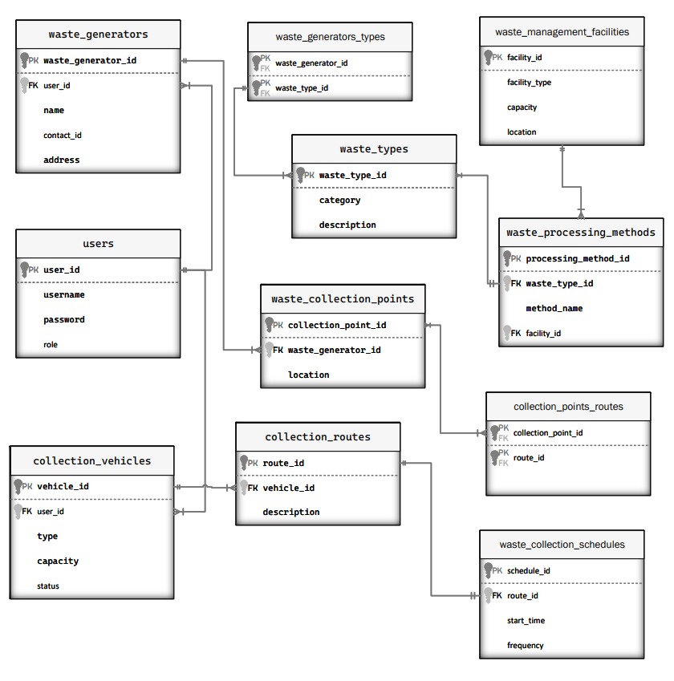

# System Data Dictionary

|  |  |  |  |  |  |  |  |  |
| --- | --- | --- | --- | --- | --- | --- | --- | --- |
| TABLE NAME | ATTRIBUTE NAME | CONTENTS | TYPE | FORMAT | RANGE | REQUIRED | PK OF FK | FK REFERENCED TABLE |
| Waste_generators | Waste_generater_id | Unique identifier for a waste generator | VARCHAR(10) | XXXXXX |  | Y | PK |  |
|  | Name | Name of the waste generator | VARCHAR(20) | Xxxxxx |  | Y |  |  |
|  | Address | Address of the waste generator | VARCHAR(20) | Xxxxxx |  | Y |  |  |
|  | Contact_Number | Contact of the waste generator | VARCHAR(20) | xxx-xxxx-xxx |  | Y |  |  |
|  | User_id | User associated with the waste generator | VARCHAR(10) | XXX |  | Y | FK | users |
| Waste_types | Waste_type_id | Unique identifier for a waste type | VARCHAR(10) | XXXXX |  | Y | PK |  |
|  | category | Category of the waste type | VARCHAR(10) | Xxxxx |  | Y |  |  |
|  | description | Description of the waste | Text | xxxx |  | Y |  |  |
| Waste_collection_points | Collection_point_id | Unique identifier for a waste collection point | VARCHAR(10) | XXXXXX |  | Y | PK |  |
|  | Waste_generator_id | Waste generator associated with the collection point | VARCHAR(10) | XXXXX |  | Y | FK | Waste_generators |
|  | location | Location of the waste collection point | VARCHAR(10) | XXXXX |  | Y |  |  |
| Collection_vehicles | Vehicle_id | Unique identifier for a collection vehicle | VARCHAR(10) | XXXX |  | Y | PK |  |
|  | type | Type of the collection vehicle | VARCHAR(10) | XXXX |  | Y |  |  |
|  | capacity | Capacity of the collection vehicle | INT(5) | XXXX |  | Y |  |  |
|  | status | Status of the collection vehicle | VARCHAR(10) | XXXXX |  | Y |  |  |
|  | User_id | User associated with the collection vehicle | VARCHAR(10) | XXXX |  | Y | FK | users |
| Collection_routes | Routes_id | Unique identifier for a collection route | VARCHAR(10) | XXXX |  | Y | PK |  |
|  | description | Description of the collection route | TEXT |  |  | Y |  |  |
|  | Vehicle_id | Collection vehicle assigned to the route | VARCHAR(10) | XXXX |  | Y | FK | Collection_vehicles |
| waste_management_facilities | Facility_id | Unique identifier for a waste management facility | VARCHAR(10) | XXXXX |  | Y | PK |  |
|  | Facility_type | Type of the waste management facility | VARCHAR(50) | Xxxxxxx |  | Y |  |  |
|  | capacity | Capacity of the waste management facility | INT(10) | XXX | 0 – 10,000,000 | Y |  |  |
|  | location | Location of the waste management facility | VARCHAR(10) | XXXXX |  | Y |  |  |
|  | email | Customer email | VARCHAR(50) | XXXXX |  | Y |  |  |
| waste_processing_methods | processing_method_id | Unique identifier for a waste processing method | VARCHAR(10) | XXXXX |  | Y | PK |  |
|  | method_name | Name of the waste processing method | VARCHAR(20) | XXXXX |  | Y |  |  |
|  | waste_type_id | Waste type processed by the method | VARCHAR(10) | ` |  | Y | FK | Waste_types |
|  | facility_id | Facility using the waste processing method | VARCHAR(10) | XXXX |  | Y | FK | Waste_management_facilities |
| Users | User_id | Unique identifier for a user | VARCHAR(10) | XXXX |  | Y | PK |  |
|  | username | Username of the user | VARCHAR(10) | XXXX |  | Y |  |  |
|  | password | Password of the user | VARCHAR(10) | XXXX |  | Y |  |  |
|  | Role | Role of user | VARCHAR | XX |  | Y |  |  |

# DATA ENTRY AND UPDATE

***Users Table***

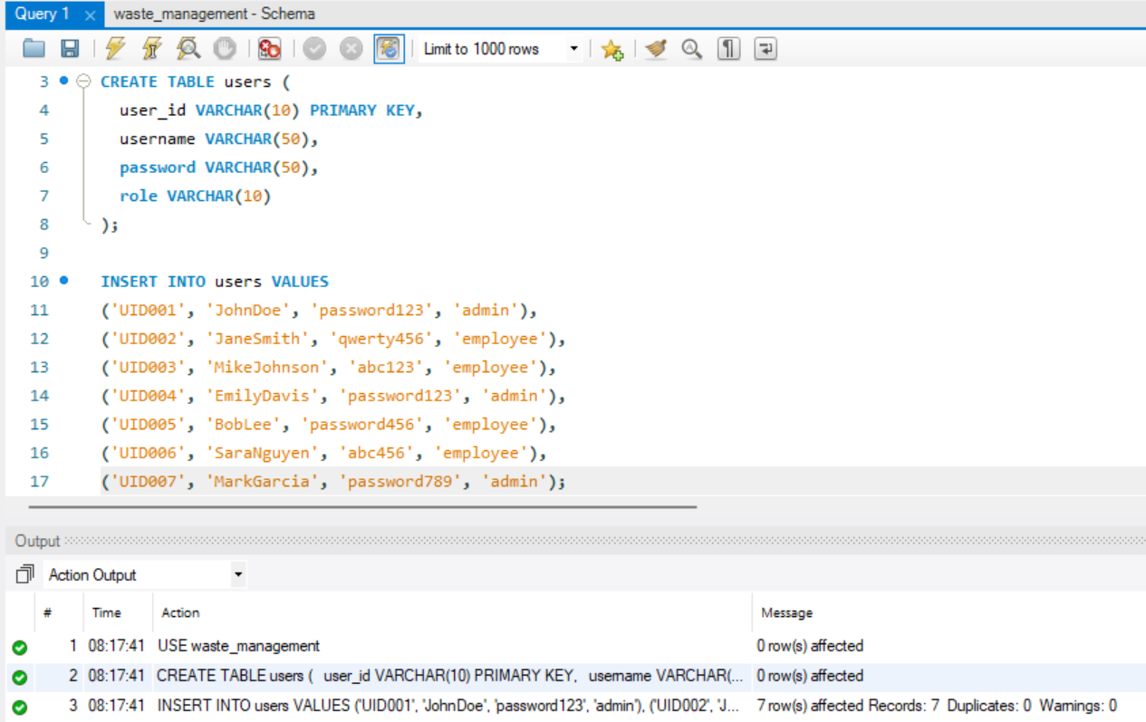

***Waste Generators Table***

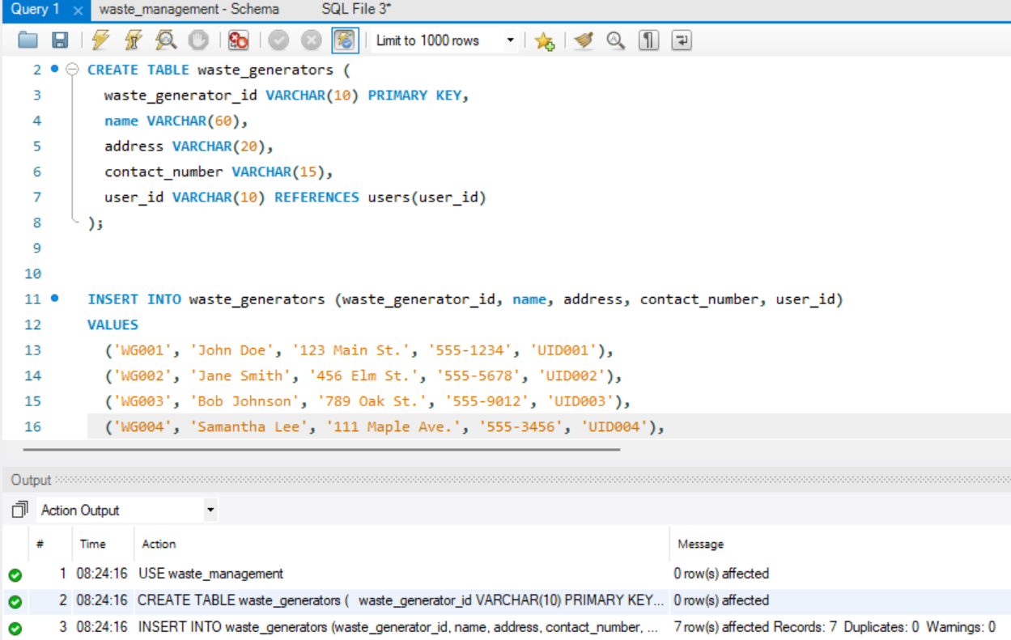

***Waste Types Table***

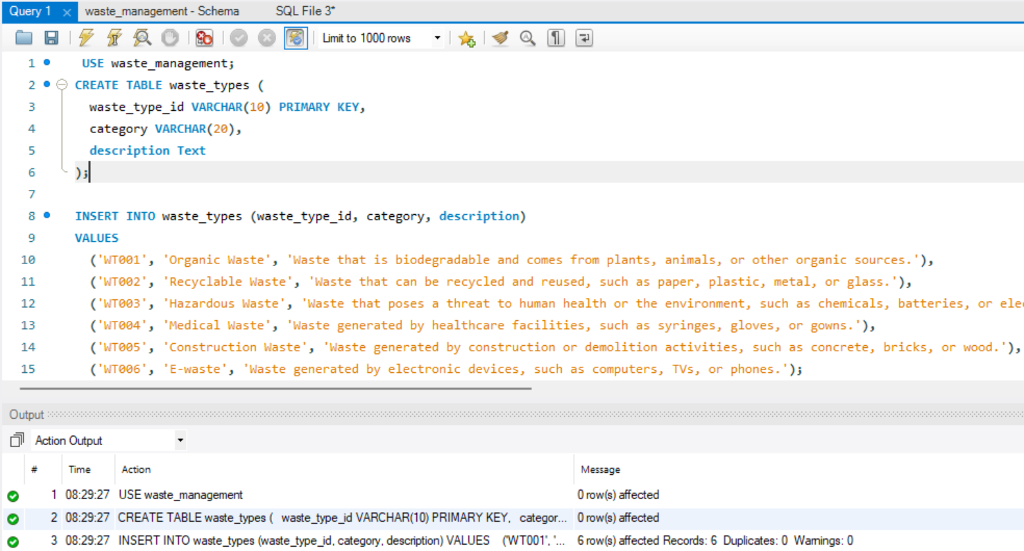

***Waste Collection Points Table***

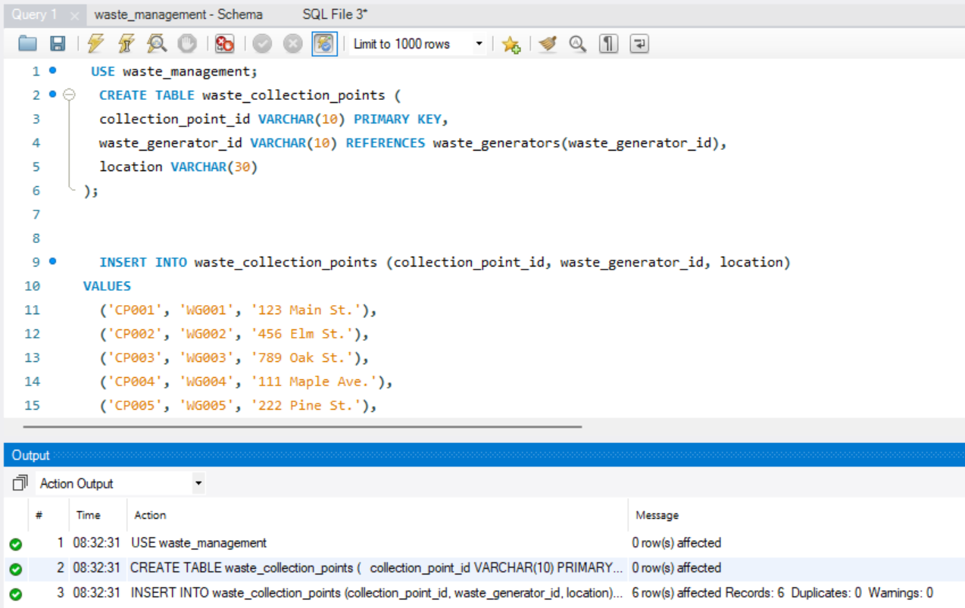

***Collection Vehicles Table***

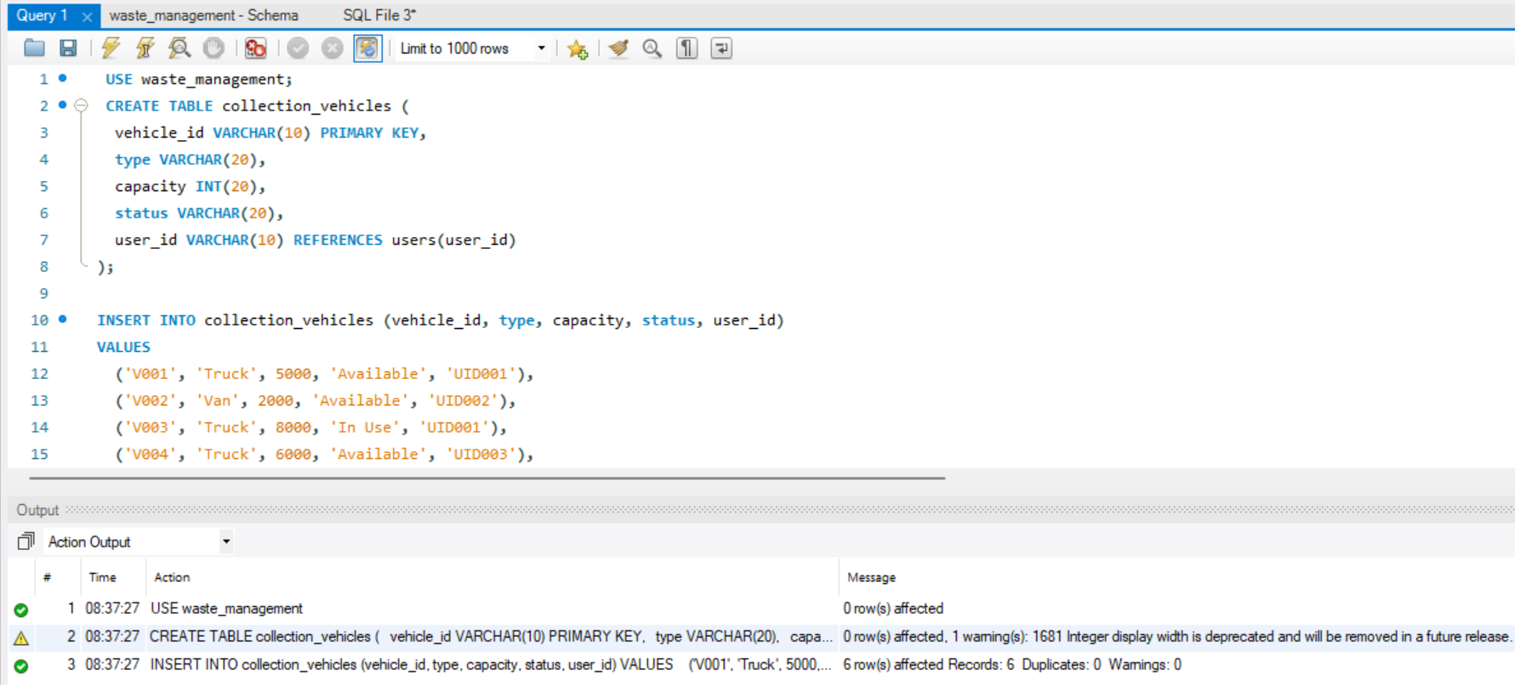

***Collection routes table***

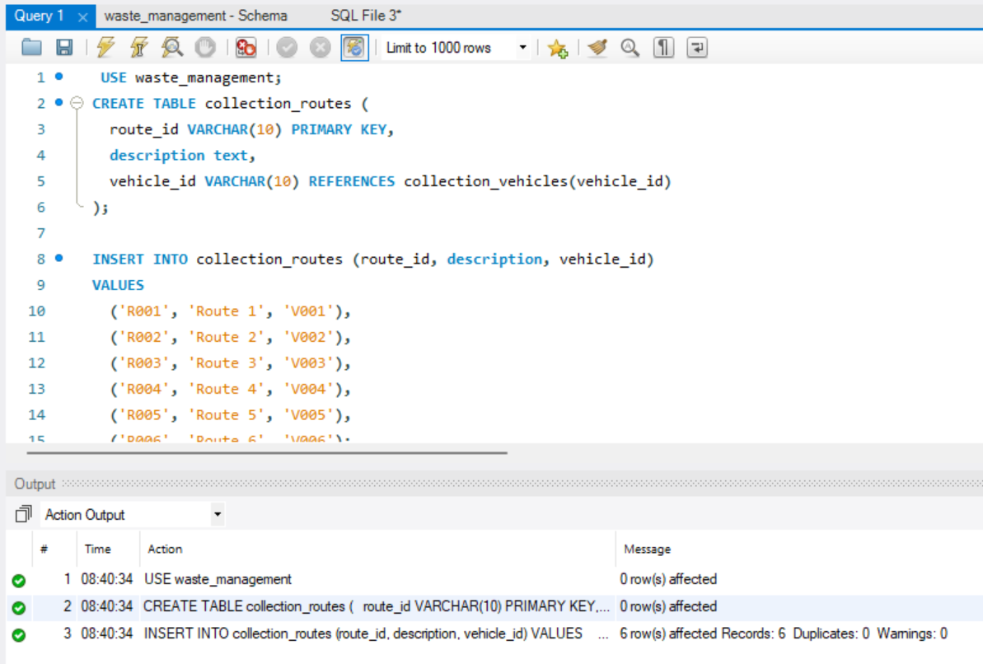

***Waste Management Facilities table***

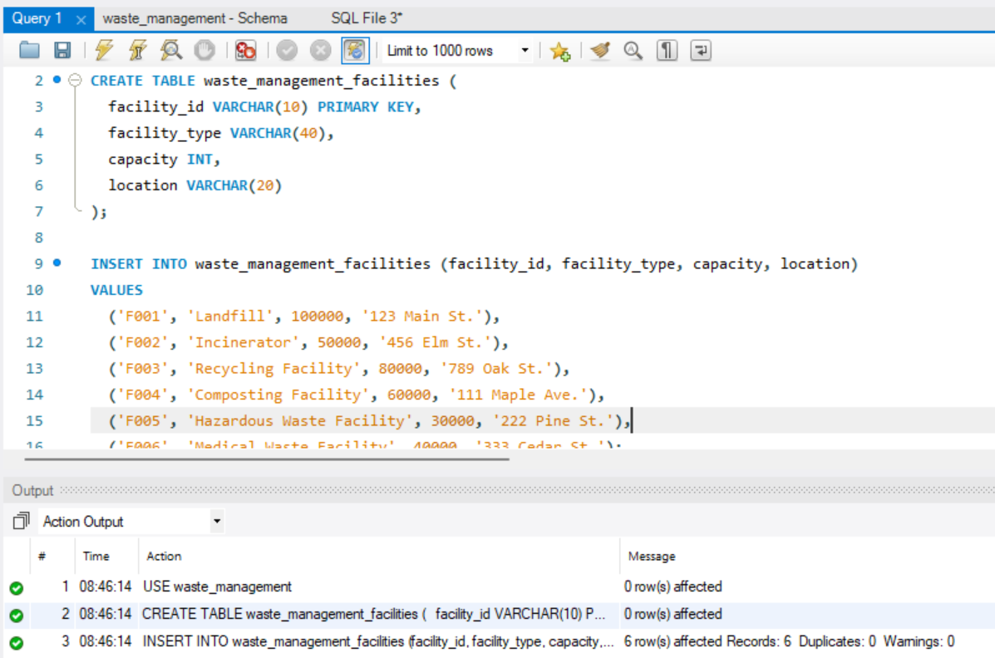

***Waste Processing Methods Table***

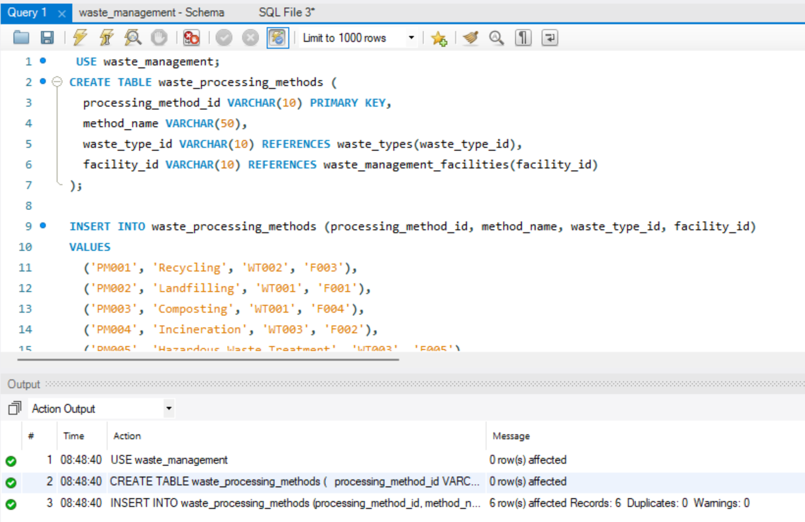

***Waste collection schedules***

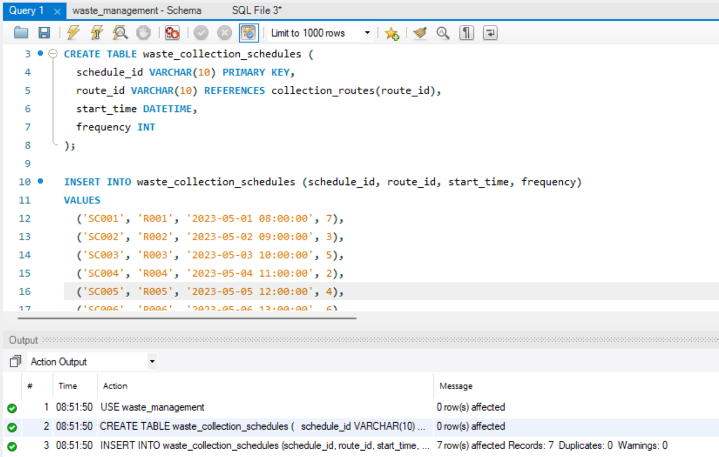

***Waste Generators Types Table***

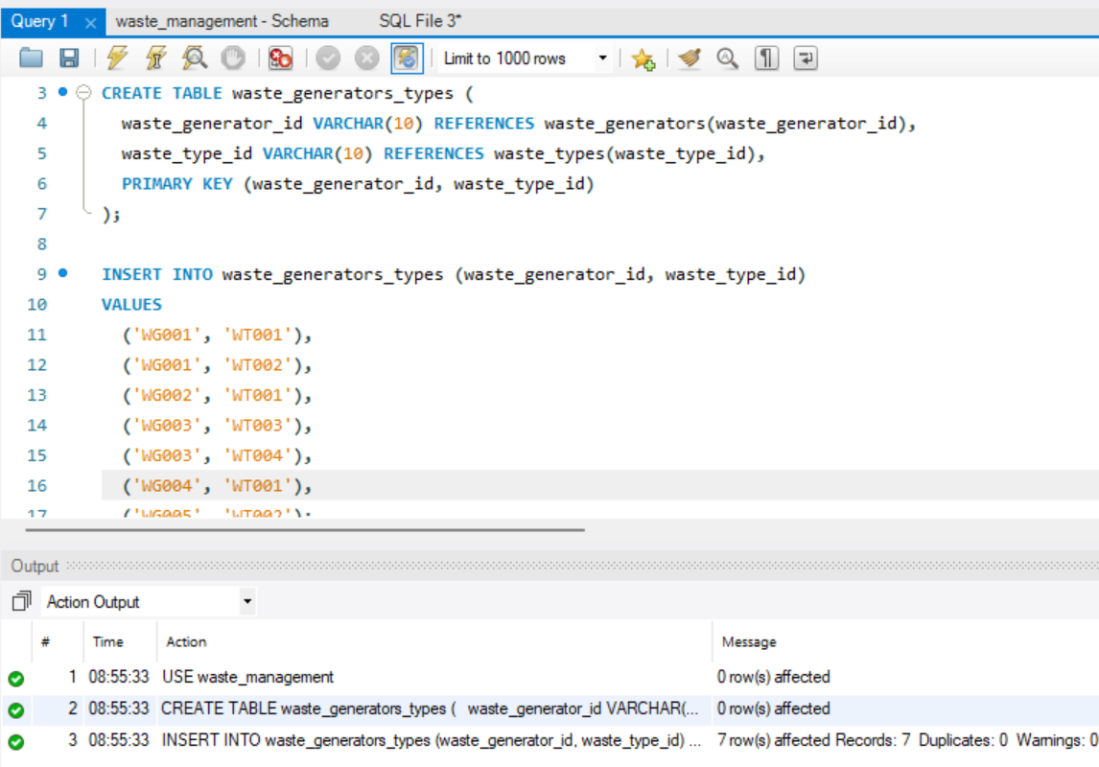

# Data Retrival Queries

**Query 1:** Retrieve the list of waste generators along with their contact information and assigned user's username.

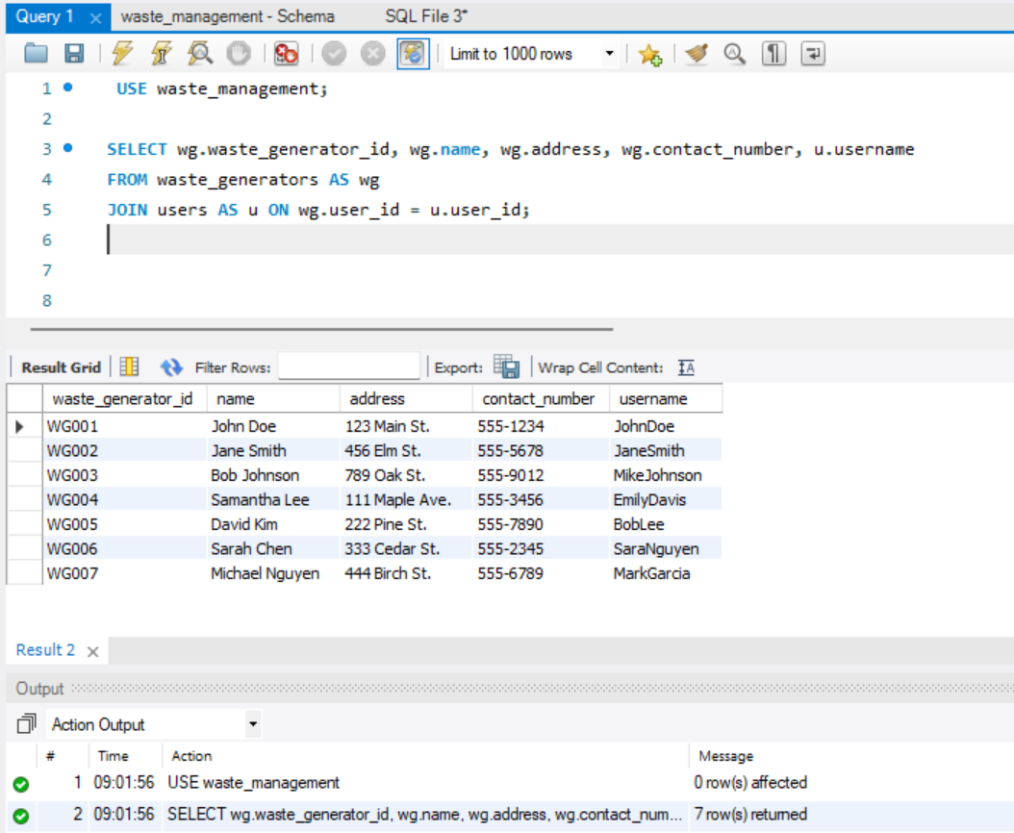

**Query2:** Retrieve the list of collection vehicles along with their capacity, current status, and assigned user's username.

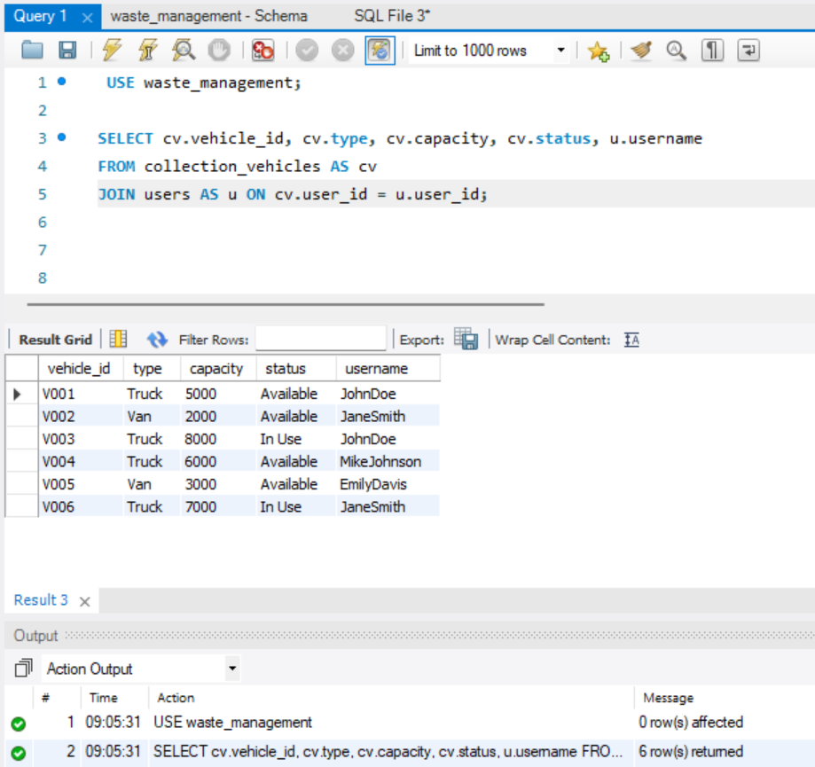

**Query 3:** Retrieve the waste types and their corresponding processing methods, along with the facility type and location.

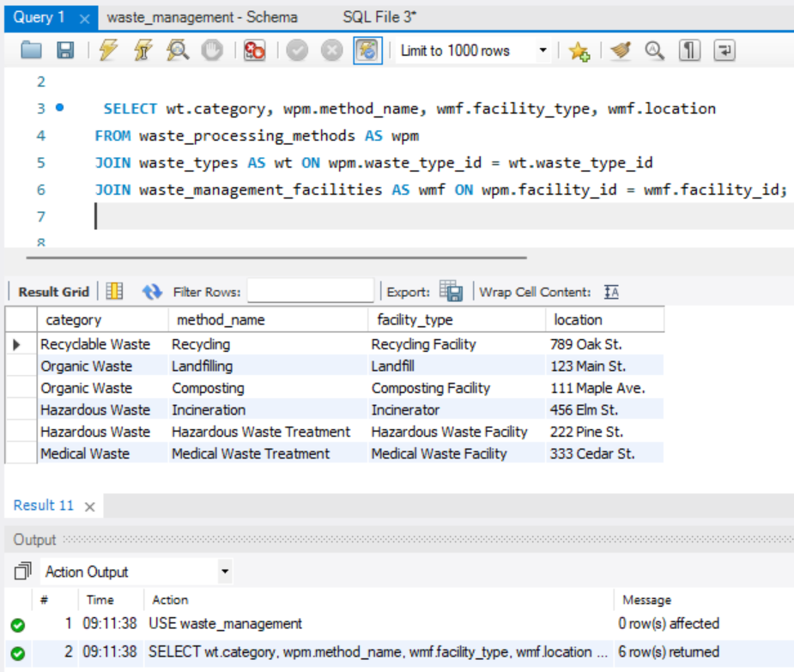

**Query 4:** Retrieve the collection routes and their corresponding vehicles, along with the waste collection schedules.

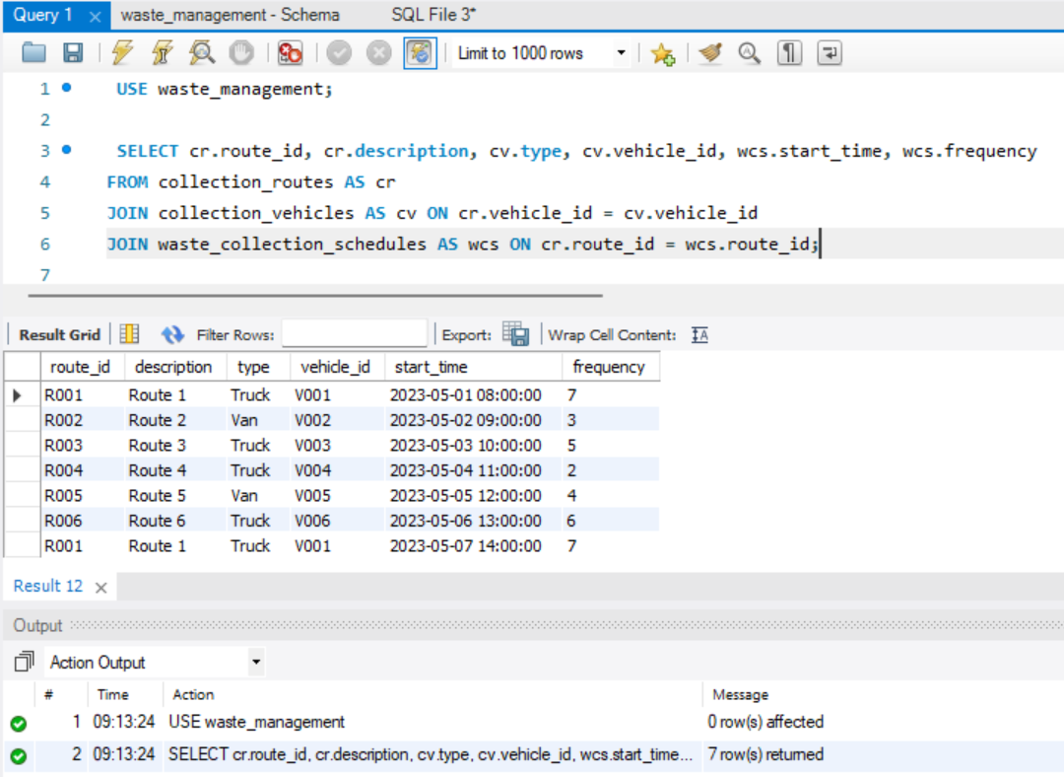

**Query 5 :** Retrieve the list of waste generators along with the waste types they generate.

