HEART DISEASE
CLASSIFICATION
End-to-End MLOps Project Report
Data preparation • Model development • Experiment tracking • API • CI/CD • Containerization • Kubernetes

Report detail | Value
Project | heart-disease-mlops
Programming environment | Python 3.11 / Anaconda (Windows development environment)
Dataset source | UCI Machine Learning Repository — Heart Disease (Cleveland subset used by project code)
Experiment tracking | MLflow with SQLite backend (local development)
API framework | FastAPI / Uvicorn
Deployment target | Docker and Minikube Kubernetes (local demonstration)
Prepared for | Chaitanya Patil (2025af05025)
PROJECT ARCHITECTURE OVERVIEW
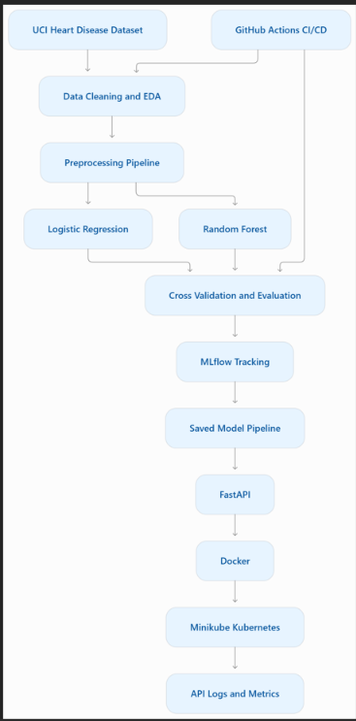

1.1. Executive Summary
Project purpose, scope, and intended outcomes
This project demonstrates a practical, end-to-end Machine Learning Operations (MLOps) workflow for a binary classification task using the UCI Heart Disease dataset. The implementation brings together data preparation, exploratory analysis, model comparison, experiment tracking, automated checks, API serving, containerization, and local Kubernetes deployment.

Objectives
Create a repeatable data preparation step that obtains the dataset, handles missing-value markers, and constructs a binary target according to the project code.
Explore feature distributions, target balance, and correlations to understand the data before training.
Train and compare Logistic Regression and Random Forest models using a reproducible train/test split and cross-validation as configured.
Record experiment metrics and model artifacts with MLflow using a SQLite-backed tracking store for local development.
Expose model inference through a FastAPI service with health and metrics endpoints.
Apply code-quality checks and unit tests, then package and run the service with Docker and Kubernetes.

Scope and deliverables
The intended deliverables are source code, dependency definitions, data download/processing instructions, tests, a GitHub Actions workflow, a Dockerfile, Kubernetes manifests, screenshots, and this written report. The workflow described here is continuous integration: it lints, trains, tests, and uploads available artifacts. Automated image publishing or deployment is a separate enhancement unless added to the pipeline.

Current evidence to insert

No model performance values are asserted in this report because the final training output has not been supplied here. Populate the results section with values copied from your actual MLflow run and training output.

2. Dataset and Data Preparation
Source, target definition, and repeatability

Dataset source
The project uses the Heart Disease dataset from the UCI Machine Learning Repository. The data preparation module (src/data.py) is designed to retrieve the dataset using the ucimlrepo package, normalize missing-value markers, convert columns to numeric where appropriate, remove rows without a usable target, and save a processed local CSV.

Target construction
The project code maps the original target to a binary label by treating target values greater than zero as the positive class and zero as the negative class. This conversion is part of the project's implementation and should be documented consistently in the code, report, and API explanation.

Data preparation sequence
- Retrieve the dataset from its stated source.
- Replace string missing markers such as '?' with missing values.
- Convert feature columns to numeric values where appropriate.
- Remove rows where the target is missing.
- Create the binary target label using the configured mapping.
- Write the processed dataset to data/heart.csv for subsequent EDA and training.

Reproducibility and data handling
The data download script should be committed to GitHub, while generated data may be excluded from version control by .gitignore. This keeps the repository lighter and allows CI to regenerate the dataset. The README should include the exact download command and note that internet access is required for a fresh download.
Insert screenshot of the data preparation command completing, or a notebook/table showing rows, columns, data types, and missing values.
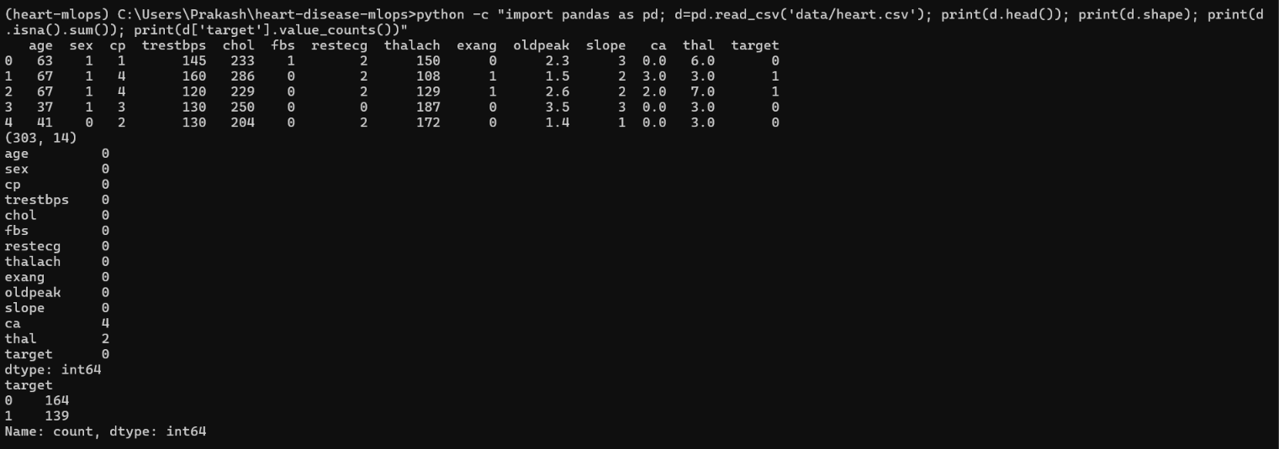

Validation notes: record the final row count, feature count, target class counts, and any rows removed after running the actual pipeline.

3. Exploratory Data Analysis
Understanding distributions and relationships
Exploratory Data Analysis (EDA) is used to inspect the data before fitting models. The project's EDA script is intended to generate a target class-balance summary, feature distribution plots, and a correlation heatmap. These visualizations help identify skewed variables, possible data-quality issues, class imbalance, and relationships among numeric features.

Recommended interpretation
Class balance: compare the number of positive and negative examples; imbalance can affect the interpretation of accuracy.
Feature distributions: inspect ranges, unusual values, and skew. Do not remove observations solely because they appear unusual without a defensible reason.
Correlation heatmap: use it as an exploratory aid, not proof of causality. Correlation among predictors can influence some model types and coefficient interpretation.
Data leakage: perform preprocessing inside the scikit-learn pipeline so statistics such as imputation and scaling are learned from training folds rather than the full dataset.

EDA outputs
Output | Purpose | Evidence to record
Target class balance | Understand label distribution | Counts and/or bar chart
Feature histograms | Inspect shape and range of features | Representative plots
Correlation heatmap | Review linear relationships among numeric columns | Heatmap image
Data-quality summary | Identify missingness and conversion issues | Rows/columns and missing counts

[ EDA FIGURE 1 — TARGET CLASS BALANCE ]
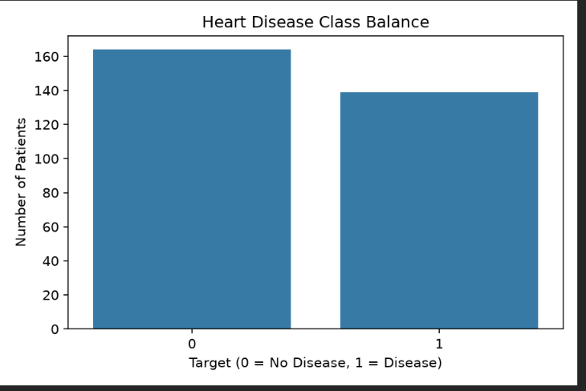

[ CORRELATION HEATMAP ]
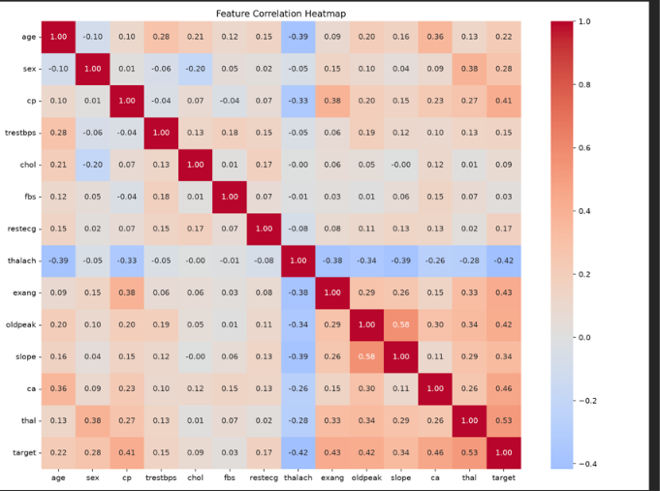

4. Model Development and Evaluation
Baseline comparison and validation
The training module is designed to compare Logistic Regression and Random Forest classifiers. Logistic Regression provides a relatively interpretable linear baseline, while Random Forest can represent nonlinear relationships and interactions. Their performance should be compared using the same split strategy and metrics.

Pipeline design
The project uses scikit-learn pipelines and preprocessing components so that imputation, scaling, and categorical-feature handling can be applied consistently. Pipeline-based preprocessing also reduces the risk of leakage during cross-validation. The feature list and categorical columns must remain consistent between training and the FastAPI request schema.

Evaluation measures
Metric | What it measures | Interpretation caution
Accuracy | Fraction of predictions that are correct | Can hide poor minority-class performance
Precision | Fraction of predicted positives that are true positives | False positives affect this value
Recall | Fraction of actual positives detected | False negatives affect this value
ROC-AUC | Ranking quality across classification thresholds | Requires appropriate probability/score output

[TRAINING OUTPUT / MODEL COMPARISON ]

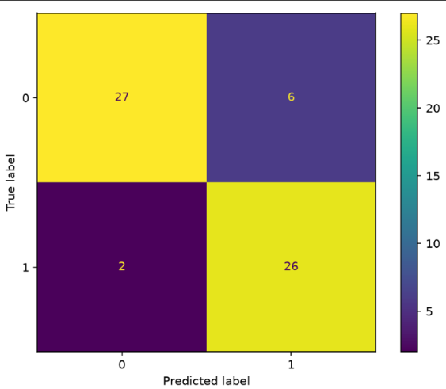
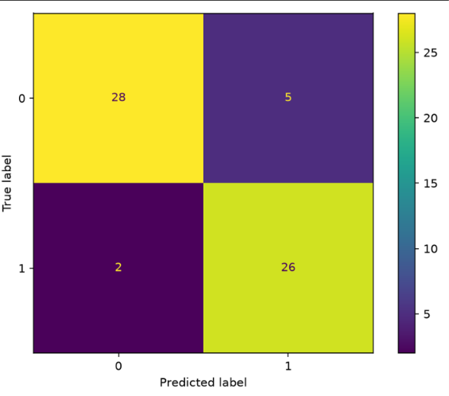
Logistic Regression Random Forest
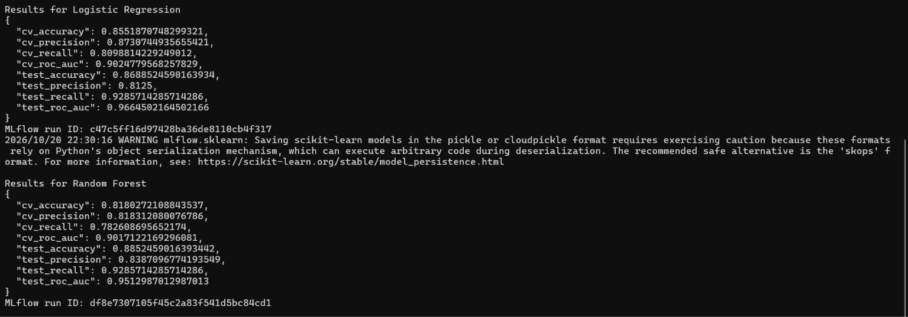

Model selection should be justified using the evaluation evidence and the intended error trade-offs. Do not describe a model as clinically accurate based only on performance on this small public dataset.

5. MLflow Experiment Tracking
Logging parameters, metrics, and artifacts
MLflow is used to organize and compare model-training runs. In the local Windows environment, the tracking URI is configured as sqlite:///mlflow.db. The training script should log the experiment name, model/run details, evaluation metrics, and available plots or model artifacts. The MLflow UI is launched separately so that experiments can be inspected in a browser.

Local workflow
- Activate the heart-mlops Conda environment.
- Run data preparation and training from the project root.
- Start the UI with: mlflow ui --backend-store-uri sqlite:///mlflow.db --host 127.0.0.1 --port 5000
- Open http://127.0.0.1:5000 and select the relevant experiment.
- Compare run metrics and inspect logged artifacts before deciding which model to use.

Tracking benefits
Creates a record of model runs and their evaluation results.
Supports comparison across model types and parameter settings.
Helps reviewers reproduce the reported result when the code, dependencies, data source, and run configuration are preserved.
Separates model experimentation from API serving, although this prototype still uses local storage rather than a centralized production tracking service.
[MLFLOW EXPERIMENT OVERVIEW ]
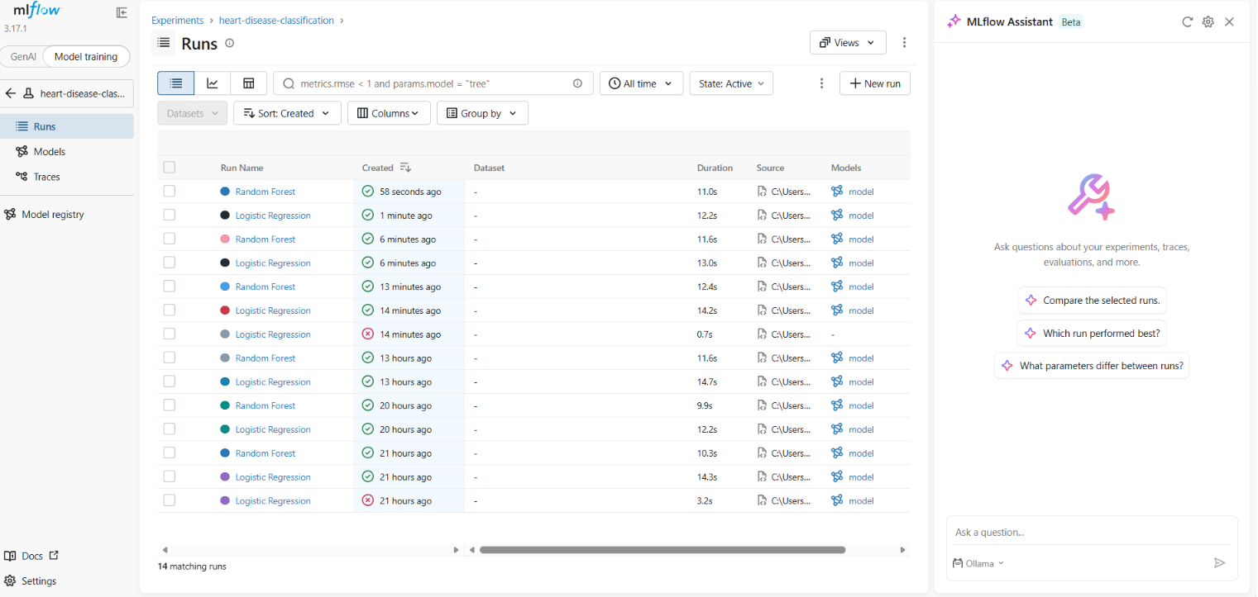

[ MLFLOW RUN DETAILS ]
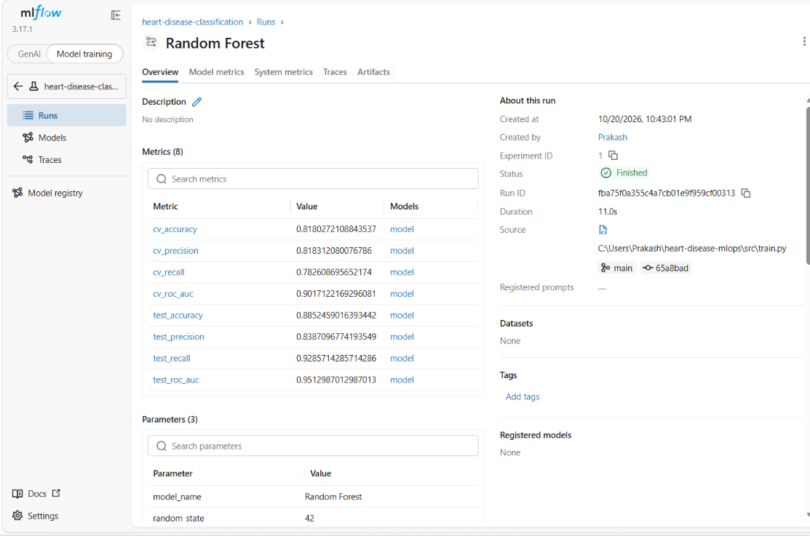

If the UI displays no runs, verify that training and the UI use the same tracking URI and working directory.

6. API, Inference, and Monitoring
Serving predictions with FastAPI
The API module (src/api.py) loads the serialized model and exposes HTTP endpoints through FastAPI. The /health endpoint indicates whether the service is healthy and whether the model was loaded. The /predict endpoint accepts a JSON record containing the 13 configured Cleveland dataset features. A /metrics endpoint exposes Prometheus-compatible request metrics where configured.

API test workflow
- Start the service from the repository root with: uvicorn src.api:app --reload
- Open http://127.0.0.1:8000/docs.
- Check GET /health and confirm model_loaded is true.
- Use POST /predict with a valid sample request matching the Pydantic schema.
- Inspect GET /metrics and the server logs to verify basic observability.

Example request fields
The schema includes age, sex, cp, trestbps, chol, fbs, restecg, thalach, exang, oldpeak, slope, ca, and thal. Values should match the expected feature meanings and coding used by the source dataset. Request validation can reject malformed inputs, but schema validation alone does not establish clinical appropriateness.
[ FASTAPI SWAGGER UI ]
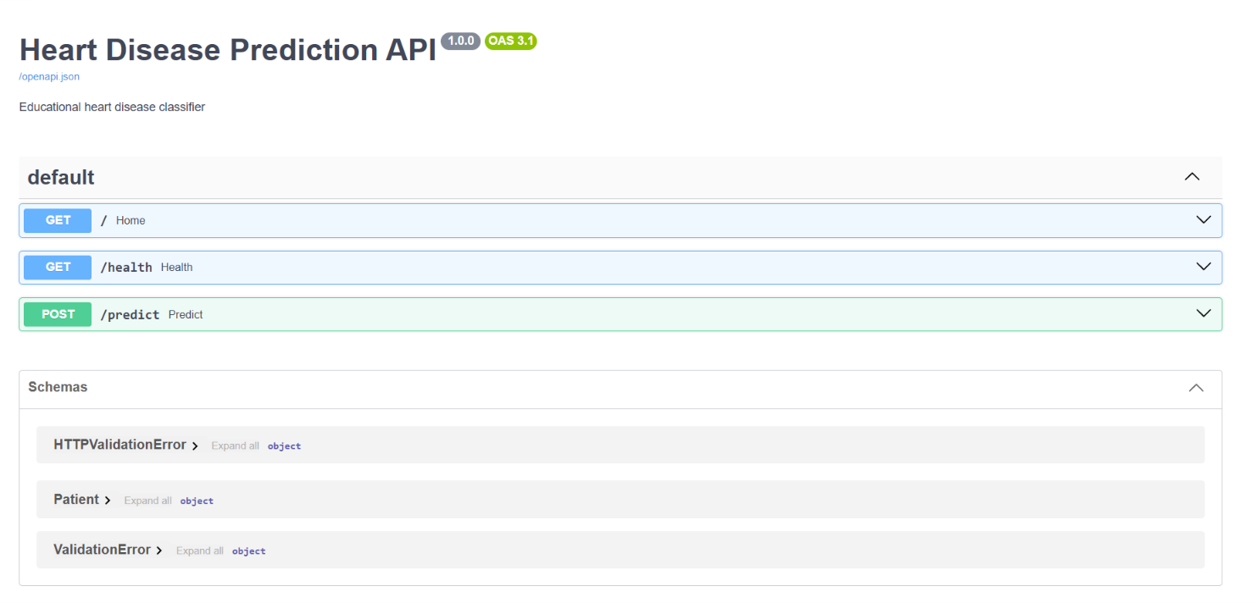

[ PREDICTION RESPONSE ]
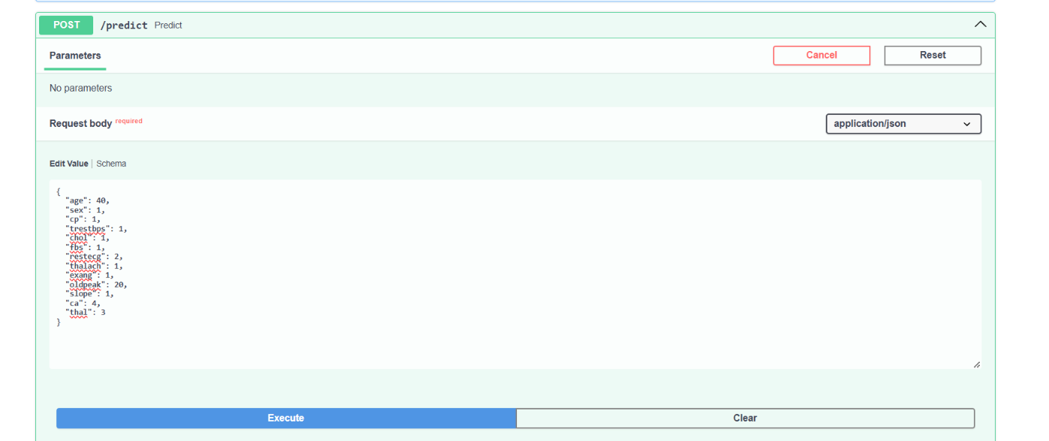
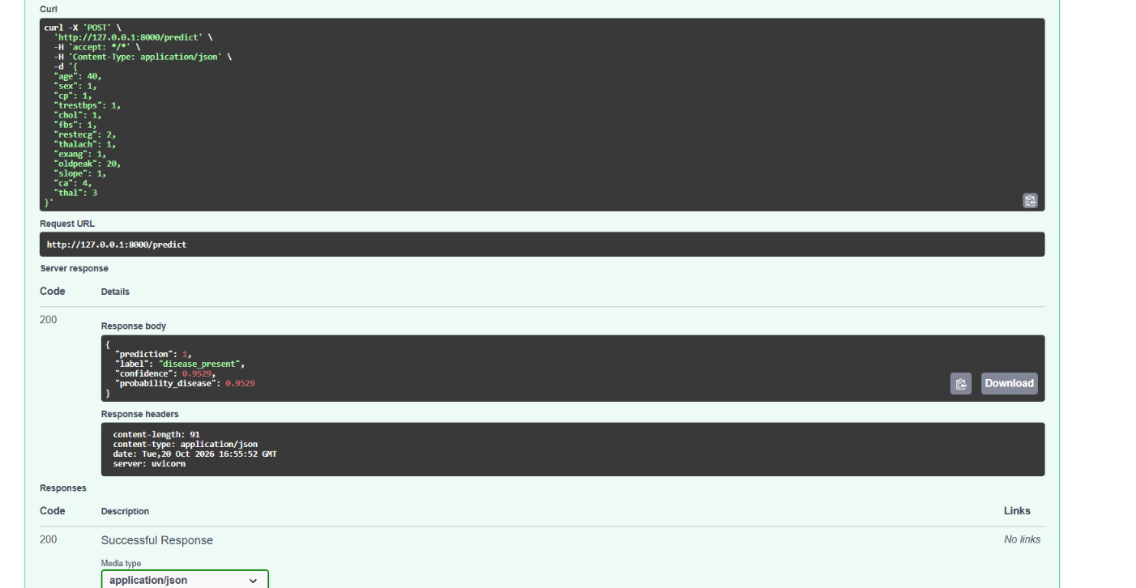

Monitoring in this prototype is intentionally lightweight. Prometheus metrics and container logs provide basic evidence of activity, but production monitoring would also require alerting, access controls, retention policies, error analysis, and privacy protections.

7. Testing, Code Quality, and CI/CD
Automated verification through GitHub Actions
The project includes pytest tests for data handling and API behavior, and Ruff is used to check source-code quality and import organization. The GitHub Actions workflow (.github/workflows/ci.yml) is configured to run on pushes and pull requests targeting main. It checks out the repository, installs dependencies, lints the code, downloads/prepares the data, trains models, runs tests, and uploads available artifacts.

Local verification commands
ruff check src tests
python -m src.data
python -m src.train
python -m pytest -v

CI behavior and limitations
A green workflow run means the configured checks passed for that commit; it does not prove the model is clinically safe.
The workflow must use the same dependency versions and commands as the repository documentation.
Dataset download requires network access in the hosted runner.
SQLite and MLflow artifact paths should be configured deliberately if artifacts are expected to be uploaded.
The current CI workflow does not automatically publish a Docker image or deploy to Kubernetes unless those stages are added.
[ GITHUB ACTIONS SUCCESSFUL RUN ]
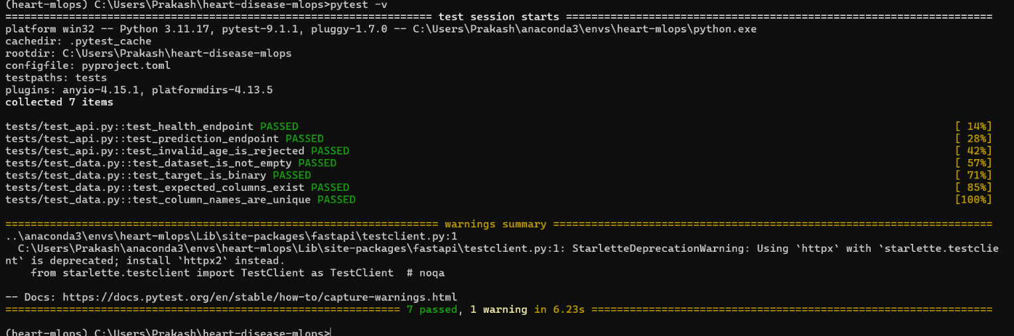

8. Docker and Kubernetes Deployment
Container packaging and local cluster validation
Docker packages the API code, runtime dependencies, and saved model into a container image. Kubernetes deployment is demonstrated locally with Minikube. The Kubernetes manifest defines the application deployment and service and can include health probes. On Windows with the Docker driver, the terminal used by `minikube service --url` may need to remain open while the service tunnel is active.

Docker workflow
- Confirm that Docker Desktop is running.
- Ensure Dockerfile, requirements.txt, src/, and models/model.joblib are present.
- Build the image: docker build -t heart-disease-api:1.0 .
- Run locally: docker run --rm -p 8000:8000 heart-disease-api:1.0
- Verify /health and /docs through localhost.

Minikube workflow
- Start the cluster: minikube start --driver=docker.
- Confirm the node is Ready: kubectl get nodes.
- Build the image for Minikube: minikube image build -t heart-disease-api:1.0 .
- Apply the manifest: kubectl apply -f deployment/deployment.yaml.
- Inspect resources: kubectl get pods and kubectl get services.
- Expose the API with `minikube service heart-disease-api --url` or use `kubectl port-forward`.
[ DOCKER BUILD / CONTAINER HEALTH ]
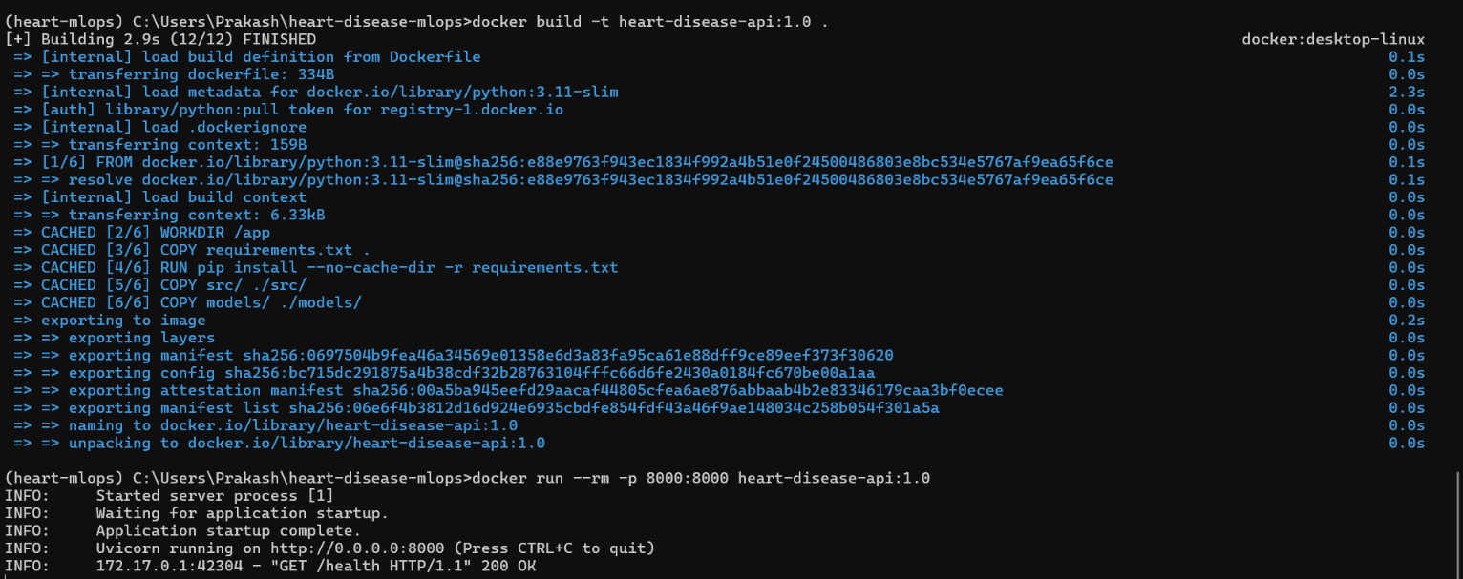

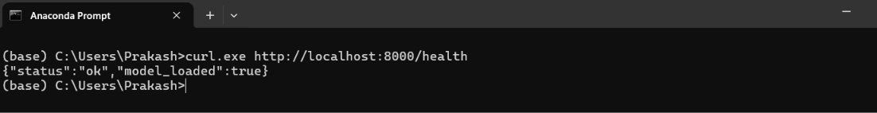

The Minikube URL is a local access URL, not a public production endpoint. For a persistent public deployment, hosting, network exposure, TLS, authentication, and operational monitoring would need to be configured separately.

9. Conclusion, Limitations, and Submission Checklist
Final review and evidence

Conclusion
This project demonstrates the main stages of an applied MLOps workflow: data preparation, exploratory analysis, model comparison, experiment tracking, API serving, automated tests, CI, containerization, and local Kubernetes deployment. It provides a foundation for learning how model code can be moved from an experiment into a reproducible service. The final quality of the submission depends on running the complete pipeline successfully and replacing placeholders with genuine evidence from the implementation.

Limitations and responsible use
The dataset is small and may not represent current clinical practice or all populations.
The model is a learning exercise, not a validated clinical tool or medical device.
Metrics on a held-out subset do not demonstrate generalization to hospitals, geographies, or real-world populations.
The local development setup is not production-hardened; secrets, access control, TLS, privacy, audit, drift monitoring, and incident response need further design.
Report actual model metrics, test results, and deployment outcomes; do not invent or estimate missing results.

Final submission checklist
Item | Before submission
Source code, requirements, README | Verify files are committed and pushed
Data download/processing | Run successfully and document source
EDA and model evaluation | Include actual figures and metric values
MLflow | Include screenshots of experiment and run details
Tests and lint | Capture passing output and successful CI run
Docker and Kubernetes | Capture successful build and running resources
Screenshots | Replace all placeholders with genuine screenshots
Report | Review pagination, add name/course/date, and export PDF if required
GitHub repository | Push latest report and evidence; verify Actions status

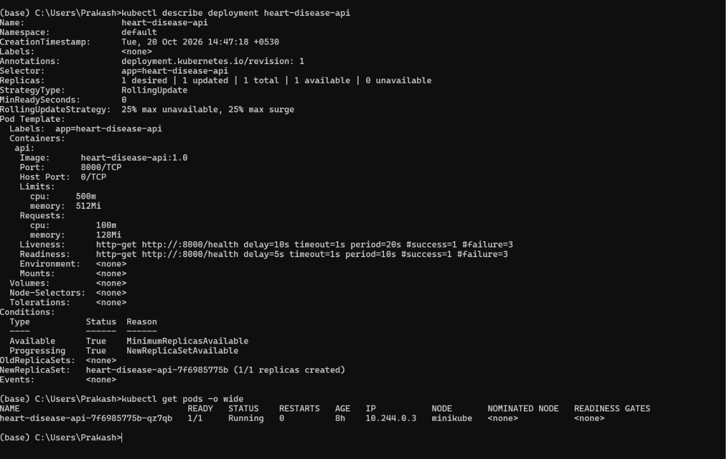

References
UCI Machine Learning Repository, Heart Disease dataset: https://archive.ics.uci.edu/dataset/45/heart+disease
Project implementation and outputs: local source code, MLflow run records, GitHub Actions logs, and Kubernetes resources. Add repository URL here: [paste GitHub repository URL].

