Hyper Text Markup Language

HTML in 5 topics :

Index.html is used to create a main file.

In Body of html if we want to write new pargraph we need to use P in that if we use lorem 1 to n any number it will genarate 1 to n words.

for html children items are head & body

for comments of any line use control slash in vs code

e.g: <!-- My name is Chaitanya -->

html is a case insensitive language as <h1> or <H1>

**In image** tag src and alt will be there we add image link or image file in "src" where as image details in "alt".

<img src="" alt="" width ="">

width used to adjust size

cntl + alt c is used to store comments

**br** tag is used to enter in new lines

**sub** and **super** tags are used html as co2 and used in power

**<hr>** is used to insert horizontal lines in the HTML document to separate sections of the document. It is an empty or unpaired tag, meaning there is no need for a closing tag.

**pre** tag used to maintain any paragraphs structure as new lines and description

<!DOCTYPE html>

<html lang="en">

<head>

    <meta charset="UTF-8">

    <meta name="viewport" content="width=device-width, initial-scale=1.0">

    <title>Document</title>

</head>

<body>

    <h1>Hi Chaitanya</h1>

    <p>How are you</p>

    <p>tell me about yourself</p>

    <a href="https://www.youtube.com/">click here to go to youtube</a>

    <p>Lorem ipsum dolor sit amet consectetur adipisicing elit. Ipsa necessitatibus cupiditate consectetur quasi velit tempore fuga esse beatae corrupti impedit culpa dolorem amet provident delectus, aut dolorum quaerat error in quod!</p>

    <a href="new.html">click me to go another web page using html</a>

    <hr>

    <!-- image tag -->

    <img src="virat.jpeg" alt="humanimage" width="120">

    <hr>

    <br>

    <!--bold and italic and underline usages-->

    <b>explain your goals</b>

    <br>

    <i>your longterm goal</i>

    <br>

    <u>acheive your goals</u>

    <br>

    <!--br tag is used to enter in new lines-->

    <!--hr tags used to seperate in horizontal lines-->

    <big>This is Chaitanya</big>

    <br>

    <small>This is Chaitanya</small>

    <br>

    <p>Co<sub>2</sub></p>

    <p>ax<sup>2</sup>+bx+c</p>

    <pre>

        There are 27 = 128 printable characters which can be represented by different 7-BIT ASCII codes. Another set of characters are not for HTML representation but they are devised to control hardware.

        Following tables list down all the 7-BIT ASCII codes and their equivalent HTML Entity Codes.

        If you want to see equivalent HEX, OCT and extended set of ASCII codes then check next chapter.

    </pre>

</body>

</html>

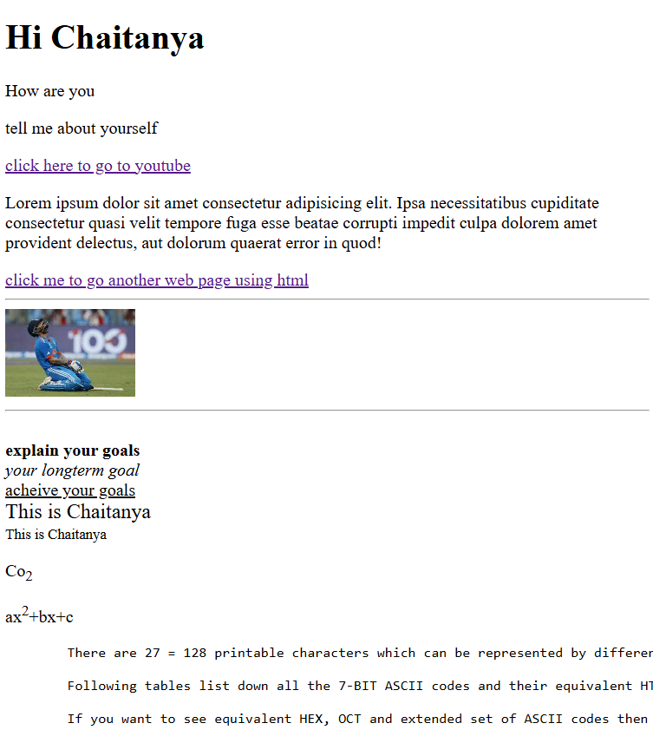

**3 topic**: HTML page layout

<header>

<main>

<footer>

In main tag we use section,article, aside

**div** tag is used as container for other tag

<body>

    <header>

    <h1> web development</h1>

    </header>

    <main>

     <!--<p> for adding information</p>-->

     <section>

        <a href="https://www.youtube.com/">youtube</a>

        <br>

        <a href="https://www.youtube.com/" target = "_main">

            <img src="virat.jpeg" alt="virat" height="240" width="250">

        </a>

     </section>

     <section>

        <!-- using div tag it is used as block element & always takes full width -->

        <div>

            <h1> Why we need html</h1>

            <p>Lorem ipsum dolor sit amet consectetur, adipisicing elit. Adipisci possimus odio laudantium veritatis voluptates consequuntur nulla minus impedit praesentium, cupiditate inventore.</p>

        </div>

        <div>

            <h1>Explain about css</h1>

            <p>Lorem ipsum, dolor sit amet consectetur adipisicing elit. Unde amet pariatur porro itaque quam neque.</p>

        </div>

        <div>

            Lorem ipsum dolor, sit amet consectetur adipisicing elit. Velit fugiat excepturi molestias.

        </div>

        <!-- span is an example of inline element & and takes width as its neccesary -->

        <span>

            <p> Useage of span tag. Unde amet pariatur porro itaque quam neque.</p>

        </span>

        <span>

            detailed explaination of span ag

        </span>

     </section>

    </main>

    <footer>

        conclusion

    </footer>

</body>

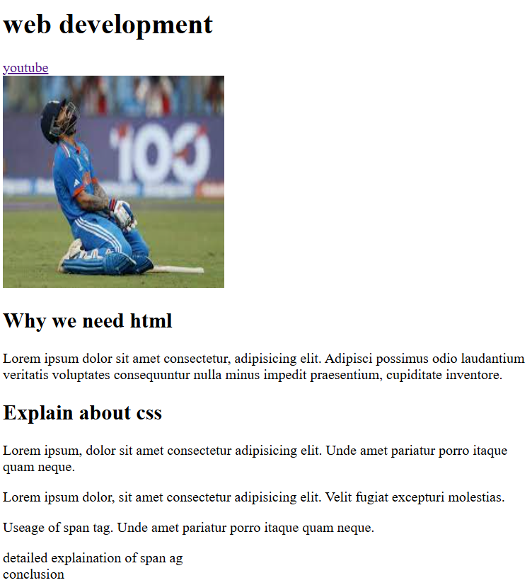

**Topic 4: lists**

Unordered list ul tags we can arrange lists with square or disc or circle brackets;

<ul type="disc">

<li>name</li>

<li>place</li>

<li>thing</li>

<li>animal</li>

</ul>

Ordered lists we can arrange lists with numbers are roman numbers;

<ol type="a">

        <li>name</li>

        <li>place</li>

        <li>thing</li>

        <li>animal</li>

    </ol>

**Table tag:** It is used to define table tags in html. It is divided into 3 types td,tr,th

I we want to add caption then we use caption tag in table and we can use thead & tbody tags we will use

Colspan tag is used to combine colums in a table as 2 or 3 columns

<table>

        <caption>

            Displaying players with highest score in ODI format

        </caption>

    <thead>

        <tr>

            <th>s.no</th>

            <th>batsman_name</th>

            <th>runs_scored</th>

            <th>opponent</th>

        </tr>

    </thead>

    <tbody>

        <tr>

            <td>1</td>

            <td>virat</td>

            <td>183</td>

            <td>pakistan</td>

        </tr>

</tbody>

</table>

**Form tag:** it is used to collect input from user

Mainly different types of tags are there input

In input tag there are many text, checkbox, radio etc

<h1>Basic input details form</h1>

    <form action="">

        <h4>Please enter your name:</h4>

        <input type="text" placeholder="enter your name"><br>

        <h4>choose your section </h4>

        <label for="sectionida">

        <input type="radio" value="section a" name="section" id="sectionida"> Section A

        </label>

        <label for="sectionidb">

        <input type="radio" value="section b" name="section" id="sectionidb"> Section B

        </label>

        <label for="sectionidc">

            <input type="radio" value="section c" name="section" id="sectionidc"> Section C <br>

            </label>

        <div>

        <h4>please select your interested subject</h4> <br>

            <input type="checkbox" id="mathscourse" class="mpc" name="course">

            <label for="mathscourse">maths course </label>

        </div>

        <div>

            <input type="checkbox" id="biologycourse" class="Bipc" name="course">

            <label for="biologycourse">Biology course</label>

        </div>

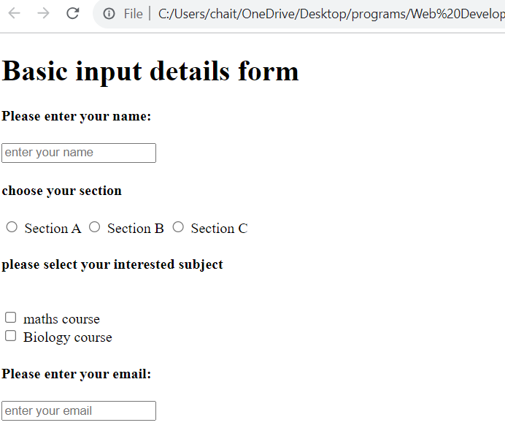

2) Textarea

<textarea name="explain" id="explain" cols="30" rows="10" placeholder="Explain why do you like maths/biology"></textarea><br>

It used to display box of input   
  
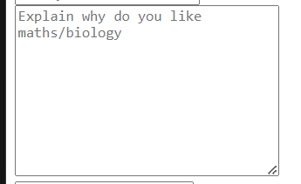

3)select tag is used select required details in a tag

<select name="subject" id="subject">

            <option value="default">choose your fav subject</option>

            <option value="maths">maths</option>

            <option value="physics">physics</option>

            <option value="chemistry">chemistry</option>

        </select>

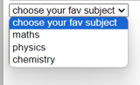



Vedio tags : used to embed youtube vedio or mp4 files etc.

<div>

        <iframe width="560" height="315" src="https://www.youtube.com/embed/BsDoLVMnmZs?si=hqAYFTLdu4dlD0sz" title="YouTube video player" frameborder="0" allow="accelerometer; autoplay; clipboard-write; encrypted-media; gyroscope; picture-in-picture; web-share" allowfullscreen></iframe><br>

        <iframe src="https://www.CodeWithHarry.com" frameborder="0" width="540p"></iframe><br>

        <video src="kingdom.mp4" controls autoplay loop width="1080p"></video>

    </div>

Chapter 5: SEOS

Content optimisation of seo

Seos mainly in 2 types : on type seo and off type seo

On seo is covered in 5 types

1. Set the title into on point
2. Set the meta description   
   <mete name =”description” content =”………..”>
3. Set a nice url slug
4. Set the meta keywords tag
5. Set the meta authr tag  
   <meta name =”author” tag =”chaitanya”>
6. Set a favicon
7. Compress images and other resourses

<meta name="description" content="SEO is important topic useful in many process">

    <meta name="keywords" content="seo, search, seo 2021">

    <link rel="shortcut icon" href="favicon.ico" type="image/x-icon">