

Dimensionality Reduction for Classification

Name: Chaitanya Gupta
Matriculation No.: U2223050E
Course: IE4476: Image Processing & Computer Vision

- Introduction
Dimensionality reduction is an important technique in machine learning that aims to address the bottleneck of dimensionality by transforming high-dimensional data into lower-dimensional representations while preserving essential information. This project explores how dimensionality reduction using two popular approaches affects classification performance, computational efficiency, and information retention, comparing unsupervised (PCA) and supervised (LDA) approaches.

- Methodology

  - Dimensionality Reduction Techniques
Principal Component Analysis (PCA): This method (PCA) is an unsupervised linear transformation technique that projects data onto principal components directions of maximum variance. It does so by finding axes that capture the most information in the data, ordered by the amount of variance. This method is popular and considered most effective for removing redundant features and noise, preserving the most significant patterns.
Linear Discriminant Analysis (LDA): This method (LDA) is a supervised dimensionality reduction method that maximizes the separation between classes while minimizing within class variance. LDA uses class labels to find projections for classification. The maximum number of dimensions in LDA is (C-1), where C is the number of classes.

  - Classification Methods
Following classification algorithms were used on the low dimensional features:
k-Nearest Neighbors (k-NN): This classifier works on principle of classifying samples based on the majority class of the k nearest neighbors in the feature space. The project evaluated k=3 and k=5, since these values typically provide a good balance between bias and variance.
Linear Support Vector Machine (SVM): This classifier finds the optimal hyperplane that separates classes with maximum margin. It is effective for linearly separable data and provides good generalization performance.
Minimum Mahalanobis Distance Classifier: This classifier works by assigning samples to the class with the minimum Mahalanobis distance. It accounts for the covariance structure of each class.

- Experimental Setup

3.1 Dataset
The project program was implemented using the MNIST dataset. It consists of 70,000 grayscale images of handwritten digits (0-9), each represented as a 784-dimensional vector (28 x 28 pixels). The dataset was accessed using the scikit-learn library.
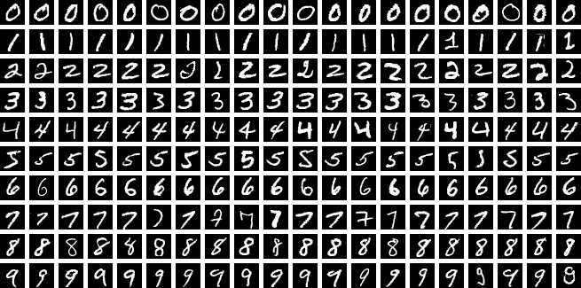
MNIST Dataset: Sample images

3.2 Data Preprocessing
5,000 samples were randomly selected to balance computational efficiency with statistical significance. Features were standardized using StandardScaler. Statistics were computed only form the training set. NaN and infinite values were removed to ensure data quality. The dataset was split into 80% training (4,000 samples) and 20% testing (1,000 samples) using stratified sampling to maintain proportional data across both subsets.
All dimensionality reduction parameters (transformation matrices, component selection) and classifier parameters were learned exclusively from the training data. The test set was only used for final accuracy computation.
A fixed random seed (42) was used for reproducibility.

- Results
4.1 PCA Results
Dim | Variance | Dim Reduction | k-NN (k=3) | k-NN (k=5) | LinSVM | Mahalanobis
2 | 10.58% | 99.7% | 0.2990 | 0.3120 | 0.3340 | 0.3320
5 |  | 99.4% | 0.7000 | 0.7160 | 0.6970 | 0.6940
10 |  | 98.7% | 0.8520 | 0.8580 | 0.8250 | 0.8210
20 | 42.11% | 97.4% | 0.8970 | 0.9010 | 0.8760 | 0.8770
30 |  | 96.2% | 0.8980 | 0.8950 | 0.8830 | 0.8730
50 | 61.57% | 93.6% | 0.9020 | 0.9100 | 0.8940 | 0.8640
75 | 71.19% | 90.4% | 0.9020 | 0.9110 | 0.8920 | 0.8490
100 |  | 87.2% | 0.9010 | 0.9090 | 0.8880 | 0.7950
150 |  | 80.9% | 0.8850 | 0.9060 | 0.8840 | 0.7810
200 | 91.93% | 74.5% | 0.8810 | 0.9020 | 0.8880 | 0.7710
784 | 100% | 0.0% | 0.8770 | 0.8910 | 0.8920 | 0.6500

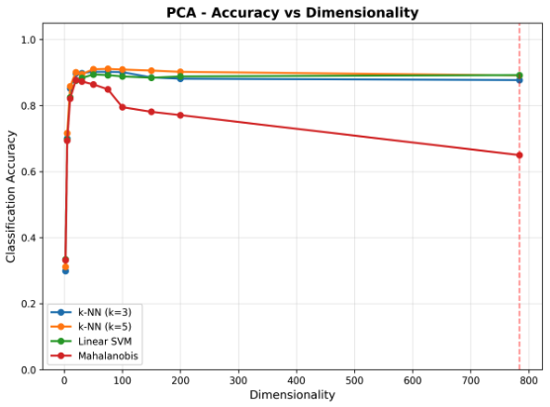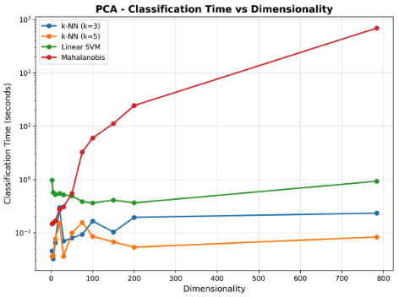
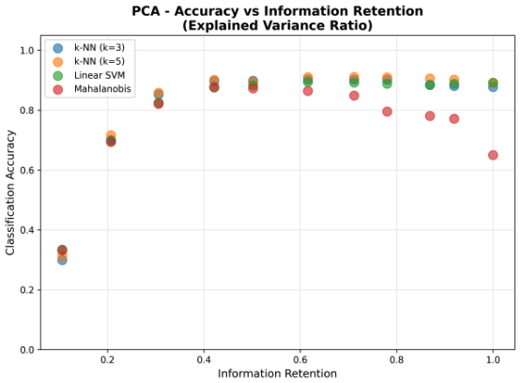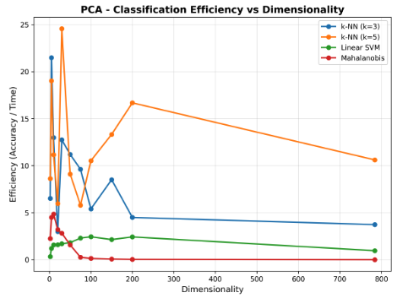
Key observations from the table:
- Accuracy increases from 2 to 20 dimensions (29.9% to 90.1%).
- Best Accuracy is at 75 dimension with k-NN k=5 (91.1%) with 90.4% dimension reduction.
- Performance plateaus and slightly decreases beyond 75 dimensions.
- Original 784-dimensional data performs worse than original reduced dimensions.
- At optimal dimension (75), PCA retains 71.19% of variance achieving peak accuracy (91.1%). This shows that full variance retention is not necessary for optimal classification.
From the figures, we can see that mahalanobis classifier shows exponential time increase with dimensionality. k-NN and Linear SVM show relatively stable times across dimensions. Optimal dimensions (50-75) provide good balance between accuracy and time. Original 784-D data requires significantly more computation time.

4.2 LDA Results
Dim | Dim Reduction | k-NN (k=3) | k-NN (k=5) | LinSVM | Mahalanobis
2 | 99.7% | 0.4390 | 0.4610 | 0.5110 | 0.4910
3 | 99.6% | 0.6360 | 0.6580 | 0.6820 | 0.6630
4 | 99.5% | 0.7430 | 0.7550 | 0.7570 | 0.7540
5 | 99.4% | 0.7420 | 0.7660 | 0.7670 | 0.7590
6 | 99.2% | 0.7610 | 0.7680 | 0.7740 | 0.7720
7 | 99.1% | 0.7960 | 0.8020 | 0.8040 | 0.7980
8 | 99.0% | 0.8210 | 0.8300 | 0.8280 | 0.8170
9 | 98.9% | 0.8200 | 0.8340 | 0.8190 | 0.8220

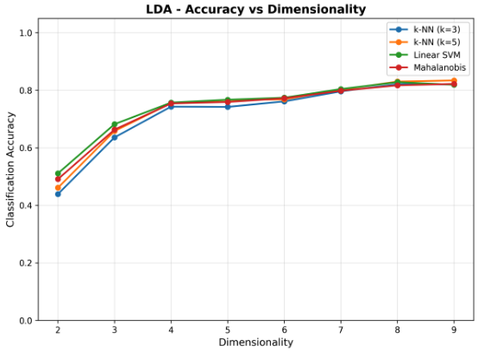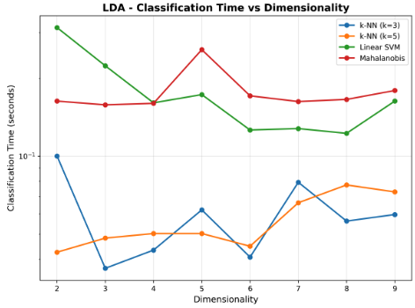
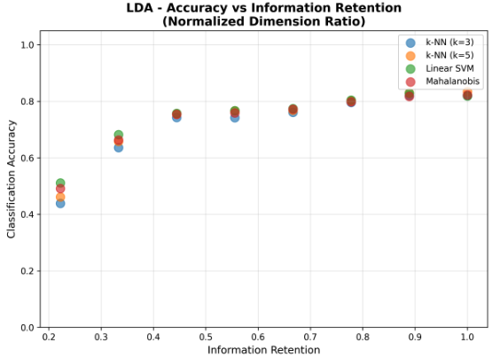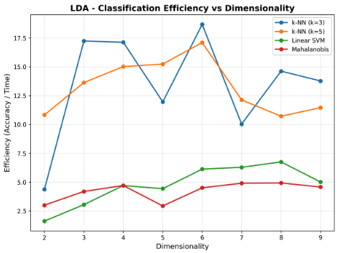

Key observations from the table:
- LDA shows steady improvement as the number of dimension increases.
- Best Accuracy is at 9 dimension with k-NN k=5 (83.4%) with 98.9% dimension reduction.
- Performance is consistently lower than PCA’s optimal results.
- Linear SVM performs competitively with k-NN at higher dimensions.
For LDA, classification times are consistently low (0.04-0.18 seconds) across all dimensions, demonstrating superior computational efficiency compared to PCA at higher dimensions.

- Analysis and Comparison

Method | Classifier | Best Dim | Reduction | Accuracy | Time (s)
PCA | k-NN (k=3) | 50 | 93.6% | 0.9020 | 0.0805
PCA | k-NN (k=5) | 75 | 90.4% | 0.9110 | 0.1571
PCA | Lin SVM | 50 | 93.6% | 0.8940 | 0.4932
PCA | Mahalanobis | 20 | 97.4% | 0.8770 | 0.2734
LDA | k-NN (k=3) | 8 | 99.0% | 0.8210 | 0.0561
LDA | k-NN (k=5) | 9 | 98.9% | 0.8340 | 0.0728
LDA | Lin SVM | 8 | 99.0% | 0.8280 | 0.1225
LDA | Mahalanobis | 9 | 98.9% | 0.8220 | 0.1793

We can see from the above comparative table, LDA achieves higher efficiency (accuracy/time) than PCA for most classifiers. LDA with k-NN (k=3) achieves the highest efficiency (14.62) despite lower accuracy. On the other hand, PCA achieves higher accuracy but at the cost of longer computation time. Optimal efficiency occurs at intermediate dimensions for both methods.
PCA outperformance LDA in classification accuracy, achieving 91.1% as compared to LDA’s 83.4%. LDA demonstrates better computational efficiency. This difference can be attributed to factors such as:
- Information Preservation: PCA preserves maximum variance in the data. This is very important in the case of image data, since pixel relationships contain important information. LDA focuses on class separation, which might lead to variance getting discarded, important for classification.
- Dimensionality Flexibility: PCA allows testing up to the original dimensionality. LDA is constrained to (C-1) dimensions. This limitation of LDA prevents it from capturing more complex patterns.
- Data Characteristics: MNIST digits have significant variation within their classes, due to different writing styles. This makes PCA, which is variance based reduction technique more effective.
- Computational Efficiency: For real-time applications where speed is an important factor, LDA is more practical approach. LDA achieves faster classification time and higher efficiency scores.

- Conclusion
This project provides several important insights into dimensionality reduction for classification. PCA outperforms LDA in accuracy for the MNIST dataset, likely due to better variance preservation and flexibility in dimensionality selection. However, LDA achieves superior computational efficiency. We also observed that, optimal dimensionality is at intermediate values, not at the original 784 dimensions. This demonstrates that dimensionality reduction can improve both accuracy and efficiency simultaneously. Information retention analysis reveals that optimal classification doesn’t require full variance retention. PCA achieves peak accuracy with only 71.19% variance retention, indicating effective noise filtering. k-NN (k=5) is the best classifier performance wise. Mahalanobis distance becomes an impractical choice at high dimensions, while k-NN and Linear SVM maintain reasonable performance. We see that dimensionality reduction provides multiple benefits, such as, improved accuracy, reduced computational cost, noise reduction, and implicit regularization. The optimal configuration achieves 90.4% dimension reduction while improving accuracy by 2.2% compared to original data. This shows that the curse of dimensionality is evident, since the original high-dimensional data (784-D) performs worse than optimally reduced data, confirming the importance of dimensionality reduction for both accuracy and efficiency.

References

Appendix

