Impact Measurement Dashboard for a Partner NGO
Recruiter-Grade Final Project Report
Prepared By: Chaitanya Sonowal , Enrollment Number – 22411012
Branch – Geophysical Technology , Int Mtech , Earth Sciences Department
Indian Institute of Technology Roorkee
Year: 2026

Abstract
This project presents the design and implementation of an NGO Impact Measurement Dashboard aimed at transforming raw beneficiary-level data into meaningful performance indicators and actionable insights. The solution combines data engineering, analytics, SQL querying, dashboard visualization, and impact measurement methodologies to support evidence-based decision making within non-governmental organizations.

NGO Background and Context
Non-Governmental Organizations play a critical role in addressing social challenges through education, healthcare, livelihood development, and community empowerment programs. However, many organizations struggle to quantify the effectiveness of their interventions. This project focuses on building a scalable framework that enables NGOs to move from activity-based reporting to impact-based reporting.

Problem Statement
Most NGOs report metrics such as number of workshops conducted and beneficiaries reached. While these metrics are useful, they fail to answer whether lives were actually improved. The challenge addressed by this project is the creation of a system that measures outputs, outcomes, and long-term impact in a structured and visual manner.

Project Objectives
• Design a KPI framework for impact measurement.
• Create a beneficiary-level dataset.
• Perform data cleaning and validation.
• Conduct SQL-based business analysis.
• Build an interactive Power BI dashboard.
• Develop a KPI Tree.
• Create user documentation for non-technical stakeholders.
• Generate actionable insights and recommendations.

Literature Review
Modern monitoring and evaluation frameworks emphasize the importance of outcome-based and impact-based measurement. Organizations increasingly adopt dashboards and business intelligence tools to evaluate intervention effectiveness. Data-driven decision making improves transparency, accountability, donor confidence, and operational efficiency.

Project Methodology
The project followed a structured analytics lifecycle:
1. Business Understanding
2. KPI Design
3. Dataset Development
4. Data Cleaning
5. SQL Analysis
6. Dashboard Development
7. Documentation
8. Reporting and Recommendations

KPI Tree Framework
The KPI Tree developed in this project links organizational activities to long-term impact.
Activity → Output → Outcome → Impact
Activities:
• Digital Literacy Programs
• Skill Development Programs
• Employment Readiness Training
Outputs:
• Beneficiaries Reached
• Training Hours Delivered
• Program Completion Rate
Outcomes:
• Skill Improvement
• Increased Job Readiness
• Improved Confidence
Impact:
• Employment Generation
• Income Growth
• Improved Quality of Life

Dataset Design
A synthetic but realistic NGO dataset was developed containing more than 1000 beneficiary records. The dataset includes demographic information, program details, assessment scores, costs, employment outcomes, and impact indicators. The dataset structure was specifically designed to support dashboard analytics and KPI measurement.

Data Dictionary
A detailed data dictionary was developed documenting all variables used within the dataset. Each field includes its definition, datatype, business meaning, and validation rules. This ensures maintainability and facilitates future adoption by NGO staff.

Data Cleaning and Quality Assurance
Data quality checks were conducted using Python and Pandas. Validation procedures included duplicate detection, missing-value analysis, age validation, score validation, consistency checks, and dataset integrity verification. The resulting dataset was exported as a cleaned analytical dataset.

SQL Analysis
SQL queries were used to answer key business questions:
• How many beneficiaries were reached?
• Which district has the highest participation?
• Which program performs best?
• What is the employment rate?
• What is the impact success rate?
• What is the cost per impact?
These analyses formed the foundation for dashboard development.

Dashboard Architecture
The dashboard consists of four pages:
Page 1 – Executive Summary
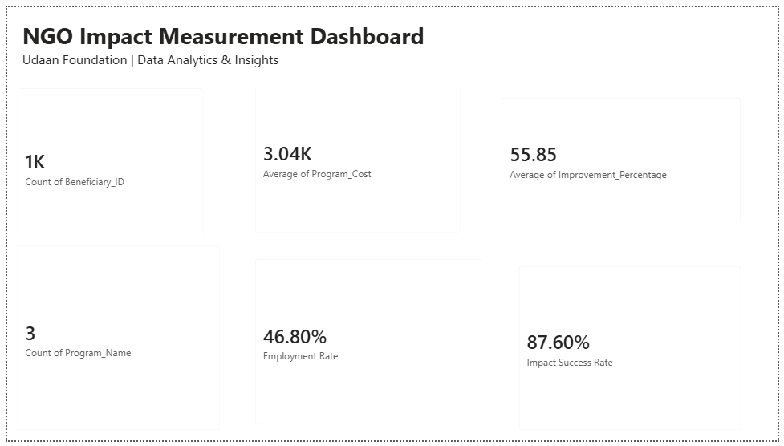
Executive Summary
The Executive Summary Dashboard provides a consolidated view of the NGO's overall performance and impact. It presents key metrics such as total beneficiaries served, average program cost, participant improvement percentage, employment rate, and impact success rate. This dashboard helps stakeholders monitor program effectiveness, evaluate outcomes, and support data-driven decision-making for maximizing social impact and community development.
Key Highlights:
1,000+ beneficiaries reached
55.85% average improvement achieved
46.80% employment rate generated
87.60% overall impact success rate
This dashboard serves as a quick and effective tool for measuring the success of NGO initiatives.

Page 2 – Program & Demographic Analysis
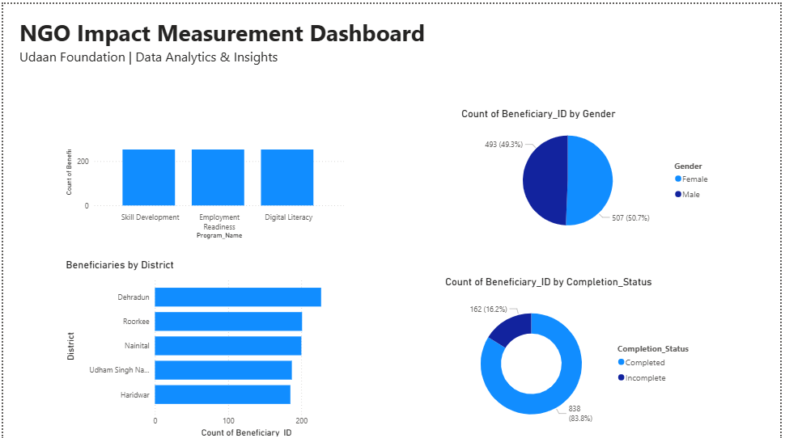
Program & Demographic Analysis
This dashboard provides a detailed analysis of NGO programs and beneficiary demographics. It visualizes the distribution of beneficiaries across different programs, districts, gender groups, and completion status. The insights help identify participation trends, monitor program reach, and evaluate beneficiary engagement across regions.
Key Highlights:
Balanced participation across all training programs.
Nearly equal representation of male and female beneficiaries.
Strong beneficiary coverage across multiple districts.
High program completion rate, indicating effective program delivery and engagement.
This analysis supports data-driven planning and helps the NGO ensure inclusive and impactful community development initiatives.

Page 3 – Impact & Trends
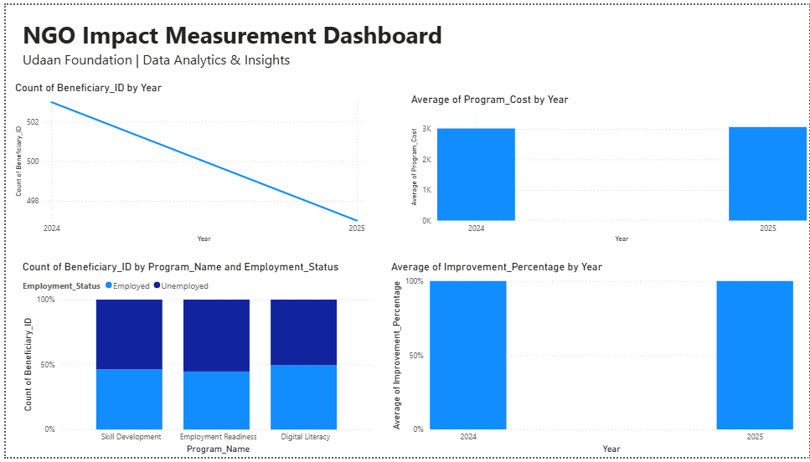
Impact & Trends Analysis
This dashboard analyzes the overall impact and performance trends of NGO programs over time. It tracks beneficiary participation, program costs, employment outcomes, and improvement percentages across different years and programs. The visualizations help measure program effectiveness, identify growth patterns, and evaluate long-term social impact.
Key Highlights:
- Tracks year-wise beneficiary participation and program performance.
- Compares program costs across different years.
- Analyzes employment outcomes of beneficiaries after program completion.
- Monitors improvement percentages to assess program effectiveness.
This analysis enables the NGO to evaluate progress, optimize resource utilization, and make informed decisions for achieving sustainable community development goals.

Page 4 – KPI Tree
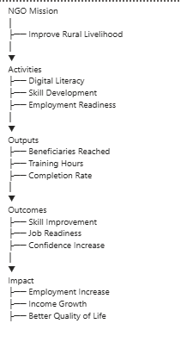
KPI Tree Analysis
The KPI Tree provides a structured view of how the NGO's activities contribute to achieving its mission of improving rural livelihoods. It establishes a clear connection between operational activities, measurable outputs, expected outcomes, and long-term social impact. This framework helps track performance, monitor progress, and ensure that organizational efforts are aligned with strategic goals.
Key Highlights:
Links NGO activities directly to measurable results.
Tracks outputs such as beneficiaries reached, training hours, and completion rates.
Measures outcomes including skill improvement, job readiness, and confidence growth.
Evaluates long-term impact through employment generation, income growth, and improved quality of life.
This KPI Tree serves as a strategic performance management tool, enabling stakeholders to assess program effectiveness and demonstrate the NGO's contribution to sustainable community development.

Key Performance Indicators
The project measures:
• Total Beneficiaries
• Total Program Cost
• Average Improvement Percentage
• Employment Rate
• Completion Rate
• Impact Success Rate
• Cost per Beneficiary
• Cost per Impact
These KPIs collectively provide a comprehensive view of NGO performance.

Business Insights and Findings
The dashboard enables management to identify successful interventions, compare regional performance, monitor beneficiary engagement, evaluate training effectiveness, and assess employment outcomes. Such insights support better resource allocation and strategic planning.

Recommendations
1. Increase investment in programs demonstrating the highest improvement rates.
2. Expand successful programs to under-served districts.
3. Strengthen post-training monitoring mechanisms.
4. Develop longitudinal impact measurement systems.
5. Introduce automated reporting and dashboard refresh workflows.

Benefits of the Solution
The proposed dashboard provides measurable value through:
• Increased transparency
• Better donor reporting
• Faster decision making
• Improved accountability
• Enhanced monitoring and evaluation
• Data-driven program optimization

Technical Skills Demonstrated
This project demonstrates competencies in:
• Python Programming
• Data Cleaning
• SQL Querying
• Database Management
• Data Visualization
• Dashboard Design
• KPI Development
• Business Analysis
• Documentation and Reporting

Challenges and Lessons Learned
Several challenges were encountered, including KPI design, realistic dataset generation, dashboard layout optimization, and balancing analytical depth with usability. Addressing these challenges provided valuable experience in end-to-end analytics project development.

Future Scope
Future enhancements may include cloud integration, GIS-based mapping, machine learning for impact prediction, real-time data pipelines, automated reporting, and mobile dashboard deployment.

Conclusion
The NGO Impact Measurement Dashboard successfully demonstrates how analytics can be leveraged to improve social impact measurement. By converting raw beneficiary data into meaningful insights, the solution empowers NGOs to make informed decisions, optimize programs, and maximize societal impact.

References
1. Microsoft Power BI Documentation
2. Python Pandas Documentation
3. SQLite Documentation
4. Monitoring and Evaluation Frameworks
5. Business Intelligence Best Practices
6. NGO Impact Assessment Methodologies

