* **Use case**

**Cloud Server**

Alice

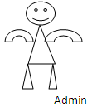 

Bob

View All Datasets,

View All Datasets Blockchain,

View All Attackers,

View Disease Results,

View Attacker Results.

