**ABSTRACT**

Acuity test is conducted by Ophthalmologist using a standardized chart (Snellen chart). The test is very simple, it requires the user to stand at a standard distance away from a chart and read letters to estimate one’s visual acuity. We intent to design a system which is capable of performing this Visual Acuity Test on its own. The project is to design a system which is capable of replacing the manual process. The system displays the various charts for various characters (20/20,20/40 and so on) to identify the eyesight issues. Visual-audio system is introduced for interaction with the Snellen chart.

The idea is that we want to bring this common test to every household, so that people can take the initiative in taking care of their health in a way that does not require having to drive over and wait until it is their turn to complete the test. Thus, the system. It displays large letters and waits for the user to guess which letter has been displayed. Microphone is used to identify the letter. The system determines the next step based on whether the user tells the displayed letter correctly or not. If the user guesses enough correctly the text size will continue getting smaller until it reaches the minimum text size or starts guessing incorrectly. This way the system will display the result corresponding to the correct text size. The main purpose of the system is to test the visual acuity using machine learning concept such as classifiers, gradient boosting concept, random forest algorithm etc.

**CHAPTER 1**

**INTRODUCTION**

* 1. **Introduction**

Visual acuity test is a test conducted for the people who are suffering from various eyesight issues. This system uses machine learning algorithms such as classifiers, gradient boosting concept, random forest algorithm etc. The machine is trained using these algorithms and the results of the particular test is got.

Commonly used eye testing methods are:

• Snellen chart

The Snellen test uses a chart of letters or symbols. Youve probably seen the chart in a school nurses office or eye doctor’s office. The letters are different sizes and arranged in rows and columns. Viewed from 14 to 20 feet away, this chart helps determine how well you can see letters and shapes.

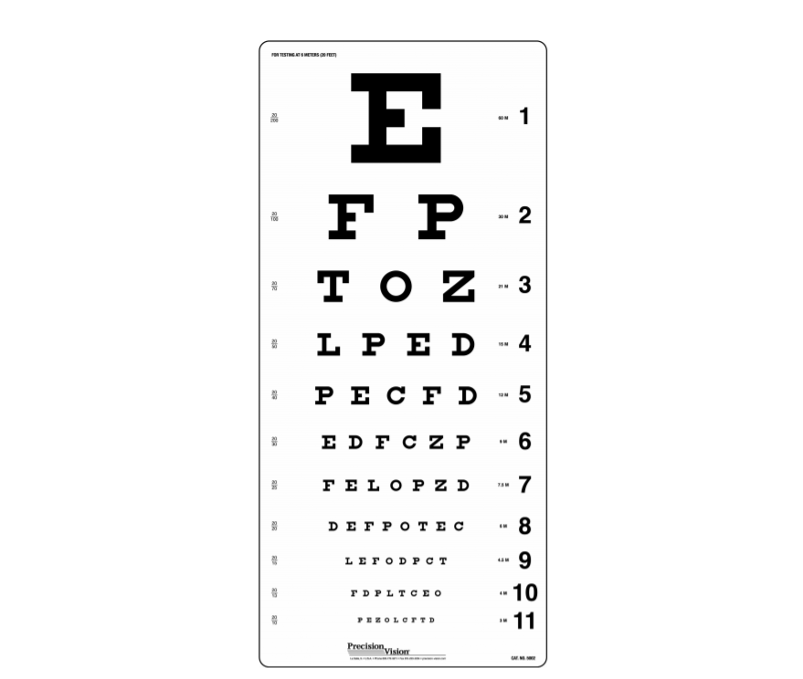

• Landolt C

Landolt proposed an eye chart that had only one symbol, a ring with a break at top, bottom, left or right, and 45-degree positions in between, basically the letter C in various orientations. To match Snellen’s results, the standard size of the C was 0.35 (which subtends 5 arc minutes at 20 feet) with a gap of 0.07 or 1 arc minute.

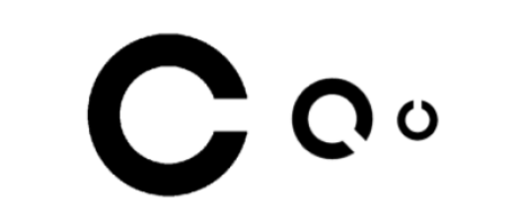

• Lea test

Lea Test uses a set of pictorial optotypes that are symbolic outlines of an apple, a house, a square and a circle. Various versions for testing near vision, far vision, contrast sensitivity, amblyopia and brain damage have been used.

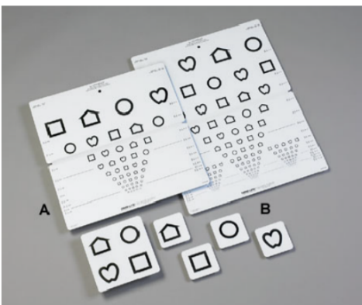

• Random E

In the random E test, you’ll identify the direction the letter E is facing. Looking at the letter on a chart or projection, you’ll point in the direction the letter is facing: up, down, left, or right.

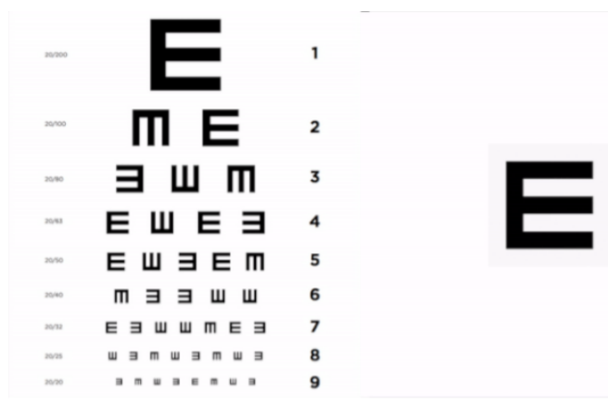

It starts by displaying large letters and waits on the user to guess which letter has been displayed. The user speaks his/her guess into the microphone. The speech recognition portion uses energy threshold to make sure background noise does not interfere with the user's guess. The system will then determine the next step based on whether the user guessed the displayed letter correctly or not. If the user guesses enough correctly, the text size will continue getting smaller until the user either reaches the minimum text size (corresponding to 20/20) or starts guessing enough incorrectly. If the user guesses too many letters incorrectly, the system will display the result corresponding to the current text size (e.g. 20/30). The thresholds for amount guessed and amount guessed correctly are set in the code. Our eye test uses a dictionary containing the letters "A", "E", "I", "R", and "L" with the same 6 possible text sizes for each of these letters.

**1.2 Literature Survey**

(Priya, M. (2017). Voice Recognition Eye Test. International Research Journal of Engineering and Technology (IRJET) 10-15) proposed a paper on “Visual Recognition Eye Test”. In this paper an attempt has been made to review on design of voice recognition eye test that is capable of performing the entire eye test on its own. This project attempted to design an implement a voice recognition system. Each user inputs audio samples those were to be stored in database for later comparison with future audio inputs.

In 1868 Green [2], who had worked with Snellen, proposed a chart with the geometric progression of letter sizes and proportional spacing between letters. This approach re-invented by Bailey and Lovie in 1976[3] using British letters (4x5 grid) and 6 meters test distance.

In 1982 the National Institute adopted a chart used in the early treatment of Diabetic Retinopathy Study [4] which used the Bailey and Lovie layout with Sloan opto types and standard test distance of 4 meters, back illuminated to a calibrated light level, and which required a detailed protocol of counting each correctly identified letter.

[Farzin F](https://www.ncbi.nlm.nih.gov/pubmed/?term=Farzin%20F%5BAuthor%5D&cauthor=true&cauthor_uid=20817914)1, [Rivera SM](https://www.ncbi.nlm.nih.gov/pubmed/?term=Rivera%20SM%5BAuthor%5D&cauthor=true&cauthor_uid=20817914), [Whitney D](https://www.ncbi.nlm.nih.gov/pubmed/?term=Whitney%20D%5BAuthor%5D&cauthor=true&cauthor_uid=20817914). University of California, Davis, USA. ffarzin@stanford.edu We designed an eye-tracking paradigm to psychophysically measure crowding in infants between 6 months and 15 months of age. We showed infants pairs of faces at three eccentricities, in the presence or absence of flankers, and recorded infants' first saccade from central fixation to either face.  We found that the effective spatial resolution of infants' visual perception increased with age, but was only half that of adults.

* 1. **Motivation and Problem Definition**

By referring to above papers, done in the literature survey we got know about various problems in the eyesight of the humans and also tests carried out by the doctors for its treatment. There are many difficulties in conducting the tests and the manual work has to be made, hence we have developing the system that will reduce few of the problems that occur while conducting the test. This makes the work easy for the doctors as well as the persons to take the test. And it reduces the manual works that is done before taking the test. The various charts are displayed on the screen and according to the performance of the person the accuracy is calculate and the output is got in the audio format.

* 1. **Objectives**

1. It gives the eyesight accuracy of the person who has undergone the test.
2. It helps the doctors to reduce their manual work and conduct the test in a more easy way.
3. The user or the person who is undergoing the test has the option to select the required charts that he is comfortable for reading.
4. The results got can be shared to the suggested doctors as per their requirements.
5. The output is given in audio format by the system.

**1.4 Scope**

1. Many of the eye vision tests being performed by the specialists can be completely replaced by integrating required equipment onto the framework and implementing corresponding algorithm into it.
2. Visionary problems such as glaucoma, black eye and similar tests can be added and be successfully identiﬁed and in some cases, may be treated as well before permanent damage.
3. It can be put in online resources like android app.
4. The proposed method can be installed in smart homes as part of Internet of Things where the results can be sent directly to the personal practitioner for further analysis.

**1.5 Limitations**

1. The computation power is low to the point that it can be run on a Raspberry Pi which

further helps in reducing its overall cost.

1. Requires a system for testing.

**1.6 Relevance and Type**

The visual acuity test is performed under the guidance of specialist which may not be accurate and is time consuming as well this motivated us to design a system which performs the above test by its own so that people can take the initiative in taking care of health in a way that does not require having to drive over and wait until it is their turn to complete the test.

Type: Health care.

**CHAPTER 2**

**2.1 Methodology**

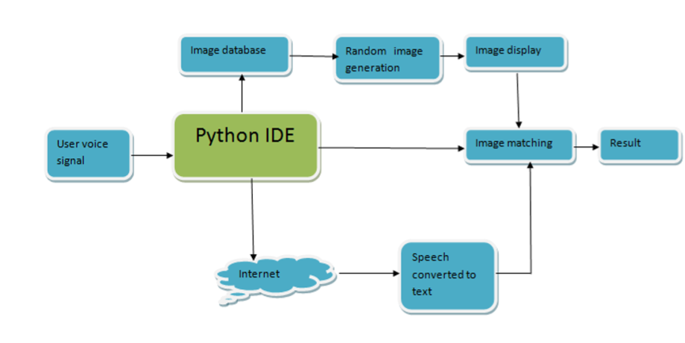

Figure 2.1: Flow of the system.

1. Creation of image database using python

2. After the code is executed it starts displaying letters

3. A user who is performing the eye test recognizes the letter and gives the answer.

4. Using user’s response which is audio signal, the system converts the audio to text using

Google’s audio to text conversion.

5. The system matches the user response and the text displayed

6. If the response is correct the dimension of next letter will decrease

7. If the response is registered wrong the dimension of letter for next iteration will be same

8. If the response is registered wrong for three times then it will exit the test.

* 1. **Flow Chart**

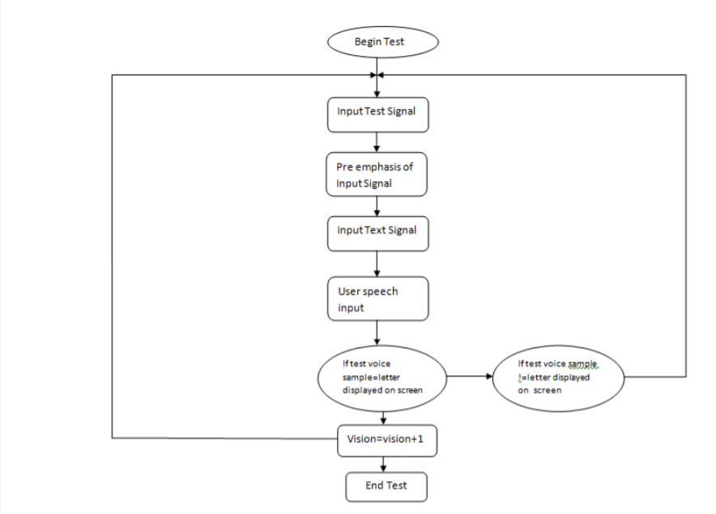

Figure 2.2.1: Flow chart

1. Image data is stored at a location in the device(controller) and the format will be JPG type.

2. Image will be modified in the next step (change of image dimensions).

3. User voice will be recorded and converted into text that will be stored in a variable.

4. Next step is comparison

5. If result is right then it will go to step-2

6. If result is wrong then the image dimension will remain same and go to step-3

7. After completion accuracy is given.

**2.3 Resources Required**

**2.3.1 Hardware and Software Requirements**

1. Operating system: windows 10

2. 4 GB RAM

3. 1TB hard disk

4. Microphone

5. Python IDE

**2.4 Applications**

1. The system is very accurate because this system will be mainly used for health care purpose.

2. The system is user friendly which will encourage people to take initiative in taking care of their health.

3. This system can be used in eye testing camps conducted in villages where the traditional method cannot be used because of refraction due to light.

3. The system is reliable.

4. The system is cost effective.

5. It can also be used as mobile application to test the visual acuity.

**2.5 References**

[1] ASEEM SAXENA, 2. K. (2013). SPEECH RECOGNITION USING MATLAB. International Journal of Advances in Computer Science and Cloud Computing, ISSN 5-10.

[2] Hakan Erdogan. (n.d.). SPEECH RECOGNITION FOR A TRAVEL RESERVATION SYSTEM. 5-10.

[3] Mr. Sanjay Bhardwaj, M. S. (2015). Speech Recognition using Hidden Markov and Viterbi Algorithm. International Journal of Advanced Research in Electronics and Communication Engineering (IJARECE) 510.

[4] Priya, M. (2017). Voice Recognition Eye Test. International Research Journal of Engineering and Technology (IRJET) 10-15.

[5] Wolbarsht ML. Method and apparatus for testing vision. Google Patents; 1979. US Patent 4,155,632.

Project Coordinator H.O.D

Date: