PROFESSIONAL PORTFOLIO
Artifact 2
Machine Learning vs. Deep Learning
A comparison of logistic regression for email spam detection and
convolutional neural networks for image recognition
Student | Chaitanya Chowdary Paladugu
Course | AIML 500 Machine Learning Fundamentals
Source Work | Assignment 2.3: Machine Learning vs. Deep Learning
Portfolio Role | Professional Portfolio Artifact 2
Date | July 16, 2026

Project Overview
This artifact presents a professional comparison of traditional machine learning and deep learning through two real-world problem types. Email spam detection represents a structured binary-classification problem suited to logistic regression. Image recognition represents a raw, high-dimensional visual problem suited to a convolutional neural network (CNN). The artifact explains how data structure, feature engineering, interpretability, computational requirements, and model complexity affect algorithm selection.

Objective
The objective was to demonstrate that model selection should begin with the problem and the available data rather than with model complexity. The artifact explains why logistic regression is appropriate when useful inputs can be engineered in advance and why a CNN is appropriate when visual features must be learned automatically from raw pixels. It also evaluates why the alternative approach is less practical in each case.

Relevance to AIML 500
- Distinguishes traditional machine learning from deep learning.
- Connects supervised classification to email spam detection.
- Explains logistic regression, class probabilities, and relative interpretability.
- Explains CNNs, hierarchical feature learning, and image recognition.
- Compares manual feature engineering with automatic feature extraction.
- Applies foundational model-selection principles to familiar real-world systems.

Audience and Customization
The original coursework was written as an academic report. For the portfolio audience, I reorganized the material into a concise web artifact with clear headings, comparison cards, skills, challenges, lessons learned, and direct supporting-file links. I retained the technical reasoning, in-text citations, and references in the report while making the public page easier for an instructor, recruiter, or technical reviewer to scan.

Process
- Reviewed the assignment expectations. I identified the required traditional machine-learning example, deep-learning example, real-world applications, comparison, conclusion, citations, and references.
- Defined the comparison. I paired email spam detection with logistic regression and image recognition with a CNN so the difference in data structure and feature learning would be clear.
- Researched supporting evidence. I used the AIML 500 lesson, official Google material, and FaceNet research to support the discussion while avoiding unsupported claims about proprietary production models.
- Explained model suitability. For each case, I connected the problem type to inputs, outputs, interpretability, data needs, computational cost, and feature-engineering requirements.
- Qualified real-world claims. I distinguished documented product capabilities from the algorithms evaluated in the report. Gmail and Google Photos illustrate applications; the report does not claim knowledge of their complete internal architectures.
- Customized the work for a professional audience. I transformed the academic content into a responsive portfolio page with an overview, objective, comparison, applications, skills, challenges, solutions, and reflection.
- Tested and published the artifact. I verified page loading, navigation, report downloads, image loading, desktop and mobile layouts, horizontal overflow, and browser-console behavior before publishing through GitHub Pages.

Tools and Resources
Tool or resource | Purpose
Microsoft Word | Prepared and finalized the academic source report.
AIML 500 course lesson | Provided the foundational comparison between traditional machine learning and deep learning.
Official Google sources | Supported real-world context for spam filtering and photo organization.
FaceNet research paper | Supported the explanation of CNN-based face recognition and learned embeddings.
HTML and CSS | Presented the artifact in a clear, responsive professional layout.
GitHub Pages | Published the artifact and supporting documents at a stable public URL.
Desktop and mobile browser testing | Verified page behavior, links, images, layout, and console status.

Traditional Machine Learning Case Study

Email Spam Detection with Logistic Regression
Spam detection is a binary-classification problem because each incoming message must be classified as spam or not spam. Logistic regression can work with structured numerical inputs such as word frequencies, links, sender characteristics, and message length. It estimates a class probability, supports threshold adjustment, is comparatively efficient, and offers relative interpretability through feature coefficients.
Deep learning could be applied to email classification, but it may add training, computing, maintenance, and interpretability costs when the relevant features can already be structured effectively. The artifact therefore treats logistic regression as an appropriate traditional method without claiming that Gmail currently uses it in production.

Deep-Learning Case Study

Image Recognition with a Convolutional Neural Network
Image recognition begins with grids of raw pixel values. A CNN learns useful visual patterns automatically: early layers identify edges and gradients, middle layers combine those patterns into shapes and textures, and deeper layers identify larger objects or faces. This hierarchical feature learning is a strong match for raw, high-dimensional, unstructured visual data.
A traditional classifier would require a separate hand-designed feature-extraction pipeline. Such features may be difficult to define across changes in lighting, angle, scale, background, and resolution. Google Photos supplies a real-world application context, while CNN and FaceNet research explains why deep learning is suitable; the artifact does not claim to identify Google Photos’ exact internal model.
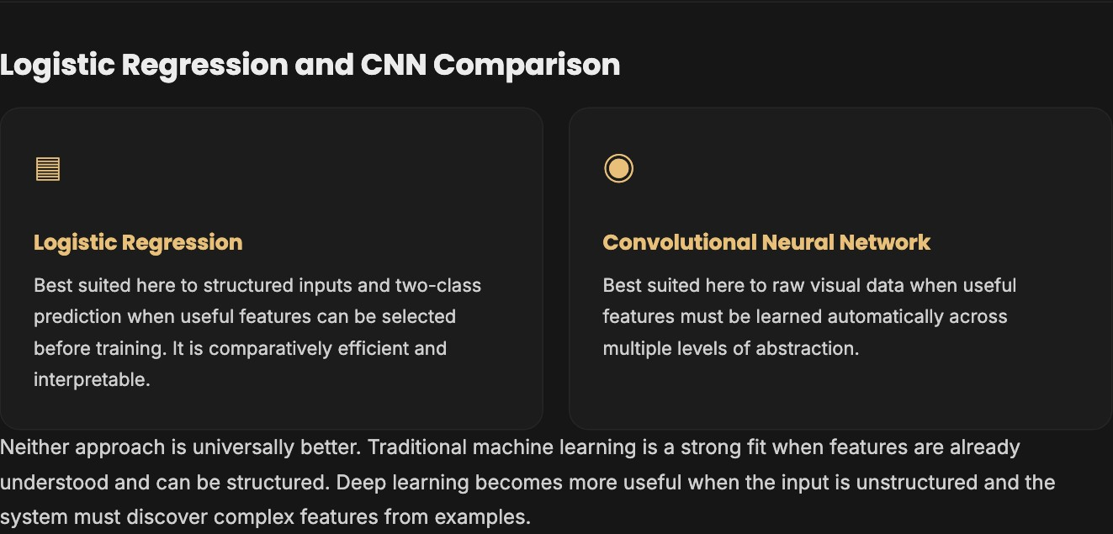
Figure 1. Portfolio comparison of logistic regression and a convolutional neural network.

Value Proposition
This artifact gives a reviewer a concise, evidence-based way to see how I reason about model selection. Its value is not simply defining two categories of machine learning; it shows how problem structure, feature representation, interpretability, data volume, computational cost, and real-world variation guide the choice of an approach.

Unique Value
The artifact pairs two familiar applications with two contrasting learning approaches. The side-by-side structure makes the technical difference concrete: logistic regression scores engineered features for a binary outcome, while a CNN learns layered visual features directly from raw pixels. The report also carefully separates verified product capabilities from illustrative algorithm choices, demonstrating responsible technical communication.

Skills Demonstrated
- Selecting algorithms based on the data and problem type.
- Explaining binary classification and logistic regression.
- Explaining CNNs and hierarchical feature learning.
- Comparing interpretability, feature engineering, data requirements, and computational complexity.
- Connecting course concepts to real-world applications.
- Researching, citing, and qualifying technical claims.
- Revising academic work for a professional portfolio audience.
- Publishing and testing a responsive web artifact.
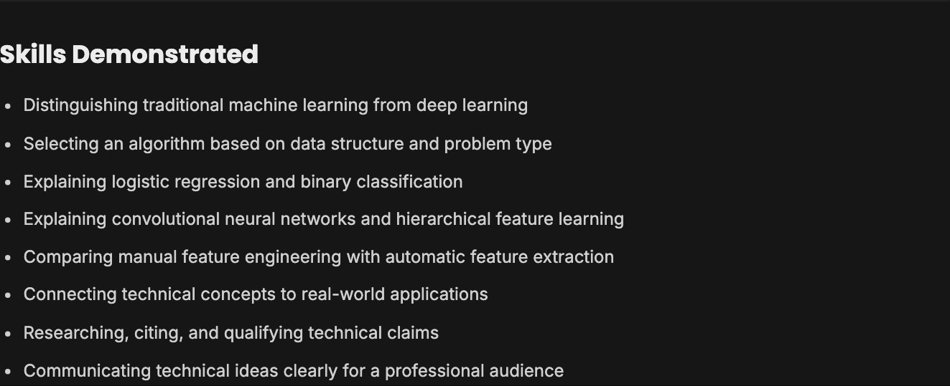
Figure 2. Skills demonstrated section on the published Artifact 2 page.

Challenges and Solutions

Choosing Comparable Examples
The examples needed to show a meaningful technical difference. I solved this by pairing a structured two-class prediction problem with a raw visual-data problem and comparing how each approach obtains useful features.

Keeping Product Claims Accurate
A product can demonstrate a real application without revealing its entire internal model. I separated official descriptions of product capabilities from the algorithms evaluated in the report and stated the limits of the comparison directly.

Explaining Technical Differences Clearly
The comparison could become too abstract if it relied only on terminology. I connected feature engineering, probabilities, layered feature learning, interpretability, data requirements, computational cost, and real-world variation to the two case studies.

Adapting Coursework for a Portfolio
A long academic report is useful as evidence but is not always easy to scan online. I retained the full report as a supporting download and built a shorter web presentation that surfaces the objective, key comparison, applications, skills, challenges, and lessons learned.

Tangible Evidence
The published page, report, and screenshots below provide direct evidence of the completed work. The final report contains the two case studies, detailed comparison, in-text citations, conclusion, and references. The web artifact presents the same core learning in a concise professional format.

Figure 3. Published Artifact 2 page with title, overview, navigation, and report link.

Reflection

Customization for the Audience
I learned that a portfolio artifact must do more than reproduce a class submission. The academic report provides depth, but the public page needs a visible purpose, quick navigation, concise explanations, evidence, and a clear statement of skills. I therefore retained the report as supporting evidence while designing the web page for faster review by an instructor or professional audience.

Lessons Learned
The main technical lesson was that greater model complexity does not automatically produce a better solution. Logistic regression is valuable when inputs can be structured and the output is binary, while CNNs are valuable when useful visual features must be learned from raw data. I also learned that technical communication requires careful boundaries: a real product may illustrate an application, but that does not prove which exact model runs inside it.

Review Input and Revisions
No formal instructor feedback had been received when this portfolio version was completed. I therefore used the assignment instructions, rubric criteria, source verification, and structured self-review as revision inputs. Those checks led me to make the artifact’s title, objective, process, tools, value proposition, evidence, audience customization, lessons, challenges, and revisions explicit. I also added direct links to both the documentation and the finalized report and tested the live page at desktop and mobile sizes.

Future Improvements
A future revision could add a small original dataset demonstration, train baseline logistic-regression and CNN models, report evaluation metrics, and compare performance, resource use, and error patterns. That would extend the artifact from a concept-and-application comparison into an empirical model comparison while preserving the current explanation as context.

Final Product Links
Published Artifact 2: https://chaitanyachowdarypaladugu.github.io/professional-portfolio/artifact-2.html
Portfolio Report: https://chaitanyachowdarypaladugu.github.io/professional-portfolio/assets/artifact-2/Chaitanya_Machine_Learning_vs_Deep_Learning_Portfolio.pdf

