**Program to implement STACK using Arrays.**

#include<stdio.h>

#define MAX 5

int STACK[MAX];

int top = -1;

int isEmpty();

int isFull();

void push(int element);

void pop();

void peek();

void display();

int main() {

int choice, element;

printf("====MENU====\n");

printf("1.PUSH\n");

printf("2.POP\n");

printf("3.PEEK\n");

printf("4.DISPLAY\n");

printf("5.Exit\n");

while (choice != 5) {

printf("\nEnter your choice:");

scanf("%d", &choice);

switch (choice)

{

case 1:

printf("Enter the element to be added in the stack:");

scanf("%d", &element);

push(element);

break;

case 2:

pop();

break;

case 3:

peek();

break;

case 4:

display();

break;

case 5: printf("Exiting....\n");

break;

default:printf("Wrong Choice\n");

break;

}

}

return 0;

}

int isEmpty() {

if (top == -1) {

return 1;

}

else {

return 0;

}

}

int isFull() {

if (top == MAX -1) {

return 1;

}

else {

return 0;

}

}

void push(int element) {

if (isFull()) {

printf("STACK OVERFLOW\n");

}

else {

top = top + 1;

STACK[top] = element;

printf("Element added succesfully\n");

}

}

void pop() {

int element;

if (isEmpty()) {

printf("STACK UNDERFLOW\n");

}

else {

element = STACK[top];

top = top - 1;

printf("The element %d is sucessfully deleted\n",element);

}

}

void peek() {

int element;

if (isEmpty()) {

printf("STACK UNDERFLOW\n");

}

else {

printf("The top most element of the STACK is %d\n",STACK[top]);

}

}

void display() {

int i, element;

if (isEmpty()) {

printf("STACK is empty. \n");

}

else {

printf("Stack Elements: ");

for (i = top;i >= 0;i--)

printf("%d\t", STACK[i]);

printf("\n");

}

}

**Output:**

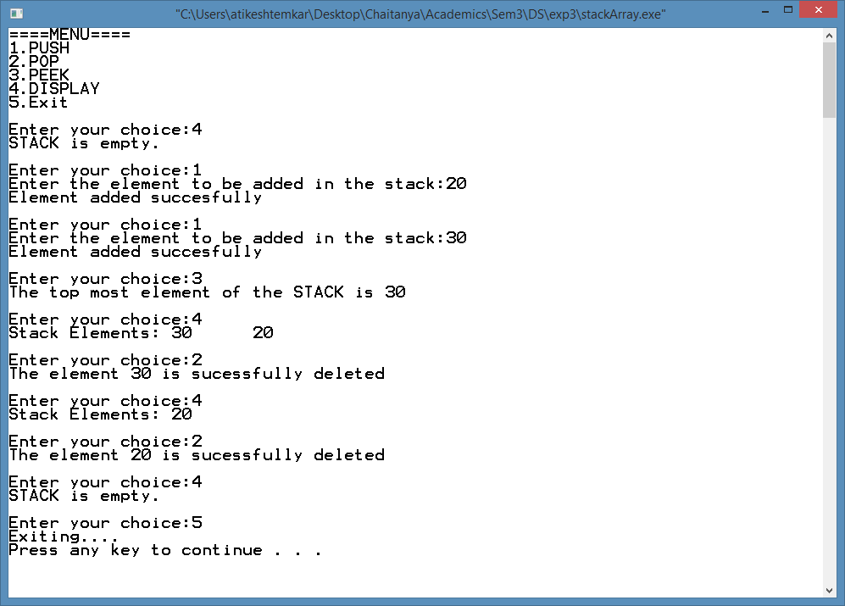

**Program to implement Queue using Array.**

#include<stdio.h>

#define MAX 5

int QUEUE[MAX];

int front = -1, rear = -1;

void Enqueue(int element);

void Dequeue();

void peek();

int isEmpty();

int isFull();

void display();

int main() {

int choice, element;

printf("\n====MENU====\n");

printf("1.Enqueue\n");

printf("2.Dequeue\n");

printf("3.Peek\n");

printf("4.Display\n");

printf("5.Exit\n");

while (choice != 5) {

printf("\nEnter your choice: ");

scanf("%d", &choice);

switch (choice) {

case 1:

printf("Enter the element to be inserted:");

scanf("%d", &element);

Enqueue(element);

break;

case 2:

Dequeue();

break;

case 3:

peek();

break;

case 4:

display();

break;

case 5: printf("Exiting...");

break;

default:

printf("Wrong Choice\n");

break;

}

}

return 0;

}

int isEmpty() {

if (front == -1 || front == rear + 1)

return 1;

else

return 0;

}

int isFull()

{

if (rear == MAX - 1)

return 1;

else

return 0;

}

void Enqueue(int element)

{

if (isFull())

{

printf("\n QUEUE OVERFLOW\n");

return;

}

if (front == -1 || rear == -1)

{

front = rear = 0;

QUEUE[rear] = element;

}

else

{

rear = rear + 1;

QUEUE[rear] = element;

}

printf("\nElement inserted ");

}

void Dequeue()

{

int element;

if (isEmpty())

{

printf("QUEUE UNDERFLOW\n");

}

else

{

element = QUEUE[front];

front = front + 1;

printf("\ndeleted element is:%d\n", element);

}

}

void peek()

{

if (isEmpty())

{

printf("QUEUE UNDERFLOW\n");

}

else

{

printf("Element present at the front of the queue is %d\n", QUEUE[front]);

}

}

void display()

{

int i;

if (isEmpty())

{

printf("QUEUE is Empty\n");

}

else

{

printf("Elements of the queue are:");

for (i = front;i <= rear;i++)

{

printf("%d\t", QUEUE[i]);

}}}

**Output:**

