**Program to implement Linear Search.**

#include<stdio.h>

#define MAX 8

void linearSearch(int elem, int arr[MAX]);

int main() {

int arr[MAX] = { 0 };

int searchElem = 0, i = 0;

printf("Enter the elements of the array\n");

for (i = 0; i < MAX; i++) {

printf("arr[%d] = ", i);

scanf("%d", &arr[i]);

printf("\n");

}

printf("Enter the element to be searched: ");

scanf("%d", &searchElem);

linearSearch(searchElem, arr);

return 0;

}

void linearSearch(int elem, int arr[MAX]) {

int i = 0;

for (i = 0; i < MAX; i++) {

if (elem == arr[i]) {

printf("Element found at index: %d", i);

return;

}}

printf("Element not found.");

return;

}

**Output:**

**Case 1: element not found Case 2: element found**

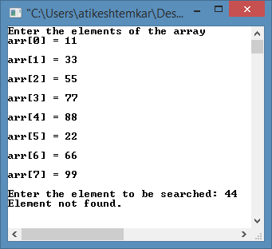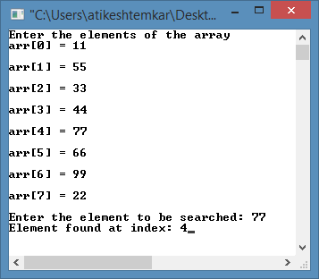

**Program to implement Binary Search.**

#include<stdio.h>

#define SIZE 8

int binSearch(int key,int arr[],int len){

int low = 0, high = len-1, mid;

while(low<=high){

mid=(low+high)/2;

if(arr[mid]==key){

printf("Element found at index %d\n", mid);

return;

}else if(arr[mid]>key){

high=mid-1;

}else{

low=mid+1;

}

}

if (low > high)

printf("Element not Found\n");

}

int main() {

int arr[SIZE] = { 0 };

int searchElem = 0, i = 0;

printf("Enter the elements of the array in sorted order.\n");

for (i = 0; i < SIZE; i++) {

printf("array[%d] = ", i);

scanf("%d", &arr[i]);

printf("\n");

}

printf("Enter the element to be searched: ");

scanf

("%d", &searchElem);

binSearch(searchElem,arr,SIZE);

return 0;

}

**Output:**

**Case 1: element not found**

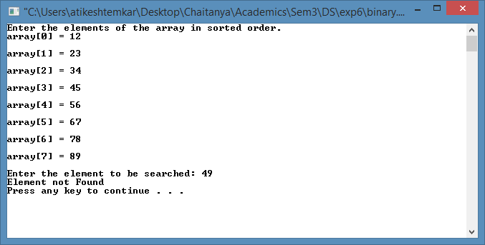

**Case 2: element found**

