**Programs :**

1. Print “C++ is better than C” and use comments.

#include <iostream>

using namespace std;

int main (){

// prints c++ is better than c to the screen

cout << "c++ is better than c" << endl;

return 0;

}

**Output:**

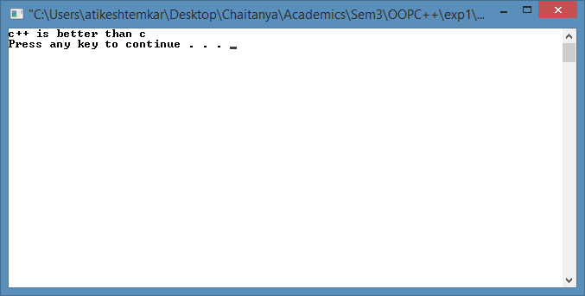

1. Find the sum and average of two numbers.

#include<iostream>

using namespace std;

int main (){

int a, b, sum;

float average;

cout << "Enter A value: ";

cin >> a;

cout << "Enter B value: ";

cin >> b;

sum = a + b;

cout << "The sum is:" << sum << endl;

average = sum / 2;

cout << "The avgerage is :" << average << endl;

return 0;

}

**Output:**

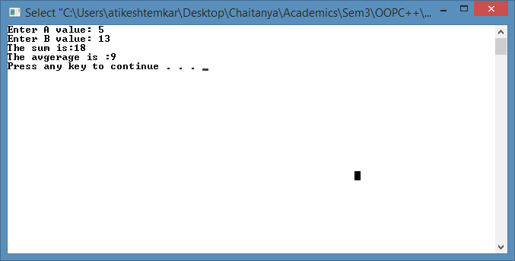

1. Even & Odd numbers

#include<iostream>

using namespace std;

int main() {

int num;

cout << "Enter the number:";

cin >> num;

if (num % 2 == 0)

cout << "Even Number.";

else

cout << "Odd Number.";

return 0;

}

**Output:**

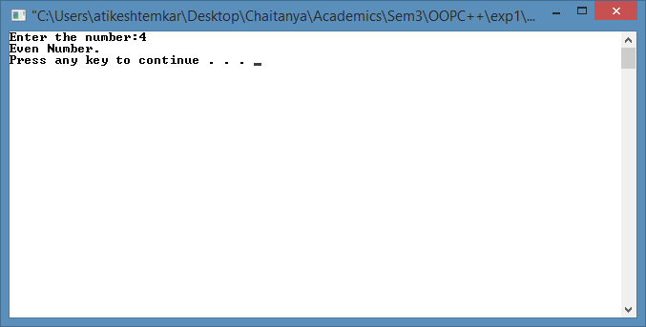

1. Quadratic Equations

#include<iostream>

#include<math.h>

using namespace std;

int main(){

float root1, root2, x, y, z, a, b, c;

cout << "Enter the values of a , b , c\n";

cin >> a >> b >> c;

x = -b;

y = sqrt((b*b) - (4 * a * c));

z = 2 * a;

root1 = (x + y) / z;

root2 = (x - y) / z;

cout << "root 1 : " << root1 << endl;

cout << "root 2 : " << root2 << endl;

return 0;

}

**Output:**

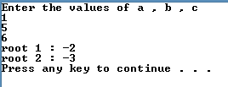

1. Factorial number

#include<iostream>

using namespace std;

void factorial(int i)

{

int fact = 1;

for (int j = 1; j <= i; j++)

fact = fact*j;

cout << "Factorial: " << fact << endl;

}

int main() {

int num;

cout << "Enter the number: ";

cin >> num;

factorial(num);

return 0;

}

**Output:**



1. Fibonacci of number

#include<iostream>

using namespace std;

int main() {

int i1 = 0, i2 = 1, t, a;

cout << "Enter the number of fibonacci numbers to be display:";

cin >> a;

if (a == 1)

cout << i1;

else if (a == 2)

cout << i1 << "\t" << i2;

else if (a>2) {

cout << i1 << "\t" << i2 << "\t";

for (int i = 1; i <= a - 2; i++) {

t = i1 + i2;

cout << t << "\t";

i1 = i2;

i2 = t;

}

}

return 0;

}

**Output:**

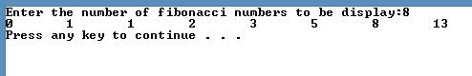

1. Area of circle

#include<iostream>

#include<math.h>

using namespace std;

int main()

{

float pi = 3.14, area, radius;

cout << "please enter the radius of the circle: ";

cin >> radius;

area = pi*radius*radius;

cout << "The answer is :" << area << endl;

return 0;

}

**Output:**



1. Find the Sum of elements of an array.

#include<iostream>

using namespace std;

int main() {

int i, sum = 0;

cout << "Enter the no. of elements of the array\n";

cin >> i;

int a[50];

cout << "Enter the elements of the array\n";

for (int j = 0; j < i; j++) {

cin >> a[j];

sum = sum + a[j];

}

cout << "\nSum: " << sum << endl;

return 0;

}

**Output:**

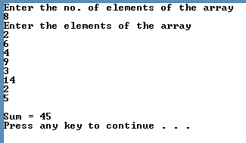

1. Find largest element of an array.

#include<iostream>

using namespace std;

int main() {

int i, temp, largest = 0;

int a[50];

cout << "Enter the no. of elements of the array: ";

cin >> i;

for (int j = 0; j < i; j++) {

cout << "Enter element: ";

cin >> a[j];

if (largest < a[j])

largest = a[j];

}

cout << "\nLargest: " << largest << endl;

return 0;

}

**Output:**

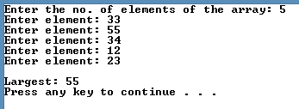

1. Implement default arguments.

#include <iostream>

using namespace std;

int Add(int x = 10, int y = 20, int z = 30)

{

return x + y + z;

}

int main(){

int a;

a = Add(5);

cout << "The sum is : " << a << endl;

a = Add(5, 10);

cout << "The sum is : " << a << endl;

a = Add(7, 3, 4);

cout << "The sum is : " << a << endl;

return 0;

}

**Output:**

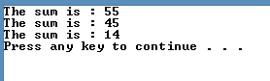

1. Add, subtract, multiply and divide two numbers using inline functions.

#include<iostream>

using namespace std;

inline int add(int a, int b) {

return a + b;

}

inline int sub(int a, int b) {

return a - b;

}

inline int division(int a, int b) {

return a / b;

}

inline int multi(int a, int b) {

return a * b;

}

int main() {

int a, b;

float ans;

cout << "1.Addition\n2.Subtraction\n3.Multipication\n4.Division\n5.Exit\n\n";

while (1) {

cout << "Enter your choice: ";

cin >> a;

switch (a) {

case 1: cout << "\nEnter the numbers to find the sum\n"; cin >> a >> b;

ans = add(a, b); break;

case 2: cout << "\nEnter the numbers to find the difference\n"; cin >> a >> b;

ans = sub(a, b); break;

case 3: cout << "\nEnter the numbers to multiply\n"; cin >> a >> b;

ans = multi(a, b); break;

case 4: cout << "\nEnter the numbers to evaluate the division\n"; cin >> a >> b;

ans = division(a, b); break;

case 5: exit(0);

default: cout << "Incorrect choice";

break;

}

cout << "Ans = " << ans << endl << endl;

}

return 0;

}

**Output:**

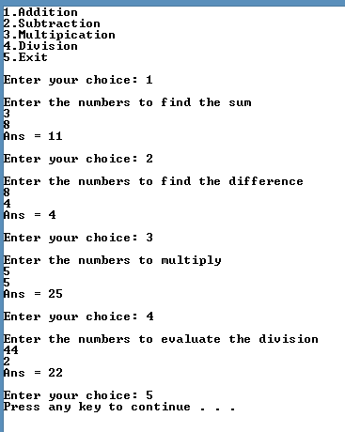

1. Write a function to implement static variables.

#include <iostream>

using namespace std;

void count(){

static int c = 0;

cout << c++;

}

void main(){

for (int i = 0; i<10; i++)

count();

cout << endl;}

**Output:**

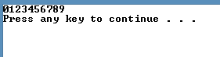

1. Using Bar Charts Display Array Data Graphically.

#include<iostream>

using namespace std;

int main()

{

const int arrSize = 11;

int arr[arrSize] = { 1, 3, 4, 2, 1, 3, 0, 2, 4, 1, 2 };

cout << "Grade Distribution"<<endl;

for (int i = 0; i < arrSize; i++)

{

if (i == 0)

cout << "0 - 9\t: ";

else if (i == 10)

cout << "100\t: ";

else

cout << i * 10 << " - " << (i * 10) + 9 << " : ";

for (int j = 0; j < arr[i]; j++)

cout << "*";

cout << endl;

}

return 0;

}

**Output:**

