Programs:

1. Create a class called Box with three data members length, breadth, and height.

Provide Set() and Get() functions for each data member.

Also write a member function to calculate volume of a box.

#include<iostream>

using namespace std;

class box {

public:

float l, b, h, v;

void set() {

cout << "Enter the length breadth and height of the box\n:";

cin >> l >> b >> h;

}

void get() {

cout << "Length = " << l<< endl;

cout << "Breadth = " << b << endl;

cout << "Height = " << h << endl;

}

void calvol() {

v = l*b*h;

cout << "Volume = " << v<<endl;

}

};

int main() {

box cube, cuboid;

cube.set();

cube.get();

cube.calvol();

cout << "\n";

cuboid.set();

cuboid.get();

cuboid.calvol();

return 0;

}

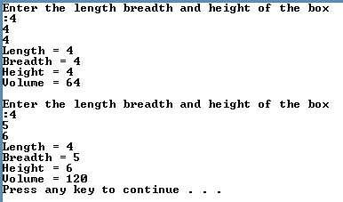

**Output:**

1. Create a class called as Employee with data members first_name, last_name and monthly_salary. Provide set and get functions for each data member. Also write a member function that calculates yearly salary of an employee and displays it.

#include<iostream>

using namespace std;

class employee {

public:

char firstName[20], lastName[20];

float monthlySalary, yearlySalary;

void setFName() {

cout << "Enter First Name : ";

cin >> firstName;

}

void setLName(){

cout << "Enter Last Name : ";

cin >> lastName;

}

void setMSalary(){

cout << "Enter Monthly Salary : ";

cin >> monthlySalary;

}

void set(){

setFName();

setLName();

setMSalary();

}

void calcYearlySalary() {

yearlySalary = monthlySalary * 12;

cout << "Calculated yearly salary." << endl;

}

void display() {

cout << "----- Details -----" << endl;

cout << "First Name : " << firstName << endl;

cout << "Last Name : " << lastName << endl;

cout << "Monthly Salary : " << monthlySalary << endl;

cout << "Yearly Salary : " << yearlySalary << endl;

}

};

int main() {

employee emp1, emp2;

emp1.set();

emp1.calcYearlySalary();

emp1.display();

cout << endl;

emp2.set();

emp2.calcYearlySalary();

emp2.display();

return 0;

}

**Output:**

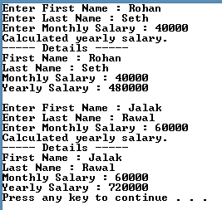

1. Write a object-oriented C++ program to create a library information system containing the following for all books in the library: accession number, name of author, title of book, year of publication, publishers name, cost of book. Find the most expensive book.

#include<iostream>

#include<string.h>

using namespace std;

class Book {

int accNumber, year, cost;

string bookName, publisherName, authorName;

public:

void set() {

cout << "Enter name of the book: ";

getline(cin, bookName);

cout << "Enter name of the author:";

getline(cin,authorName);

cout << "Enter publishers name:";

getline(cin, publisherName);

cout << "Enter the year of publication:";

cin >> year;

cout << "Enter accession number:";

cin >> accNumber;

cout << "Enter the cost:";

cin >> cost;

}

void get()

{

cout << "\nName of the author : " << authorName << endl;

cout << "Year of publication : " << year << endl;

cout << "Name of book : " << bookName << endl;

cout << "Publishers name : " << publisherName << endl;

cout << "Name of accession number : " << accNumber << endl;

cout << "Cost of book : " << cost << endl;

}

friend void max(Book, Book, Book);

};

void max(Book a, Book b, Book c) {

if (a.cost > b.cost)

if (a.cost > c.cost)

cout << a.bookName << " is the most expensive book." << endl;

else

cout << c.bookName << " is the most expensive book." << endl;

else

if (b.cost > c.cost)

cout << b.bookName << " is the most expensive book." << endl;

else

cout << c.bookName << " is the most expensive book." << endl;

}

int main() {

Book book1, book2, book3;

cout << "\nEnter Details for Book 1" << endl;

book1.set();

cout << "\nEnter Details for Book 2" << endl;

book2.set();

cout << "\nEnter Details for Book 3" << endl;

book3.set();

book1.get();

book2.get();

book3.get();

max(book1, book2, book3);

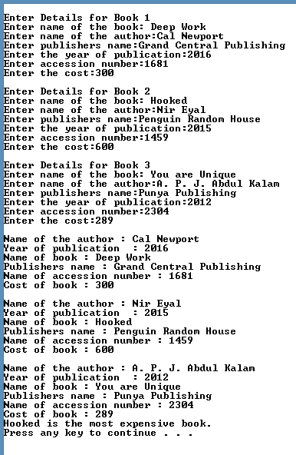

return 0;

}

**Output:**

1. Write a C++ Program to Calculate Electricity Bill of a user using Class.

Tariff is as follows: 100 Rs. 1.20 per unit; 200 Rs. 2 per unit; 300 Rs. 3 per unit.

#include<iostream>

using namespace std;

class Bill {

public:

float customerNo, units, totalBill;

char customerName[20];

void set() {

cout << "Enter the Customer No. : ";

cin >> customerNo;

cout << "Enter the Customer Name : ";

cin >> customerName;

cout << "Enter the Units : ";

cin >> units;

}

void calcBill() {

if (units <= 100)

totalBill = units * 1.20;

else if (units <= 200)

totalBill = 100 * 1.20 + (units - 100) * 2;

else

totalBill = 100 * 1.20 + 100 * 2 + (units - 200) * 3;

cout << "Total Bill : " << totalBill << endl;

}

};

int main() {

Bill b1, b2, b3;

cout << "--- Customer 1 ---" << endl;

b1.set();

b1.calcBill();

cout << endl;

cout << "--- Customer 2 ---" << endl;

b2.set();

b2.calcBill();

cout << endl;

cout << "--- Customer 3 ---" << endl;

b3.set();

b3.calcBill();

cout << endl;

return 0;

}

**Output:**

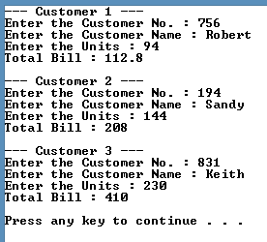

1. Write an object-oriented C++ program to add time.

**#include<iostream>**

**using namespace std;**

**class Time{**

**public:**

**int min, hr;**

**void set() {**

**cout << "Enter the Hours and minutes : ";**

**cin >> hr >> min;**

**}**

**void display() {**

**cout << "Time is " << hr << ":" << min << endl;**

**}**

**void addTime(Time t1, Time t2 ) {**

**min = t1.min + t2.min;**

**hr = min / 60;**

**min = min % 60;**

**hr += t1.hr + t2.hr;**

**display();**

**}**

**};**

**int main() {**

**Time t1, t2, t3;**

**t1.set();**

**t2.set();**

**t3.addTime(t1, t2);**

**return 0;**

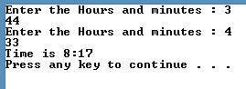**}**

**Output:**