**Program 1**

<html>

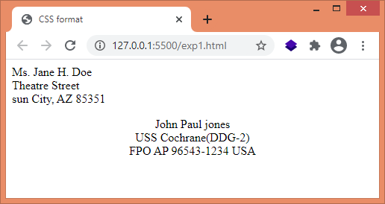 <head>

<title>CSS format</title>

<style>

#one {

text-align: left; }

#two {

text-align: center; }

</style>

</head>

<body>

<p id="one">

Ms. Jane H. Doe <br />

Theatre Street <br />

sun City, AZ 85351

</p>

<p id="two">

John Paul jones <br />

USS Cochrane(DDG-2) <br />

FPO AP 96543-1234 USA

</p>

</body>

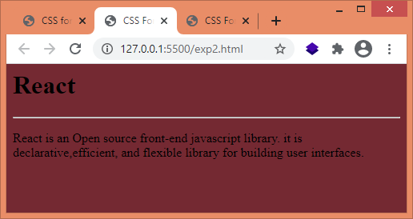</html>

**Program 2**

<html>

<head>

<title>CSS Format</title>

<style>

body {

background-color: #742932; }

</style>

</head>

<body>

<h1>React</h1><hr />

<p>

React is an Open source front-end javascript library. it is

declarative,efficient, and flexible library for building user interfaces.

</p>

</body>

</html>

**Program 3**

<html>

<head>

<title>CSS Format</title>

<style>

body {

background-color: #048390;

color: #d9f754;

}

</style>

</head>

<body>

<h1>React</h1>

<hr />

<p>

React is an Open source front-end javascript library. it is

declarative,efficient, and flexible library for building user interfaces.

</p>

</body>

</html>

