**Validate Email and password**

<html>

<head>

<title>onSubmit Event</title>

<script type="text/javascript">

function validate() {

var emailPattern = /^[a-zA-Z0-9._-]+@[a-zA-Z0-9.-]+\.[a-zA-Z]{2,4}$/;

var pwdPattern = /^[A-Za-z]\w{6,}[A-Za-z]$/;

var enteredEmail = document.getElementById("emailText").value;

var enteredPwd = document.getElementById("pwdText").value;

if (!emailPattern.test(enteredEmail)) alert("Invalid Email Id");

if (!pwdPattern.test(enteredPwd))

alert("Invalid Password: Password must be 8 Characters and start and end with a letter");

}

</script>

</head>

<body>

<form onsubmit="validate();">

<label for="email"

>Enter your Email Id: <input type="text" id="emailText" size="50"

/></label>

<br /><br />

<label for="password"

>Enter Password: <input type="password" id="pwdText"

/></label>

<br /><br />

<input type="submit" id="submitBtn" />

</form>

</body>

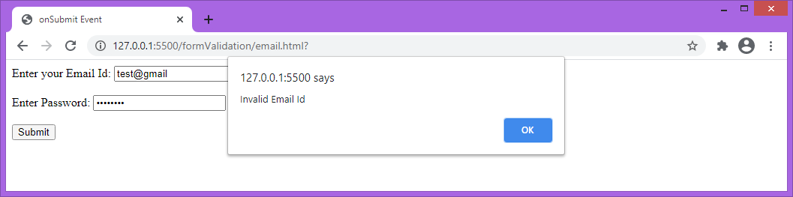</html>

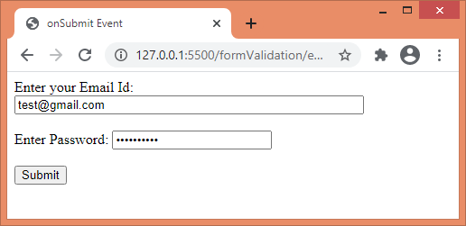

**Results form**

<html>

<head>

<title>Student Data Example</title>

<script type="text/javascript">

function showResult() {

var name = document.getElementById("name").value;

var cls = document.getElementById("class").value;

var mark1 = parseInt(document.getElementById("sub1").value);

var mark2 = parseInt(document.getElementById("sub2").value);

var mark3 = parseInt(document.getElementById("sub3").value);

if (!(name && cls && mark1 && mark2 && mark3)) {

alert("All fields are important. Pleae enter values in all field.");

} else {

var total = mark1 + mark2 + mark3;

var avg = total / 3;

var grade, result;

if (avg >= 60) {

grade = "A";

result = "First Class";

} else if (avg < 60 && avg >= 50) {

grade = "B";

result = "Second Class";

} else if (avg < 50 && avg >= 40) {

grade = "C";

result = "Third Class";

} else {

grade = "D";

result = "Fail";

}

document.write("<h2>Results</h2>");

document.write("<b>Name :" + name + "</b></br></br>");

document.write("<b>Class :" + cls + "</b></br></br>");

document.write("<b>Total Marks :" + total + "</b></br></br>");

document.write("<b>Average :" + avg + "</b></br></br>");

document.write("<b>Grade :" + grade + "</b></br></br>");

document.write("<b>Result :" + result + "</b></br></br>");

}

}

</script>

</head>

<body>

<form onsubmit="showResult()">

<label>Enter Student's Name: <input type="text" id="name" /></label

><br /><br />

<label>Enter Student's Class: <input type="text" id="class" /></label

><br /><br />

<label>Enter Subject1's Marks: <input type="text" id="sub1" /></label

><br /><br />

<label>Enter Subject2's Marks: <input type="text" id="sub2" /></label

><br /><br />

<label>Enter Subject3's Marks: <input type="text" id="sub3" /></label

><br /><br />

<input type="submit" />

</form>

</body>

</html>

