**HTML**

3.1 Html stands for hyper text markup language and was first created by Tim Berners-lee, Robert cailliau, and others in 1989.

Html is the language in which most websites are written and is used to create pages and make them functional.

It is used to define the layout and attributes of a www document as well as create links between web pages .This means that the document contains links that allow the reader to jump to other places in the document or to another document altogether. The latest version is HTML5.

Hypertext is text that works as a link. A html document is a plain text file which contains rich text which is text with tags

Markup language is language of writing layout information within documents and is a way that computers speak to each other to control how text is processed and presented. To do this html uses two things: tags and attributes.

TAGS AND ATTRIBUTES

Tags and attributes are the basis of html.

They work together but perform different functions .

Html tags

The fundamental syntactic units of html are called tags

In general tags are used to specify categories of content.

The syntax of a tag is the tags name surrounded by angle brackets(< and >)

Most tags appear in pairs : an opening tag and a closing tag

The name of a closing tag is the name of its corresponding opening tag with a slash attached to the beginning. For example if the tag’s name is p the corresponding closing tag is /p

Whatever appears between a opening tag and its closing tag is the content of the tag. Not all tags have content.

TAGS are used to mark up the start of an html element and they are usually enclosed in angle brackets. An example of a tag is: <h1>.

Most tags must be opened <h1> and closed </h1> in order to function.

Html attributes

Attributes contain additional pieces of information. Attributes take the form of an opening tag and additional info is placed inside.

An example of an attribute is:

<img src="mydog.jpg" alt="a photo of my dog.">

In this instance, the image source (src) and the alt text (alt) are attributes of the <img> tag.

Rules to remember

1. The vast majority of tags must be opened (<tag>) and closed (</tag>) with the element information such as a title or text resting between the tags.
2. When using multiple tags, the tags must be closed in the order in which they were opened. For example:  
   <strong><em>this is really important!</em></strong>

3.1.1 CONTAINER TAGS

Html has two types of tags: empty or standalone and container. Most html elements consist of a starting tag, an ending tag, and everything that comes between the two tags, which is known as the element's contents. Here's an example of an element with a starting tag, and ending tag, and content: <p>hello, world!</p>

When tags are part of an element that can have content, the tags are called *container tags*.

Most html elements or components are containers, meaning they have a *start tag* and an *end tag*. The text enclosed within the tags follows the tag's instructions. In the following example, the <i> container tags make the enclosed text italic:

The weather is <i>*wonderful*</i> today. Result: the weather is *wonderful* today.

The end tag contains the same name as the start tag, but it is preceded by a slash ( / ). You can think of it as an "off " switch for the tag.

For some tags, the end tag is optional and the browser determines when the tag ends by context. This practice is most common with the <p> (paragraph) tag. Most browsers automatically end a paragraph when they encounter a new start tag (although navigator 4.x has some problems with autoclosing), so many web authors take advantage of the shortcut. Not all tags allow this, however, and not all browsers support this , so when in doubt include the end tag. This is especially important when using cascading style sheets with your document. The new xhtml standard also requires that all tags be closed.

3.1.1 STANDALONE TAGS OR EMPTY TAGS

Some elements only have a single tag and therefore can't have any content. These elements are called *empty* elements or empty tags also called standalone tags. Empty elements have the following syntax:

<tagname>

Or

<tagname att1="value" att2="value">

A few tags do not have end tags because they are used to place standalone elements in the document or on the page. The image tag (<img>) is such a tag; it simply plops a graphic into the flow of the page. Other standalone tags include the linebreak (<br>), horizontal rule (<hr>), and tags that provide information about a document and don't affect its displayed content, such as the <meta> and <base> tags. The list below states all the tags in the html 4.01 specification that do not take end tags.

**<area> <frame> <link> <base> <hr> <meta>**

**<hr> <meta> <basefont> <img> <param> <br>**

**<input> <col> <isindex>**

**3.1.2 HTML PAGE STRUCTURE**

**There are four sets of**[**HTML tags**](http://www.simplehtmlguide.com/whatishtml.php#htmltags)**that are needed to form the basic structure for every**[**HTML file**](http://www.simplehtmlguide.com/whatishtml.php#htmlfiles)**:**

* **<html></html>**
* **<head></head>**
* **<title></title>**
* **<body></body>**

**Definition - <html> </html>**

**This basically defines the document as web page. It also identifies the beginning and end of the HTML document. All other tags must fall between the html tags.**

**Header - <head> </head>**

**The header contains information about the document that will not appear on the actual page, such as the title of the document, the author, which style sheet to use and also meta tags.** **This is where all the metadata for the page goes — stuff mostly meant for search engines and other computer programs.**

**Title - <title> </title>**

**The title tag defines the title that will appear in the title bar of your web browser. The title must appear between the head tags.**

**Body - <body> </body>**

**The body tags contain all the information and other visible content on the page. All your images, links and plain text must go between the <body> and </body> tags.**

**These four tags are special. There must only be one set of each and they must be in the correct order**

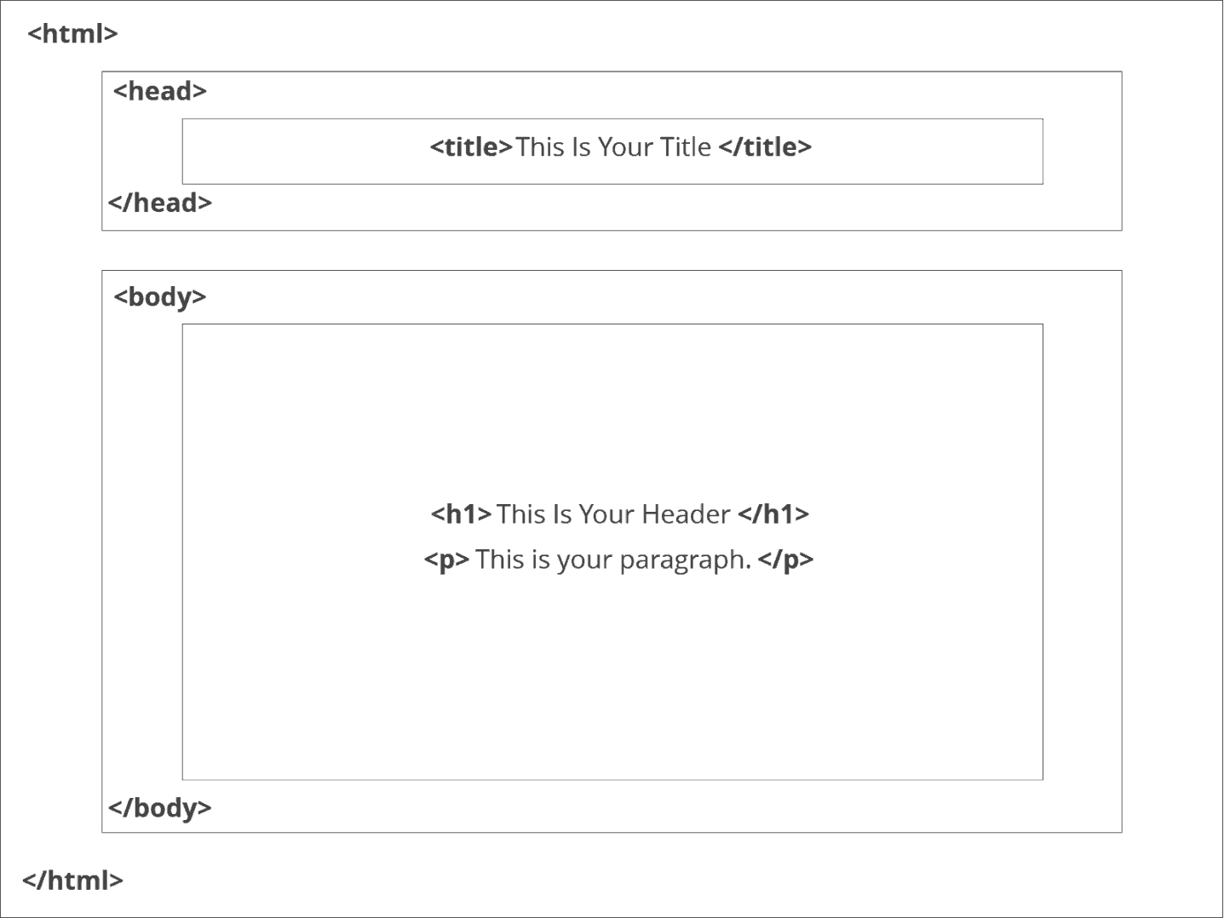

**<HTML> TAG**

The <html> tag represents the root of an HTML document.

The <html> tag is the container for all other HTML elements (except for the <!DOCTYPE> tag).

**Note:** You should always include the Lang attribute inside the <html> tag, to declare the language of the Web page. This is meant to assist search engines and browsers.

A simple HTML document:

<!DOCTYPE html>  
<html lang="en">  
<head>  
  <title>Title of the document</title>  
</head>  
<body>  
  
<h1>This is a heading</h1>  
<p>This is a paragraph.</p>  
  
</body>  
</html>

**3.1.3 DOCUMENT STRUCTURE TAGS**

<HEAD> TAG

The HTML <head> tag is used for indicating the head section of the HTML document. Tags included inside head tags are not displayed on browser window.

<!DOCTYPE html>

<html>

<head>

<title>HTML head Tag</title>

</head>

<body>

actual content goes here

</body>

</html>

**HTML - <base> Tag**

Description

The HTML <base> tag is used to specify a base URI, or URL, for relative links.

For example, you can set the base URL once at the top of your page in header section, then all subsequent relative links will use that URL as a starting point.

Example

<!DOCTYPE html>

<html>

<head>

<title>HTML base Tag</title>

<base href = "https://www.google.com" />

</head>

<body>

HTML: <img src = "/images/html.gif" />

</body>

</html>

The HTML <base> tag also supports the following additional attributes −

|  |  |  |
| --- | --- | --- |
| **Attribute** | **Value** | **Description** |
| href | URL | Specifies the URL of a page or the name of the anchor that the link goes to. |
| target | _blank _parent _self _top | Where to open the target URL.  _blank − the target URL will open in a new window.  _self − the target URL will open in the same frame as it was clicked.  _parent − the target URL will open in the parent frameset  _top − the target URL will open in the full body of the window |

**<META> TAG**

HTML lets you specify metadata - additional important information about a document in a variety of ways. The META elements can be used to include name/value pairs describing properties of the HTML document, such as author, expiry date, a list of keywords, document author etc.

The **<meta>** tag is used to provide such additional information. This tag is an empty element and so does not have a closing tag but it carries information within its attributes.

You can include one or more meta tags in your document based on what information you want to keep in your document but in general, meta tags do not impact physical appearance of the document so from appearance point of view, it does not matter if you include them or not.

Adding Meta Tags to Your Documents

You can add metadata to your web pages by placing <meta> tags inside the header of the document which is represented by **<head>** and **</head>** tags. A meta tag can have following attributes in addition to core attributes –

|  |  |
| --- | --- |
| **Sr.No** | **Attribute & Description** |
| 1 | **Name**  Name for the property. Can be anything. Examples include, keywords, description, author, revised, generator etc. |
| 2 | **content**  Specifies the property's value. |
| 3 | **scheme**  Specifies a scheme to interpret the property's value (as declared in the content attribute). |
| 4 | **http-equiv**  Used for http response message headers. For example, http-equiv can be used to refresh the page or to set a cookie. Values include content-type, expires, refresh and set-cookie. |

The <meta> tag is also used for :

**Specifying Keywords**

You can use <meta> tag to specify important keywords related to the document and later these keywords are used by the search engines while indexing your webpage for searching purpose.

**Document Description**

You can use <meta> tag to give a short description about the document. This again can be used by various search engines while indexing your webpage for searching purpose.

**Document Revision Date**

You can use <meta> tag to give information about when last time the document was updated. This information can be used by various web browsers while refreshing your webpage.

**Document Refreshing**

A <meta> tag can be used to specify a duration after which your web page will keep refreshing automatically.

**Page Redirection**

You can use <meta> tag to redirect your page to any other webpage. You can also specify a duration if you want to redirect the page after a certain number of seconds.

**Setting Cookies**

Cookies are data, stored in small text files on your computer and it is exchanged between web browser and web server to keep track of various information based on your web application need.

You can use <meta> tag to store cookies on client side and later this information can be used by the Web Server to track a site visitor.

**Setting Author Name**

You can set an author name in a web page using meta tag

**HTML - <link> Tag**

The HTML <link> tag is used for defining a link to an external document. It is placed in the <head> section of the document.

<!DOCTYPE html>

<html>

<head>

<title>HTML link Tag</title>

<link rel = "stylesheet" href = "stylenew.css">

</head>

<body>

<div id = "contentinfo">

<p>Welcome to our website. We provide tutorials on various subjects.</p>

</div>

</body>

</html>

Here is the css file *stylenew.css*

#contentinfo p {

line-height: 20px;

margin: 30px;

padding-bottom: 20px;

text-align: justify;

width: 140px;

color: red;

}

Specific Attributes

The HTML <link> tag also supports the following additional attributes −

|  |  |  |
| --- | --- | --- |
| **Attribute** | **Value** | **Description** |
| charset | charset | Defines the character encoding of the linked document. |
| href | URL | Specifies the URL of the resource document. |
| hreflang | language | Language code of the destination URL |
| media | screen tty tv projection handheld print braille aural all | Specifies the device the document will be displayed on |
| rel | alternate appendix bookmark chapter contents copyright glossary help home index next prev section start stylesheet subsection | Describes the relationship between the current document and the destination URL. |
| rev | alternate appendix bookmark chapter contents copyright glossary help home index next prev section start stylesheet subsection | Describes a reverse between the destination URI and the current document. |
| sizes | HeightxWidth | Specifies the size of the linked resource. |
| target | blank _self _top _parent | Specifies the target frame to load the page into. |
| type | mimetype | The MIMEtype of content at the link destination |

<SCRIPT> TAG

The HTML <script> tag is used for declaring a script (such as JavaScript) within your HTML document.

<!DOCTYPE html>

<html>

<head>

<title>HTML script Tag</title>

</head>

<body>

<script type = "text/JavaScript">

document.write("You're visiting SCRIPTS!")

</script>

</body>

</html>

Specific Attributes

The HTML <script> tag also supports the following additional attributes −

|  |  |  |
| --- | --- | --- |
| **Attribute** | **Value** | **Description** |
| async | sync | Specifies that the script is executed asynchronously. |
| charset | charset | Defines the character encoding that the script uses. |
| defer | defer | Declares that the script will not generate any content. Therefore, the browser/user agent can continue parsing and rendering the rest of the page. |
| src | URL | Specifies a URI/URL of an external script. |
| type | text/JavaScript application/ecmascript application/JavaScript text/vbscript | Specifies the scripting language as a content-type (MIME type). |
| xml:space | preserve | *Deprecated* − Whether the whitespace in code should be preserved |

**HTML - <title> Tag**

The HTML <title> tag is used for indicating the title of the HTML document. The body title is placed between the <head> and the </head> tags.

HTML document title is visible via browser’s title bar.

Example

<!DOCTYPE html>

<html>

<head>

<title>Title comes here</title>

</head>

<body>

<p>title tag is used for indicating the title of the HTML document. HTML document

title is visible via browser’s title bar.</p>

</body>

</html>

**<BODY> TAG**

The HTML <body> tag is used for indicating the main content section of the HTML document.

<!DOCTYPE html>

<html>

<head>

<title>HTML body Tag</title>

</head>

<body>

Body of the document...

</body>

</html>

Specific Attributes

The HTML <body> tag also supports the following additional attributes −

|  |  |  |
| --- | --- | --- |
| **Attribute** | **Value** | **Description** |
| alink | rgb(x,x,x) #xxxxxx colorname | *Deprecated* − Specifies the color of the active links in the document. |
| background | URL | *Deprecated* − Specifies the background image file path. |
| bgcolor | rgb(x,x,x) #xxxxxx colorname | *Deprecated* − Specifies the background color. |
| link | rgb(x,x,x) #xxxxxx colorname | *Deprecated* − Specifies the color of all the links in the document. |
| text | rgb(x,x,x) #xxxxxx colorname | *Deprecated* − Specifies the color of the text in the document. |
| vlink | rgb(x,x,x) #xxxxxx colorname | *Deprecated* − Specifies the color of the visited links in the document. |

|  |  |
| --- | --- |
| **Formatting tags:**  **Tags** | **Description** |
| <b> | Anything that appears in a <b>...</b> element is displayed in bold |
| <i> | Anything that appears in a <i>...</i> element is displayed in italics |
| <u> | Anything that appears in a <u>...</u> element is displayed with underline |
| <strike> | Puts a line right through the centre of the text, crossing it out. Often used to show that text is old and no longer relevant. |
| <sup> | Defines superscripted text |
| <sub> | Defines subscripted text |
| <big> | The content of the <big> element is displayed one font size larger than the rest of the text surrounding it. |
| <small> | The content of the <small> element is displayed one font size smaller than the rest of the text surrounding it. |

**Font tag (<font>):**

The <font> tag specifies the font face, font size, and font color of text.

|  |  |  |
| --- | --- | --- |
| **Attribute** | **Value** | **Description** |
| color | rgb(x,x,x) #xxxxxx colorname | Specifies the color of text |
| face | font_family | Specifies the font of text |
| size | number | Specifies the size oftext |

**Image tag (<img>):**

In HTML, images are defined with the <img> tag.

The <img> tag is empty, which means that it contains attributes only, and has no closing tag.

To display an image on a page, use the src attribute. Src stands for "source". The value of the src attribute is the URL of the image you want to display. The URL points to the location where the image is stored. The browser displays the image where the <img> tag occurs in the document. If you put an image tag between two paragraphs, the browser shows the first paragraph, then the image, and then the second paragraph.

|  |  |  |
| --- | --- | --- |
| : **Attribute** | **Value** | **Description** |
| src | URL | Specifies the URL of an image |
| align | top bottom middle left right | Specifies the alignment of an image according to surrounding elements |
| border | pixels | Specifies the width of the border around an image |
| height | pixels | Specifies the height of an image |
| width | pixels | Specifies the width of an image |
| hspace | pixels | Specifies the whitespace on left and right side of an image |
| vspace | pixels | Specifies the whitespace on top and bottom of an image |

**Horizontal Rule (hr):**

The <hr> tag is used for creating a horizontal line. This is also called Horizontal Rule in HTML. The <hr> tag defines a thematic break in an HTML page (e.g. a shift of topic). In HTML, the <hr> tag has no end tag.

|  |  |  |
| --- | --- | --- |
| Attributes of <hr> tag: **Attribute** | **Value** | **Description** |
| align | left center right | Specifies the alignment of a <hr> element |
| size | pixels | Specifies the height of a <hr> element |
| width | pixels  % | Specifies the width of a <hr> element |
| color | #xxxxxx colorname | Specifies the color of a <hr> element |

**HTML colors:**

HTML colors are defined using a hexadecimal notation (HEX) for the combination of Red, Green, and Blue color values (RGB).

The lowest value that can be given to one of the light sources is 0 (in HEX: 00). The highest value is 255 (in HEX: FF).

|  |  |  |
| --- | --- | --- |
| HEX values are specified as 3 pairs of two-digit numbers, starting with a # sign. **Color** | **Color HEX** | **Color RGB** |
| Red | #FF0000 | rgb(255,0,0) |
| Green | #00FF00 | rgb(0,255,0) |
| Blue | #0000FF | rgb(0,0,255) |
| Black | #000000 | rgb(0,0,0) |
| White | #FFFFFF | rgb(255,255,255) |

**SOME BASIC EXAMPLES**

**Exercise 1 – Starting a web page**

<HTML>

<HEAD>

<TITLE>Basic</TITLE>

</HEAD>

<BODY>

My name is TOM

</BODY>

</HTML>

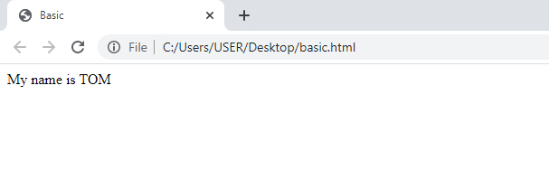

***Exercise 2 – Changing the background colour***

**<HTML>**

**<HEAD>**

**<TITLE>Background</TITLE>**

**</HEAD>**

**<BODY STYLE="BACKGROUND-COLOR:YELLOW;">**

**MY NAME IS TOM**

**<P>My last page was dull</P>**

**<P>This one has a background colour!</P>**

**</BODY>**

**</HTML>**

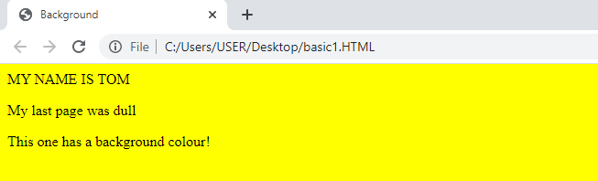

***Exercise 3 – Different sizes of text***

**<HTML>**

**<HEAD>**

**<TITLE>Text sizes</TITLE>**

**</HEAD>**

**<BODY>**

**<BODY STYLE="BACKGROUND-COLOR:RED;">**

**<H1>TEXT SIZES USING HEADERS</H1>**

**<H2>MY NAME IS TOM .THIS USES HEADER TAG H2</H2>**

**<H3>THE BACKGROUND COLOUR HERE IS RED AND WE ARE USING HEADER TAG H3</H3>**

**<H4>RED IS BETTER THAN YELLOW. HEADER TAG 4</H4>**

**<H5>TEST HEADING 5</H5>**

**<H6>WITH HEADER 6 THE TEXT IS SMALLEST</H6>**

**</BODY>**

**</HTML>**

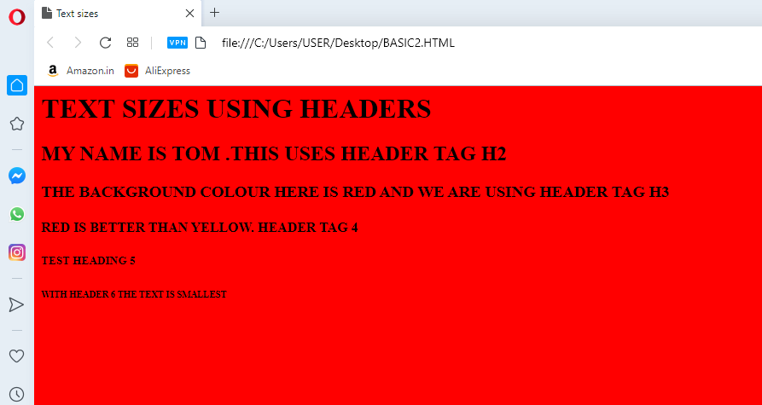

Exercise 4 – Changing font style & colour

**<HTML>**

**<HEAD>**

**<TITLE>**

**Font style and color**

**</TITLE>**

**<Body Style="background-color:green;">**

**<H1>font style and color </h1>**

**<p style="color:red;">my text is red </p>**

**<p style="font-family:comic sans ms;">this text is in comic sans ms </p>**

**</body>**

**</html>**

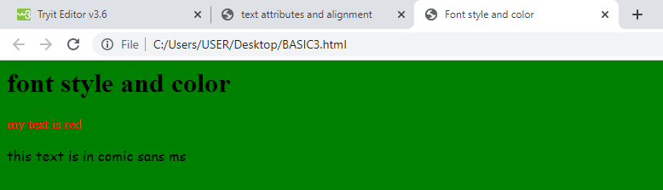

**Exercise 4 alignment of text in html**

**<html>**

**<head>**

**<title>HTML text alignment Document</title>**

**</head>**

**<body>**

**<h1>Tutorial</h1>**

**<p style="text-align:center;">dce 3 class is learning html</p>**

**<p style="text-align:right;">dce 3 class is learning html</p>**

**<p style="text-align:left;">dce 3 class is learning html</p>**

**</body>**

**</html>**

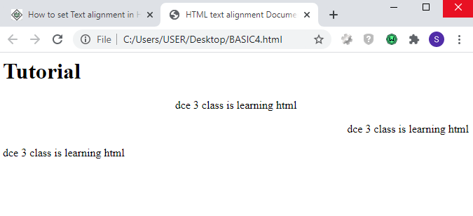

**<html>**

**<head>**

**<title>this is the title</title>**

**</head>**

**<body>**

**<h1>My Heading</h1>**

**<p>This is the first paragraph of text.</p>**

**<p>This is the second paragraph of text.</p>**

**<p>An image: <img src="photo.jpg"> </p>**

**<p>A link: <a href="http://www.google.com "> search engine </a></p>**

**</body>**

**</html>**

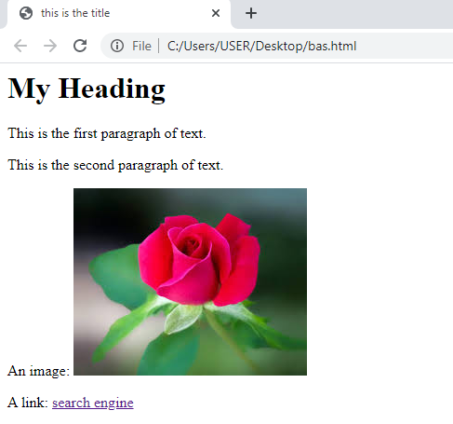

**Example:**

**<html>**

**<body>**

**<p align="right">The first paragraph of text, aligned to the right.</p>**

**<p>This text is now in the second paragraph.**

**<br>A new line, but still part of the second paragraph.</p>**

**<p>A third paragraph, and then a horizontal line</p>**

**<hr>**

**<p>Some modified horizontal lines:</p>**

**<hr width="50%" size="8" align="center">**

**<hr noshade>**

**</body>**

**</html>**

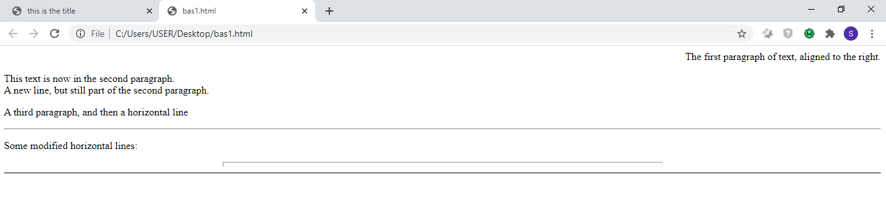

**<!DOCTYPE html>**

**<html lang="en">**

**<head>**

**<title>Formatting Text in HTML</title>**

**</head>**

**<body>**

**<p>This is <b>bold text</b>.</p>**

**<p>This is <strong>strongly important text</strong>.</p>**

**<p>This is <i>italic text</i>.</p>**

**<p>This is <em>emphasized text</em>.</p>**

**<p>This is <mark>highlighted text</mark>.</p>**

**<p>This is <code>computer code</code>.</p>**

**<p>This is <small>smaller text</small>.</p>**

**<p>This is <sub>subscript</sub> and <sup>superscript</sup> text.</p>**

**<p>This is <del>deleted text</del>.</p>**

**<p>This is <ins>inserted text</ins>.</p><p>This is <b>bold text</b>.</p>**

**</body>**

**</html>**

