**INTERNET TECH. AND WEB DESIGNING PROJECT REPORT**

Introduction:

* The project was based on a blogging website and was created considering the Esports theme and content. Basically it is an three page blogging site where any user can read existing post and create an new blog post from the provided portal.
* The website is dynamic meaning all the listings and its data on the home page as well as on the single post are retrieved from the database and rendered from the server.
* Even the website is Responsive meaning on different screen sizes the website would have different arrangements and different sizes of the elements.
* The language that was used to make the site dynamic is PHP and Mysql database. And Bootstrap was used to make the website responsive.
* Technologies used in front-end: HTML, CSS , JavaScript, Bootstrap, , Summernote.
* Technologies used in Back-end: PHP, MySQL.
* Tools used for development: Visual studio code, Chrome, Git, Xampp.

Discription of the pages :

* The common navbar to all the pages consists of the website logo on the left side and the navigation links on the right side.
* A back to top button is fixed to the bottom of the screen for easy scroll from bottom to top. The buttons functionality is created using JavaScript.
* Common Footer which has the social handles of the page.

**HomePage:**



* First part of the part of the page has an showcase slides which runs through couple of the quotes and images on gaming.

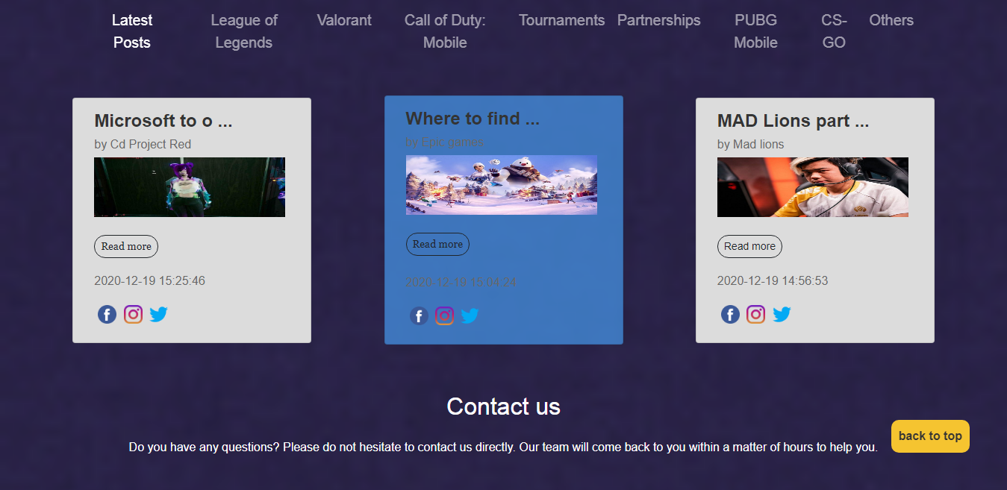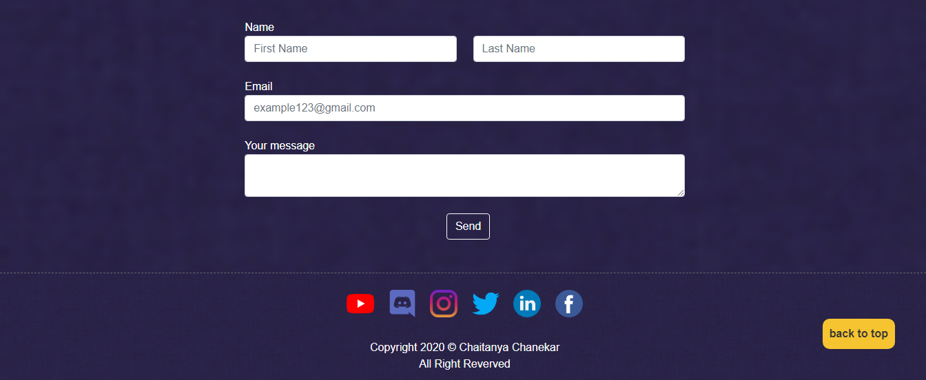

* Second part consists of another navbar which controls listing of the posts to be displayed on the homepage according to the category selected from the navbar.
* Third part consists of the listing of the blog posts previews that belongs to a particular category clicking on any of the previews will redirect the user to read the full blog post.
* Forth part has the contact form which collects the message and email from the user.

Create Post page

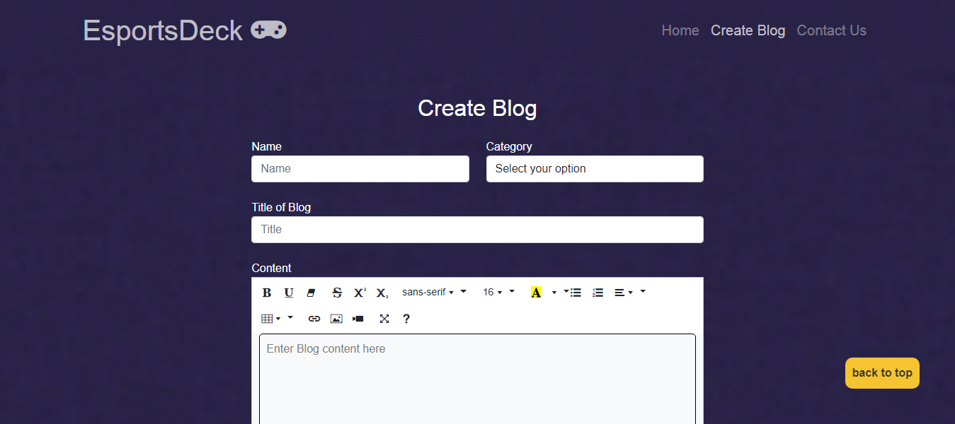

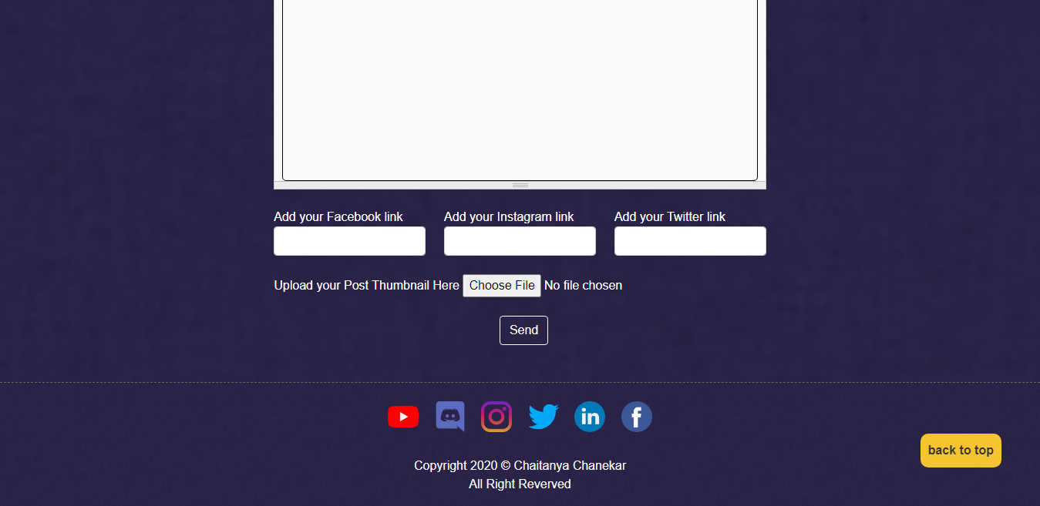

* When a user would click on “create blog” from the navbar the user will be redirected to the create post page. Which consists of Form that takes in data of the blog.
* The first field takes in the name of the author , the second field takes the category of the blog post using an dropdown menu. Third field take in the title of the blog. The fourth field has an text editor integrated which allows to add images and format text in the blog.
* there are three fields which takes in links of socials of the author. Last there is an option to add thumbnail and submit the post.

Single Post page

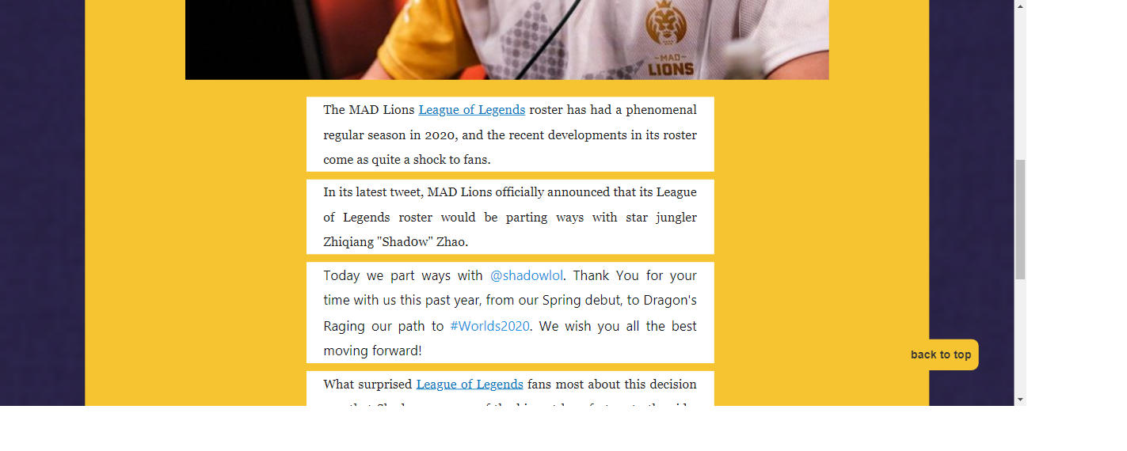

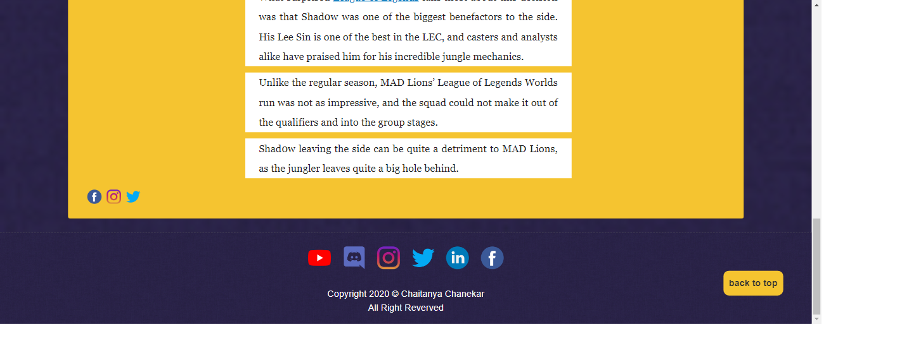

* this page displays particular blog post when the user clicks on the previewed post on the homepage. This page shows the title, timestamp of when the post was uploaded and its contents, socials.

Conclusion:

* HTML was used to implement the structure of the site.
* CSS was used to beautify the pages.
* Javascript was used to provide minor features.
* The server side scripting language used was PHP which interacted with the MySQL database to make the site dynamic.
* An experience of building a webapp was gained.