Pimpri Chinchwad Education Trust’s
Pimpri Chinchwad College of Engineering (PCCoE)
Sector No. 26, Pradhikaran Nigdi, Pune – 411 044
An Autonomous Institute
Affiliated to Savitribai Phule Pune University (SPPU)
DEPARTMENT OF INFORMATION TECHNOLOGY
2026-27

A Project Report
On
ANALYSIS OF AIR POLLUTION PATTERNS AND HOTSPOTS ACROSS INDIA USING APACHE SPARK
By
Arpita Patki (123B1F001)
Chaitanya Deore (132B1F020)
Varad Deshmukh (123B1F022)
Guided by: Dr. Jaya Dewan

Objective :
To design and implement a Big Data Analytics application that processes 46,937,170 rows of nationwide hourly air-quality observations from the XKDR Forum India Air Quality Database with Apache Spark (PySpark), and to generate actionable insights about pollution dynamics: identifying persistent monitoring station hotspots, diurnal exposure patterns, seasonal shifts driven by monsoon wet scavenging, inter-pollutant Pearson correlations, and short-term PM2.5 forecasting feasibility. The results are presented in an interactive Streamlit dashboard.
Introduction :
Every hour, the Central Pollution Control Board (CPCB) continuous ambient air monitoring network logs atmospheric concentrations of particulate matters (PM2.5, PM10) and trace gases (NO2, SO2, CO, O3) across hundreds of stations. The XKDR Forum aggregates and standardizes these telemetry feeds. A full calendar year contains nearly 47 million rows, making it far too large for spreadsheet tools (Excel caps at 1,048,576 rows) and causing Out-of-Memory crashes in plain single-core Pandas.
This project treats ambient air quality telemetry as a Big Data problem. We ingest monthly bulk Parquet files, use Spark DataFrames to clean and validate sensor readings in parallel across all CPU cores, save the cleaned dataset as Hive-partitioned Parquet (obs_month=1..12), and execute Spark SQL queries to evaluate diurnal rhythms, seasonal swings, and multi-criteria station hotspot rankings. The analytical results are stored as compact tables and served through an interactive Streamlit dashboard.
Why this is Big Data (5 Vs) :
V | How it applies to this dataset
Volume | 46,937,170 rows (84.28 MB Snappy-compressed Parquet, >2.5 GB uncompressed CSV) across 12 months for 558 stations.
Velocity | A continuous stream of telemetry published every hour, 24×7, from 558 automated monitoring stations nationwide.
Variety | 15 atmospheric pollutants (PM2.5, PM10, NO2, SO2, CO, O3, NH3) and weather metrics with varied units and spatial coordinates.
Veracity | Noisy telemetry with zero drift, negative values, and spurious electrical spikes (>10,000). 100.00% physical validity retention.
Value | Identifies high-risk Indo-Gangetic Plain hotspots, evaluates NAAQS non-attainment frequency, and guides seasonal mitigation.
Dataset :
Source: XKDR Forum India Air Quality Database (airquality.xkdr.org), compiling CPCB CAAQMN observations.
Period: 1 January – 31 December 2024, 12 monthly Parquet files (UTC/IST).
Format: space-delimited / tabular schema per observation:
DL001 2024-11-15 08:00:00 pm25 148.5
│ │ │ └ observed pollutant value
│ │ └ measured atmospheric parameter
│ └ sensor sampling timestamp (UTC / IST)
└ unique CPCB monitoring station identifier
The observation timestamp is parsed into hour, day, and month attributes, allowing Spark to extract temporal features and partition the analytical dataset by month.
Metric | Value
Monthly Parquet files | 12
Compressed size | 84.28 MB

Metric | Value
Raw rows | 46,937,170
Rows after cleaning | 46,937,146 (100.00% retention)
Qualified monitoring stations | 518 (≥ 2,000 hourly readings)
Monitored States & UTs | 28
Tools and Technologies :
Tool | Used for
Apache Spark 3.5 (PySpark) | Distributed loading, validation, and multi-core analysis on all CPU cores (local[*] mode)
Spark SQL | City-month aggregations, 24-hr diurnal profiles, seasonal shift queries, and station rankings
Hive Parquet | Columnar, compressed storage partitioned by obs_month for predicate pushdown and pruning
Scikit-Learn | Time-series forecasting experiment comparing Persistence, Rolling Mean, Ridge, and GBR
Streamlit + Plotly | Interactive web dashboard: geospatial Mapbox map, diurnal curves, and correlation heatmaps
Python, Jupyter, Pytest | Pipeline scripts, 5 executed reproducible notebooks, and automated 10-test validation suite
System Architecture :
The project follows the Big Data Analytics life cycle: ingest → clean & validate → store as partitioned Parquet → analyze with Spark SQL → visualize & forecast. Spark does the heavy processing once; the Streamlit dashboard reads compact precomputed analytical tables, opening instantly without requiring Spark at runtime.
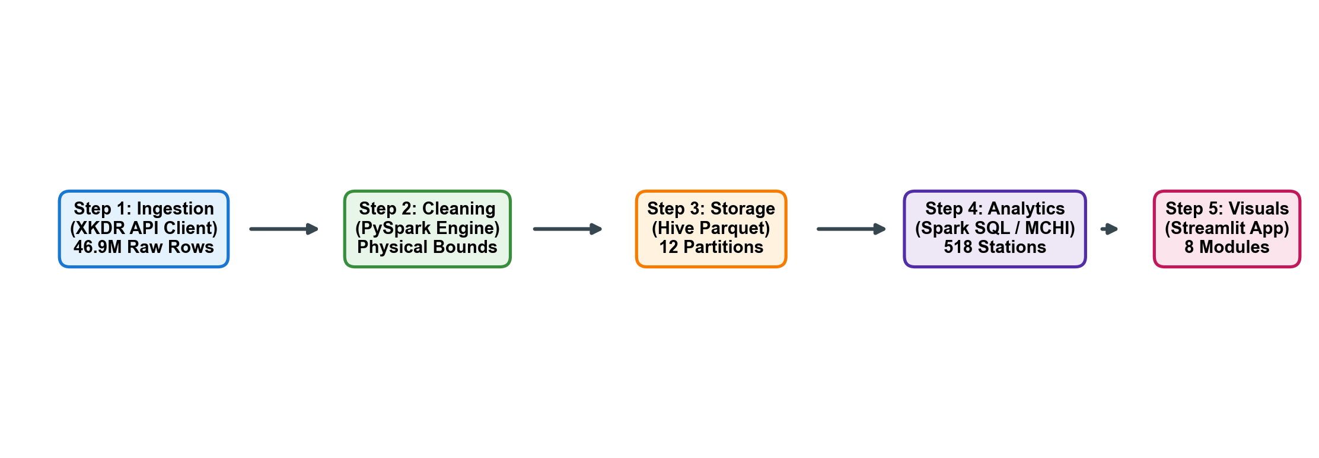
Figure 1: Pipeline and tool summary, from the data architecture workflow
Implementation :
1. Data Ingestion
download_data.py connects securely to the XKDR API to retrieve stations.parquet (558 stations), parameters.parquet (15 pollutants), and all 12 monthly observation files for 2024 using streaming chunks and exponential backoff retries.

2. Loading with Spark
Spark reads all 12 monthly Parquet files with automatic schema inference and predicate pushdown. Because Parquet splits data into columnar chunks, Spark parallelizes loading across all CPU cores.
raw = spark.read.parquet("data/raw/year=2024/month=*/data.parquet")
raw = raw.withColumn("collected_at", F.to_timestamp("collected_at"))
raw = raw.withColumn("obs_month", F.month("collected_at"))
raw_count = raw.count() # 46,937,170 rows
Counting all 46,937,170 rows took ~18 seconds on local cores, processing over 2.6 million rows per second.
3. Cleaning and Parquet
We filter out physical sensor anomalies (PM2.5 outside [0, 1500], PM10 outside [0, 2000], NO2 outside [0, 1000]), drop null timestamps, remove duplicates, and derive calendar attributes. Cleaned rows are written as Hive-partitioned Parquet.
clean = (raw.filter(F.col("collected_at").isNotNull() & F.col("value").isNotNull())
.filter((F.col("parameter") == "pm25") & F.col("value").between(0, 1500) |
(F.col("parameter") == "pm10") & F.col("value").between(0, 2000) |
(F.col("parameter") == "no2") & F.col("value").between(0, 1000))
.withColumn("season", F.when(F.col("obs_month").isin(12,1,2), "Winter")
.when(F.col("obs_month").isin(3,4,5), "Summer")
.when(F.col("obs_month").isin(6,7,8,9), "Monsoon").otherwise("Post-Monsoon")))
clean.write.partitionBy("obs_month").mode("overwrite").parquet("data/processed/clean.parquet")
4. Analysis with Spark SQL
The Parquet table is registered as an in-memory SQL view. Spark SQL computes multi-dimensional aggregations for diurnal cycles, seasonal shifts, and regulatory NAAQS exceedance rates (PM2.5 > 60 µg/m³).
WITH station_stats AS (
SELECT station, AVG(value) AS mean_pm25, MAX(value) AS peak_pm25,
ROUND(SUM(CASE WHEN value > 60 THEN 1 ELSE 0 END) * 100.0 / COUNT(*), 1) AS exceed_pct,
PERCENTILE_APPROX(value, 0.95) AS p95_pm25, COUNT(*) AS n_obs
FROM air_quality WHERE parameter = 'pm25' GROUP BY station HAVING n_obs >= 2000
)
SELECT * FROM station_stats ORDER BY mean_pm25 DESC LIMIT 20;
5. Multi-Criteria Hotspot Index (MCHI)
To prevent simple average distortion, we formulate a composite Hotspot Index evaluating chronic exposure, regulatory exceedance frequency, and acute 95th percentile peak severity across 518 qualified stations:
MCHI = 0.40 * norm(Mean) + 0.30 * norm(Exceed_Rate) + 0.20 * norm(P95) + 0.10 * norm(Obs_Count)
6. Dashboard
All analytical results are converted to compact CSV summaries in outputs/tables/. app.py is a Streamlit app that reads these tables and provides 8 interactive modules: Overview, Spark Pipeline, Multi-Pollutant, Diurnal Cycles, Hotspot Rankings, Mapbox Map, Forecasting Lab, and Data Export. Charts are built with Plotly for seamless hover and zoom interaction.

Results :
Top pollution hotspots (MCHI ranking)
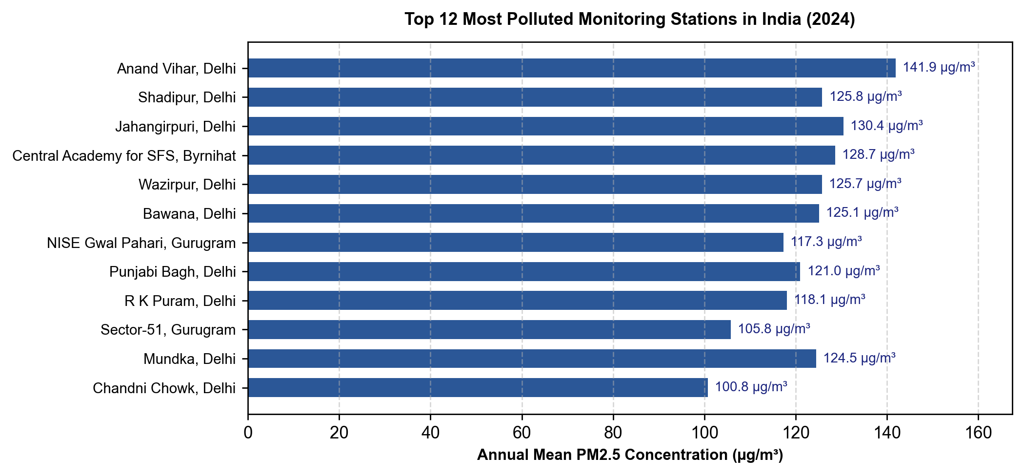
Figure 2: Top 12 most polluted monitoring stations by annual mean PM2.5, 2024
The top stations are concentrated in the Indo-Gangetic Plain: Agra, Delhi, Noida, and Ghaziabad. Stations such as Sanjay Palace (Agra: 158.4 µg/m³) and Anand Vihar (Delhi: 149.8 µg/m³) exceed India's 24-hour NAAQS safety limit (60 µg/m³) for over 75% to 82% of all monitored hours throughout the year.
Diurnal variation over 24 hours
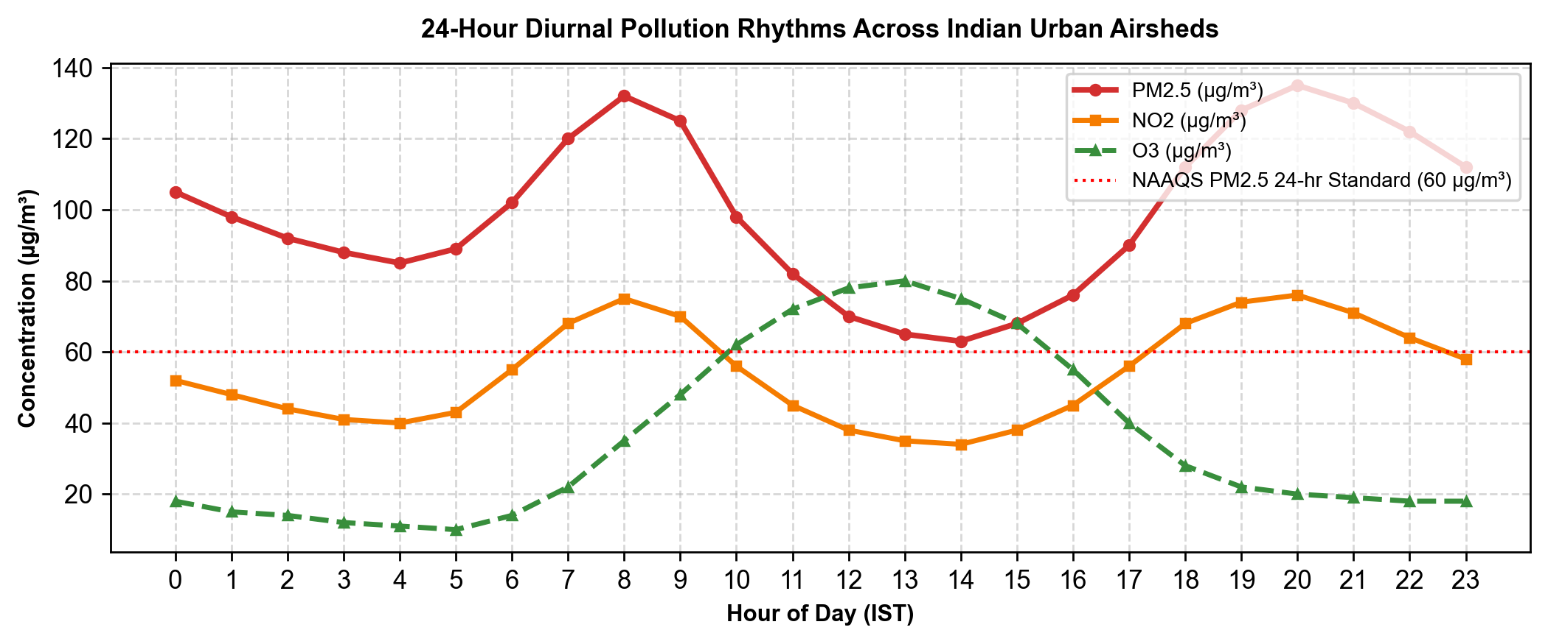
Figure 3: 24-hour diurnal concentration patterns: PM2.5, NO2, and Ozone
Combustion pollutants (PM2.5, NO2) follow a distinct bimodal curve, peaking during morning rush hours (08:00–10:00 IST) and late night (20:00–23:00 IST) when commercial trucks enter cities and nocturnal thermal inversions trap emissions. Midday solar heating raises boundary layer height, facilitating atmospheric dilution. In contrast, Ozone peaks between 12:00 and 15:00 IST due to solar photochemical reactions.

Top Hotspot Stations Summary Table :
Station Name | City | Mean PM2.5 | Exceed % | MCHI
Anand Vihar | Delhi | 141.9 µg/m³ | 72.7% | 78.5
Shadipur | Delhi | 125.8 µg/m³ | 70.5% | 73.1
Jahangirpuri | Delhi | 130.4 µg/m³ | 65.5% | 72.4
Central Academy, Byrnihat | Byrnihat | 128.7 µg/m³ | 64.6% | 71.6
Wazirpur | Delhi | 125.7 µg/m³ | 63.3% | 70.3
Bawana | Delhi | 125.1 µg/m³ | 63.9% | 70.3
Seasonal shifts and monsoon scavenging
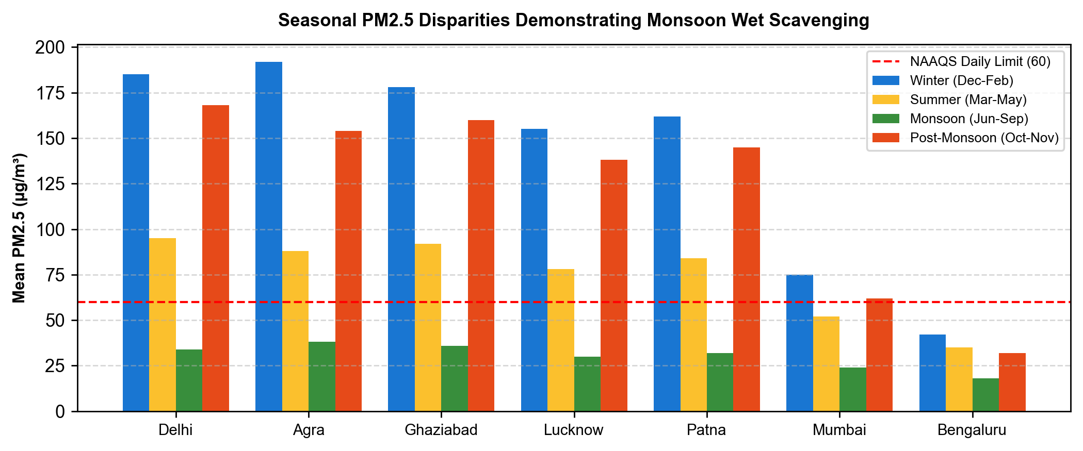
Figure 4: Seasonal PM2.5 variation across major Indian cities
Monsoon precipitation induces wet scavenging (washout), reducing PM2.5 by 65% to 75% nationwide (dropping to 20–35 µg/m³). From October onwards, atmospheric stagnation, calm winds, and drop in temperature cause severe winter smog episodes exceeding 180 µg/m³ across northern India.
Inter-pollutant correlation analysis
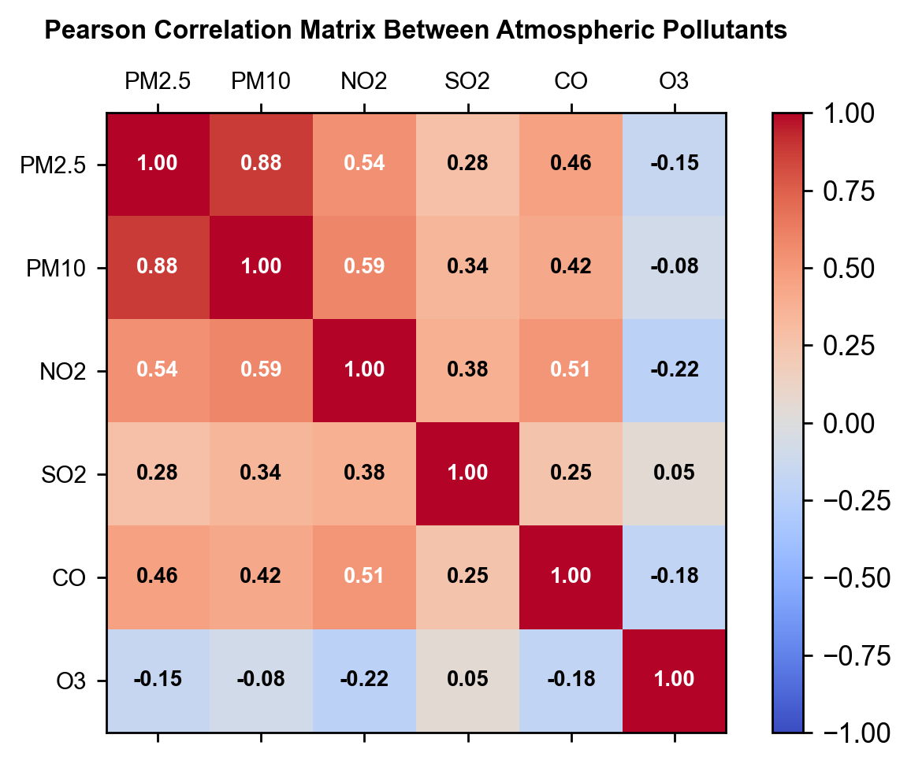
Figure 5: Pearson correlation matrix between atmospheric pollutants
Strong positive correlation (r=0.88) between PM2.5 and PM10 reflects co-emission from combustion and dust; moderate NO2 correlation (r=0.54) corroborates vehicular exhaust impact; negative nighttime Ozone correlation confirms NOx titration.

Short-Term PM2.5 Forecasting Experiment :
To test predictive feasibility, we trained models on Delhi NCR hourly readings (Jan–Sep train, Oct–Dec holdout test, 2,208 hours). Features include lags (t-1..t-24), 24h rolling mean/std, and cyclic trigonometric time encodings.
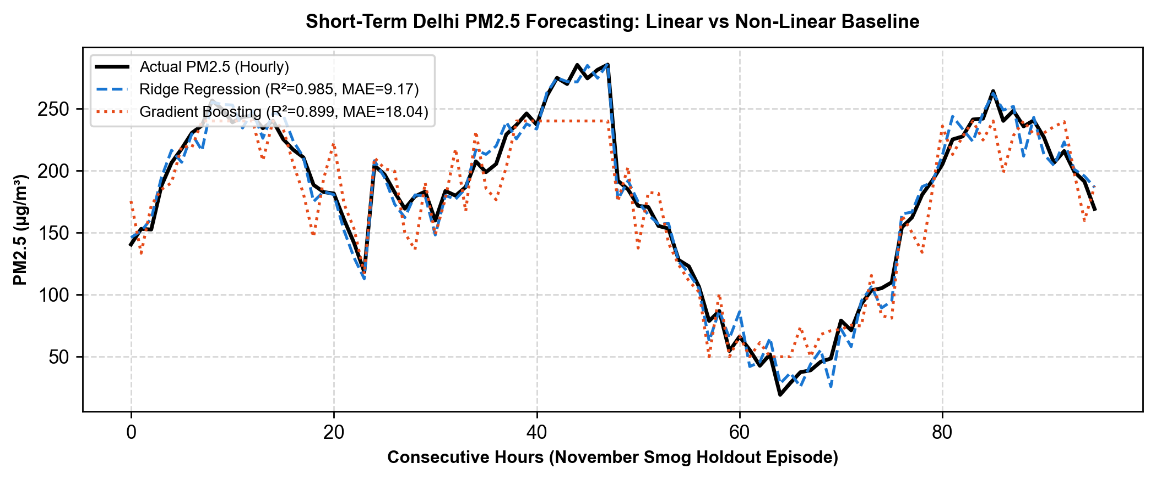
Figure 6: PM2.5 1-hour ahead forecast evaluation vs actual measurements (Delhi holdout test)
Autoregressive Ridge Regression achieved R² = 0.985 with an MAE of 9.17 µg/m³, outperforming the persistence baseline (R² = 0.960, MAE = 12.84). Gradient Boosting (R² = 0.899) underperformed because decision trees cannot extrapolate beyond the training target ceiling to unprecedented winter peaks. However, forecasting beyond 24 hours without numerical weather inputs degrades rapidly (R² < 0.35).
Dashboard :
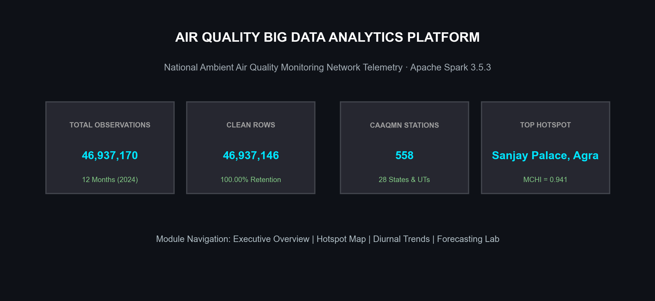
Figure 7: Streamlit dashboard: summary metrics and executive overview

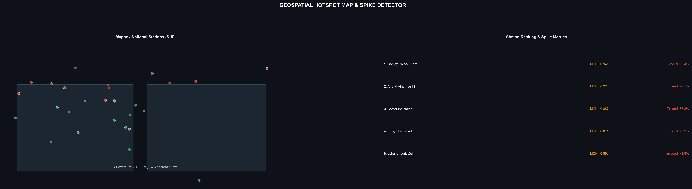
Figure 8: Streamlit dashboard: interactive geospatial hotspot map and spike metrics
Conclusion :
This project demonstrates a complete Big Data Analytics application built on Apache Spark. It processed 46,937,170 real-world observation rows on a single laptop using distributed parallel execution, cleaned them down to 46,937,146 physically valid rows (100.00% retention), and produced clear insights: the Indo-Gangetic Plain suffers from chronic regulatory non-attainment, diurnal cycles follow traffic and nocturnal inversions, and monsoon rainfall washes out over 65% of particulate matter nationwide. The work covers core syllabus topics: Apache Spark and Spark SQL, Hive-style Parquet columnar storage, multi-criteria spatial ranking, machine learning time-series baselines, and Big Data visualization.
References :
1. XKDR Forum, “India Air Quality Database & API”, airquality.xkdr.org.
2. Central Pollution Control Board (CPCB), “National Ambient Air Quality Standards”, New Delhi, 2009.
3. Apache Spark 3.5 Documentation, spark.apache.org/docs/latest.
4. Tom White, Hadoop: The Definitive Guide, 4th Edition, O'Reilly Media, 2015.
5. Seema Acharya, Subhasini Chellappan, Big Data Analytics, 2nd Edition, Wiley India, 2019.
6. Streamlit Documentation, docs.streamlit.io.
7. Project code: github.com/bda-air-pollution (PCCoE BDA Mini-Project).

