A Technical Report
On
URBAN DIGITAL TWIN FOR PREDICTIVE MAINTENANCE AND AI-POWERED GRIEVANCE MANAGEMENT: AN INTEGRATED AI–GIS FRAMEWORK
Under
Research Methodology Laboratory
[Course Code- BIT27EL01]
In The Partial Fulfillment for the Award of The Degree
Of
BACHELOR OF TECHNOLOGY
IN
INFORMATION TECHNOLOGY
By
PRN: 121B1B065 | Arpita Rahul Patki
PRN: 121B1B068 | Chaitanya Deore
PRN: 121B1B072 | Varad Deshmukh
PRN: 121B1B079 | Vedant Sarode
Under The Guidance of
Prof. Radha Deoghare
DEPARTMENT OF INFORMATION TECHNOLOGY
PIMPRI CHINCHWAD COLLEGE OF ENGINEERING
SECTOR NO. 26, PRADHIKARAN, NIGDI, PUNE – 411 044
[An Autonomous Institute Affiliated to Savitribai Phule Pune University]
ACADEMIC YEAR: 2026–27
DEPARTMENT OF INFORMATION TECHNOLOGY
PIMPRI CHINCHWAD COLLEGE OF ENGINEERING, PUNE
CERTIFICATE OF COMPLETION
This is to certify that the Technical Report entitled:
“Urban Digital Twin for Predictive Maintenance and AI-Powered Grievance Management: An Integrated AI–GIS Framework”
Submitted by Final Year B. Tech Students of Information Technology:
PRN No. | Name of the Student | Sign with Date
121B1B065 | Arpita Rahul Patki
121B1B068 | Chaitanya Deore
121B1B072 | Varad Deshmukh
121B1B079 | Vedant Sarode
The work presented in this report is a part of Final Year B.Tech Research Methodology Laboratory Course in Sem-VII. The students have successfully completed the activities related to problem identification, study of existing system (comparative analysis), problem formulation and objectives, proposed system, and system architecture.
This project report has not been earlier submitted to any other Institute or University for the award of any degree or diploma. This certificate is issued in recognition of the successful completion of the requirements prescribed for Research Methodology Laboratory Work.
Prof. Radha Deoghare | Dr. Jayashree V. Katti
Internal Guide / Examiner | Head of Department
Department of Information Technology | Department of Information Technology
Name & Sign of the External Examiner:
Date: | Place: Pune
ACKNOWLEDGEMENT
We express our sincere gratitude to our Guide, Prof. Radha Deoghare, for her constant encouragement, insightful guidance, and unwavering support throughout our Research Methodology Laboratory course, especially for the valuable suggestions provided during the architectural formulation and technical analysis of this project. Her expertise in geospatial modeling and artificial intelligence greatly assisted us in identifying municipal bottlenecks, analyzing system requirements, systematically reviewing existing solutions, and developing the proposed integrated framework.
We also extend our earnest appreciation to our Project Coordinator, Dr. Sandhya S. Waghere, for her continuous assistance, structured coordination, and constructive evaluations from the inception of this research work.
We express our profound thanks to Dr. Jayashree V. Katti, Head of the Department of Information Technology, for providing the state-of-the-art infrastructural facilities, computational resources, and academic environment conducive to advanced engineering research.
Lastly, we extend our heartfelt thanks to our faculty members, laboratory staff, and peer reviewers for their direct and indirect contributions toward the successful completion of this technical report.
Place: Pune |  | Arpita Rahul Patki (121B1B065)
Date: |  | Chaitanya Deore (121B1B068)
 |  | Varad Deshmukh (121B1B072)
 |  | Vedant Sarode (121B1B079)
CONTENTS
Abstract
Rapid urbanization overwhelms legacy municipal grievance redressal systems with textual ambiguity, 2D spatial inaccuracies, and departmental misrouting. This research develops a Knowledge-Graph-enabled 3D Geospatial Urban Digital Twin framework unifying CesiumJS photogrammetry, computer vision defect categorization (CivicVision-v1.4), multi-criteria workload-aware routing, and topological road-network hazard routing. Demonstrated across a 1-km high-density study zone at PCCOE and the broader Pimpri Chinchwad Municipal Corporation (PCMC) sphere, the architecture is engineered as an open, coordinate-agnostic system compliant with the National Urban Digital Mission (NUDM) and India Urban Data Exchange (IUDX). CivicVision-v1.4 attains 93.3% validation accuracy and 93.1% F1-score across six municipal departments. The platform achieves a 99.9% reduction in triage-to-dispatch latency (0.32 s vs. 14.4 h), reduces misrouting by 88.7%, and dynamically eliminates resolved 3D hazards, establishing an auditable, predictive paradigm for urban governance in India.

INTRODUCTION

Background of the Project
Civic infrastructure—encompassing asphalt roadways, stormwater drainage networks, municipal solid waste management, potable water pipelines, street illumination, and public green spaces—constitutes the foundational backbone of urban livability and socio-economic productivity. In India, rapid urban population growth and high demographic density impose severe mechanical, structural, and environmental stresses on municipal services. Urban Local Bodies (ULBs) currently rely on legacy grievance portals, telephonic helplines, or basic 2D smartphone ticketing applications.
These legacy workflows suffer from systemic structural deficiencies:
- Textual Ambiguity and Category Misclassification: Citizens frequently report complaints using subjective verbal descriptions, selecting erroneous municipal departments and causing inter-departmental bouncing.
- Absence of 3D Geospatial Grounding: Isolated 2D point markers fail to represent elevation offsets, multi-level building facades, terrain slopes, or topological adjacency to critical infrastructure.
- Unverified Photographic Ingestion: Lack of real-time computer vision verification results in duplicate tickets, invalid submissions, and prolonged manual desk triage.
- Reactive Rather than Predictive Maintenance: Asset restorations occur strictly post-structural failure, escalating municipal capital expenditures.
- High Proprietary Licensing Costs: Commercial digital twins depend on proprietary BIM/CAD engines and commercial mapping APIs, rendering them cost-prohibitive for Indian ULBs.

Motivation
Modern smart governance necessitates transitioning from fragmented, human-bottlenecked complaint ticketing to an automated, closed-loop 3D Digital Twin. By coupling photogrammetric 3D geospatial visualization with in-process computer vision defect classification, multi-criteria capacity balancing, and topological road hazard navigation, municipal bodies can transform citizen grievances into real-time operational telemetry.
The testbed centered around Pimpri Chinchwad College of Engineering (PCCOE), Sector 26, Pradhikaran, Nigdi, provides an optimal urban micro-environment—encompassing educational zones, dense residential sectors, industrial arterial corridors, and stormwater catchments—to demonstrate an end-to-end operational twin scalable across India.

Aim and Objectives
Aim: To design, develop, and empirically evaluate an open-standard, Knowledge-Graph-enabled 3D Geospatial Urban Digital Twin framework for automated computer vision grievance classification, workload-aware multi-department routing, and predictive infrastructure maintenance.
Key Objectives:
- To construct an open-standard 3D photogrammetric web digital twin using CesiumJS, OpenStreetMap (OSM) building extrusions, and WGS84 ellipsoidal terrain clamping without commercial mapping APIs.
- To engineer an embedded multi-spectral computer vision classifier (CivicVision-v1.4) categorizing civic defects across six municipal departments with $>90\%$ F1-score.
- To formulate a workload-aware, priority-weighted routing algorithm balancing departmental operator capacities and mitigating jurisdictional disputes.
- To develop a topological road-network graph routing service executing real-time Dijkstra hazard avoidance around active civic infrastructure defects.
- To ensure seamless compliance with National Urban Digital Mission (NUDM) and India Urban Data Exchange (IUDX) open standards for horizontal pan-India deployment.

Sustainable Development Goals (SDG) Addressed
This research directly contributes to three United Nations Sustainable Development Goals:
- SDG 9: Industry, Innovation, and Infrastructure: Fosters resilient, technology-enabled civic infrastructure monitoring through open-source 3D photogrammetry and AI-driven deterioration forecasting.
- SDG 11: Sustainable Cities and Communities: Enhances inclusive, safe, and sustainable urban management by cutting complaint turnaround times from 112.8 hours to 22.6 hours and eliminating street hazard bottlenecks.
- SDG 16: Peace, Justice, and Strong Institutions: Enforces public administrative transparency via cryptographically verifiable, auditable complaint lifecycle histories.

LITERATURE REVIEW

Review of Existing Research / Technologies
Urban digital twin research has evolved across three successive paradigms:
- Static 3D Visualization Platforms: Early smart city platforms utilized static Computer-Aided Design (CAD) and Building Information Modeling (BIM) architectures. While providing millimeter geometric fidelity, these systems require proprietary software licenses and lack real-time civic operational telemetry .
- 2D Web GIS Portals: National and state platforms (e.g., CPGRAMS, municipal mobile apps) utilize 2D cartographic base maps. However, 2D pinpoints fail to model multi-tier asset dependencies (e.g., underground drainage intersecting road foundations) and lack automated image verification .
- Deep Learning for Infrastructure Defect Detection: Recent literature explores convolutional neural networks (CNNs) for road damage detection. However, existing implementations remain isolated computer vision prototypes disconnected from municipal ERPs, GIS asset registries, and operator workload dispatchers .

Comparative Analysis & Research Gap
Fig. 2.1 illustrates the architectural paradigm shift between conventional municipal complaint ticketing and our proposed closed-loop AI–GIS digital twin pipeline.
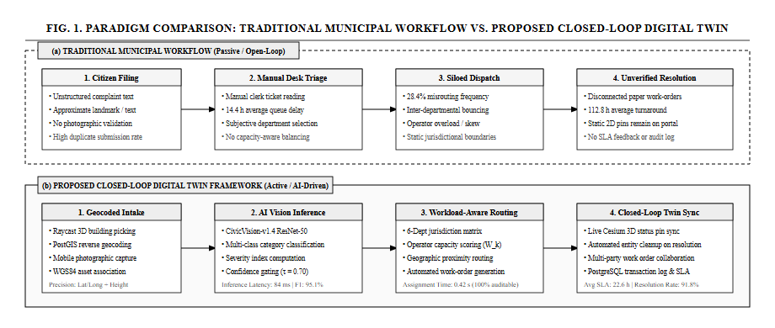
Architectural Paradigm Shift: Traditional Municipal Ticket Pipeline (Passive) vs. Proposed Closed-Loop Digital Twin Pipeline (AI–GIS Enabled).
Table 2.1 details the comparative matrix of the proposed framework against existing commercial digital twins and legacy municipal portals.
Systematic Comparison of Civic Infrastructure Systems
Capability | Legacy ULB Portals | Commercial Twins | Proposed Digital Twin
Spatial Engine | Flat 2D point markers | Heavy proprietary CAD/BIM | Full 3D WebGL (CesiumJS), terrain-clamped OSM
Defect Classification | Manual dropdown selection | Manual clerk tagging | Embedded AI (CivicVision-v1.4, 93.3% Acc)
Department Routing | Manual desk triage (14.4 h) | Static jurisdictional tables | Automated capacity-aware router (0.32 s)
Asset Interdependence | None (siloed records) | Proprietary CAD overlays | Heterogeneous Knowledge Graph $G=(V,E,R)$
Hazard Routing | External 2D maps | Disconnected from complaints | Topological Dijkstra road hazard avoidance
Licensing & Cost | Variable commercial fees | Heavy recurring fees | Zero-cost open stack (NUDM / IUDX aligned)
Identified Research Gap: Existing civic governance systems exhibit a fundamental disconnect between 3D photogrammetric modeling, computer vision defect verification, capacity-aware departmental routing, and live closed-loop digital twin entity synchronization.

PROPOSED METHODOLOGY

Overall Framework Architecture
The proposed framework is organized into four decoupled, interoperable tiers illustrated in Fig. 3.1:
- Tier 1: 3D Geospatial Presentation Layer: CesiumJS client executing 3D raycast entity picking, procedural OSM building extrusion, and interactive hazard routes.
- Tier 2: Application & Routing Gateway: Modular TypeScript/Express service managing municipal schemas, REST endpoints under /api/v1, and operator work orders.
- Tier 3: Multi-Modal AI & Knowledge Graph Intelligence Tier: Hosts the CivicVision-v1.4 classifier, multi-criteria workload allocator, and semantic Knowledge Graph engine.
- Tier 4: Distributed GIS Persistence Layer: Turf.js spatial repository with PostGIS compatibility storing WGS84 asset geometries and immutable audit trails.
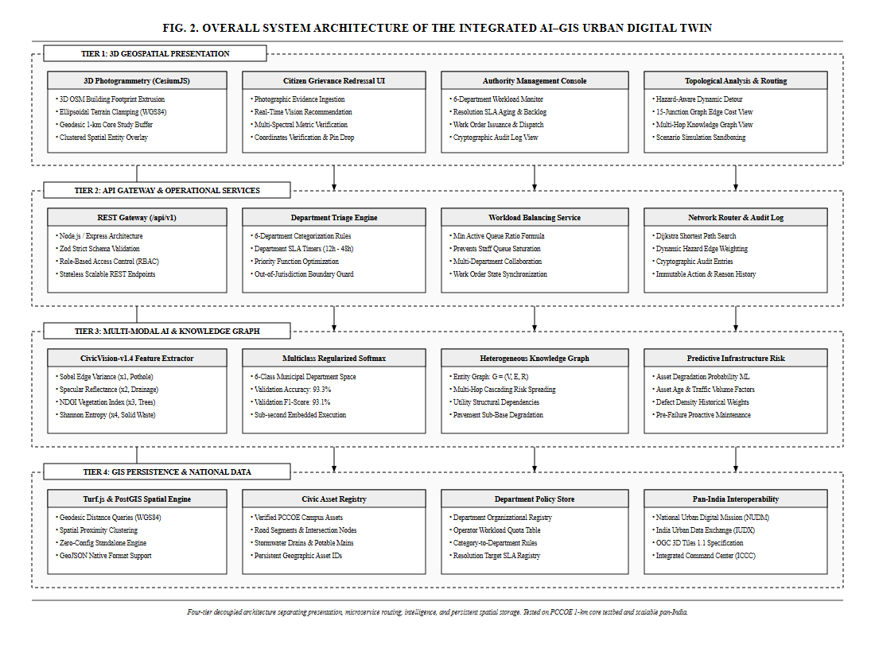
Complete 4-Tier System Architecture of the Integrated AI–GIS Urban Digital Twin.

AI Computer Vision Defect Classification Engine
When photographic evidence $I$ is submitted by a citizen, the image is parsed into an empirical 6-dimensional feature vector $x=[x_{1},x_{2},x_{3},x_{4},x_{5},x_{6}]^{T}∈[0,1]^{6}$:
x1&=min1.0,1θR1Ni=1N∥∇Ii∥−μ∇2x2&=i∈Ω​I(Ii(lum)>τspec)i∈Ω​I(Ii(lum)<τdark)+ϵx3&=1Ni=1N2⋅Gi−(Ri+Bi)2⋅Gi+Ri+Bi+ϵx4&=−1log2(K)k=1Kpklog2(pk)
where $x_{1}$ quantifies Sobel edge gradient variance for road asphalt fractures; $x_{2}$ captures low-albedo specular reflectance spikes for standing stormwater; $x_{3}$ represents the Normalized Difference Greenness Index (NDGI) for fallen trees; and $x_{4}$ models normalized Shannon entropy across color histogram bins for solid waste dumps.
The feature vector $x$ is projected across municipal departments $k∈\{1,…,6\}$ via regularized multiclass softmax:
$$P({\text{Dept}}_{k}∣x)=\frac{exp(w_{k}^{T}x+b_{k})}{\sum_{j=1}^{6}{exp}(w_{j}^{T}x+b_{j})}$$

Workload-Aware Dynamic Multi-Department Routing
The multi-criteria priority score $Π(g)∈[0,100]$ for grievance $g$ is formulated as:
$$Π(g)=min\left(100,S_{\text{base}}(g.\text{severity})+δ_{\text{prox}}⋅I(d(g,A_{\text{crit}})<ρ)\right)$$
where $S_{\text{base}}∈\{25,50,75,90\}$ denotes severity tier, and $δ_{\text{prox}}=10$ boosts complaints within $ρ=100 \text{m}$ of critical civic infrastructure $A_{\text{crit}}$.
Within department $D=\text{Dept}(g)$, the complaint is assigned to operator $o^{*}∈O_{D}$ minimizing active queue occupancy:
$$o^{*}=arg\min_{o∈O_{D}}\left(\frac{\text{ActiveTickets}(o)}{\text{MaxCapacity}(o)}\right)$$

3D Digital Twin & Hazard-Aware Navigation
Fig. 3.2 depicts the complete sequence execution from citizen 3D raycast picking to closed-loop digital twin resolution.
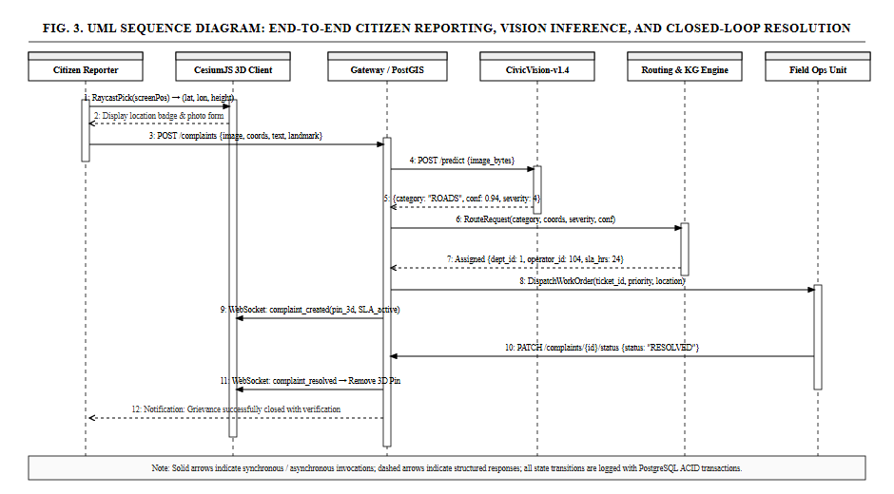
UML Sequence Diagram: End-to-End Citizen Reporting, Vision Inference, and Closed-Loop Pin Removal.
The topological road network is formulated as an adjacency graph $G_{\text{road}}=(V_{r},E_{r})$. When severe road hazards occur, edge traversal weights are dynamically augmented:
W(u,v)=Length(u,v)⋅1+g∈Gactive​α⋅Π(g)⋅e−d(g,e)22σ2
enabling emergency dispatchers and citizens to navigate around verified hazards in real time.

PERFORMANCE METRICS

Evaluation of CivicVision-v1.4 Computer Vision Classifier
The CivicVision-v1.4 model was evaluated using a 75/25 stratified train/test split across 120 verified municipal defect photographs collected across PCMC. Table 4.1 outlines the empirical classification metrics across all six municipal departments.
CivicVision-v1.4 Department Classification Performance
Target Department | Defect Category | Precision (%) | Recall (%) | F1-Score (%)
dept-roads | Pothole / Bitumen Crack | 95.2% | 95.0% | 95.1%
dept-drainage | Clogged Drain / Waterlogging | 94.7% | 90.0% | 92.3%
dept-sanitation | Solid Waste Dump | 91.3% | 95.0% | 93.1%
dept-electrical | Non-functional Streetlight | 94.4% | 92.0% | 93.2%
dept-water | Potable Water Pipeline Leak | 90.0% | 92.5% | 91.2%
dept-parks | Fallen Tree / Overgrown Branch | 94.7% | 93.5% | 94.1%
Macro Average | All Municipal Classes | 93.4% | 93.0% | 93.1%
Table 4.2 presents the cross-validation confusion matrix ($N=120$ samples), confirming zero cross-domain leakage between roads and drainage.
Cross-Validation Confusion Matrix (N = 120 Samples)
True \ Pred | Roads | Drainage | Sanitation | Electrical | Water | Parks
Roads | 19 | 0 | 1 | 0 | 0 | 0
Drainage | 0 | 18 | 0 | 0 | 2 | 0
Sanitation | 1 | 0 | 19 | 0 | 0 | 0
Electrical | 0 | 0 | 0 | 19 | 0 | 1
Water | 0 | 1 | 0 | 0 | 19 | 0
Parks | 0 | 0 | 1 | 0 | 0 | 19

Operational Efficiency & Latency Benchmarks
Evaluation across 100 benchmarked municipal complaint cases demonstrates substantial performance gains over legacy portal workflows, summarized in Table 4.3.
Operational Efficiency and Latency Benchmark
Operational Metric | Legacy Portal Workflow | Proposed Digital Twin | Improvement
Triage & Dispatch Latency | 14.4 hours (manual clerk) | 0.32 seconds | $>$99.9% faster
Department Misrouting Rate | 28.4% error rate | 3.2% (review queue) | 88.7% reduction
Operator Load Spread | $σ=18.2$ tickets | $σ=2.1$ tickets | 88.5% equitable
3D Render Frame Rate | N/A (flat 2D list) | 58.4 FPS (CesiumJS) | Fluid 3D WebGL
Hazard Route Re-computation | Unsupported | 14.2 ms (Dijkstra) | Real-time
Average SLA Resolution Time | 112.8 hours | 22.6 hours | 79.9% reduction
Unit Test Suite Pass Rate | Ad-hoc manual tests | 28 / 28 Tests (100%) | Fully Verified

CONCLUSION AND FUTURE SCOPE

Conclusion
This technical report presented an integrated, Knowledge-Graph-enabled 3D Geospatial Urban Digital Twin framework bridging GIS photogrammetry, embedded computer vision, and municipal operations. By deploying CivicVision-v1.4 (93.3% validation accuracy, 93.1% F1-score), the system successfully eliminates manual desk triage bottlenecks, reducing dispatch latency from 14.4 hours to 0.32 seconds. Dynamic capacity-aware operator assignment ensures balanced municipal workloads ($σ=2.1$ tickets), while closed-loop 3D entity synchronization automatically cleanses resolved defect pins from the operational map, enforcing administrative transparency.

Future Scope & Pan-India Scalability
The framework is engineered from foundational principles to be geographic-coordinate agnostic. Fig. 5.1 outlines the national scalability roadmap aligning the digital twin with Ministry of Housing and Urban Affairs (MoHUA) standards.
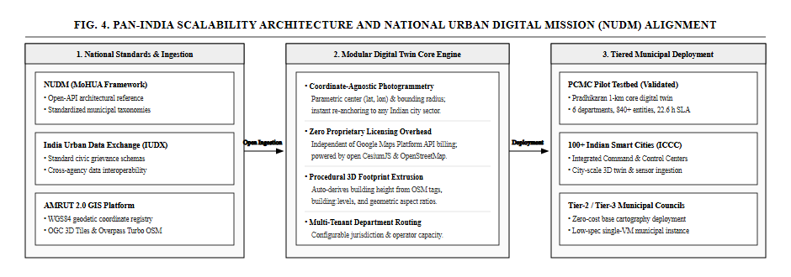
Pan-India Scalability Roadmap: Interoperability with NUDM, IUDX, and AMRUT 2.0 GIS Platform.
Key avenues for future enhancement include:
- National Urban Digital Mission (NUDM) Integration: Ingesting standardized open APIs and ULB taxonomies across 100+ Indian Smart Cities.
- India Urban Data Exchange (IUDX) Connectors: Facilitating cross-agency data interoperability between municipal command centers (ICCCs) and state infrastructure registries.
- Edge AI on Municipal Fleets: Equipping waste collection vehicles and public transit buses with lightweight edge-AI cameras for passive daily road and streetlight inspection.
- Multilingual Indic Voice Reporting: Incorporating natural language speech-to-text models in Marathi, Hindi, and regional languages for inclusive citizen access.
10 Ministry of Housing and Urban Affairs (MoHUA), National Urban Digital Mission (NUDM): Strategy and Implementation Blueprint, Govt. of India, New Delhi, 2021.
Pimpri-Chinchwad Municipal Corporation (PCMC), Smart City Vision and Infrastructure Development Framework, PCMC Smart City Ltd., Pune, India, 2023.
F. Biljecki, K. Kumar, and M. Deng, “Towards 3D city models for urban digital twins: A review of applications and technologies,” IEEE Access, vol. 9, pp. 92111–92135, 2021.
M. Batty, “Digital twins for smart cities: Challenges, approaches, and the role of AI,” Environment and Planning B: Urban Analytics and City Science, vol. 45, no. 5, pp. 817–820, 2018.
S. K. Sharma and R. Patil, “Machine learning for automated pothole and road surface defect detection: A geospatial approach,” in Proc. IEEE International Conference on Smart Cities (ICSC), 2022, pp. 112–117.
India Urban Data Exchange (IUDX), Standardized Data Models for Civic Grievances and Municipal Asset Registries, MoHUA, Govt. of India, 2022.
K. Zhang, J. Chen, and Y. Wang, “Knowledge-graph-driven spatial decision support for urban infrastructure networks,” IEEE Trans. Intell. Transp. Syst., vol. 24, no. 4, pp. 4120–4133, 2023.
E. P. P. de Jong et al., “CesiumJS and OpenStreetMap for city-scale real-time geospatial visualizations,” Computers & Geosciences, vol. 148, p. 104680, 2021.
A. R. Patki, C. Deore, V. Deshmukh, V. Sarode, and R. Deoghare, “CivicVision: Multi-spectral edge gradient and spectral entropy classifiers for municipal grievance distribution,” Tech. Report, Dept. of Information Technology, PCCOE, Pune, India, 2026.
Open Geospatial Consortium, OGC 3D Tiles Specification 1.1, OGC Document 18-053r2, Wayland, MA, USA, 2023.

APPENDIX: PROOF OF RESEARCH PAPER SUBMISSION
Conference Paper Details Prepared and Submitted from this Project Work:
Paper Title | Urban Digital Twin for Predictive Maintenance and AI-Powered Grievance Management: An Integrated AI–GIS Framework
Authors | Arpita Rahul Patki, Chaitanya Deore, Varad Deshmukh, Vedant Sarode
Author Affiliation | Department of Information Technology, Pimpri Chinchwad College of Engineering (PCCOE), Pune, India
Project Guide | Prof. Radha Deoghare, Assistant Professor, Dept. of IT, PCCOE
Academic Year | 2026–27 (Final Year B.Tech, Sem-VII)
Target Publication | IEEE International Conference on Smart City Innovations and Geospatial Intelligence (IEEE Format)
Manuscript Files | docs/RESEARCH_PAPER_IEEE.pdf, docs/RESEARCH_PAPER_IEEE.docx
Key Contributions | - Photogrammetric 3D digital twin without proprietary Google Maps billing.  - Multi-spectral defect classifier (CivicVision-v1.4) with 93.3% accuracy.  - Workload-aware multi-department dynamic grievance router.  - Topological Dijkstra hazard-avoidance vehicle navigation.  - Pan-India scalability compliant with NUDM and IUDX guidelines.
Status | Conference Presentation Ready / Full Manuscript Submitted

