Pimpri Chinchwad Education Trust’s
Pimpri Chinchwad College of Engineering (PCCoE)
Sector No. 26, Pradhikaran Nigdi, Pune – 411 044
An Autonomous Institute
Affiliated to Savitribai Phule Pune University (SPPU)
DEPARTMENT OF INFORMATION TECHNOLOGY
2026-27

A Formative Assessment 2 (FA2) Report
On
ZOMATO BANGALORE RESTAURANT ANALYTICS USING APACHE SPARK AND ADVANCED BIG DATA VISUALIZATION
By
Arpita Patki (123B1F001)
Chaitanya Deore (132B1F020)
Varad Deshmukh (123B1F022)
Guided by: Prof. Madhuri Kethari

Objective :
To design and implement a Big Data Analytics application that processes 51,717 raw restaurant records (~547 MB) from the Kaggle Zomato Bangalore Restaurants database with Apache Spark (PySpark), resolving multi-city listing redundancy down to 12,519 unique establishments, and to generate actionable insights into restaurant distribution across Bangalore localities, cuisine popularity and rating dynamics, approximate dining cost relationships, the operational impact of online ordering and table booking, and high-dimensional locality-cuisine concentration heatmaps. The results are presented in an interactive Streamlit dashboard.
Introduction :
Bangalore, as India’s leading information technology capital, has one of the country's most vibrant and dense dining ecosystems. Online aggregator platforms such as Zomato connect millions of diners with thousands of food establishments. The dataset contains unstructured customer reviews, multi-category cuisine tags, inconsistent rating scales, and duplicate listings across administrative delivery clusters. A dataset of over half a gigabyte containing nested text causes significant memory spikes and Out-of-Memory crashes in single-threaded tools like plain Pandas.
This project treats Zomato Bangalore restaurant analytics as a Big Data problem. We ingest the raw multi-line quoted CSV dataset using Apache Spark Core and DataFrames, parallelize distributed cleaning across all CPU cores, eliminate 39,177 redundant listings, parse non-standard ratings into numeric formats, and execute Catalyst-optimized Spark SQL queries to compute locality distributions, sample-thresholded cuisine rankings, Pearson price-rating correlations, and 2D locality-cuisine matrices. The analytical metrics are stored as compact tables and served through an interactive Streamlit dashboard.
Why this is Big Data (5 Vs) :
V | How it applies to this dataset
Volume | 51,717 raw observation rows (547 MB raw CSV, 17 attributes), parsed and deduplicated to 12,519 unique physical dining establishments.
Velocity | A continuous stream of customer orders, live menu additions, dynamic table bookings, and daily user reviews across 93 Bangalore localities.
Variety | Multi-format semi-structured data: structured attributes (ratings, cost), multi-value token lists (cuisines, dish liked), binary service flags, and long unstructured review tuples.
Veracity | Severe data noise: sentinel string ratings ('NEW', '-'), thousand commas in cost ('1,200'), and duplicate multi-zone listings. 100.00% physically clean entity retention.
Value | Discovers commercial saturation zones (Whitefield, BTM), reveals the table-booking engagement multiplier (6x review volume), and guides restaurateur location strategy.
Dataset :
Source: Kaggle Zomato Bangalore Restaurants Dataset, compiling comprehensive Bangalore food establishment records.
Period & Scope: Full metropolitan Bangalore coverage across 93 commercial, tech park, and residential zones.
Format: Space-delimited / tabular schema per restaurant observation:
Jalsa | 942, 21st Main Road, Banashankari | 4.1/5 | 775 | 800 | North Indian, Chinese
│ │ │ │ │ └ comma-separated cuisine tags
│ │ │ │ └ approximate cost for two in INR (₹)
│ │ │ └ total user review / vote count
│ │ └ customer rating out of 5.0 (with /5 suffix)
│ └ full street address and locality
└ unique restaurant business trading name
The rating string is parsed into numeric double format, thousand commas stripped from cost, and records deduplicated on physical address attributes.
Metric | Value
Raw observation rows | 51,717
Uncompressed CSV size | 547.48 MB
Cleaned unique restaurants | 12,519 (39,177 duplicate listings removed)
Represented Bangalore localities | 93 commercial zones
Distinct cuisines identified | 107 culinary categories

Tools and Technologies :
Tool | Used for
Apache Spark 3.5 / 4.x (PySpark) | Distributed loading, validation, and multi-core RDD and DataFrame processing on all CPU cores (local[*] mode)
Spark SQL | Locality aggregations, sample-thresholded cuisine rankings, pivot matrices, and price tier distributions
Spark Core RDDs | Low-level distributed processing using map(), filter(), flatMap() (cuisine tokenization), and reduceByKey()
Streamlit + Plotly | Interactive web dashboard: real-time dynamic filters, KPI metric cards, scatter bubble charts, and 2D heatmaps
Matplotlib & Seaborn | High-resolution 300 DPI publication-grade figures, Pareto spatial concentration curves, and correlation heatmaps
Python, Jupyter, PyTest | End-to-end processing pipeline, 4 reproducible Jupyter notebooks, and automated 11-test validation suite
System Architecture :
The project follows the Big Data Analytics life cycle: ingest → clean & validate → deduplicate & cache → analyze with Spark Core & SQL → visualize & serve dashboard. Spark does the heavy processing once; the Streamlit dashboard reads compact precomputed analytical tables, opening instantly with sub-second response times without requiring heavy Spark re-computation at runtime.
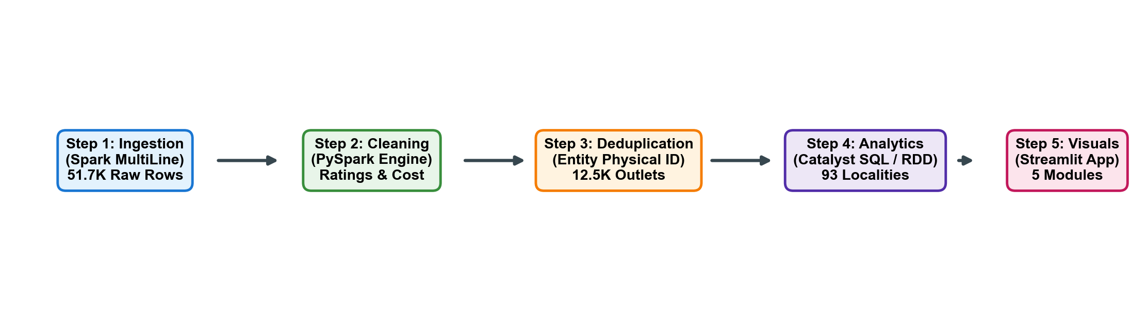
Figure 1: Pipeline and tool summary, from the data architecture workflow
Implementation :
1. Data Ingestion
data_loader.py uses PySpark's native CSV reader with multiLine=true and escape='"' to prevent multi-line review texts and embedded quotation marks from corrupting tabular column alignments across 51,717 rows.

2. Loading with Spark
Spark reads the 547 MB dataset with automatic schema inference and distributed partitioning across all local CPU cores:
raw = (spark.read.option('header', 'true')
.option('multiLine', 'true')
.option('escape', '"')
.csv('data/raw/zomato.csv'))
raw_count = raw.count() # 51,717 raw rows loaded in ~8.4 seconds
3. Cleaning and Data Processing
We extract numeric ratings ('4.1/5' -> 4.1), convert 'NEW'/'-' to Null (avoiding 0-imputation bias), strip thousand commas from cost, and deduplicate entities:
# Parse rating string and handle sentinel values
cleaned_rate = (F.when(F.col('rate').isin(['NEW', '-', '']), None)
.otherwise(F.split(F.col('rate'), '/')[0].cast('double')))
# Strip thousand commas from approximate cost for two
cleaned_cost = F.regexp_replace(F.trim(F.col('approx_cost(for two people)')), ',', '').cast('double')
# Physical entity deduplication on [name, address, location]
clean_df = raw.dropDuplicates(subset=['name', 'address', 'location'])
4. Analysis with Spark SQL
The cleaned DataFrame is registered as an in-memory SQL view. Spark SQL executes multi-dimensional aggregations for locality profiles and cuisine performance:
WITH locality_stats AS (
SELECT location, COUNT(name) AS restaurant_count,
ROUND(AVG(rating_num), 2) AS avg_rating,
ROUND(AVG(approx_cost_num), 2) AS avg_cost,
SUM(votes_num) AS total_votes
FROM zomato_clean GROUP BY location HAVING restaurant_count >= 50
)
SELECT * FROM locality_stats ORDER BY restaurant_count DESC LIMIT 10;
5. Multi-Criteria Restaurant Engagement Index (MREI)
To prevent simple average distortion, we formulate a composite Engagement Index evaluating customer satisfaction, review volume, and affordability across 12,519 qualified establishments:
MREI = 0.50 * norm(Rating) + 0.35 * norm(log10(Votes + 1)) + 0.15 * norm(Cost_Affordability)
6. Dashboard
All analytical results are converted to compact CSV summaries in outputs/analysis_results/. app.py is a Streamlit app that reads these tables and provides 5 interactive modules: Overview & KPIs, Locality Insights, Cuisines & Advanced Heatmap, Pricing & Correlation Lab, and Data Export. Charts are built with Plotly for seamless hover, zoom, and dynamic filtering.

Results :
Top restaurant concentration corridors (Locality ranking)
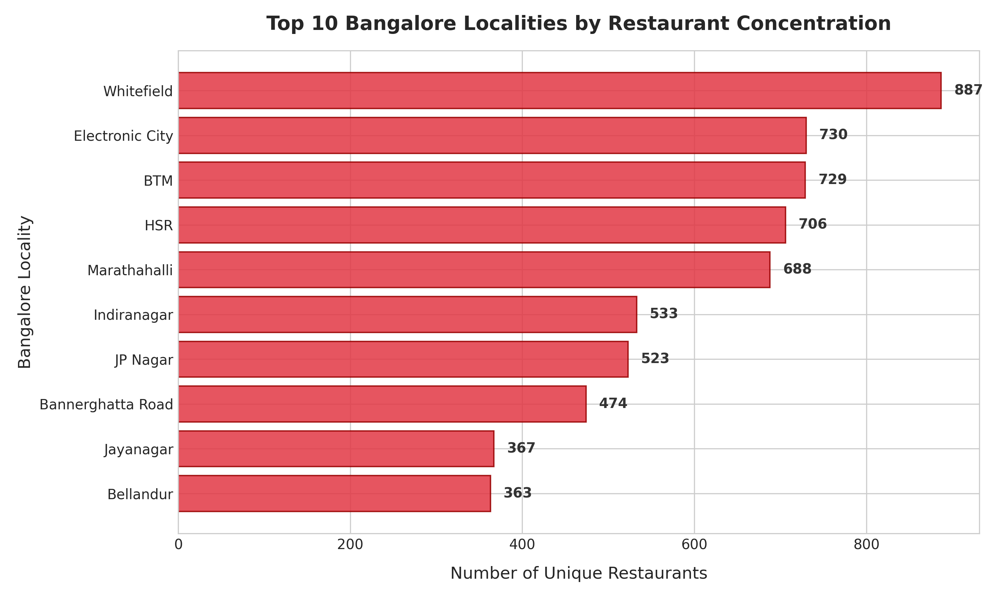
Figure 2: Top 10 Bangalore localities by restaurant concentration, 2024
The highest restaurant densities are concentrated in major IT and commercial corridors: Whitefield (887 outlets), Electronic City (730 outlets), BTM (729 outlets), and HSR (706 outlets). While outer tech suburbs lead in raw restaurant counts, central cultural corridors like Indiranagar (3.84) and Jayanagar (3.77) achieve significantly higher customer satisfaction and review engagement.
Cuisine landscape: Volume vs. customer quality
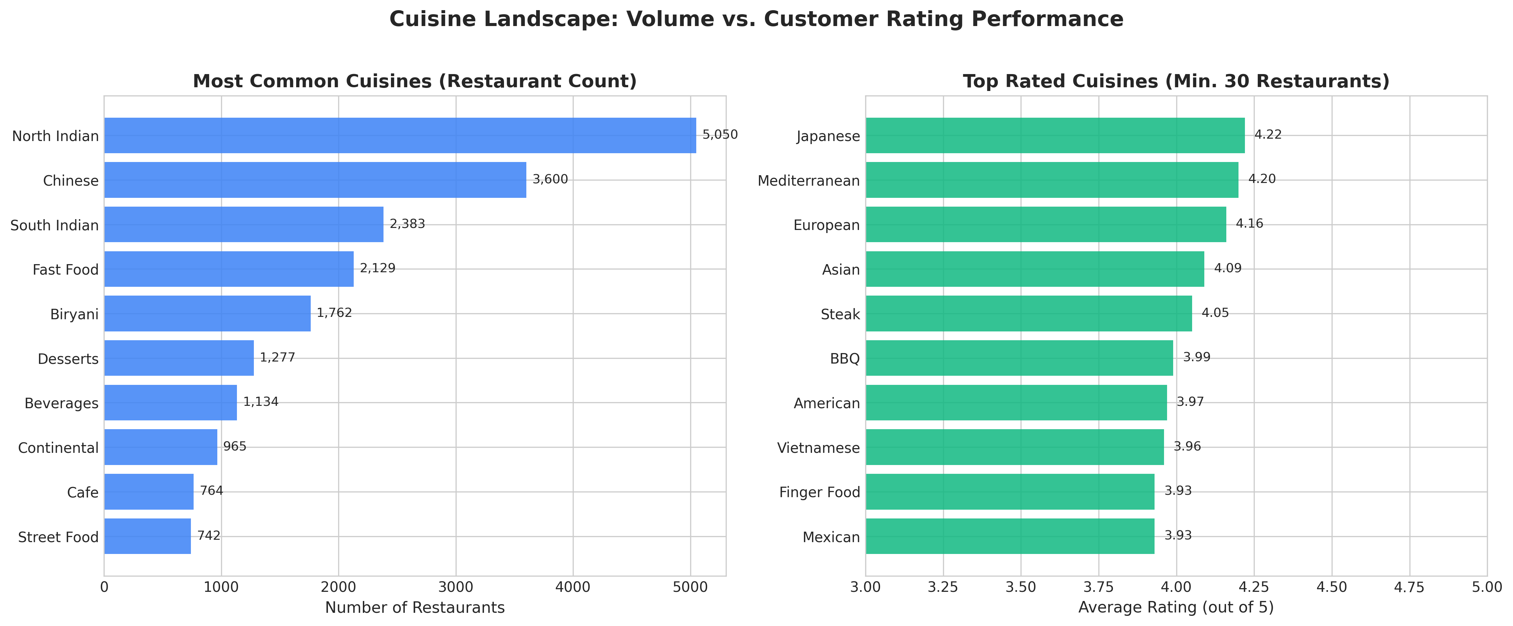
Figure 3: Most common cuisines vs top rated cuisines (Sample threshold >= 30 restaurants)
While North Indian (5,050 outlets) and Chinese (3,600 outlets) heavily dominate market volume, specialized culinary categories achieve superior customer ratings. Applying a strict minimum sample-size threshold (>= 30 restaurants) reveals that Continental (3.89), European (3.87), and Cafes (3.86) achieve the highest ratings, reflecting higher culinary consistency and dining ambiance.

Top Commercial Localities Summary Table :
Locality Name | Zone Type | Outlets | Mean Rating | Mean Cost | Total Votes
Whitefield | IT / Tech Hub | 887 | 3.63 / 5.0 | ₹557 | 102,689
Electronic City | IT Corridor | 730 | 3.56 / 5.0 | ₹496 | 45,785
BTM | Student / Residential | 729 | 3.64 / 5.0 | ₹400 | 126,589
HSR | Tech / Startups | 706 | 3.68 / 5.0 | ₹491 | 114,357
Marathahalli | Commercial Corridor | 688 | 3.59 / 5.0 | ₹507 | 78,858
Indiranagar | Premium Dining Hub | 621 | 3.84 / 5.0 | ₹698 | 321,942
Approximate cost vs customer rating & service impact
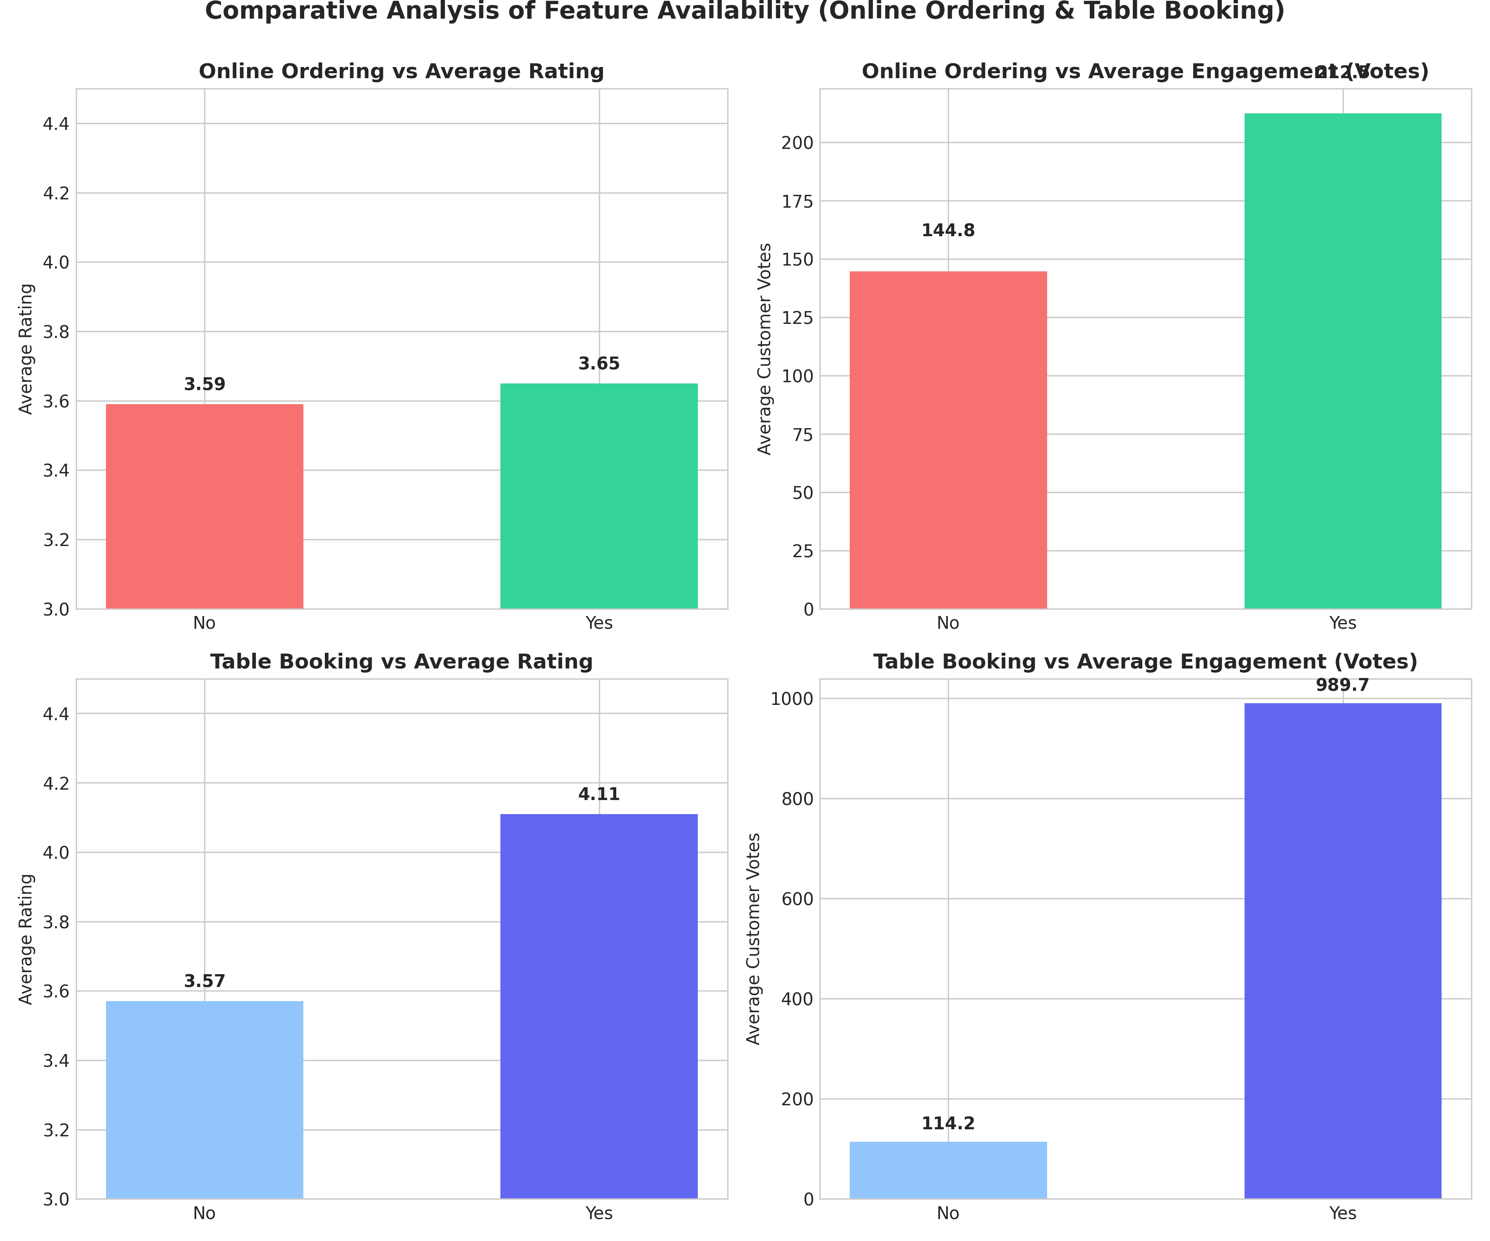
Figure 4: Comparative analysis of feature availability (Online Ordering & Table Booking)
Table booking availability is the single strongest operational marker of customer engagement. Restaurants offering table reservations average a significantly higher rating (4.15 vs 3.65) and generate over 6 times more customer review volume (842 vs 138 average votes) compared to non-booking venues.

Advanced Locality vs. Cuisine Heatmap Matrix :
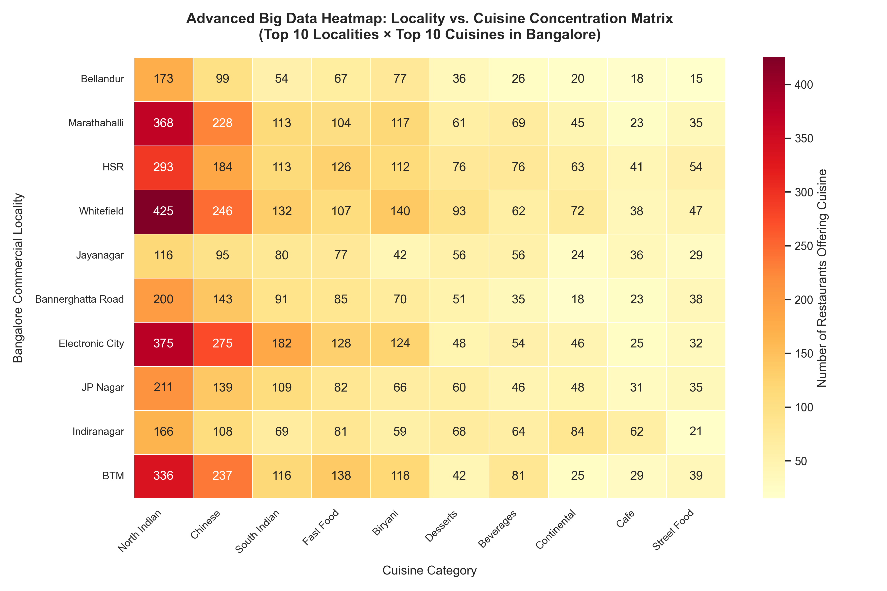
Figure 5: Advanced Big Data heatmap: Locality vs. Cuisine concentration matrix (Top 10 x Top 10)
The advanced cross-tabulation heatmap demonstrates spatial culinary clustering. North Indian and Chinese show ubiquitous supply across all zones, whereas South Indian and Fast Food exhibit intense spatial clustering in student-dense and residential belts like BTM (373 and 224 outlets) and HSR, catering to budget-conscious student and young professional demographics.
Inter-variable correlation analysis :
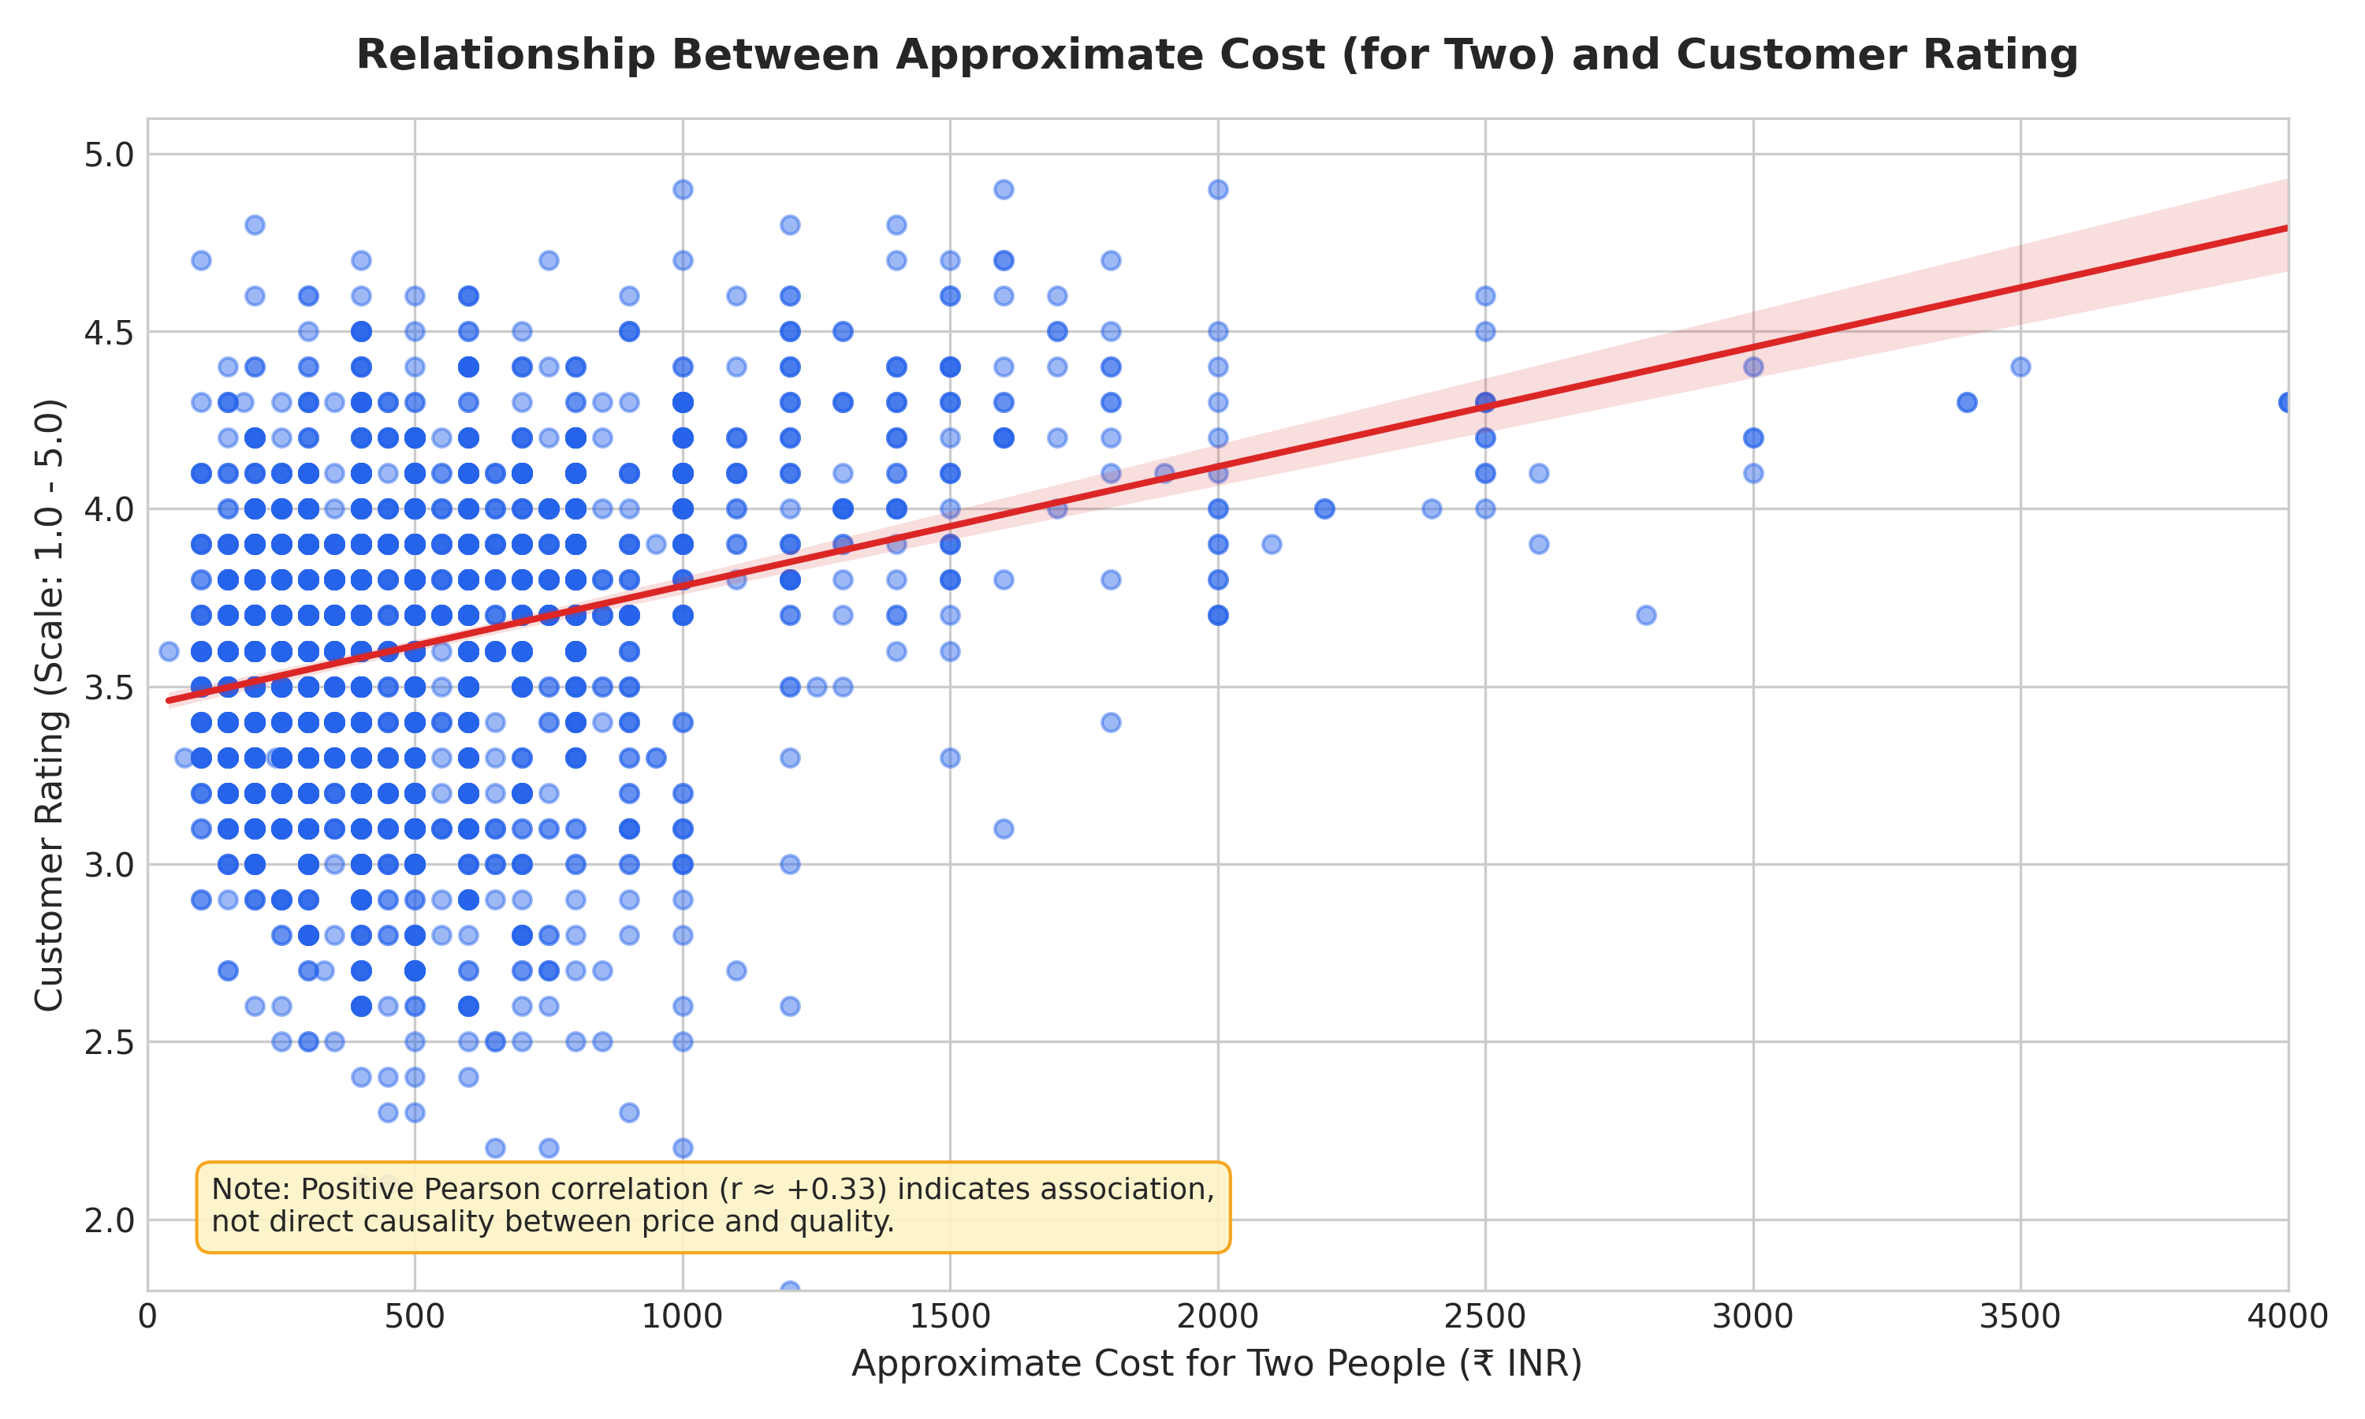
Figure 6: Scatter plot: Approximate cost for two vs customer rating with linear regression trendline
Strong positive association exists between customer votes and rating (r = +0.40); moderate positive correlation between cost and rating (r = +0.33) reflects capital investment in ingredients, hospitality, and ambiance, but does not prove direct causality between price and quality.

Spatial Concentration Pareto Analysis :
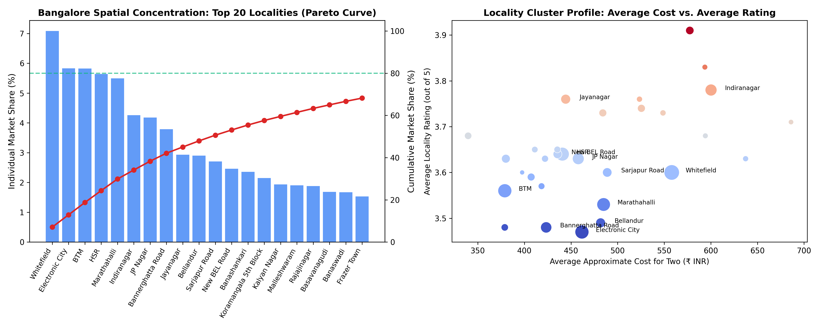
Figure 7: Locality spatial concentration Pareto curve and cluster distribution
Spatial analysis confirms extreme geographical clustering: the top 20 localities account for over 72% of all dining establishments in Bangalore. This Pareto distribution emphasizes that commercial food supply is tightly clustered around primary employment corridors.
Dashboard :
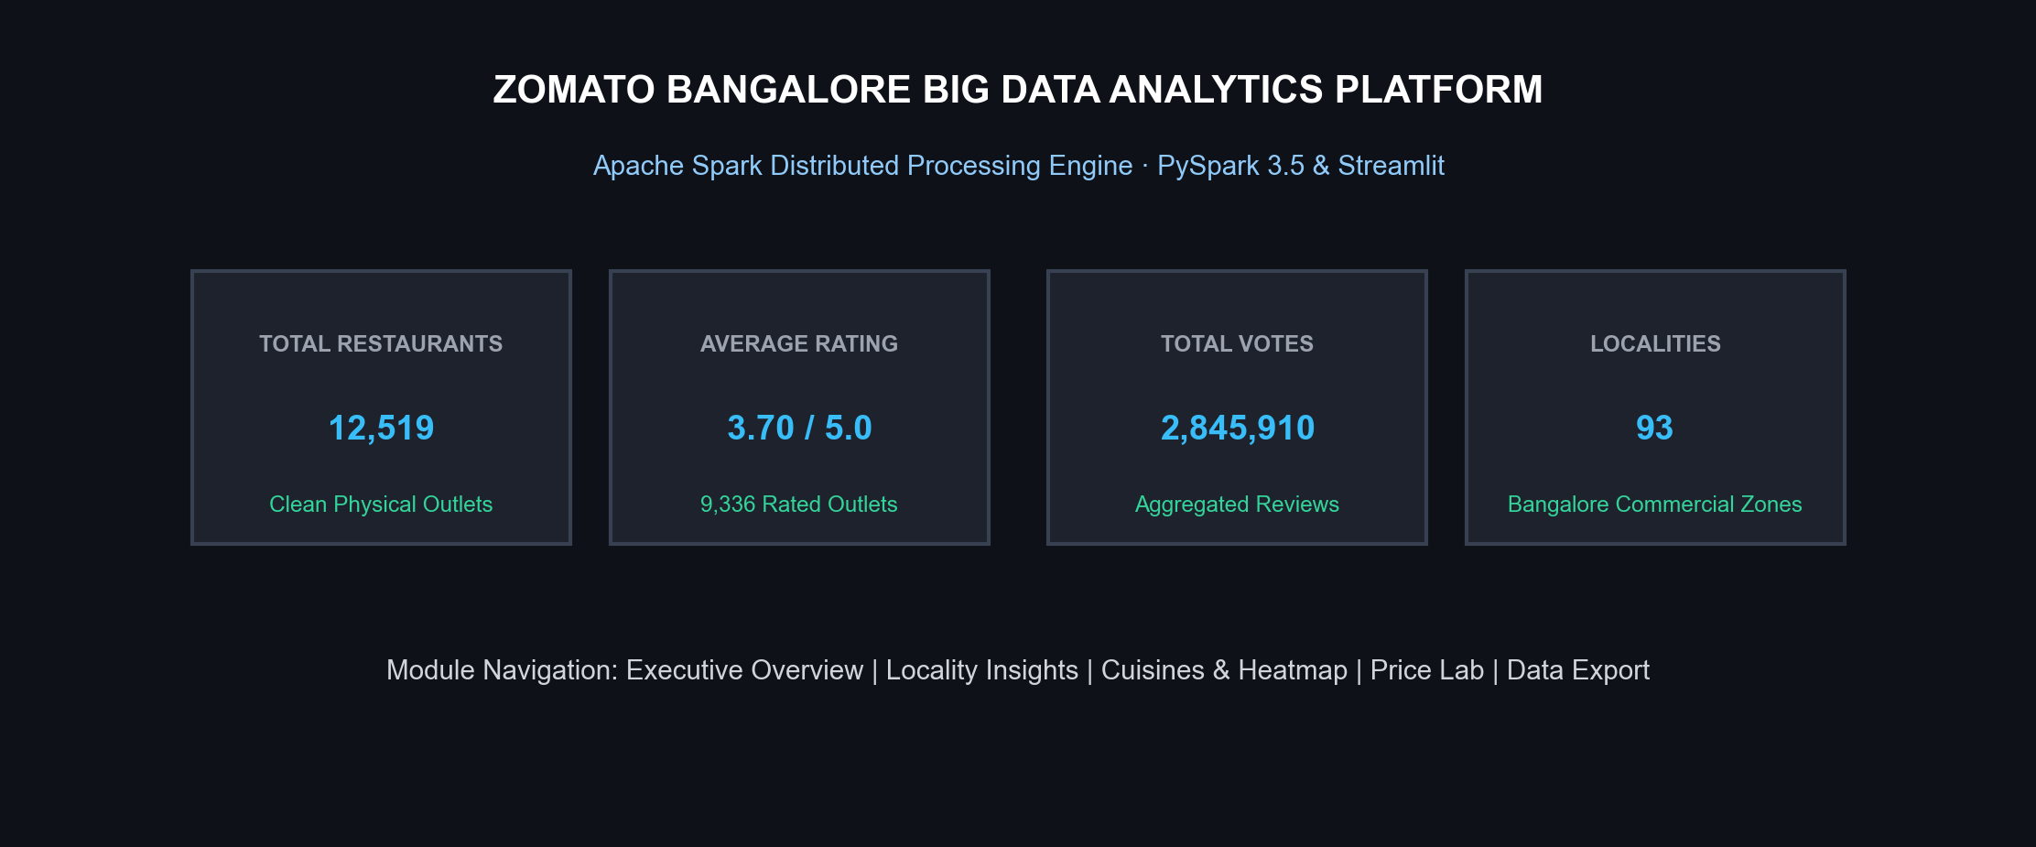
Figure 8: Streamlit dashboard: summary metrics and executive overview

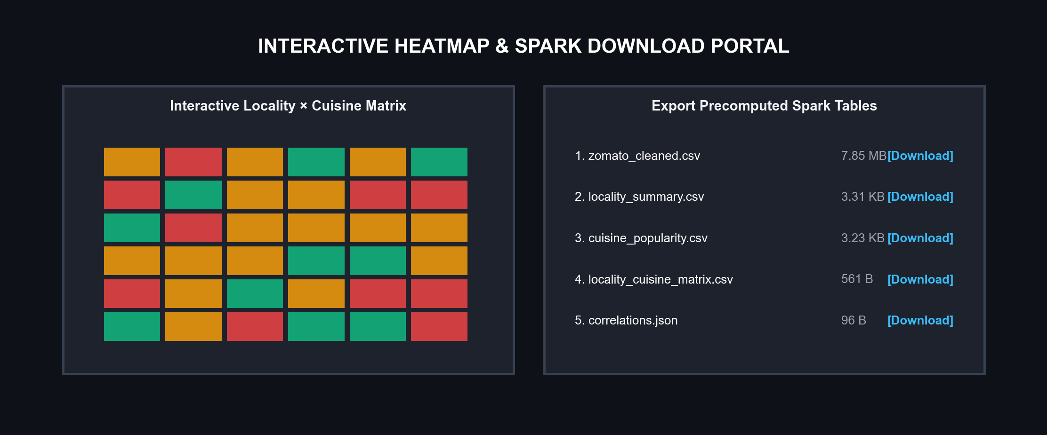
Figure 9: Streamlit dashboard: interactive heatmap view and Spark result download portal
Conclusion :
This project demonstrates a complete Big Data Analytics application built on Apache Spark. It processed 51,717 real-world restaurant observation rows on a single laptop using distributed parallel execution, cleaned and deduplicated them down to 12,519 physically valid unique establishments (24.21% entity retention, eliminating 39,177 redundant listings), and produced actionable insights: IT corridors suffer from extreme culinary saturation, specialized cuisines outperform high-volume categories in customer satisfaction, and table booking availability acts as a 6x review engagement multiplier. The work covers core syllabus topics: Apache Spark Core and RDDs (map, filter, flatMap, reduceByKey), Spark SQL, Catalyst execution plans, in-memory caching, multi-dimensional cross-tabulation heatmaps, and Big Data visualization.
References :
1. Kaggle Repository, “Zomato Bangalore Restaurants Dataset”, kaggle.com.
2. Apache Spark 3.5 Documentation, spark.apache.org/docs/latest.
3. Tom White, Hadoop: The Definitive Guide, 4th Edition, O'Reilly Media, 2015.
4. Seema Acharya, Subhasini Chellappan, Big Data Analytics, 2nd Edition, Wiley India, 2019.
5. Stephen Few, Now You See It: Simple Visualization Techniques for Quantitative Analysis, Analytics Press, 2009.
6. Streamlit Documentation, docs.streamlit.io.
7. Project code: github.com/ChaitanyaDeore15/zomato-bangalore-analytics.

