Accordion with Filters

Code repository link - <https://github.com/ChaitanyaGVK/React-Filtered-Accordion.git>

**Functionality:**

1. On application launch or refresh all the key results(child objectives) of an objective(accordion) will be displayed with default category(all) filter applied.

1. On clicking the arrow in the accordion, each parent objective toggles the display of key results. Different color codes used on accordions to identify the selected and non-selected accordions.

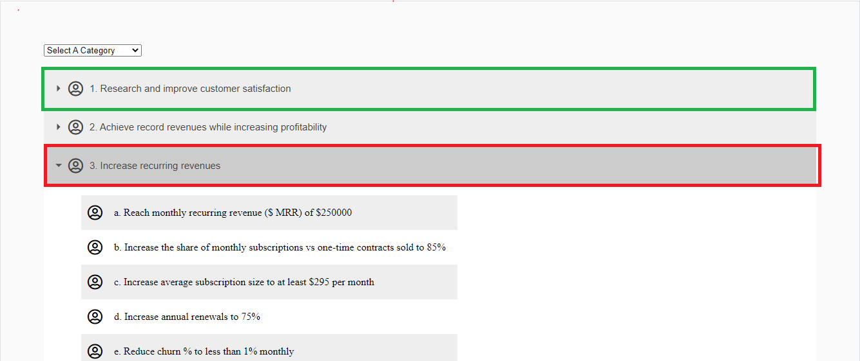

1. A filter for the “Category” field is created as a dropdown at the top to filter the objectives and key results for that selected category from the dropdown.

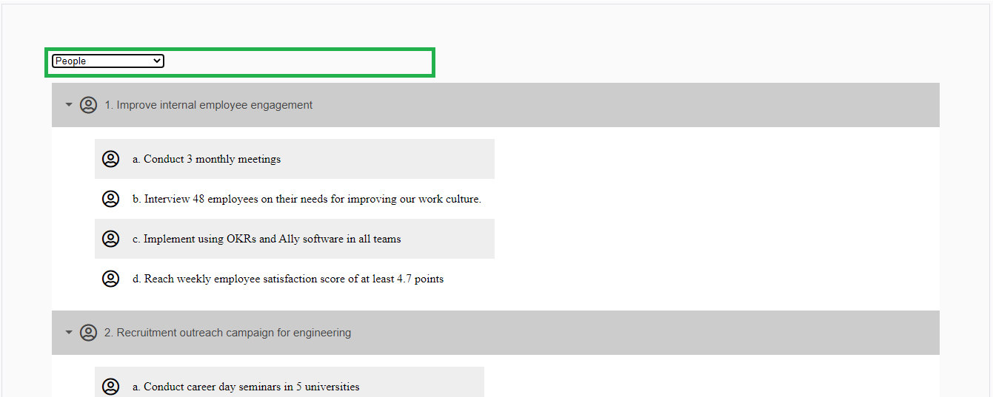

1. An extra requirement of displaying a popup upon clicking any parent or child objective is added. This popup/modal can be dismissed on clicking anywhere on the screen to go back to the objectives page.

