ASSIGNMENT 3

K-MEANS CLUSTERING ON IMAGES

Original images:

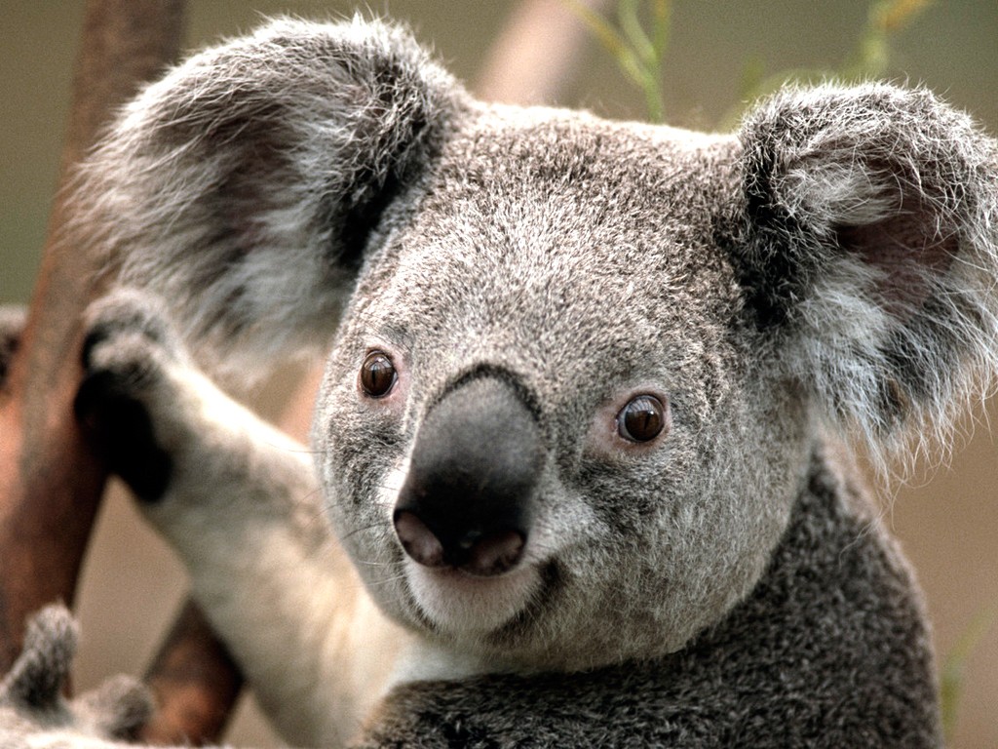

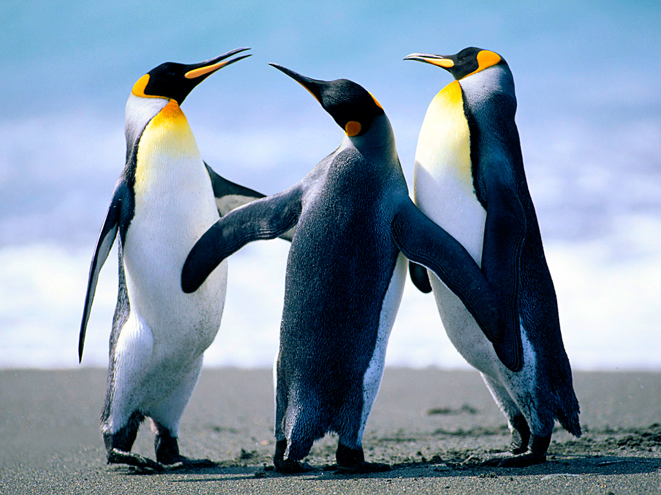

New Image formed for k = 2:

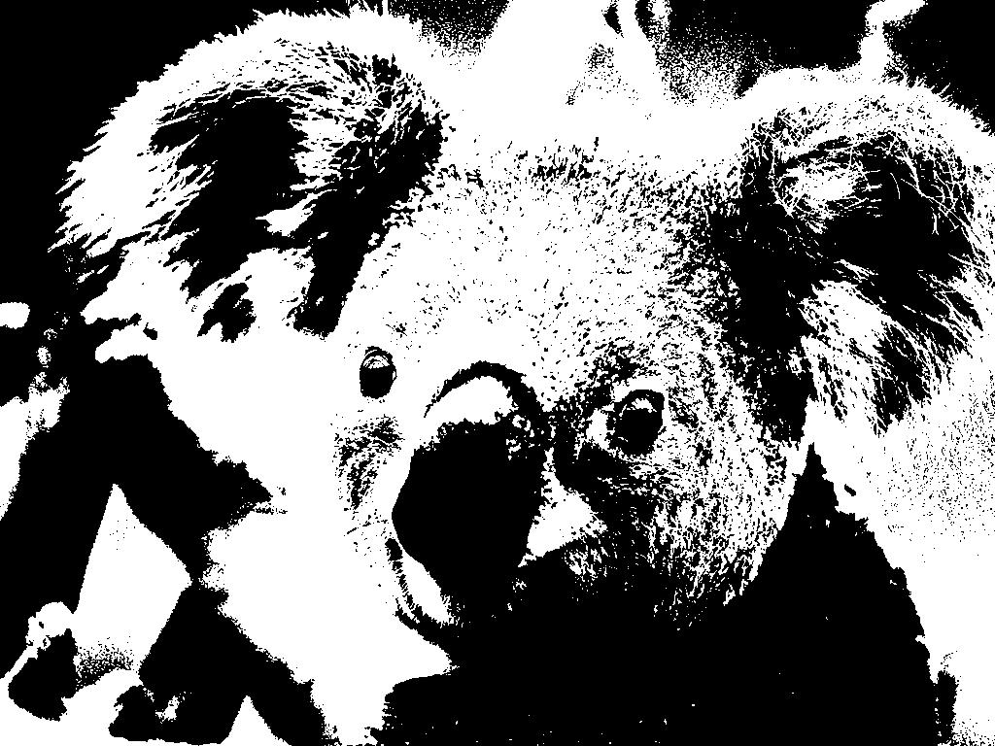

Compression ratio = 762/191 kb = 3.98

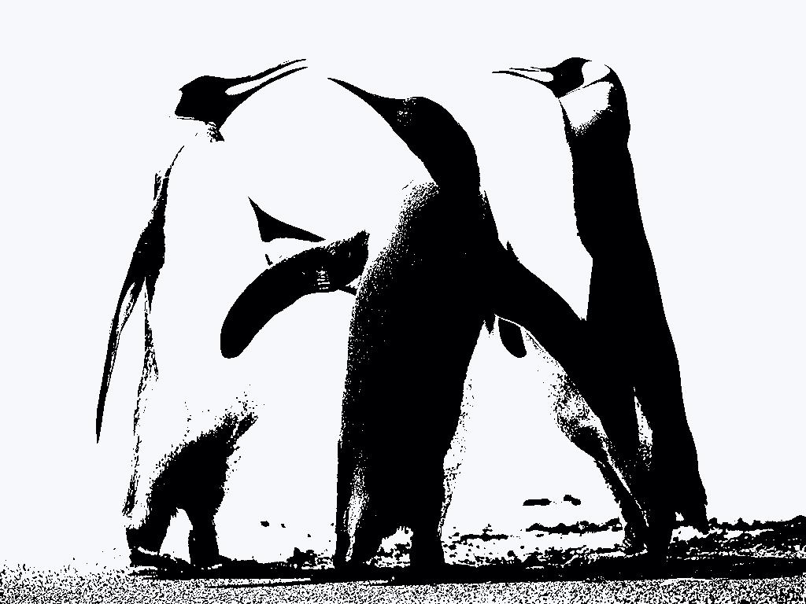

Compression ratio = 759/98.8 kb = 7.68

New Image formed for k = 5:

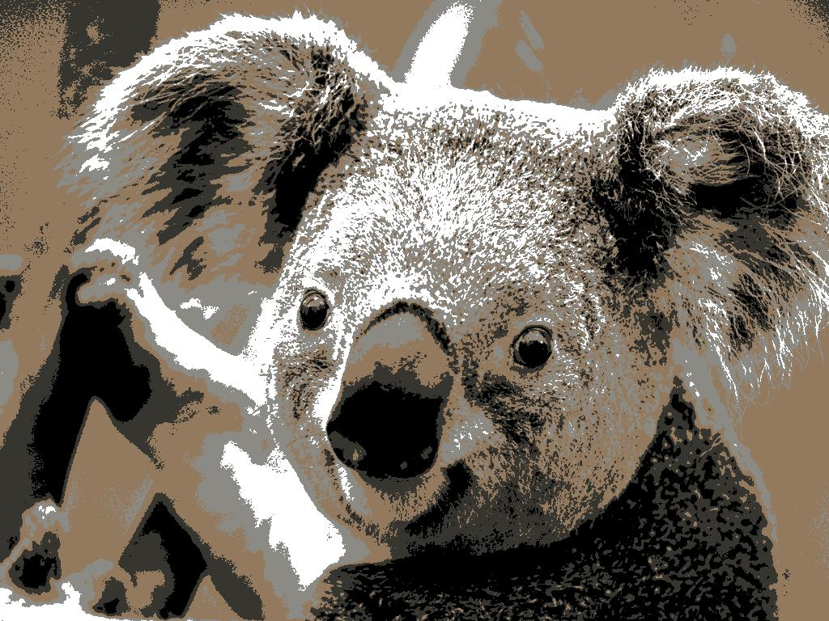

Compression ratio = 762/198 kb = 3.84

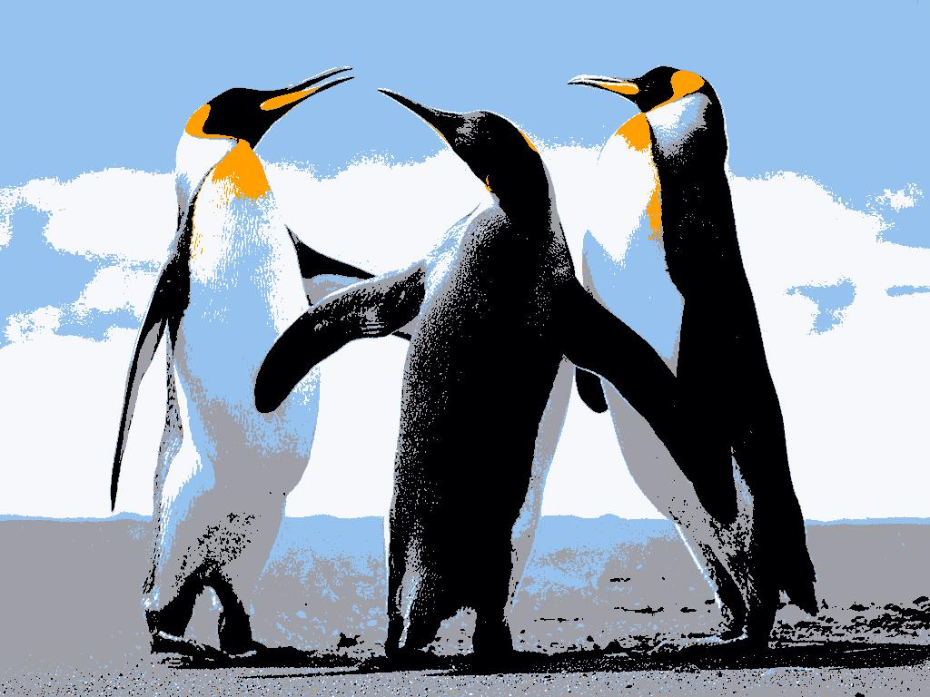

Compression ratio: 759/114 kb = 6.65

New Image formed for k = 10:

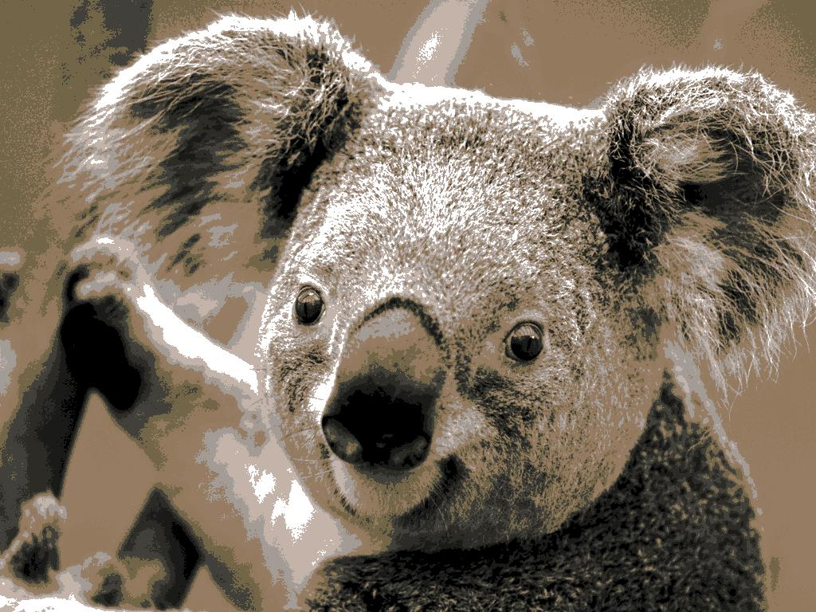

Compression ratio: 762/169 kb = 4.50

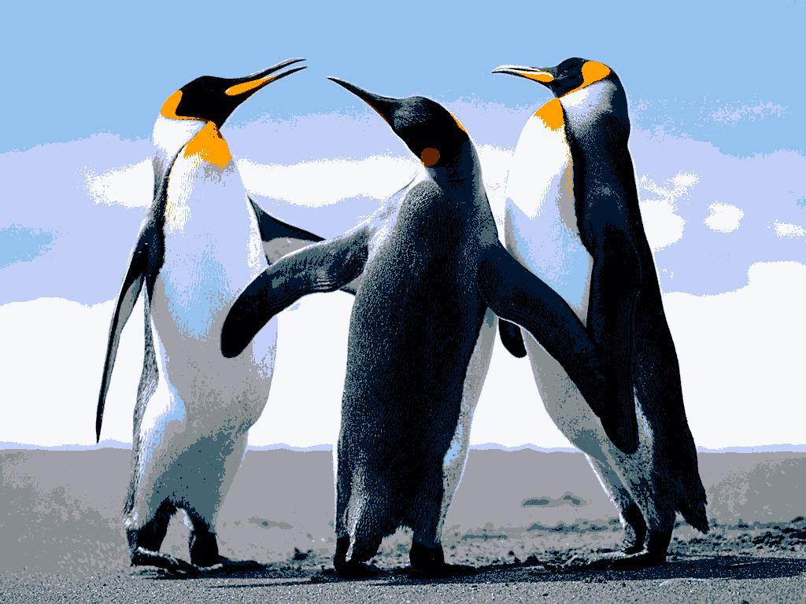

Compression ratio: 759/117 kb = 6.48

New Image formed for k = 15:

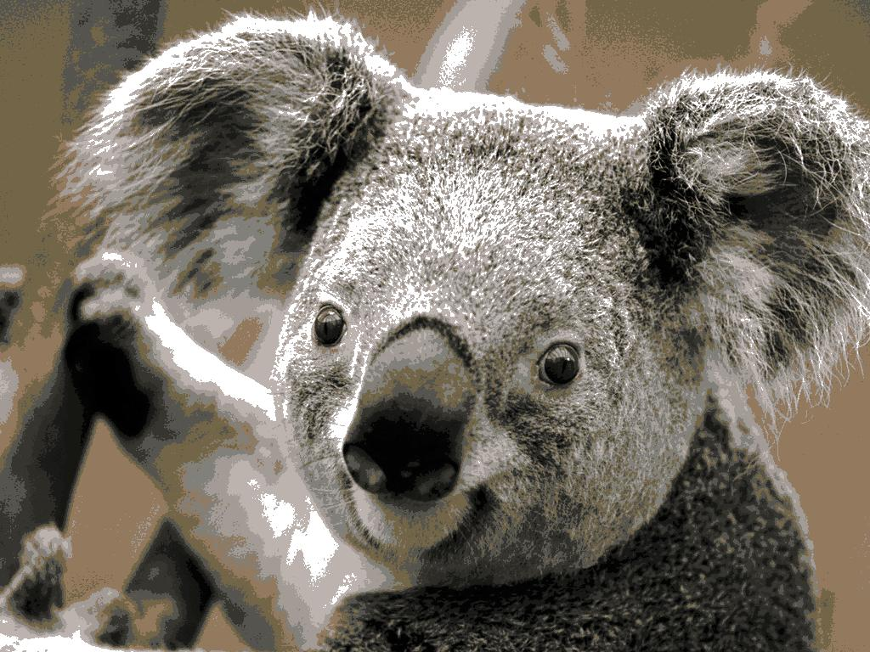

Compression ratio: 762/166kb = 4.59

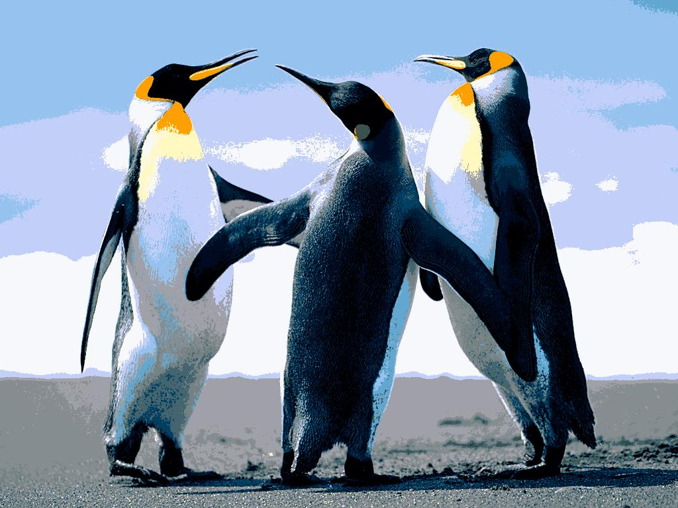

Compression ratio: 759/113 kb = 6.71

New Image formed for k = 20:

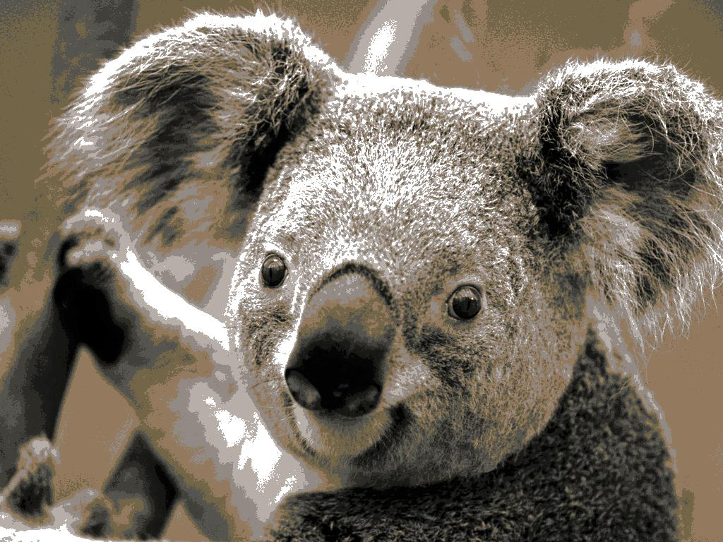

Compression ratio: 762/167kb = 4.56

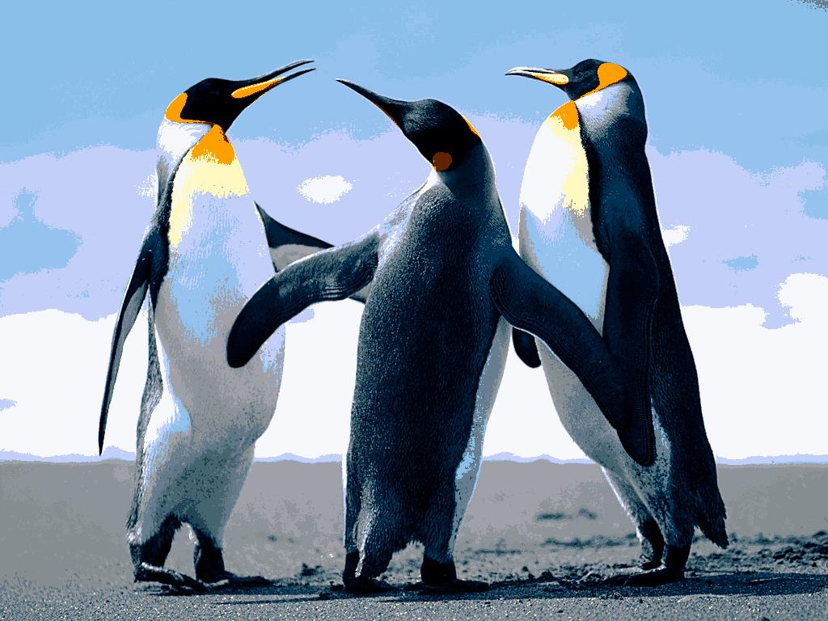

Compression ratio: 759/109 kb = 6.96

Average Compression rate:

1. Koala.jpg: 4.294 (3.84,3.98,4.50,4.56,4.59)
2. Penguins.jpg: 6.896 (6.48,6.65,6.71,6.96,7.68)

Variance:

1. Koala.jpg: Compression rate varies by 0.1 for different values of k.
2. Penguins.jpg: Compression rate varies by 0.177 for different values of k.

Tradeoff:

We get higher quality of image with higher degree of compression.

20 seems to be the good value of k for koala image and 60 for Penguins image.