Heart Disease Risk Prediction
End-to-End MLOps Pipeline
Machine Learning Operations (MLOps) — AIMLCZG523
Assignment 01

Name: Chaitanya Kumar Goddu
BITS ID: 2024ac05880@wilp.bits-pilani.ac.in
GitHub Repository: https://github.com/ChaitanyaKumarGoddu/BITSMLOPSAssignment
Video walkthrough: ______________________________________________

1. Project Overview
This project builds a machine-learning classifier that predicts the risk of heart disease from patient clinical data and deploys it as a cloud-ready, monitored REST API, following modern MLOps practice end to end: data acquisition and EDA, feature engineering, multi-model training with hyper-parameter tuning and cross-validation, MLflow experiment tracking, reproducible packaging, automated testing with GitHub Actions CI/CD, Docker containerisation, Kubernetes deployment, and Prometheus/Grafana monitoring.
Dataset: UCI Heart Disease (Cleveland), 303 patient records, 13 clinical features, binary target (presence/absence of disease).
Headline result: the tuned Logistic Regression pipeline achieves ROC-AUC 0.968, accuracy 0.90, and recall 0.93 on the held-out test set — recall being the priority metric for a screening tool where a missed case is costly.

Technology stack
Python 3.14 · pandas / scikit-learn / XGBoost · MLflow (SQLite backend) · FastAPI + Uvicorn · Pytest · Docker (multi-stage) · Kubernetes (Docker Desktop) + Helm · Prometheus + Grafana · GitHub Actions.

2. Setup & Installation
Requires Python 3.11-3.14. All commands are run from the repository root.
Source files:
- requirements.txt (runtime deps)
- requirements-dev.txt (+ EDA, tests, lint, notebook)
Commands:
python -m venv .venv
.venv\Scripts\Activate.ps1 # Windows PowerShell
pip install --upgrade pip
pip install -r requirements-dev.txt
Dependencies are pinned to wheel-available versions verified on Python 3.14 (Windows) and Python 3.12 (Linux CI). The runtime Docker image uses only requirements.txt; requirements-dev.txt adds EDA, testing, linting and Jupyter.

3. Task 1 - Data Acquisition & Exploratory Data Analysis
Source files:
- src/config.py - paths + feature schema (single source of truth)
- src/data/download.py - fetch dataset (ucimlrepo id=45, URL fallback)
- src/data/preprocess.py - clean(): coerce numeric, binarise target, de-dup
- src/data/eda.py - generate the EDA figures
- notebooks/01_eda.ipynb - narrated EDA notebook
download.py fetches the Cleveland dataset via the official ucimlrepo package (id=45), falling back to a direct download of processed.cleveland.data. preprocess.clean() coerces every column to numeric, binarises the 0-4 severity field into a 0/1 target (0 = no disease, >=1 = disease), and drops exact duplicates. Missing values (the UCI '?' marker) appear only in ca (4 rows) and thal (2 rows) and are imputed later inside the modelling pipeline rather than dropped. The two classes are close to balanced (~46% positive).
Commands:
python -m src.data.download # -> data/raw/heart_disease_raw.csv (303 rows)
python -m src.data.preprocess # -> data/processed/heart_disease_clean.csv
python -m src.data.eda # -> reports/figures/eda_*.png
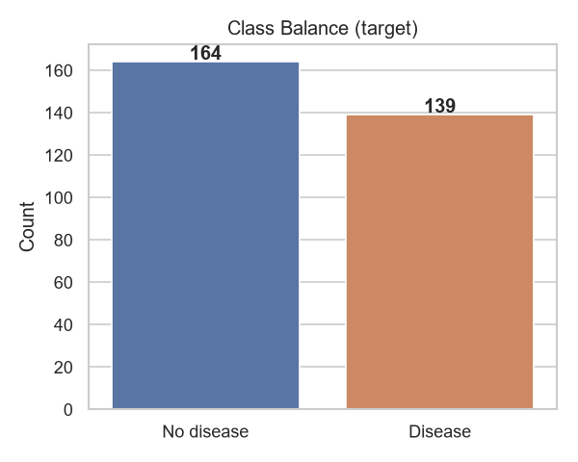
Figure 1. Class balance (~46% positive).
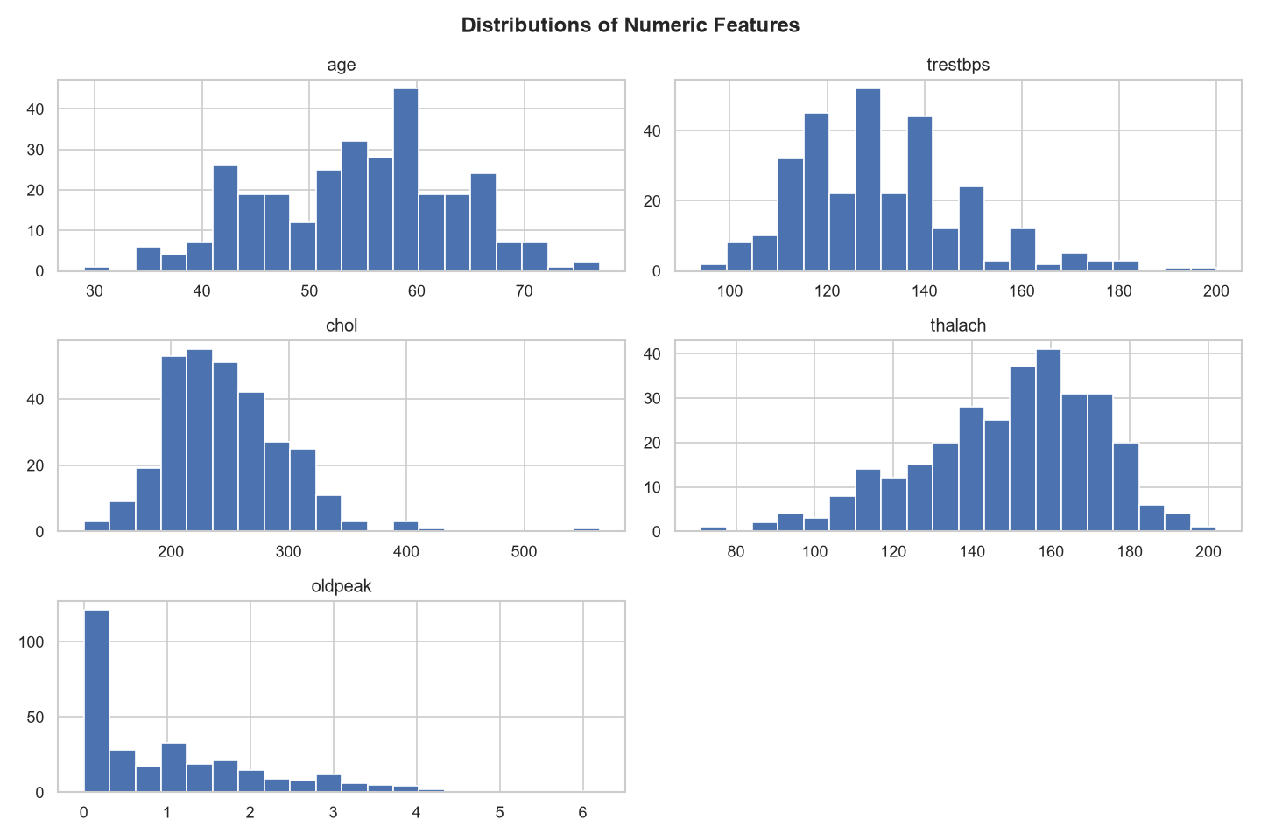
Figure 2. Distributions of numeric features.
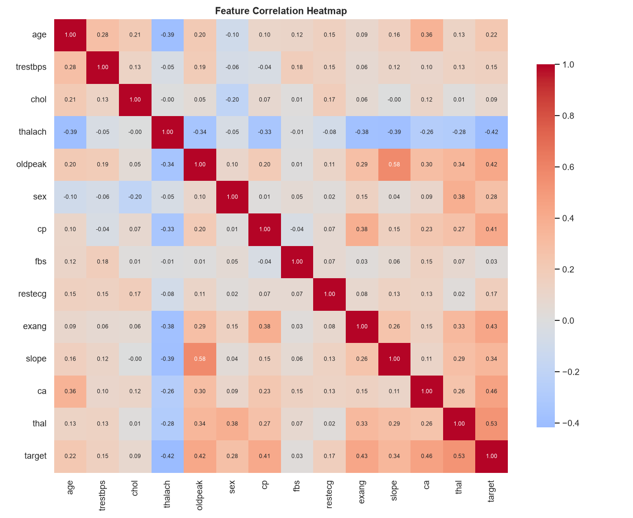
Figure 3. Correlation heatmap. Strongest target correlates: cp, thalach, oldpeak, ca, exang.
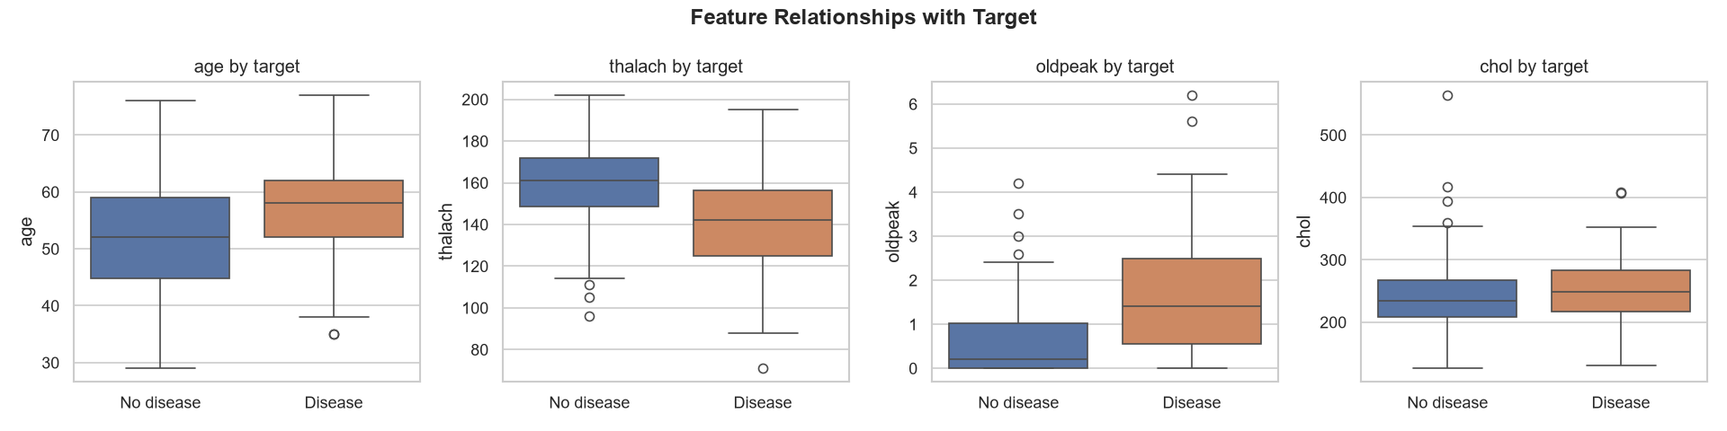
Figure 4. Key features by target - diseased patients show lower max heart rate, higher ST depression, and more affected vessels.

4. Task 2 - Feature Engineering & Model Development
Source files:
- src/features/pipeline.py - ColumnTransformer (impute + scale + one-hot)
- src/models/train.py - train 3 models, GridSearchCV, select best
- src/models/evaluate.py - metrics + ROC / confusion-matrix plots
All feature engineering lives in a single scikit-learn ColumnTransformer (build_preprocessor): numeric features get median imputation + standard scaling; categorical features get most-frequent imputation + one-hot encoding with handle_unknown='ignore'. Because the transformer is bundled with the estimator into one Pipeline, it is fitted only on the training folds and reused byte-for-byte at inference, eliminating train/serving skew. Three classifiers are tuned with GridSearchCV (5-fold, ROC-AUC scoring) on a stratified 80/20 split (random_state=42).
Commands:
python -m src.models.train

Model comparison (held-out test set, n=61)
Model | Accuracy | Precision | Recall | F1 | Test ROC-AUC | CV ROC-AUC
Logistic Regression * | 0.902 | 0.867 | 0.929 | 0.897 | 0.968 | 0.898 +/- 0.047
Random Forest | 0.885 | 0.839 | 0.929 | 0.881 | 0.952 | 0.897 +/- 0.043
XGBoost | 0.869 | 0.813 | 0.929 | 0.867 | 0.947 | 0.879 +/- 0.025
* Selected production model. Logistic Regression wins on every headline metric, is cheap to serve, and is interpretable (coefficients map to clinical risk factors) - a real advantage in healthcare. Best hyper-parameters: C=0.1, solver=liblinear. All three models achieve 0.929 recall, the metric we most care about for a screening tool.
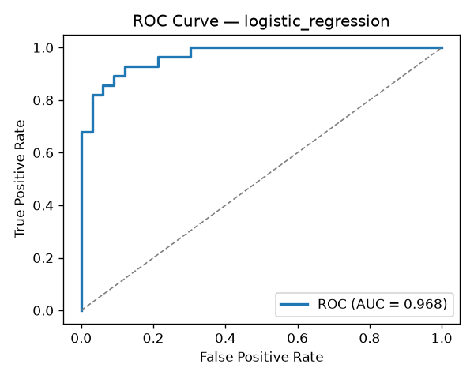
Figure 5. ROC curve - Logistic Regression (AUC = 0.968).
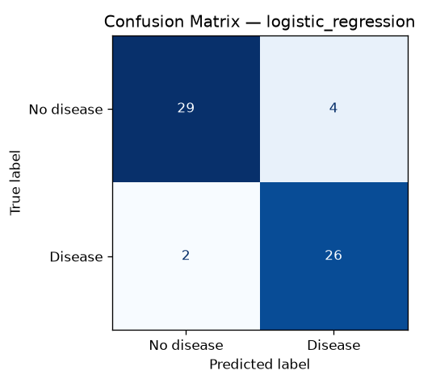
Figure 6. Confusion matrix - Logistic Regression.

5. Task 3 - Experiment Tracking (MLflow)
Source files:
- src/models/train.py - mlflow.start_run / log_params / log_metrics / log_artifact / log_model
- src/config.py - MLFLOW_TRACKING_URI (sqlite), MLFLOW_ARTIFACT_LOCATION
- scripts/mlflow_ui.py - launches the UI on Python 3.14 (compat shim)
Training logs everything to MLflow using a SQLite backend (sqlite:///mlflow.db; the file store is deprecated in MLflow 3.x). One parent run (model-selection-*) contains a nested run per model, each logging the best hyper-parameters, all metrics (accuracy, precision, recall, f1, test ROC-AUC, CV ROC-AUC mean/std), the ROC-curve and confusion-matrix artifacts, and the fitted sklearn Pipeline.
Commands:
python scripts/mlflow_ui.py --port 5000 # then open http://localhost:5000
# (Python <=3.13: mlflow ui --backend-store-uri sqlite:///mlflow.db --port 5000)
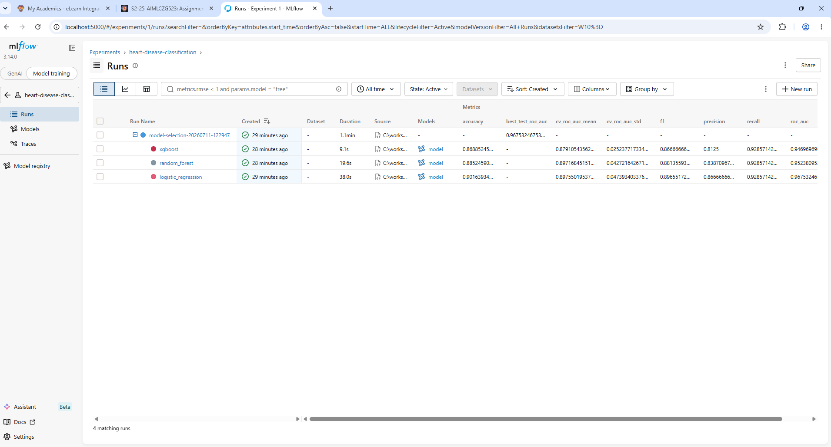
Screenshot: MLflow runs table - all three models compared side by side (accuracy, ROC-AUC, recall, F1, CV scores).

Logistic Regression (selected model)
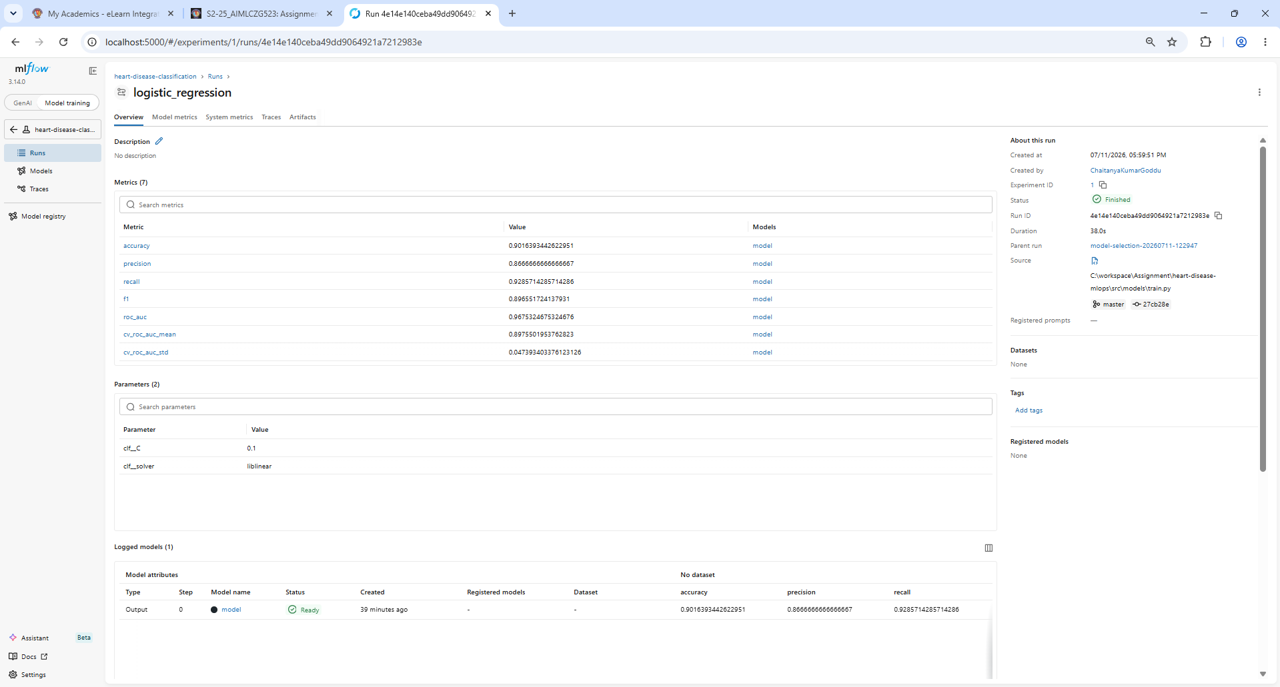
Screenshot: Logistic Regression run overview - metrics + tuned params (C=0.1, solver=liblinear) + logged model.
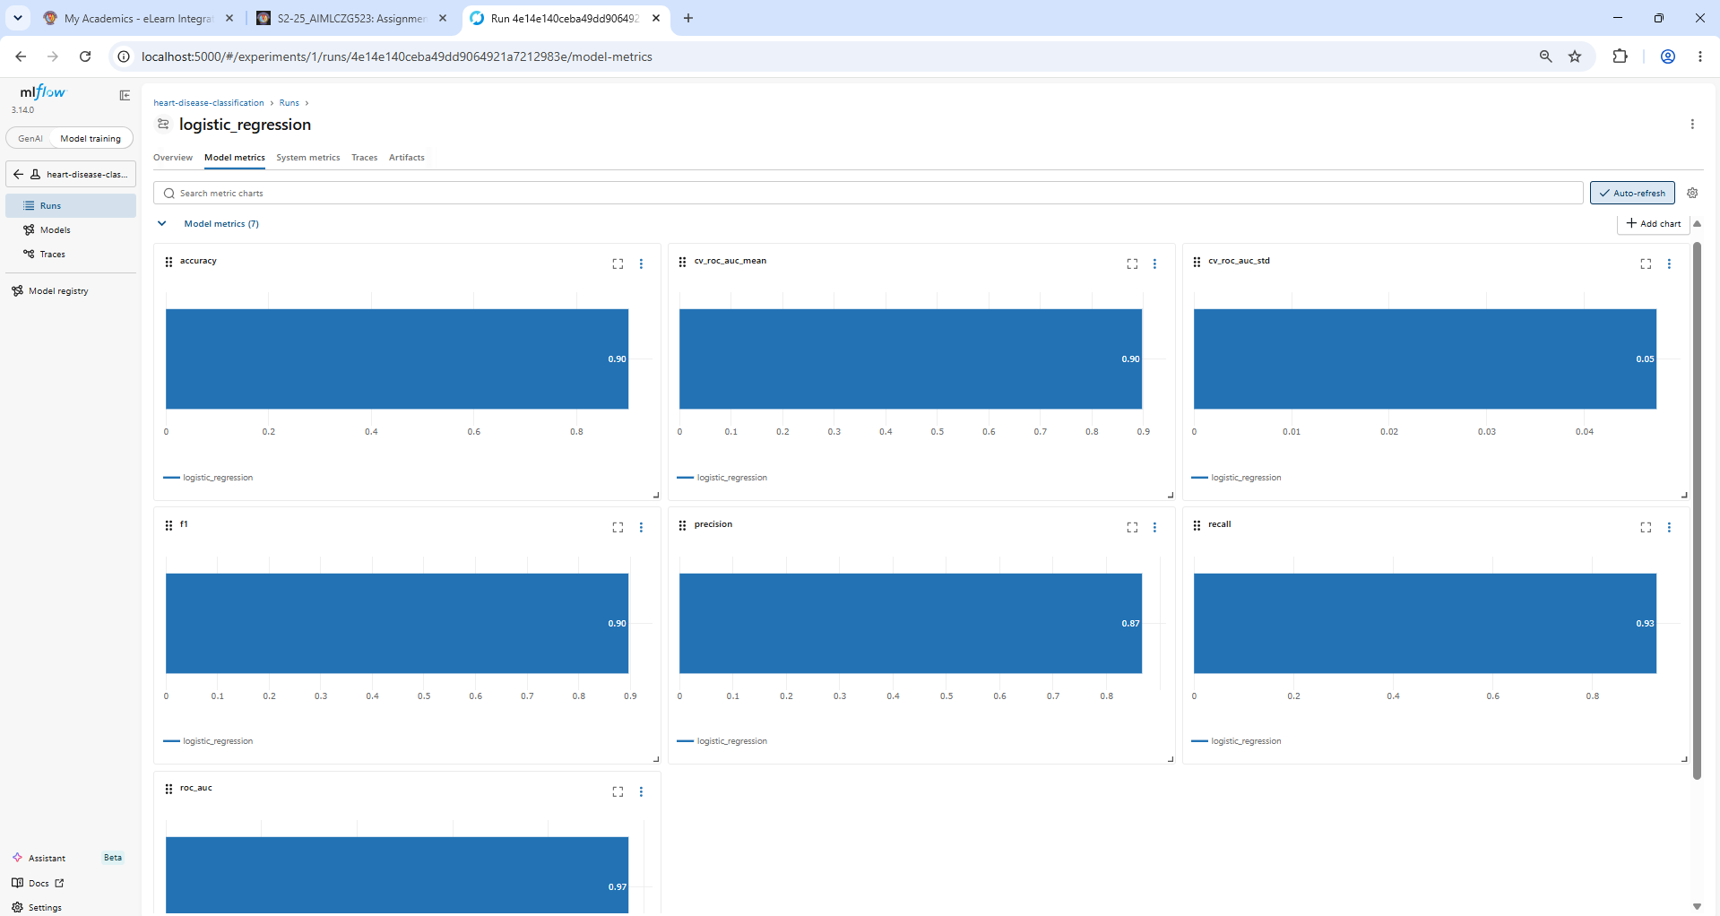
Screenshot: Logistic Regression - model-metric charts.
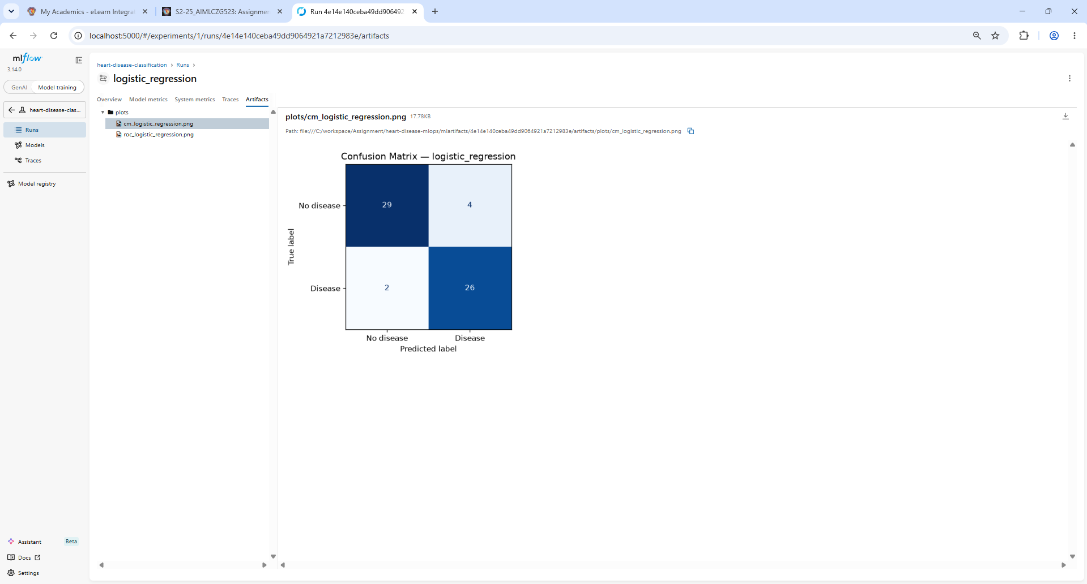
Screenshot: Logistic Regression - logged artifact: confusion matrix.
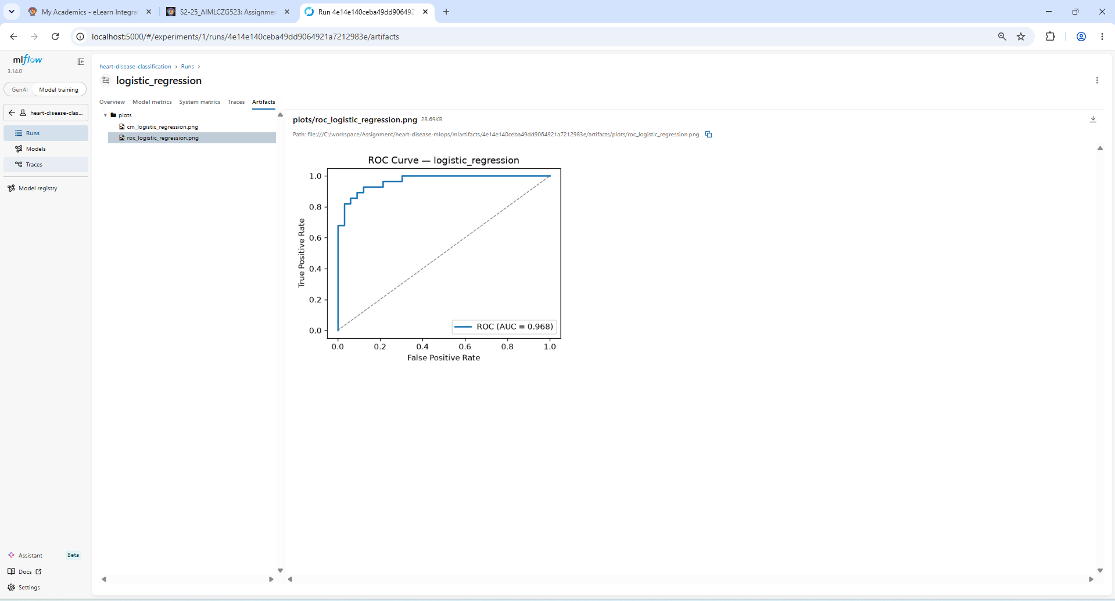
Screenshot: Logistic Regression - logged artifact: ROC curve (AUC = 0.968).

Random Forest
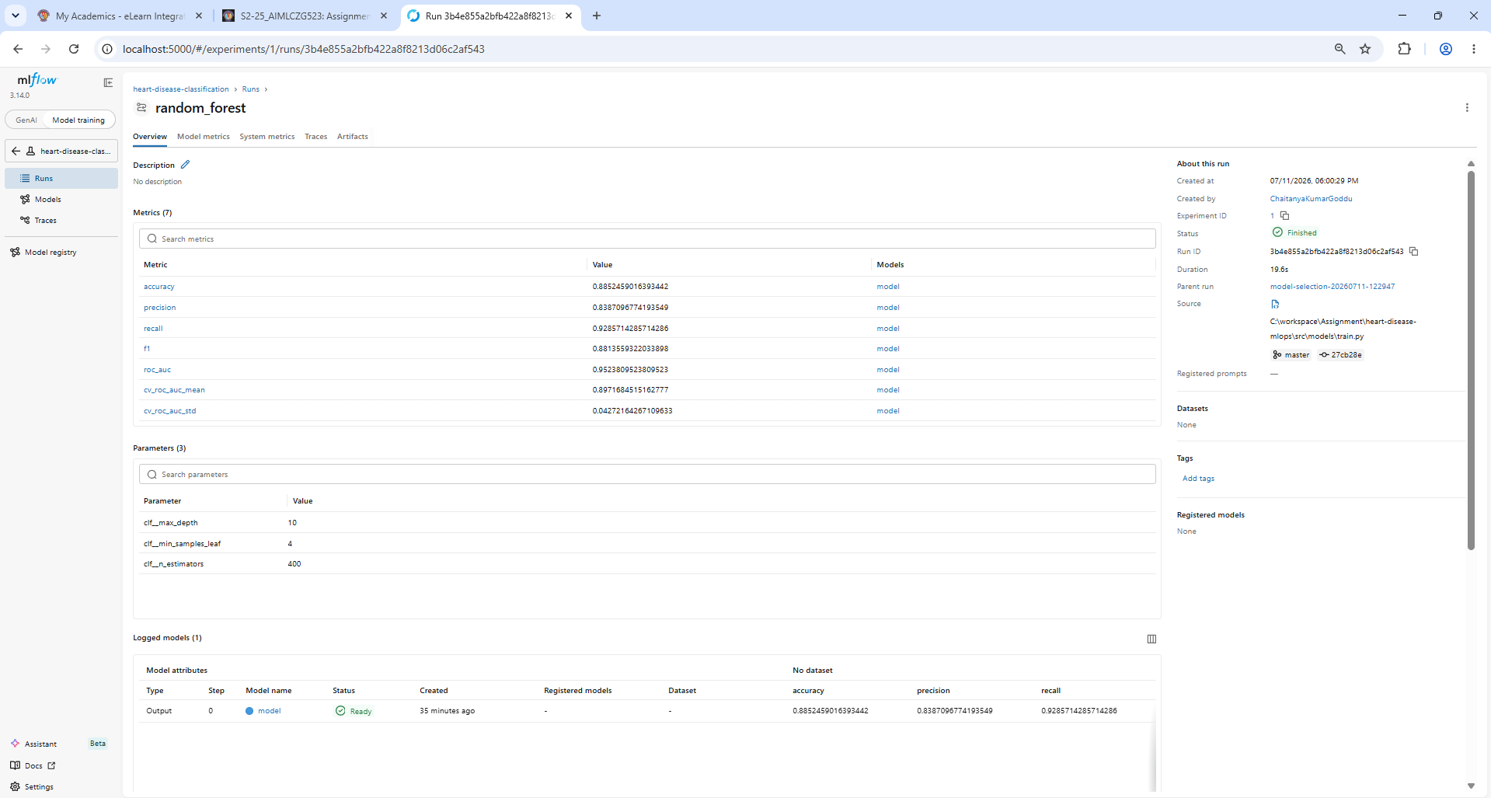
Screenshot: Random Forest run overview - metrics + tuned params (n_estimators=400, max_depth=10, min_samples_leaf=4).
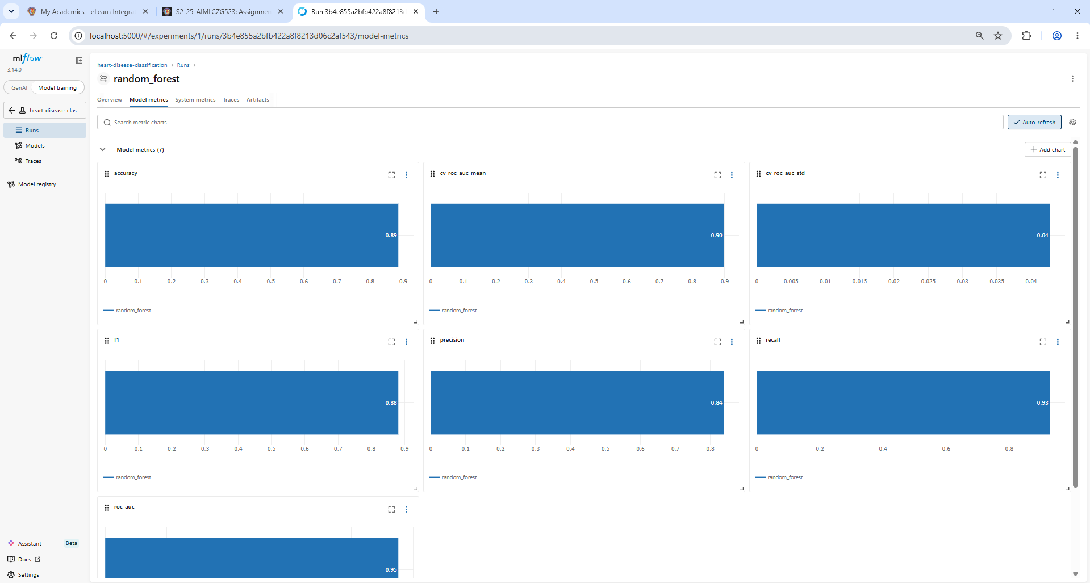
Screenshot: Random Forest - model-metric charts.
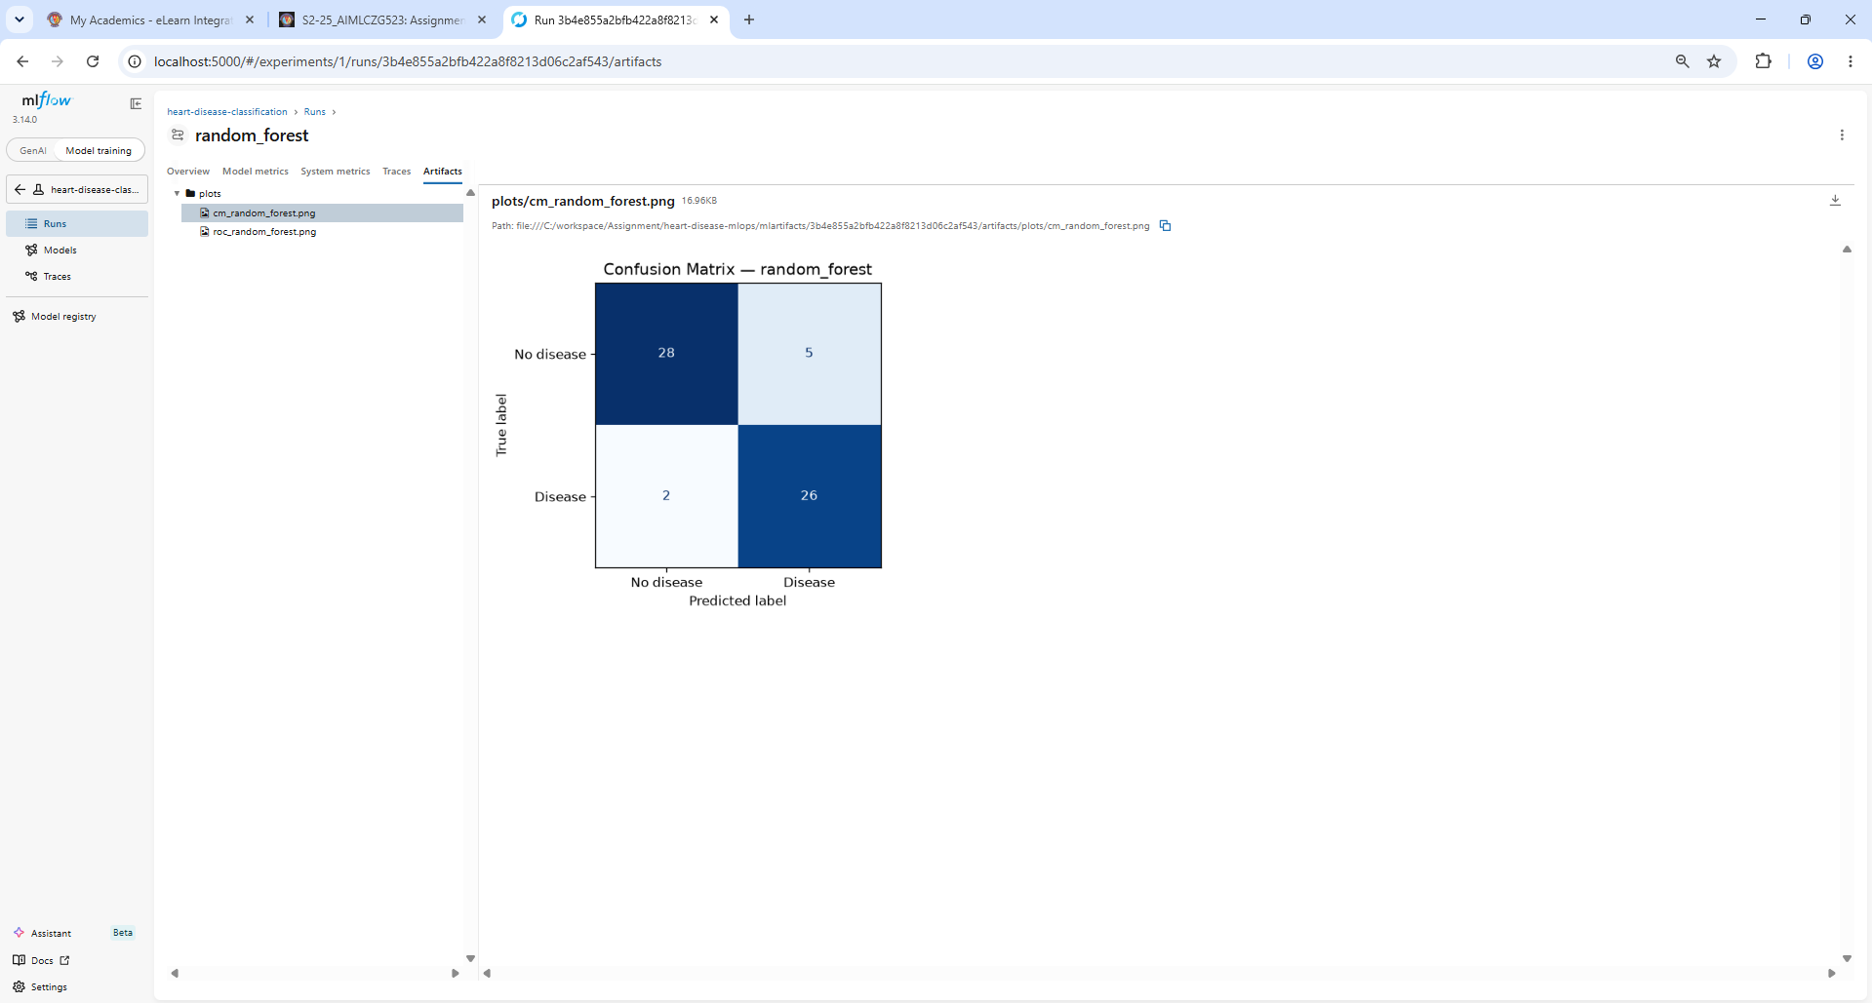
Screenshot: Random Forest - confusion matrix artifact.
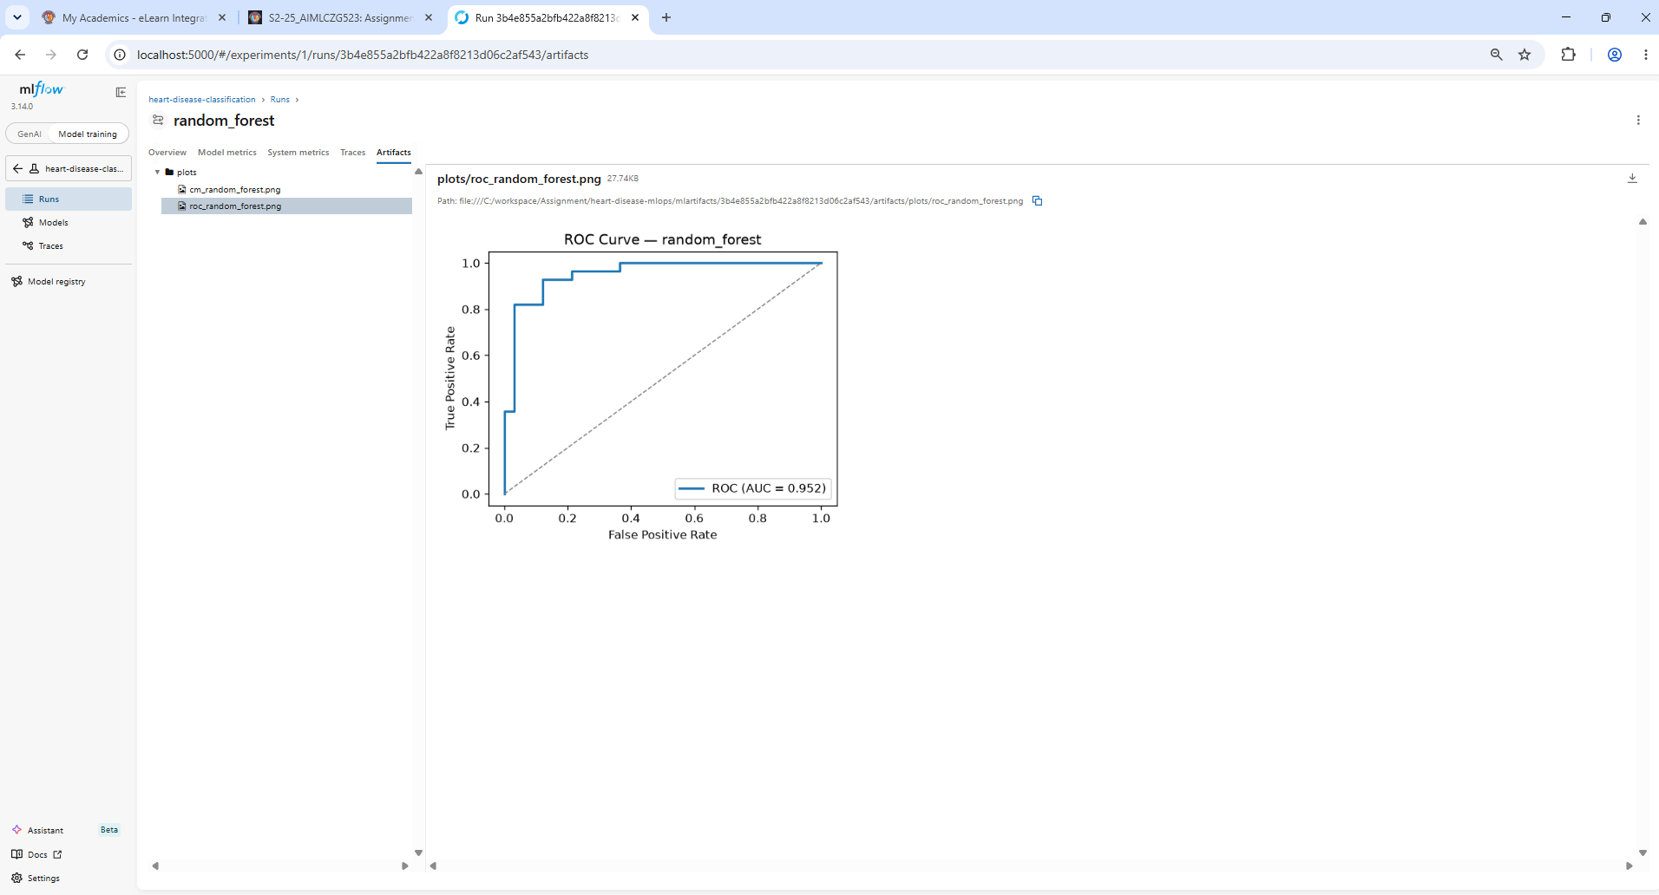
Screenshot: Random Forest - ROC curve artifact (AUC = 0.952).

XGBoost
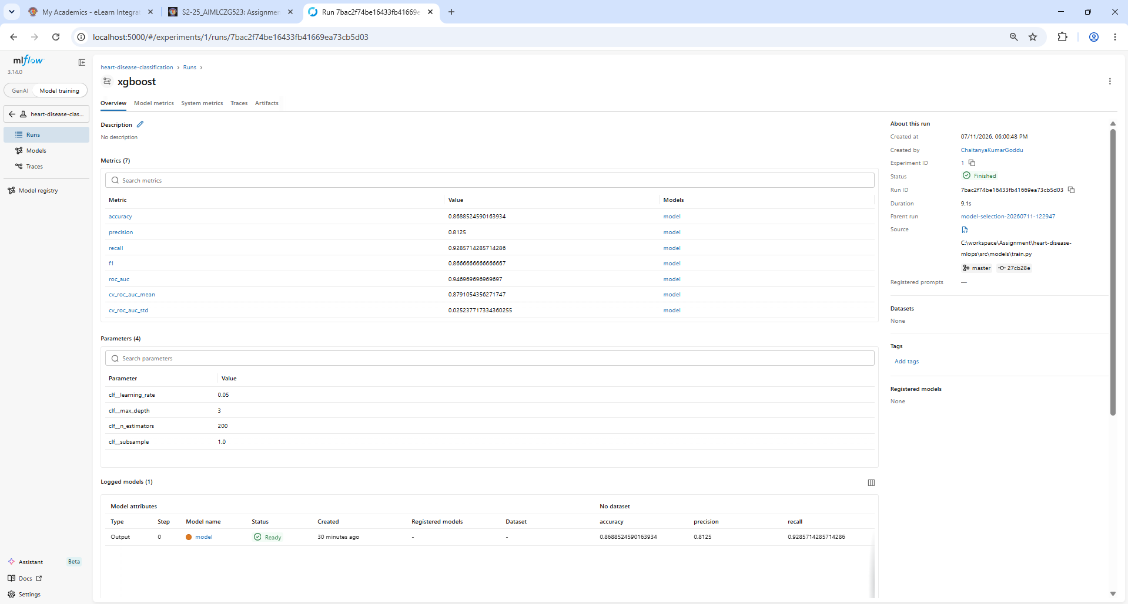
Screenshot: XGBoost run overview - metrics + tuned params (learning_rate=0.05, max_depth=3, n_estimators=200).
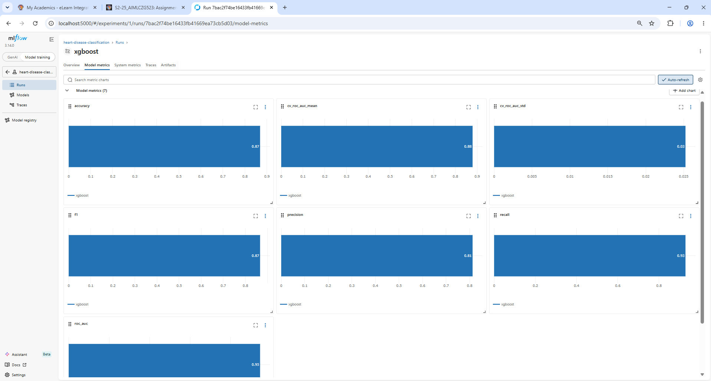
Screenshot: XGBoost - model-metric charts.
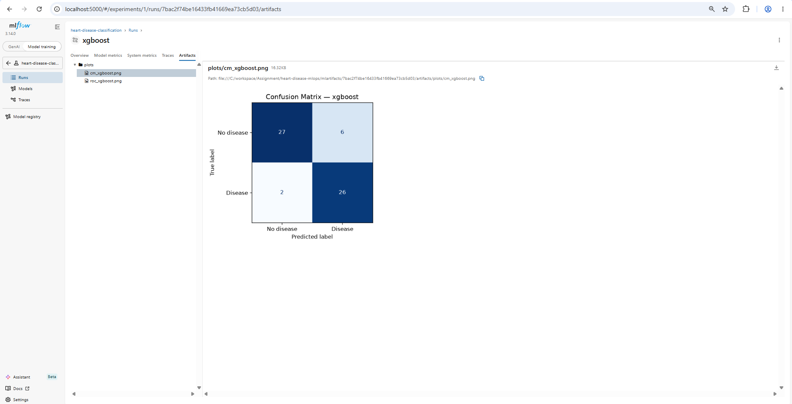
Screenshot: XGBoost - confusion matrix artifact.
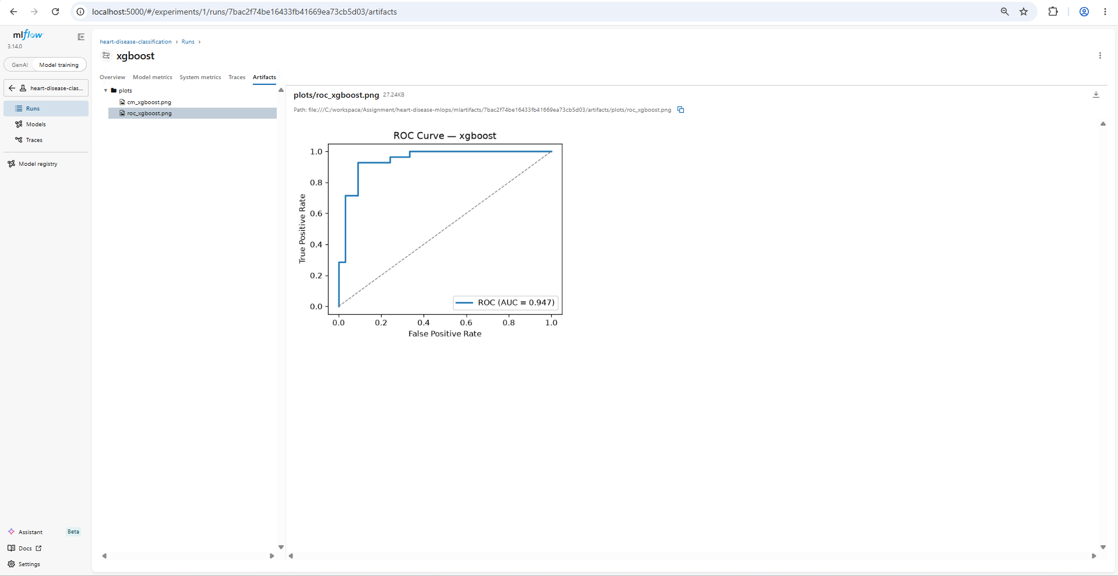
Screenshot: XGBoost - ROC curve artifact (AUC = 0.947).

6. Task 4 - Model Packaging & Reproducibility
Source files:
- models/model.pkl - fitted sklearn Pipeline (joblib)
- models/model_metadata.json - model name, best params, metrics, feature order
- src/models/train.py - joblib.dump(best_estimator, MODEL_PATH)
- requirements.txt - pinned dependency versions
The winning pipeline is serialised to models/model.pkl with joblib, alongside model_metadata.json (model name, best params, metrics, feature order, timestamp). Because preprocessing lives inside the pipeline, the artifact is fully self-contained: the API just calls predict_proba on a raw feature row. requirements.txt pins exact versions and random_state=42 fixes every stochastic step, so a clean environment reproduces the same model and metrics.

7. Task 5 - CI/CD Pipeline & Automated Testing
Source files:
- tests/conftest.py - offline fixtures (synthetic data + tiny pipeline)
- tests/test_data.py - cleaning / preprocessing tests
- tests/test_model.py - pipeline + metrics tests
- tests/test_api.py - FastAPI /predict, /health, validation, 503, /metrics
- .github/workflows/ci.yml - lint -> test -> train -> docker build + smoke test
- pyproject.toml, .flake8 - pytest / black / isort / flake8 config
The suite has 17 unit/integration tests covering target binarisation, missing-value handling, de-duplication, the column contract, the preprocessor removing NaNs, pipeline output shape/range, metric computation, and the API (happy path, 422 validation errors, 503 when no model, /metrics exposure). The GitHub Actions workflow runs on every push/PR with three dependent jobs - Lint & Test, Train Model, and Docker Build Validation - and fails the run on any lint or test error.
Commands:
pytest # 17 passed
flake8 src tests # lint (clean)
black --check src tests && isort --check-only src tests
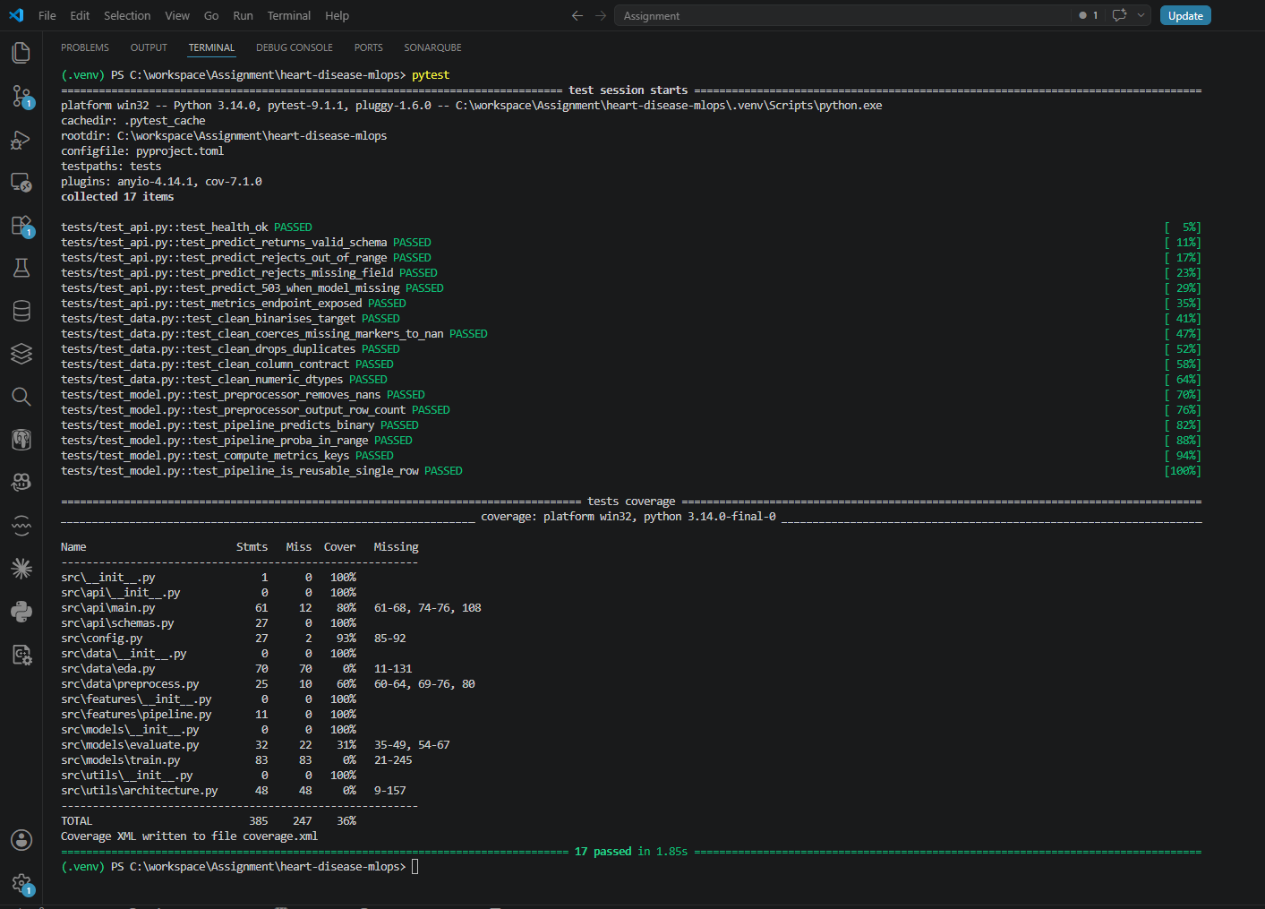
Screenshot: Local Pytest run - all 17 tests pass, with the coverage summary.
[SCREENSHOT NEEDED - GitHub Actions: a green 'CI/CD Pipeline' run showing the 3 jobs (Lint & Test -> Train Model -> Docker Build Validation). Capture from your repo's Actions tab after pushing.]

8. Task 6 - Containerisation (Docker) & Serving API
Source files:
- Dockerfile - multi-stage build, non-root user, HEALTHCHECK
- .dockerignore - keep the image lean
- src/api/main.py - FastAPI app: /predict, /health, /metrics
- src/api/schemas.py - Pydantic request/response models + validation
- sample_request.json - example high-risk patient payload
A multi-stage Dockerfile (Python 3.12-slim) builds wheels in stage 1 and installs them offline in stage 2, runs as a non-root user, exposes port 8000, and defines a container HEALTHCHECK against /health. The /predict endpoint accepts JSON, validates it with Pydantic (out-of-range values are rejected with HTTP 422), and returns the prediction plus a confidence score. Swagger UI is auto-generated at /docs.
Commands:
docker build -t heart-disease-api:latest .
docker run --rm -p 8000:8000 heart-disease-api:latest
curl.exe -X POST http://localhost:8000/predict -H "Content-Type: application/json" -d "@sample_request.json"
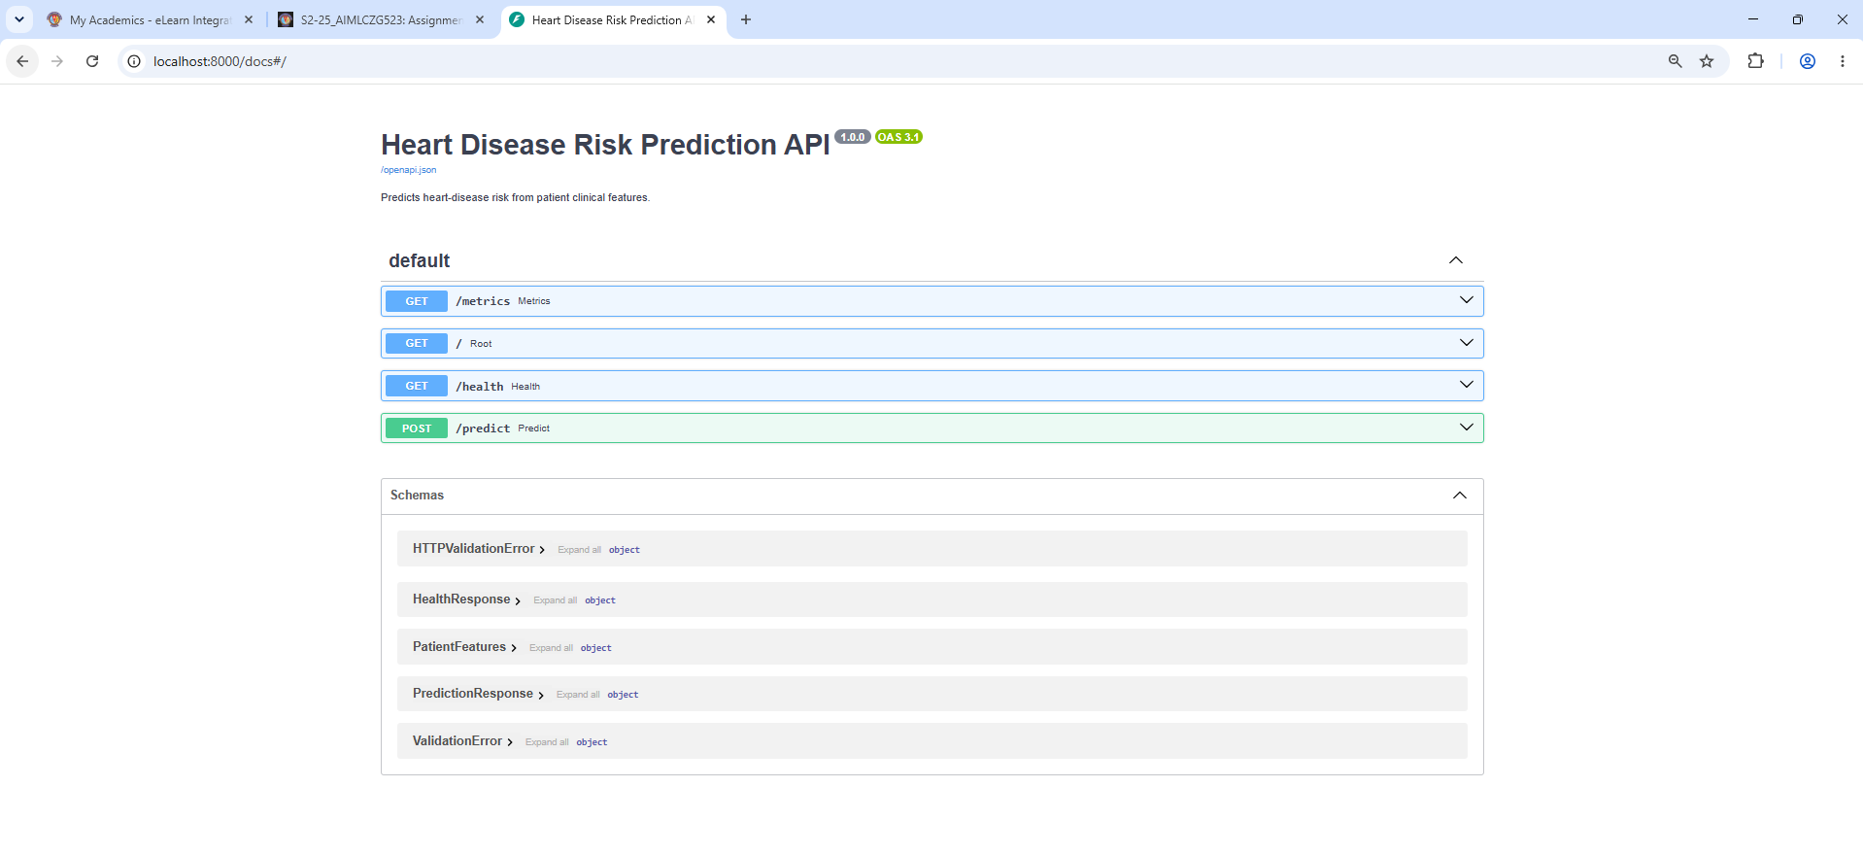
Screenshot: FastAPI Swagger UI (/docs) exposing /predict, /health, /metrics and / endpoints.
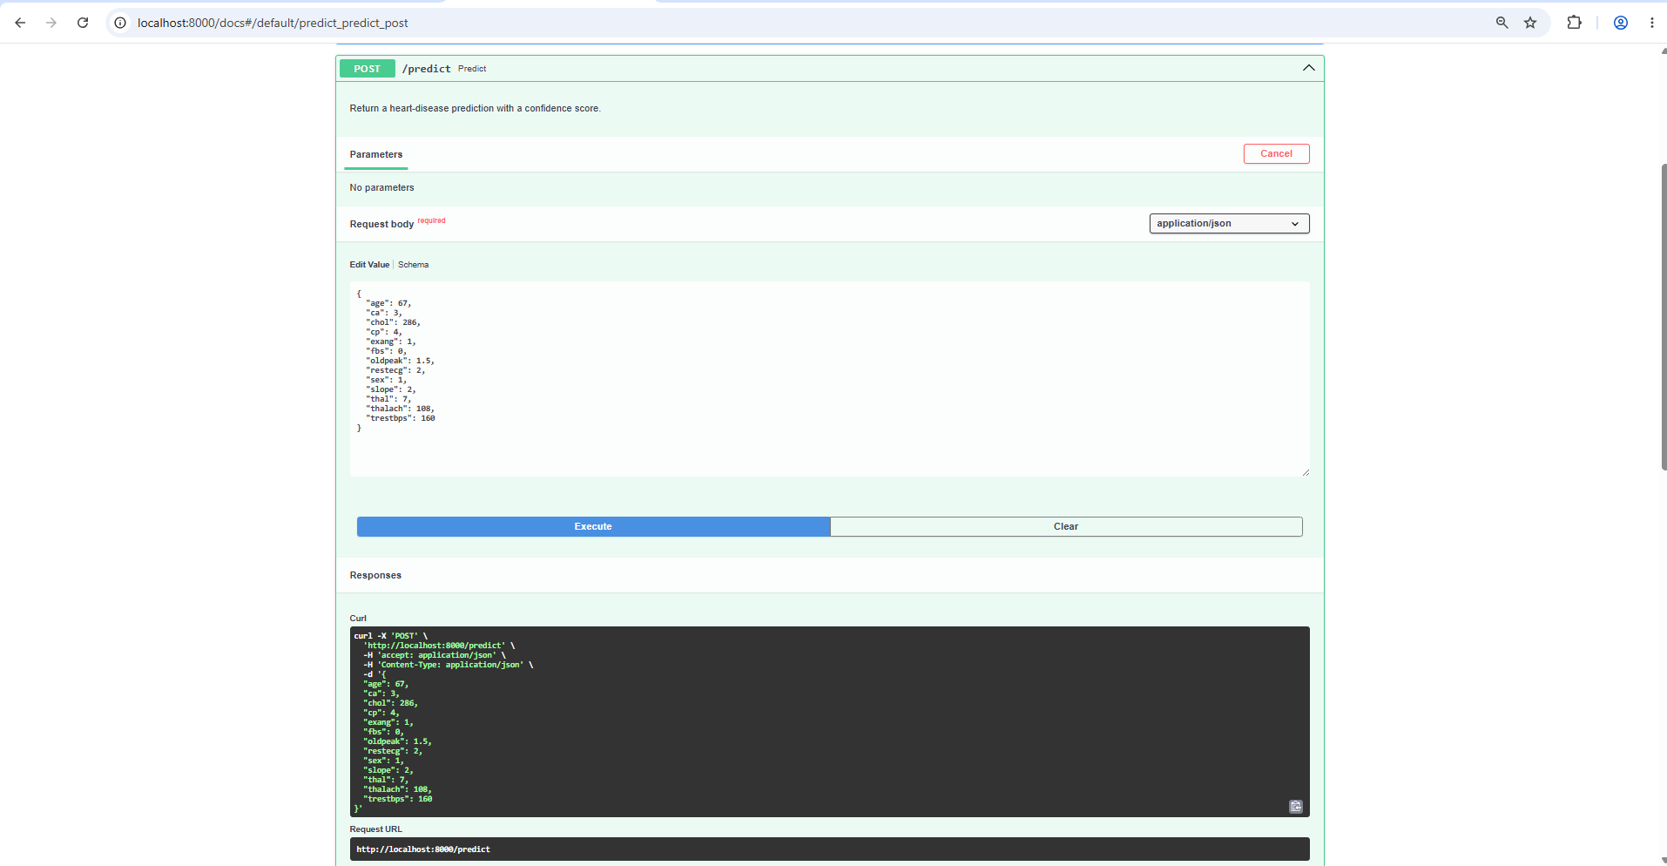
Screenshot: Swagger UI - /predict 'Try it out' with the sample request body.
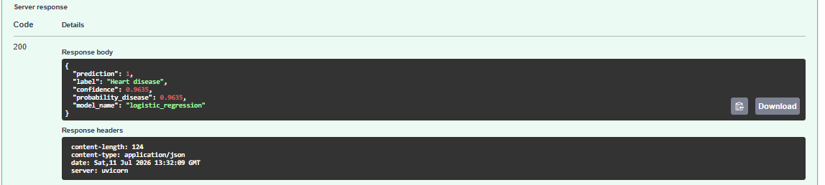
Screenshot: Swagger UI - /predict returns HTTP 200: prediction=1, confidence 0.9635.
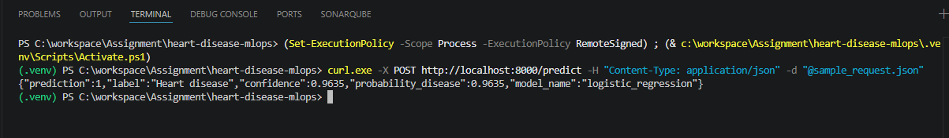
Screenshot: Local /predict call via curl returning prediction + confidence.
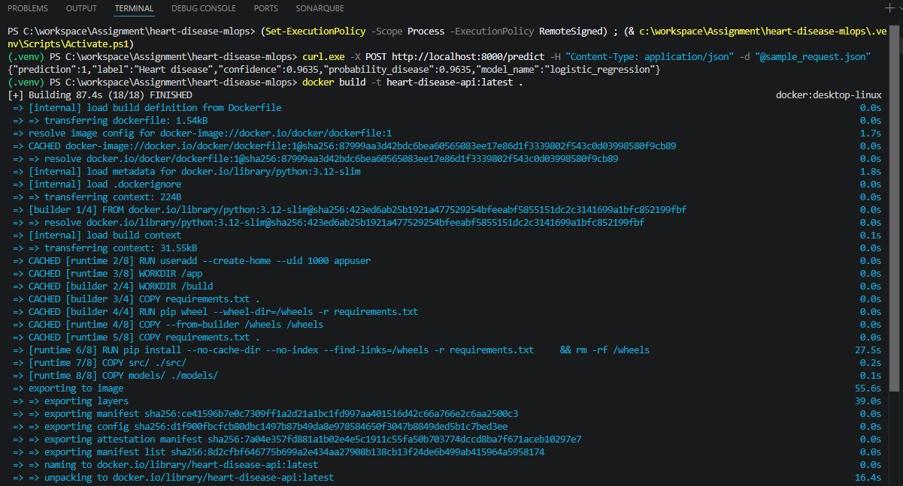
Screenshot: Docker image build - multi-stage build completes (18/18 FINISHED).
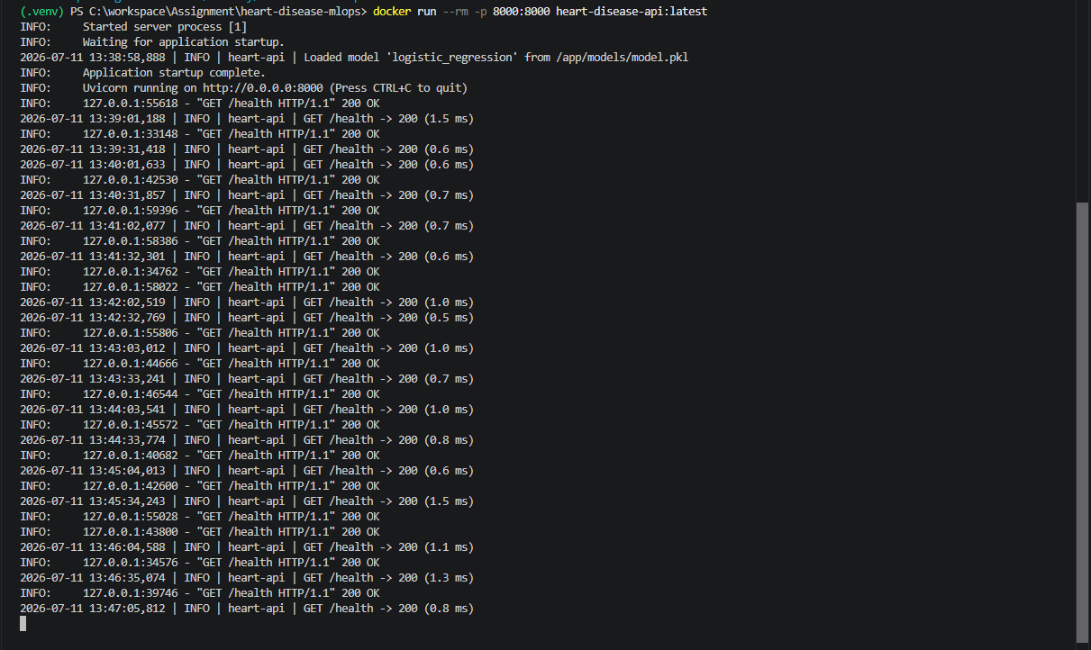
Screenshot: Container startup logs - model 'logistic_regression' loaded, health checks returning 200.
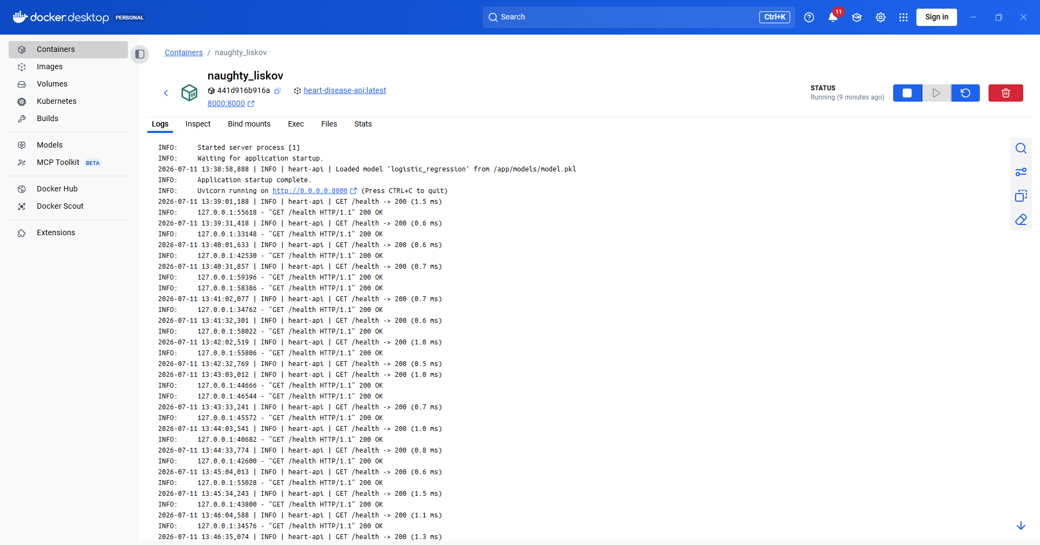
Screenshot: Docker Desktop - the heart-disease-api container running on port 8000.
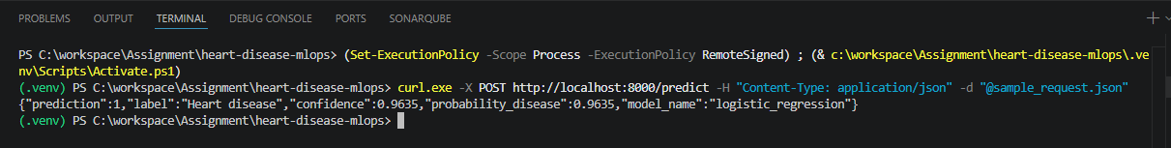
Screenshot: /predict verified against the running container (prediction=1, confidence 0.9635).

9. Task 7 - Production Deployment (Kubernetes)
Source files:
- k8s/deployment.yaml - 2 replicas, resource limits, readiness/liveness probes
- k8s/service.yaml - LoadBalancer service on port 8000
- helm/heart-disease-api/ - equivalent parameterised Helm chart
The API is deployed to Docker Desktop Kubernetes. deployment.yaml runs 2 replicas with CPU/memory requests+limits, readiness and liveness probes on /health, and Prometheus scrape annotations; service.yaml exposes a LoadBalancer on port 8000 (reachable at http://localhost:8000 on Docker Desktop). A Helm chart provides the same deployment parameterised via values.yaml.
Commands:
kubectl apply -f k8s/
kubectl get pods,svc # wait until both pods are 1/1 Running
curl.exe -X POST http://localhost:8000/predict -H "Content-Type: application/json" -d "@sample_request.json"
# Helm alternative: helm install heart ./helm/heart-disease-api
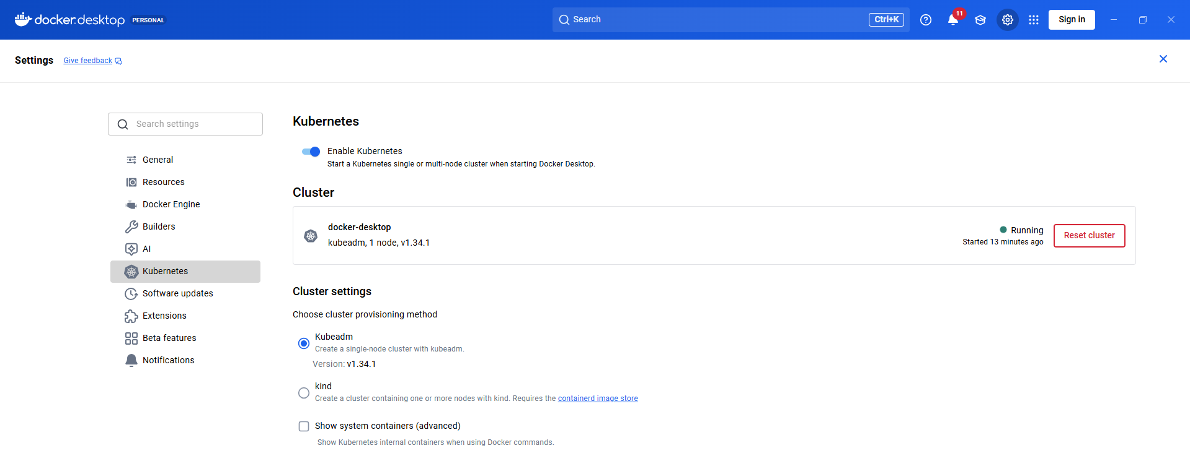
Screenshot: Docker Desktop Kubernetes cluster enabled and Running (kubeadm, 1 node, v1.34.1).
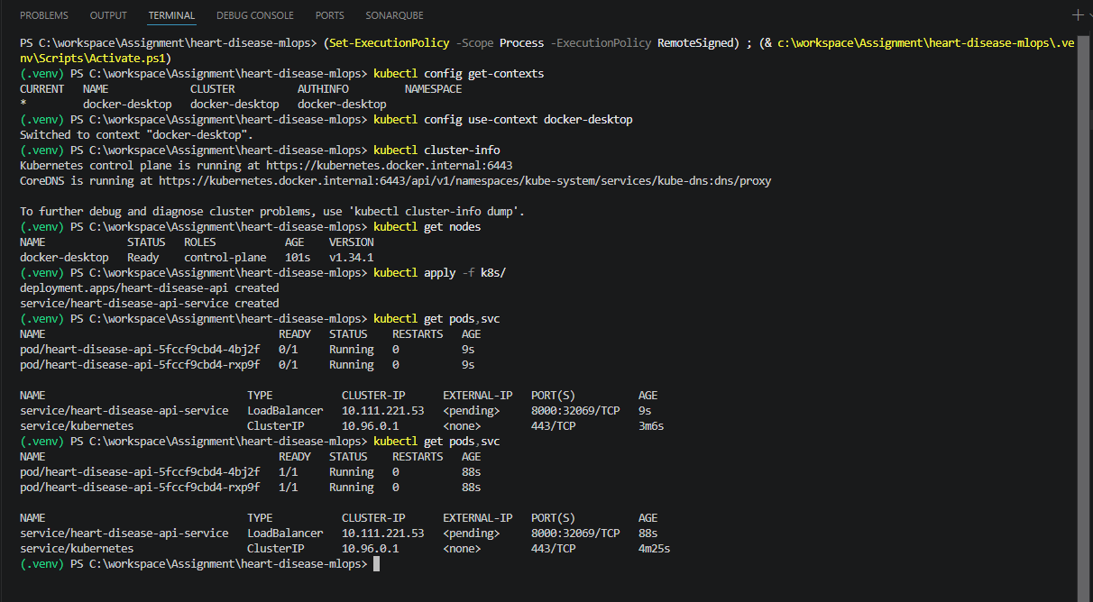
Screenshot: kubectl - context, cluster-info, get nodes (Ready), apply -f k8s/, and 2/2 pods Running behind the LoadBalancer service.
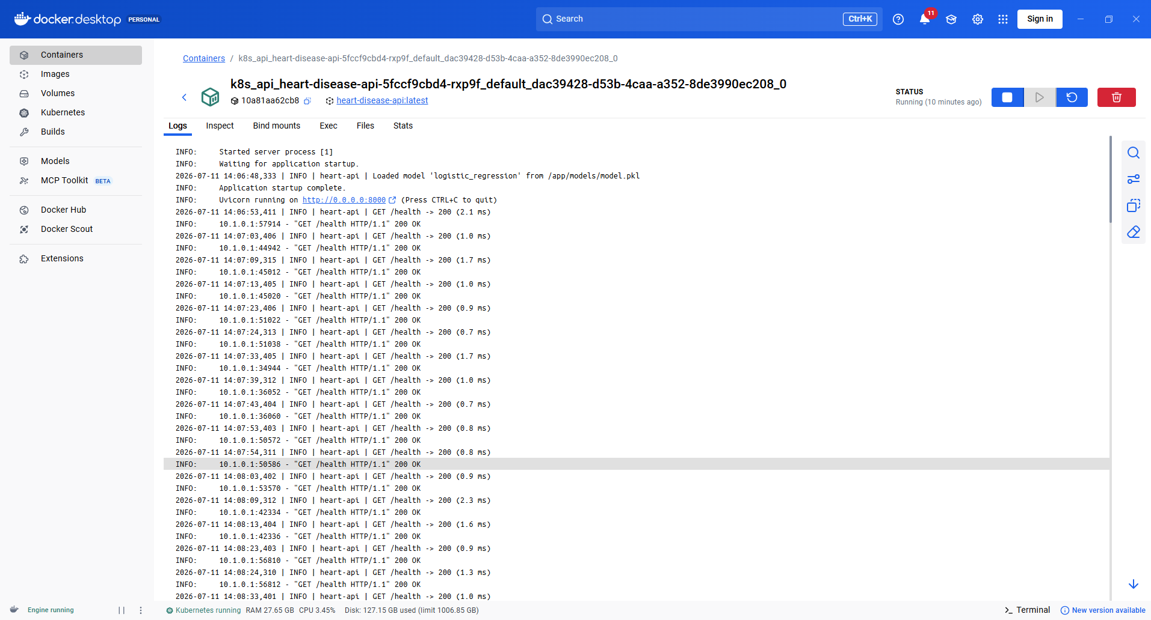
Screenshot: Kubernetes pod logs (replica 1) - model loaded, readiness probes returning 200.
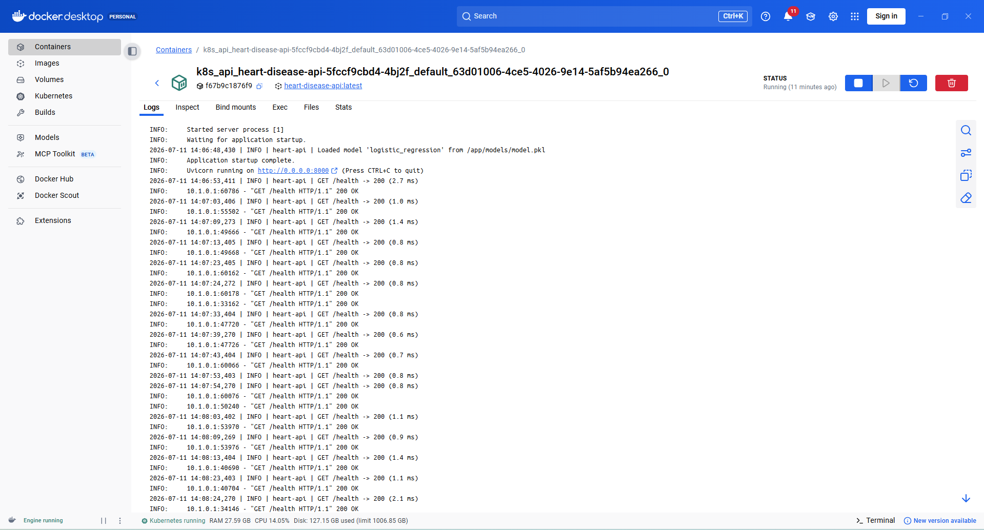
Screenshot: Kubernetes pod logs (replica 2) - model loaded, health checks passing.
Screenshot: /predict verified through the Kubernetes LoadBalancer service.

10. Task 8 - Monitoring & Logging
Source files:
- src/api/main.py - request-logging middleware + Prometheus metrics
- (Instrumentator /metrics + heart_predictions_total{outcome=...} Counter)
- monitoring/prometheus.yml - scrape config (api:8000 every 10s)
- docker-compose.yml - API + Prometheus + Grafana stack
- monitoring/grafana/provisioning/ - auto-provisioned datasource + dashboard
A FastAPI middleware logs every request (method, path, status, latency). prometheus-fastapi-instrumentator exposes standard HTTP latency/throughput metrics at /metrics, plus a custom heart_predictions_total{outcome=...} counter that tracks the positive/negative prediction mix (a simple drift signal). docker compose brings up the API (host port 8001, to coexist with the K8s deployment on 8000), Prometheus (host 9091), and Grafana (host 3000) with the datasource and dashboard auto-provisioned.
Commands:
docker compose up --build
# generate traffic (API on 8001):
1..30 | ForEach-Object { curl.exe -s -X POST http://localhost:8001/predict -H "Content-Type: application/json" -d "@sample_request.json" | Out-Null }
# Prometheus: http://localhost:9091 Grafana: http://localhost:3000 (admin/admin)
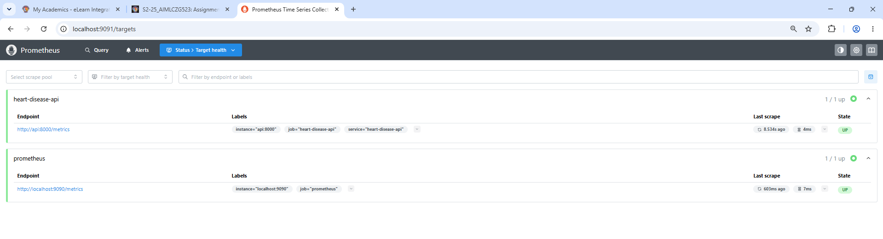
Screenshot: Prometheus - both scrape targets UP (heart-disease-api scraped at api:8000/metrics).
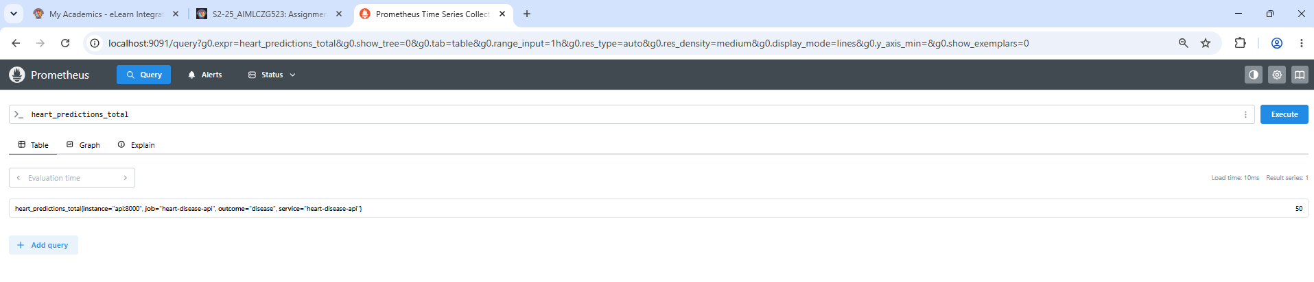
Screenshot: Prometheus query - heart_predictions_total = 50 for outcome='disease'.
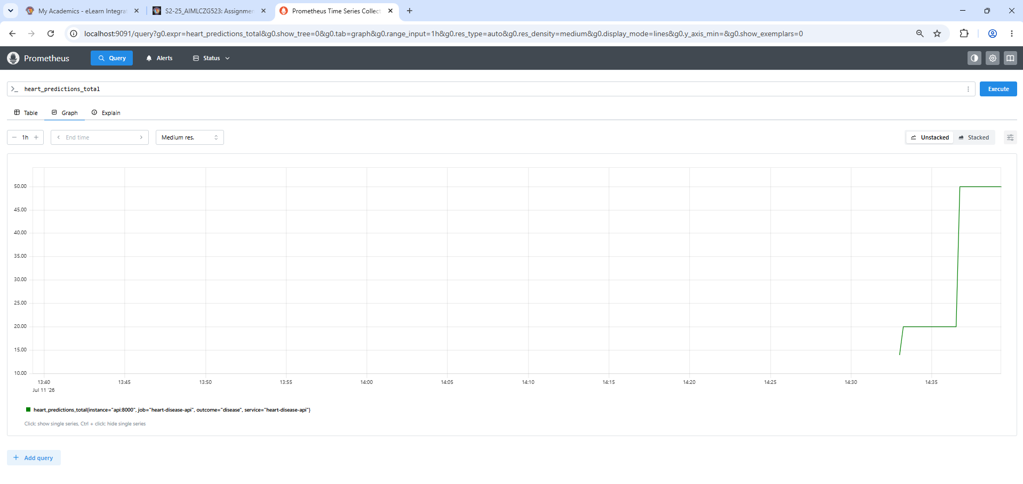
Screenshot: Prometheus graph - heart_predictions_total over time.
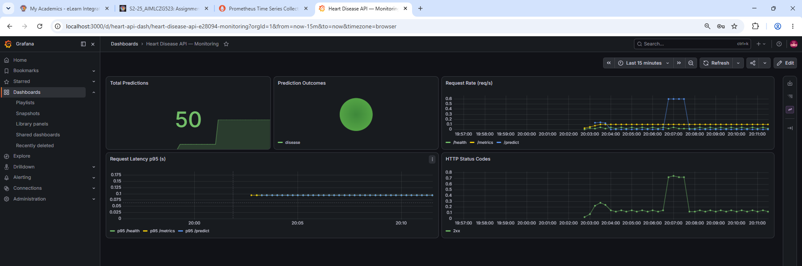
Screenshot: Grafana dashboard - Total Predictions, Prediction Outcomes, Request Rate, p95 Latency, HTTP Status Codes.

11. Task 9 - System Architecture
Development produces a tracked, versioned model artifact; CI/CD validates and packages it into a Docker image; Kubernetes serves it behind a LoadBalancer; Prometheus and Grafana observe it in production.
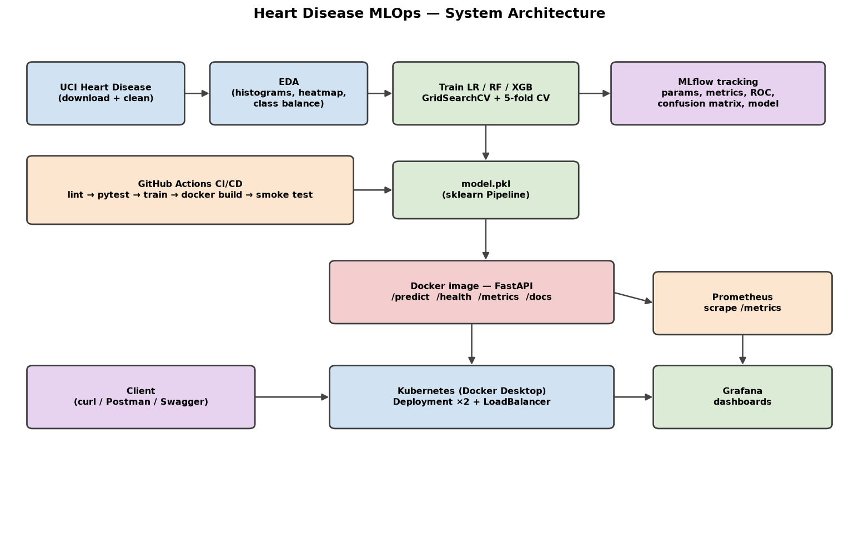
Figure 7. End-to-end system architecture.

12. Repository & Deliverables
GitHub repository: https://github.com/ChaitanyaKumarGoddu/BITSMLOPSAssignment
Deliverable | Location in repo
Code + Dockerfile + requirements | repo root, src/
Dataset + download script | src/data/download.py, data/processed/
Notebook / scripts (EDA, train, inference) | notebooks/, src/
Unit tests | tests/
GitHub Actions workflow | .github/workflows/ci.yml
Deployment manifests / Helm chart | k8s/, helm/
Monitoring config | monitoring/, docker-compose.yml
Report + figures | reports/

13. Conclusion
This project delivers a reproducible, tested, containerised, and monitored heart-disease classifier that meets every assignment requirement. The tuned Logistic Regression (ROC-AUC 0.968, recall 0.93) is both accurate and interpretable - the right choice for a clinical screening context - and the surrounding MLOps scaffolding (MLflow, CI/CD, Docker, Kubernetes, Prometheus/Grafana) makes it safe to iterate on and operate in production. Possible extensions: data-drift detection with Evidently, a model registry with staged promotion, automated retraining triggers, and canary deployments.

