A Project Report on

Stylora
By
Chaitanya Milind Chavan
(Roll No - 20250202016)
MCA – I, SEM – II
2025-26

To
Savitribai Phule Pune University, Pune

In Partial Fulfillment of the Degree of
Master in Computer Application (M. C. A.)

Under The Guidance Of
Prof. Anagha Sawant

Suryadatta Group of Institutes, Pune
Suryadatta Institute of Business Management & Technology -SIBMT

Date:-
CERTIFICATE
This is to certify that Mr. Chaitanya Milind Chavan has successfully completed their project work entitled “Stylora” in partial fulfillment of MCA – I Semester-program for the year A.Y. 2025-26. They have worked under our guidance and direction.

Prof. Anagha Sawant Dr. Manisha Kumbhar
Project Guide Professor & Director (SIBMT)

Examiner 1 Examiner 2

Date :
Place :

Acknowledgment
I am the student of MCA first year. Here by I express my thanks to our project guide for allowing us to do the project on “Stylora”. This project work has been the most exciting part of our learning experience which would be an asset for our future carrier. We would especially like to thank our guide and mentor Prof. Anagha Sawant, who constantly guided me in developing, pushing me to search for more answers to her numerous questions. Also I would like to thank Prof. Apurva Patil, project coordinators for their support. As a building block of MCA Department, I thank Dr. Manisha Kumbhar, Professor & Director, SIBMT for her continuous support and help. I am grateful to many classmates who contributed their suggestions. Their hard work and examples push us to limits of our capability and encourage us daily.

Thank You,
Chaitanya Milind Chavan
(SIBMT, Div. – A, Roll No - 20250202016)

Index
Chapters | Page No
CHAPTER 1: INTRODUCTION | 6
1.1 Existing System | 6
1.2 Need for System | 8
1.3 Operating Environment (Hardware and Software) | 10
1.4 Brief Description about Technology Used | 11
CHAPTER 2: PROPOSED SYSTEM | 13
2.1 Proposed System (Introduction of system) | 14
2.2 Module Specifications (Scope) | 17
2.3 Objectives of System | 21
CHAPTER 3: ANALYSIS & DESIGN | 24
3.1 Use Case Diagram | 25
3.2 Activity Diagram | 42
3.3. Sequence Diagram | 62
3.4 Class Diagram | 76
3.5 Module Hierarchy Diagram | 77
3.6 ERD | 78
3.7 Table Specifications (Database Design) | 79
3.8 Data Dictionary | 81
CHAPTER 4: USER MANUAL | 84
4.1 User Interface Screens Input and Output Screens with data | 84
4.2 Data Reports | 96
4.3 Sample program code | 99
4.4 Test Cases | 114
4.5 Limitations | 123
Bibliography | 126
Web Reference | 127

CHAPTER 1: INTRODUCTION

1.0 Introduction

Due to the rapid expansion of digital technologies and internet services, professionals are increasingly utilising the internet for displaying their work and reaching potential clients. For interior design professionals, it is essential to have a strong presence on the internet for displaying their creativity and reaching new clients. However, it is often hard for clients to find suitable interior designers according to their tastes, budgets, and requirements.

Stylora is a web-based application designed for bridging the gap between interior designers and clients. Stylora is designed for interior designers who can create visually attractive web pages for displaying their work and abilities. Clients can easily find suitable interior designers based on different criteria such as style, location, and budget.

Stylora is designed for facilitating communication between interior designers and clients. Clients can easily schedule appointments with interior designers using Stylora. Additionally, email notifications are sent to designers and clients for ensuring a highly organized interaction process. Stylora is built using modern technologies and frameworks such as Django, Python, and PostgreSQL for creating a highly responsive and efficient environment for interior designers and clients.

1.1 Existing System
In the current scenario, interior designers are able to reach potential customers and promote themselves through:
• Social media sites like Instagram, Pinterest, and Facebook, where they showcase their work.
• Personal websites, which are hard to find unless promoted properly.
• Referrals, where customers get to know the designer through word of mouth.
This is where the discovery and communication process is not efficient, as there is no platform where the customer can easily search and get in touch with the designer based on their requirements.
Most existing systems suffer from the following limitations:

1. Lack of a Dedicated Platform for Interior Designers

Currently, interior designers mostly use general platforms such as social media, personal websites, and other third-party portfolio websites. These platforms are not specifically designed for interior design services, and it becomes difficult for them to present their work in a structured and professional way. They are not able to categorize their work according to style, type, and budget, and it becomes difficult for them to showcase their work and attract suitable clients.

2. Difficulty in Finding Suitable Designers

The clients usually face difficulties in finding designers that suit their particular needs and preferences, such as design style, location, project types, and budgets. However, the current platforms do not offer an efficient way of filtering, making the process time-consuming and less effective.

3. Inefficient Communication Process

Communication between designers and clients is mostly done through emails, phone calls, and social media messages. This is an unstructured process and may lead to delays and difficulties in scheduling consultation.

4. Lack of Structured Portfolio Management

Many designers tend to showcase their designs using social media or unorganized websites. These websites cannot categorize the designs, and this may not help the client to know what the designer is capable of.

5. Limited Platform Management

In the conventional systems, there is no facility of having a centralized admin control panel. This becomes difficult while monitoring and managing the users, portfolios, and activities on the platform.

As the conventional systems are limited, there are difficulties faced by the designers as well as the clients.

1.2 Need for the System

1.2 Need for the System

The development of the Stylora platform is necessary to address several challenges faced by both interior designers and clients in the current digital environment.

1.2.1 Creating a Dedicated Platform for Interior Designers

Interior designers often rely on social media or general portfolio websites to showcase their work.

• The Problem: These platforms are not specifically designed for interior design portfolios, making it difficult for designers to organise projects and for clients to discover suitable professionals.

• The Solution: Stylora provides a specialised platform where designers can create structured portfolios that highlight their projects, design styles, and expertise professionally.

1.2.2 Simplifying Designer Discovery for Clients

Finding the right interior designer can be a complex process for clients.

• The Problem: Clients usually need to browse multiple websites or social media profiles to find designers that match their preferences, which is time-consuming and inefficient.

• The Solution: Stylora introduces a smart filter-based search system that allows clients to easily find designers based on factors such as design style, location, project type, and budget.

1.2.3 Streamlining Communication Through Appointment Booking

Communication between designers and clients is often unstructured and difficult to manage.

• The Problem: Scheduling consultations typically requires multiple phone calls, emails, or messages, which can lead to delays and confusion.

• The Solution: Stylora integrates an appointment booking system where clients can schedule consultations directly through the platform, with automatic email confirmations sent to both parties.

1.2.4 Centralised Portfolio and Platform Management

Managing portfolios and platform activities can be difficult without proper administrative tools.

• The Problem: Designers often lack a single platform to manage their portfolios efficiently, and administrators cannot easily monitor user activities.

• The Solution: Stylora includes a centralised admin panel and role-based dashboards that allow administrators to manage users, portfolios, and platform categories, while designers can easily update and maintain their project showcases.

1.2.5 Secure Authentication and Role-Based Access

Security is an important aspect of any online platform.

• The Problem: Without proper authentication and access control, platforms are vulnerable to unauthorised access and misuse of data.

• The Solution: Stylora implements secure login systems with role-based access control for designers, clients, and administrators, ensuring that each user only has access to relevant features and data.

1.2.6 Scalability and Automation
The choice of the MERN stack (MongoDB, Express, React, Node) ensures the platform can grow.
- Database Scalability: MongoDB is "Schema-less," meaning if you decide to add new features (like "Product Reviews" or "Video Recipes") later, you can do so without breaking your existing database structure.
- Automated Workflow: From the moment a user clicks "Pay" to the generation of a PDF Invoice via PDFKit, the system minimizes manual data entry. This allows the business owner to focus on sourcing products rather than managing paperwork.

Thus, Stylora fulfills the need for a centralized digital platform that helps interior designers build their professional presence while enabling clients to easily discover and connect with the right design professionals.

1.3 Operating Environment (Hardware and Software)
The operating environment defines the hardware and software requirements needed to run the system efficiently.

1.3.1 Hardware Requirements
- Processor: Intel i3 or higher
Required to handle frontend rendering, backend processing, and database operations.
- RAM: Minimum 8 GB
Ensures smooth multitasking during development and execution of the application.
- Storage: Minimum 256 GB SSD
Required for storing application files, databases, and logs.
- Internet Connection:
Necessary for API communication, payment gateway integration, and cloud services.

1.3.2 Software Requirements

Frontend Environment
- Operating System: Windows / Linux / macOS
- Web Browser: Google Chrome, Mozilla Firefox, Microsoft Edge
- Framework: React.js
- Build Tool: Vite
- Styling Framework: Tailwind CSS
- Language: JavaScript (ES Modules)
The frontend provides an interactive and responsive user interface for browsing products, reading recipes, and placing orders.

Backend Environment
- Runtime Environment: Node.js
- Framework: Express.js
- Database: MongoDB
- Authentication: JWT
The backend handles business logic, API requests, database communication, authentication, and payment processing.

1.4 Brief Description of Technology Used

1.4.1 React.js
React.js is a JavaScript library used for building dynamic and responsive user interfaces. It follows a component-based architecture, making the application modular, reusable, and easy to maintain. React improves performance using a virtual DOM, which updates only the necessary components instead of reloading the entire page.

1.4.2 Vite
Vite is a modern frontend build tool that provides fast development startup and optimized production builds. It improves developer productivity by enabling hot module replacement and faster compilation compared to traditional bundlers.

1.4.3 Node.js
Node.js is a server-side JavaScript runtime environment that allows the application to handle multiple requests asynchronously. It is highly scalable and suitable for building real-time and data-intensive applications like e-commerce platforms.

1.4.4 Express.js
Express.js is a lightweight and flexible Node.js framework used to develop RESTful APIs. It simplifies routing, middleware integration, and request handling, making backend development efficient and structured.

1.4.5 JavaScript
JavaScript isn't just for browsers anymore. Over the last decade, it has expanded into almost every area of tech:

Frontend (The Browser)
Libraries and frameworks make building complex apps faster:
- React: Created by Meta, great for building interactive UIs.
- Vue & Angular: Other heavy hitters used for "Single Page Applications."

Backend (The Server)
- Node.js: This allowed developers to use JavaScript to write server-side code. Now, you can build an entire app—front to back—using just one language.

Mobile & Desktop
- React Native: Lets you build real mobile apps for iOS and Android using JS.
- Electron: Powers desktop apps like Discord, VS Code, and Slack.

1.4.6 MongoDB
MongoDB is a NoSQL database that stores data in a flexible, JSON-like format. It is used to store user details, product information, recipes, orders, and payment records. MongoDB supports scalability and high performance.

1.4.7 JWT (JSON Web Token)
JWT is used for secure authentication and authorization. After successful login, a token is generated and sent to the client. This token is used to verify user identity and enforce role-based access control throughout the application.

1.4.8 Cloudinary
Cloudinary is a cloud-based media management service used to store and manage product and recipe images. It provides fast image delivery, optimisation, and secure storage.

CHAPTER 2: PROPOSED SYSTEM

2.0 Introduction
The proposed system, Stylora, is a web-based platform designed to connect interior designers with potential clients through a structured and user-friendly digital environment. The system aims to eliminate the limitations of traditional methods where designers rely on social media or personal references to showcase their work, and clients struggle to find suitable designers based on their requirements.
Stylora provides a centralised platform where interior designers can create professional portfolios to display their projects, skills, and design expertise. Clients can browse these portfolios and use advanced filtering options such as design style, location, and budget to identify designers that match their preferences. This significantly improves the discovery process and reduces the time required to find the right professional.
The system also integrates an appointment booking feature that allows clients to schedule consultations directly with designers. This eliminates the need for unstructured communication through calls or messages and ensures a smooth and organised interaction process. Once an appointment is booked, the system sends confirmation notifications to both the client and the designer, ensuring transparency and reliability.
Stylora follows a role-based architecture, where different users, such as clients, designers, and administrators, have access to specific functionalities. Designers can manage their portfolios and appointments, clients can search and book consultations, and administrators can monitor and manage the overall platform.
The system is developed using modern web technologies, ensuring high performance, scalability, and responsiveness. It is designed to provide an intuitive user experience while maintaining data security and efficient system operations. Overall, Stylora serves as a comprehensive digital solution that bridges the gap between interior designers and clients, enhancing both visibility for designers and accessibility for users.

2.1 Proposed System (Introduction of System)

The proposed Stylora system introduces a specialized digital platform designed to connect interior designers with potential clients through a structured portfolio-based system. Unlike general platforms where designers showcase their work informally through social media, Stylora provides a professional environment where designers can present their projects in an organized and visually appealing way. The platform focuses on improving the discoverability of designers and simplifying the process for clients to find professionals that match their requirements.

Stylora integrates several modern features such as portfolio management, smart search filters, appointment booking, and role-based dashboards for designers, clients, and administrators. These features help streamline the interaction between designers and clients while ensuring efficient platform management. The system is built using modern web technologies such as React js, Node js, Express js and Mongo DB ensuring high performance, scalability, and a responsive user experience across different devices.

Key Features of the Proposed System

1. Designer Portfolio Showcase

The Designer Portfolio Showcase feature allows interior designers to present their work in a professional and structured manner. Designers can upload multiple projects and organize them in categories based on design style, project type, or theme. Each project can include detailed descriptions, images, and information about the design concept, materials used, and overall aesthetic approach. This helps designers effectively communicate their creativity and expertise to potential clients.

This feature also improves the credibility and professional presence of designers by providing them with a dedicated space to display their work instead of relying on scattered social media posts. Clients visiting the platform can easily browse through portfolios and understand the designer’s design philosophy, experience, and previous work. By presenting projects in a visually appealing and organized format, the platform helps designers attract the right audience and build a strong digital identity.

2. Smart Filter-Based Designer Search

The Smart Filter-Based Designer Search feature enables clients to quickly find interior designers that match their preferences and project requirements. Instead of manually browsing through multiple portfolios, clients can apply filters such as design style, location, project type, and budget range to narrow down their search results. This makes the discovery process more efficient and user-friendly.

The filtering system helps users find designers whose expertise aligns with their needs, whether they are looking for modern, traditional, minimalist, or luxury interior designs. By providing a structured search mechanism, the platform saves time for users and improves the overall experience of finding the right professional. This feature also benefits designers because it connects them with clients who are specifically interested in their style or specialization, increasing the chances of meaningful collaborations.

3. Appointment Booking System

The Appointment Booking System is designed to simplify the communication and scheduling process between clients and interior designers. Instead of relying on phone calls or emails to schedule meetings, clients can directly book consultation appointments through the platform. The system allows users to select available time slots and submit booking requests easily.

Once an appointment is scheduled, the system automatically sends confirmation emails to both the client and the designer, ensuring that both parties are informed about the booking details. This feature helps reduce scheduling conflicts and eliminates the need for multiple back-and-forth messages. By providing a structured appointment management system, Stylora makes the consultation process more organized and convenient for both designers and clients, improving overall efficiency and user satisfaction.

4. Secure User Authentication

Security is an important aspect of any digital platform, especially one that manages user profiles and appointments. Stylora includes a secure user authentication system that ensures only authorized users can access specific features of the platform. Users must register and log in before accessing personalized functionalities such as portfolio management or appointment booking.

The platform also supports role-based access control, which means different users have different permissions depending on their role. Designers can manage their portfolios and view appointment requests, while clients can search designers and book consultations. Administrators have additional privileges to manage platform activities and monitor user interactions. This security mechanism protects user data, prevents unauthorized access, and ensures that the platform operates in a safe and controlled environment.

5. User Dashboard

The User Dashboard provides a personalized interface for users to manage their activities on the platform. Once logged in, designers and clients are directed to their respective dashboards where they can access relevant features and information. Designers can upload new projects, update existing portfolios, manage appointment requests, and review their profile information.

Clients, on the other hand, can browse designers, track their booked appointments, and manage their profile details. The dashboard acts as a centralized workspace where users can easily perform all their actions without navigating through multiple pages. By providing a structured and organized interface, the user dashboard enhances usability and helps users interact with the platform more efficiently.

6. Admin Dashboard

The Admin Dashboard is a centralized control system that allows administrators to manage and monitor the overall operations of the Stylora platform. Through this dashboard, administrators can oversee user registrations, manage designer profiles, and monitor platform activities to ensure smooth functioning.

Administrators also have the authority to manage categories, review portfolios, and maintain the overall quality of the content available on the platform. This centralised management system helps maintain the platform's reliability and integrity while ensuring that users follow appropriate guidelines. By providing administrative tools and monitoring capabilities, the admin dashboard helps maintain order, security, and efficient operation of the entire system.

7. Responsive and Modern Interface

Stylora is designed with a responsive and modern user interface to ensure a smooth browsing experience across different devices. The platform automatically adapts its layout and functionality based on the screen size, allowing users to access it from desktops, tablets, or smartphones without any usability issues.

The interface is developed using modern frontend technologies that provide a clean design, easy navigation, and visually appealing layouts. A responsive design ensures that images, portfolios, and interactive elements load correctly on all devices. This enhances user engagement and ensures that both designers and clients can access the platform conveniently anytime and from anywhere. A well-designed interface also improves user satisfaction and encourages users to spend more time exploring the platform.

2.2 Module Specifications (Scope)

The Stylora system is designed using a modular architecture where each module performs a specific set of functionalities. This modular approach improves system maintainability, scalability, and ease of development. The system is divided into the following core modules:

2.2.1 User Management Module

This module is responsible for managing all user-related operations in the system. It handles registration, authentication, authorization, and profile management for clients, designers, and administrators.

Key Functionalities:

New user registration with validation

Secure login using credentials (email/password)

Role-based access control (Client, Designer, Admin)

Session management after authentication

Profile management (view/update personal details)

Logout functionality

Working Process:

User registers by providing required details.

System validates and stores user data securely.

During login, credentials are verified by the backend.

Upon successful authentication, access is granted based on role.

Relevant Model: User

Attributes: id, name, email, password, role, phone, created_at

Ensures secure storage of user credentials and identity

2.2.2 Designer Profile Module

This module is specifically designed for interior designers to create and manage their professional profiles.

Key Functionalities:

Create and update designer profile

Add specialization (e.g., modern, traditional, minimalistic)

Add years of experience

Specify location and service areas

Write portfolio description

Working Process:

Designer logs into the system.

Designer creates or updates profile details.

Information is stored and displayed to clients.

Relevant Model: DesignerProfile

Attributes: id, user_id, specialization, experience, location, portfolio_description

Linked to User table through foreign key

2.2.3 Portfolio Management Module

This module allows designers to showcase their design work through structured portfolios.

Key Functionalities:

Upload multiple project images

Add project title and detailed descriptions

Categorize projects (modern, luxury, minimal, etc.)

Edit or delete existing portfolio entries

Display portfolio to clients

Working Process:

Designer uploads project details and images.

System stores portfolio data in database.

Clients can view portfolios while browsing designers.

Relevant Model: Portfolio

Attributes: id, designer_id, project_title, project_description, image_url, category, created_at

Maintains structured project data

2.2.4 Appointment Management Module

This module facilitates interaction between clients and designers through appointment booking.

Key Functionalities:

Book appointments with selected designers

Select preferred date and time

View appointment history

Manage appointment status (pending, confirmed, cancelled)

Send confirmation notifications

Working Process:

Client selects a designer and clicks “Book Appointment”.

Client chooses date and time.

System stores booking details in database.

Confirmation is sent to both client and designer.

Relevant Model: Appointment

Attributes: id, client_id, designer_id, appointment_date, appointment_time, status, created_at

Tracks all consultation interactions

2.2.5 Admin Management Module

This module provides centralized control over the entire system and ensures smooth functioning of the platform.

Key Functionalities:

View and manage all registered users

Monitor designer profiles and portfolios

Manage platform categories and content

Monitor appointments and user activities

Maintain system integrity and security

Working Process:

Admin logs into the admin dashboard.

Admin views system data and activities.

Admin performs operations such as updating or removing records.

System updates database accordingly.

Relevant Model: Admin

Attributes: id, username, email, password, role

Provides privileged access to system operations

2.3 Objectives of the System

The primary objectives of the Stylora system are as follows:

1. To Develop a Dedicated Platform for Interior Designers

The main objective of the Stylora system is to develop a specialized digital platform exclusively designed for interior designers to showcase their work. Currently, many designers rely on social media platforms or personal websites to display their projects, which often lack proper organization and professional presentation. Stylora aims to provide a structured platform where designers can create detailed portfolios, present their projects, and highlight their design expertise in a visually appealing manner.

By providing a centralized platform, Stylora helps designers build a strong professional identity and reach a wider audience. Clients can easily explore portfolios without navigating multiple websites or social media pages. This objective ensures that designers have a dedicated space to present their creativity while improving their visibility in the competitive interior design industry.

2. To Simplify the Process of Finding Interior Designers

Another important objective of the system is to make it easier for clients to discover and connect with interior designers who match their preferences. In traditional systems, clients often struggle to find suitable designers because portfolios are scattered across different platforms and are not easily searchable.

Stylora solves this problem by providing a smart filter-based search system where users can search designers based on criteria such as design style, location, project type, and budget. This structured search mechanism allows clients to quickly identify professionals whose work aligns with their needs. By simplifying the discovery process, the platform improves user convenience and increases the chances of successful collaboration between designers and clients.

3. To Provide a Structured Portfolio Management System

Stylora aims to provide designers with a structured system for managing their portfolios and design projects. Instead of uploading random images on social media platforms, designers can organize their projects with proper descriptions, categories, and visual presentations.

This feature allows designers to maintain a well-organized portfolio that clearly reflects their experience, creativity, and professional capabilities. Clients can easily understand the designer’s style, previous projects, and design approach. A structured portfolio management system not only improves presentation quality but also helps designers maintain and update their work efficiently.

4. To Enable an Efficient Appointment Booking System

An important objective of Stylora is to simplify the communication and consultation process between designers and clients. In traditional methods, scheduling meetings often requires multiple phone calls, emails, or messages, which can lead to delays and confusion.

Stylora introduces an integrated appointment booking system where clients can schedule consultations directly through the platform. Once an appointment is booked, automatic email confirmations are sent to both the client and the designer. This feature ensures clear communication, reduces scheduling conflicts, and provides a more organized workflow for managing consultations.

5. To Ensure Secure Access and Role-Based Control

Security is another important objective of the Stylora system. The platform is designed to ensure that user data and platform activities remain protected through secure authentication mechanisms. Users must create accounts and log in before accessing personalized features of the platform.

Stylora also implements role-based access control, which means that different users such as designers, clients, and administrators have access to different functionalities. Designers can manage portfolios, clients can browse and book appointments, and administrators can manage platform activities. This separation of roles ensures system security and prevents unauthorized access.

6. To Provide Efficient Administrative Management

Stylora also aims to simplify platform management through a centralized admin panel. Administrators can monitor and manage different aspects of the system such as user accounts, designer portfolios, categories, and overall platform activities.

Through this system, administrators can ensure that the platform operates smoothly and that all content follows platform guidelines. The admin panel also allows administrators to manage system updates, review platform usage, and maintain overall system quality. This objective ensures efficient platform administration and reduces manual management efforts.

7. To Build a Scalable and Modern Web Platform

The final objective of Stylora is to create a scalable and maintainable web platform that can support future growth and improvements. The system is developed using modern web technologies such as HTML, CSS, Tailwind, Bootstrap, JavaScript, Django, Python, Django REST Framework, and PostgreSQL.

This technology stack ensures high performance, secure data handling, and efficient system architecture. A scalable system design allows the platform to support future enhancements such as advanced analytics, mobile application integration, and improved user features without major system modifications.

CHAPTER 3: ANALYSIS & DESIGN
3.1 Use Case Diagram
Actors in the System
- Client (User)
- Designer
- Admin
- notification – for appointment confirmation
- System (Backend) – implicit actor handling data processing

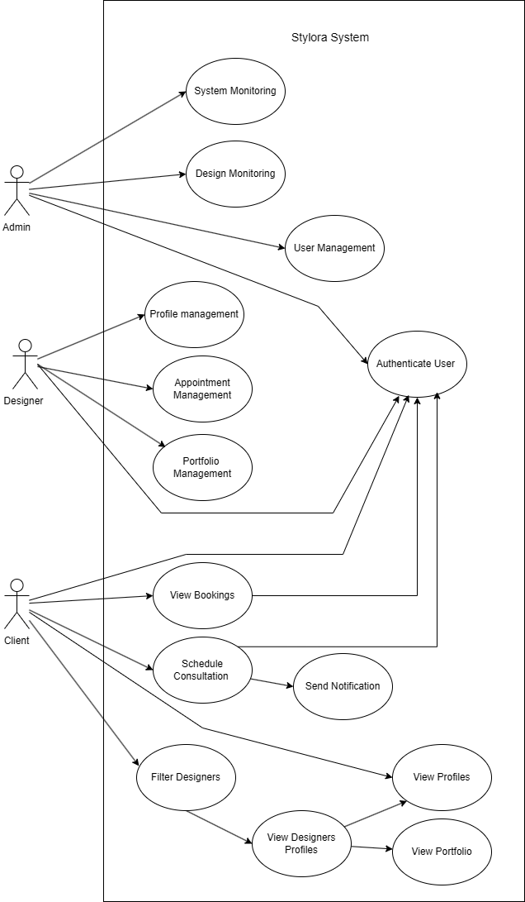
CLIENT (USER) USE CASES
Step 1 – User Registration / Login
Actor: Client
Use Case: Authenticate User
Steps:
- Client opens the Login / Register page.
- Client enters registration or login credentials.
- System validates the user credentials.
- If valid, the system authenticates the user.
- User session is created.
- Client gains access to platform features such as browsing designers and booking appointments.

Step 2 – Browse Designers
Actor: Client
Use Case: View Designer Profiles
Steps:
- Client visits the Home / Designer Listing page.
- System fetches designer profiles from the database.
- Designer portfolios are displayed.
- Client selects a designer profile.
- Detailed portfolio and project information are displayed.

Step 3 – Apply Search Filters
Actor: Client
Use Case: Filter Designers
Steps:
- Client applies filters such as design style, location, project type, or budget.
- System processes the filter request.
- Backend fetches matching designer profiles.
- Filtered designer results are displayed.
- Client selects a suitable designer.

Step 4 – View Designer Portfolio
Actor: Client
Use Case: View Portfolio
Steps:
- Client opens a designer’s profile.
- System fetches portfolio projects from database.
- Portfolio images and descriptions are displayed.
- Client reviews the designer’s work and design style.

Step 5 – Book Appointment
Actor: Client
Use Case: Schedule Consultation
Steps:
- Client clicks “Book Appointment”.
- Client selects date and time.
- System sends booking request to backend.
- Backend stores appointment details.
- Confirmation email is sent to both client and designer.

Step 6 – View Appointment History
Actor: Client
Use Case: View Bookings
Steps:
- Client opens Appointments Page.
- System fetches appointment history.
- Appointment details are displayed.

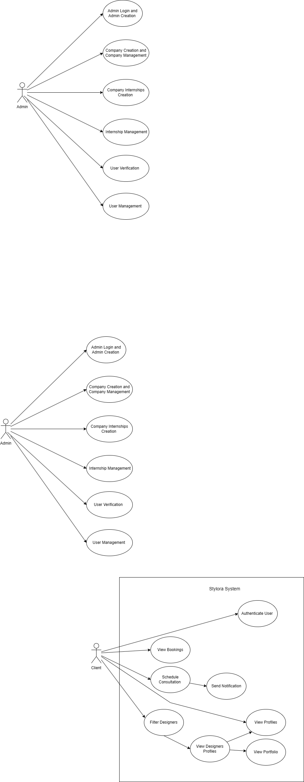
DESIGNER USE CASES
Step 1 – Designer Login
Actor: Designer
Use Case: Authenticate Designer
Steps:
- Designer logs into the platform.
- System verifies credentials.
- Designer gains access to the designer dashboard.

Step 2 – Manage Portfolio
Actor: Designer
Use Case: Portfolio Management
Steps:
- Designer uploads new project images.
- Designer adds project details and descriptions.
- Designer edits or deletes existing projects.
- Updated portfolio is saved in the database.

Step 3 – Manage Appointments
Actor: Designer
Use Case: Appointment Management
Steps:
- Designer views appointment requests.
- Designer confirms or manages consultation schedule.
- Appointment details are stored in the system.

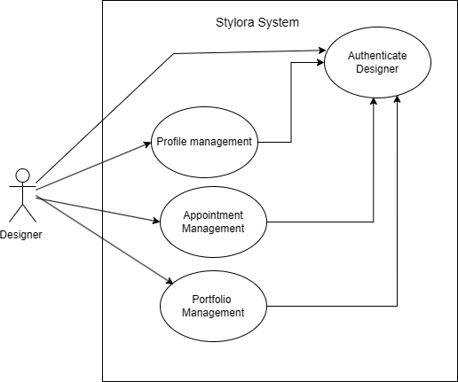

ADMIN USE CASES
Step 1 – Admin Login
Actor: Admin
Use Case: Authenticate Admin
Steps:
- Admin logs into the admin panel.
- System verifies credentials.
- Admin dashboard access is granted.

Step 2 – Manage Users
Actor: Admin
Use Case: User Management
Steps:
- Admin views all registered users.
- Admin can manage or remove accounts.
- System updates user records.

Step 3 – Monitor Designers
Actor: Admin
Use Case: Designer Monitoring
Steps:
- Admin views designer profiles.
- Admin monitors portfolios and activity.
- Admin manages categories or platform content.
Step 4 – Platform Monitoring
Actor: Admin
Use Case: System Monitoring
Steps:
- Admin views platform activity.
- Admin monitors appointments and user interactions.
- Admin ensures smooth system operation.

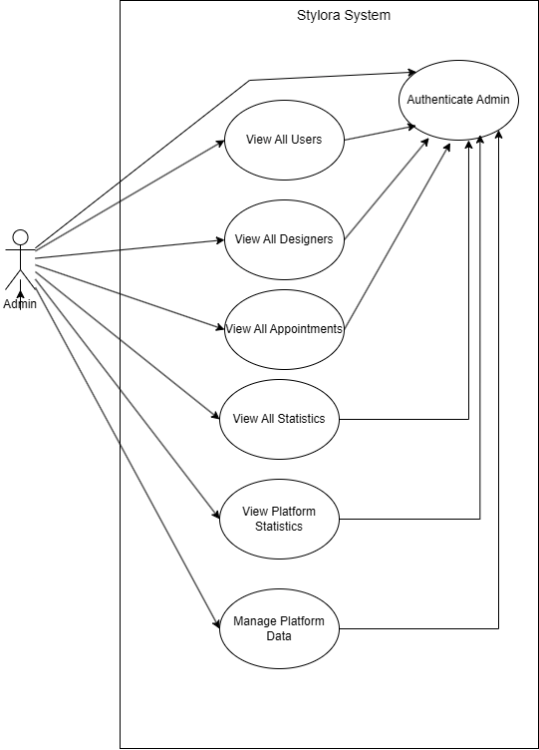
AUTHENTICATION USE CASES
Step 1 – User Login Actor: Admin, Designer, Client Use Case: Login Steps:
- Actor interacts with the platform to log in.
- The Login use case includes the "Provide Credentials" step.
- The process further includes the "Validate Credentials" step to verify the actor's identity.

Step 2 – User Registration Actor: Designer, Client Use Case: Register Steps:
- Actor interacts with the platform to create a new account.
- The Register use case includes the "Provide Credentials" step.
- The process further includes the "Validate Credentials" step to verify the new registration details.

Step 3 – Display Message Actor: Admin, Designer, Client Use Case: Display message Steps:
- The system triggers a response based on the authentication outcome
- If validation succeeds, the system processes a "Login successful" event.
- If validation fails, the system processes an "Error Message" event.
4. The resulting confirmation or error status is displayed to the actor.
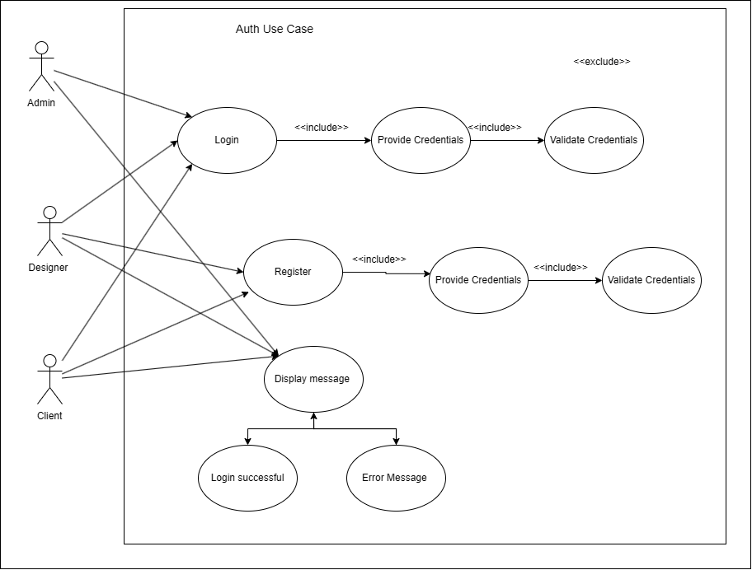
DESIGNER PORTFOLIO USE CASES
Step 1 – Manage Portfolio Actor: Designer Use Case: Portfolio Management Steps:
- Designer accesses the Portfolio Management system.
- The Portfolio Management base use case includes the specific actions to create, update, delete, or view a portfolio.
Step 2 – Create Portfolio Actor: Designer Use Case: Create Portfolio Steps:
- Designer chooses to build a new portfolio profile.
- The system initiates the portfolio creation process as part of Portfolio Management.
- Designer adds initial details, projects, or images to establish their showcase.
Step 3 – Update Portfolio Actor: Designer Use Case: Update Portfolio Steps:
- Designer selects an existing portfolio to modify.
- The system updates the details, descriptions, or imagery based on new designer input.
- The modifications are saved under the Portfolio Management umbrella.
Step 4 – Delete Portfolio Actor: Designer Use Case: Delete Portfolio Steps:
- Designer requests the removal of an existing portfolio or specific portfolio project.
- The system processes the deletion request within Portfolio Management.
- The selected portfolio data is permanently removed from the platform.
Step 5 – View Portfolio Actor: Designer, Client Use Case: View Portfolio Steps:
- Designer views the completed portfolio for quality assurance or reference.
- Client accesses and browses through the designer's published portfolio to evaluate their work.
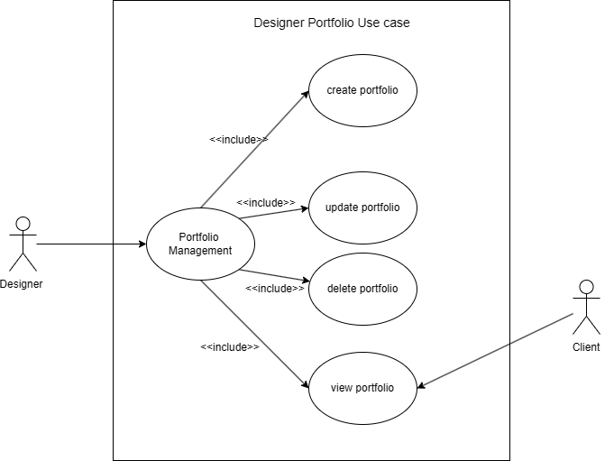
DESIGNER PROFILE USE CASES
Step 1 – Manage Profile Actor: Designer Use Case: Profile Management Steps:
- Designer accesses the Profile Management system.
- The Profile Management base use case can be extended by specific optional actions to create, update, delete, or view a profile based on user flow.
Step 2 – Create Profile Actor: Designer Use Case: Create profile Steps:
- Designer chooses to set up a new profile.
- The Profile Management use case extends into the "create profile" process.
- Designer inputs personal bio, skills, and professional details to establish their account identity.
Step 3 – Update Profile Actor: Designer Use Case: Update profile Steps:
- Designer selects their existing profile to modify current information.
- The Profile Management use case extends into the "update profile" process.
- Designer saves changes to their contact details, profile picture, or bio information.
Step 4 – Delete Profile Actor: Designer Use Case: Delete profile Steps:
- Designer requests the removal of their account or profile details.
- The Profile Management use case extends into the "delete profile" process.
- The profile data is removed or deactivated within the system database.
Step 5 – View Profile Actor: Designer, Client Use Case: View profile Steps:
- Designer views their public profile layout to verify how it looks to others.
- Client searches for or clicks on a designer's profile to read their background and contact information.
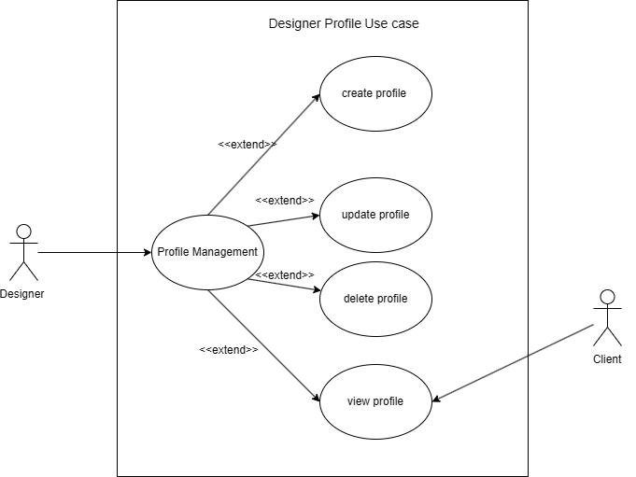
CLIENT NOTIFICATION USE CASES
Step 1 – Manage Notifications Actor: Client Use Case: Notification Management Steps:
- Client accesses the Notification Management features in the system.
- The Notification Management base use case links to actions for viewing, marking single, or marking all notifications as read.
Step 2 – View Notifications Actor: Client Use Case: view Notification Steps:
- Client interacts directly with the system to open their notification feed.
- The system retrieves and displays the unread and read alerts under Notification Management.
- Client reads the details of the incoming system updates or messages.
Step 3 – Mark Notification as Read Actor: Client Use Case: mark notification as read Steps:
- Client selects a specific unread notification to acknowledge it.
- The system changes the status of that individual notification to "read" within Notification Management.
- This action includes the "mark all notification as read" capability as an integrated system step.
Step 4 – Mark All Notifications as Read Actor: Client Use Case: mark all notification as read Steps:
- Client triggers a command to clear all alerts at once, or the system auto-includes it via individual management flows.
- The Notification Management system updates the database status for every alert associated with the client.
- All pending notification badges and unread counters are cleared simultaneously.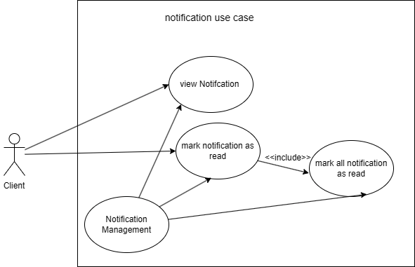

APPOINTMENT USE CASES
Step 1 – Manage Appointments Actor: Designer, Client Use Case: Appointment Management Steps:
- Actor accesses the central Appointment Management portal.
- The Appointment Management base use case can be optionally extended to accept, reject, complete, view, create, or cancel booking schedules.
Step 2 – Create Appointment Actor: Client Use Case: create appointment Steps:
- Client selects a preferred time slot to schedule a consultation with a designer.
- The system links this activity as a secondary process feeding into core Appointment Management.
Step 3 – View Appointment Actor: Designer, Client Use Case: view appointment Steps:
- Actor requests to see pending or upcoming consultation details.
- The Appointment Management base use case extends to display the requested schedule information.
Step 4 – Accept Appointment Actor: Designer Use Case: accept appointment Steps:
- Designer reviews an incoming request and selects the option to approve it.
- The primary Appointment Management flow extends into the "accept appointment" sequence.
Step 5 – Reject Appointment Actor: Designer Use Case: reject appointment Steps:
- Designer reviews an incoming request and decides to decline the booking.
- The primary Appointment Management flow extends into the "reject appointment" sequence.
Step 6 – Complete Appointment Actor: Designer Use Case: complete appointment Steps:
- Designer marks an active consultation session as finalized once the service is rendered.
- The core Appointment Management system extends to log the status update.
Step 7 – Cancel Appointment Actor: Designer, Client Use Case: Cancel appointment Steps:
- Actor requests to call off an existing booking.
- The base Appointment Management flow extends into the "Cancel appointment" process.
- To complete the cancellation, the system mandates an internal dependency step by including the "Reason" use case to collect cancellation feedback.
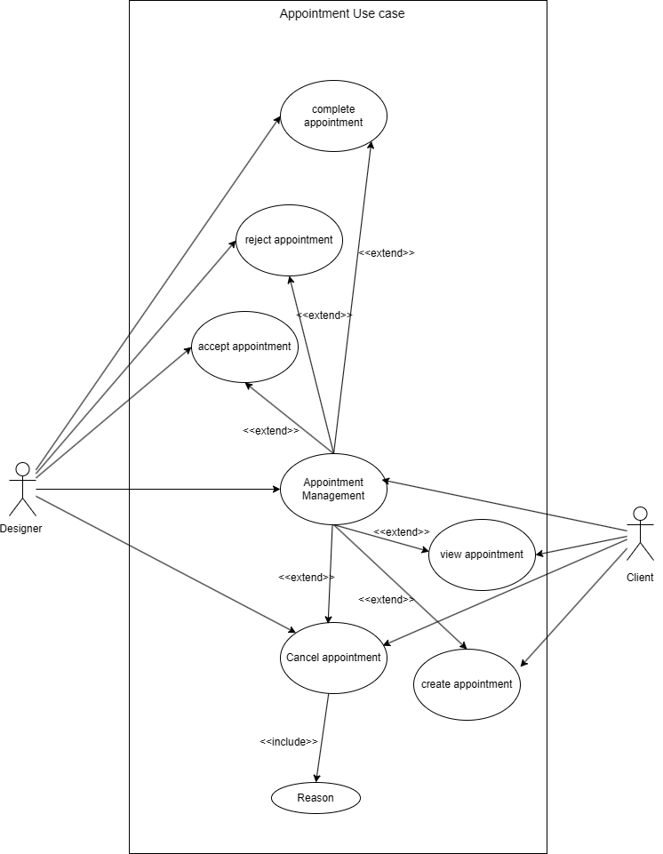

REVIEWS USE CASES
Step 1 – Create Reviews Actor: Client Use Case: create reviews Steps:
- Client interacts with the platform to submit feedback for a completed service.
- The system passes data down to update the underlying notification context or records.
Step 2 – View Reviews Actor: Designer, Client Use Case: view reviews Steps:
- Actor requests to read text-based customer testimonials on the platform.
- The system fetches and presents the data to the respective user.
Step 3 – View Ratings Actor: Client Use Case: view ratings Steps:
- Client browses through overall numerical evaluation scores or metrics on the system.
- The system generates and renders the visual scores on the screen.
Step 4 – Manage Feedback Notifications Actor: System-driven (linked implicitly to Client actions) Use Case: Notification Management Steps:
- The platform tracks updates within the system triggered by review changes.
- Notification Management interacts internally to direct users toward updating reviews, reading testimonials, or refreshing ratings.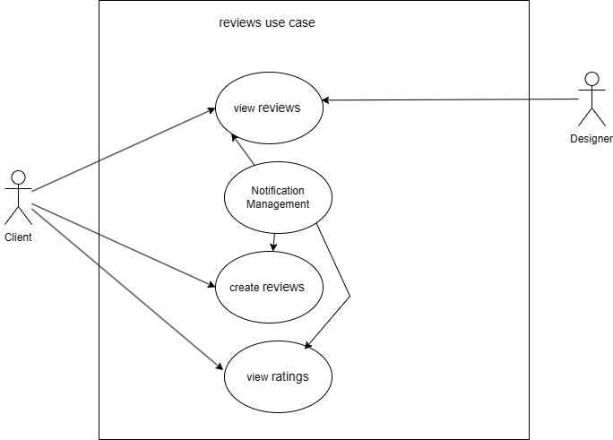
3.2 Activity Diagram 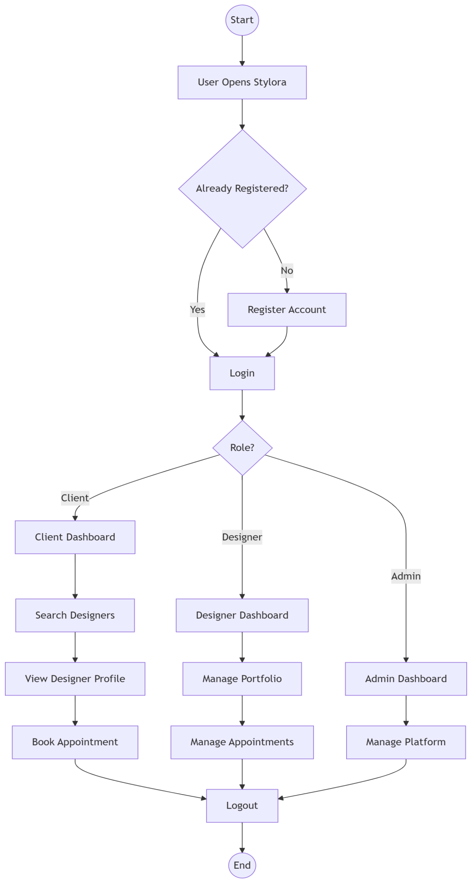

STYLORA INTEGRATED SYSTEM ACTIVITY FLOW
Swimlanes
- Users (Client / Designer / Admin)
- Frontend System
- Backend System
- Database
Activity Flow
Step 1 – Entry & Registration Check
- User opens the Stylora application.
- The application checks the local session or database to see if the user is Already Registered?.
- If No: User is directed to the Register Account module to create their credentials.
- If Yes: User bypasses registration and proceeds straight to the Login portal.
Step 2 – Authentication & Role Evaluation
1. User enters their credentials and submits the Login form.
2. The Frontend System securely transmits the payload to the Backend System.
3. The Backend System validates the credentials against the Database and evaluates the user's explicit Role?.
Step 3 – Conditional Path Routing (Based on Role)
Path A: Client
1. System routes the user to the Client Dashboard.
2. Client executes a query to Search Designers.
3. Client selects a profile to View Designer Profile.
4. Client triggers a request to Book Appointment with their chosen designer.
Path B: Designer
1. System routes the user to the Designer Dashboard.
2. Designer interacts with the platform interface to Manage Portfolio assets.
3. Designer updates availability or handles requests to Manage Appointments.
Path C: Admin
1. System routes the user to the secure Admin Dashboard.
2. Admin executes system-level operations to Manage Platform configurations, users, and data.
Step 4 – Session Termination & End
1. Regardless of the role pathway, the user terminates their active session by selecting Logout.
2. The Frontend requests session destruction, the Backend processes the teardown, and the Database clears active authentication tokens.
3. The workflow reaches the End node.

AUTHENTICATION SYSTEM ACTIVITY FLOW
Swimlanes
- User
- Frontend System
- Backend System
- Database
Activity Flow
Step 1 – Start
- Start node.
Step 2 – Input & Request Submission
1. User enters their email and password into the login interface.
2. User triggers the action to submit their login request.
3. The Frontend System captures the input and transmits it as an authentication payload to the Backend System.
Step 3 – User Existence Check
1. The Backend System queries the Database to determine if the User Exists?.
2. If No: The flow routes immediately to the failure handling sequence to show an error.
3. If Yes: The Backend System proceeds to the password verification sequence.
Step 4 – Password Validation
1. The Backend System retrieves the stored security credentials to verify the password.
2. The system evaluates: Password Correct?.
3. If No: The flow routes to the failure handling sequence.
4. If Yes: The flow routes to the successful authorization sequence.
Step 5 – Handling Authentication Outcomes
Failure Pathway (Invalid Credentials):
1. The Backend System rejects the request and instructs the frontend to handle the violation.
2. The Frontend System executes the action to Show Invalid Credentials to notify the user of the error.
Success Pathway (Authorized Access):
1. The Backend System completes verification and runs a task to Generate JWT (JSON Web Token) for the active session.
2. The Frontend System processes the secure token response, resulting in a Login Successful state.
3. The Frontend System completes the routing sequence to Redirect Dashboard, granting the user interface access.
Step 6 – End
1. End node.
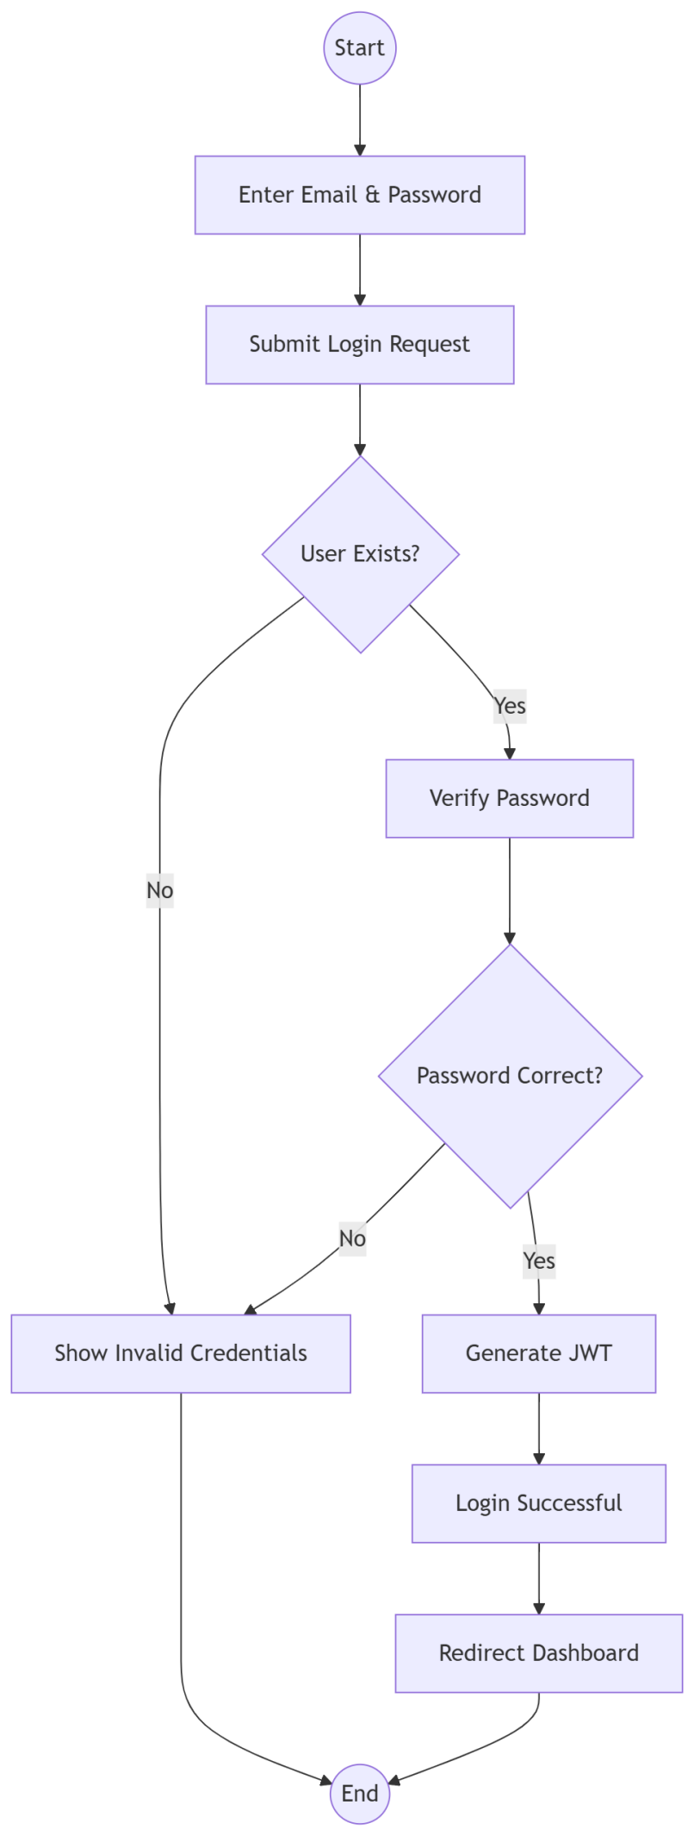

REGISTRATION SYSTEM ACTIVITY FLOW
Swimlanes
- User
- Frontend System
- Backend System
- Database
Activity Flow
Step 1 – Start
- Start node.
Step 2 – Input & Request Submission
1. User provides their required details to Fill Registration Form.
2. User triggers the action to Submit Form.
3. The Frontend System bundles the registration details and sends them as a request payload to the Backend System.
Step 3 – Validation Check
1. The Backend System runs an evaluation to check: Email Exists?.
2. If Yes: The user already has an account, and the flow routes to the failure handling path.
3. If No: The email is unique, and the system proceeds to account creation.
Step 4 – Handling Registration Outcomes
Failure Pathway (Duplicate Account):
1. The Backend System blocks the request due to the existing email conflict.
2. The Frontend System processes the rejection and triggers the action to Show Error to the user.
Success Pathway (Account Provisioning):
1. The Backend System processes the incoming plain-text password and runs an operation to Hash Password for security.
2. The Backend System saves the new record to Create User within the Database.
3. The system triggers an authorization step to Generate JWT (JSON Web Token) for the newly established user session.
4. The Frontend System registers the incoming token response and updates the UI state to Registration Successful.
Step 5 – End
1. End node.

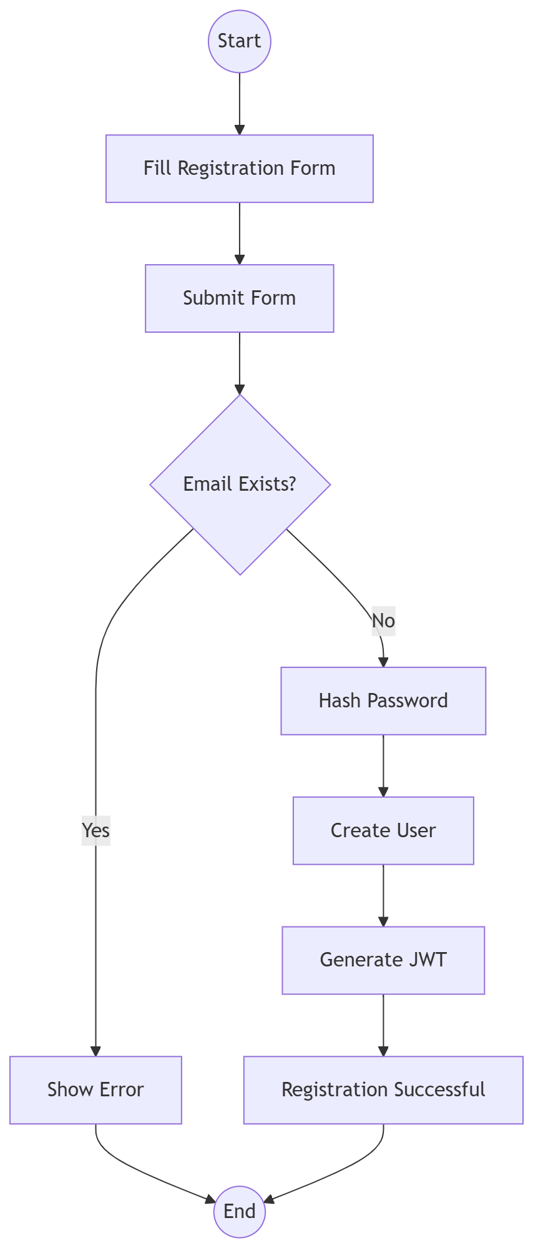

DESIGNER PROFILE SYSTEM ACTIVITY FLOW
Swimlanes
- Designer
- Frontend System
- Backend System
- Database
Activity Flow
Step 1 – Start
- Start node.
Step 2 – Input & Profile Submission
1. Designer opens the profile management interface to Open Profile Page.
2. Designer enters their personal background, expertise, and professional info to Enter Profile Details.
3. Designer adds their professional photograph or avatar path via Upload Profile Image URL. 4. Designer triggers the action to Submit Profile.
5. The Frontend System bundles all inputs and transmits the profile configuration data to the Backend System.
Step 3 – Data Validation
1. The Backend System processes the incoming request packet to Validate Data.
2. The system runs an optimization evaluation to determine: Valid?.
3. If No: The submitted metrics violate validation checks, routing the system to the failure tree.
4. If Yes: The data satisfies all system requirements, routing the system to the persistent storage tree
Step 4 – Handling Validation Outcomes
Failure Pathway (Invalid Details):
1. The Backend System rejects the payload and returns structural error indicators.
2. The Frontend System parses the incoming error objects to Show Validation Errors on the interface.
Success Pathway (Profile Persistent Storage):
1. The Backend System commits the approved metadata record to Save Profile into the Database.
2. The Database updates state registries successfully, and the Frontend System renders a Profile Created success view to the user.
Step 5 – End
1. End node.
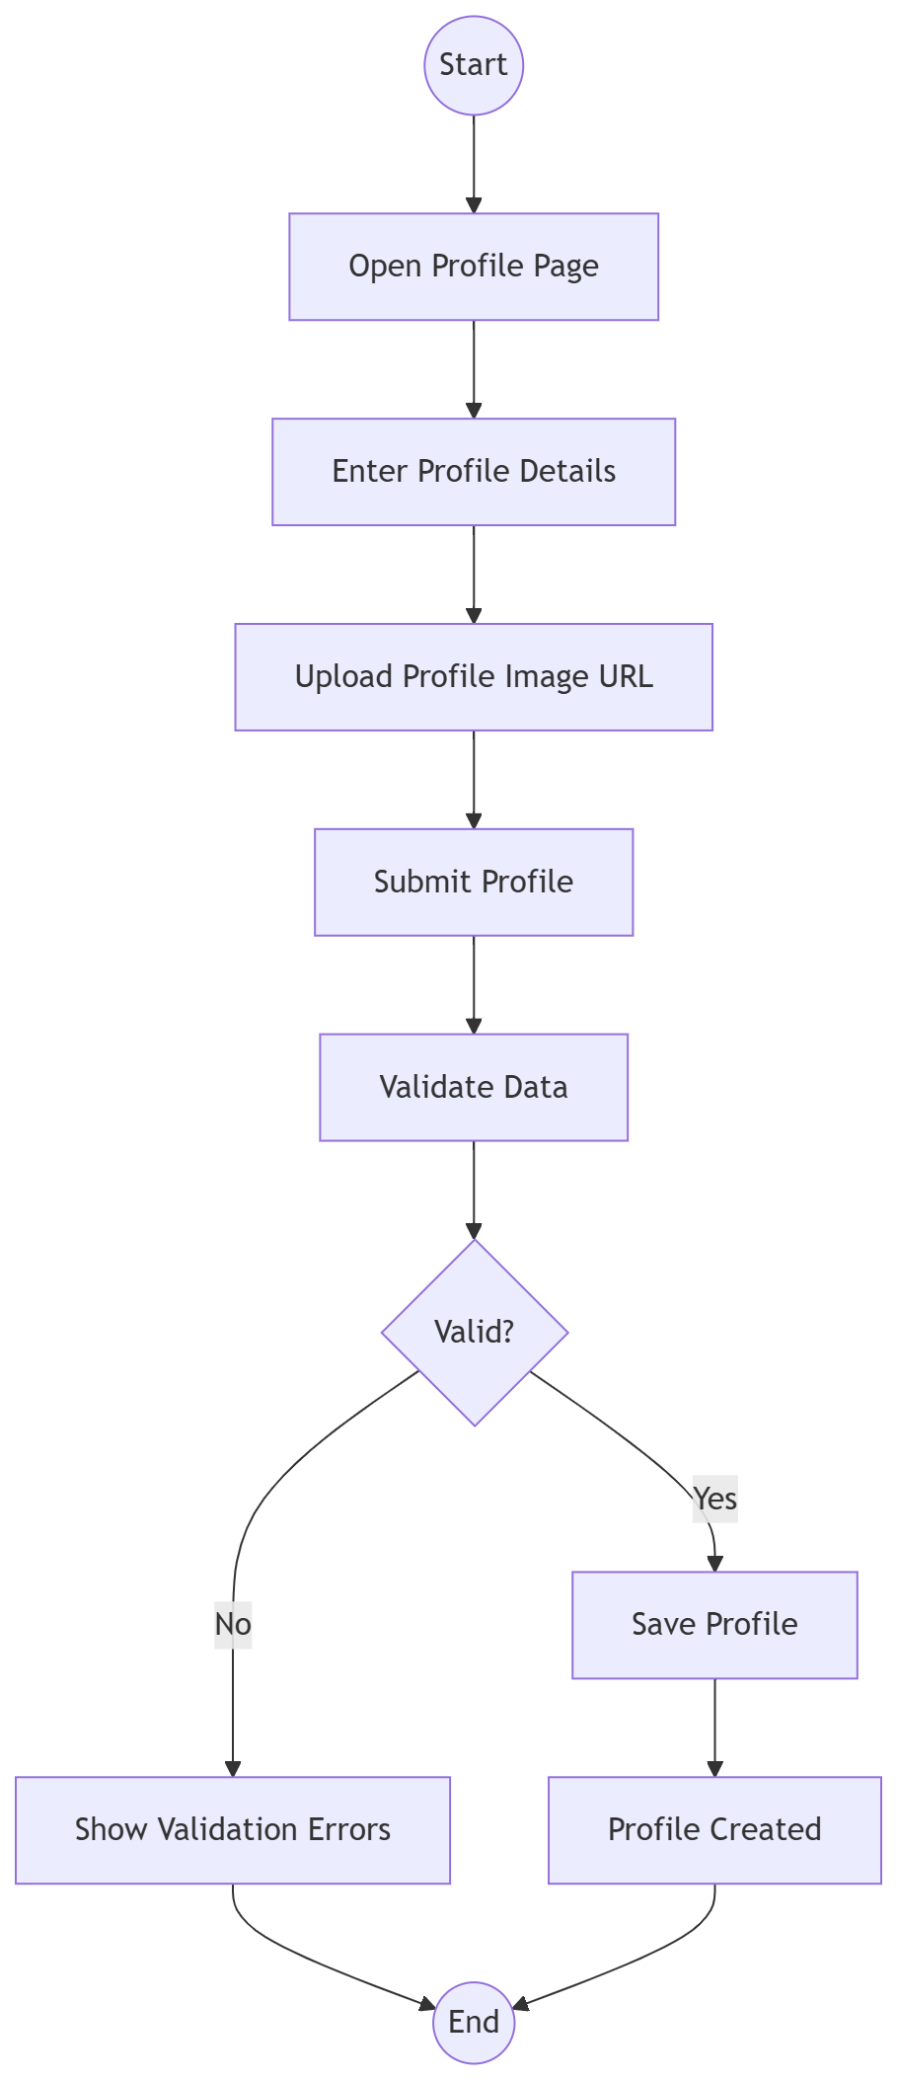

DESIGNER PORTFOLIO SYSTEM ACTIVITY FLOW
Swimlanes
- Designer
- Frontend System
- Backend System
- Database
Activity Flow
Step 1 – Start
- Start node.
Step 2 – Creation & Input Assembly
1. Designer accesses the showcase module to Open Portfolio Page.
2. Designer initiates a new creation process to Add Portfolio Item.
3. Designer attaches visual media files or assets via Upload Images.
4. Designer enters descriptions, titles, and project metrics to Enter Details.
5. Designer triggers the client-side submit command to Save Portfolio.
6. The Frontend System bundles all assets and text payloads, transmitting the request to the Backend System.
Step 3 – Integrity Validation
1. The Backend System processes the incoming request packet to verify: Valid Data?.
2. If No: The system identifies structural issues or missing fields, routing down the failure branch.
3. If Yes: The data meets all backend specifications, routing down the storage branch.
Step 4 – Handling Validation Outcomes
Failure Pathway (Data Error):
1. The Backend System rejects the payload and returns validation fault logs.
2. The Frontend System processes the failure state to Display Error messages on the user interface.
Success Pathway (Data Archival):
1. The Backend System commits the validated project items to Store Portfolio securely into the Database.
2. The Database saves the relational records successfully, updating the UI state to present a Portfolio Added confirmation to the designer.
Step 5 – End
1. End node.
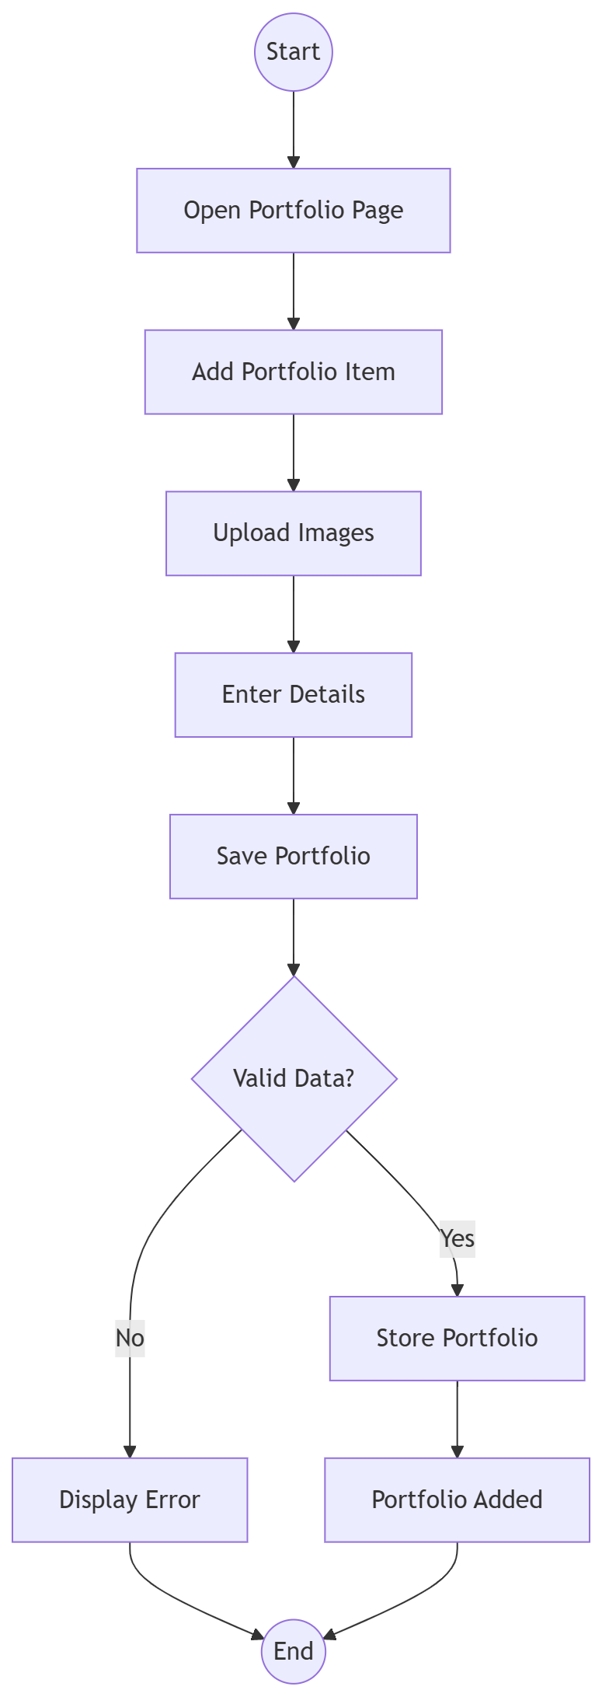

APPOINTMENT SCHEDULING SYSTEM ACTIVITY FLOW
Swimlanes
- Client
- Designer
- Frontend System
- Backend System
- Database
Activity Flow
Step 1 – Start
1. Start node.
Step 2 – Selection & Booking Request
1. Client views the profile details to Client Views Designer.
2. Client interacts with the calendar interface to Select Date & Time slots.
3. Client triggers the submission action to Book Appointment.
4. The Frontend System processes the submission and sends the initial scheduling payload to the Backend System.
Step 3 – Creation & Notification Routing
1. The Backend System handles the request and interacts with the Database to Create Appointment in a preliminary state.
2. The system triggers a message protocol to Notify Designer of the new incoming schedule request.
3. The Frontend System updates the booking registry view to show an Appointment Pending status.
Step 4 – Review & Decision Processing
1. Designer accesses their schedule panel to Designer Reviews Request.
2. The system evaluates the designer's interactive decision flag: Accept?.
3. If Yes: The flow routes down the approval branch where the system processes the request to Accept Appointment.
4. If No: The flow routes down the disapproval branch where the system processes the request to Reject Appointment.
Step 5 – Client Acknowledgment & End
1. Regardless of the decision branch, the Backend System compiles the updated status and initiates an alert sequence to Notify Client.
2. The Frontend System displays the final acceptance or rejection confirmation to the client.
3. End node.
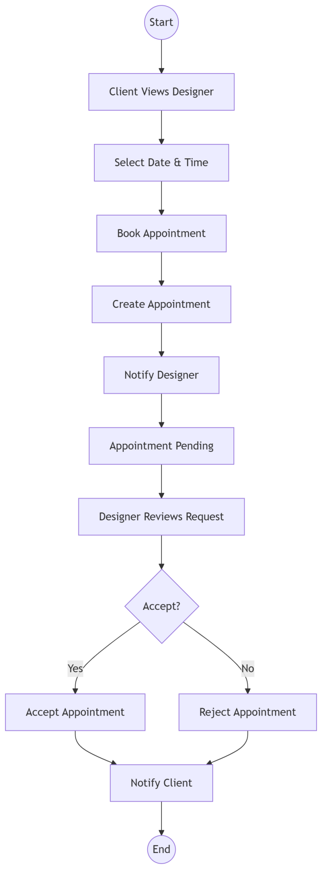

PAYMENT TRANSACTION SYSTEM ACTIVITY FLOW
Swimlanes
- Client
- Frontend System
- Backend System
- Database
Activity Flow
Step 1 – Start
1. Start node.
Step 2 – Initialization & Input Processing
1. The system fetches an Accepted Appointment record to trigger the billing lifecycle.
2. The client initiates settlement as the Client Pays Amount action on the gateway interface. 3. The Frontend System processes the transaction request to Enter Payment Amount.
Step 3 – State Updates & Data Persistence
1. The Backend System processes the secure gateway confirmation to Mark Payment Paid. 2. The Backend System runs a database routine to Update Appointment status parameters from pending to active/paid.
3. The Database saves the transaction ledger and relational booking entries securely.
Step 4 – Notification & Completion
1. The system executes an asynchronous message sequence to Notify Designer of the successful clearance.
2. The Frontend System renders a final Payment Completed dashboard state to the client.
Step 5 – End
1. End node.
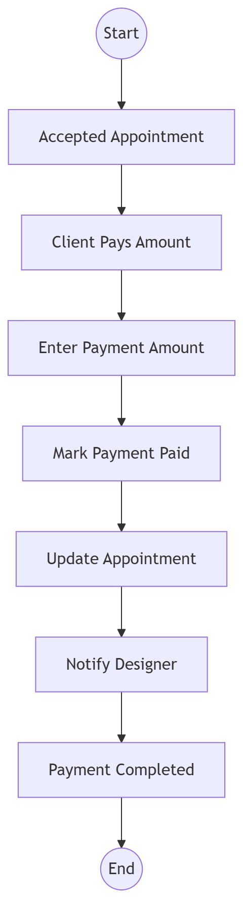

NOTIFICATION SYSTEM ACTIVITY FLOW
Swimlanes
- User
- Frontend System
- Backend System
- Database
Activity Flow
Step 1 – Start
1. Start node.
Step 2 – Event Trigger & Archival
1. An automated or user-driven System Event Occurs.
2. The Backend System runs a process to Create Notification.
3. The Backend System commits the notification object to Store Notification securely in the Database.
Step 3 – Fetching & Rendering Feed
1. The user interacts with the interface alerts icon as User Opens Notifications.
2. The Frontend System calls the backend to Fetch Notifications.
3. The Frontend System refreshes the view container to Display Notifications to the user.
Step 4 – State Update Acknowledgement
1. The user clicks on the incoming alert panel to Mark As Read.
2. The Backend System runs an asynchronous query to Update Status registries within the Database.
Step 5 – End
1. End node.

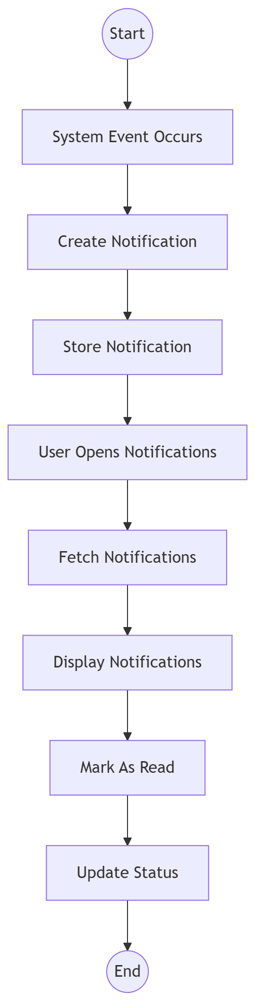

REVIEWS AND RATINGS SYSTEM ACTIVITY FLOW
Swimlanes
- Client
- Frontend System
- Backend System
- Database
Activity Flow
Step 1 – Start
1.Start node.
Step 2 – Review Input Assembly
1. The platform tracks a finalized session state as a Completed Appointment.
2. The client interacts with the completion alert as Client Opens Review Form.
3. Client chooses a metric value to Enter Rating.
4. Client types text-based feedback to Enter Comment.
5. Client triggers the submission action to Submit Review.
6. The Frontend System transmits the feedback payload to the Backend System.
Step 3 – Duplicate Submission Verification
1. The Backend System verifies against previous relational records: Already Reviewed?.
2. If Yes: The request violates validation parameters, routing down the error pathway.
3. If No: The feedback entry is clean and unique, routing down the entry pipeline.
Step 4 – Handling Validation Outcomes
Failure Pathway (Duplicate Entry):
1. The Backend System rejects the duplicate feedback payload.
2. The Frontend System displays an alert window to Show Error.
Success Pathway (Feedback Processing):
1. The Backend System commits the fresh metadata entry to Save Review into the Database.
2. The system executes an alert dispatch to Notify Designer of new feedback.
3. The Backend System recalculates the designer's overall score parameters to Update Rating Stats in the Database.
Step 5 – End
1. End node.

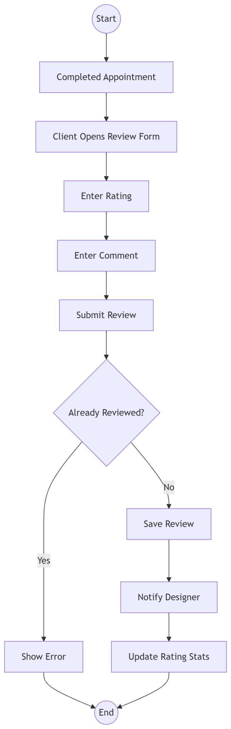

ADMINISTRATIVE PLATFORM SYSTEM ACTIVITY FLOW
Swimlanes
- Admin
- Frontend System
- Backend System
- Database
Activity Flow
Step 1 – Start
1. Start node.
Step 2 – Authentication & Dashboard Entry
1. Admin logs into the system via Admin Login.
2. Upon validation, the Frontend System triggers the command to Open Dashboard.
Step 3 – Data Aggregation
1. The Backend System queries the Database to Fetch Users.
2. The Backend System queries the Database to Fetch Designers.
3. The Backend System queries the Database to Fetch Appointments.
4. The Backend System queries the Database to Fetch Reviews.
Step 4 – Statistics Generation & Reporting
1. The Backend System processes the collected operational records to Generate Platform Statistics.
2. The Frontend System renders the compiled graphical analytics to Display Reports.
Step 5 – End
1. End node.

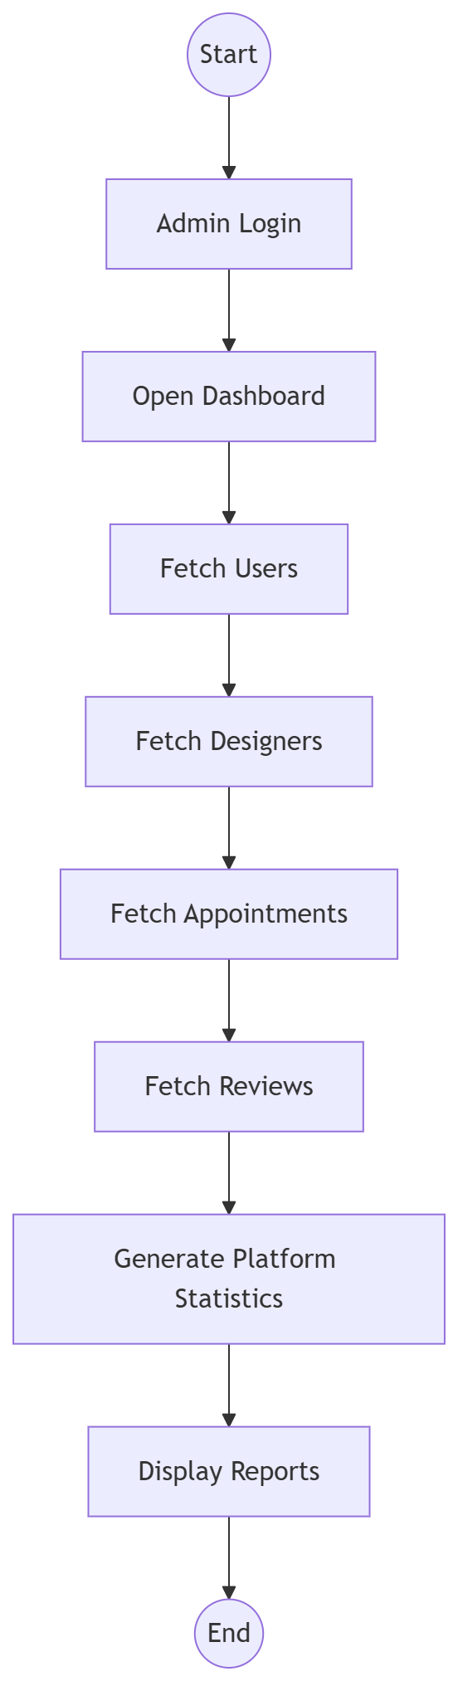

3.3 Sequence Diagram
STYLORA SYSTEM SEQUENCE DIAGRAM
Actors / Lifelines
- Client
- Designer
- Admin
- Frontend
- AuthAPI
- DesignerAPI
- PortfolioAPI
- AppointmentAPI
- ReviewAPI
- NotificationAPI
- DashboardAPI
- AdminAPI
- MongoDB
Sequence Steps
Step 1 – Register / Login
1. Client, Designer, or Admin triggers the Register / Login action on the Frontend.
2. Frontend sends a POST /register or /login request to AuthAPI.
3. AuthAPI executes a Create/Validate User operation with MongoDB.
4. MongoDB returns User Data back to AuthAPI.
5. AuthAPI returns a JWT Token to the Frontend.
Step 2 – Search Designers
1. Client triggers the Search Designers action on the Frontend.
2. Frontend sends a GET /designers request to DesignerAPI.
3. DesignerAPI issues a Fetch Designers call to MongoDB.
4. MongoDB returns Designer Data to DesignerAPI.
5. DesignerAPI returns a Designer List response to the Frontend.
Step 3 – View Designer Profile
1. Client triggers the View Designer Profile action on the Frontend.
2. Frontend sends a GET /designer/:id request to DesignerAPI.
3. DesignerAPI issues a Fetch Profile call to MongoDB.
4. MongoDB returns Profile Data to DesignerAPI.
5. DesignerAPI returns the Profile payload back to the Frontend.
Step 4 – Manage Portfolio
1. Designer triggers the Manage Portfolio action on the Frontend.
2. Frontend sends a Create/Update Portfolio message to PortfolioAPI.
3. PortfolioAPI executes a Save Portfolio action in MongoDB.
4. MongoDB returns a Success confirmation to PortfolioAPI.
5. PortfolioAPI returns a Response back to the Frontend.
Step 5 – Book Appointment
1. Client triggers the Book Appointment action on the Frontend.
2. Frontend sends a POST /appointment request to AppointmentAPI.
3. AppointmentAPI saves the transaction details using Save Appointment in MongoDB.
4. AppointmentAPI issues a Create Notification command to NotificationAPI.
5. NotificationAPI saves the alert record using Save Notification in MongoDB.
6. AppointmentAPI passes an Appointment Created confirmation back to the Frontend.
Step 6 – Accept Appointment
1. Designer triggers the Accept Appointment action on the Frontend.
2. Frontend sends an Update Status request to AppointmentAPI.
3. AppointmentAPI updates the database state via Update Appointment in MongoDB.
4. AppointmentAPI issues a Notify Client command to NotificationAPI.
5. NotificationAPI saves the client alert record using Save Notification in MongoDB.
6. AppointmentAPI returns an Accepted notification response to the Frontend.
Step 7 – Mark Payment Paid
1. Client triggers the Mark Payment Paid action on the Frontend.
2. Frontend sends an Update Payment Status request to AppointmentAPI.
3. AppointmentAPI writes the transaction update using Update Payment in MongoDB.
4. AppointmentAPI issues a Notify Designer command to NotificationAPI.
5. NotificationAPI saves the designer alert record using Save Notification in MongoDB.
6. AppointmentAPI returns a Payment Updated confirmation back to the Frontend.
Step 8 – Submit Review
1. Client triggers the Submit Review action on the Frontend.
2. Frontend routes a Create Review message to ReviewAPI.
3. ReviewAPI writes the feedback log using Save Review in MongoDB.
4. ReviewAPI issues a Notify Designer command to NotificationAPI.
5. NotificationAPI saves the alert using Save Notification in MongoDB.
6. ReviewAPI returns a Review Created message back to the Frontend.
Step 9 – View Dashboard
1. Designer or Client triggers the View Dashboard action on the Frontend.
2. Frontend issues a Get Metrics call to DashboardAPI.
3. DashboardAPI instructs MongoDB to Aggregate Data.
4. MongoDB compiles and feeds the Statistics back to DashboardAPI.
5. DashboardAPI returns the compiled Dashboard Data view to the Frontend.
Step 10 – Manage Platform
1. Admin triggers the Manage Platform action on the Frontend.
2. Frontend passes Admin Requests downstream to AdminAPI.
3. AdminAPI performs structural system adjustments via CRUD Operations directly in MongoDB.
4. MongoDB streams structural Results back to AdminAPI.
5. AdminAPI sends the system Response back to the Frontend.
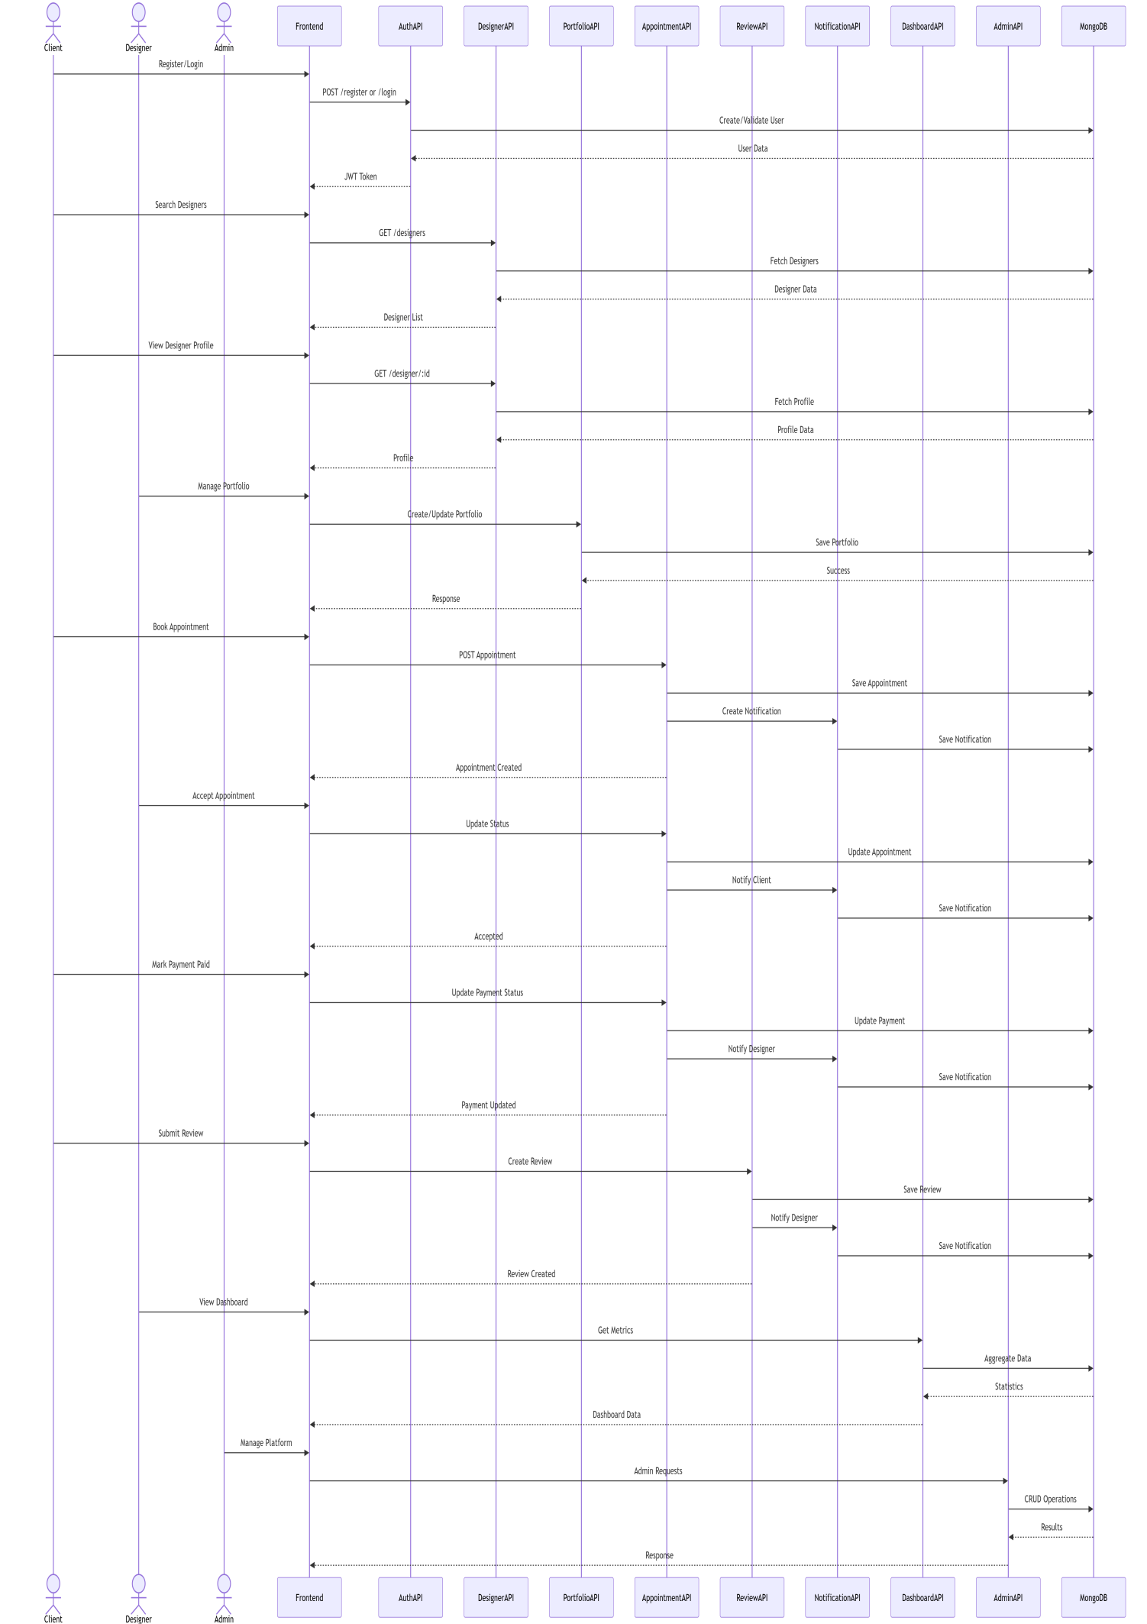

ADMINISTRATIVE SYSTEM INTERACTION
Actors / Lifelines
- Admin
- Frontend
- AdminController
- MongoDB
Sequence Steps: Manage Platform
Step 1 – Initiate Access
- Admin clicks "Open Admin Panel" on the UI.
- Frontend sends an Admin Request to the AdminController.
Step 2 – Data Collection
1. AdminController requests core information using Fetch System Data from MongoDB.
2. MongoDB returns Results back to the AdminController.
Step 3 – Completion
1. AdminController sends a Response payload back to the Frontend.

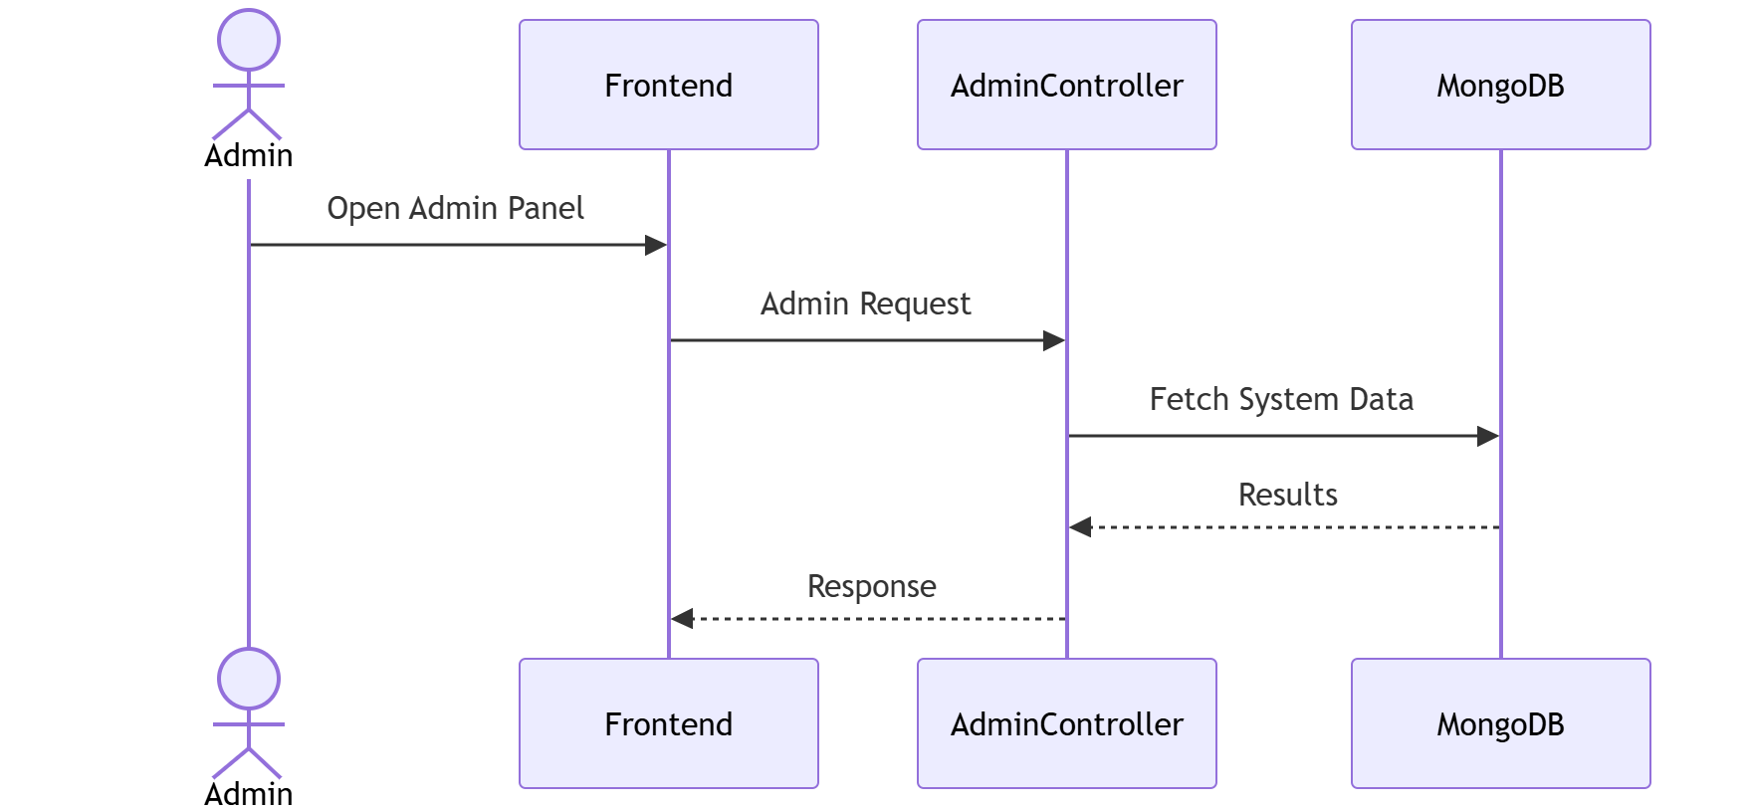

METRICS DASHBOARD SYSTEM INTERACTION
Actors / Lifelines
- Designer
- Frontend
- DashboardController
- MongoDB
Sequence Steps: View Dashboard
Step 1 – Initiate Access
- Designer clicks "Open Dashboard" on the UI.
- Frontend sends a Get Dashboard request to the DashboardController.
Step 2 – Data Aggregation
1. DashboardController initiates an Aggregate Metrics call to MongoDB.
2. MongoDB compiles the analytics and returns Statistics back to the DashboardController.
Step 3 – Completion
1. DashboardController sends the compiled Dashboard Data response back to the Frontend.

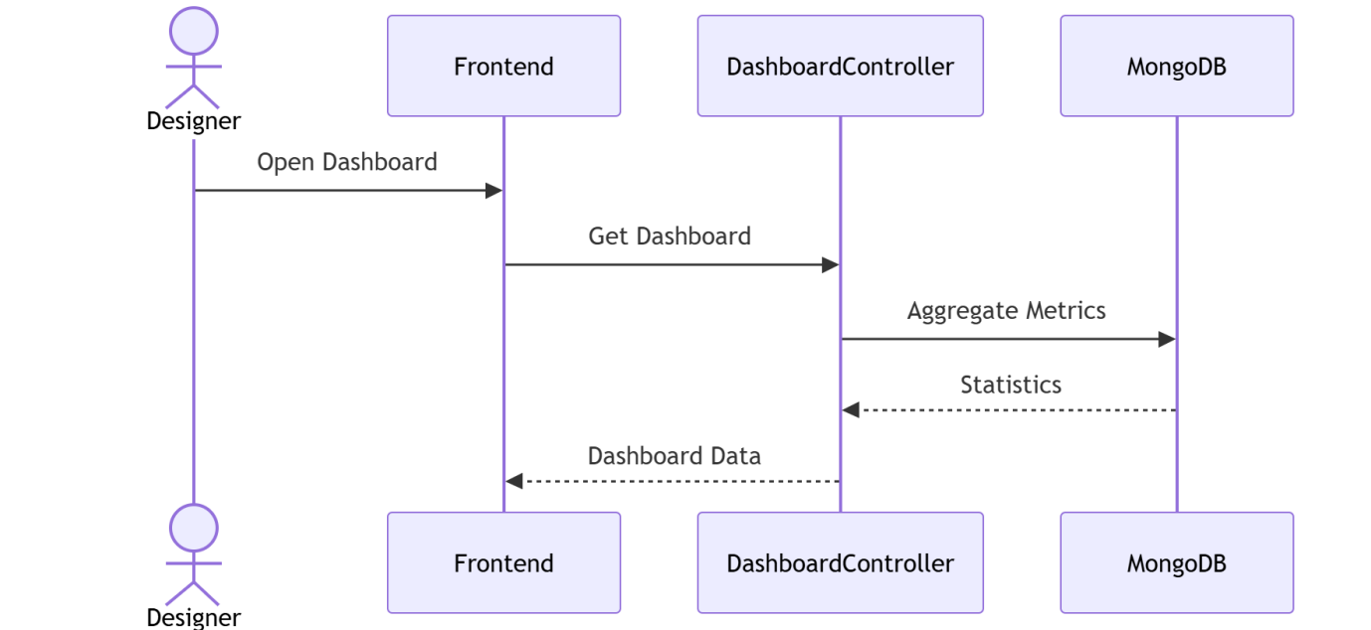

NOTIFICATION SYSTEM INTERACTION
Actors / Lifelines
- User
- Frontend
- NotificationController
- MongoDB
Sequence Steps: Manage Notifications
Step 1 – Fetch Notification Feed
- User clicks "Open Notifications" on the UI.
- Frontend sends a GET Notifications request to the NotificationController.
- NotificationController triggers a Fetch Notifications database query to MongoDB.
- MongoDB returns a Notification List payload back to the NotificationController.
- NotificationController sends the structured Notifications array back to the Frontend.
Step 2 – Acknowledgment Update
1. User clicks "Mark Read" on the UI panel.
2. Frontend sends a PUT Read All request to the NotificationController.
3. NotificationController pushes an Update Notifications query to MongoDB.
Step 3 – Completion
1. NotificationController returns a Success confirmation back to the Frontend.

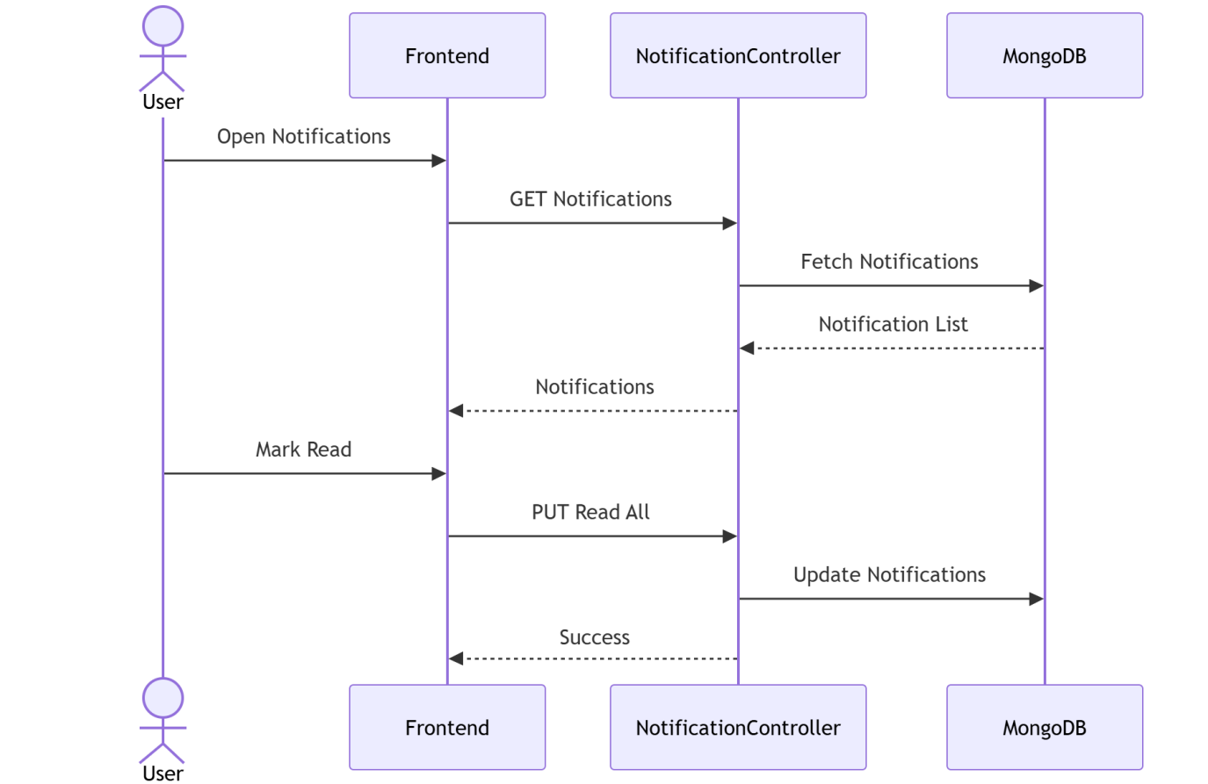

REVIEWS AND RATINGS SYSTEM INTERACTION
Actors / Lifelines
- Client
- Frontend
- ReviewController
- NotificationController
- MongoDB
Sequence Steps: Submit Review
Step 1 – Initiate Feedback Submission
- Client clicks "Submit Review" on the UI.
- Frontend sends a POST Review request payload to the ReviewController.
Step 2 – Integrity Validation & Storage
1. ReviewController sends a Validate Appointment query to MongoDB to verify session eligibility.
2. ReviewController executes a Save Review operation directly into MongoDB.
Step 3 – Notification Routing
1. ReviewController forwards a Notify Designer event trigger to the NotificationController.
2. NotificationController commits the persistent alert entry using Save Notification in MongoDB.
Step 4 – Completion
1. ReviewController sends a Review Added confirmation response back to the Frontend.

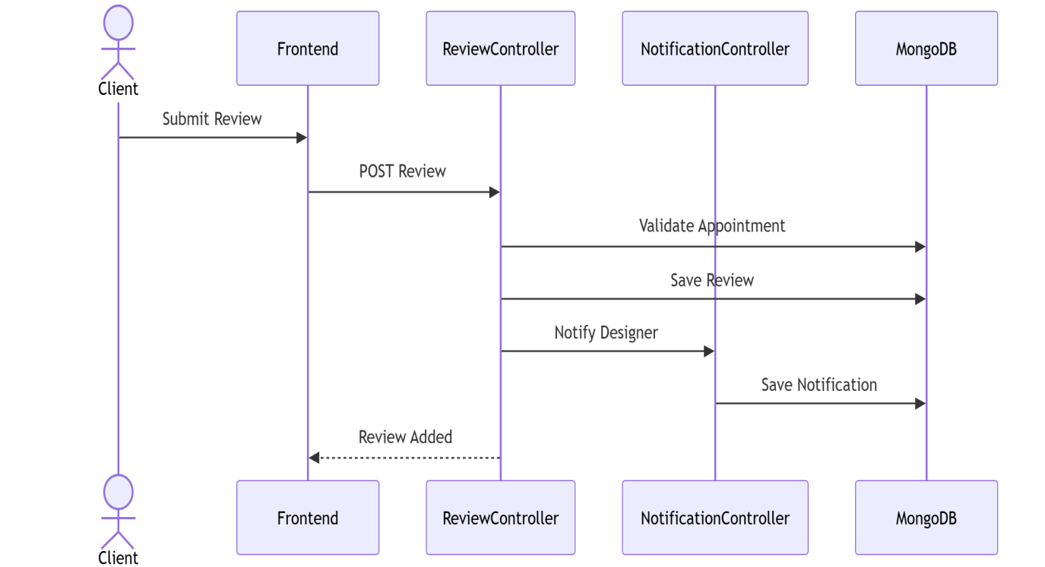

PAYMENT TRACKING SYSTEM INTERACTION
Actors / Lifelines
- Client
- Designer
- Frontend
- AppointmentController
- NotificationController
- MongoDB
Sequence Steps: Mark Payment Paid
Step 1 – Initiate Clearance Entry
- Client clicks "Mark Payment Paid" on the UI.
- Frontend dispatches an Update Payment tracking request to the AppointmentController.
Step 2 – State Persistence & Alerts
1. AppointmentController updates transaction metadata using Save Payment Status in MongoDB.
2. AppointmentController triggers a Notify Designer message packet to the NotificationController.
3. NotificationController registers the persistent data log via Save Notification in MongoDB.
Step 3 – Completion
1. AppointmentController sends a Success response back to the Frontend.

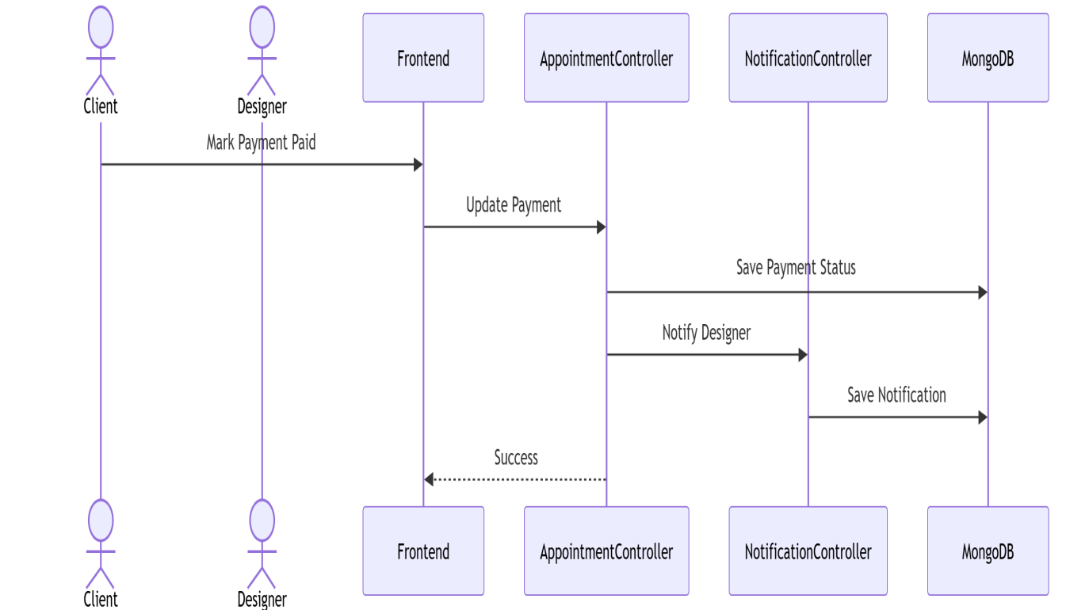

APPOINTMENT BOOKING SYSTEM INTERACTION
Actors / Lifelines
- Client
- Designer
- Frontend
- AppointmentController
- NotificationController
- MongoDB
Sequence Steps: Book & Process Appointment
Step 1 – Initiate Booking Request
- Client clicks "Book Appointment" on the UI.
- Frontend sends a Create Appointment transaction packet to the AppointmentController.
- AppointmentController commits the initial schedule record using Save Appointment in MongoDB.
- AppointmentController drops an alert event to Notify Designer inside the NotificationController.
- NotificationController writes the document ledger using Save Notification in MongoDB.
- AppointmentController returns an Appointment Created state acknowledgement to the Frontend.
Step 2 – Provider Review Approval
1. Designer clicks "Accept Appointment" on the UI dashboard interface.
2. Frontend sends an Update Status execution command to the AppointmentController.
3. AppointmentController alters system state constraints via Update Appointment in MongoDB.
4. AppointmentController registers a Notify Client instruction with the NotificationController.
5. NotificationController logs the update query using Save Notification in MongoDB.
Step 3 – Completion
1. AppointmentController issues an Accepted status response callback to the Frontend.

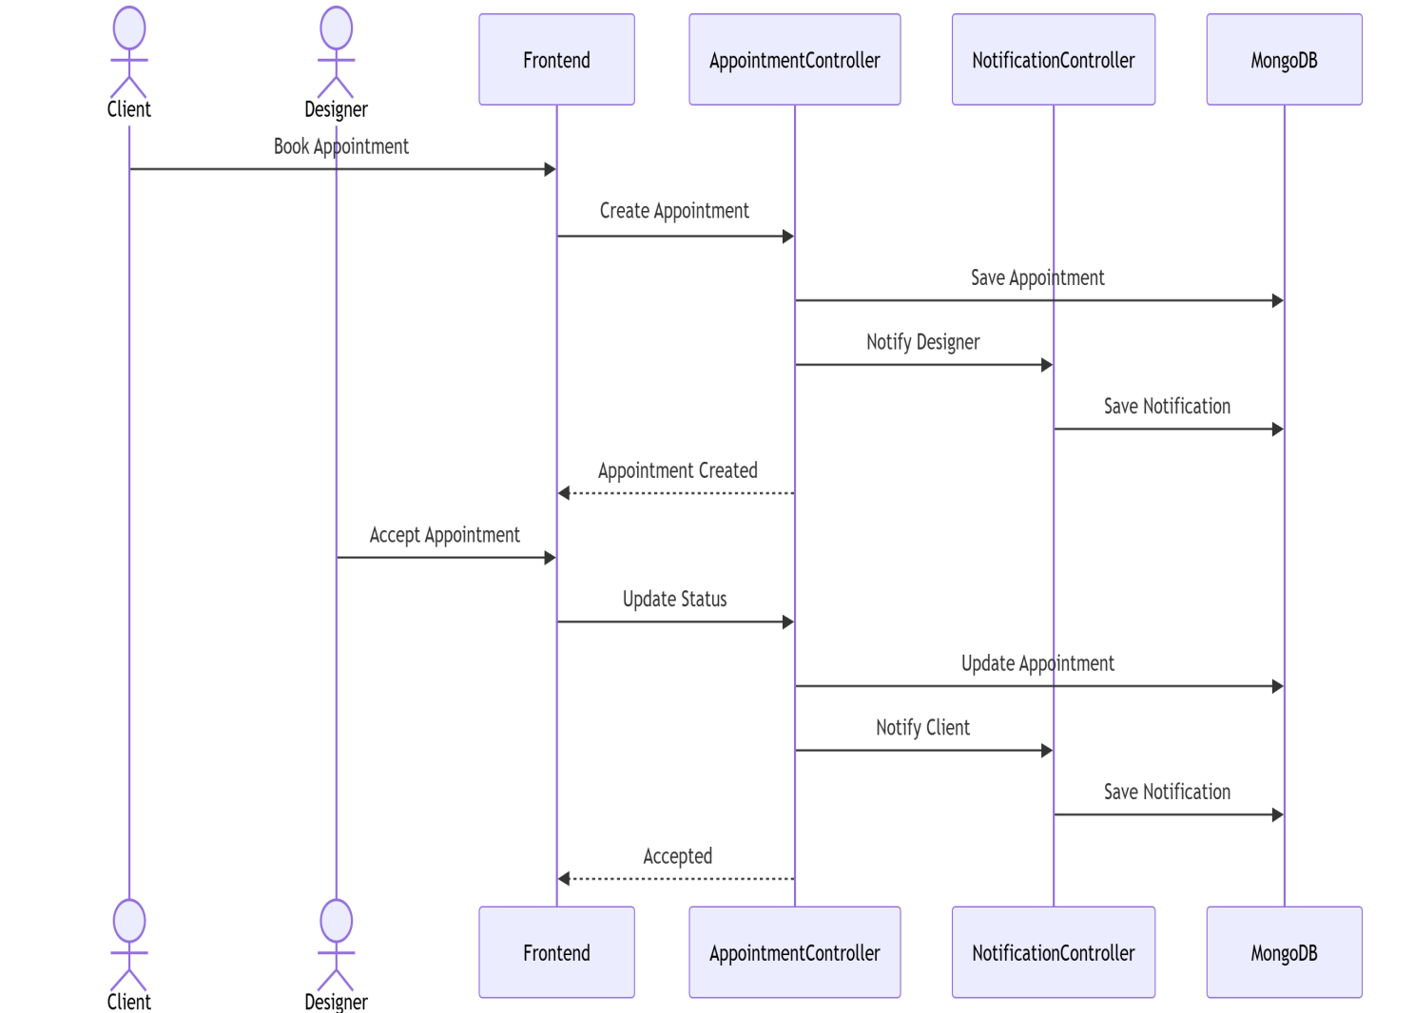

DESIGNER PORTFOLIO MANAGEMENT SYSTEM INTERACTION
Actors / Lifelines
- Designer
- Frontend
- PortfolioController
- Portfolio
- MongoDB
Sequence Steps: Add Portfolio Item
Step 1 – Content Dispatch
- Designer clicks "Add Portfolio" on the UI.
- Frontend issues a POST Portfolio multipart request body to the PortfolioController.
Step 2 – Logic Mapping & Data Storage
1. PortfolioController forwards parameter properties via a Create call to the internal Portfolio sub-module.
2. The Portfolio module securely commits the data records using Save in MongoDB.
3. MongoDB streams back a Success confirmation callback message to the Portfolio module.
Step 3 – Completion
1. PortfolioController transfers a Portfolio Created resolution state response back to the Frontend.

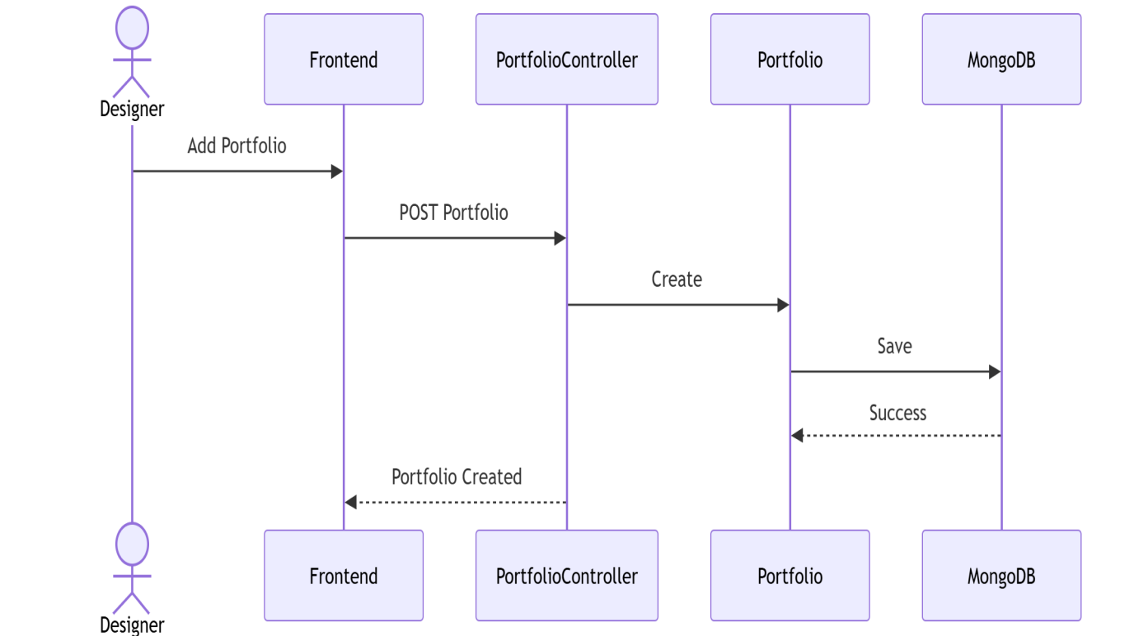

DESIGNER PROFILE MANAGEMENT SYSTEM INTERACTION
Actors / Lifelines
- Designer
- Frontend
- DesignerController
- DesignerProfile
- MongoDB
Sequence Steps: Update Profile
Step 1 – Information Update Dispatch
- Designer clicks "Update Profile" on the UI configuration screen.
- Frontend passes a PUT Profile request modification body to the DesignerController.
Step 2 – Record Update Processing
1. DesignerController transfers parameter criteria via Update Data directly into the DesignerProfile module instance.
2. The DesignerProfile system executes a Save operations statement targeting MongoDB.
3. MongoDB responds with a Success completion state signal to the DesignerProfile engine.
Step 3 – Completion
1. DesignerController relays an Updated Profile response packet structure back to the Frontend view layout.

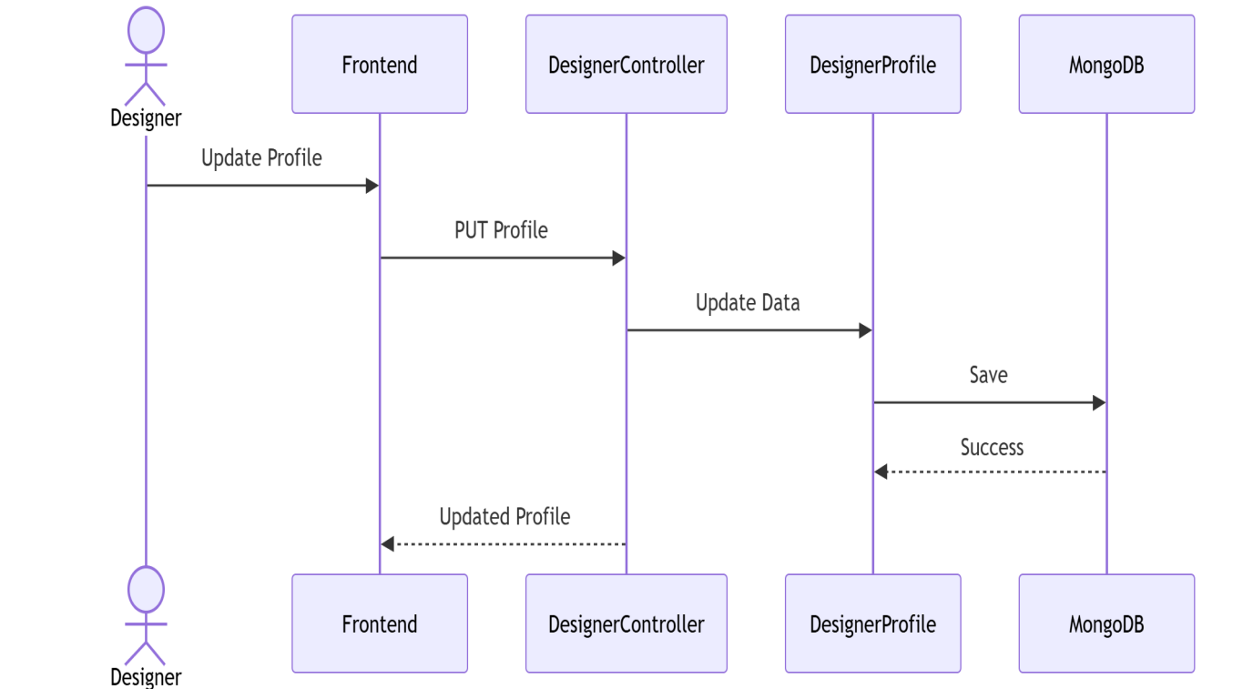

AUTHENTICATION SYSTEM INTERACTION
Actors / Lifelines
- User
- Frontend
- AuthController
- UserModel
- MongoDB
- JWT
Sequence Steps: Register / Login
Step 1 – Initiate Identity Check
- User enters data and submits a "Register/Login" event block from the UI interface.
- Frontend packages details and routes a Request object downstream to the AuthController.
Step 2 – Account Verification Check
1. AuthController passes core identity properties using Check/Create User to the structural UserModel schema component.
2. UserModel processes authentication properties via a Query User database transaction request against MongoDB.
3. MongoDB provides identity validation metadata back as a Result dataset array directly to the UserModel layer.
Step 3 – Token Generation Routine
1. AuthController calls the token service engine to Generate Token against the JWT interface. 2. The JWT processing engine mints a credential string and returns the JWT Token block to the AuthController.
Step 4 – Completion
1. AuthController transmits the bundled User + Token dataset callback straight back to the Frontend layout view handler.
2. Frontend sets session status properties and displays a Success completion greeting view block to the User.

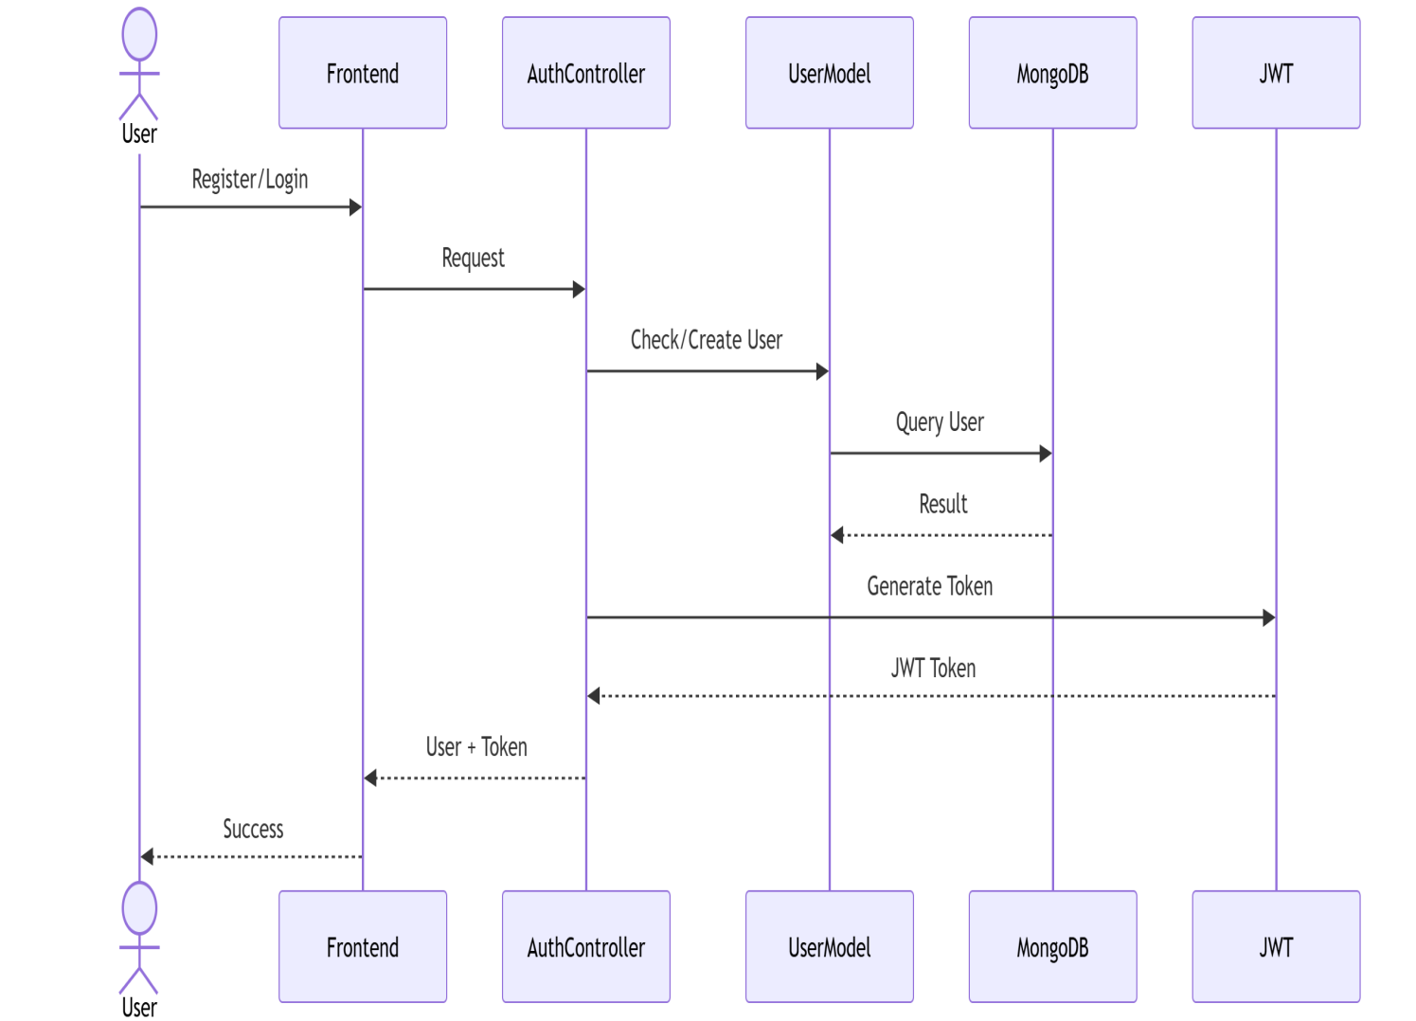
3.4 Class Diagram

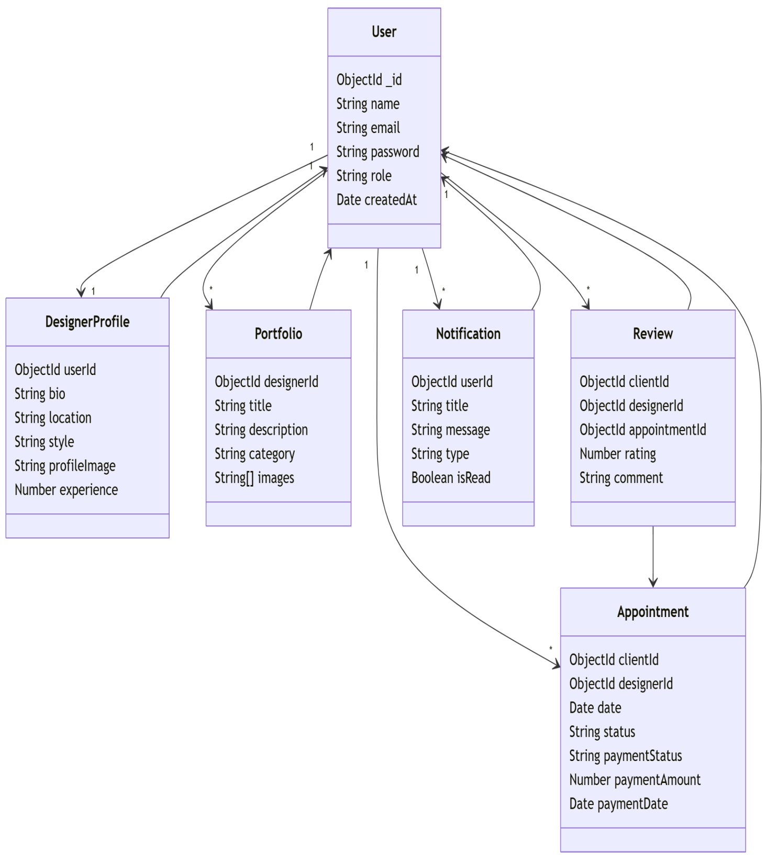

3.5 System Hierarchy Diagram

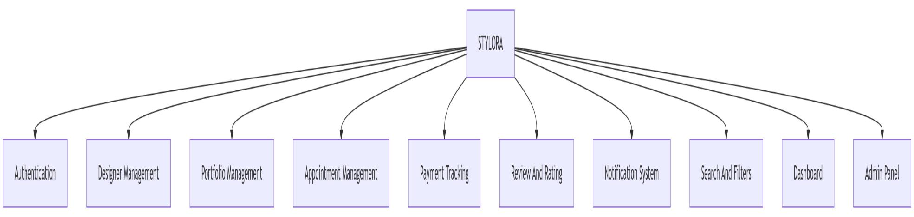

3.6 Entity Relationship Diagram (ERD)

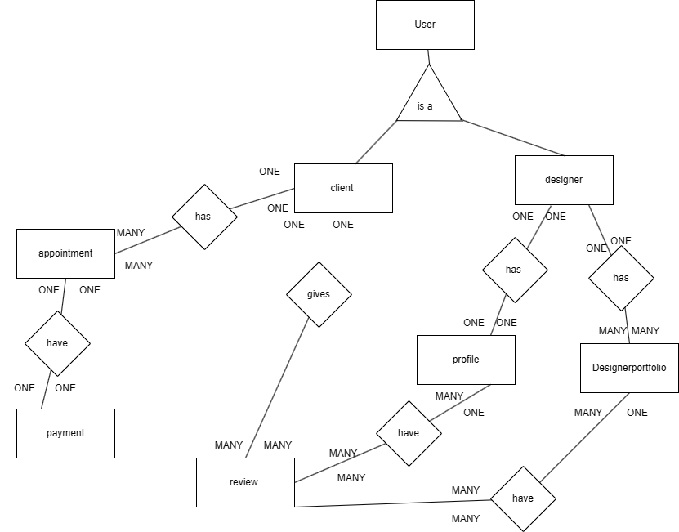

3.7 Table Specifications (Database Design)
Below is the Table Specification and Data Dictionary adapted for your Stylora project (Interior Designer Portfolio Platform). The structure is kept similar to your example format, but the tables reflect your actual system modules, such as Users, Designers, Portfolios, Appointments, and Admin.
1. User Table
Field | Type | Description
id | Integer | Primary Key
name | Varchar | Name of the user
email | Varchar | Unique email address
password | Varchar | Encrypted password
role | Varchar | User role (client/designer/admin)
phone | Varchar | Contact number
created_at | DateTime | Account creation date

2. Designer Profile Table
Field | Type | Description
id | Integer | Primary Key
user_id | Integer | Foreign Key referencing User
specialization | Varchar | Designer specialization
experience | Integer | Years of experience
location | Varchar | Designer location
portfolio_description | Text | Designer introduction

3. Portfolio Table
Field | Type | Description
id | Integer | Primary Key
designer_id | Integer | Foreign Key referencing Designer
project_title | Varchar | Title of the project
project_description | Text | Description of design project
image_url | Varchar | Project image path
category | Varchar | Type of design (modern, minimal, luxury)
created_at | DateTime | Date of project upload

4. Appointment Table
Field | Type | Description
id | Integer | Primary Key
client_id | Integer | Foreign Key referencing User
designer_id | Integer | Foreign Key referencing Designer
appointment_date | Date | Consultation date
appointment_time | Time | Consultation time
status | Varchar | Appointment status (pending/confirmed/cancelled)
created_at | DateTime | Booking timestamp

5. Admin Table
Field | Type | Description
id | Integer | Primary Key
username | Varchar | Admin username
email | Varchar | Admin email
password | Varchar | Encrypted password
role | Varchar | Admin role

3.8 Data Dictionary
Field Name | Data Type | Constraints | Table Name
id | Integer | Primary Key, Auto Increment | User
name | Varchar | Required | User
email | Varchar | Unique, Required | User
password | Varchar | Required, Encrypted | User
role | Varchar | Enum (client, designer, admin) | User
phone | Varchar | Optional | User
created_at | DateTime | Auto generated | User
id | Integer | Primary Key | Designer_Profile
user_id | Integer | Foreign Key → User | Designer_Profile
specialization | Varchar | Optional | Designer_Profile
experience | Integer | Optional | Designer_Profile
location | Varchar | Optional | Designer_Profile
portfolio_description | Text | Optional | Designer_Profile
id | Integer | Primary Key | Portfolio
designer_id | Integer | Foreign Key → Designer_Profile | Portfolio
project_title | Varchar | Required | Portfolio
project_description | Text | Required | Portfolio
image_url | Varchar | Required | Portfolio
category | Varchar | Optional | Portfolio
created_at | DateTime | Auto generated | Portfolio
id | Integer | Primary Key | Appointment
client_id | Integer | Foreign Key → User | Appointment
designer_id | Integer | Foreign Key → Designer_Profile | Appointment
appointment_date | Date | Required | Appointment
appointment_time | Time | Required | Appointment
status | Varchar | Enum (pending, confirmed, cancelled) | Appointment
created_at | DateTime | Auto generated | Appointment
id | Integer | Primary Key | Admin
username | Varchar | Required | Admin
email | Varchar | Unique | Admin
password | Varchar | Required, Encrypted | Admin
role | Varchar | Enum (admin) | Admin

CHAPTER 4: USER MANUAL
4.1 User Interface Screens Input and Output Screens with data
Landing Page

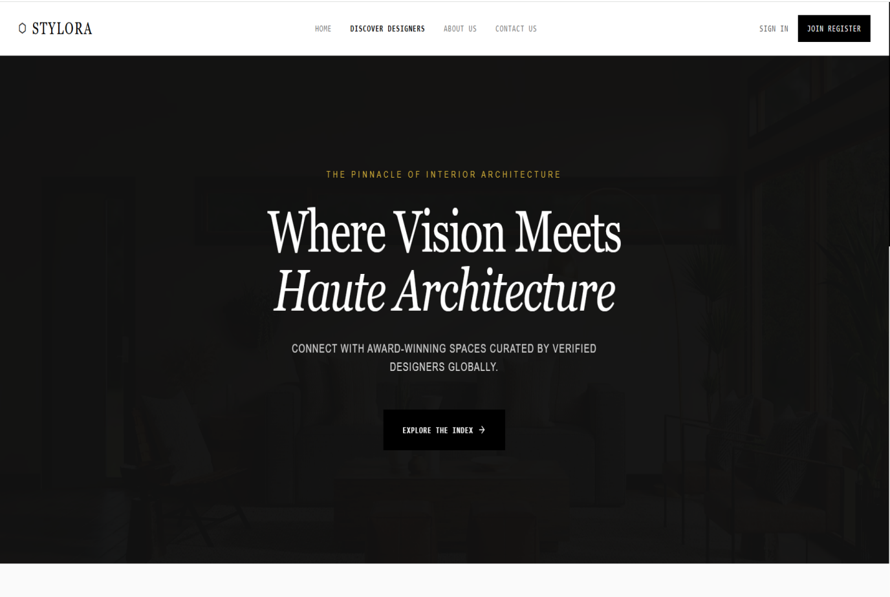
Home Page
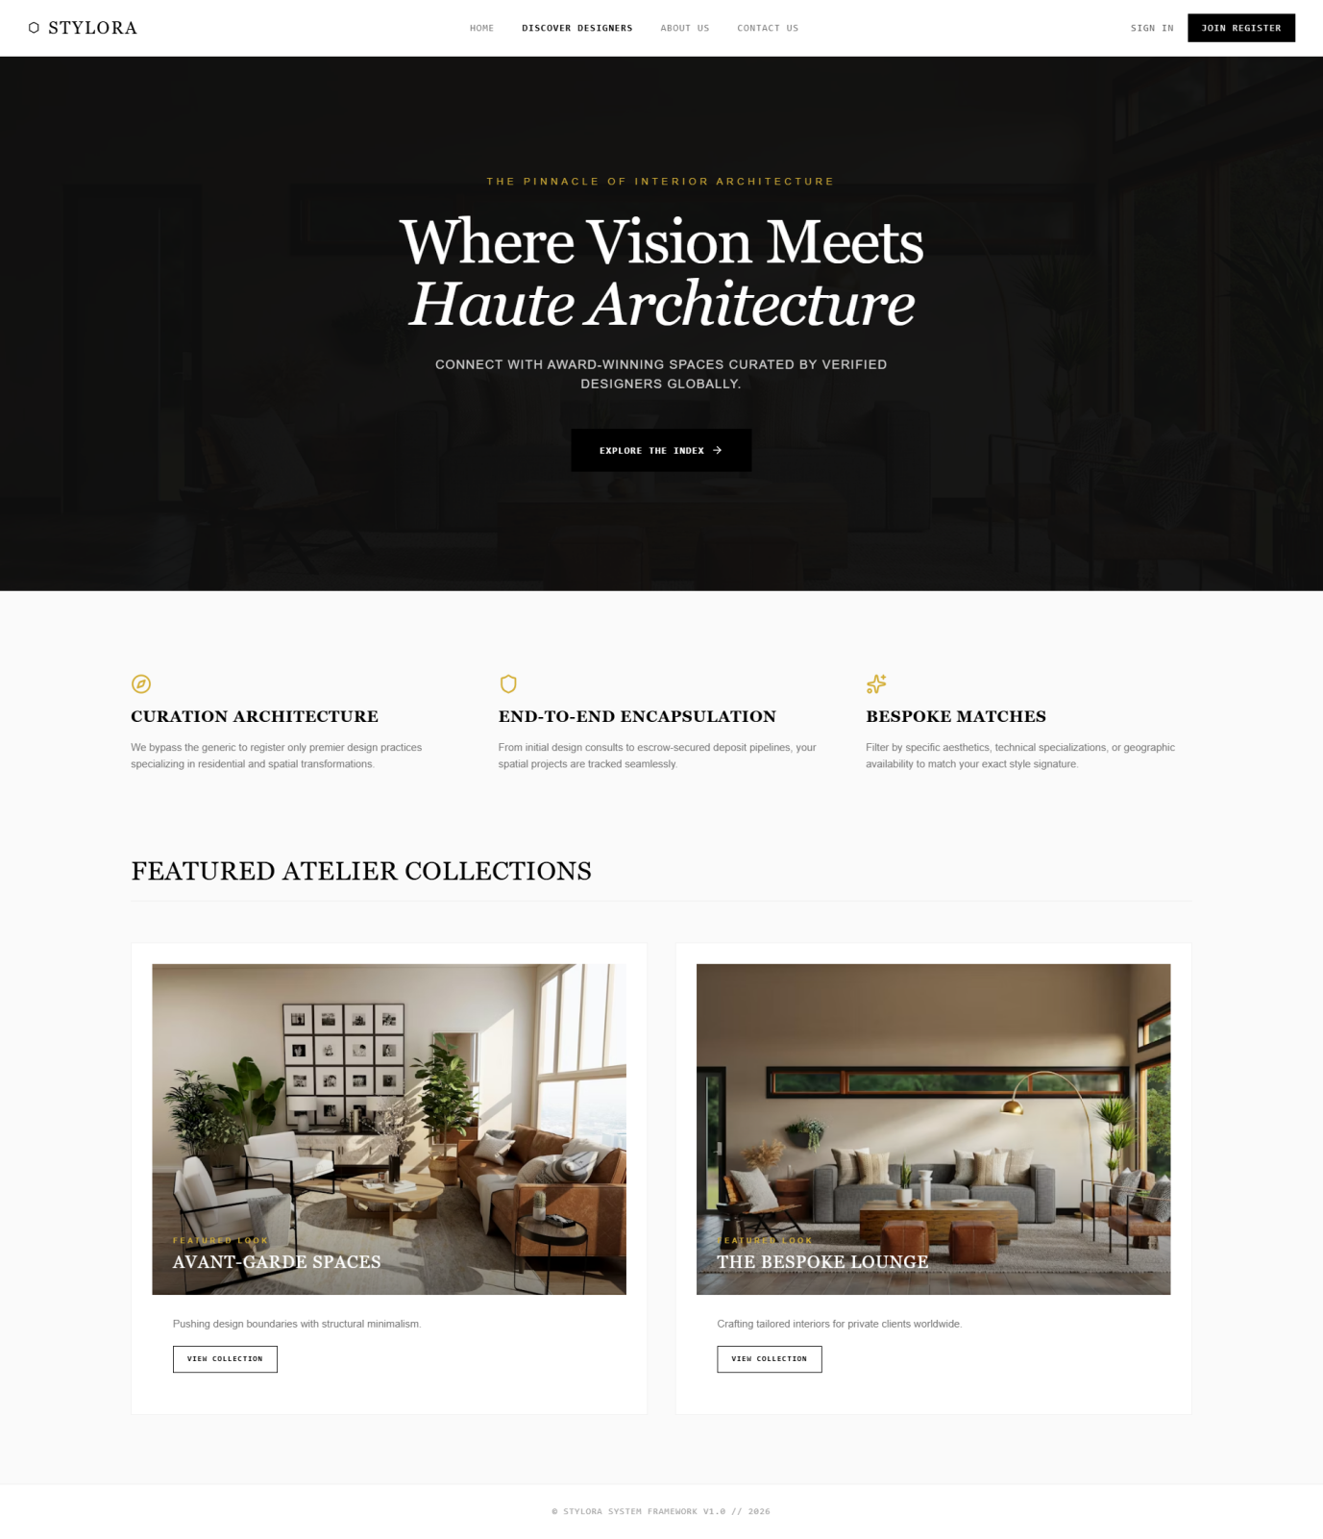

Discover Designer page
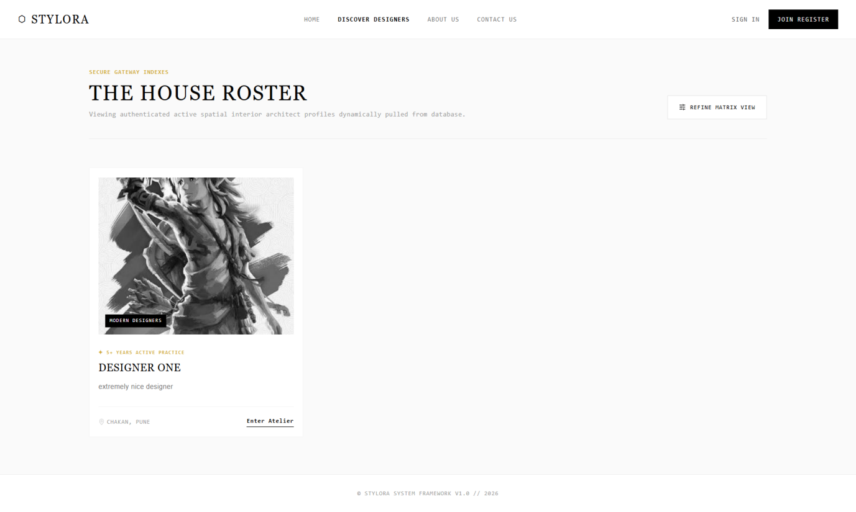
Contact us Page
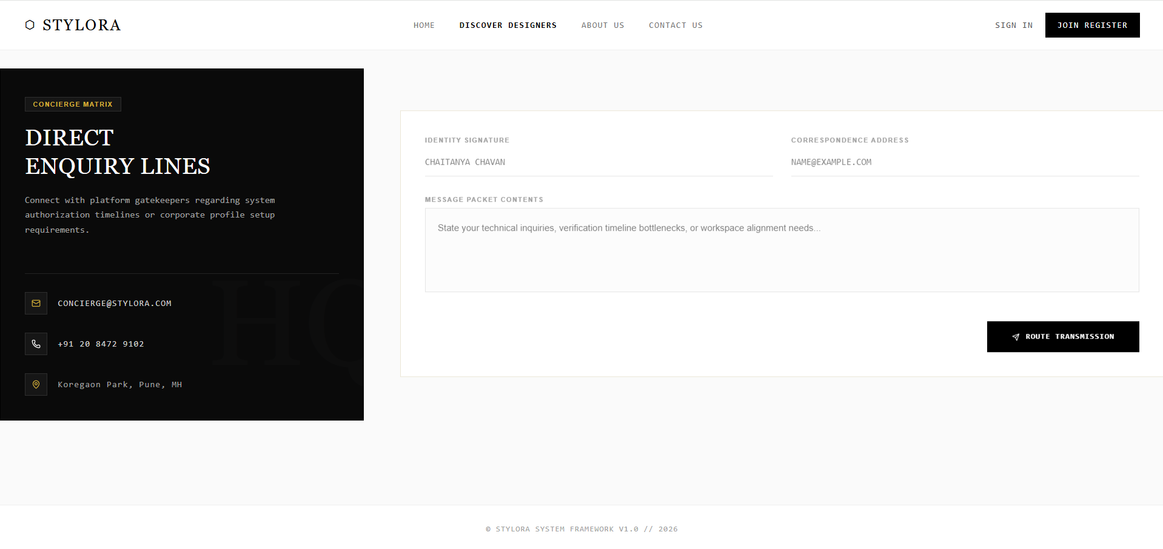

About Us Page
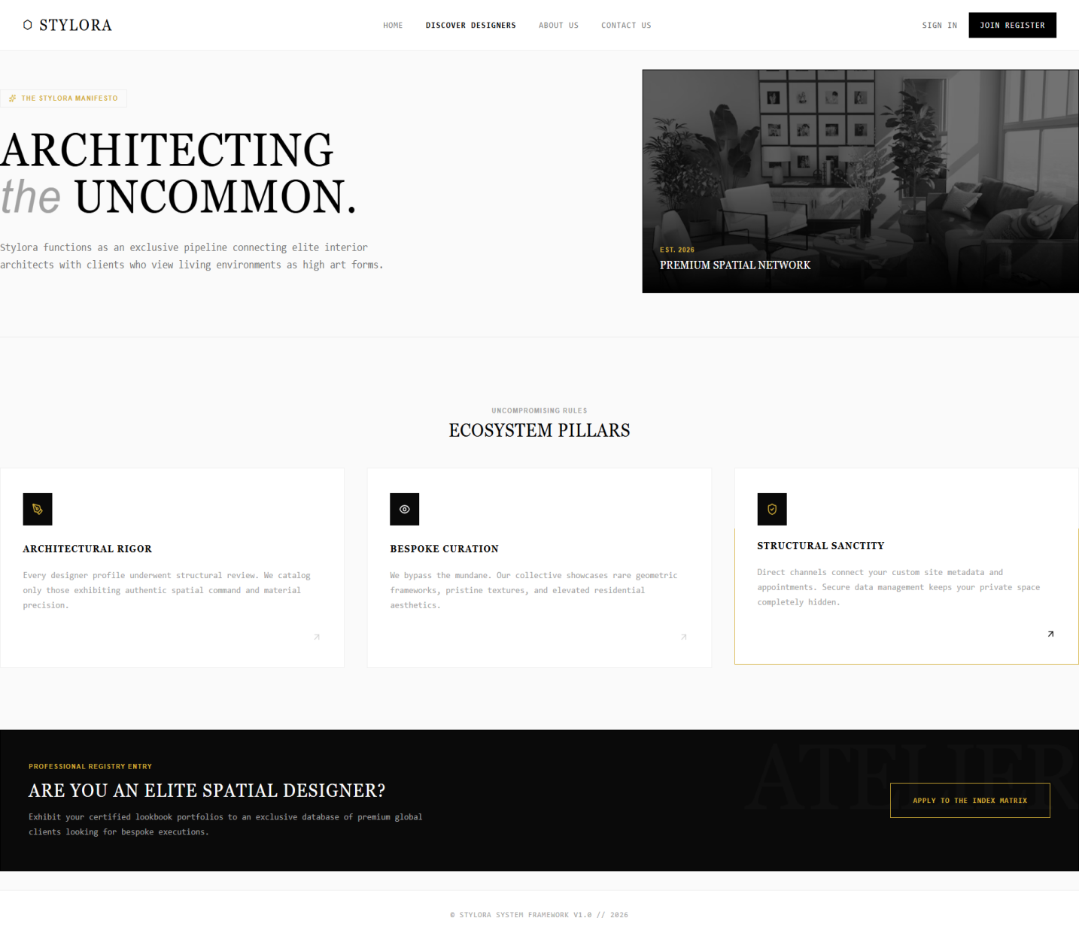
Register page
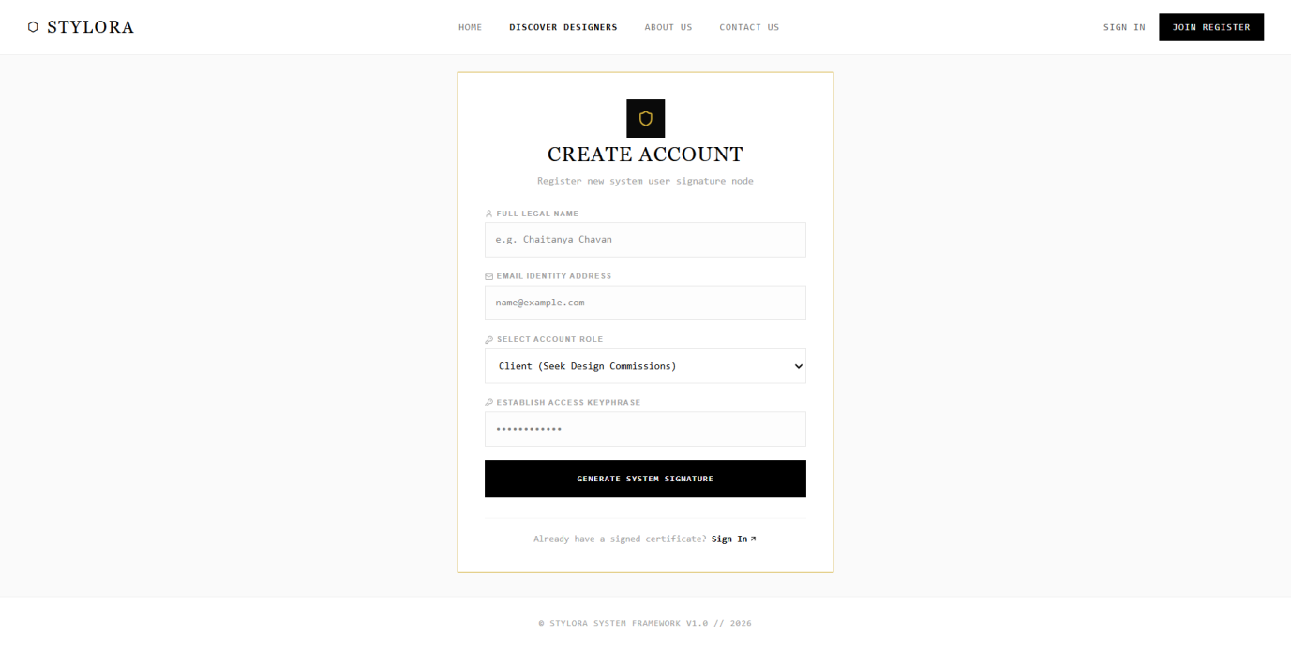
Login page
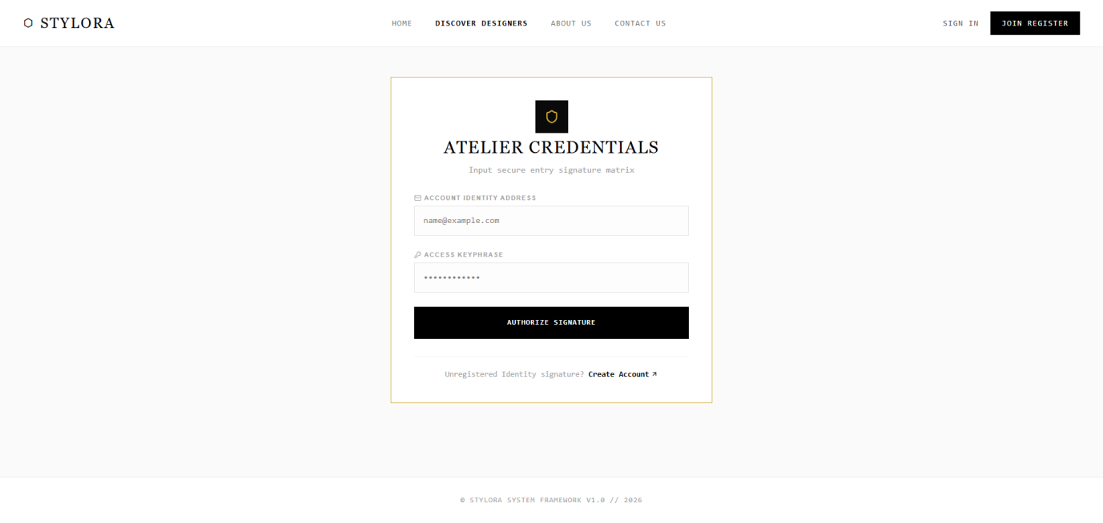
Client Dashboard
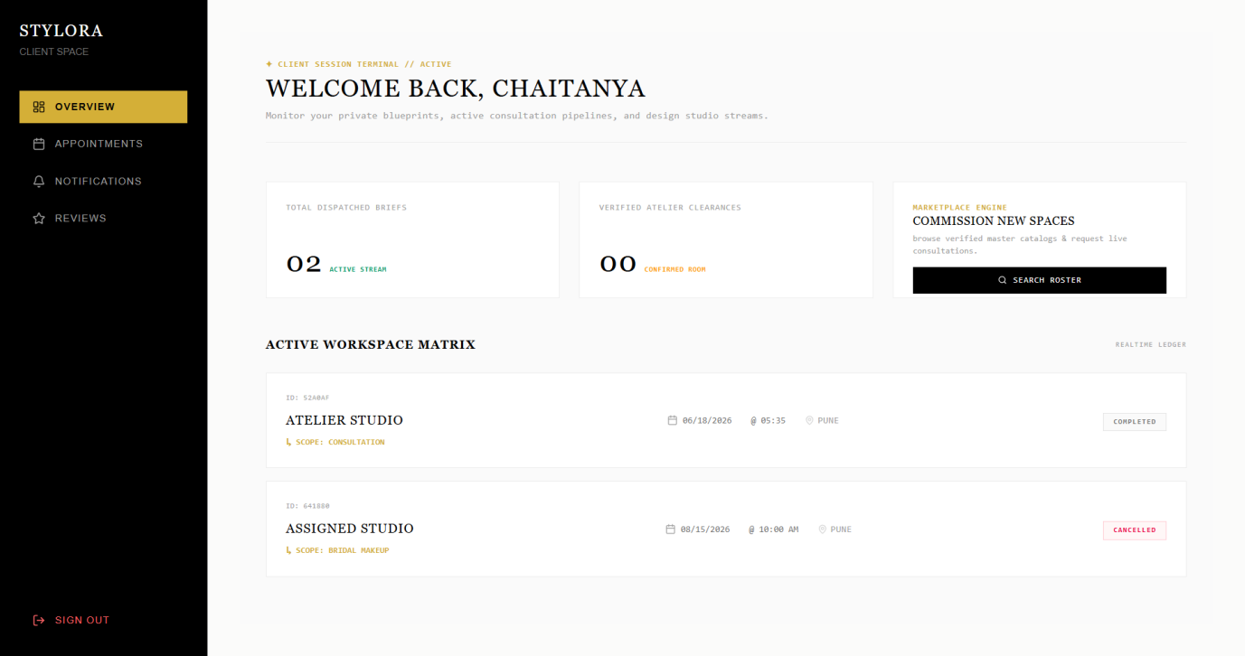
Appointment page
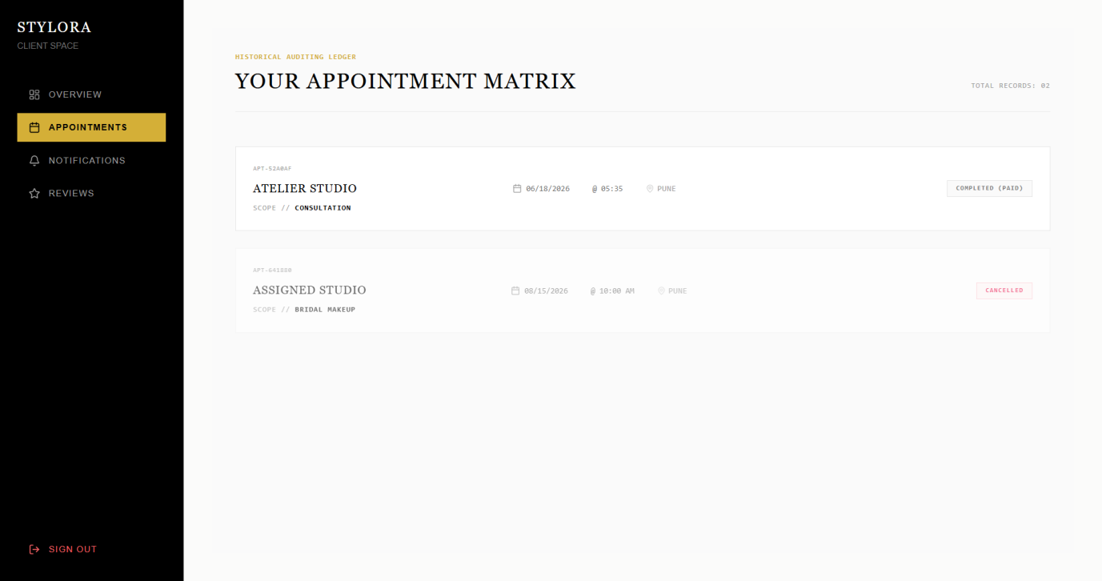
Booking Appointment
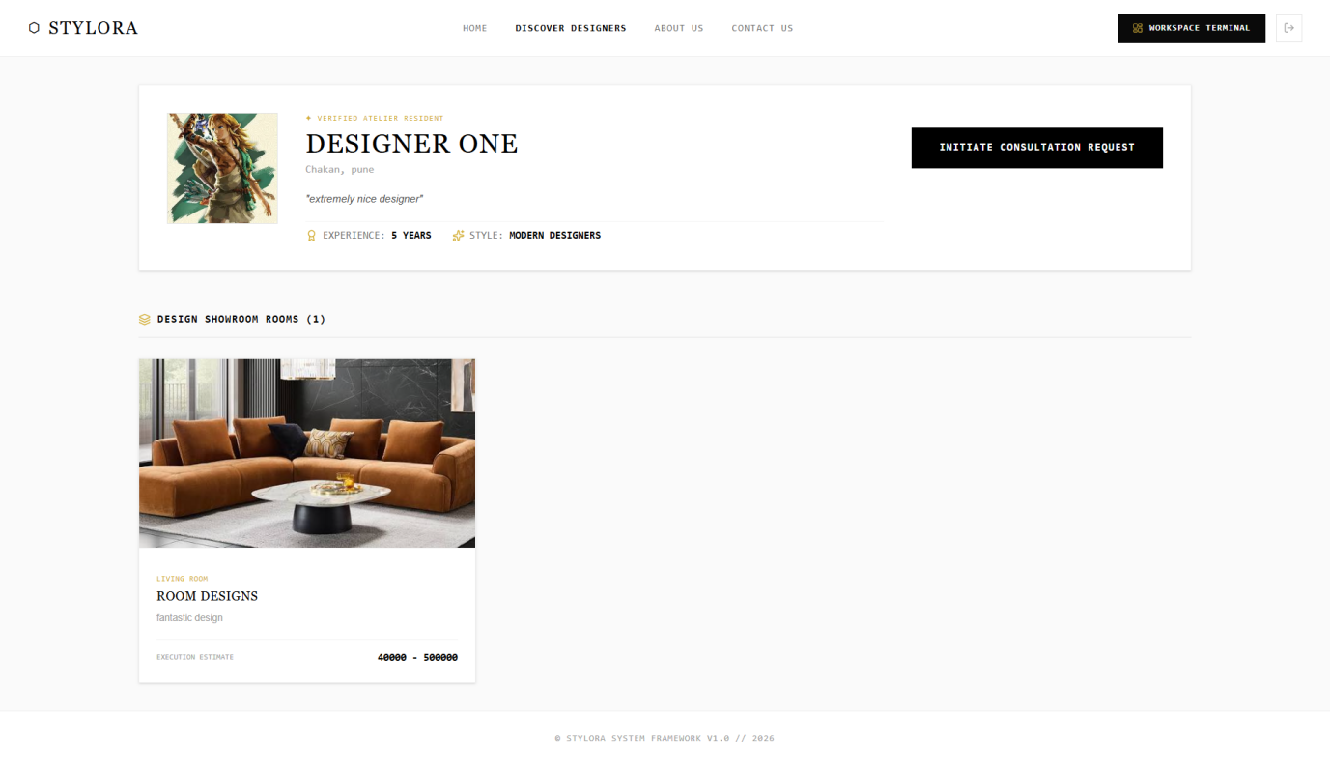
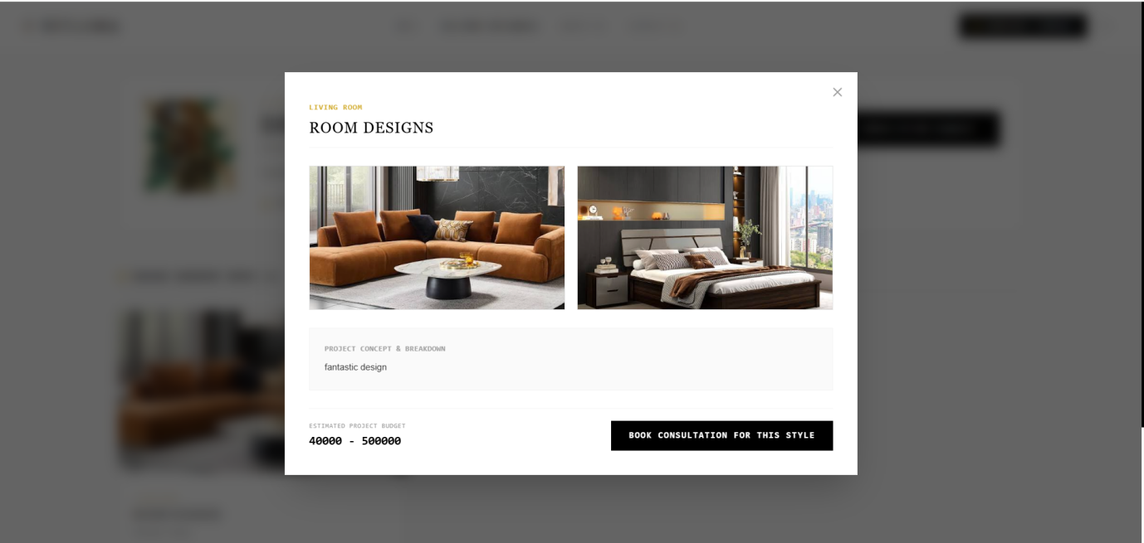
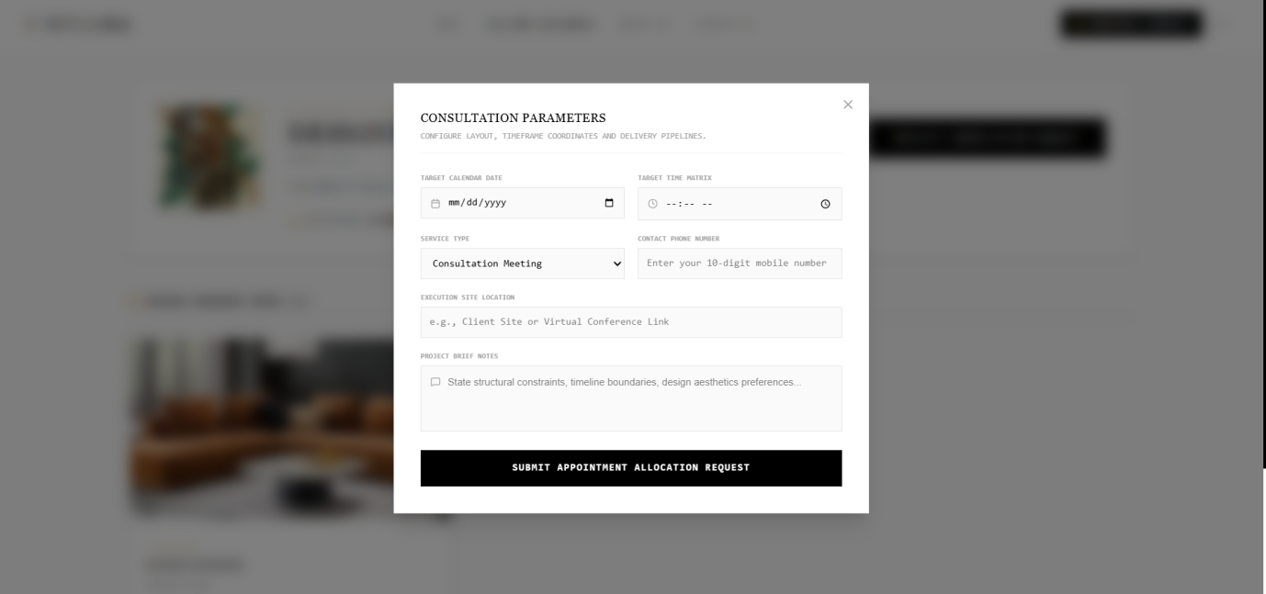
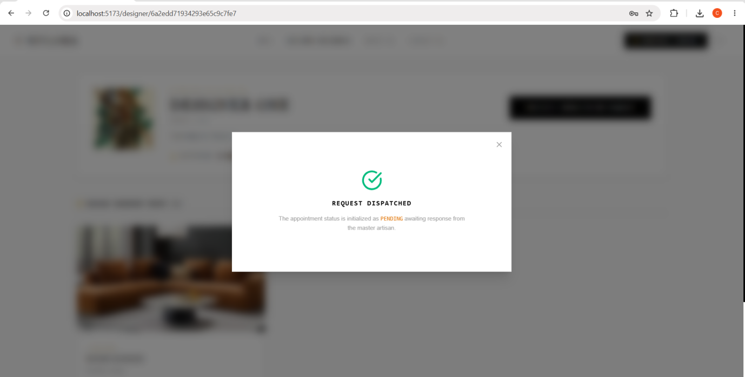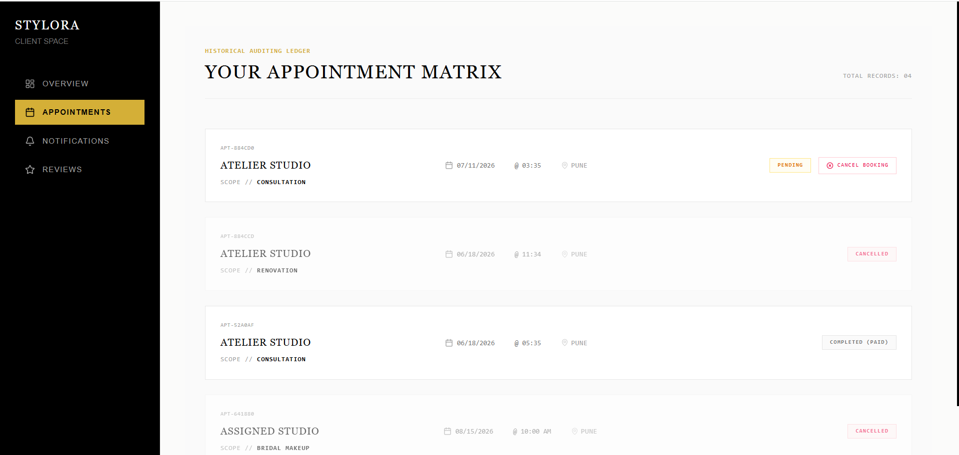
Notification page -client
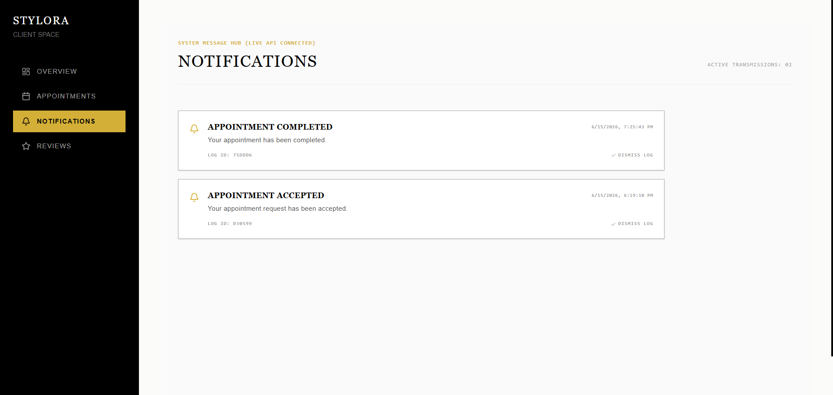
Review page -client
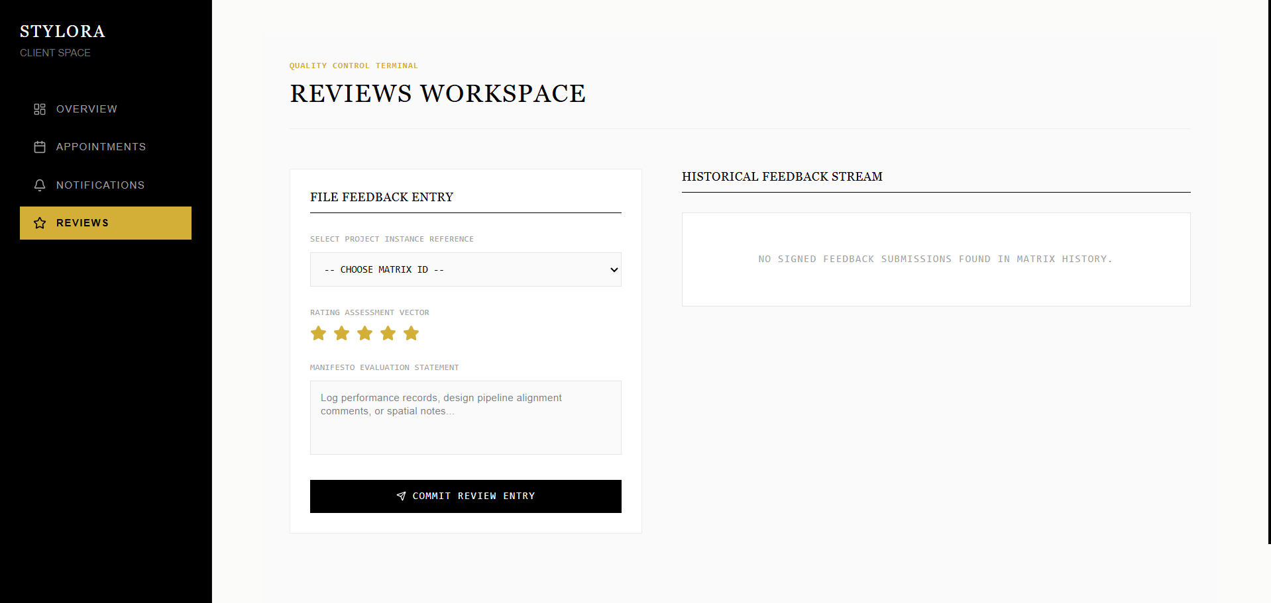
Designer dashboard page
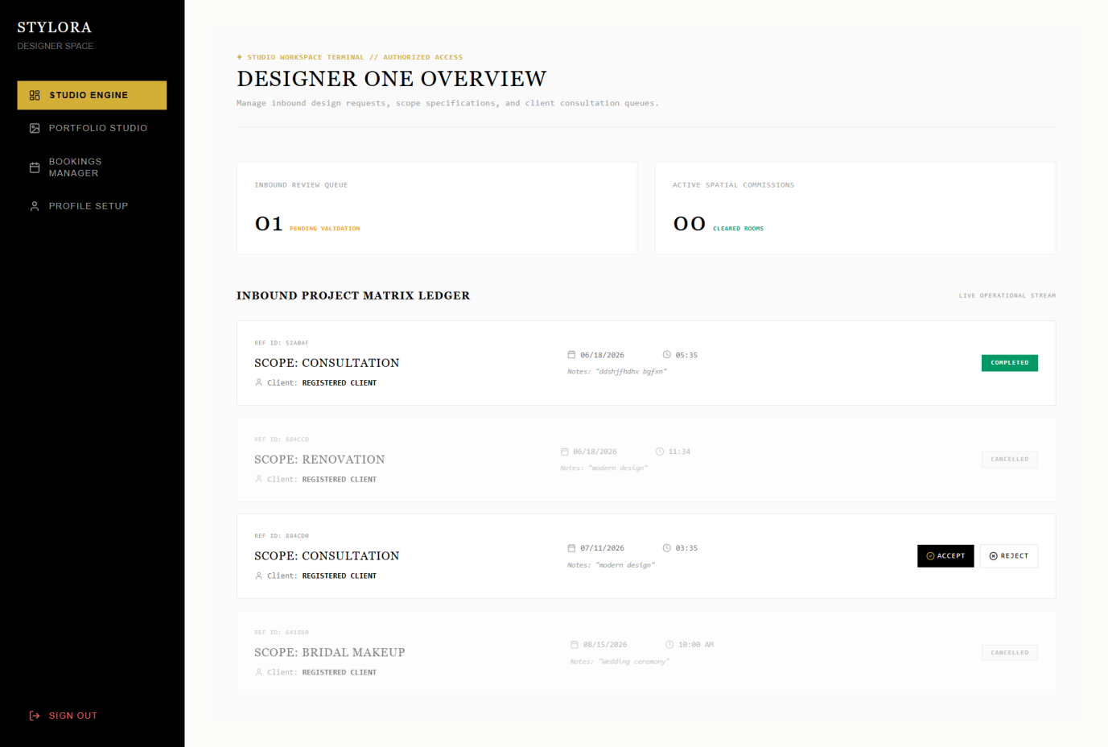
Portfolio page -Designer
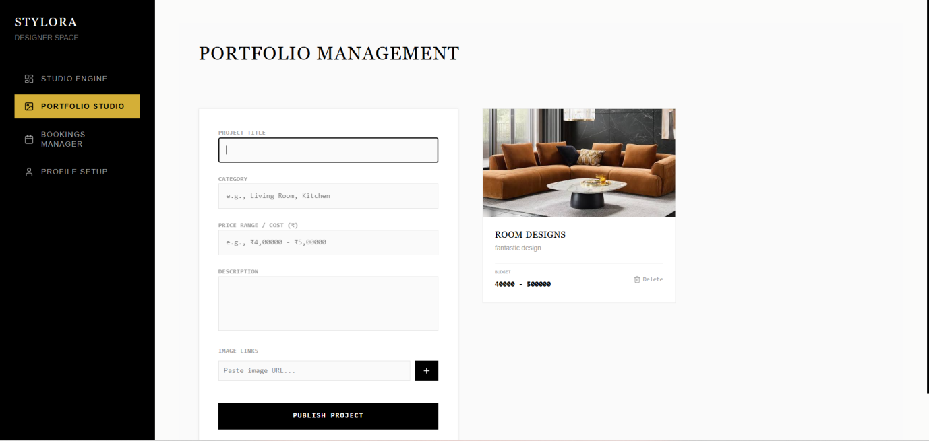
Booking Manager -Designer page
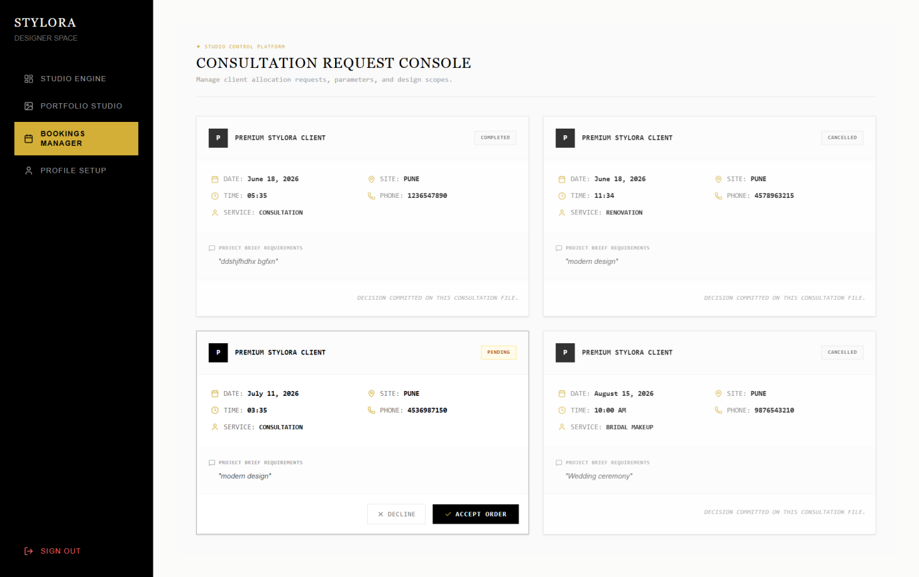
Designer Profile Page
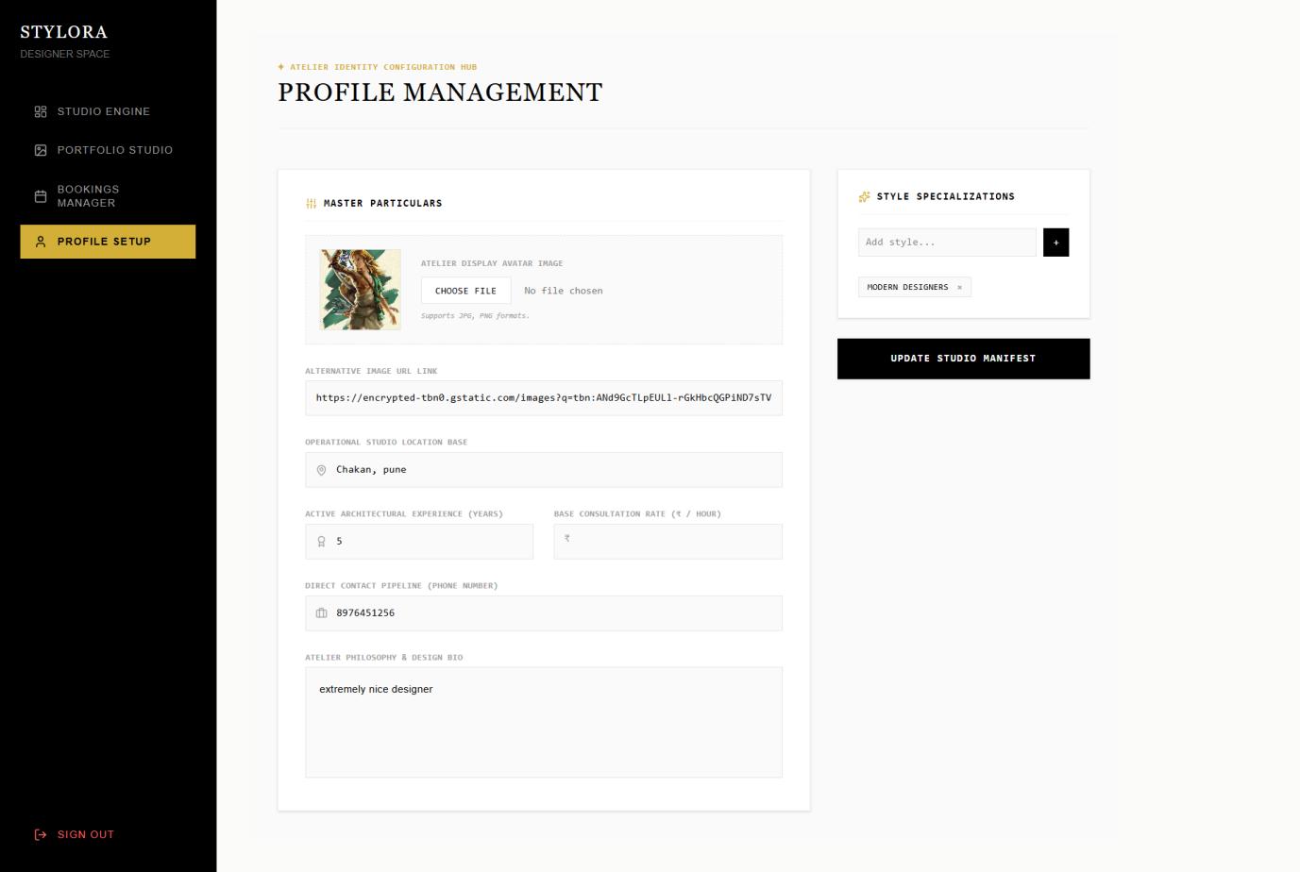
Admin Dashboard
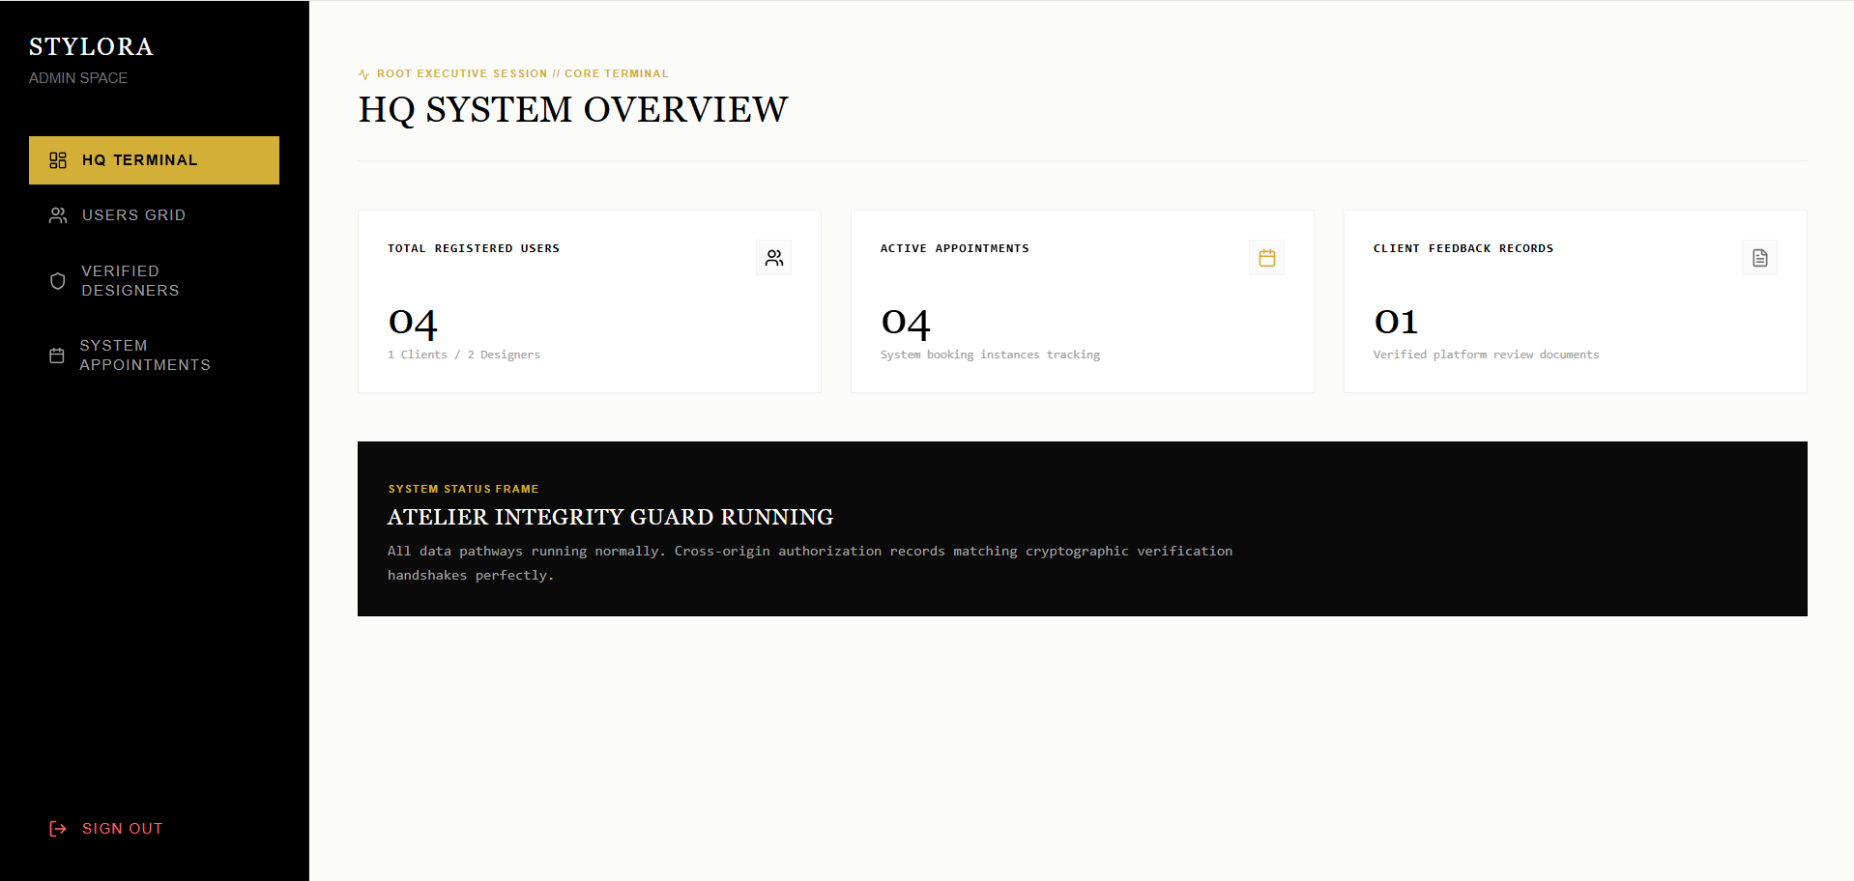
User Grid
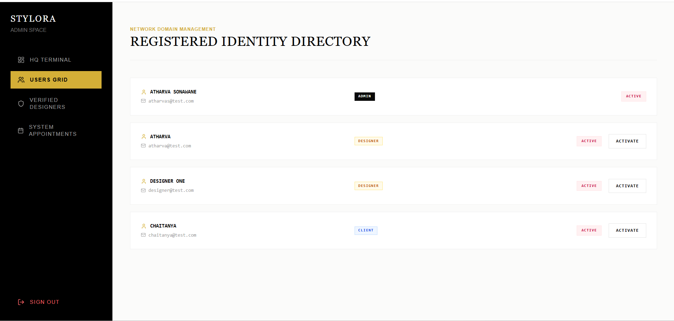
System Appointments
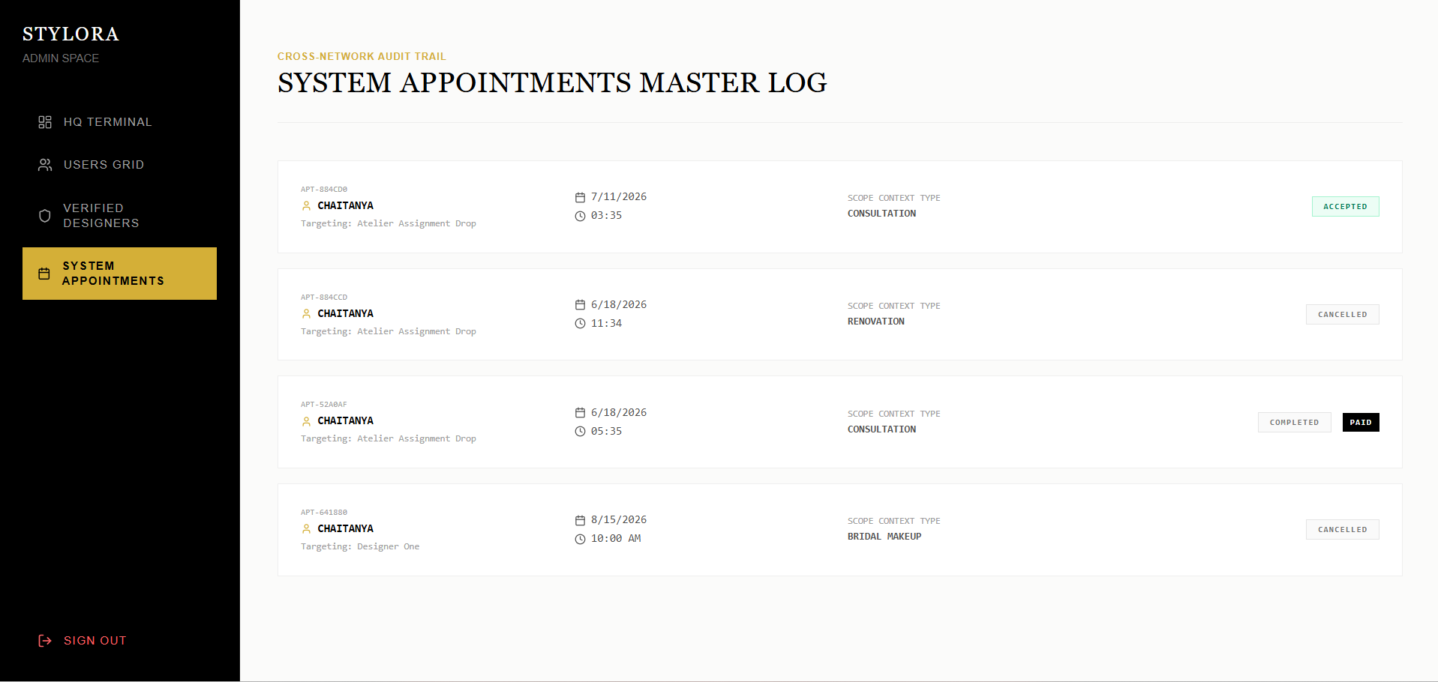

4.2 Data Reports
user table
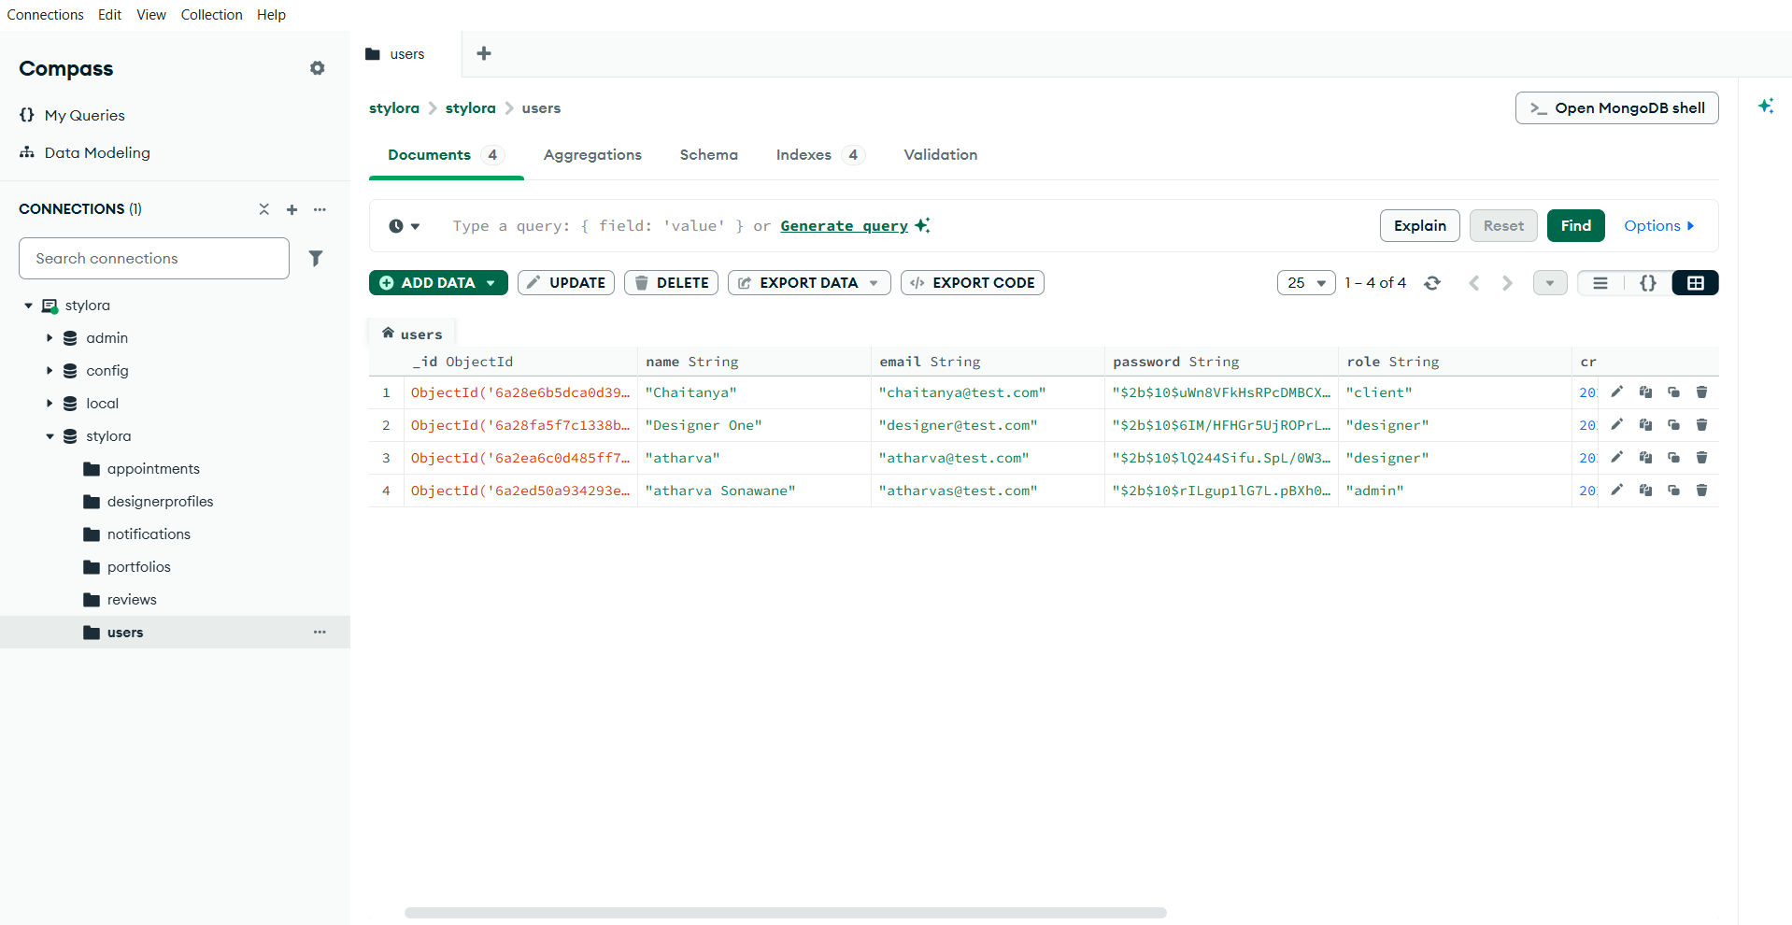
review table
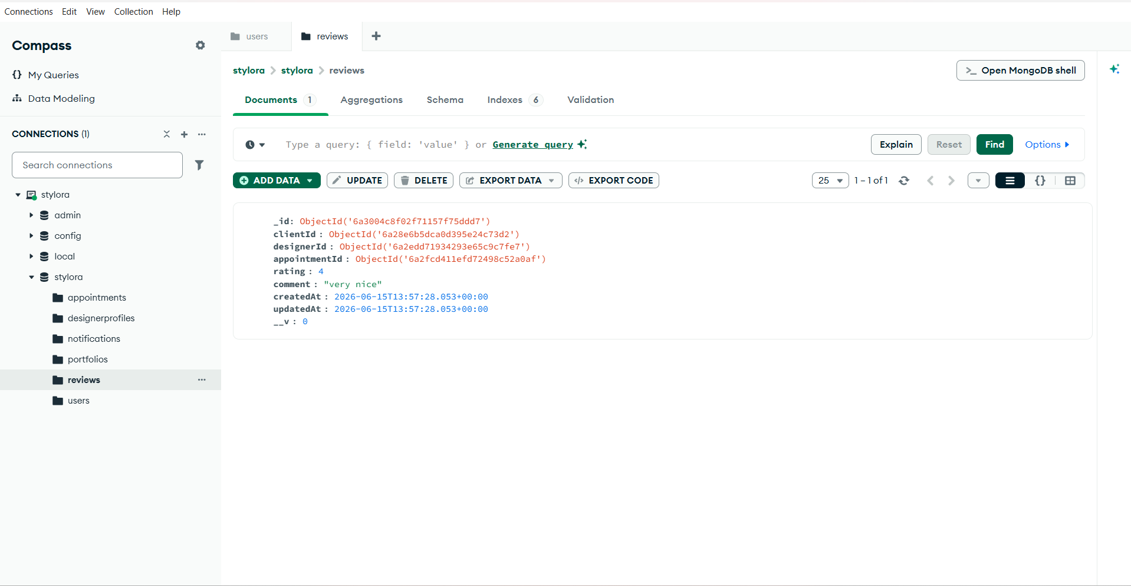
Portfolio table
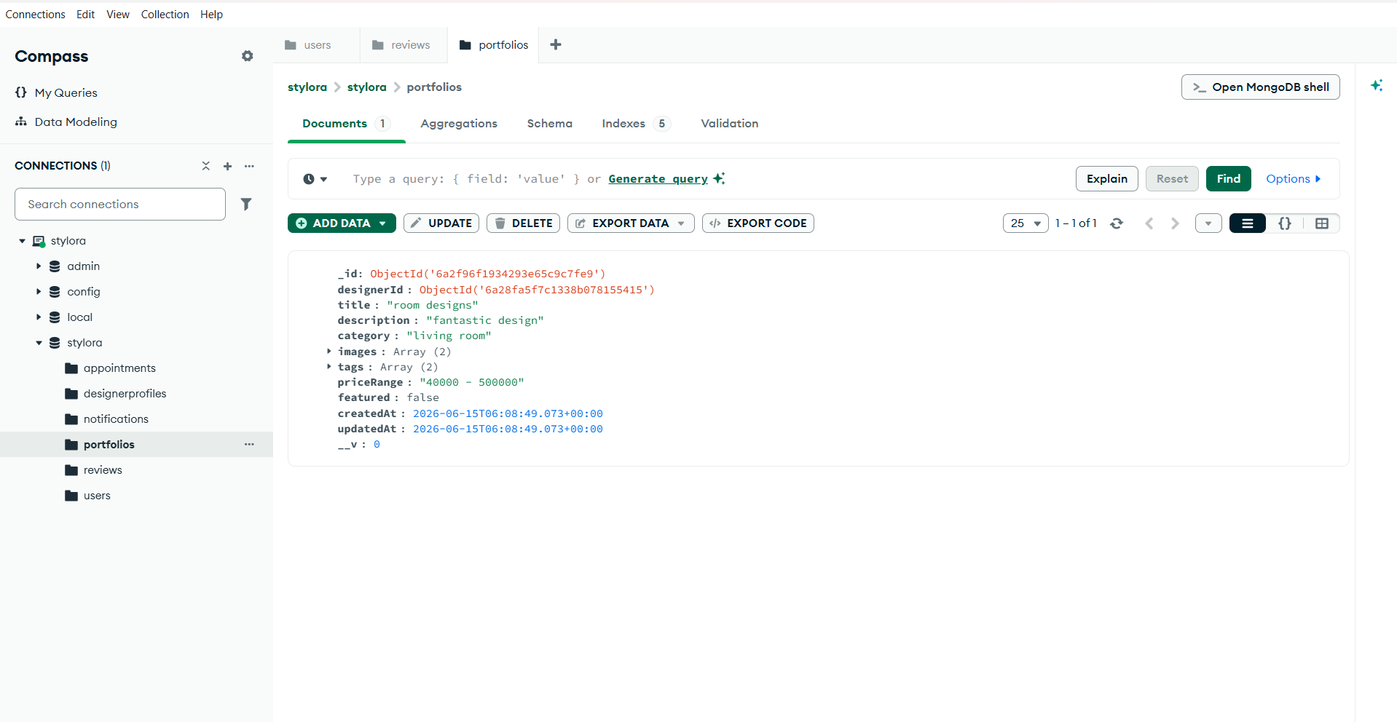
Notification table
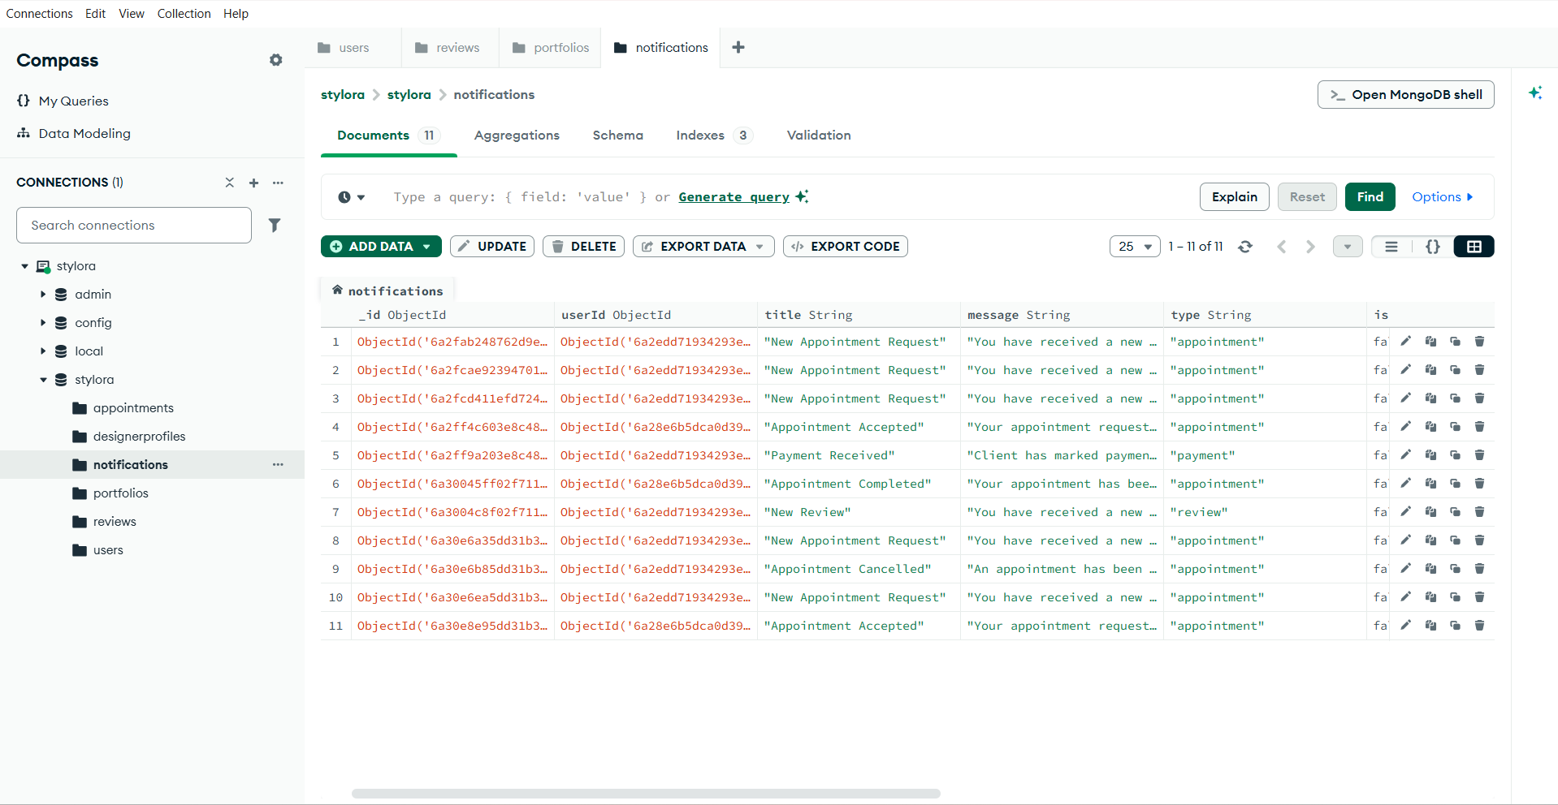
Designer Profile table
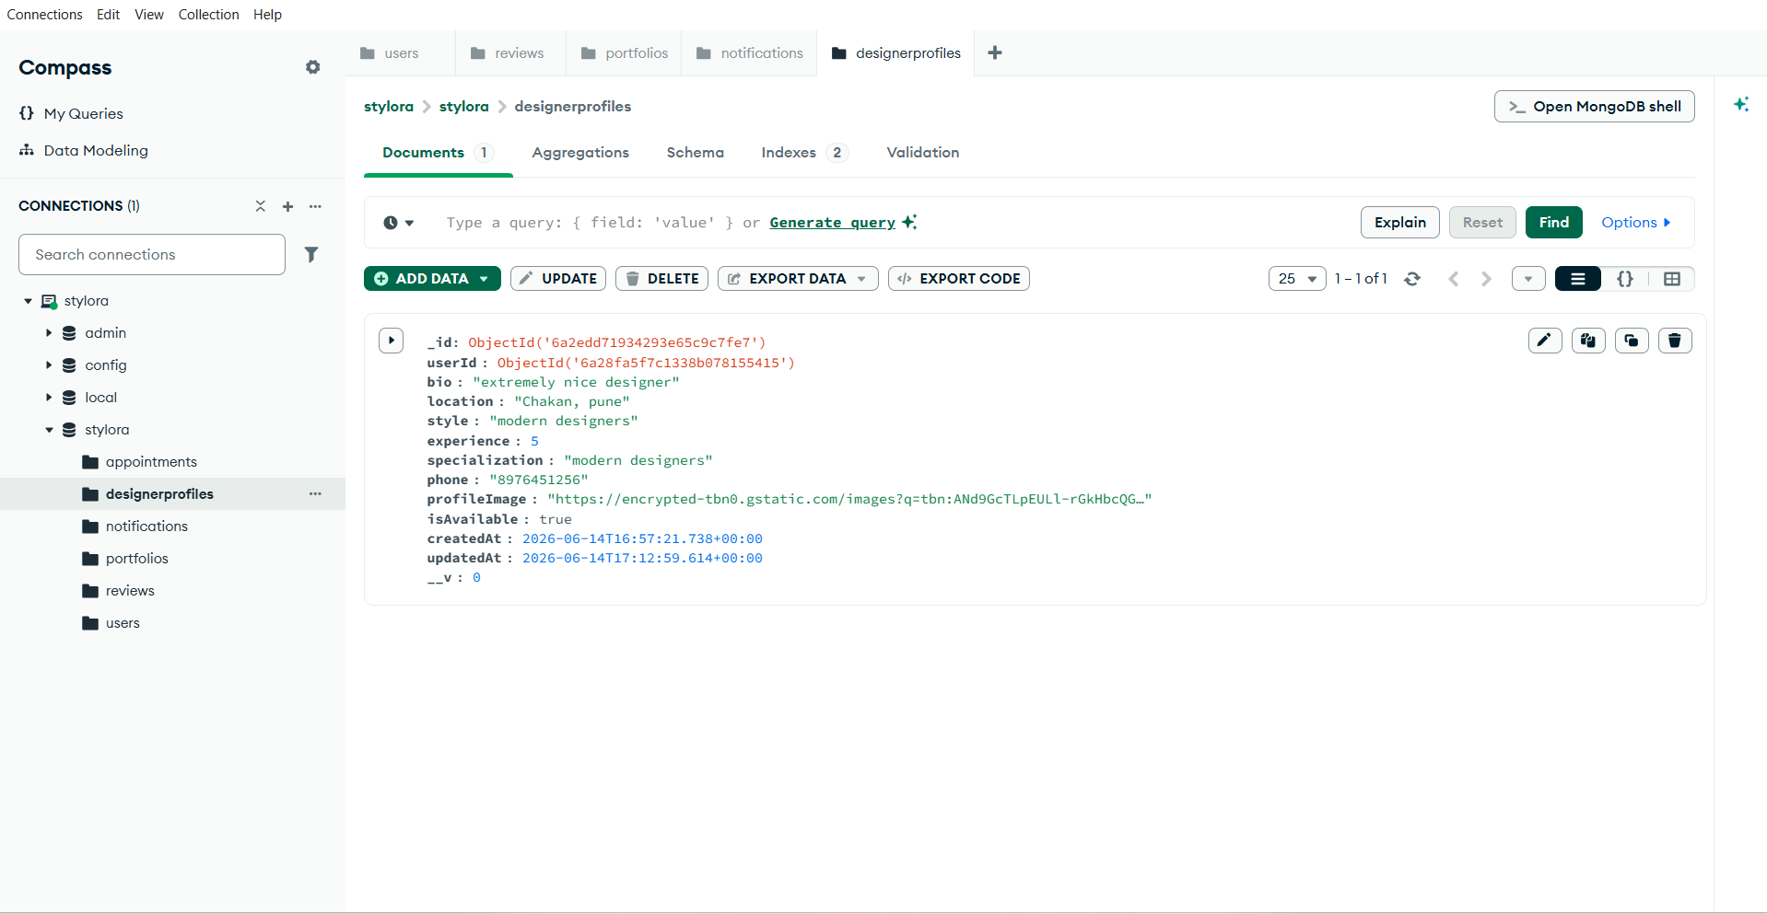
Appointments table
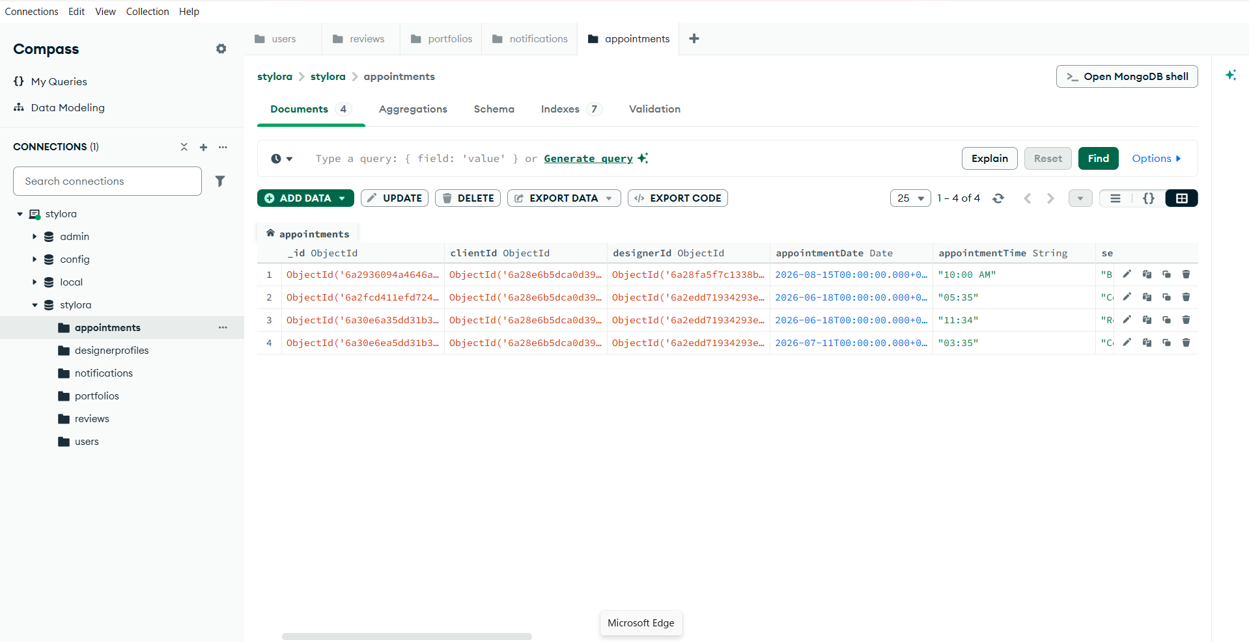

4.3 Sample program code
File notificationController.js
const Notification = require("../models/Notification");
/**
* Get logged-in user's notifications
*/
const getMyNotifications = async (
req,
res,
next
) => {
try {
const notifications =
await Notification.find({
userId: req.user.userId,
}).sort({
createdAt: -1,
});
res.status(200).json({
success: true,
count: notifications.length,
notifications,
});
} catch (error) {
next(error);
}
};
/**
* Mark single notification as read
*/
const markNotificationRead = async (
req,
res,
next
) => {
try {
const notification =
await Notification.findById(
req.params.id
);
if (!notification) {
return res.status(404).json({
success: false,
message:
"Notification not found",
});
}
if (
notification.userId.toString() !==
req.user.userId
) {
return res.status(403).json({
success: false,
message: "Access denied",
});
}
notification.isRead = true;
await notification.save();
res.status(200).json({
success: true,
message:
"Notification marked as read",
});
} catch (error) {
next(error);
}
};
/**
* Mark all notifications as read
*/
const markAllNotificationsRead =
async (req, res, next) => {
try {
await Notification.updateMany(
{
userId: req.user.userId,
isRead: false,
},
{
isRead: true,
}
);
res.status(200).json({
success: true,
message:
"All notifications marked as read",
});
} catch (error) {
next(error);
}
};
module.exports = {
getMyNotifications,
markNotificationRead,
markAllNotificationsRead,
};
File : authController.js
const bcrypt = require("bcryptjs");
const jwt = require("jsonwebtoken");
const User = require("../models/User");
// Helper to create errors with status codes
const createError = (message, statusCode) => {
const error = new Error(message);
error.statusCode = statusCode;
return error;
};
/**
* @desc Register a new user
* @route POST /api/auth/register
* @access Public
*/
const registerUser = async (req, res, next) => {
try {
const { name, email, password, role } = req.body;
// 1. Validate input types and presence (Security: Prevent MongoDB Query Injection & check missing values)
if (typeof name !== "string" || typeof email !== "string" || typeof password !== "string") {
throw createError("Name, email, and password must be strings", 400);
}
const trimmedName = name.trim();
const trimmedEmail = email.trim();
const trimmedPassword = password.trim();
if (!trimmedName || !trimmedEmail || !trimmedPassword) {
throw createError("All fields (name, email, password) are required and cannot be empty", 400);
}
// 2. Prevent Denial of Service (DoS) via excessively long inputs
if (trimmedName.length > 100) {
throw createError("Name must be less than 100 characters long", 400);
}
if (trimmedEmail.length > 255) {
throw createError("Email must be less than 255 characters long", 400);
}
if (trimmedPassword.length > 128) {
throw createError("Password must be less than 128 characters long", 400);
}
// 3. Validate password minimum length
if (trimmedPassword.length < 6) {
throw createError("Password must be at least 6 characters long", 400);
}
// 4. Normalize email
const normalizedEmail = trimmedEmail.toLowerCase();
// 5. Validate email format
const emailRegex = /^[^\s@]+@[^\s@]+\.[^\s@]+$/;
if (!emailRegex.test(normalizedEmail)) {
throw createError("Please provide a valid email address", 400);
}
// 6. Validate role if provided
if (role !== undefined) {
if (typeof role !== "string") {
throw createError("Role must be a string", 400);
}
if (!["client", "designer", "admin"].includes(role)) {
throw createError("Invalid user role", 400);
}
}
// 7. Check if user already exists
const existingUser = await User.findOne({ email: normalizedEmail });
if (existingUser) {
throw createError("A user with this email already exists", 409);
}
// 8. Hash password (10 rounds)
const hashedPassword = await bcrypt.hash(trimmedPassword, 10);
// 9. Create user in database
const user = await User.create({
name: trimmedName,
email: normalizedEmail,
password: hashedPassword,
role: role || "client",
});
// 10. Send response without password
res.status(201).json({
success: true,
message: "User registered successfully",
user: {
id: user._id,
name: user.name,
email: user.email,
role: user.role,
createdAt: user.createdAt,
},
});
} catch (error) {
next(error);
}
};
/**
* @desc Login user & get token
* @route POST /api/auth/login
* @access Public
*/
const loginUser = async (req, res, next) => {
try {
const { email, password } = req.body;
// 1. Validate input types and presence (Security: Prevent MongoDB Query Injection)
if (typeof email !== "string" || typeof password !== "string") {
throw createError("Email and password must be strings", 400);
}
const trimmedEmail = email.trim();
const trimmedPassword = password.trim();
if (!trimmedEmail || !trimmedPassword) {
throw createError("Email and password are required", 400);
}
// 2. Prevent DoS via excessively long inputs
if (trimmedEmail.length > 255) {
throw createError("Email must be less than 255 characters long", 400);
}
if (trimmedPassword.length > 128) {
throw createError("Password must be less than 128 characters long", 400);
}
// 3. Normalize email
const normalizedEmail = trimmedEmail.toLowerCase();
// 4. Find user
const user = await User.findOne({ email: normalizedEmail });
// Dummy hash for timing attack mitigation (Security check: prevent user enumeration timing attacks)
const dummyHash = "$2b$10$7XvW7d59b2N70eD9ZtF7eu2X.r.G8K7n4eA7yK15.y72b7aB3x6/q"; // bcrypt hash for "dummy_password"
let isMatch = false;
if (user) {
isMatch = await bcrypt.compare(trimmedPassword, user.password);
} else {
// Run comparison against dummy hash to consume similar CPU cycles
await bcrypt.compare(trimmedPassword, dummyHash);
}
// Security: Use generic error message for both incorrect email and incorrect password to prevent user enumeration
if (!user || !isMatch) {
throw createError("Invalid email or password", 401);
}
// 5. Validate JWT secret availability (Security check: check if JWT_SECRET environment variable is configured)
const jwtSecret = process.env.JWT_SECRET;
if (!jwtSecret) {
console.error("JWT_SECRET is not configured in environment variables");
throw createError("Internal server configuration error", 500);
}
// 6. Generate JWT token (Payload: { userId, role }, expires in 2 hours)
const token = jwt.sign(
{
userId: user._id,
role: user.role,
},
jwtSecret,
{ expiresIn: "2h" }
);
// 7. Return response without password
res.status(200).json({
success: true,
message: "Login successful",
token,
user: {
id: user._id,
name: user.name,
email: user.email,
role: user.role,
},
});
} catch (error) {
next(error);
}
};
module.exports = {
registerUser,
loginUser,
};
File : Login.tsx
import React, { useState } from 'react';
import { useNavigate, Link } from 'react-router-dom';
import { useAuth } from '../../context/AuthContext';
import { Card } from '../../components/ui/card';
import { Button } from '../../components/ui/Button';
import { Shield, ShieldAlert, KeyRound, Mail, ArrowUpRight } from 'lucide-react';
export const Login: React.FC = () => {
const navigate = useNavigate();
const { loginUser } = useAuth();
const [email, setEmail] = useState('');
const [password, setPassword] = useState('');
const [errorMsg, setErrorMsg] = useState<string | null>(null);
const [isSubmitting, setIsSubmitting] = useState(false);
const handleFormSubmission = async (e: React.FormEvent) => {
e.preventDefault();
setErrorMsg(null);
setIsSubmitting(true);
const targetAction = await loginUser(email, password);
if (targetAction.success) {
// Redirect directly to the correct workflow dashboard role mapping framework
if (targetAction.role === 'admin') navigate('/admin');
else if (targetAction.role === 'designer') navigate('/designer');
else navigate('/client');
} else {
setErrorMsg(targetAction.error || 'Authentication transmission failed');
setIsSubmitting(false);
}
};
return (
<div className="min-h-[75vh] flex items-center justify-center py-6 animate-fade-in">
<Card className="w-full max-w-md bg-white p-8 border border-neutral-200/60 rounded-none shadow-none space-y-6">
{/* Visual Brand Identity Row */}
<div className="text-center space-y-2">
<div className="inline-flex p-3 bg-neutral-950 text-white border border-black rounded-none mb-1">
<Shield size={20} className="text-[#D4AF37]" />
</div>
<h1 className="text-2xl font-luxury uppercase tracking-wider text-black">Atelier Credentials</h1>
<p className="text-xs text-neutral-400 font-mono">Input secure entry signature matrix</p>
</div>
{/* Display System Error Alert Messages */}
{errorMsg && (
<div className="p-3 bg-rose-50 border border-rose-100 text-rose-700 text-xs font-mono flex items-center gap-2">
<ShieldAlert size={14} className="shrink-0" />
<span>{errorMsg}</span>
</div>
)}
{/* Form Interactive Processing Engine */}
<form onSubmit={handleFormSubmission} className="space-y-5">
<div className="space-y-1">
<label className="block text-[9px] tracking-widest uppercase text-neutral-400 font-bold flex items-center gap-1">
<Mail size={10} /> Account Identity Address
</label>
<input
type="email"
required
className="w-full border border-neutral-200 p-3 text-xs focus:outline-none focus:border-black bg-neutral-50/30 rounded-none font-mono"
placeholder="name@example.com"
value={email}
onChange={(e) => setEmail(e.target.value)}
disabled={isSubmitting}
/>
</div>
<div className="space-y-1">
<label className="block text-[9px] tracking-widest uppercase text-neutral-400 font-bold flex items-center gap-1">
<KeyRound size={10} /> Access Keyphrase
</label>
<input
type="password"
required
className="w-full border border-neutral-200 p-3 text-xs focus:outline-none focus:border-black bg-neutral-50/30 rounded-none font-mono"
placeholder="••••••••••••"
value={password}
onChange={(e) => setPassword(e.target.value)}
disabled={isSubmitting}
/>
</div>
<Button
type="submit"
variant="primary"
fullWidth
disabled={isSubmitting}
className="pt-3.5 pb-3.5"
>
{isSubmitting ? 'Verifying Gateway...' : 'Authorize Signature'}
</Button>
</form>
{/* Alternate Navigation Redirect Node */}
<div className="border-t border-neutral-100 pt-4 text-center">
<p className="text-[11px] font-mono text-neutral-400">
Unregistered Identity signature?{' '}
<Link to="/register" className="text-black font-bold hover:underline inline-flex items-center gap-0.5">
Create Account <ArrowUpRight size={10} />
</Link>
</p>
</div>
</Card>
</div>
);
};
4.5 Test Cases
Authentication
Test ID | Module | Test Description | Input Data | Expected Result | Actual Result | Status
TC001 | Authentication | Verify user registration with valid parameters | POST /api/auth/registerBody: { "name": "John Client", "email": "client@test.com", "password": "SecurePassword123", "role": "client" } | Status: 201 CreatedJSON response: { "success": true, "message": "User registered successfully" } | Status: 201 CreatedJSON matches expected format, password omitted. | Pass
TC002 | Authentication | Verify registration fails if input types are not strings | POST /api/auth/registerBody: { "name": 12345, "email": "test@test.com", "password": "Password123" } | Status: 400 Bad RequestJSON: { "message": "Name, email, and password must be strings" } | Status: 400 Bad RequestError message matches exactly. | Pass
TC003 | Authentication | Verify registration fails with missing mandatory fields | POST /api/auth/registerBody: { "name": "", "email": "test@test.com", "password": " " } | Status: 400 Bad RequestJSON: { "message": "All fields (name, email, password) are required..." } | Status: 400 Bad RequestEmpty string rejected. | Pass
TC004 | Authentication | Verify registration fails if name exceeds 100 characters | POST /api/auth/registerBody: { "name": "A...[101 chars]", "email": "a@test.com", "password": "Pass" } | Status: 400 Bad RequestJSON: { "message": "Name must be less than 100 characters long" } | Status: 400 Bad RequestLength validation enforced. | Pass
TC005 | Authentication | Verify login with valid credentials yields JWT token | POST /api/auth/loginBody: { "email": "client@test.com", "password": "SecurePassword123" } | Status: 200 OKJSON response includes success: true, message: "Login successful", and token | Status: 200 OKJWT token generated and returned. | Pass
TC006 | Authentication | Verify login security defenses against brute-force user enumeration | POST /api/auth/loginBody: { "email": "nonexistent@test.com", "password": "wrong" } | Status: 401 UnauthorizedGeneric response: { "message": "Invalid email or password" } | Status: 401 UnauthorizedGeneric obfuscated error returned. | Pass
TC007 | Authentication | Verify user can pull their token summary data securely | GET /api/auth/meHeaders: Authorization: Bearer <valid_token> | Status: 200 OKJSON payload matching user payload { success: true, user: { userId, role } } | Status: 200 OKDecoded payload retrieved accurately. | Pass
TC008 | Authentication | Verify token protection rejects expired signatures | GET /api/auth/meHeaders: Authorization: Bearer <expired_token> | Status: 401 UnauthorizedJSON: { "message": "Access denied. Token has expired." } | Status: 401 UnauthorizedToken expiration handled safely. | Pass
Designer Profile
TC009 | Designer Profile | Verify designer can create a profile successfully | POST /api/designers/profileHeaders: Bearer Token (Role: Designer)Body: { "bio": "Modernist", "location": "Pune" } | Status: 201 CreatedJSON: { "success": true, "message": "Designer profile created successfully" } | Status: 201 CreatedDocument built in DB. | Pass
TC010 | Designer Profile | Verify system blocks client roles from creating a designer profile | POST /api/designers/profileHeaders: Bearer Token (Role: Client) | Status: 403 ForbiddenJSON payload: { "message": "Forbidden" } | Status: 403 ForbiddenAccess restricted by Role RBAC. | Pass
TC011 | Designer Profile | Verify profile constraint protects against duplicate profiles | POST /api/designers/profileHeaders: Bearer Token (Existing Designer Profile) | Status: 409 ConflictJSON payload: { "success": false, "message": "Designer profile already exists" } | Status: 409 ConflictDuplicate profile block verified. | Pass
TC012 | Designer Profile | Verify designer can retrieve their own profile details | GET /api/designers/profile/meHeaders: Bearer Token (Designer) | Status: 200 OKJSON container holding target profile payload | Status: 200 OKProfile object fields parsed perfectly. | Pass
TC013 | Designer Profile | Verify public viewing of designer profiles via document ID | GET /api/designers/profile/:idHeaders: None (Public route) | Status: 200 OKReturns targeted public designer object data structure. | Status: 200 OKProfile found and returned. | Pass
TC014 | Designer Profile | Verify update modifications save accurately | PUT /api/designers/profileHeaders: Bearer Token (Designer)Body: { "location": "Mumbai", "isAvailable": false } | Status: 200 OKJSON feedback indicating profile updated successfully | Status: 200 OKDatabase parameters changed successfully. | Pass
TC015 | Designer Profile | Verify profile deletion drops document records | DELETE /api/designers/profileHeaders: Bearer Token (Designer) | Status: 200 OKJSON message indicating profile deleted successfully | Status: 200 OKDocument swept from collection. | Pass
TC016 | Designer Profile | Verify bulk profile roster retrieval | GET /api/designersHeaders: None | Status: 200 OK containing fully populated associated user models. | Status: 200 OKList populated with related username/email. | Pass
Portfolio
TC017 | Portfolio | Verify designer can create portfolio items | POST /api/portfolioHeaders: Bearer Token (Designer)Body: { "title": "Minimalist Kitchen" } | Status: 201 CreatedJSON indicating portfolio item created successfully | Status: 201 CreatedPortfolio record generated. | Pass
TC018 | Portfolio | Verify asset validation limits uploading more than 10 project images | POST /api/portfolioBody: { "title": "Eco Home", "images": ["img1", ..., "img11"] } | Status: 500/400 Mongoose Validation ErrorMessage: "Maximum 10 images allowed" | Status: 400 Bad RequestArray size ceiling verification passed. | Pass
TC019 | Portfolio | Verify portfolio title uniqueness under a single designer ID | POST /api/portfolioBody: { "title": "Minimalist Kitchen" } | Status: 409 ConflictJSON: { "success": false, "message": "Portfolio title already exists" } | Status: 409 ConflictDuplicate context locked. | Pass
TC020 | Portfolio | Verify user can extract portfolio items attached to themselves | GET /api/portfolio/myHeaders: Bearer Token (Designer) | Status: 200 OK returning array of portfolio items owned by designer. | Status: 200 OKDesigner elements listed. | Pass
TC021 | Portfolio | Verify fetching a single public portfolio record via ID | GET /api/portfolio/:portfolioId | Status: 200 OK returning specific matching portfolio layout schema. | Status: 200 OKItem payload rendered cleanly. | Pass
TC022 | Portfolio | Verify fetching all portfolio entries linked to a specific designer ID | GET /api/portfolio/designer/:designerId | Status: 200 OK returning matching collection array items. | Status: 200 OKRoster parsed for target designer. | Pass
TC023 | Portfolio | Verify modifications to a specific portfolio asset | PUT /api/portfolio/:portfolioIdBody: { "featured": true } | Status: 200 OKJSON: { "message": "Portfolio updated successfully" } | Status: 200 OKFields saved to database context. | Pass
TC024 | Portfolio | Verify update block when malicious actor attempts modifying another's portfolio | PUT /api/portfolio/:portfolioId (Belongs to Designer A)Headers: Token (Designer B) | Status: 403 ForbiddenJSON: { "success": false, "message": "Unauthorized access" } | Status: 403 ForbiddenSecurity block executed safely. | Pass
TC025 | Portfolio | Verify owner can delete portfolio items completely | DELETE /api/portfolio/:portfolioIdHeaders: Bearer Token (Owner) | Status: 200 OK with success confirmation message schema. | Status: 200 OKRecord evicted from data cluster. | Pass
TC026 | Portfolio | Verify deletion rejection against random unauthenticated actors | DELETE /api/portfolio/:portfolioIdHeaders: Bearer Token (Stranger Account) | Status: 403 ForbiddenJSON: { "success": false, "message": "Unauthorized access" } | Status: 403 ForbiddenOperation dropped safely. | Pass
Appointment
TC027 | Appointment | Verify client can place booking requests successfully | POST /api/appointmentsHeaders: Token (Client)Body: { "designerId": "des_id", "appointmentDate": "2026-12-01", "appointmentTime": "14:00", "serviceType": "Consult", "contactPhone": "123", "location": "Pune" } | Status: 201 Created/200 OK tracking appointment object with status set to pending. | Status: 201 CreatedAppointment item committed down to DB. | Pass
TC028 | Appointment | Verify missing parameters block booking creation actions | POST /api/appointmentsBody: { "serviceType": "Incomplete Data" } | Status: 400 Bad RequestJSON: { "success": false, "message": "All required fields must be provided" } | Status: 400 Bad RequestMissing field triggers error. | Pass
TC029 | Appointment | Verify self-booking prevention constraint | POST /api/appointmentsHeaders: Token (Designer A)Body: { "designerId": "Designer A ID", ... } | Status: 400 Bad RequestJSON: { "success": false, "message": "You cannot book yourself" } | Status: 400 Bad RequestSelf-booking anomaly caught. | Pass
TC030 | Appointment | Verify validation drops booking records requested in past dates | POST /api/appointmentsBody: { "appointmentDate": "2020-01-01", ... } | Status: 400 Bad RequestJSON: { "success": false, "message": "Appointment date must be in the future" } | Status: 400 Bad RequestHistorical tracking rejected. | Pass
TC031 | Appointment | Verify double booking slot collision prevention | POST /api/appointmentsBody: Same designer, date, and time slot | Status: 400 Bad RequestJSON: { "success": false, "message": "This time slot is already booked" } | Status: 400 Bad RequestCollision checked during entry. | Pass
TC032 | Appointment | Verify client can view all their submitted appointments | GET /api/appointments/myHeaders: Bearer Token (Client) | Status: 200 OK returning user list with populating elements. | Status: 200 OKPersonal history payload array read. | Pass
TC033 | Appointment | Verify designer can pull incoming task lists | GET /api/appointments/designerHeaders: Bearer Token (Designer) | Status: 200 OK containing corresponding appointment objects. | Status: 200 OKInbox requests compiled accurately. | Pass
TC034 | Appointment | Verify designer can transition state to accepted | PUT /api/appointments/:id/acceptHeaders: Bearer Token (Designer) | Status: 200 OK updating state enum code directly to accepted. | Status: 200 OKStatus updated, notification dispatched. | Pass
TC035 | Appointment | Verify designer can transition state to rejected | PUT /api/appointments/:id/rejectHeaders: Bearer Token (Designer) | Status: 200 OK updating state enum code directly to rejected. | Status: 200 OKRequest declined, workflow complete. | Pass
TC036 | Appointment | Verify state engine protects completed workflows from changing status | PUT /api/appointments/:id/accept (Target is already 'completed') | Status: 400 Bad Request with protective processing logic warning. | Status: 400 Bad RequestTerminal state mutation rejected. | Pass
TC037 | Appointment | Verify designer can mark work orders as completed | PUT /api/appointments/:id/completeHeaders: Bearer Token (Designer) | Status: 200 OK updating state enum code directly to completed. | Status: 200 OKState shifted to finalized cleanly. | Pass
TC038 | Appointment | Verify client can issue job cancellation actions | PUT /api/appointments/:id/cancelHeaders: Bearer Token (Client)Body: { "cancellationReason": "Change of plans" } | Status: 200 OK updating state enum code directly to cancelled. | Status: 200 OKOrder successfully cancelled. | Pass
TC039 | Appointment | Verify payment processing records capture transaction flows | PUT /api/appointments/:id/payHeaders: Bearer Token (Client)Body: { "amount": 5000 } | Status: 200 OK setting paymentStatus to paid and generating transaction parameters. | Status: 200 OKPayment marked, notification pushed. | Pass
TC040 | Appointment | Verify payment step blocks transactions on unaccepted tasks | PUT /api/appointments/:id/payTarget status: pending | Status: 400 Bad RequestJSON: { "message": "Appointment must be accepted before payment" } | Status: 400 Bad RequestPre-condition catch verified. | Pass
TC041 | Appointment | Verify system rejects negative values in payment input | PUT /api/appointments/:id/payBody: { "amount": -100 } | Status: 400 Bad RequestJSON: { "message": "Valid payment amount required" } | Status: 400 Bad RequestNegative threshold blocked. | Pass
Reviews
TC042 | Reviews | Verify client can submit a transaction evaluation review | POST /api/reviewsHeaders: Token (Client)Body: { "appointmentId": "apt_123", "rating": 5, "comment": "Great work!" } | Status: 201 Created/200 OK verifying item injection down to data records. | Status: 201 CreatedReview written, index populated. | Pass
TC043 | Reviews | Verify evaluation engine restricts submissions to completed appointments only | POST /api/reviewsBody: { "appointmentId": "pending_apt", "rating": 4 } | Status: 400 Bad RequestJSON: { "message": "Only completed appointments can be reviewed" } | Status: 400 Bad RequestWorkflow validation held. | Pass
TC044 | Reviews | Verify database constraints protect against duplicate review generation | POST /api/reviewsBody: { "appointmentId": "already_reviewed_apt", ... } | Status: 400 Bad RequestJSON: { "success": false, "message": "Review already submitted" } | Status: 400 Bad RequestUnique index check passed. | Pass
TC045 | Reviews | Verify rating upper boundary scale verification limits inputs | POST /api/reviewsBody: { "appointmentId": "apt_id", "rating": 6 } | Status: 500/400 Mongoose Validation Error (Max limit 5 exceeded). | Status: 400 Bad RequestInvalid score dropped safely. | Pass
TC046 | Reviews | Verify fetching reviews for a targeted designer identity profile | GET /api/reviews/designer/:designerId | Status: 200 OK listing out matching array summaries. | Status: 200 OKReviews array array parsed seamlessly. | Pass
TC047 | Reviews | Verify metrics computation engine totals star ratings perfectly | GET /api/reviews/designer/:designerId/rating | Status: 200 OK parsing out fields containing averageRating, totalReviews, and star breakdown. | Status: 200 OKMath averages compiled dynamically. | Pass
Search
TC048 | Search | Verify search query filters profiles by location parameter | GET /api/search/designers?location=pune | Status: 200 OK filtering designers down using case-insensitive regex pattern checks. | Status: 200 OKFiltered list contains Pune values. | Pass
TC049 | Search | Verify search query filters profiles by style specialization | GET /api/search/designers?style=modern | Status: 200 OK tracking specific filtered records returned. | Status: 200 OKModern styles matched accurately. | Pass
TC050 | Search | Verify query limits profiles below structural experience thresholds | GET /api/search/designers?minExperience=5 | Status: 200 OK executing $gte database operator routines. | Status: 200 OKProfiles below 5 years omitted. | Pass
TC051 | Search | Verify list sorting controls sort items by top average rating | GET /api/search/designers?sortBy=rating | Status: 200 OK delivering objects sorted in descending order of calculated score. | Status: 200 OKHighest rated designer listed first. | Pass
Notifications
TC052 | Notifications | Verify user can extract personal alert streams | GET /api/notificationsHeaders: Bearer Token (Authenticated User) | Status: 200 OK providing arrays sorted with newest created items first. | Status: 200 OKPersonal feed returned cleanly. | Pass
TC053 | Notifications | Verify updating single read parameter flags via document parameter ID | PUT /api/notifications/:id/readHeaders: Bearer Token | Status: 200 OK shifting target isRead value safely to true. | Status: 200 OKAlert state flagged as read. | Pass
TC054 | Notifications | Verify security protection drops cross-user modification attempts | PUT /api/notifications/:id/read (Belongs to User A)Headers: Token (User B) | Status: 403 ForbiddenJSON: { "success": false, "message": "Access denied" } | Status: 403 ForbiddenUnauthorized clear block works. | Pass
TC055 | Notifications | Verify complete clearance mass update updates items instantly | PUT /api/notifications/read-allHeaders: Bearer Token | Status: 200 OK shifting all items owned by matching ID down to read states. | Status: 200 OKBatch operations finalized. | Pass
Dashboard
TC056 | Dashboard | Verify designer dashboard tracking metrics compile aggregates | GET /api/dashboard/designerHeaders: Token (Designer) | Status: 200 OK compiling structural statistics counting totals across statuses. | Status: 200 OKCalculated counts map safely. | Pass
TC057 | Dashboard | Verify client dashboard components display isolated performance summaries | GET /api/dashboard/clientHeaders: Token (Client) | Status: 200 OK tracking personal interaction statistics aggregates. | Status: 200 OKUnread and paid records totaled. | Pass
Admin
TC058 | Admin Operations | Verify admin dashboard metrics route triggers security block on non-admins | GET /api/admin/dashboardHeaders: Token (Client role profile mapping) | Status: 403 ForbiddenJSON: { "success": false, "message": "Admin access required" } | Status: 403 ForbiddenStrict route authorization validated. | Pass
TC059 | Admin Operations | Verify admin route can run aggregate metrics summaries | GET /api/admin/dashboardHeaders: Token (Admin role authorization profile) | Status: 200 OK detailing global statistics metrics array elements across entire ecosystem. | Status: 200 OKEcosystem metrics compiled. | Pass
TC060 | Admin Operations | Verify admin capability to view complete universal appointment collection logs | GET /api/admin/appointmentsHeaders: Token (Admin) | Status: 200 OK displaying full population mapping matching design profiles. | Status: 200 OKGlobal log array populated. | Pass

4.4 Limitations
Despite the effective functionality and structured design of the Stylora system, there are certain limitations that may impact user experience, scalability, and overall system performance. These limitations highlight areas for future improvement and enhancement.
1. Dependence on Internet Connectivity
Stylora is a fully web-based application that requires a stable and continuous internet connection. Users in areas with poor network connectivity may experience delays in loading pages, difficulty in accessing portfolios, or failure in booking appointments. This dependency reduces accessibility for users with limited internet resources.
2. Lack of Real-Time Communication Features
The system primarily relies on appointment booking and email notifications for communication between clients and designers. There is no provision for real-time chat or instant messaging. This limitation may lead to delays in communication, especially when users require immediate clarification or discussion before booking a consultation.
3. Limited Personalization and Recommendation System
The platform provides basic filter-based search functionality; however, it lacks advanced personalization features such as AI-based recommendations. The system does not analyze user preferences, browsing history, or past interactions to suggest suitable designers, which may reduce efficiency in decision-making.
4. Absence of Integrated Payment Gateway
Currently, Stylora does not support online payment integration for booking consultations or services. Users must rely on external payment methods outside the platform, which may reduce convenience and trust. The absence of secure payment handling also limits the platform’s ability to provide a complete end-to-end service experience.
5. Limited Portfolio Interaction and Feedback Mechanism
While designers can showcase their work through portfolios, the system does not include interactive features such as ratings, reviews, or comments. This prevents clients from evaluating designers based on feedback from other users and reduces engagement within the platform.
6. Scalability and Performance Constraints
As the number of users, designers, and portfolio data increases, system performance may degrade if not optimized properly. The current system may face challenges in handling high traffic, large data volumes, and concurrent user requests without additional infrastructure support such as load balancing and database optimization.
7. Basic Security Implementation
Although the system implements authentication and role-based access control, advanced security mechanisms such as multi-factor authentication, data encryption, and protection against cyber threats (e.g., SQL injection, cross-site scripting) may not be fully implemented. This could pose potential risks in real-world deployment.
8. No Dedicated Mobile Application
Stylora is currently available only as a web application. While it may support responsive design, the absence of a dedicated mobile application can limit user experience, performance, and accessibility on smartphones and tablets.
9. Dependency on External Email Services
The system relies on third-party email services to send appointment confirmations and notifications. Any delay, failure, or downtime in these external services can impact communication between users and reduce system reliability.
10. Limited Administrative Automation
Administrative functionalities such as user monitoring, portfolio management, and system control are performed manually through the admin dashboard. The lack of automated moderation tools, analytics, and reporting systems increases the workload on administrators and may reduce operational efficiency.
11. No Offline Functionality
The system does not support offline access or caching mechanisms. Users cannot access previously viewed data or perform actions without an active internet connection, which limits usability in low-connectivity environments.
12. Limited Integration with External Platforms
Stylora does not currently integrate with external platforms such as social media, design tools, or third-party APIs. This restricts the ability to enhance user experience through features like social sharing, external portfolio imports, or cross-platform visibility.

Bibliography
The following references were used for understanding concepts, technologies, and tools applied in the development of the Stylora system.
Books
- Pressman, Roger S.
Software Engineering: A Practitioner’s Approach, McGraw-Hill Education.
- Sommerville, Ian.
Software Engineering, Pearson Education.
- Elmasri, Ramez and Navathe, Shamkant B.
Fundamentals of Database Systems, Pearson.
Web References
- Mozilla Developer Network
https://developer.mozilla.org
(Reference for HTML, CSS, and JavaScript concepts)
- React Official Documentation
https://react.dev
(Used for frontend development concepts)
- Node.js Official Documentation
https://nodejs.org
(Backend runtime environment reference)
- Express.js Official Documentation
https://expressjs.com
(Used for building REST APIs)
- MongoDB Documentation
https://www.mongodb.com/docs
(Database design and queries)
- W3Schools
https://www.w3schools.com
(Basic reference for web technologies)
- GeeksforGeeks
https://www.geeksforgeeks.org
(Conceptual understanding and examples)

