**Dataset Description**

1. **Title.akas**

* titleId (string)
* ordering (integer)
* title (string)
* region (string)
* language (string)
* types (array)
* attributes (array)
* isOriginalTitle (boolean)
  + This dataset mainly gives us info on the release of a movie in different regions.
  + Hence, we may have different title names in various languages in different region for the same movie.
  + The titleId which is given in **string** format identifies a given movie but may be repeated for different regions.
  + The **Ordering** attribute helps us to overcome this and uniquely identify a particular tuple.
  + Thus, we and use Ordering and titleId together as a **primary key**.
  + Other attributes like region tell us the place in the world where the corresponding title is ongoing.
  + We also have information on whether given **title name** is original.
  + As we know many movies have alternate titles. The type attribute further gives us more info of under what categories the title has been released. "dvd", "festival", "tv", "video", "working", etc
  + Hence, in **summary** if someone searches for a movie from a different region(country) or language, we can use this file to provide faster and better access to info.

1. **Title.basics**
   * tconst (string)
   * titleType (string)
   * primaryTitle (string)
   * originalTitle (string)
   * isAdult (boolean)
   * startYear (YYYY)
   * endYear (YYYY)
   * runtimeMinutes
   * genres (string array)
   * In this dataset, each movie has a unique ID.
   * This files contents can be used to get info on the Genre of a particular movie

Eg: when we search of horror movies on Netflix

* This file can also be used to sort out movies which are adult or not adult.

Eg: The children section in Netflix would not have any adult movies.

* Title.basics also tells us the start and end date of a movie or a tvseries.
* The **TitleType** tells us the type of the title. As we many times see when we search of any title online.
  + Eg: Interstellar : Movie The last one : TvEpisode
* This file will be useful for making a table which consists of **movies** with t_const as PK.

1. **Title.crew**
   * tconst (string)
   * directors (array of nconsts)
   * writers(array of nconsts)
   * This file has contains info of directors and writers.
   * We can extract info of the **directors** and the **writers** who directed a particular movie
2. **Title.episode**
   * tconst (string)
   * parentTconst (string)
   * seasonNumber (integer)
   * episodeNumber (integer)

* + This file contains information on tv series and their episodes
  + We have tconst which is a unique identifier for each episode.
  + We can also extract info of the parent episode.
  + Season and episode number of corresponding to a given episode is also present.

Example: When we click on a particular tvseries, we are able to view info of

The seasons, the episodes in each season. Also each episode has a recap of the previous episodes associated with it.

1. **Title.principal**
   * tconst (string)
   * ordering (integer)
   * nconst (string)
   * category (string)
   * job (string)
   * characters (string)
   * This a tuple in this file consists of :
     + a unique identifier of a particular movie **(tconst)**
     + a unique identifier for the cast of that particular movie **(nconst)**
     + The role or category that cast played in the given movie. (actor,director,writer,etc) **(category)**

* This dataset can be used to make various tables like actors , directors , writers, producers, etc. Hence we can then write a query to get all the actors which are associated with a particular movie.

1. **Title.ratings**
   * tconst (string)
   * averageRating
   * numVotes

* Every movie has a rating associated with it.
* The **averageRating** gives us the mean of all ratings divided by the total number of votes given.
* Each movie can be mapped to one rating.
* Thus, we can use this datasets averageRating and numvotes attribute can add it to the movies table.
* Hence, when we search for a movie, we will be able to the rating given and the number of votes associated with it.

1. **Name.basics**
   * nconst (string)
   * primaryName (string)
   * birthyear (YYYY)
   * deathYear (YYYY)
   * primaryProfession( array of strings)
   * knownForTitles (array of tconsts)
   * This file consists of a unique attribute **n_const**.
   * We can extract the name , birth and death year of a person from a table made from this dataset.
   * We can also extract the unique IDs of the movie that person is known for and thus the movie names the person is known for.
   * We also get info of the Primary profession of every person.

**Relational Model for IMDB dataset**

Ans.

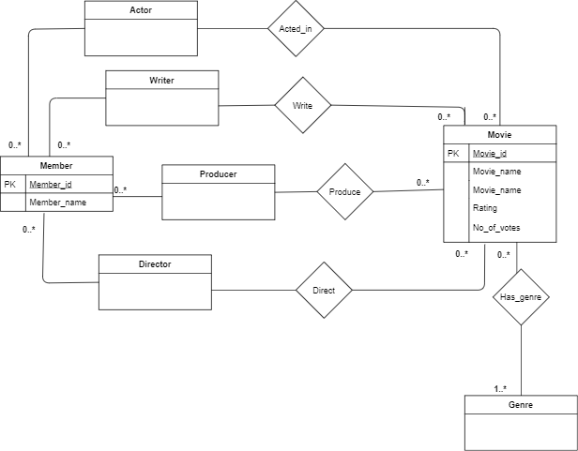

**Relational Model and table descriptions**

**Table Name :** Movie (**Movie_id**(PK) , movie_name, Rating, no_of_votes)

|  |  |  |  |
| --- | --- | --- | --- |
| Movie_id (PK) | movie_name | Rating | no_of_votes |
| 1 | Interstellar | 10.00 | 10000 |
| 2 | Rush | 10.00 | 5000 |

* Movie table has been populated from the **title.basics** data file.
* To ensure that we are not committing everytime we insert a tuple, I have used **preparedStatement.addBatch**, which will be executed only when a certain counter value is reached. This helps to save time.
* It consists of the all non-adult movies
  + **Solving Issues**:
    - I chose t_const as my primary key as it was unique.

(eg: tt0000001)

* + - To convert it from **String to Integer** I discarded the first 2 alphabets, so I was left with only numbers.
    - Then I used Interger.parseInt() to covert the key from String to integer format
    - Some of the movies have really big names. Hence, I have used TEXT for movie_name to accommodate large values
    - To make sure I’m adding only non-adult movies I simply skip the movie if is_adult ==”1”
    - The values of each movie visited as been stored in a Hashmap so we can get it in O(1) time.
* **Ratings(double)** and **no_of_votes(double)** have been taken from the title.ratings table. Converted to double using **Double.parseDouble()**
* We store them in a Hashmap comprising of **Movie_primary_key: Rating** so we can add to the movie table in O(1) time.
* Null values have been checked using regex and if true, we skip.
* If we don’t have a ratings or No_of_votes, put -1 instead

**Table Name :** Member ( Member_id (PK) , member_name)

|  |  |
| --- | --- |
| Member_id (PK) | member_name |
| 56 | Matthew McConaughey |
| 92 | Chris hemsworth |

* The member table consists of all the people and has been loaded from the **name.basics** dataset
* We store each Member_id in a HashMap so that we can access it in O(1) time when needed while creating the Writer, Acted_in, Producer and Director table.

**Table Name :** Has_genre ( **moviegenre_id** , genre_name)

* + moviegenre_id FK Movie (Movie_id)

|  |  |
| --- | --- |
| moviegenre_id (FK) Movie (Movie_id) | genre_name |
| 1 | Fiction |
| 2 | Thriller |
| 2 | Short |

* Has_genre has been loaded from the **title.basics** dataset.
* Instead of creating another table for called Genre(id, genre_name), Has_genre has been created which does the same function of mapping different genres to a movie and visa versa.

**Table Name :** Acted_in ( **movieacted_id , name_id**)

* + Movieacted_id FK Movie(Movie_id)
  + Name_id FK member(member_id).

|  |  |
| --- | --- |
| Movieacted_id FK Movie(Movie_id) | Name_id FK member(member_id) |
| 1 | 56 |
| 2 |  |
|  |  |

* Created Since each member can act in many movies and each movie can have many members, (many to many relation)
* This table maps Movie_ids to Name_ids of actors, i.e only members with category = “actor” or “actress” will be included.
* We maintain FK constraint by checking if values we are adding are in the member hash table as well as in the Movie Hashtable

**Table Name :** Direct ( directed_id**, name_id**)

* + directed_id FK Movie(Movie_id)
  + Name_id FK member(member_id).

|  |  |
| --- | --- |
| directed_id FK Movie(Movie_id) | Name_id FK member(member_id) |
| 400 | 79 |
| 30 | 45 |
|  |  |

* Created Since each member can Direct many movies and each movie can have many members, (many to many relation)
* This table maps Movie_ids to Name_ids of Director, i.e only members with category = “director” will be included.
* We maintain FK constraint by checking if values we are adding are in the member hash table as well as in the Movie Hashtable

**Table Name :** Write (**written_id , name_id**)

* + **written_id** FK Movie(Movie_id)
  + Name_id FK member(member_id).

|  |  |
| --- | --- |
| **written_id** FK Movie(Movie_id | Name_id FK member(member_id) |
| 4 | 70 |
| 33 | 40 |
|  |  |

* Created Since each member can Write many movies and each movie can have many members, (many to many relation)
* This table maps Movie_ids to Name_ids of Writer, i.e only members with category = “Writer” will be included.
* We maintain FK constraint by checking if values we are adding are in the member hash table as well as in the Movie Hashtable

**Table Name :** Produce ( producer**_id , name_id**)

* + producer_id FK Movie(Movie_id)
  + Name_id FK member(member_id).

|  |  |
| --- | --- |
| **Producer_id** FK Movie(Movie_id | Name_id FK member(member_id) |
| 6 | 4570 |
| 39 | 140 |
|  |  |

* Created Since each member can Produce many movies and each movie can have many members, (many to many relation)
* This table maps Movie_ids to Name_ids of Writer, i.e only members with category = “Producer” will be included.
* We maintain FK constraint by checking if values we are adding are in the member hash table as well as in the Movie Hashtable

**Time Taken** : 25mins to load the whole dataset.