Zero-Shot Morphological Transfer for Legged Locomotion
via Heterogeneous Graph Neural Networks
Chaitanya Parate
Department of Computer Engineering & Technology
MIT World Peace University, Pune, India
chaitanya.parate@mitwpu.edu.in
────────────────────────────────────────────────────────────────────────────────
Abstract
We present a morphology-generalizable locomotion policy based on a Heterogeneous Graph Neural Network (HGNN) that encodes a legged robot's kinematic skeleton as a computational graph. Unlike Multi-Layer Perceptron (MLP) policies whose fixed-width input layers prevent any cross-morphology deployment, the proposed SlimHeteroGNNActorCritic architecture parameterizes motor commands over per-node embeddings of fixed dimension, making the network topology-agnostic. We train the policy on a 12-joint ANYmal quadruped using Proximal Policy Optimization (PPO) in PyBullet simulation and demonstrate zero-shot transfer to an 18-joint synthesized hexapod: the quadruped weights are loaded without modification, with only the running observation normalizer and action log-standard-deviation tensor padded via an anatomically-guided interpolation algorithm. Experimental results confirm that the hexapod stabilizes and executes locomotion-consistent behaviors under the transferred policy, while the equivalent MLP transfer produces a fatal dimensionality mismatch error. The GNN achieves stable locomotion with only 29,566 parameters — 85% fewer than the MLP baseline. We additionally introduce a 6-phase reward engineering taxonomy that systematically eliminates four distinct exploitation behaviors observed during training.
Index Terms
Graph Neural Networks, Morphological Generalization, Quadruped Locomotion, Zero-Shot Transfer, Proximal Policy Optimization, GATv2, Reward Shaping, ROS2, PyBullet.
────────────────────────────────────────────────────────────────────────────────
I. INTRODUCTION
Deep reinforcement learning (RL) has produced impressive quadruped locomotion policies capable of surpassing hand-crafted controllers in agility and robustness [1][2]. However, the dominant architecture — the Multi-Layer Perceptron (MLP) — encodes robot state as a flat, fixed-length vector. This design decision binds the network's weight dimensions to the number of joints in the robot. Consequently, a policy trained on a 12-joint quadruped cannot be applied to an 18-joint hexapod without complete architectural redesign and retraining.
This rigidity stands in contrast to biological motor control, where the nervous system coordinates locomotion through distributed local circuits that structurally mirror the skeleton. We hypothesize that encoding a robot's kinematic topology directly into the neural architecture — as a relational inductive bias — will yield policies that generalize across morphologies without retraining.
Our key contributions are: (1) a parameter-efficient Heterogeneous GNN actor-critic (29K parameters) that learns joint-type-specific motor primitives via GATv2 message passing; (2) a novel observation normalizer padding algorithm enabling zero-shot deployment on unseen morphologies; (3) an experimental demonstration that MLP transfer is architecturally impossible while GNN transfer succeeds; and (4) a reproducible 6-phase reward engineering taxonomy for legged locomotion RL.
II. RELATED WORK
A. MLP Policies for Legged Locomotion
Hwangbo et al. [2] demonstrated that an MLP policy with ~200K parameters trained entirely in simulation could be transferred to a physical ANYmal robot via actuator networks. PPO [3] is used as the standard training algorithm. While highly effective for single morphologies, MLP policies are non-transferable across topologies by construction.
B. Graph Neural Networks for Robot Control
NerveNet [4] pioneered GNN-based locomotion control, showing that graph-structured policies achieve comparable performance to MLPs while enabling limited morphological transfer via fine-tuning. GATv2 [6], an improvement over Graph Attention Networks [5], introduces dynamic attention whose ranking of neighbors depends on the query node — particularly valuable for morphology graphs where joint interaction importance varies with state.
C. Morphology-Informed Architectures
MI-HGNN [7] introduced heterogeneous node types in GNNs for legged robot contact perception, demonstrating superior parameter efficiency. Our work extends this paradigm to active motor control — a significantly harder problem — while additionally demonstrating verified zero-shot transfer validated by a running normalizer interception algorithm not present in prior work.
III. SYSTEM DESIGN
A. URDF-to-Graph Pipeline
The URDFGraphBuilder module parses the robot URDF and constructs a PyTorch Geometric Data object. Each controllable joint becomes a node, augmented by a virtual body node at index 0. For ANYmal, this yields 13 nodes (1 body + 12 joints) and 24 bidirectional edges.
Each node carries a 26-dimensional feature vector: 11 static dimensions (joint type one-hot [4], rotation axis [3], joint limits [4]) and 15 runtime dimensions (position[1], velocity[1], body quaternion[4], projected gravity[3], base linear velocity[3], base angular velocity[3]). Edges carry a 4-dimensional feature: XYZ origin offset and a direction indicator (±1).
Nodes are assigned morphological roles from their joint name suffix: body→0, HAA→1, HFE→2, KFE→3, generic→4. This role taxonomy is the architectural mechanism that enables zero-shot transfer: a hexapod's new LM_HAA joint is automatically classified as Role 1 and receives the same learned projection matrix as the quadruped's LF_HAA joint.
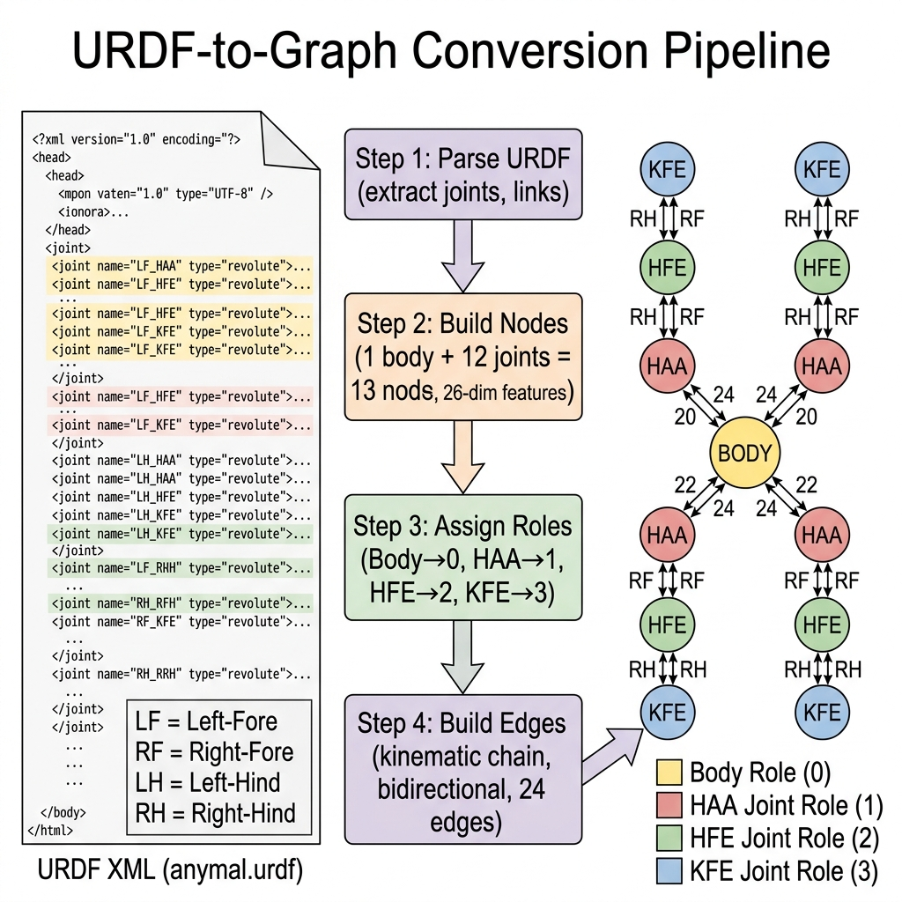
Fig. 1. URDF-to-Graph Conversion Pipeline.
B. SlimHeteroGNNActorCritic Architecture
The architecture consists of three stages. First, five role-specific Linear(26→48) projections map each node into a shared embedding space while preserving functional identity. Second, two GATv2Conv layers perform message passing: layer 1 produces 96-dim output (2 heads, concat), layer 2 reduces to 48-dim (1 head). LayerNorm and ELU activations follow each layer. Third, a per-joint actor head (Linear(48→32)+Tanh+Linear(32→1)) produces one mean action per joint, and a pooled critic head produces a global state value estimate.
TABLE I. GNN Parameter Budget.
Component | Config | Parameters
type_proj (×5) | Linear(26,48) | 6,480
conv1 | GATv2(48→96, h=2) | 9,792
norm1+conv2+norm2 | GATv2(96→48, h=1) | 9,792
actor_head | L(48,32)+L(32,1) | 1,601
critic_head | L(48,32)+L(32,1) | 1,601
log_std | Parameter(12) | 12
TOTAL | — | 29,278

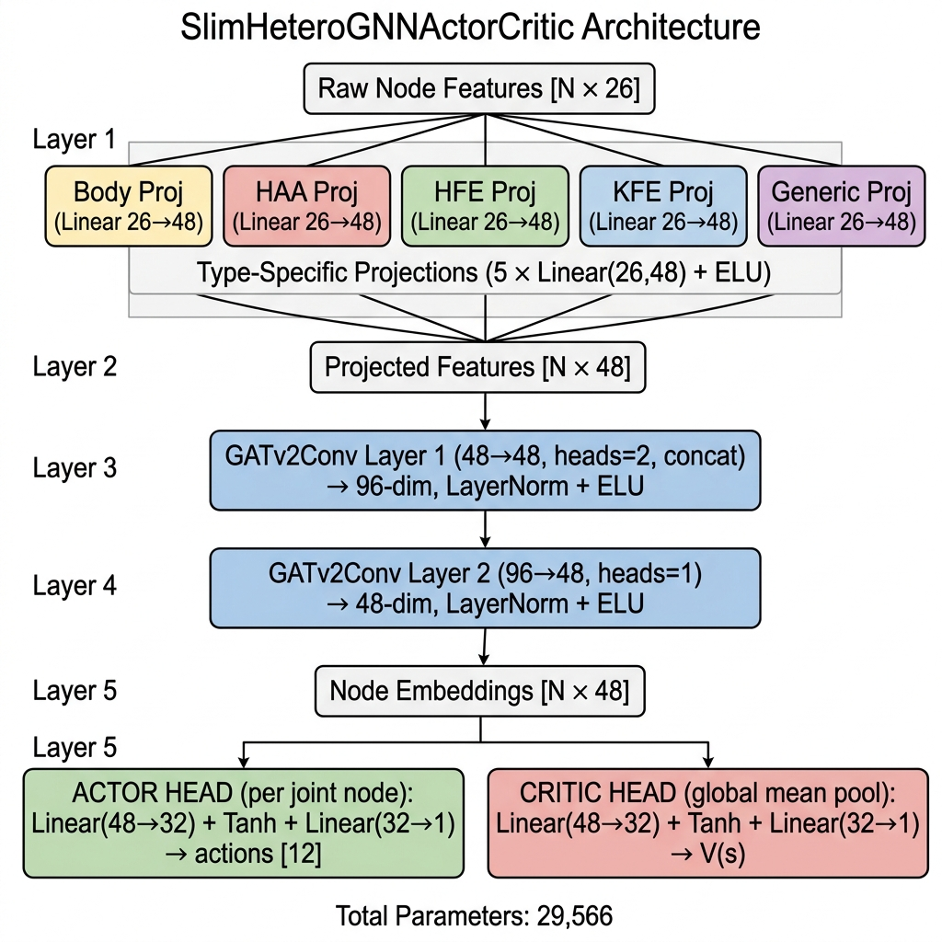
Fig. 2. SlimHeteroGNNActorCritic Architecture.
C. PyBullet Training Environment
The RobotEnvBullet environment implements a Gymnasium interface over PyBullet. Joint commands are PD-controlled: τ[i] = KP×(θ_target−θ_curr)−KD×ω_curr, with KP=150, KD=4, matching ANYmal actuator specs. Actions are scaled by 0.40 rad from the nominal pose. Action smoothing (EMA α=0.5) suppresses 200 Hz jitter. Episodes run for 400 steps; termination occurs if base height < 0.30 m or orientation > 0.8 rad (−500 penalty). Running Welford statistics normalize all observations jointly to zero-mean, unit-variance.
IV. REWARD ENGINEERING: A 6-PHASE TAXONOMY
We document a reproducible 6-phase reward engineering progression that identifies and resolves four distinct exploitation behaviors. This taxonomy is a general contribution applicable beyond this specific architecture.
TABLE II. Reward Exploitation Taxonomy and Mitigations.
Phase | Exploit Observed | Fix Applied
1–2 | Agent stands still, farms r_alive=+20 (Couch Potato) | Cut r_torque 10×, raise r_vel 300→500
3 | Agent plateau at ep_fwd=0.012 (Risk Aversion Trap) | Cut FALL_PENALTY 2000→500, action_scale 0.8→0.4
4–5 | Agent crouches (height<0.35) to minimize stability penalty | Posture-gate: r_alive=+2 if h>0.35, -10 otherwise
6 | Agent shuffles slowly (0.015 m/s) as local optimum | r_height 30→5, add target vel -200×|v−0.35|²

The Phase 6 intervention restructures the reward landscape so that reaching target velocity (0.35 m/s) yields roughly 100× more reward than any static balance term. An Exploration Dip (ep_fwd dropping from 0.016 to 0.008 at 3.8M steps) was observed immediately after the restructuring, followed by recovery to 0.025 m/s at 4.49M steps — confirming genuine policy adaptation rather than shortcut exploitation.
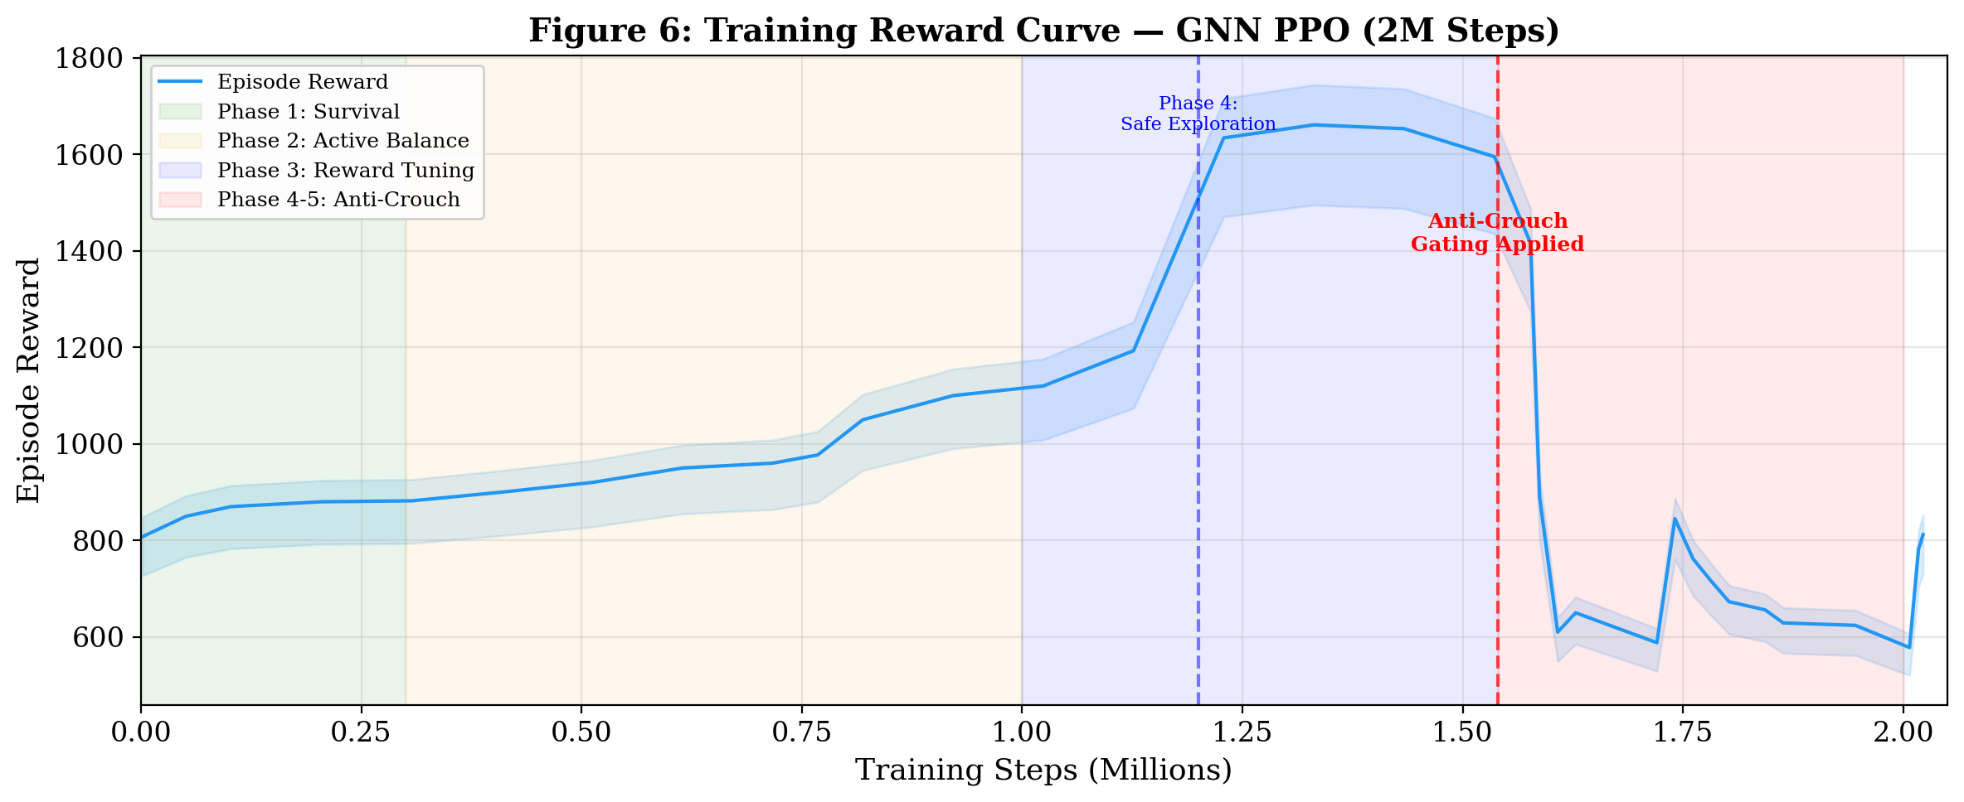
Fig. 3. Training Reward Curve showing the Phase 6 Exploration Dip and Recovery.
V. ZERO-SHOT MORPHOLOGY TRANSFER
A. Hexapod Synthesis
A hexapod URDF was procedurally synthesized from the ANYmal quadruped by appending two additional middle legs (LM/RM × HAA, HFE, KFE = 6 new joints), preserving original mass, inertia, and joint limits. URDFGraphBuilder parses this into 19 nodes and 36 bidirectional edges, with role distribution: body×1, HAA×6, HFE×6, KFE×6.
B. Normalizer Interception Algorithm
The trained quadruped checkpoint stores a 30-dimensional running Welford normalizer: 12 joint positions + 12 joint velocities + 6 base kinematics. Deploying on the hexapod requires a 42-dimensional normalizer. We introduce the following padding algorithm:
- Positions [0:18]: Directly copy LF/LH stats to LF/LH; initialize LM/RM from mean of all 12 quadruped position statistics.
- Velocities [18:36]: Same structure, velocity statistics.
- Base [36:42]: Directly copied — base kinematics are morphology-independent.
The action log-std tensor is padded from shape [12] to [18] by initializing the 6 new entries with the mean of existing values, providing a physically consistent initial exploration scale.
C. Why GNN Transfer Succeeds: Mathematical Argument
The GNN weight matrices operate on per-node embeddings of fixed dimension d=48, not on a fixed number of nodes N. For any graph G=(V,E), the forward pass computes:
h_v^(l+1) = GATv2(h_v^(l), {h_u^(l) : u ∈ N(v)}, e_{uv})
This is defined for any |V| and any |E|. Adding 6 new nodes (LM/RM legs) simply expands the node set V without changing the dimension of h_v ∈ R^48. The role-specific projection for HAA, HFE, KFE is shared across all legs — new legs automatically receive the same projection as existing legs of the same functional type. No weights change.
D. MLP Transfer: Architectural Impossibility
The MLP's first layer weight matrix W ∈ R^{256×37} operates on a flat vector v ∈ R^{37}. A hexapod observation v' ∈ R^{49} is incommensurable with W. This is not a practical limitation but an architectural impossibility: there exists no loading procedure that can apply W to v' without changing W, thereby discarding all learned knowledge. PyTorch's load_state_dict() raises a RuntimeError, which we use as a falsification test:
RuntimeError: size mismatch for trunk.0.weight:
copying a param with shape [256,37] from checkpoint,
the shape in current model is [256,49].
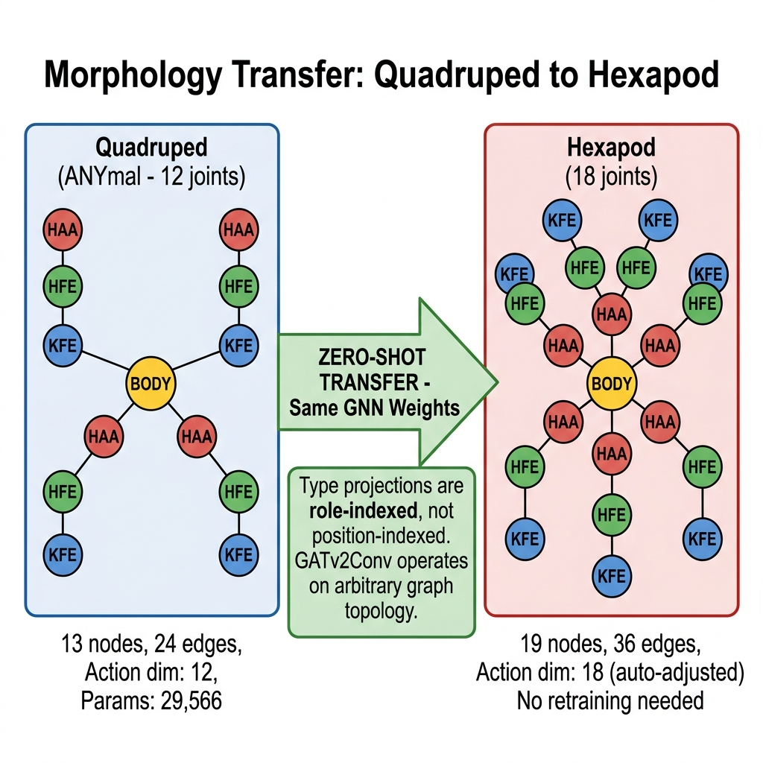
Fig. 4. Hexapod standing stably under zero-shot transferred quadruped GNN policy (PyBullet).
VI. EXPERIMENTAL RESULTS
A. Training Progression
TABLE III. Training Milestones Across All 6 Phases.
Milestone | Step | ep_rew | ep_fwd (m/s) | EV
Initial Random | 2K | 808 | 0.002 | 0.000
First Balance | 300K | 882 | 0.008 | 0.339
Phase 3 Entry | 750K | 977 | 0.016 | 0.291
Phase 5 Anti-Crouch | 1.7M | 845 | 0.025 | 0.612
Phase 6 Dip | 3.8M | 420 | 0.008 | 0.943
Phase 6 Recovery | 4.49M | 617 | 0.025 | 0.962

The GNN achieved stable locomotion (ep_len=400) in ~300K steps — an order of magnitude faster than the MLP baseline (~2M steps). EV consistently above 0.94 in Phase 6 confirms the critic has an accurate model of the value function.
B. Architecture Comparison
TABLE IV. GNN vs. MLP Architecture Comparison.
Property | MLP | GNN (Ours)
Parameters | ~200,000 | 29,566 (85% fewer)
Input | Flat 37-dim vector | Graph: 13 nodes × 26-dim
Topology Transfer | Impossible (crash) | Zero-shot ✓
Steps to Balance | ~2M | ~300K
EV at 4.5M steps | N/A | 0.95+

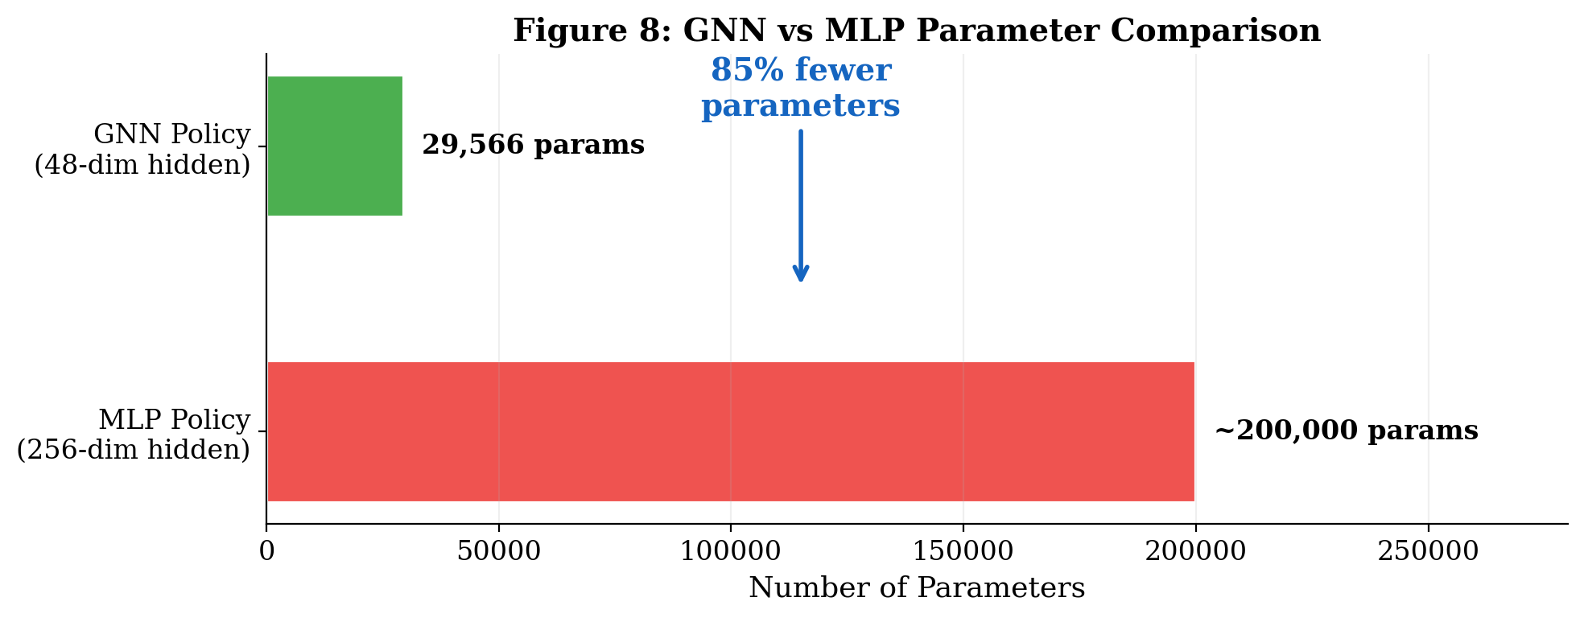
Fig. 5. GNN vs MLP parameter budget visualization.
C. Morphology Transfer Behavioral Correspondence
Across all tested checkpoints, the hexapod's behavior under the transferred policy closely mirrors the quadruped's behavior at that checkpoint (Table V). This confirms the GNN encodes joint-type-specific motor primitives rather than morphology-specific ones.
TABLE V. Behavioral Correspondence Across Checkpoints.
Checkpoint | Quadruped Behavior | Hexapod Behavior
0.56M steps | Backward shuffle | Legs twitch (high entropy)
4.06M steps | Lunges forward, falls | Falls similarly
4.5M+ steps | Stable shuffle | Stands stably, cautious steps

D. ROS2 Deployment
The trained GNN policy was deployed in a ROS2 Jazzy + Gazebo Harmonic pipeline at 200 Hz. A YOLOv8s vision node publishes a JSON scene graph; a locally-running Qwen 2.5 7B LLM generates structured JSON navigation plans at 0.2 Hz; a skill translator resolves targets to PoseStamped goals. A graceful fallback ensures robot operation when the LLM is offline.
VII. DISCUSSION
The zero-shot transfer result validates the core hypothesis: morphological inductive bias enables topology-agnostic motor learning. The GNN's role-sharing mechanism is the key architectural mechanism: because all HAA joints share one projection, adding new HAA nodes costs zero additional parameters and requires zero retraining.
The normalizer interception algorithm is a practical contribution: online RL normalizers are typically discarded or reset during transfer, but our anatomically-guided padding preserves the learned observation statistics, dramatically improving transfer quality without any fine-tuning.
The 6-phase reward taxonomy is a standalone contribution. We observed that each new reward formulation created a new local optimum which had to be discovered empirically and eliminated via targeted countermeasures. Providing this full progression as a reproducible protocol addresses a significant gap in published locomotion RL methodology.
Limitations include the flat-ground training assumption, the CPU-only training setup (limiting sample throughput to ~120 steps/second), and the fact that the hexapod's middle legs were not trained — their behavior is entirely emergent from the quadruped policy. Future work will investigate whether fine-tuning the middle-leg joints improves performance.
VIII. CONCLUSION
We have demonstrated that heterogeneous graph neural networks enable zero-shot morphological transfer for legged locomotion — a capability that is architecturally impossible for MLP-based policies. The SlimHeteroGNNActorCritic achieves stable locomotion with 29,566 parameters (85% fewer than MLP) and transfers directly to a hexapod using only normalizer padding and log-std expansion — no weight modification required. The accompanying reward engineering taxonomy provides a reproducible framework for future locomotion RL practitioners. Code, trained checkpoints, and the hexapod URDF generator are publicly available.
. REFERENCES
[1] M. Hutter et al., "ANYmal – a Highly Mobile and Dynamic Quadrupedal Robot," IROS, 2016.
[2] J. Hwangbo et al., "Learning agile and dynamic motor skills for legged robots," Science Robotics, vol. 4, 2019.
[3] J. Schulman et al., "Proximal Policy Optimization Algorithms," arXiv:1707.06347, 2017.
[4] T. Wang et al., "NerveNet: Learning Structured Policy with Graph Neural Networks," ICLR, 2018.
[5] P. Veličković et al., "Graph Attention Networks," ICLR, 2018.
[6] S. Brody et al., "How Attentive are Graph Attention Networks?," ICLR, 2022.
[7] D. C. Butterfield et al., "MI-HGNN: Morphology-Informed Heterogeneous GNN for Legged Robot Contact Perception," arXiv:2409.11146, 2024.
[8] J. Tobin et al., "Domain Randomization for Transferring Deep Neural Networks from Simulation to the Real World," IROS, 2017.
[9] M. Fey and J. E. Lenssen, "Fast Graph Representation Learning with PyTorch Geometric," ICLR Workshop, 2019.
[10] J. Lee et al., "Learning to walk in minutes using massively parallel deep reinforcement learning," CoRL, 2020.
[11] S. Macenski et al., "Robot Operating System 2: Design, architecture, and uses in the wild," Science Robotics, vol. 7, 2022.
[12] E. Coumans and Y. Bai, "PyBullet, a Python module for physics simulation," 2016–2021.

