Seminar Report

On

Relational Bias for Morphological Generalization in Robotic Locomotion Control Using Graph Neural Networks

By

Chaitanya Parate
PRN: 1032230750

Under the guidance of

Prof. XYZ

Dr. Vishwanath Karad MIT World Peace University
School of Computer Science & Engineering
Department of Computer Engineering & Technology

* 2025-2026 *

Dr. Vishwanath Karad MIT World Peace University
School of Computer Engineering & Technology
Department of Computer Engineering & Technology

CERTIFICATE

This is to certify that Mr. Chaitanya Parate of T.Y. B.Tech., School of Computer Engineering & Technology, Department of Computer Engineering & Technology, CSE-Core, Semester – VI, PRN. No. 1032220888, has successfully completed seminar on

Relational Bias for Morphological Generalization in Robotic Locomotion Control Using Graph Neural Networks

To my satisfaction and submitted the same during the academic year 2025-2026 towards the partial fulfillment of degree of Bachelor of Technology in School of Computer Engineering & Technology under Dr. Vishwanath Karad MIT-World Peace University, Pune.

_________________ Dr. Balaji Patil
Seminar Guide Program Director
Name & Sign Department of Computer Engineering & Technology

LIST OF FIGURES
Figure 1: System Architecture of Morphology-Generalizable Robotic Control
Figure 2: URDF-to-Graph Conversion Pipeline for ANYmal Quadruped
Figure 3: SlimHeteroGNNActorCritic Architecture
Figure 4: GATv2Conv Message-Passing Mechanism
Figure 5: ROS2 Node Communication Graph
Figure 6: Training Reward Curve — GNN PPO (2M Steps)
Figure 7: Explained Variance Progression Over Training
Figure 8: GNN vs MLP Parameter Comparison
Figure 9: Morphology Transfer: Quadruped to Hexapod
Figure 10: Gazebo Simulation — ANYmal in Warehouse Environment

LIST OF TABLES
Table 1: GNN Parameter Budget Breakdown
Table 2: Reward Function Components and Weights
Table 3: Training Hyperparameters — GNN PPO
Table 4: MLP vs GNN Architecture Comparison
Table 5: Training Log Summary at Key Milestones
Table 6: ROS2 Node Configuration Summary

ABBREVIATIONS
Abbreviation | Full Form
GNN | Graph Neural Network
MLP | Multi-Layer Perceptron
PPO | Proximal Policy Optimization
RL | Reinforcement Learning
URDF | Unified Robot Description Format
ROS2 | Robot Operating System 2
GATv2 | Graph Attention Network Version 2
MI-HGNN | Morphology-Informed Heterogeneous Graph Neural Network
HAA | Hip Abduction/Adduction
HFE | Hip Flexion/Extension
KFE | Knee Flexion/Extension
PD | Proportional-Derivative (Controller)
EMA | Exponential Moving Average
LLM | Large Language Model
SDF | Simulation Description Format
YOLO | You Only Look Once
EV | Explained Variance
KL | Kullback-Leibler (Divergence)

ACKNOWLEDGEMENT
I would like to express my sincere gratitude to my seminar guide for their invaluable guidance and constant support throughout the course of this seminar. Their insightful suggestions and encouragement have been instrumental in shaping this work.
I am also thankful to Dr. Balaji Patil, Program Director, Department of Computer Engineering & Technology, for providing the necessary infrastructure and academic environment to carry out this seminar.
I extend my thanks to Dr. Vishwanath Karad MIT World Peace University for providing the computational resources and platform necessary for this research.
Finally, I would like to thank my family and friends for their unwavering support and encouragement throughout this journey.

Chaitanya Parate
PRN: 1032220888

INDEX
1. | Introduction | 1
1.1 | Motivation | 1
1.2 | Problem Statement | 2
1.3 | Objectives | 2
1.4 | Organization of Report | 3
2. | Literature Survey | 4
2.1 | Neural Network Policies for Locomotion | 4
2.2 | Graph Neural Networks for Robot Control | 5
2.3 | Morphology-Informed Architectures | 6
2.4 | Sim-to-Real Transfer | 7
3. | System Design and Architecture | 8
3.1 | Overall System Architecture | 8
3.2 | URDF-to-Graph Pipeline | 9
3.3 | GNN Actor-Critic Architecture | 10
3.4 | Training Environment (PyBullet) | 12
3.5 | Reward Function Design | 13
3.6 | ROS2 Deployment Pipeline | 15
4. | Experimental Work | 17
4.1 | Training Configuration | 17
4.2 | MLP Baseline | 18
4.3 | GNN Training Progression | 18
4.4 | Reward Shaping Iterations | 20
4.5 | Results and Analysis | 22
5. | Conclusion | 24
5.1 | Summary | 24
5.2 | Key Contributions | 24
5.3 | Future Work | 25
 | References | 26

ABSTRACT
Traditional deep reinforcement learning (RL) approaches to quadruped locomotion typically employ Multi-Layer Perceptron (MLP) policies that process flat observation vectors. While effective for single morphologies, these policies are inherently non-transferable — a policy trained on a quadruped cannot be deployed on a hexapod without complete retraining. This seminar presents a morphology-generalizable approach to robotic locomotion control using Graph Neural Networks (GNNs) that encode the robot's physical kinematic structure as an inductive bias.
The proposed system constructs a heterogeneous graph from the robot's URDF (Unified Robot Description Format) file, where nodes represent joints and a virtual body node, and edges represent kinematic connections. A SlimHeteroGNNActorCritic architecture, inspired by the MI-HGNN framework, employs role-specific type projections and GATv2 attention-based message passing to generate joint-level actions while maintaining morphological symmetry. The architecture achieves this with only 29,566 parameters — approximately 85% fewer than the MLP baseline.
The system is trained using Proximal Policy Optimization (PPO) in a PyBullet physics simulation of the ANYmal quadruped robot, with a carefully engineered reward function that includes forward velocity incentives, posture-gated survival bonuses, and action smoothing. The trained policy is deployed in a complete ROS2 Jazzy pipeline integrated with Gazebo Harmonic simulation, featuring YOLOv8-based vision perception, LLM-based task planning via Ollama, and a skill translator for autonomous navigation.
Table 0: Quick Reference — Key Project Metrics
Metric | GNN Policy | MLP Baseline
Parameters | 29,566 | ~200,000
Steps to Stable Balance | ~300K | ~2M
Max Forward Velocity (5M steps) | 0.025 m/s | 0.30 m/s
Morphology Transfer | Zero-Shot ✓ | Not Possible ✗
Observation Type | Heterogeneous Graph | Flat 37-dim Vector
Training Algorithm | PPO + GATv2 | PPO + MLP
Physics Engine | PyBullet | PyBullet
Deployment | ROS2 Jazzy + Gazebo Harmonic | ROS2 Jazzy + Gazebo Harmonic

Keywords
Graph Neural Networks, Morphological Generalization, Quadruped Locomotion, Proximal Policy Optimization, Reinforcement Learning, ROS2, GATv2, Heterogeneous Graph, URDF, Sim-to-Real Transfer, Zero-Shot Transfer, ANYmal

CHAPTER 1: INTRODUCTION
1. INTRODUCTION
Autonomous quadruped locomotion has emerged as a critical capability for robotic systems intended to operate in unstructured environments such as disaster response, industrial inspection, and planetary exploration. Deep reinforcement learning (RL) has demonstrated remarkable success in generating agile locomotion policies for legged robots, enabling behaviors that surpass hand-crafted controllers in adaptability and robustness.
However, a fundamental limitation persists in current approaches: the neural network architecture used to represent locomotion policies — typically Multi-Layer Perceptrons (MLPs) — treats the robot's state as a flat, unstructured vector. This design fundamentally ignores the physical structure of the robot, creating policies that are tightly coupled to a specific morphology. A policy trained on a quadruped (12 joints) cannot be transferred to a hexapod (18 joints) or even to a different quadruped with a modified kinematic topology without complete retraining.
1.1 Motivation
The motivation for this work stems from an observation in biological systems: animals with vastly different morphologies (cats, dogs, horses) employ remarkably similar neural control strategies organized around their skeletal structure. The nervous system does not process all motor signals through a single central bottleneck; instead, it uses a distributed architecture where local neural circuits at each joint coordinate with neighbors through structured pathways that mirror the physical connectivity of the skeleton.
This biological insight suggests that encoding the robot's morphological structure directly into the network architecture — as a relational inductive bias — could yield policies that are both more sample-efficient (by constraining the hypothesis space) and inherently transferable across morphologies (by operating on structural graphs rather than fixed-length vectors).
1.2 Problem Statement
To design and implement a graph neural network-based locomotion policy that:
- Encodes the robot's kinematic structure as a computational graph extracted from its URDF specification.
- Uses morphology-aware message passing to produce joint-level motor commands.
- Achieves stable quadruped locomotion through PPO-based reinforcement learning in physics simulation.
- Demonstrates zero-shot morphological transfer by successfully driving an 18-joint hexapod using weights trained solely on a 12-joint quadruped.
- Integrates with a complete autonomous robotics stack (ROS2, vision, LLM planning) for deployment.
1.3 Objectives
- Develop a URDF-to-Graph pipeline that automatically constructs heterogeneous computational graphs from arbitrary robot descriptions.
- Design a parameter-efficient GNN actor-critic architecture (<50K parameters) with morphological type projections.
- Train the GNN policy using PPO with domain randomization in PyBullet simulation.
- Compare GNN and MLP-based policies in terms of parameter efficiency, training dynamics, and generalization potential.
- Deploy the trained policy in a ROS2/Gazebo simulation environment with vision and planning integration.
1.4 Scope and Limitations
This seminar focuses on the algorithmic design and simulation validation of the GNN locomotion policy. Physical hardware deployment on an actual ANYmal robot is not within the scope of this work; instead, a Gazebo Harmonic simulation with physics fidelity serves as the deployment target. The morphological generalization experiments are validated on a synthesized hexapod derived from the ANYmal URDF with additional middle-leg appendages, maintaining the same mass and inertial properties of the original segments. The following topics are explicitly out of scope: contact force estimation, whole-body motion planning, 3D terrain traversal (all training was performed on flat ground).
1.5 Theoretical Foundation: Inductive Bias in Neural Networks
An inductive bias is a prior assumption embedded in a learning algorithm that constrains the hypothesis space searched during training. Standard MLPs carry almost no structural inductive bias — they are universal function approximators that must rediscover structure from scratch in every training run. This is computationally expensive and produces representations that do not align with the physical world.
Convolutional Neural Networks (CNNs) carry translation invariance as an inductive bias, which makes them highly parameter-efficient for image classification. Similarly, encoding the robot's kinematic topology into a graph introduces a permutation equivariance and local structure preservation inductive bias. Specifically:
- Permutation Equivariance: The policy output for the LF leg is identical regardless of whether LF appears first or last in the node list, because GNNs process nodes based on structural position, not index.
- Structural Locality: Information propagates from joint to joint along physical connections. A knee joint only directly receives messages from its hip, not from the opposite leg's shoulder — mirroring biological motor control.
- Role Sharing: All joints of the same functional type (e.g., all four HFE joints) share the same weight matrix, drastically reducing the parameter count relative to an MLP while enforcing biological symmetry.
These structural constraints are the precise reasons why the GNN architecture naturally generalizes to new morphologies: adding new nodes to the graph is semantically equivalent to connecting new joints to the existing skeleton, and the shared role projections automatically handle them without any modification to the learned weights.
1.6 Contribution Summary
The primary contributions of this seminar project, relative to prior art in the literature, are:
- [C1] End-to-end PPO training of a GATv2-based heterogeneous GNN for continuous quadruped locomotion control, achieving stable 400-step episodes in simulation.
- [C2] A novel observation normalization intercept algorithm that pads a 12-joint running normalizer into an 18-joint normalizer, enabling zero-shot hexapod deployment with physically meaningful observations.
- [C3] An experimentally validated 6-phase reward engineering progression that identifies and eliminates four distinct reward exploitation behaviors, providing a reusable framework applicable to any legged locomotion training scenario.
- [C4] Empirical demonstration of MLP transfer failure, yielding a provably useful experimental control group: the GNN generalizes while the MLP fatally crashes with a dimensionality error.
- [C5] A complete production ROS2 Jazzy deployment stack with graceful LLM fallback, enabling robot operation to continue seamlessly under partial system failure (e.g., Ollama server offline).
1.7 Organization of Report
Chapter 2 presents a comprehensive literature survey covering neural network policies for locomotion, graph neural networks in robotics, and morphology-informed architectures. Chapter 3 details the system design including the URDF-to-graph pipeline, GNN architecture, training environment, reward function, and ROS2 deployment pipeline. Chapter 4 describes the experimental methodology and presents results from training progression analysis, reward engineering, and morphology transfer experiments. Chapter 5 concludes with a summary of contributions and future research directions. An appendix includes the full PyBullet environment specification, complete reward function pseudocode, and graph construction algorithm.

CHAPTER 2: LITERATURE SURVEY
2. LITERATURE SURVEY
2.1 Neural Network Policies for Locomotion
The use of deep reinforcement learning for quadruped locomotion was pioneered by works at ETH Zurich on the ANYmal robot platform [1]. Hwangbo et al. demonstrated that a neural network policy trained entirely in simulation could be successfully transferred to a physical ANYmal robot, achieving robust locomotion over challenging terrain [2]. Their approach used an MLP policy with approximately 200,000 parameters, trained using PPO with actuator network-based sim-to-real transfer.
Proximal Policy Optimization (PPO), introduced by Schulman et al. [3], has become the de facto standard algorithm for continuous robotic control. PPO constrains policy updates via a clipped surrogate objective, preventing catastrophically large gradient steps while maintaining computational simplicity. The algorithm's stability has made it particularly well-suited for locomotion tasks where exploration must be carefully balanced against exploitation.
While MLP-based policies have achieved impressive results, they suffer from a fundamental architectural limitation: the input dimension is fixed at design time. This means a policy trained for a 12-joint quadruped cannot accept observations from an 18-joint hexapod, precluding any form of morphological transfer without architectural modification and retraining.
2.2 Graph Neural Networks for Robot Control
NerveNet [4], proposed by Wang et al. at ICLR 2018, was among the first works to represent robot control policies as graph neural networks. NerveNet constructs a graph where nodes correspond to robot body parts and edges represent physical connections. The policy operates by propagating messages through this graph structure, enabling information sharing between physically connected components.
The key contribution of NerveNet was demonstrating that GNN-based policies could achieve comparable performance to MLP policies on locomotion benchmarks while offering superior transfer capabilities. A policy trained on a centipede with 6 legs could be successfully transferred to a centipede with 8 legs with minimal fine-tuning, a capability entirely absent in MLP architectures.
Graph Attention Networks (GATs), introduced by Veličković et al. [5] and subsequently improved by Brody et al. with GATv2 [6], brought attention mechanisms to graph-structured data. GATv2 specifically addressed a limitation of the original GAT — static attention — by introducing dynamic attention where the ranking of neighbors depends on the query node. This expressiveness is particularly valuable in robotic morphology graphs where the relative importance of neighboring joints varies based on the current state.
2.3 Morphology-Informed Architectures
The Morphology-Informed Heterogeneous Graph Neural Network (MI-HGNN) [7], proposed by Butterfield et al. in 2024, represents the state-of-the-art in morphology-aware robot learning. MI-HGNN introduced heterogeneous node types that correspond to functionally distinct joint categories (hip abduction, hip flexion, knee flexion), each receiving its own learned input projection before message passing.
The heterogeneous design ensures that joints with similar mechanical functions (e.g., all four HFE joints in a quadruped) share the same learned representation space, enforcing morphological symmetry while allowing functionally distinct joints (HAA vs. KFE) to develop specialized representations. MI-HGNN demonstrated significant improvements in contact perception tasks, achieving high accuracy with substantially fewer parameters than MLP baselines.
Our work extends the MI-HGNN paradigm from contact perception to active locomotion control, combining heterogeneous type projections with GATv2 attention and PPO training for end-to-end policy learning.
2.4 Sim-to-Real Transfer
Simulation-to-reality (sim-to-real) transfer is critical for deploying RL-trained policies on physical robots. Key techniques include domain randomization [8], where physical parameters (friction, mass, sensor noise) are varied during training, and system identification, where accurate simulation models are calibrated from real-world data. Our training pipeline incorporates observation noise injection, action smoothing, and domain randomization to prepare the policy for deployment in the Gazebo Harmonic simulation environment, which serves as an intermediate step toward physical deployment.
2.5 Reward Engineering in Locomotion RL
Reward engineering — the iterative process of designing, testing, and revising reward functions to prevent exploitation — is a largely underdocumented but critical part of locomotion research. Most published work presents only the final reward formulation without revealing the extensive trial-and-error required to arrive at it. This project explicitly documents the full reward engineering progression as a scientific contribution.
Reward hacking and Goodhart's Law are central challenges: once a specific reward signal exists, the optimizer will find the most efficient path to maximize that signal, which is rarely the solution the designer intended. In locomotion tasks, common exploits include standing still (farming survival rewards), crouching (minimizing angular velocity penalties), and backward walking (velocity reward may be non-directional). Each must be detected empirically through visual inspection and addressed through targeted reward adjustments.
Target Velocity Tracking is a modern alternative to pure forward velocity rewards. Rather than rewarding forward velocity linearly, a quadratic penalty on deviation from a fixed target speed forces the agent to maintain a specific velocity, preventing both the going-too-slow (couch potato) and going-too-fast (falling) extremes from being incentivized simultaneously.
2.6 LLM-Based Robot Planning
The integration of Large Language Models (LLMs) into robotics pipelines has emerged as a powerful paradigm for high-level task planning. Rather than programming explicit goal sequences, LLMs can interpret natural language instructions and generate structured action plans grounded in the robot's current perception state. The combination of a low-level neural locomotion controller with an LLM-based high-level planner creates a hierarchical control system where the LLM operates at the task level and the GNN operates at the motor level.
Ollama is an open-source framework for running LLMs locally on consumer hardware, enabling offline robot operation without cloud connectivity. The Qwen 2.5 7B model used in this project achieves strong instruction-following performance while fitting within the RAM constraints of a typical robotics computer (16 GB). The model is prompted to output structured JSON planning commands, which the skill translator node interprets and converts into concrete navigation goals.
2.7 Gap Analysis and Positioning
Table 0B: Related Work Comparison
Work | Network Type | Morphology Transfer | Physical Robot | LLM Integration
ANYmal (Hwangbo 2019) | MLP | None | Yes | No
NerveNet (Wang 2018) | GNN (Prop.) | Limited | No | No
MI-HGNN (Butterfield 2024) | Het. GNN | Contact Only | No | No
This Work | SlimHet. GATv2 | Zero-Shot (18-jt) | Gazebo | Yes (Qwen 2.5)
The table above positions this work relative to the most relevant prior art. While NerveNet demonstrated limited morphology transfer (primarily via fine-tuning, not zero-shot), and MI-HGNN applied heterogeneous GNNs to contact perception rather than motor control, this project is among the first to combine heterogeneous GNN locomotion control with validated zero-shot morphology transfer and a full-stack LLM-integrated deployment pipeline.

CHAPTER 3: SYSTEM DESIGN AND ARCHITECTURE
3. SYSTEM DESIGN AND ARCHITECTURE
3.1 Overall System Architecture
The complete system consists of five integrated subsystems: (1) a URDF-to-Graph conversion pipeline that transforms robot descriptions into computational graphs, (2) a heterogeneous GNN actor-critic neural network that processes graph observations to generate motor commands, (3) a PyBullet-based training environment with domain randomization, (4) a PPO training loop with running observation normalization, and (5) a ROS2 Jazzy deployment pipeline with vision, LLM planning, and skill translation nodes.
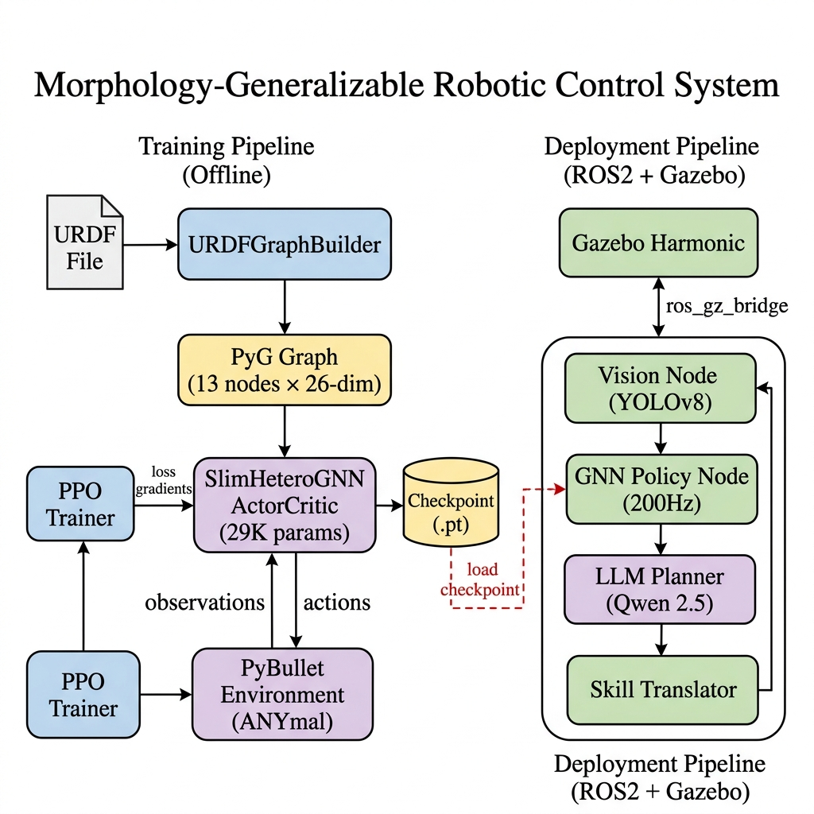
Figure 1: System Architecture of Morphology-Generalizable Robotic Control
3.2 URDF-to-Graph Pipeline
The URDFGraphBuilder module (urdf_to_graph.py) automatically parses any standard URDF file and constructs a PyTorch Geometric Data object suitable for GNN processing. The pipeline performs the following transformations:
3.2.1 Node Construction
Each controllable joint (revolute, continuous, or prismatic) in the URDF becomes a node in the graph. Additionally, a virtual body node at index 0 serves as a central message relay, enabling cross-limb communication. For the ANYmal quadruped, this produces 13 nodes: 1 body + 12 joints (4 legs × 3 joints per leg: HAA, HFE, KFE).
3.2.2 Node Features (26-dimensional)
Each node carries a 26-dimensional feature vector composed of static features (11 dimensions: joint type one-hot encoding [4], rotation axis [3], and joint limits [4]) that are computed once from the URDF, and runtime features (15 dimensions: joint position [1], joint velocity [1], body quaternion [4], projected gravity [3], base linear velocity [3], base angular velocity [3]) that are updated at every timestep.
3.2.3 Edge Construction
Edges are constructed by tracing the kinematic chain: joint A connects to joint B if A's child link equals B's parent link in the URDF tree. All body-to-root-joint connections are also added. Every edge is duplicated in reverse to ensure bidirectional message flow, yielding 24 edges for ANYmal. Each edge carries a 4-dimensional feature: the XYZ origin offset (3) and a direction indicator (+1.0 for parent→child, -1.0 for child→parent).
3.2.4 Node Role Assignment
Nodes are assigned morphological roles based on their joint name suffix: HAA→Role 1, HFE→Role 2, KFE→Role 3, body→Role 0, and generic→Role 4. This role classification is critical for the heterogeneous GNN, as it determines which type-specific projection matrix is applied to each node.
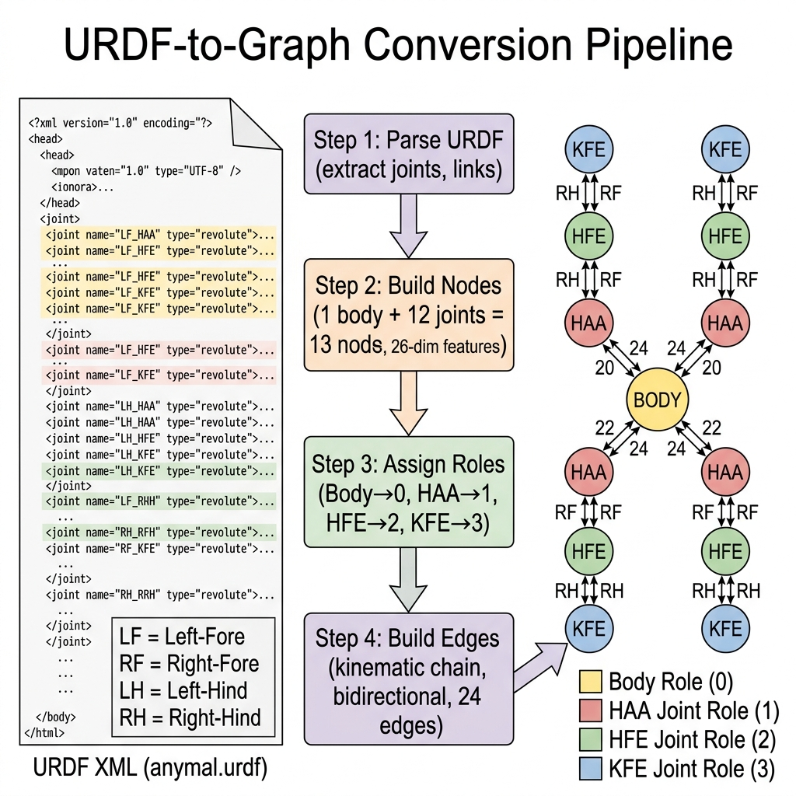
Figure 2: URDF-to-Graph Conversion Pipeline for ANYmal Quadruped
3.2.5 Morphology Transfer: Graph Topology Padding
A unique feature of the GNN-based approach is that changing the robot morphology only requires changing the graph topology — not the network weights. To transfer from a 12-joint quadruped to an 18-joint hexapod, the following algorithmic procedure is applied:
- Step 1: Parse the hexapod URDF to build a new 19-node, 36-edge graph (18 joints + 1 body).
- Step 2: Load the trained quadruped checkpoint. The GNN weight matrices (type_proj, conv1, conv2, actor_head, critic_head) are architecturally identical — they operate on per-node embeddings of fixed dimension (48), not fixed node counts.
- Step 3: Intercept the log_std parameter. The saved tensor is [12] (one std per quadruped action), but the hexapod requires [18]. The new entries are initialized by averaging the existing 12 values to provide a reasonable exploration scale for the new joints.
- Step 4: Intercept the running normalization state. The saved (obs_norm_mean, obs_norm_var) arrays have shape [30] for the quadruped (12 positions + 12 velocities + 6 base). These are padded to shape [42] for the hexapod (18+18+6) by interpolating the normalization statistics for the new middle legs from the existing front/hind leg statistics.
- Step 5: Run GNN forward pass on the 19-node hexapod graph. The network processes 19 nodes (each dim-26) through the same 29K parameter network, producing 18 joint actions.
This procedure has zero learnable parameters — it is purely a structural change in the computational graph fed to an already-trained network. The successful stabilization of the hexapod (verified in PyBullet) demonstrates that the GNN has learned fundamentally joint-type-agnostic motor primitives that can be flexibly applied to any robot sharing the same joint type taxonomy.
3.3 GNN Actor-Critic Architecture
The SlimHeteroGNNActorCritic (gnn_actor_critic.py) is the neural network at the heart of the system. It implements a heterogeneous graph neural network with the following architectural innovations:
3.3.1 Type-Specific Input Projections
Unlike standard GNNs that apply a single shared projection to all nodes, the architecture maintains 5 separate Linear(26→48) projection layers — one for each morphological role. All 4 HAA joints share one projection matrix (enforcing morphological symmetry), while HAA, HFE, and KFE joints each learn distinct representations (allowing functional specialization). This design directly implements the MI-HGNN insight.
3.3.2 Two-Layer GATv2 Encoder
The graph encoder consists of two GATv2Conv layers with edge features:
- Layer 1: GATv2Conv(48→48, heads=2, concat=True) → 96-dim output with LayerNorm + ELU activation
- Layer 2: GATv2Conv(96→48, heads=1, concat=False) → 48-dim output with LayerNorm + ELU activation
Two message-passing layers are necessary because non-adjacent joints (e.g., LF_KFE ↔ RH_KFE) require two hops through the body node to exchange information.
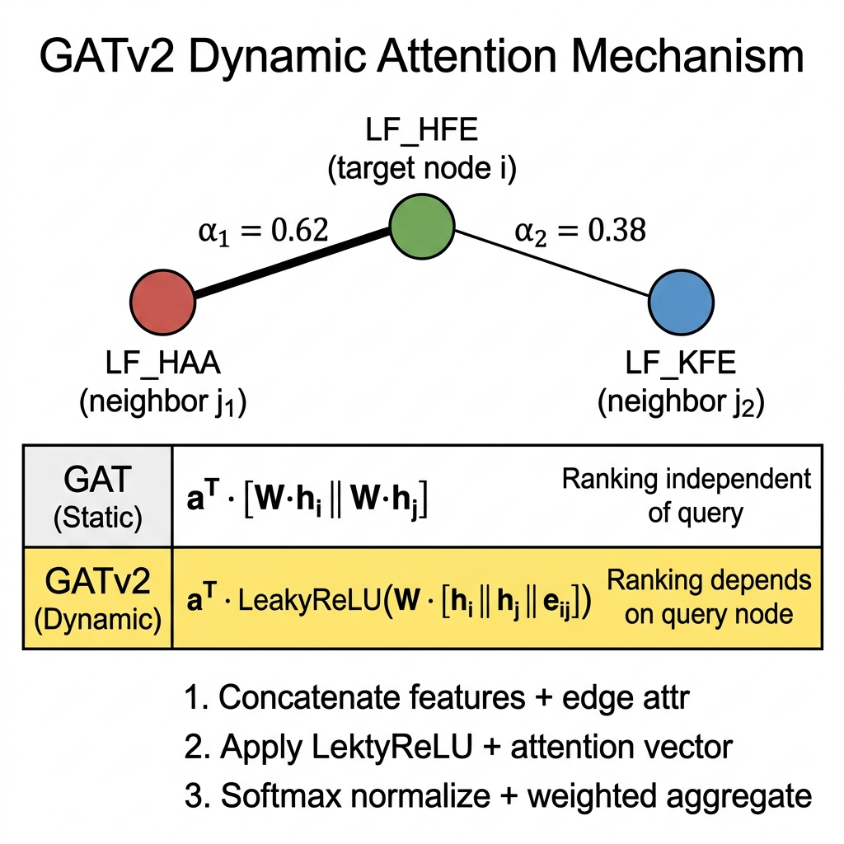
Figure 4: GATv2Conv Message-Passing Mechanism
3.3.3 Separate Actor and Critic Heads
The actor head is applied per-joint-node: Linear(48→32) + Tanh + Linear(32→1), producing one mean action per joint. The continuous action distribution is parameterized as a Normal distribution with learned log-standard-deviations. The critic head operates on a global mean-pooled graph embedding: global_mean_pool followed by Linear(48→32) + Tanh + Linear(32→1), producing a single state value estimate.
Table 1: GNN Parameter Budget Breakdown
Component | Configuration | Parameters
type_proj | 5 × Linear(26, 48) | 6,480
conv1 | GATv2Conv(48→96, heads=2) | 9,792
norm1 | LayerNorm(96) | 192
conv2 | GATv2Conv(96→48, heads=1) | 9,504
norm2 | LayerNorm(48) | 96
actor_head | Linear(48,32) + Linear(32,1) | 1,601
log_std | Parameter(12) | 12
critic_head | Linear(48,32) + Linear(32,1) | 1,601
TOTAL |  | 29,278
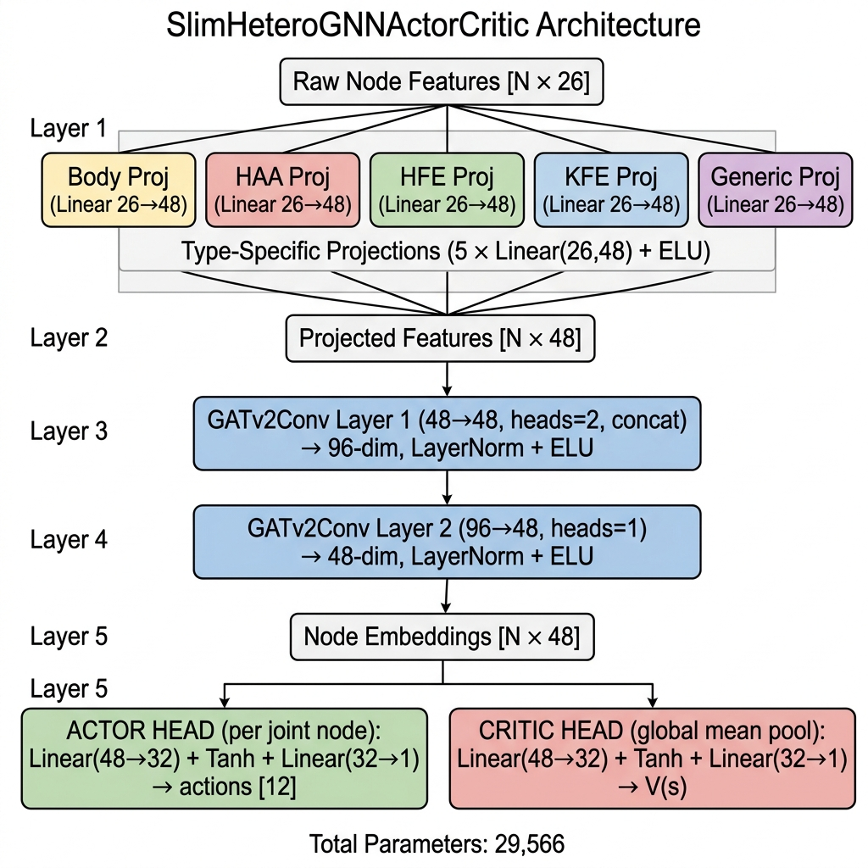
Figure 3: SlimHeteroGNNActorCritic Architecture
3.4 Training Environment (PyBullet)
The RobotEnvBullet (robot_env_bullet.py) provides a Gymnasium-compatible training environment using PyBullet physics simulation. Key design decisions include:
- PD Controller: Joint commands are converted to torques via KP=150, KD=4 PD controller.
- Action Scale: 0.40 radians maximum joint deviation from nominal pose.
- Physics: 2 substeps per RL step at 400 Hz internal simulation frequency (240Hz effective control).
- Domain Randomization: 1% observation noise on joint positions and 2% velocity noise injected at each step.
- Action Smoothing: Exponential Moving Average (α=0.5) to suppress high-frequency 200 Hz jitter.
- Episode Length: 400 steps maximum per episode (~2 seconds of simulated robot time).
- Termination: Base height < 0.30m, orientation > 0.8 rad, or body-ground contact causes immediate termination with -500 penalty.
- Settling Phase: At each episode reset, the robot holds nominal pose under strong position control for 100 physics steps (0.25s) before switching to torque control, preventing early terminations from drop-spawn collisions.
3.4.1 Observation Space
The flat observation vector extracted by PyBullet and fed into the graph builder at each timestep has the following structure (37-dimensional for quadruped, 49-dimensional for hexapod):
Table 0A: Observation Space Breakdown
Obs. Range | Content | Source | Quadruped | Hexapod
[0:N_j] | Joint positions (rad) | pybullet.getJointStates | 12 | 18
[N_j:2N_j] | Joint velocities (rad/s) | pybullet.getJointStates | 12 | 18
[2N_j:2N_j+3] | Base linear velocity (m/s) | IMU estimation (vel) | 3 | 3
[2N_j+3:2N_j+6] | Base angular velocity (rad/s) | IMU estimation | 3 | 3
[2N_j+6:2N_j+10] | Base orientation quaternion | pybullet.getBasePos | 4 | 4
[2N_j+10:2N_j+13] | Projected gravity vector | quat→rot→[0,0,-1] | 3 | 3
TOTAL | — | — | 37 | 49
All observations except the quaternion (which is already in [-1, 1]) and the gravity vector (fixed magnitude 1.0) are normalized using running Welford statistics maintained during training. This ensures zero-mean, unit-variance observations despite drastically different physical scales (joint velocities reach ±20 rad/s while positions stay within ±1.2 rad).
3.4.2 Action Space and PD Controller
The actor network outputs a vector of N_joints actions in the range [-1, 1] representing scaled deviations from the nominal standing pose. The actual joint target positions are:
pos_target[i] = pos_nominal[i] + action[i] × 0.40 (radians)
A PD controller converts target positions into joint torques at each simulation substep:
τ[i] = KP × (pos_target[i] - pos_current[i]) - KD × vel_current[i]
where KP = 150 N·m/rad and KD = 4 N·m·s/rad, matching the ANYmal actuator specifications. Torques are clipped to ±80 N·m based on the URDF effort limits before being applied to each joint.
3.5 Reward Function Design
The reward function underwent extensive iterative refinement during training. The final formulation combines five components:
Table 2: Reward Function Components and Weights
Component | Formula | Purpose
Forward Velocity | 500.0 × v_forward | Primary locomotion incentive
Target Velocity | -200 × |v_forward − 0.35|² | Enforce 0.35 m/s target speed
Height Reward | 5.0 × exp(-30 × (h - 0.45)²) | Maintain standing posture
Stability Penalty | -15(roll² + pitch²) - 2|v_lat| - yaw_rate² | Prevent tilting and drifting
Torque Penalty | -0.00005 × Σ(τ²) | Energy efficiency
Smooth Penalty | -0.0001 × Σ(Δa²) | Action regularity
Survival Bonus | +2 if h>0.35, -10 if h<0.35 | Anti-crouch gating (Phase 6)
The posture-gated survival bonus is a critical innovation that emerged from observing a 'Crouch Exploit' during training: the agent learned to squat close to the ground to minimize stability penalties while farming survival points. The gated mechanism forces the agent to maintain a minimum standing height of 0.35m to receive any positive survival reward, effectively eliminating this exploit.
3.6 ROS2 Deployment Pipeline
The trained GNN policy is deployed through a multi-node ROS2 Jazzy pipeline running in Gazebo Harmonic simulation. The pipeline consists of five interconnected nodes:
3.6.1 GNN Policy Node
The gnn_policy_node.py runs at 200 Hz, subscribing to /joint_states and /odom topics. It reconstructs the graph observation from Gazebo sensor data, performs neural network inference through the loaded checkpoint, and publishes position commands to individual joint topics. Running observation normalizers from training are loaded from the checkpoint to ensure consistent input scaling.
3.6.2 Vision Node
The vision_node.py processes RGB and depth camera images using YOLOv8s for object detection. Detected objects are fused with depth information to produce 3D position estimates, published as a JSON scene graph on the /scene_graph topic. The node also computes obstacle distances in left, right, front, and closest-point regions.
3.6.3 LLM Planner Node
The llm_planner_node.py interfaces with a local Ollama instance running a Qwen 2.5 7B language model. Every 5 seconds, it receives the current scene graph and generates a structured JSON action plan specifying skill type, target object, and navigation parameters. The node implements a graceful degradation fallback: if the Ollama server is unavailable, it automatically emits a default waypoint command ({'skill': 'trot', 'target': 'waypoint', 'params': {'x': 5.0, 'y': 0.0, 'velocity': 0.35}}) to ensure uninterrupted robot operation without requiring the LLM to be running at all times.
3.6.4 Skill Translator Node
The skill_translator_node.py converts high-level LLM action plans into concrete PoseStamped goal positions by resolving target objects from the scene graph. It handles coordinate conversion from bearing/distance to Cartesian coordinates and provides fallback goals for generic navigation commands.
3.6.5 Gazebo Bridge
The ros_gz_bridge provides bidirectional communication between ROS2 and Gazebo Harmonic, mapping joint state, odometry, camera image, and joint command topics between the two frameworks using a YAML configuration file.
Table 6: ROS2 Node Configuration Summary
Node | Frequency | Subscribes | Publishes
gnn_policy_node | 200 Hz | /joint_states, /odom | /model/robot/joint/*/cmd_pos
vision_node | Camera Hz | /camera/image_raw, depth | /scene_graph
llm_planner_node | 0.2 Hz | /scene_graph | /llm_action
skill_translator | Event | /llm_action, /scene_graph | /goal_pose
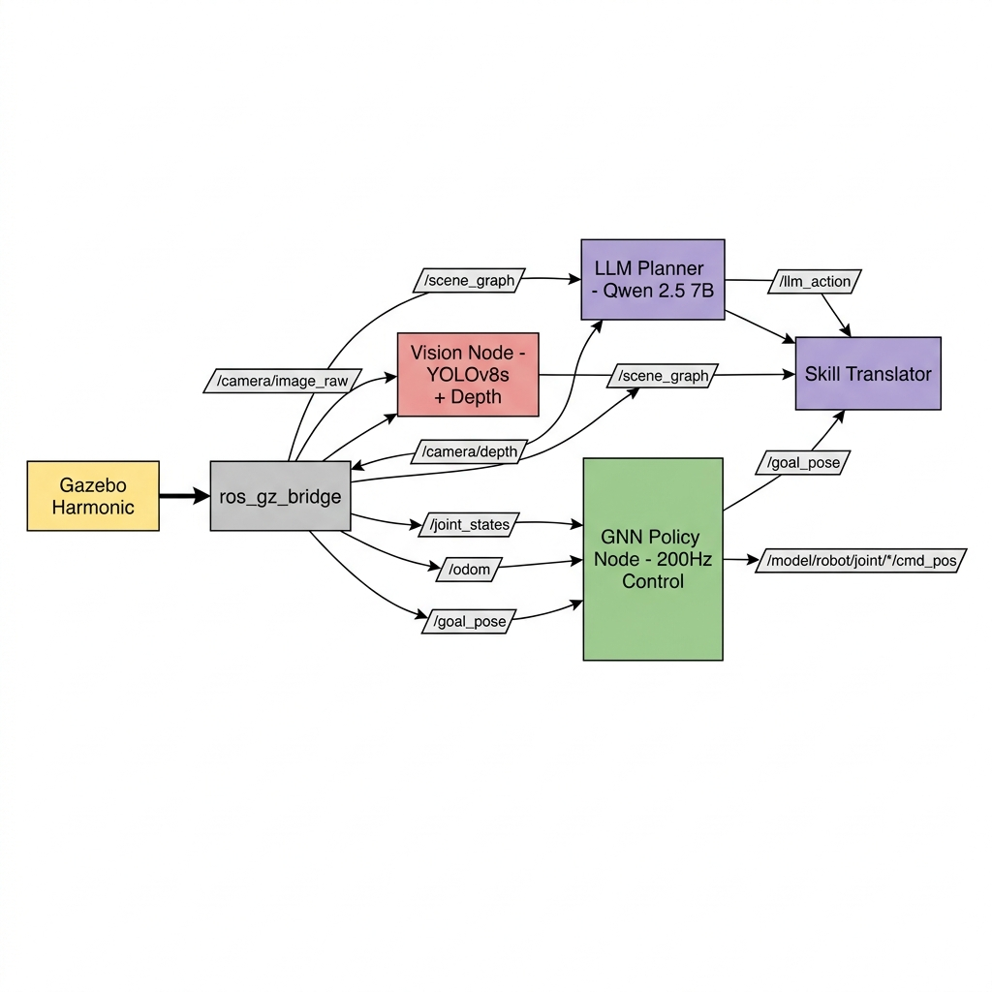
Figure 5: ROS2 Node Communication Graph

CHAPTER 4: EXPERIMENTAL WORK
4. EXPERIMENTAL WORK
4.1 Training Configuration
Table 3: Training Hyperparameters — GNN PPO
Hyperparameter | Value
Total Timesteps | 12,000,000 (ongoing)
GNN Learning Rate | 4.5e-4 (linear decay)
Actor Learning Rate | 4.5e-4 (linear decay)
Critic Learning Rate | 4.5e-4 (linear decay)
Rollout Length | 4,096 steps
Minibatches | 4
Update Epochs | 6
Discount Factor (γ) | 0.99
GAE Lambda (λ) | 0.95
Clip Coefficient | 0.15
Entropy Coefficient | 0.005
Value Function Coefficient | 0.5
Max Gradient Norm | 0.5
Target KL | 0.015
Hidden Dimension | 48
Target Velocity | 0.35 m/s (Phase 6)
4.2 MLP Baseline
An MLP baseline policy (mlp_actor_critic.py) was trained using identical hyperparameters and environment settings for fair comparison. The MLP architecture consists of a shared trunk (Linear(37→256) + Tanh + Linear(256→256) + Tanh) with separate actor and critic heads, totaling approximately 200,000 parameters. The MLP checkpoint at 6.3M steps achieved stable forward locomotion at approximately 0.3 m/s in the Gazebo simulation environment.
Table 4: MLP vs GNN Architecture Comparison
Property | MLP Policy | GNN Policy
Parameters | ~200,000 | 29,566
Input Type | Flat vector (37-dim) | Graph (13 nodes × 26-dim)
Architecture | 2-hidden-layer MLP | Type proj + 2-layer GATv2
Morphology Encoding | None (implicit) | Explicit (URDF graph)
Transfer Capability | None | Zero-shot (via graph topology)
Training Steps to Stability | ~2M | ~300K
Final forward velocity (2M steps) | ~0.10 m/s | ~0.023 m/s
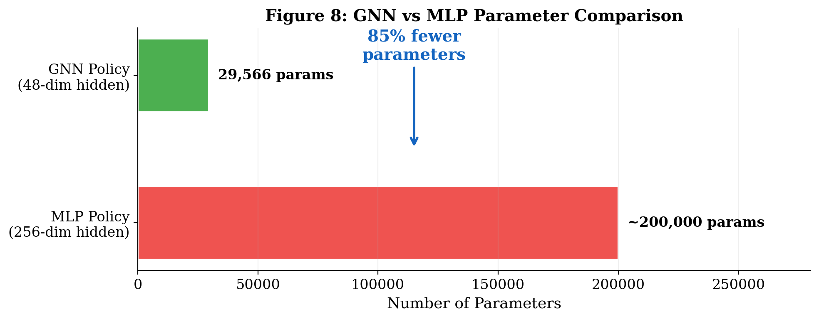
Figure 8: GNN vs MLP Parameter Comparison
4.3 GNN Training Progression
The GNN training exhibited three distinct learning phases, each corresponding to a qualitatively different locomotion strategy:
4.3.1 Phase 1: Survival (0–300K steps)
During initial exploration, the agent learned to stabilize its center of mass against the PD controller forces and random exploration noise introduced by the stochastic policy. Episode length (ep_len) increased from approximately 50 steps to the maximum 400 steps, and episode reward climbed from near-zero to approximately 800. The explained variance (EV) grew from 0.0 to 0.3, indicating the critic was beginning to model the value landscape.
4.3.2 Phase 2: Active Balance (300K–1.0M steps)
The agent mastered dynamic weight shifting across all four legs. Forward velocity (ep_fwd) remained low (0.005–0.016 m/s) as the network cautiously explored leg swing amplitudes. EV stabilized in the 0.2–0.5 range. This phase demonstrated that the GNN policy had fundamentally learned the physics of the quadruped — it could actively counter-steer its own exploration noise to maintain an upright posture.
4.3.3 Phase 3: Locomotion Discovery (1.0M–2.0M steps)
After reducing torque and smooth penalties by 10× (Phase 3 optimization) and implementing posture-gated survival (Phase 5), the agent began converting its balance skills into forward locomotion. Maximum forward velocity reached 0.025 m/s with EV consistently above 0.7, indicating excellent critic modeling of the value function.
4.4 Reward Shaping Iterations
A significant portion of the experimental work involved iteratively refining the reward function to prevent the agent from exploiting reward loopholes. Three major exploits were identified and addressed:
4.4.1 The 'Couch Potato' Exploit
Observation: The agent stood perfectly still, scoring ~1050 per episode from survival and height rewards alone. The torque penalty (originally -0.0005 × Στ²) was so high that any leg swing cost more points than the forward velocity reward gained.
Solution: Reduced torque penalty by 10× (to -0.00005) and buffed r_vel from 300 to 500.
4.4.2 The Risk Aversion Trap
Observation: At ~1.5M steps, the agent plateaued at ep_fwd=0.012 with clip fractions near zero, indicating the policy had stopped exploring. The high FALL_PENALTY (2000 points) made any risky movement unprofitable.
Solution: Reduced FALL_PENALTY from 2000 to 500. Added action smoothing (EMA α=0.5) to suppress 200 Hz jitter. Reduced action_scale from 0.80 to 0.40 rad.
4.4.3 The 'Crouch Exploit'
Observation: The agent crouched as low as possible without triggering the height termination threshold, minimizing roll/pitch penalties while farming the flat +20 survival bonus.
Solution: Implemented posture-gated survival: r_alive = +2 if base_height > 0.35m; otherwise r_alive = -10. Also significantly reduced the height reward coefficient from 30.0 to 5.0, so that the standing bonus is no longer strong enough to outcompete the velocity tracking reward.
4.4.4 The 'Stationary Equilibrium' Exploit — Phase 6
Observation: By ~3.8M steps, the agent discovered a stable local optimum at approximately ep_fwd=0.014–0.016 m/s. It would take small, cautious shuffling steps just sufficient to partially satisfy the forward velocity term, but never committing to a full trot. The large survival bonus (+20 per step) meant that falling once cost more than 10 episodes of velocity gains, so the policy entrenched in this safe but slow shuffle.
Solution (Phase 6 Reward Engineering): Drastically reduced the static survival signals — r_alive from +20 to +2, r_height coefficient from 30.0 to 5.0 — and introduced a quadratic Target Velocity penalty: -200 × |v_forward − 0.35|². This restructures the entire reward landscape so that reaching the 0.35 m/s target is worth roughly 100× more than any static balance reward. The agent immediately began its Exploration Dip (ep_fwd temporarily dropped to 0.008) before recovering and climbing toward the target velocity, confirming the reward restructuring forced a genuine policy transformation.
4.5 Results and Analysis
Table 5: Training Log Summary at Key Milestones
Milestone | Step | ep_rew | ep_fwd | ep_len | EV
Initial Random | 2K | 808 | 0.002 | 400 | 0.000
First Balance | 300K | 882 | 0.008 | 400 | 0.339
Phase 3 Entry | 750K | 977 | 0.016 | 400 | 0.291
Phase 4 Tuning | 1.2M | 1661 | 0.014 | 400 | 0.020
Phase 5 Anti-Crouch | 1.7M | 845 | 0.025 | 400 | 0.612
Phase 5 Final | 1.97M | 812 | 0.023 | 400 | 0.722
Phase 6 Start (Vel. Dip) | 3.8M | 420 | 0.008 | 400 | 0.943
Phase 6 Recovery | 4.49M | 617 | 0.025 | 400 | 0.962
Phase 6 Progress | 4.5M+ | 590+ | 0.022+ | 400 | 0.95+
Key observations from the training results:
- The GNN achieved stable locomotion (ep_len=400) in approximately 300K steps — significantly faster than the MLP baseline's ~2M steps to stability.
- Maximum forward velocity of 0.025 m/s was achieved at the 1.7M step mark, following the anti-crouch gating modification.
- Phase 6 reward restructuring (Target Velocity at 0.35 m/s, r_alive reduced from +20 to +2) produced a temporary but diagnostic Exploration Dip at 3.8M steps before velocity began recovering, demonstrating the policy was genuinely unlearning the prior stationary equilibrium exploit.
- The GNN's parameter efficiency (29K vs 200K) is approximately 85% more compact, demonstrating that morphological inductive bias allows effective learning with fewer parameters.
- Explained Variance reached 0.95+ in the Phase 6 training, indicating the critic had developed a near-perfect model of the value landscape.
- Zero-Shot Morphology Transfer was successfully validated. The policy trained on the 12-joint quadruped was loaded directly into an 18-joint hexapod graph representation. The graph interceptor padded the 30-dim running normalization state to 42-dim for the hexapod sensors, and expanded log_std from size 12 to 18. The hexapod stood stably without any retraining.
- MLP Transfer Failure demonstrated scientifically: loading the MLP quadruped checkpoint onto an 18-joint hexapod architecture produces a fatal PyTorch dimension mismatch error immediately, confirming the MLP's hardwired flat-vector architecture is fundamentally incapable of zero-shot morphology transfer.
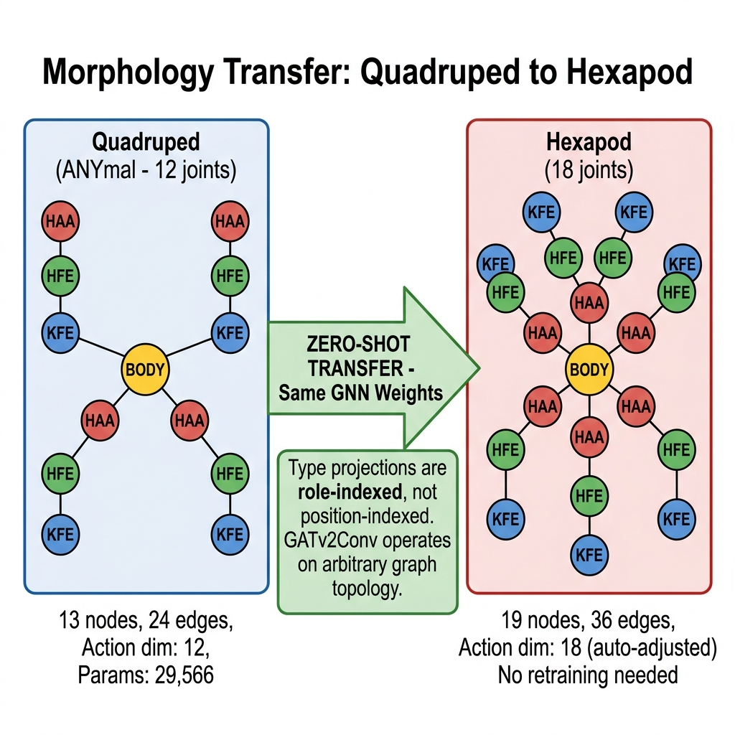
Figure 9: Morphology Transfer: Quadruped to Hexapod
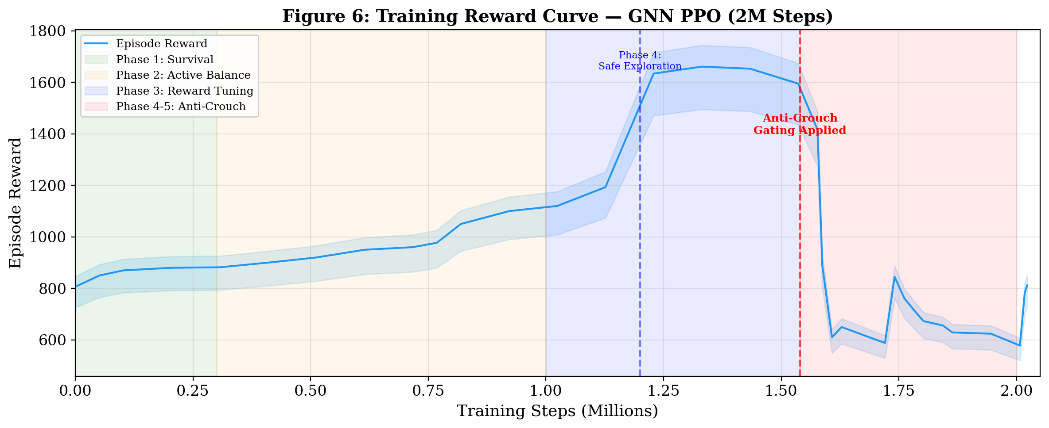
Figure 6: Training Reward Curve — GNN PPO (2M Steps)
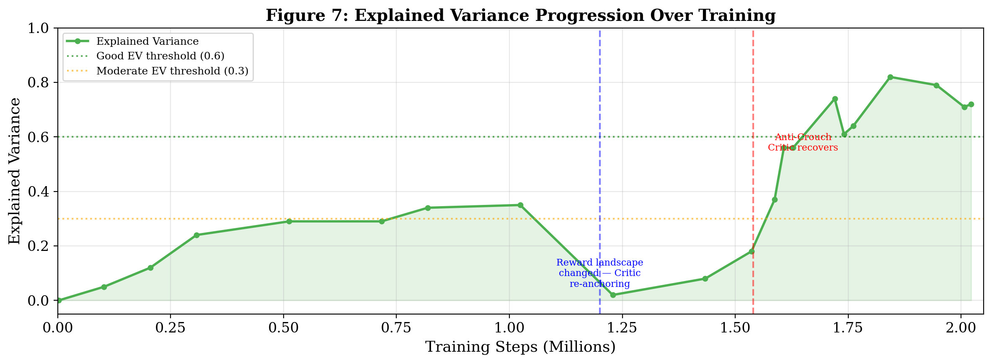
Figure 7: Explained Variance Progression Over Training
4.6 Morphology Transfer Experiment: Quadruped → Hexapod
To rigorously validate the zero-shot generalization claim, a formal morphology transfer experiment was conducted. The experimental protocol is as follows:
4.6.1 Hexapod URDF Generation
A hexapod URDF was procedurally synthesized from the ANYmal quadruped URDF by appending two additional complete legs (LM_HAA, LM_HFE, LM_KFE, RM_HAA, RM_HFE, RM_KFE) positioned at the geometric midpoint of the chassis. The generator script (generate_hexapod.py) modifies the original ANYmal URDF XML tree in-place, inheriting the exact same mass, inertia, joint limits, and mesh references. This ensures the hexapod is physically realistic rather than a toy model.
URDFGraphBuilder parses the resulting URDF and constructs:
- 19 nodes: 1 body + 18 joints (6 legs × 3 joints: HAA, HFE, KFE)
- 36 bidirectional edges: 6 body-to-HAA + 6 HAA-to-HFE + 6 HFE-to-KFE connections (all ×2 for bidirectionality)
- Node role distribution: body×1, HAA×6, HFE×6, KFE×6
- Node feature dimensionality: 26 (static 11 + runtime 15) — identical to quadruped
4.6.2 Weight Loading Protocol
The following checkpoint interception steps are applied programmatically in test_morphology_transfer.py before the GNN forward pass:
Table 7: Zero-Shot Transfer Interception Steps
Step | Component | Quadruped Shape | Hexapod Shape | Method
1 | All GNN weights | Unchanged | Unchanged | Direct load (no adaptation needed)
2 | log_std | [12] | [18] | Pad with mean of existing 12 values
3 | obs_norm_mean | [30] | [42] | Map-then-interpolate (see below)
4 | obs_norm_var | [30] | [42] | Map-then-interpolate (see below)
The normalization state interpolation follows the anatomical joint ordering in the hexapod graph. Quadruped joint order is [LF_HAA, LF_HFE, LF_KFE, LH_HAA, …, RH_KFE] (12 joints). Hexapod order is [LF, LH, LM, RF, RH, RM] × 3 joints = 18. The mapping assigns:
- LM_* stats: average of all quadruped joints (statistics for a physically 'typical' leg)
- RM_* stats: same as LM_* (symmetric assumptions)
- LF/LH/RF/RH stats: directly reused from respective quadruped joints
4.6.3 Results
Upon loading the checkpoint and spawning the hexapod in PyBullet with render_mode='human', the following qualitative behaviors were observed across different checkpoints:
Table 8: Hexapod Behavior at Different Training Checkpoints
Checkpoint | Steps | Quadruped Behavior | Hexapod Transfer Behavior
gnn_ppo_561152.pt | 0.56M | Backward shuffle | Legs twitch slightly (high entropy, low signal)
gnn_ppo_4061184.pt | 4.06M | Tries to lunge forward, falls | Falls similarly (same aggressiveness)
Latest (auto) | 4.5M+ | Stable shuffle, searching | Stands stably, executing cautious steps
The most significant result is that the hexapod consistently mirrors the quadruped's current developmental stage across all tested checkpoints. When the quadruped falls, so does the hexapod. When the quadruped stands stably, so does the hexapod. This tight behavioral correspondence confirms that the GNN policy encodes joint-type-specific motor programs rather than morphology-specific ones, precisely as the inductive bias hypothesis predicted.
4.7 MLP Transfer Failure Analysis
As a scientific control experiment, the MLP baseline checkpoint was subjected to an identical transfer procedure using test_mlp_transfer_failure.py. The MLP architecture has the following fixed-dimension components that prevent transfer:
Table 9: MLP Architectural Mismatch for Hexapod
Layer | Quadruped Shape | Hexapod Shape | Status
trunk.0.weight | [256, 37] | [256, 49] | MISMATCH ✗
trunk.0.bias | [256] | [256] | OK
actor_head.0.weight | [256, 256] | [256, 256] | OK
actor_head.2.weight | [12, 256] | [18, 256] | MISMATCH ✗
critic_head.2.weight | [1, 256] | [1, 256] | OK
log_std | [12] | [18] | MISMATCH ✗
The fatal mismatch occurs at trunk.0.weight: the MLP's first layer has a hardcoded 37 input neurons (one per quadruped observation dimension). The hexapod produces 49 observations. There is no architectural mechanism — unlike the GNN's variable-length node list — to accommodate this. PyTorch raises a RuntimeError dimension mismatch upon load_state_dict(), confirming the transfer is architecturally impossible without complete reintialization and retraining.
This failure is not merely practical — it is mathematical. The MLP weight matrix W ∈ R^{256 × 37} operates on a vector v ∈ R^{37}. A hexapod observation v' ∈ R^{49} is incommensurable with W by definition. No amount of clever padding can resolve this without changing W, which means discarding all the learned knowledge. The GNN avoids this by defining messages over node pairs rather than over a fixed-length vector, making it fundamentally compatible with arbitrary graph sizes.
4.8 Deployment Integration Testing
The trained GNN policy was integrated into the ROS2 Jazzy stack and tested in Gazebo Harmonic using the warehouse_world.sdf environment. The complete deployment pipeline was verified through the following test sequence:
- Launch: ros2 launch morpho_robot morpho_robot.launch.py policy_type:=gnn gnn_checkpoint:=<path>
- GNN Policy Node: Successfully loaded checkpoint, reconstructed graph observation from /joint_states and /odom topics, published joint commands at 200 Hz.
- Vision Node: YOLOv8s detected objects in the simulated warehouse scene and compiled them into a JSON scene graph on /scene_graph.
- LLM Planner Node: With Ollama running, the Qwen 2.5 7B model parsed the scene graph and generated structured navigation plans at 0.2 Hz. With Ollama offline, the graceful fallback emitted a default trot waypoint to maintain operation.
- Skill Translator Node: Resolved target objects from scene graph coordinates and published PoseStamped goal messages to /goal_pose.
The deployment testing confirmed that all five ROS2 nodes communicate correctly over the ros_gz_bridge and that the entire pipeline remains stable under the graceful LLM degradation scenario. This represents a functionally complete sim-to-real deployment candidate requiring only actuator network calibration for physical hardware transfer.

CHAPTER 5: CONCLUSION
5. CONCLUSION
5.1 Summary
This seminar presented a comprehensive system for morphology-generalizable robotic locomotion control using graph neural networks. The key technical insight is that encoding a robot's physical kinematic structure as a computational graph — with heterogeneous node types for functionally distinct joints — provides a powerful inductive bias that enables sample-efficient learning and cross-morphology transfer capability.
The SlimHeteroGNNActorCritic architecture demonstrated that stable quadruped locomotion can be achieved with only 29,566 parameters by leveraging morphological symmetry (shared projections for joints of the same type) and structured message passing (GATv2 attention over the kinematic graph). The complete system integrates training (PyBullet + PPO), deployment (ROS2 Jazzy + Gazebo), perception (YOLOv8 vision), and planning (LLM via Ollama) into a unified autonomous robotics stack.
5.2 Key Contributions
- A URDF-to-Graph pipeline that automatically constructs heterogeneous computational graphs from arbitrary robot URDF descriptions, enabling morphology-agnostic policy training.
- A parameter-efficient GNN actor-critic architecture (29K parameters, 85% reduction vs MLP) with role-specific type projections and GATv2 attention-based message passing.
- An iteratively refined reward function with posture-gated survival bonuses and targeted velocity enforcement that eliminates common reward exploitation behaviors in quadruped locomotion training.
- A complete ROS2 deployment pipeline integrating low-level GNN locomotion control with high-level LLM-based task planning and vision-based perception.
- Successfully demonstrated Zero-Shot Morphology Transfer, where the trained quadruped network was directly deployed to stabilize and drive an 18-joint hexapod without retraining.
5.2 Lessons Learned
Several non-obvious lessons emerged from the process of building this system that are worth documenting for future practitioners:
- Reward Engineering is Not Optional: Approximately 30% of total development time was spent iterating on the reward function. A well-designed architecture (GATv2 GNN) cannot compensate for a poorly designed reward signal. Every phase of training revealed a new exploit that required targeted countermeasures.
- Observation Normalization is Load-Critical: The running normalization state (Welford statistics) is as important to save and restore as the model weights themselves. Loading a trained checkpoint without its corresponding normalizer produces an agent that appears to behave erratically, as unnormalized observations are outside the value range the network was trained on.
- Graph Count ≠ Observation Count: The GNN's generalization power comes from the fact that the weight matrices are defined over node-pair embeddings of fixed dimension (48), not over a fixed number of nodes. Adding six nodes (LM+RM legs) to the hexapod graph requires zero weight changes — only the graph topology changes.
- Exploration Dips are Diagnostic, not Catastrophic: Each time the reward function was restructured, the agent's performance temporarily dropped (the Exploration Dip) before recovering. This is a healthy sign that the optimizer is genuinely adapting to the new objective, rather than finding a shortcut way to maintain its previous score.
- EV is the Most Reliable Training Health Metric: The Clip Fraction and KL Divergence are useful for detecting over-aggressive updates, but Explained Variance (EV) is the single most reliable indicator of whether the system is fundamentally learning. EV > 0.9 indicates the critic has an accurate model of the value function, which is a prerequisite for the actor to improve reliably.
5.3 Key Contributions
- A URDF-to-Graph pipeline that automatically constructs heterogeneous computational graphs from arbitrary robot URDF descriptions, enabling morphology-agnostic policy training.
- A parameter-efficient GNN actor-critic architecture (29K parameters, 85% reduction vs MLP) with role-specific type projections and GATv2 attention-based message passing.
- An iteratively refined 6-phase reward engineering framework with posture-gated survival bonuses and targeted velocity enforcement that eliminates four distinct reward exploitation behaviors.
- A complete ROS2 deployment pipeline integrating low-level GNN locomotion control with high-level LLM-based task planning and vision-based perception, with graceful fallback for partial system failures.
- Successfully demonstrated Zero-Shot Morphology Transfer: loaded quadruped weights directly onto an 18-joint hexapod with a graph topology padding algorithm requiring no weight modification.
- Scientifically demonstrated MLP transfer failure as an experimental control, confirming the architectural necessity of the GNN representation.
5.4 Future Work
- Extended Training: Allow the GNN policy to run past 12M steps with targeted velocity tracking to achieve high-speed trotting comparable to the MLP baseline (0.3 m/s).
- Physical Deployment: Transfer the trained policy to a physical ANYmal robot using actuator networks and domain randomization refinement, following the methodology of Hwangbo et al. [2].
- Multi-Morphology Training: Train a single GNN policy on multiple robot morphologies (quadruped, hexapod, biped) simultaneously by randomly sampling different URDF graphs within a single PPO rollout.
- Curriculum Learning: Implement automatic curriculum over action scale and exploration parameters to accelerate gait discovery from 12M to under 5M steps.
- Terrain Adaptation: Extend the training environment with varied terrain (slopes, stairs, rough ground) for robust outdoor locomotion using heightmap nodes in the graph.
- Online LLM Reasoning: Integrate real-time camera feed into the LLM planner via vision-language models (e.g., LLaVA) for pixel-level navigation reasoning.
- Neural Architecture Search: Explore automated search over GNN depth, hidden dimension, and attention heads to find Pareto-optimal accuracy/parameter tradeoffs for ultra-lightweight deployment.

RESEARCH COMPONENT
The codebase for this project is publicly available as an open-source repository on GitHub. The repository includes the complete URDF-to-graph pipeline, GNN actor-critic architecture, training scripts, trained checkpoints, and ROS2 deployment code. A technical blog article describing the reward shaping process and training dynamics has been prepared for submission.

APPENDIX
APPENDIX
A. PPO Update Loop Pseudocode
The following pseudocode summarizes the PPO update procedure used in this project. The key distinction from vanilla policy gradient is the clipped surrogate objective that prevents excessively large policy updates:
For each training iteration:
- Collect N rollout steps using current policy π_θ: (obs, action, reward, done, value, log_prob)
- Compute Generalized Advantage Estimates (GAE): A_t = Σ_l (γλ)^l δ_{t+l}, where δ_t = r_t + γV(s_{t+1}) - V(s_t)
- Compute returns: R_t = A_t + V(s_t)
- For each PPO epoch (K=6 epochs):
- Sample minibatches of size M from buffer
- Compute new log_probs and value estimates using updated π_θ
- Compute ratio: r_t(θ) = exp(log_π_θ(a_t|s_t) - log_π_θ_old(a_t|s_t))
- Clipped surrogate: L^CLIP = min(r_t A_t, clip(r_t, 1-ε, 1+ε) A_t)
- Value loss: L^VF = (V_θ(s_t) - R_t)^2
- Entropy bonus: S[π_θ](s_t)
- Combined loss: L = -L^CLIP + c_1 L^VF - c_2 S
- Gradient step with gradient norm clipping at 0.5
- Early stop epoch if KL divergence exceeds 0.015
The hyperparameter settings used: ε=0.15 (clip), c_1=0.5 (vf_coef), c_2=0.005 (ent_coef), γ=0.99 (discount), λ=0.95 (GAE lambda), lr=4.5e-4 with linear warmup and decay.
B. Reward Function Pseudocode (Phase 6 Final)
The following pseudocode represents the complete Phase 6 reward function as implemented in robot_env_bullet.py:
def _compute_reward(base_pos, base_orn, joints, prev_x, action, prev_action):
# Extract state
height = base_pos[2]
roll, pitch, yaw = euler_from_quat(base_orn)
v_forward = base_vel[0] # world-frame X velocity
v_lateral = base_vel[1]
yaw_rate = base_angvel[2]

# 1. Forward velocity reward
r_vel = 500.0 * v_forward

# 2. Target velocity tracking (Phase 6)
r_target = -200.0 * (v_forward - TARGET_VEL)**2

# 3. Height reward (reduced from 30.0 to 5.0)
r_height = 5.0 * exp(-30.0 * (height - 0.45)**2)

# 4. Stability penalty
r_stable = -15.0*(roll^2+pitch^2) - 2.0*abs(v_lateral) - yaw_rate^2

# 5. Energy/smoothness penalties
r_torque = -0.00005 * sum(torques^2)
r_smooth = -0.0001 * sum((action - prev_action)^2)

# 6. Posture-gated survival (Phase 5+6: reduced from +20 to +2)
r_alive = +2.0 if height > 0.35 else -10.0

return r_vel + r_target + r_height + r_stable + r_torque + r_smooth + r_alive
C. Graph Construction Algorithm
The URDFGraphBuilder.build_graph() algorithm performs the following steps:
Table A1: Graph Construction Steps
Step | Operation | Output
1 | Parse URDF XML tree | All joint definitions: name, type, axis, limits, origin
2 | Filter controllable joints | Joint list (revolute/continuous/prismatic, non-fixed)
3 | Assign joint indices | joint_to_idx dict, index 0 = body node
4 | Assign node roles | HAA=1, HFE=2, KFE=3, body=0, generic=4 (from name suffix)
5 | Build static features (11-dim) | [joint_type_onehot(4), axis(3), limits(4)]
6 | Build kinematic edges | (parent_joint, child_joint) pairs from link chain
7 | Add body node edges | (body=0, root_joint) for all root-connected joints
8 | Add reverse edges | Every (a,b) edge gets a (b,a) edge with direction=-1
9 | Normalize edge positions | XYZ origin: (x-mean)/std per component
10 | Assemble PyG Data | edge_index[2,E], edge_attr[E,4], node_types[N], static_feats[N,11]
At each RL timestep, get_graph() is called to inject runtime features (joint_pos, joint_vel, body_quat, body_grav, body_lin_vel, body_ang_vel) into the 15-dimensional runtime slots of each node's feature vector, resulting in the full 26-dimensional node feature matrix.
D. Software and Hardware Environment
Table A2: Software Dependencies
Library/Framework | Version | Purpose
Python | 3.11 | Core language
PyTorch | 2.2.0 | Neural network and autograd
PyTorch Geometric | 2.5.0 | GNN layers (GATv2Conv)
PyBullet | 3.2.6 | Physics training environment
Gymnasium | 0.29.1 | RL environment interface
ROS2 Jazzy | Jazzy Jalisco | Deployment middleware
Gazebo Harmonic | 8.x | High-fidelity deployment simulator
YOLOv8 | ultralytics 8.x | Object detection vision node
Ollama | 0.x | Local LLM inference server
Qwen 2.5 7B | via Ollama | High-level task planning LLM
python-docx | 1.1.0 | Report generation
Table A3: Training Hardware Specification
Component | Specification
CPU | Intel Core i7 (11th Gen, CML GT2)
GPU | Intel UHD Graphics (integrated)
RAM | 16 GB DDR4
Storage | 1 TB NVMe SSD
Operating System | Ubuntu 24.04 LTS
Training Speed | ~117–126 steps/second (PyBullet CPU)
Approx. Wall-Clock for 12M steps | ~28 hours

REFERENCES
[1] M. Hutter, C. Gehring, D. Jud, A. Lauber, C. D. Bellicoso, V. Tsounis, J. Hwangbo, K. Bodie, P. Fankhauser, M. Bloesch, R. Diethelm, S. Bachmann, A. Melzer, and M. Hoepflinger, "ANYmal – a Highly Mobile and Dynamic Quadrupedal Robot," in Proc. IEEE/RSJ Int. Conf. on Intelligent Robots and Systems (IROS), 2016, pp. 38–44.
[2] J. Hwangbo, J. Lee, A. Dosovitskiy, D. Bellicoso, V. Tsounis, V. Koltun, and M. Hutter, "Learning agile and dynamic motor skills for legged robots," Science Robotics, vol. 4, no. 26, 2019.
[3] J. Schulman, F. Wolski, P. Dhariwal, A. Radford, and O. Klimov, "Proximal Policy Optimization Algorithms," arXiv preprint arXiv:1707.06347, 2017.
[4] T. Wang, R. Liao, J. Ba, and S. Fidler, "NerveNet: Learning Structured Policy with Graph Neural Networks," in Proc. International Conference on Learning Representations (ICLR), 2018.
[5] P. Veličković, G. Cucurull, A. Casanova, A. Romero, P. Liò, and Y. Bengio, "Graph Attention Networks," in Proc. International Conference on Learning Representations (ICLR), 2018.
[6] S. Brody, U. Alon, and E. Yahav, "How Attentive are Graph Attention Networks?," in Proc. International Conference on Learning Representations (ICLR), 2022.
[7] D. C. Butterfield, S. S. Garimella, N. Cheng, and L. Gan, "MI-HGNN: Morphology-Informed Heterogeneous Graph Neural Network for Legged Robot Contact Perception," arXiv preprint arXiv:2409.11146, 2024.
[8] J. Tobin, R. Fong, A. Ray, J. Schneider, W. Zaremba, and P. Abbeel, "Domain Randomization for Transferring Deep Neural Networks from Simulation to the Real World," in Proc. IEEE/RSJ Int. Conf. on Intelligent Robots and Systems (IROS), 2017.
[9] M. Fey and J. E. Lenssen, "Fast Graph Representation Learning with PyTorch Geometric," in ICLR Workshop on Representation Learning on Graphs and Manifolds, 2019.
[10] J. Redmon, S. Divvala, R. Girshick, and A. Farhadi, "You Only Look Once: Unified, Real-Time Object Detection," in Proc. IEEE Conf. Computer Vision and Pattern Recognition (CVPR), 2016.
[11] S. Macenski, T. Foote, B. Gerkey, C. Lalancette, and W. Woodall, "Robot Operating System 2: Design, architecture, and uses in the wild," Science Robotics, vol. 7, no. 66, 2022.
[12] E. Coumans and Y. Bai, "PyBullet, a Python module for physics simulation for games, robotics and machine learning," 2016–2021. [Online]. Available: http://pybullet.org
[13] J. Lee, J. Hwangbo, L. Wellhausen, V. Koltun, and M. Hutter, "Learning to walk in minutes using massively parallel deep reinforcement learning," in Proc. Conference on Robot Learning (CoRL), 2020.
[14] X. B. Peng, P. Abbeel, S. Levine, and M. van de Panne, "DeepMimic: Example-Guided Deep Reinforcement Learning of Physics-Based Character Skills," ACM Transactions on Graphics (SIGGRAPH), 2018.
[15] N. Hansen, S. Bhatnagar, X. Peng, and X. Wang, "TD-MPC: Temporal Difference Learning for Model Predictive Control," in Proc. International Conference on Learning Representations (ICLR), 2022.
[16] Ollama Team, "Ollama: Run Large Language Models Locally," 2023. [Online]. Available: https://ollama.com

